Relative or absolute variations can be determined by using the ratio of any component. By taking the ratio of the component with the smallest variance on a basis, the absolute amount variation can be found.

Table S1. Sample data were shown. This showed basis.
E | F | G | H | Total
100 | 1870 | 2000 | 705 | 4675
98 | 142 | 100 | 15 | 355
99 | 2200 | 1000 | 2201 | 5500
103 | 132 | 60 | 35 | 330
105 | 1666 | 105 | 2289 | 4165
94 | 834 | 500 | 657 | 2085
97 | 904 | 600 | 659 | 2260
106 | 1016 | 1000 | 418 | 2540
107 | 1726 | 10 | 2472 | 4315
109 | 2048 | 3 | 2960 | 5120
91 | 2536 | 4 | 3709 | 6340
104 | 3384 | 80 | 4892 | 8460
108 | 2062 | 2900 | 85 | 5155
93 | 1634 | 960 | 1398 | 4085
95 | 3884 | 4000 | 1731 | 9710
104 | 1808 | 1600 | 1008 | 4520
105 | 1456 | 500 | 1579 | 3640
101 | 1152 | 6 | 1621 | 2880
100 | 3052 | 8 | 4470 | 7630
99 | 3380 | 19 | 4952 | 8450

Table S2. This showed composition.
E | F | G | H
0.021 | 0.400 | 0.428 | 0.151
0.276 | 0.400 | 0.282 | 0.042
0.018 | 0.400 | 0.182 | 0.400
0.312 | 0.400 | 0.182 | 0.106
0.025 | 0.400 | 0.025 | 0.550
0.045 | 0.400 | 0.240 | 0.315
0.043 | 0.400 | 0.265 | 0.292
0.042 | 0.400 | 0.394 | 0.165
0.025 | 0.400 | 0.002 | 0.573
0.021 | 0.400 | 0.001 | 0.578
0.014 | 0.400 | 0.001 | 0.585
0.012 | 0.400 | 0.009 | 0.578
0.021 | 0.400 | 0.563 | 0.016
0.023 | 0.400 | 0.235 | 0.342
0.010 | 0.400 | 0.412 | 0.178
0.023 | 0.400 | 0.354 | 0.223
0.029 | 0.400 | 0.137 | 0.434
0.035 | 0.400 | 0.002 | 0.563
0.013 | 0.400 | 0.001 | 0.586
0.012 | 0.400 | 0.002 | 0.586

As summarized in Table S3, the correlation coefficients differ between basis and composition. This indicated that normal arithmetic operations cannot be performed. Four arithmetic operations can be performed in special cases, that is, when the Total in basis is the same.

Table S3. Statistics of the sample data.
BASIS | E | F | G | H
Coefficient of variation | 0.051438 | 0.558858554 | 1.418847 | 0.840849
Skewness | -0.26789 | 0.273592995 | 1.848419 | 0.750792
Kurtosis | -0.8526 | -0.312479588 | 3.19178 | -0.4766
Correlation with E | 1 | -0.09275376 | -0.06897 | -0.04585
COMPOSITION | E | F | G | H
Coefficient of variation | 1.645673 | 1.42383E-16 | 0.961962 | 0.56555
Skewness | 2.833757 | -1.082977149 | 0.483885 | -0.2812
Kurtosis | 6.964984 | -2.235294118 | -0.88205 | -1.46947
Correlation with E | 1 | 8.47821E-18 | 0.105724 | -0.50088

Examples of ratio analysis was shown in the graphs below.
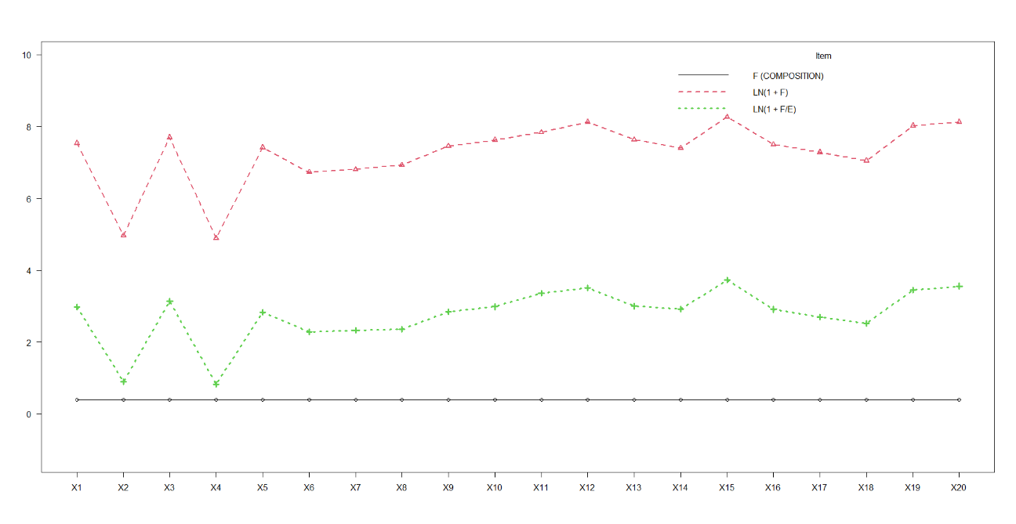
Figure S1. Absolute variation and apparent variation of F.
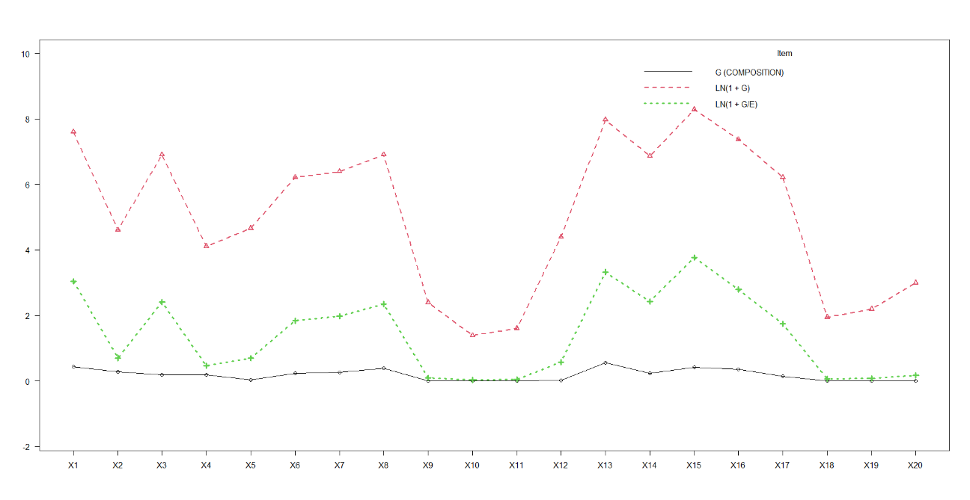
Figure S2(a). Absolute variation and apparent variation of G.

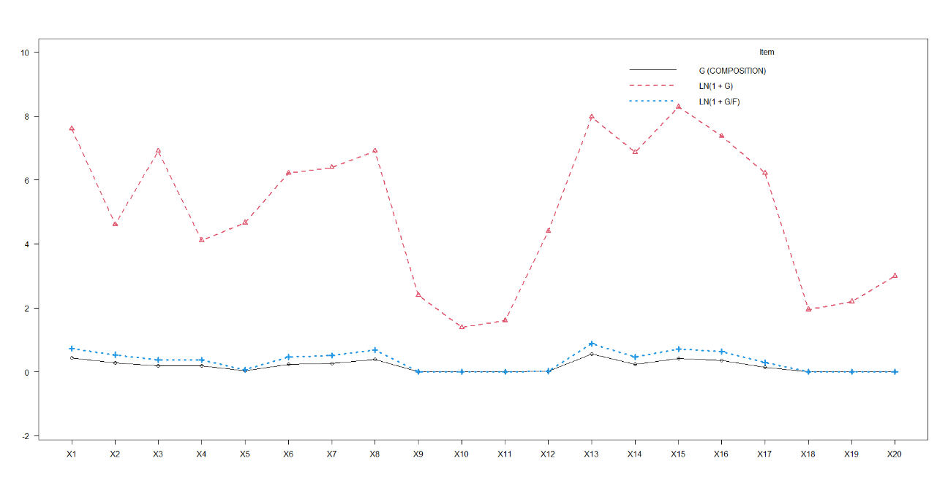
Figure S2(b). The difference between absolute and apparent variation of G.
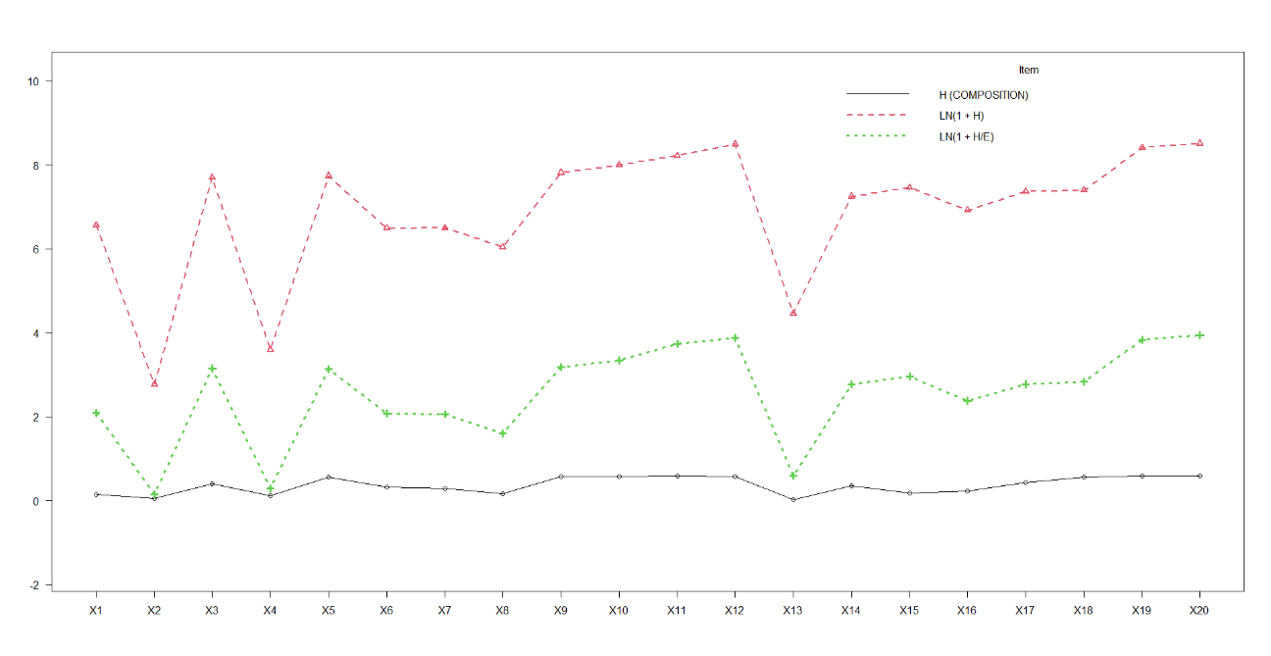
Figure S3(a). Absolute variation and apparent variation of H.

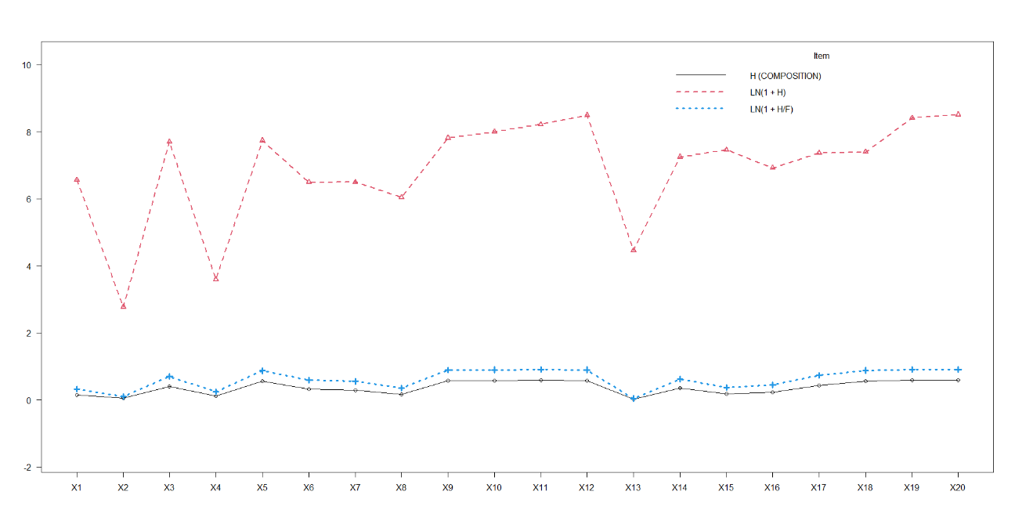
Figure S3(b). The difference between absolute and apparent variation of H.

The component selected for the denominator determined the absolute variation and relative variation. Red and green lines indicated absolute variation, blue and black indicated relative variation. The absolute variance information for the red and green lines holds scientific significance.
The data shown in Table S4 was the artificial compositional data. Row names are numbered to distinguish each data item. A, B, C and D are column names and are used to distinguish columns. A multidimensional scaling method (principal coordinate analysis/PCoA) was performed using the artificial compositional data (Table S4). The PCoA results were shown in Figure S4 for the artificial dataset shown in Table S4. Different analysis results were obtained for the same data. PCoA should not be performed since an example where the result changed every time it was calculated through its algorithm. Therefore, the results of PCoA do not make any mathematical sense and therefore have no scientific basis.
Table S4. The artificial compositional data.
ID | A | B | C | D
1 | 0.1 | 0.1 | 0.4 | 0.4
2 | 0.1 | 0.2 | 0.35 | 0.35
3 | 0.1 | 0.3 | 0.3 | 0.3
4 | 0.1 | 0.4 | 0.25 | 0.25
5 | 0.1 | 0.5 | 0.2 | 0.2
6 | 0.1 | 0.6 | 0.15 | 0.15
7 | 0.1 | 0.7 | 0.1 | 0.1
8 | 0.1 | 0.8 | 0.05 | 0.05
9 | 0.1 | 0.1 | 0.4 | 0.4
10 | 0.1 | 0.2 | 0.35 | 0.35
11 | 0.1 | 0.3 | 0.3 | 0.3
12 | 0.1 | 0.4 | 0.25 | 0.25
13 | 0.1 | 0.5 | 0.2 | 0.2
14 | 0.1 | 0.6 | 0.15 | 0.15
15 | 0.1 | 0.7 | 0.1 | 0.1
16 | 0.1 | 0.8 | 0.05 | 0.05
17 | 0.1 | 0.1 | 0.4 | 0.4
18 | 0.1 | 0.2 | 0.35 | 0.35
19 | 0.1 | 0.3 | 0.3 | 0.3
20 | 0.1 | 0.4 | 0.25 | 0.25
21 | 0.1 | 0.5 | 0.2 | 0.2
22 | 0.1 | 0.6 | 0.15 | 0.15
23 | 0.1 | 0.7 | 0.1 | 0.1
24 | 0.1 | 0.8 | 0.05 | 0.05
25 | 0.1 | 0.1 | 0.4 | 0.4
26 | 0.1 | 0.2 | 0.35 | 0.35
27 | 0.1 | 0.3 | 0.3 | 0.3
28 | 0.1 | 0.4 | 0.25 | 0.25
29 | 0.1 | 0.5 | 0.2 | 0.2
30 | 0.1 | 0.6 | 0.15 | 0.15

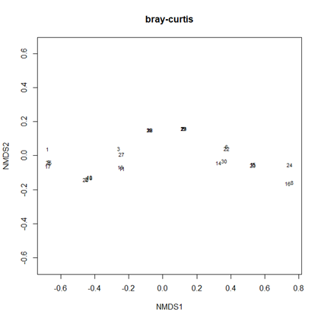 | 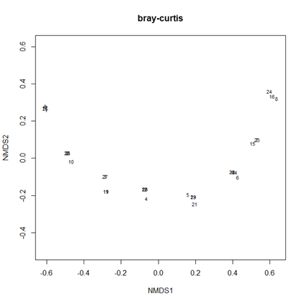
(a) | (b)
Figure S4. The results of principal coordinates analysis of the same data in Table S4. The first and second calculations based on the Bray-Curtis distance were represented by (a) and (b), respectively. The plots did not match. An apparent change occurred.

