Supplementary Materials
Little fish costume: | Orange with sequins
Props: | Ocean (long flowing fan with blue and white gradient dye) + Fish Spitting Pearls (Polystyrene sequin ball)
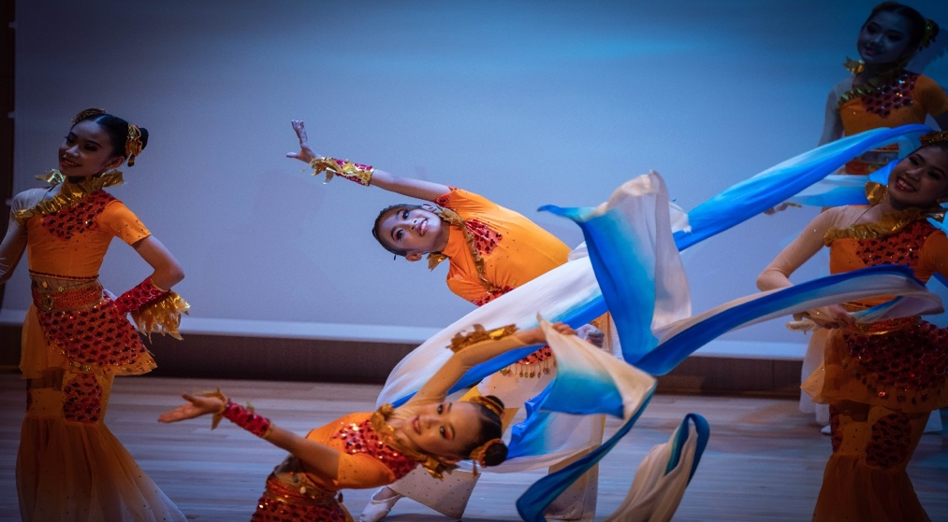
(a)
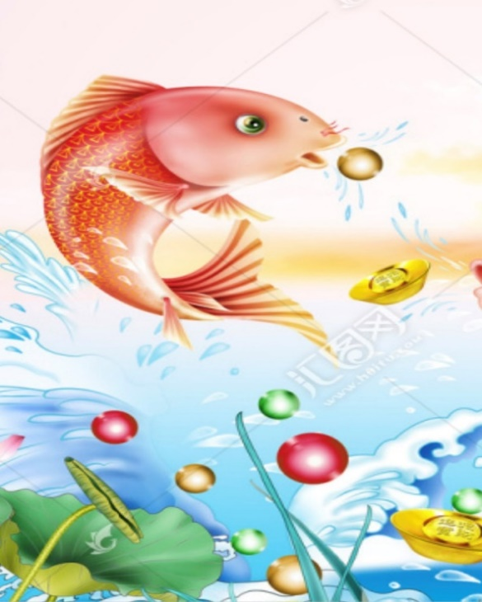  (b) |  | 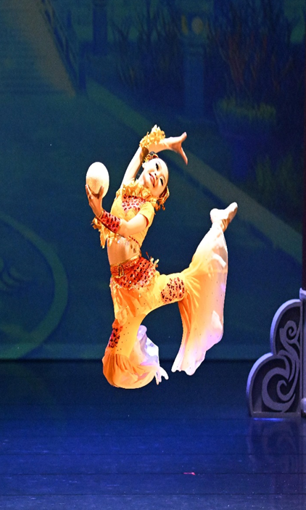  (c)
Figure a-c. Ocean and Fish Spitting Pearls Representing the Piece of Underwater Life Where the Fish Dancing Happily

Dragon King Costume: | Green Dragon Robe
Props: | Dragon Head Headdress
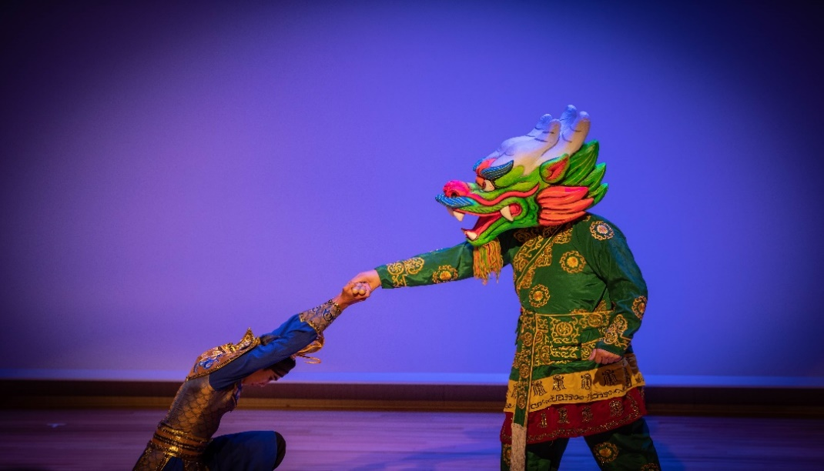
(d)
Figure d. Dragon Costume and Soldier, Representing the Dragon is a Master of the Ocean

Sea Spirit Performance Costume: | Bare Torso with Blue Pants / White Attire
Performance Props: | Glow-in-the-dark Tambourine/Magical Cube
(e) |  | 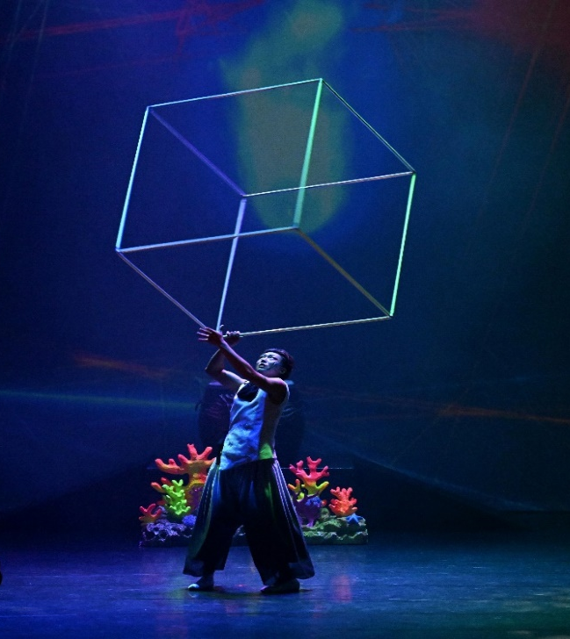  (f)
Figure e & f. Representing the Destruction of Underwater Life and Dragon Palace by the Many Kind of Trash

Sea Beast Costume: | Guandong Lion Custome (Robe and Pants)
Props: | Lion Head Headdress
(g)
Figure g. Sea Beast Represent the Actor Who Bring the Destruction

Ocean Wave Costume: | Blue Pants Skirt
Props: | Long Flowing fan with Dep Blue and White Gradient Dye
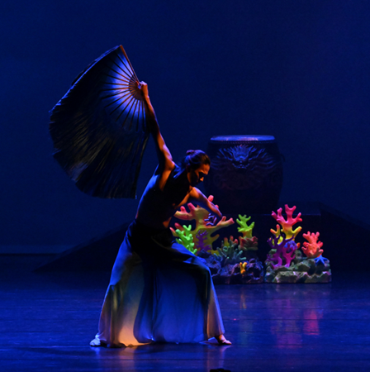  (h) |  | 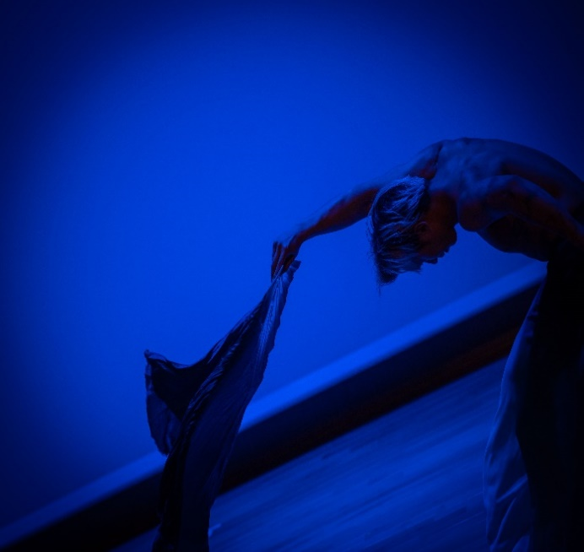  (i)
Figure h & i. The Ocean Dynamics

Shrimp Soldiers and Crab General Costume: |  | Dark Blue and Light Blue Battle Robes
Props: |  | Oriental Big Drum, Large and Small Golden Battle Flags
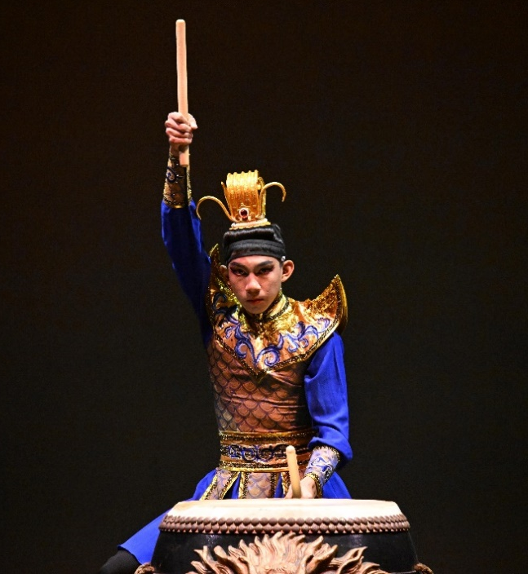  (j) | 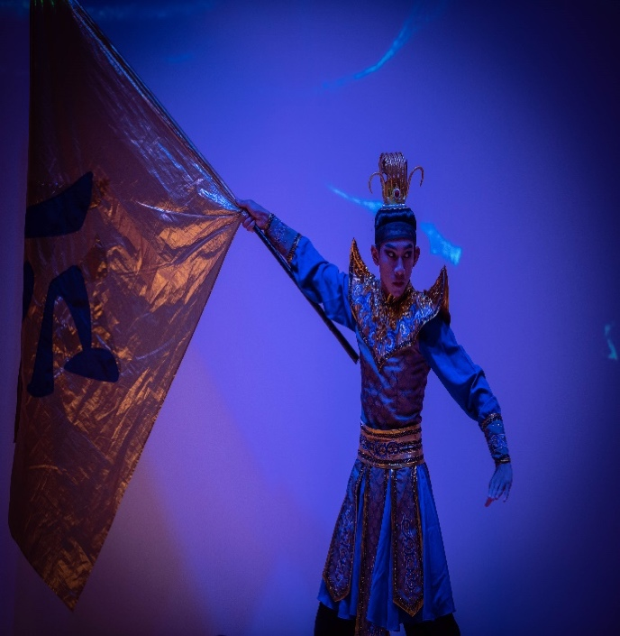  (k)
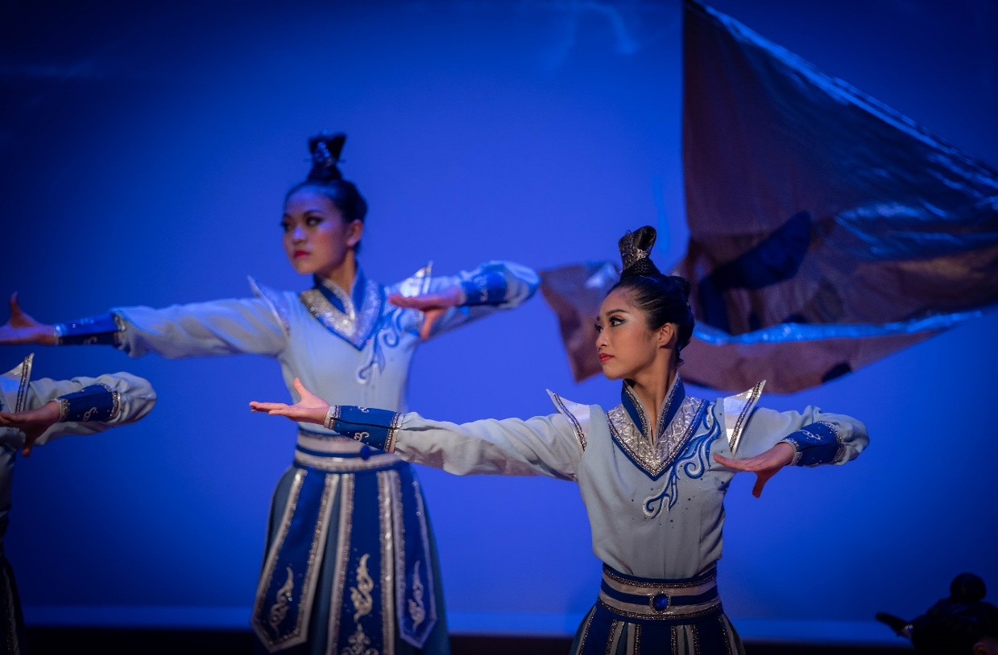
(l)
Figure j-l. Soldiers of Dragon Palace Who Fights Against Sea Beast and Clean the Water

Celebration Performance Costume: | Orang Top, Purple Pants Performance
Props: | Drum, Cymbals, Offering of Fruits for Ritual, Red Embroidered Ball with Ribbons
(m) |  | 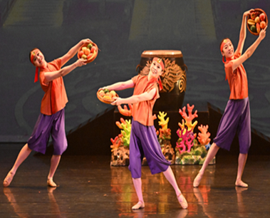  (n)
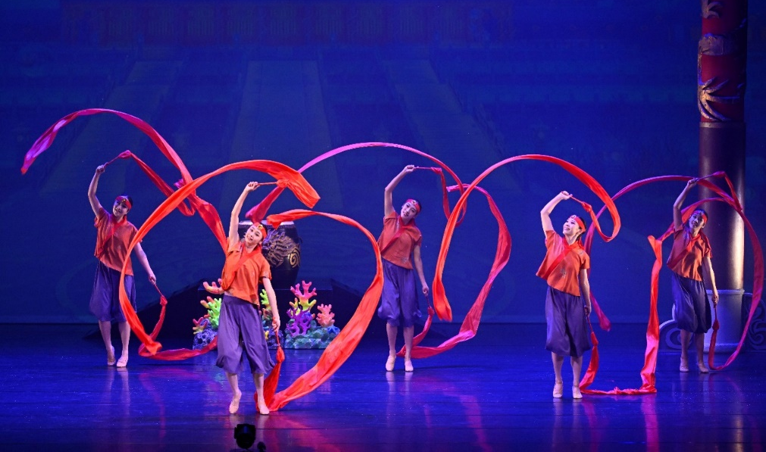
(o)
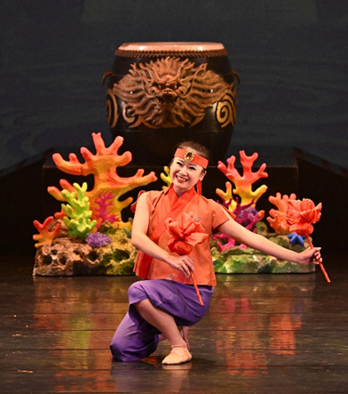
(p)
Figure m-p. Representing the Celebration After the Soldiers Won the Fights to Defend Dragon Palace and Brought Happiness to Underwater Life

