Supplementary Materials For:
Shear Stress Quantification in Tissue Engineering Bioreactor Heart Valves: A Computational Approach
Grid Independence
The mesh independence study is carried out for the largest GOA corresponding to each valve for a flow of 30 LPM. The figures S1, S2 and S3 summarize the results of consecutive mesh refinement on the 50th (median) and 99th percentile WSS for valves 24.6, 18.45 and 12.3 mm respectively. The meshing parameters from the circled data points are utilized for meshing other GOAs of the corresponding valve size.
We evaluated six meshes ranging from 5x10³ to 5.7x10⁴ elements per leaflet (total number of elements ranging from 1.4 to 7.5 million) for the 24.6 mm diameter valve. The results are considered converged when there is less than 5% and 10% change in the 50th and 99th percentile WSS respectively. The meshing parameters that met the convergence criteria resulted in a mesh with 5.3 million total elements (fig. S1). Three meshes were evaluated for the 18.45 mm valve and less than 3% change in the quantities of interest were observed (fig. S2). Therefore, the parameters from the third mesh resulting in a total of 5.79 million total elements were selected for all 18.45 mm valve simulations. Seven meshes ranging from 1.1x10⁴ to 3.4x10⁴ elements per leaflet (total elements ranged from 3.6 to 12 million) are evaluated for the 12.3 mm diameter valve, where each successive mesh resulted in an average of a 20% increase in the number of cells per leaflet (fig S3). Comparing the 6th and 7th data points in fig. S3 with the 5th (circled), the change observed in 50th percentile WSS is -4% and 8.7%, while the change in 99th percentile WSS is -6.5% and 2.4%. These do not meet the criteria for median WSS of less than 5% but the successive mesh resulted in doubling of the total number of elements as well as doubling of the simulation computing time from 22 to 44 hours. Thus, practical considerations limited us to meshing parameters containing 2.3x10⁴ elements per leaflet and a total of 5.9 million elements.
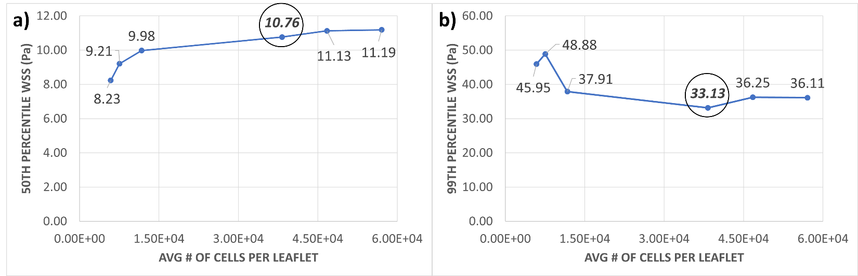
Figure S1: a) Median (50th percentile), b) 99th percentile WSS are plotted for successive mesh refinement, quantified in terms of average number of cells per leaflet, for the largest GOA of the 24.6 mm valve. The numbers displayed next to each data point represents the Y axis value.

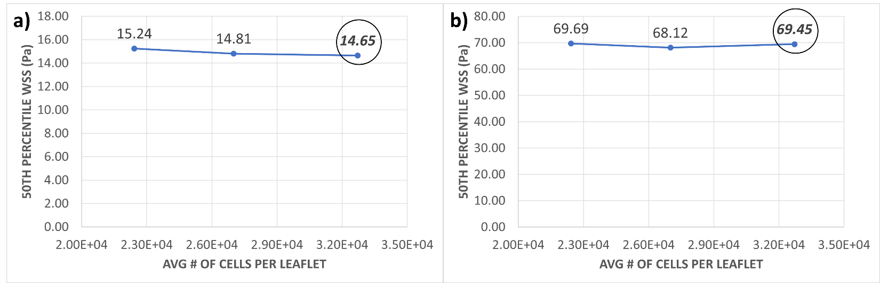
Figure S2: a) Median (50th percentile), b) 99th percentile WSS are plotted for successive mesh refinement, quantified in terms of average number of cells per leaflet, for the largest GOA of the 18.45 mm valve. The numbers displayed next to each data point represents the Y axis value.

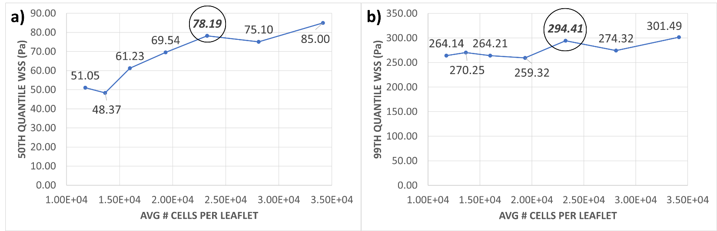
Figure S3: a) Median (50th percentile), b) 99th percentile WSS are plotted for successive mesh refinement, quantified in terms of average number of cells per leaflet, for the largest GOA of the 12.3 mm valve. The numbers displayed next to each data point represents the Y axis value.

Index | Flow (LPM) | GOA (mm²) | Valve Diameter (mm) | Data X Axis | Data Y Axis (median) | Data Y Axis (99th percentile)
1 | 5 | 279.4 | 24.60 | 9.418 | -0.170 | 0.659
2 | 5 | 255.4 | 24.60 | 9.507 | -0.107 | 0.965
3 | 5 | 218.4 | 24.60 | 9.664 | 0.022 | 1.361
4 | 5 | 171.9 | 24.60 | 9.903 | 0.184 | 1.851
5 | 5 | 160.9 | 18.45 | 9.969 | 0.362 | 1.629
6 | 5 | 148.7 | 18.45 | 10.05 | 0.594 | 1.845
7 | 5 | 129.5 | 24.60 | 10.19 | 0.397 | 2.283
8 | 11 | 279.4 | 24.60 | 10.21 | 0.989 | 2.098
9 | 5 | 118.9 | 18.45 | 10.27 | 0.986 | 2.401
10 | 11 | 255.4 | 24.60 | 10.30 | 1.069 | 2.219
11 | 11 | 218.4 | 24.60 | 10.45 | 1.227 | 2.547
12 | 5 | 97.42 | 18.45 | 10.47 | 1.231 | 2.778
13 | 11 | 171.9 | 24.60 | 10.69 | 1.423 | 2.996
14 | 18 | 279.4 | 24.60 | 10.70 | 1.717 | 2.778
15 | 5 | 76.79 | 18.45 | 10.71 | 1.424 | 3.180
16 | 11 | 160.9 | 18.45 | 10.76 | 1.415 | 2.908
17 | 5 | 71.58 | 12.30 | 10.78 | 1.290 | 3.084
18 | 18 | 255.4 | 24.60 | 10.79 | 1.786 | 2.979
19 | 11 | 148.7 | 18.45 | 10.84 | 1.661 | 3.091
20 | 5 | 64.21 | 12.30 | 10.89 | 1.603 | 3.104
21 | 18 | 218.4 | 24.60 | 10.95 | 1.933 | 3.224
22 | 11 | 129.5 | 24.60 | 10.98 | 1.623 | 3.406
23 | 24 | 279.4 | 24.60 | 10.99 | 2.061 | 3.207
24 | 5 | 54.34 | 12.30 | 11.06 | 1.781 | 3.342
25 | 11 | 118.9 | 18.45 | 11.06 | 2.163 | 3.546
26 | 24 | 255.4 | 24.60 | 11.08 | 2.165 | 3.460
27 | 18 | 171.9 | 24.60 | 11.18 | 2.196 | 3.662
28 | 5 | 46.72 | 12.30 | 11.21 | 1.936 | 3.423
29 | 30 | 279.4 | 24.60 | 11.21 | 2.383 | 3.493
30 | 24 | 218.4 | 24.60 | 11.23 | 2.344 | 3.722
31 | 18 | 160.9 | 18.45 | 11.25 | 2.001 | 3.558
32 | 11 | 97.42 | 18.45 | 11.26 | 2.377 | 3.895
33 | 30 | 255.4 | 24.60 | 11.30 | 2.514 | 3.721
34 | 18 | 148.7 | 18.45 | 11.33 | 2.299 | 3.795
35 | 5 | 39.73 | 12.30 | 11.37 | 2.559 | 4.008
36 | 30 | 218.4 | 24.60 | 11.46 | 2.686 | 3.993
37 | 18 | 129.5 | 24.60 | 11.47 | 2.342 | 4.098
38 | 24 | 171.9 | 24.60 | 11.47 | 2.563 | 4.052
39 | 11 | 76.79 | 18.45 | 11.50 | 2.602 | 4.294
40 | 24 | 160.9 | 18.45 | 11.54 | 2.338 | 3.940
41 | 18 | 118.9 | 18.45 | 11.55 | 2.853 | 4.265
42 | 11 | 71.58 | 12.30 | 11.57 | 2.333 | 4.182
43 | 24 | 148.7 | 18.45 | 11.62 | 2.715 | 4.182
44 | 11 | 64.21 | 12.30 | 11.68 | 2.589 | 4.190
45 | 18 | 97.42 | 18.45 | 11.75 | 3.160 | 4.602
46 | 30 | 160.9 | 18.45 | 11.76 | 2.685 | 4.241
47 | 30 | 148.7 | 18.45 | 11.84 | 2.913 | 4.476
48 | 24 | 118.9 | 18.45 | 11.84 | 3.296 | 4.645
49 | 11 | 54.34 | 12.30 | 11.84 | 2.806 | 4.465
50 | 18 | 76.79 | 18.45 | 11.99 | 3.285 | 4.978
51 | 11 | 46.72 | 12.30 | 11.99 | 3.046 | 4.601
52 | 24 | 97.42 | 18.45 | 12.04 | 3.589 | 5.002
53 | 18 | 71.58 | 12.30 | 12.06 | 3.503 | 4.949
54 | 30 | 118.9 | 18.45 | 12.06 | 3.597 | 5.040
55 | 11 | 39.73 | 12.30 | 12.16 | 3.766 | 5.171
56 | 18 | 64.21 | 12.30 | 12.17 | 3.209 | 4.874
57 | 18 | 54.34 | 12.30 | 12.34 | 3.551 | 5.189
58 | 24 | 71.58 | 12.30 | 12.35 | 3.869 | 5.341
59 | 24 | 64.21 | 12.30 | 12.46 | 3.837 | 5.256
60 | 18 | 46.72 | 12.30 | 12.49 | 4.031 | 5.578
61 | 30 | 71.58 | 12.30 | 12.57 | 4.359 | 5.685
62 | 24 | 54.34 | 12.30 | 12.62 | 3.941 | 5.585
63 | 18 | 39.73 | 12.30 | 12.65 | 4.507 | 5.872
64 | 30 | 64.21 | 12.30 | 12.68 | 4.117 | 5.546
65 | 24 | 46.72 | 12.30 | 12.77 | 4.456 | 5.930
66 | 30 | 54.34 | 12.30 | 12.85 | 4.379 | 5.904
Table S1: Values of data points in figures 8 & 9. Note that both figures have a common X axis

