Supplementary Material for

High-entropy diborides - Silicon carbide composites by reactive and non-reactive spark plasma sintering: a comparative study
Ekaterina Pakhomova, Giacomo Cao, Roberto Orrù,
Sebastiano Garroni, Paolo Ferro, Roberta Licheri

Supplementary Figures S1-S4 and Tables S1- S4

Figure S1. (a) SEM micrograph along with the corresponding EDS elemental maps, and (b) X-EDS pattern of HEB_Nb-SiC powders synthesized by SHS

Figure S2. XRD patterns of HEB_Nb-SiC products obtained by SHS-SPS at different T_{D} values: (a) t_{D}=5 min, (b) t_{D}=20 min. The XRD pattern of SHS powders is also included, for comparison.

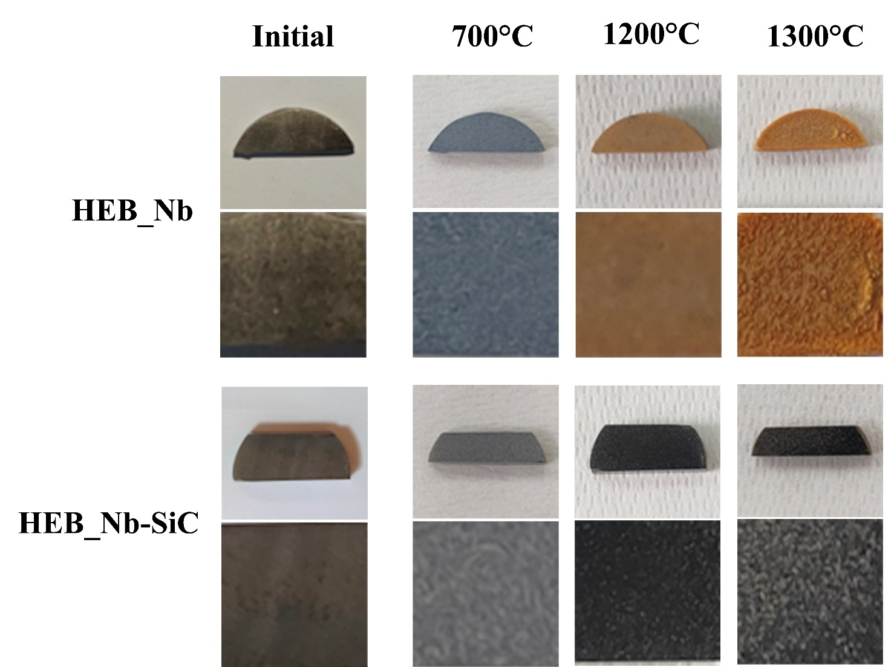
Figure S3. Optical images (complete and detailed view) showing the surface changes of (Hf_{0.2}Mo_{0.2}Ti_{0.2}Ta_{0.2}Nb_{0.2})B₂ and (Hf_{0.2}Mo_{0.2}Ti_{0.2}Ta_{0.2}Nb_{0.2})B₂-SiC samples after oxidation experiments in air furnace at different temperatures.

Figure S4. Optical images (complete and detailed view) showing the surface changes of (Hf_{0.2}Mo_{0.2}Ti_{0.2}Ta_{0.2}Zr_{0.2})B₂ and (Hf_{0.2}Mo_{0.2}Ti_{0.2}Ta_{0.2}Zr_{0.2})B₂-SiC samples after oxidation experiments in air furnace at different temperatures.

Table S1. Phases and quantitative phase analysis results of the HEB_Nb-SiC product obtained by Reactive SPS. (SS): Solid Solution
R-SPS (2000°C, 20 min)
Phase | wt. (%) | a (Å) | b (Å) | c (Å) | β (°) | Symmetry | Space Group | Crystallite size (Å) | Microstrain
(Hf_{0.2}Mo_{0.2}Ti_{0.2}Ta_{0.2}Nb_{0.2})B₂ (SS)-1 | 20.4 | 3.0974 | - | 3.3196 | - | Hexagonal | P6/mmm | 1104 | 4.59 E-4
(Hf_{0.2}Mo_{0.2}Ti_{0.2}Ta_{0.2}Nb_{0.2})B₂ (SS)-2 | 20.3 | 3.0904 | - | 3.3032 | - | Hexagonal | P6/mmm | 1092 | 1.14 E-3
SiC | 12.8 | 4.3529 | - | 3.3196 | - | Cubic | F-43m | >1500 | 1.24 E-3
MoB₂ | 16.7 | 3.1030 | - | 3.2118 | - | Hexagonal | P6/mmm | 988 | 1.53 E-4
NbB₂ | 15.1 | 3.0746 | - | 3.2620 | - | Hexagonal | P6/mmm | 1006 | 1.82 E-3
(Ta_{0.5}Ti_{0.5})B₂ | 14.7 | 3.0496 | - | 3.2381 | - | Hexagonal | P6/mmm | 991 | 1.58 E-4

Table S2. Phases and quantitative phase analysis results of the HEB_Nb-SiC product obtained by SHS
SHS
Phase | wt. (%) | a (Å) | b (Å) | c (Å) | β (°) | Symmetry | Space Group | Crystallite size (Å) | Microstrain
(Hf_{0.2}Mo_{0.2}Ti_{0.2}Ta_{0.2}Nb_{0.2})B₂ | 14.9 | 3.1051 | - | 3.4182 | - | Hexagonal | P6/mmm | 845 | 4.93 E-3
SiC | 11.5 | 4.3614 | - | - | - | Cubic | F-43m | >1500 | 3.09 E-3
TaB₂ | 14.6 | 3.0769 | - | 3.2720 | - | Hexagonal | P6/mmm | 1125 | 2.15 E-3
TiB₂ | 13.4 | 3.0566 | - | 3.2437 | - | Hexagonal | P6/mmm | 1382 | 4.21E-3
NbB₂ | 12.8 | 3.1014 | - | 3.3110 | - | Hexagonal | P6/mmm | 1265 | 1.58 E-3
MoB₂ | 9.5 | 2.9870 | - | 3.1920 | - | Hexagonal | P6/mmm | 1038 | 5.56 E-3
HfB₂ | 9.0 | 3.1412 | - | 3.4739 | - | Hexagonal | P6/mmm | 1227 | 1.21 E-3
(MoTi)B₄ | 3.9 | 3.2788 | - | 2.6036 | - | Hexagonal | P6/mmm | 799 | 1.46 E-3
MoSi₂ | 2.9 | 3.2088 | - | 7.8529 | - | Tetragonal | I4/mmm | 1077 | 9.54 E-4
C | 2.9 | 2.4646 | - | 6.7332 | - | Hexagonal | P63mc | 1030 | 1.28 E-3
SiO₂ | 1.7 | 7.0669 | 12.3077 | 7.1960 | 120.4 | Monoclinic | C2/c:b1 | 896 | 1.34 E-3
Si | 1.6 | 5.4375 | - | - | - | Cubic | Fd-3m:1 | 972 | 1.43 E-3
B₄C | 1.3 | 5.6010 | - | 12.2410 | - | Trigonal | R-3m:H | 978 | 1.1 E-4

Table S3. Phases and quantitative phase analysis results of the HEB_Nb-SiC products obtained by SPS, at different operating conditions, from SHS powders.
SPS (1800°C, 20 min)
Phase | wt. (%) | a (Å) | b (Å) | c (Å) | β (°) | Symmetry | Space Group | Crystallite size (Å) | Microstrain
(Hf_{0.2}Mo_{0.2}Ti_{0.2}Ta_{0.2}Nb_{0.2})B₂ | 83.1 | 3.0887 | - | 3.3035 | - | Hexagonal | P6/mmm | 1089 | 1.33 E-3
SiC | 13.6 | 4.3605 | - | - | - | Cubic | F-43m | >1500 | 1.43 E-3
HfO₂ | 2.4 | 5.1201 | 5.1748 | 5.2851 | 99.1 | Monoclinic | P21/c:b1 | 974 | 3.33 E-3
C | 0.9 | 2.4584 | - | 6.7480 | - | Hexagonal | P63mc | 1005 | 2.72E-4

SPS (1900°C, 5 min)
Phase | wt. (%) | a (Å) | b (Å) | c (Å) | β (°) | Symmetry | Space Group | Crystallite size (Å) | Microstrain
(Hf_{0.2}Mo_{0.2}Ti_{0.2}Ta_{0.2}Nb_{0.2})B₂ | 85.6 | 3.0887 | - | 3.3035 | - | Hexagonal | P6/mmm | 1319 | 1.52 E-4
SiC | 13.0 | 4.3605 | - | - | - | Cubic | F-43m | >1500 | 1.03 E-3
HfO₂ | 1.4 | 5.1201 | 5.1748 | 5.2851 | 99.1 | Monoclinic | P21/c:b1 | 993 | 6.05 E-4

SPS (1900°C, 20 min)
Phase | wt. (%) | a (Å) | b (Å) | c (Å) | β (°) | Symmetry | Space Group | Crystallite size (Å) | Microstrain
(Hf_{0.2}Mo_{0.2}Ti_{0.2}Ta_{0.2}Nb_{0.2})B₂ | 85.2 | 3.0891 | - | 3.3027 | - | Hexagonal | P6/mmm | 1517 | 1.04 E-4
SiC | 13.7 | 4.3611 | - | - | - | Cubic | F-43m | >1500 | 1.31 E-3
HfO₂ | 1.1 | 5.1248 | 5.1777 | 5.2948 | 99.3 | Monoclinic | P21/c:b1 | 1069 | 1.21 E-4

Table S4. Phases and quantitative phase analysis results of the HEB_Zr-SiC products obtained by SHS, and SPS.
SHS
Phase | wt. (%) | a (Å) | b (Å) | c (Å) | β (°) | Symmetry | Space Group | Crystallite size (Å) | Microstrain
(Hf_{0.2}Mo_{0.2}Ti_{0.2}Ta_{0.2}Zr_{0.2})B₂ | 11.9 | 3.1091 | - | 3.4226 | - | Hexagonal | P6/mmm | 1032 | 5.28 E-3
(MoTi)B₄ | 3.4 | 3.2902 | - | 2.5892 | - | Hexagonal | P6/mmm | 845 | 3.66 E-3
ZrB₂ | 13.7 | 3.0969 | - | 3.3188 | - | Hexagonal | P6/mmm | 1430 | 3.52 E-3
TaB₂ | 15.2 | 3.0758 | - | 3.2806 | - | Hexagonal | P6/mmm | 1197 | 2.67 E-3
HfB₂ | 10.7 | 3.1405 | - | 3.4731 | - | Hexagonal | P6/mmm | 1275 | 2.45 E-3
SiC | 10.9 | 4.3613 | - | - | - | Cubic | F-43m | >1500 | 5.55 E-4
MoB₂ | 10.8 | 2.9741 | - | 3.1920 | - | - | P6/mmm | 1039 | 2.69 E-3
TiB₂ | 14.6 | 3.0567 | - | 3.2424 | - | - | P6/mmm | 1383 | 4.17E-3
MoSi₂ | 2.6 | 3.2086 | - | 7.8408 | - | - | I4/mmm | 1062 | 1.24 E-3
SiO₂ | 1.9 | 7.0685 | 12.3074 | 7.1961 | 120.4 | Monoclinic | C2/c:b1 | 799 | 7.45 E-3
C | 1.8 | 2.4677 | - | 6.7188 | - | Hexagonal | P63mc | 1030 | 1.17 E-3
Si | 1.3 | 5.4378 | - | - | - | Cubic | Fd-3m:1 | 972 | 2.32 E-3
B₄C | 1.2 | 5.6005 | - | 12.2459 | - | Trigonal | R-3m:H | 999 | 7.86 E-4

SPS (1800°C, 20 min)
Phase | wt. (%) | a (Å) | b (Å) | c (Å) | β (°) | Symmetry | Space Group | Crystallite size (Å) | Microstrain
(Hf_{0.2}Mo_{0.2}Ti_{0.2}Ta_{0.2}Zr_{0.2})B₂ | 84.4 | 3.0976 | - | 3.3628 | - | Hexagonal | P6/mmm | 1229 | 8.30 E-4
SiC | 14.1 | 4.3593 | - | - | - | Cubic | F-43m | >1500 | 4.50 E-4
HfO₂ | 1.5 | 5.1958 | 5.2193 | 5.3845 | 99.2 | Monoclinic | P21/c:b1 | 1069 | 1.21 E-4

