Supplementary Material

Adults of sun-coral Tubastraea coccinea are resistant to new antifouling biocides
Isabela Martins, Kátia Cristina Cruz Capel, and Denis Moledo de Souza Abessa

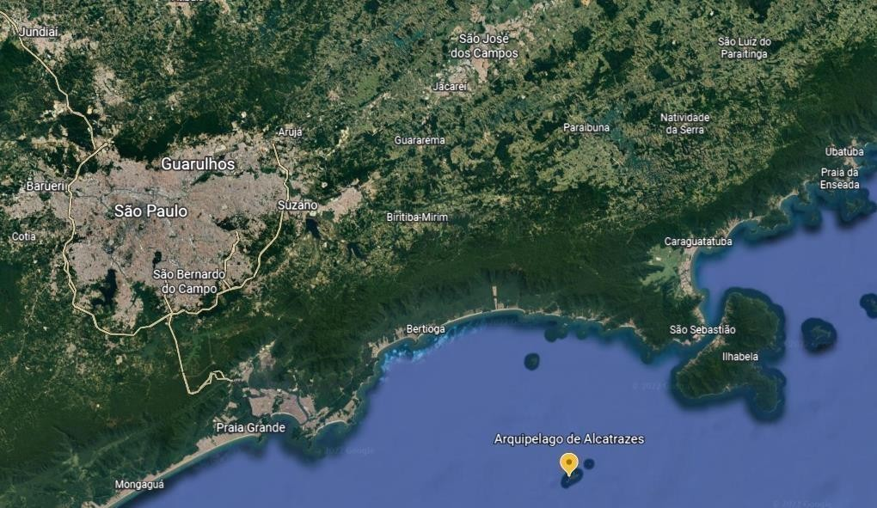
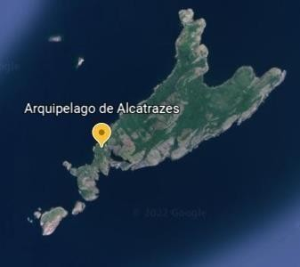
Figure S1. Map showing the sampling site of colonies of Tubastraea coccínea (sun-coral) in the Alcatrazes Archipelago, SP, Brazil. Source: Google Earth (2022).

Table S1. Concentration of the test-substances during the experiments with antifouling biocides and the sun-coral Tubastraea coccinea.
Substance | Concentrations (µg L⁻¹)
DCOIT | 3.33  10  33.3  100
SiNC | 500  1000  2000  4000
SiNC-DCOIT | 74.1  222.2  666.7  2000
SiNC-DCOIT-Ag | 74.1  222.2  666.7  2000

Table S2. Physicochemical parameters of test-solutions measured in the start and the end of the experiments with Tubastraea coccinea and new antifouling biocides.
Treatment | Concentration (µg L⁻¹) | Replicate (n.) | pH |  | T (°C) |  | D.O. (%)
 |  |  | initial | final | initial | final | initial | final
Control | - | 1 | 7.79 | 7.90 | 23.5 | 23.2 | 79.7 | 88.7
 | - | 2 | 7.79 | 7.97 | 23.5 | 23.2 | 80.1 | 87.8
 | - | 3 | 7.74 | 7.89 | 23.5 | 23.2 | 79.3 | 87.0
DCOIT | 3.33  10 | 1  1 | 7.66  7.56 | 7.96  7.82 | 23.7  23.7 | 22.7  23.1 | 83.3  77.9 | 89.2  93.4
 | 33 | 3 | 7.57 | 7.69 | 23.8 | 22.8 | 83.8 | 94.3
 | 100 | 3 | 7.65 | 7.99 | 24.0 | 23.2 | 80.1 | 97.6
SiNC | 500  1000 | 1  1 | 7.92  7.94 | 7.97  8.01 | 24.4  23.5 | 23.8  23.2 | 91.7  83.8 | 97.5  94.4
 | 2000 | 2 | 7.97 | 8.03 | 24.1 | 23.3 | 89.6 | 94.4
 | 4000 | 1 | 7.82 | 7.98 | 24.2 | 23.3 | 83.9 | 91.9
SiNC-DCOIT | 74.1 | 1 | 7.61 | 7.90 | 23.9 | 23.8 | 75.5 | 86.1
 | 222.2 | 2 | 7.83 | 7.85 | 23.4 | 23.6 | 81.1 | 88.0
 | 666.7 | 1 | 7.76 | 7.89 | 24.1 | 23.7 | 83.5 | 83.8
 | 2000 | 1 | 7.88 | 7.98 | 23.6 | 23.8 | 84.5 | 92.6
SiNC-DCOIT-Ag | 74.1 | 1 | 7.86 | 7.99 | 23.3 | 23.5 | 87.7 | 88.4
 | 222.2 | 3 | 7.88 | 7.99 | 23.3 | 23.3 | 82.0 | 87.4
 | 666.7 | 2 | 7.81 | 8.02 | 23.4 | 23.5 | 81.9 | 89.1
 | 2000 | 3 | 7.88 | 7.99 | 23.4 | 23.4 | 85.5 | 88.7

Table S3. Raw data regarding the effects of new antifouling biocides on colonies of Tubastraea coccinea, for each experimental replicate.
Treatment | Concentration (µg L⁻¹) | Replicate (n.) | Total of polyps (n.) | Tissue loss / polyp (n.) | Algae on polyps margins (Presence/Absence)
Control | - | 1 | 19 | 3 | Absent
 | - | 2 | 17 | 6 | Present
 | - | 3 | 14 | 0 | Present
DCOIT | 3.33 | 1 | 14 | 1 | Absent
 |  | 2 | 17 | 7 | Present
 |  | 3 | 15 | 3 | Present
 | 10 | 1 | 13 | 6 | Present
 |  | 2 | 15 | 3 | Present
 |  | 3 | 16 | 6 | Absent
 | 33 | 1 | 13 | 2 | Absent
 |  | 2 | 12 | 3 | Present
 |  | 3 | 12 | 5 | Present
 | 100 | 1 | 13 | 3 | Present
 |  | 2 | 20 | 3 | Absent
 |  | 3 | 11 | 5 | Present
SiNC | 500 | 1 | 8 | 0 | Absent
 |  | 2 | 17 | 0 | Absent
 |  | 3 | 12 | 0 | Absent
 | 1000 | 1 | 9 | 0 | Absent
 |  | 2 | 12 | 0 | Absent
 |  | 3 | 13 | 0 | Absent
 | 2000 | 1 | 10 | 0 | Absent
 |  | 2 | 7 | 0 | Absent
 |  | 3 | 11 | 0 | Absent
 | 4000 | 1 | 11 | 0 | Absent
 |  | 2 | 14 | 0 | Absent
 |  | 3 | 12 | 0 | Absent
SiNC-DCOIT | 74.1 | 1 | 13 | 2 | Present
 |  | 2 | 18 | 3 | Present
 |  | 3 | 15 | 3 | Absent
 | 222.2 | 1 | 15 | 7 | Present
 |  | 2 | 15 | 8 | Present
 |  | 3 | 11 | 6 | Present
 | 666.7 | 1 | 10 | 2 | Absent
 |  | 2 | 12 | 0 | Absent
 |  | 3 | 11 | 0 | Absent
 | 2000 | 1 | 9 | 0 | Absent
 |  | 2 | 8 | 0 | Absent
 |  | 3 | 10 | 1 | Absent
SiNC-DCOIT-Ag | 74.1 | 1 | 16 | 4 | Present
 |  | 2 | 19 | 8 | Present
 |  | 3 | 21 | 6 | Present
 | 222,2 | 1 | 15 | 6 | Present
 |  | 2 | 13 | 8 | Present
 |  | 3 | 14 | 1 | Absent
 | 666.7 | 1 | 17 | 5 | Absent
 |  | 2 | 20 | 20 | Present
 |  | 3 | 20 | 18 | Present
 | 2000 | 1 | 19 | 7 | Present
 |  | 2 | 12 | 3 | Present
 |  | 3 | 20 | 5 | Absent

