Supplementary Material
Methods
Wettability measurement of PA-ChNCs
To estimate the degree of hydrophilicity of PA-ChNCs, the wettability was analyzed using the sessile drop method with an Attension Theta optical tensiometer (Biolin Scientific, Linthicum Heights, MD, USA) (Ma et al., 2021). PA-ChNCs suspensions of various pH values were deposited on coverslips (22 mm × 22 mm) and then were dried in a desiccator until fully cured. Thereafter, deionized water (50 µL) was dispensed at the center of the PA-ChNCs-coated coverslips to form a sessile drop. The OneAttension software (Version 1.8) was used to capture video for drop formation (10 s at 20 fps) and analyze the video for water contact angles (WCA) using the Young-Laplace model.

Result and discussion
Wettability of PA-ChNCs
The interfacial wettability of the particles is critical and decides their ability to stabilize Pickering emulsions. By providing the particles with suitable wettability, steric hindrances can be achieved at the oil-water interface, which prevents droplets from coalescence. The wetting properties of the particles were determined by examining the WCA of PA-ChNCs at various pH values (3, 5, 7, 9, and 10). As shown in Fig. 2d, the WCA increased from 28.8 ± 2.8° to 50.7 ± 3.7° as pH values increased from 3 to 10. It has been demonstrated that the WCA approach to 90° facilitate particle adsorption at the fluid-fluid interface, thereby improving emulsion stability (Ma et al., 2021; Parajuli et al., 2022). Therefore, PA-ChNCs at pH 10 with a WCA of 50.7° were more suitable than others for stabilizing Pickering emulsions by reducing surface tension.

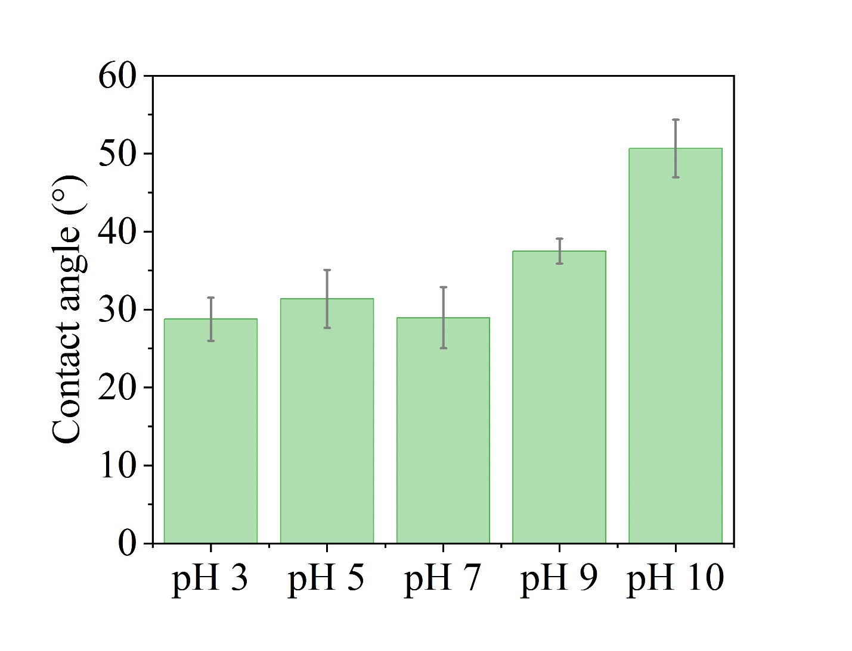
Fig. S1. Contact angle of PA-ChNCs from pH 3 to pH 10.

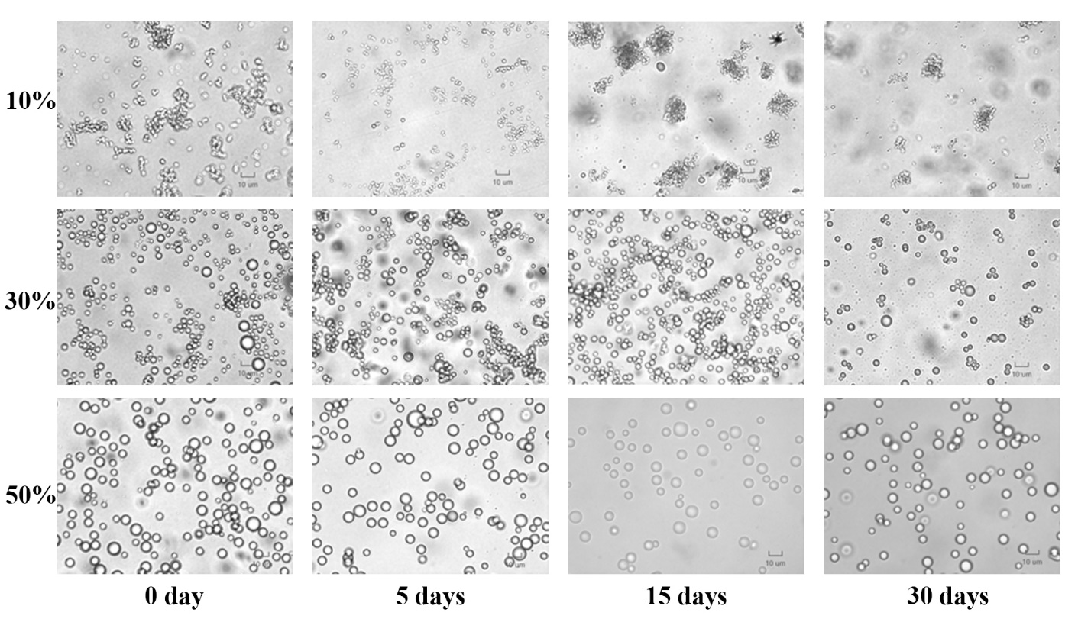
Fig. S2. Optical micrographs of Pickering emulsions stabilized by 1.0 wt% PA-ChNCs at pH 7 with different oil-water ratios during 30 days of storage.

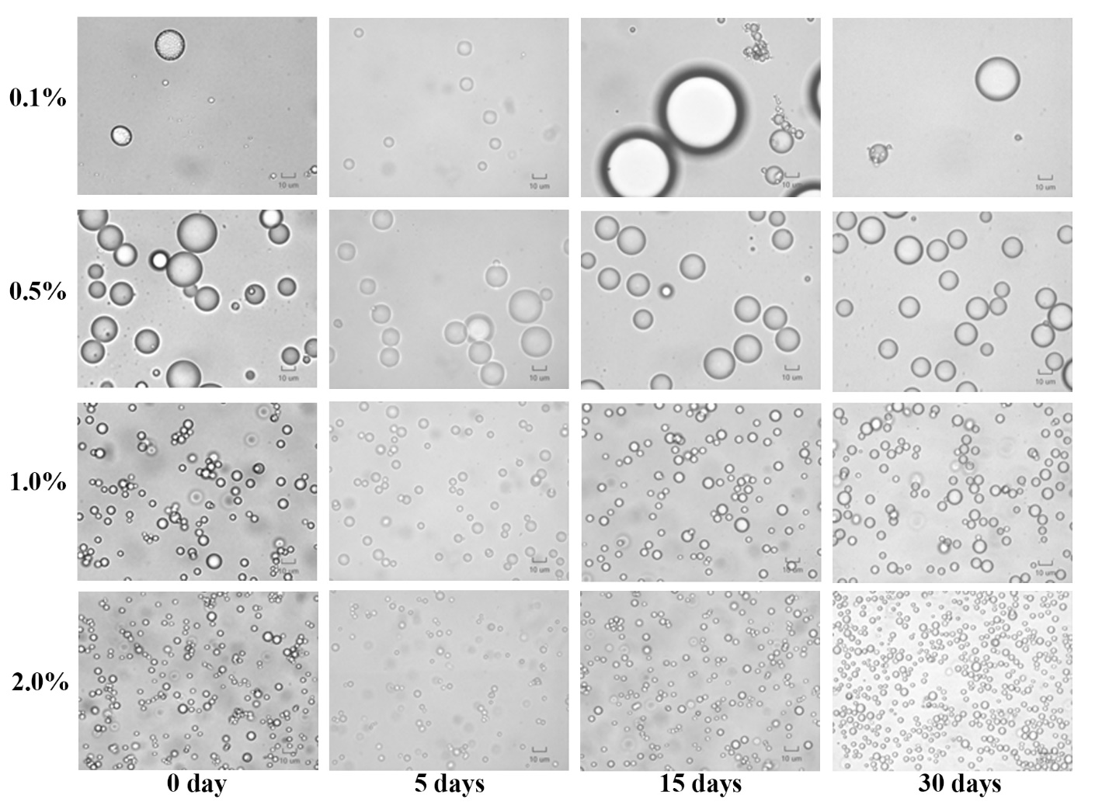
Fig. S3. Optical micrographs of 50% O:W Pickering emulsions stabilized by various PA-ChNCs concentrations at pH 7 during 30 days of storage.

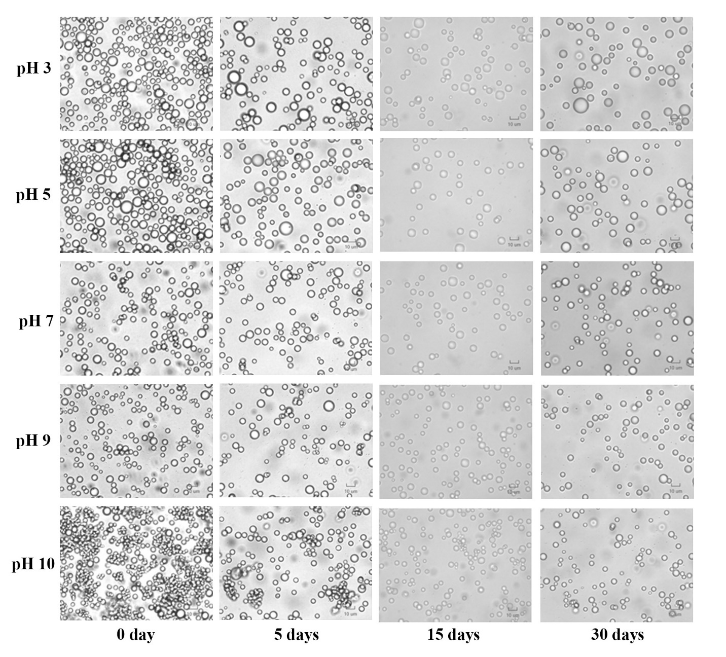
Fig. S4. Optical micrographs of 50% O:W Pickering emulsions stabilized by 1.0 wt% PA-ChNCs at various pH values during 30 days of storage.

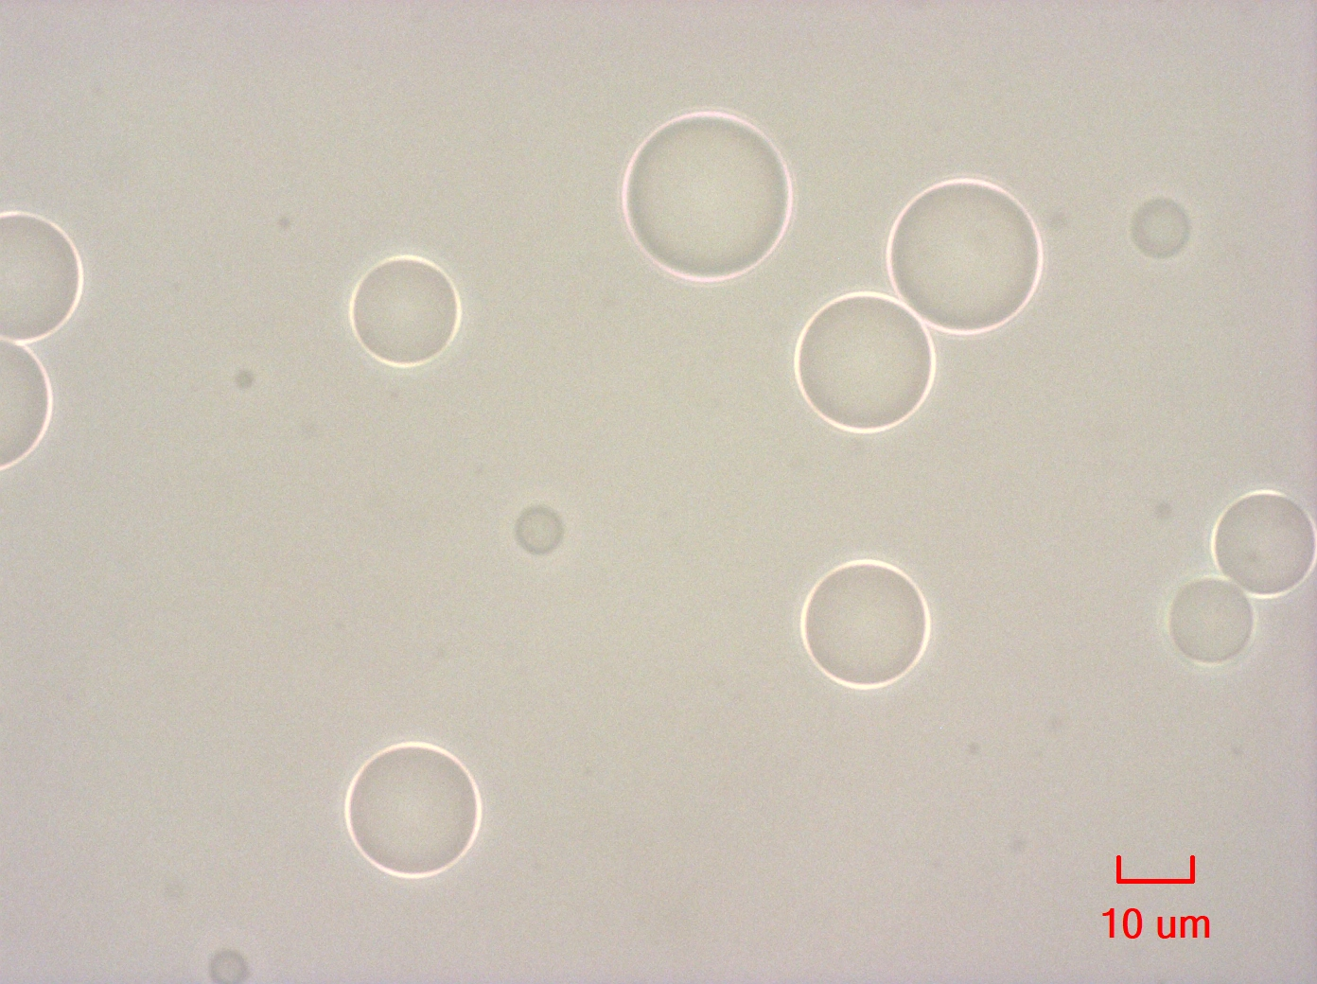
Fig. S5. Polarized light microscopy images of fresh Pickering emulsion stabilized by 0.5 wt% PA-ChNCs with 50% O:W at pH 3.

References:
Ma, P., Zhang, J., Teng, Z., Zhang, Y., Bauchan, G. R., Luo, Y., ... & Wang, Q. (2021). Metal–organic framework-stabilized high internal phase pickering emulsions based on computer simulation for curcumin encapsulation: Comprehensive characterization and stability mechanism. ACS omega, 6(40), 26556-26565. https://doi.org/10.1021/acsomega.1c03932
Parajuli, S., Hasan, M. J., & Ureña-Benavides, E. E. (2022). Effect of the Interactions between Oppositely Charged Cellulose Nanocrystals (CNCs) and Chitin Nanocrystals (ChNCs) on the Enhanced Stability of Soybean Oil-in-Water Emulsions. Materials, 15(19), 6673. https://doi.org/10.3390/ma15196673

