Laboratory assessment for determining microplastics in freshwater systems – characterization and identification along Somesul Mic River

Stefania Gheorghe ¹ * #, Catalina Stoica ^{1,} #, Anca Maria Harabagiu ¹, Dorian Gabriel Neidoni ², Emanuel Daniel Mighiu ¹, Costel Bumbac ¹, Ioana Alexandra Ionescu ¹, Aida Pantazi ³, Laura-Bianca Enache ³, Marius Enachescu ³

¹ National Research and Development Institute for Industrial Ecology – ECOIND, Control Polution Department, Drumul Podu Dambovitei 71-73, Sector 6, 060652, Bucharest, Romania, stefania.gheorghe@incdecoind.ro (S.G.), catalina.stoica@incdecoind.ro (C.S.), anca.harabagiu@ecoind.ro (A.H.), emanuel.mighiu@ecoind.ro (E.D.M.), costel.bumbac@incdecoind.ro (C.B.), ioana.ionescu@incdecoind.ro (I.I.)

² National Research and Development Institute for Industrial Ecology – ECOIND, Bujorilor Street, 115, Timisoasa, Timis, Romania, dorian.neidoni@ecoind.ro (D.N.)

³ National University of Science and Technology Polytechnic Bucharest, Center for Surface Science and Nanotechnology, 313 Splaiul Independentei, AN031, District 6, 060042, Bucharest, Romania, marius.enachescu@cssnt-upb.ro (M.E.), aida.pantazi@cssnt-upb.ro (AP), laura.bianca@cssnt-upb.ro (L.B.E)

* Correspondence: stefania.gheorghe@incdecoind.ro

# Stefania Gheorghe and Catalina Stoica contributed equally to this scientific work.

Figure S1. Photos taken during the sampling campaign on Somesul Mic River

Figure S2 Images of the river banks taken at the sampling points along the Somesul Mic River (A, B – upstream and downstream of Floresti and C, D, E - upstream and downstream of the Cluj-Napoca Wastewater Treatment Plant)

a)
b)
c)
d)
Figure S3 Visualization of plastic particles - large, micro and macro floating MPs < 1 mm separated from Somesul Mic River (surface water and sediment): a) UP Floresti; b) DW Floresti; c) UP Cluj- Napoca WWTP; d) DW Cluj- Napoca WWTP; e) WWTP influent. Each square represents 5mm x 5mm. Four squares together represent 10 mm x 10 mm.

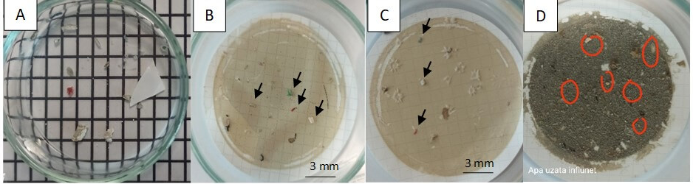
Figure S4 Visualization of plastic particles in the influent of Cluj-Napoca WWTP. A: Each square represents 5 mm x 5 mm. Four squares together represent 10 mm x 10 mm. B, C, D: Scale is 3 mm. Particles suspected to be MPs are indicated by black arrows and are smaller than 3-5 mm.

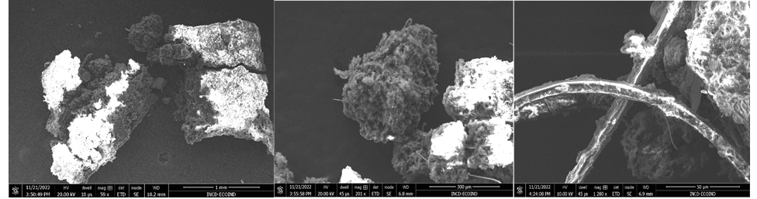
Figure S5 SEM images of suspected MPs - decomposing floating MPs

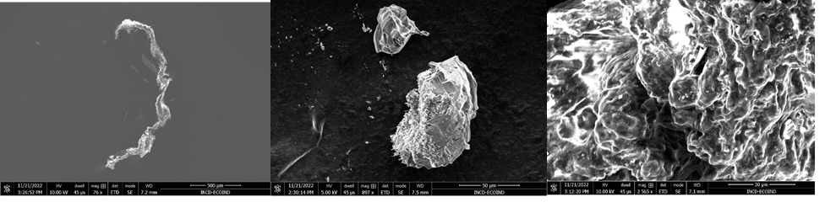
Figure S6 SEM images of suspected MPs without exposure to digestion treatment, scale bar = 500 µm, 50 µm, 20 µm

Figure S7 ATR-FTIR spectra of the ester cellulose filter membrane

Table S1. Assignment of the ATR-FTIR band exhibited by the filter membrane

Peak Number | Wavenumber (cm⁻¹) | Assignment
1 | 2909.7 | stretching vibrations of CH/CH₂/CH₃ groups [1]
2 | 1750.1 | C=O carbonyl stretching [2]
3 | 1625.5 | C=C stretching [2-4]
4 | 1428.9 | CH₂ bending vibration [1]
5 | 1368.4 | CH₃ Umbrella bending mode [5]
6 | 1285.3 | C-O stretching [6]
7 | 1163.4 | CF₂ stretching vibration [1]
8 | 1071.4 | C-O stretching vibration [7]
9 | 1000.4 | C=C stretching [7]
10 | 753.5 | C-H bending [7]
11 | 684.1 | C–Cl stretching vibration [1]
12 | 623.5 | O-S-O scissoring vibration mode [8]

Table S2. Assignment of the ATR-FTIR band exhibited by the UP Cluj-Napoca WWTP 200 µm (PE) - Fig. 27
Peak Number | Wavenumber (cm⁻¹) | Assignment
1 | 2916 | stretching vibrations of CH/CH₂/CH₃ groups [1]
2 | 2846.8 | stretching vibrations of CH/CH₂/CH₃ groups [1]
3 | 1735.2 | C=O carbonyl stretching [1]
4 | 1597.5 | C=C stretching [2-4]
5 | 1514.6 | C=C stretching [2-4]
6 | 1464.5 | C-H rocking vibration [6]
7 | 1368.2 | CH₃ Umbrella bending mode [5]
8 | 1248.7 | C-O stretching [7]
9 | 1165.9 | CF₂ stretching vibration [1]
10 | 1032.2 | C-O stretching vibration [7]
11 | 825.9 | Si-O bending vibration [9]
12 | 720.1 | C-H rocking vibration [6]
13 | 527.39 | O-S-O scissoring vibration mode [8]
14 | 467.67 | O-S-O scissoring vibration, [8]

Table S3. Assignment of the ATR-FTIR band exhibited by the DW Cluj-Napoca WWTP 200 µm (PE)- Fig. 28
Peak Number | Wavenumber (cm⁻¹) | Assignment
1 | 2913.8 | stretching vibrations of CH/CH₂/CH₃ groups [1]
2 | 2849.2 | stretching vibrations of CH/CH₂/CH₃ groups [1]
3 | 1703.3 | C=O carbonyl stretching [2]
4 | 1590.3 | C=C stretching [2-4]
5 | 1466.6 | C-H rocking vibration [6]
6 | 1293.3 | C-O stretching [7]
7 | 1168.3 | CF2 stretching vibration
8 | 1028.6 | C-O stretching vibration [7]
9 | 727.4 | C-H rocking vibration [6]
10 | 688.1 | C–Cl stretching vibration [1]
11 | 521.1 | O-S-O scissoring vibration mode [8]
12 | 464.5 | O-S-O scissoring vibration mode [8]
13 | 424.2 | O-S-O scissoring vibration mode [8]

Table S4. Assignment of the ATR-FTIR band exhibited by the DW Cluj-Napoca WWTP – 20 µm (PE) Fig. 29
Peak Number | Wavenumber (cm⁻¹) | Assignment
1 | 2925.2 | stretching vibrations of CH/CH₂/CH₃ groups [1]
2 | 2843.5 | stretching vibrations of CH/CH₂/CH₃ groups [1]
3 | 1687.2 | C=C stretching [2-4]
4 | 1518.5 | C=C stretching [2-4]
5 | 1462 | C-H rocking vibration [6]
6 | 1375.6 | CH₃ Umbrella bending mode [5]
7 | 1283.7 | C-O stretching [6]
8 | 1232.1 | C-O stretching [6]
9 | 1170.7 | CF₂ stretching vibration [1]
10 | 1027.1 | C-O stretching vibration [6]
11 | 833.4 | Si-O bending vibration [9]
12 | 720.6 | C-H rocking vibration [6]
13 | 644.7 | O-S-O scissoring vibration mode [8]
14 | 531.5 | O-S-O scissoring vibration mode [8]
15 | 470.2 | O-S-O scissoring vibration mode [8]
16 | 424.2 | O-S-O scissoring vibration mode [8]

Table S5. Assignment of the ATR-FTIR band exhibited by the UP Floresti 200 µm (PP) Fig. 30
Peak Number | Wavenumber (cm⁻¹) | Assignment
1 | 3024.3 | -OH stretching region [6]
2 | 2979.5 | stretching vibrations of CH/CH₂/CH₃ groups [1]
3 | 2917.8 | stretching vibrations of CH/CH₂/CH₃ groups [1]
4 | 2845.2 | stretching vibrations of CH/CH₂/CH₃ groups [1]
5 | 1604.8 | C=C stretching [2-4]
6 | 1492.7 | CH₂ asymmetrical vibration [1]
7 | 1453.1 | CH₂ asymmetrical vibration [1]
8 | 1021.4 | C-O stretching [7]
9 | 909.2 | C=C stretching [9]
10 | 751.8 | Split CH₂ rocking vibration [5]
11 | 690.5 | C–Cl stretching vibration [1]
12 | 538.8 | O-S-O scissoring vibration mode [8]
13 | 466.2 | O-S-O scissoring vibration mode [8]
14 | 420.2 | O-S-O scissoring vibration mode [8]

References:
- Käppler A. et al. Analysis of environmental microplastics by vibrational microspectroscopy: FT-IR, Raman or both? Anal. Bioanal. Chem. 2016, 408(29), 8377–8391.
- Sharma N., Sharma V., Jain Y., Kumari M., Gupta R., Sharma S. K. and Sachdev K. Synthesis and Characterization of Graphene Oxide (GO) and Reduced Graphene Oxide (rGO) for Gas Sensing Application. Macromol. Symp. 2017, 376(1), 1700006
- Nallasamy P., Anbarasan P.M., Mohan S. Vibrational Spectra and Assignments of cis- and Trans-1,4-Polybutadiene. Turk J Chem. 2002, 26, 105 – 111;
- Gong Y., Li D., Fu Q., and Pan C. Influence of graphene microstructures on electrochemical performance for supercapacitors. Prog. Nat. Sci.: Mater. Int. 2015, 25(5), 379–385.
- Smith B.C. The infrared spectra of polymers II: Polyethylene. Spectroscopy. 2021, 36(9), 24–29.
- Syakti A.D. et al. Simultaneous grading of microplastic size sampling in the small islands of Bintan Water, Indonesia. Mar. Pollut. Bull. 2018, 137, 593–600.
- Chirea M. et al. Gold nanowire networks: Synthesis, characterization, and catalytic activity. Langmuir. 2011, 27(7), 3906–3913
- Krylova V. and Dukštienė N. Synthesis and characterization of AG2S layers formed on polypropylene’. J. Chem. 2013, 1–11.
- Bhattacharya S.S. and Chaudhari S.B. Study on Structural, Mechanical and Functional Properties of Polyester Silica Nanocomposite Fabric. Int. J. Pure Appl. Sci. Technol., 2014, 21(1), 43-52.

