Supporting Information

Asymmetric Synthesis of Spiro[4H-Chromene-3,3′-oxindoles] via Squaramide-Organocatalyzed Three-Component Cascade Knoevenagel/ Michael/ Cyclization Sequence
Liming Wang, Hongwen Mu, Yuhong Sun, Ying Jin*, Wei Zhang*
Department of Pharmacy, Jilin Medical University, Jilin, Jilin 132013, P. R. China

¹H NMR and ¹³C NMR spectra… …………………...……………..........S2-S41
HPLC trace.....……………...…………………………...………......….....S42-S61
X-Ray crystal data of compound 3f……...………………………...........S62-S63

¹H NMR and ¹³C NMR spectra

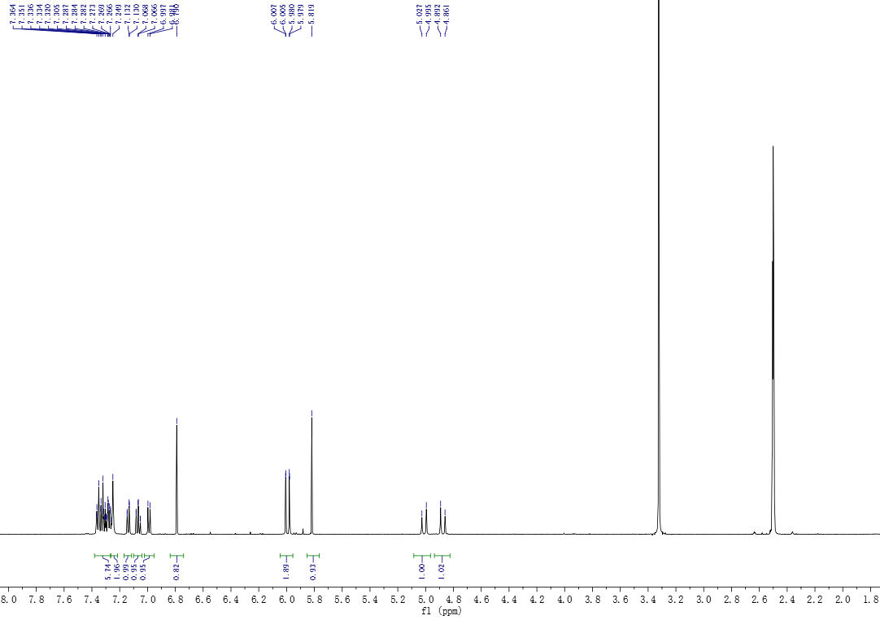
Figure 1. ¹H NMR spectrum of 3a

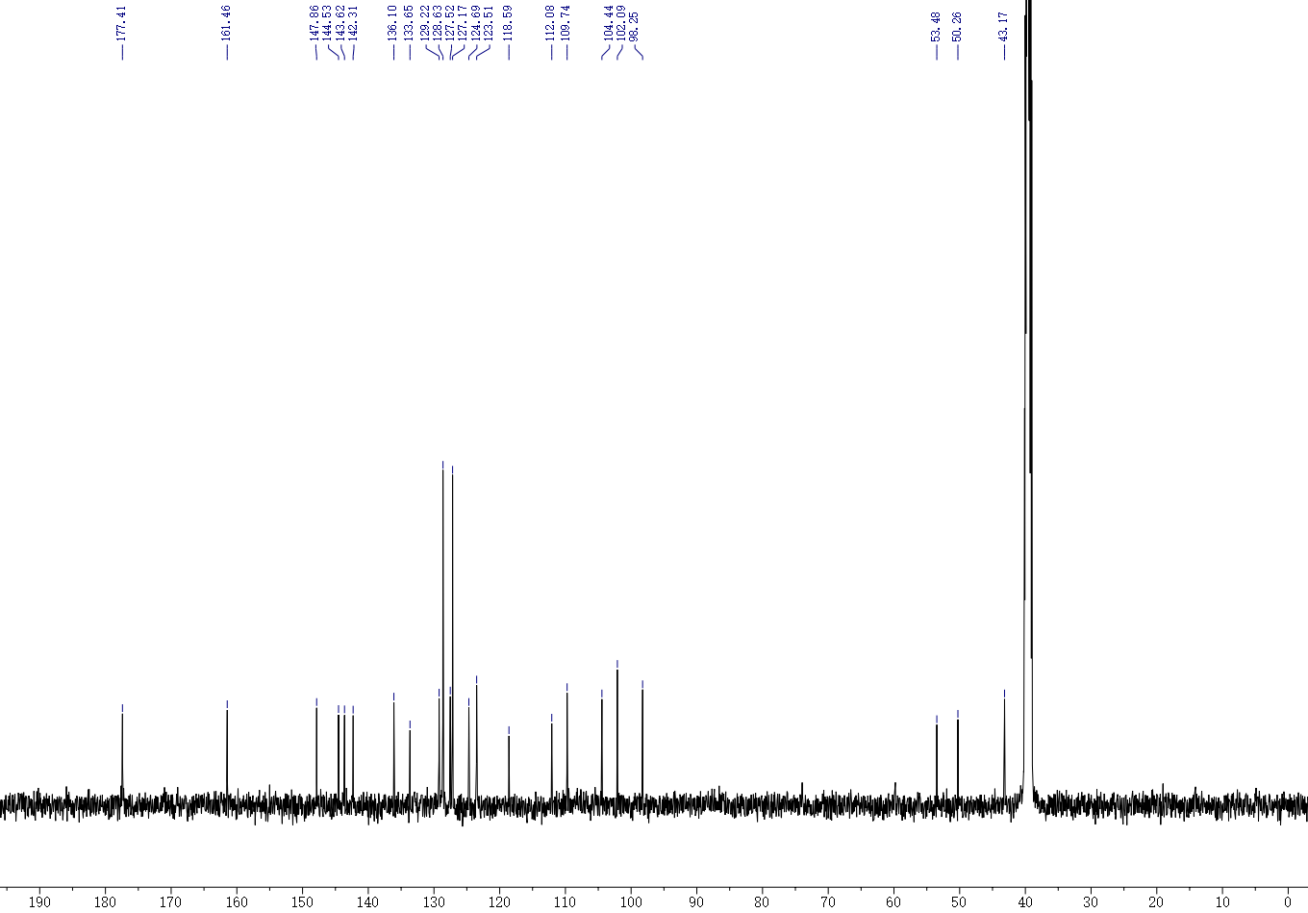

Figure 2. ¹³C NMR spectrum of 3a
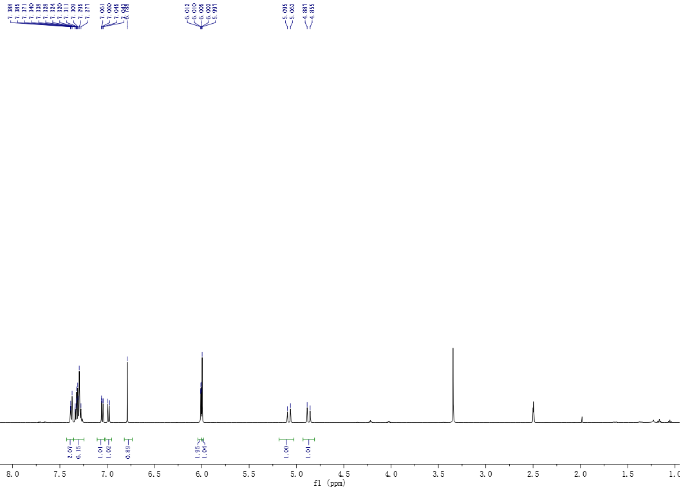

Figure 3. ¹H NMR spectrum of 3b

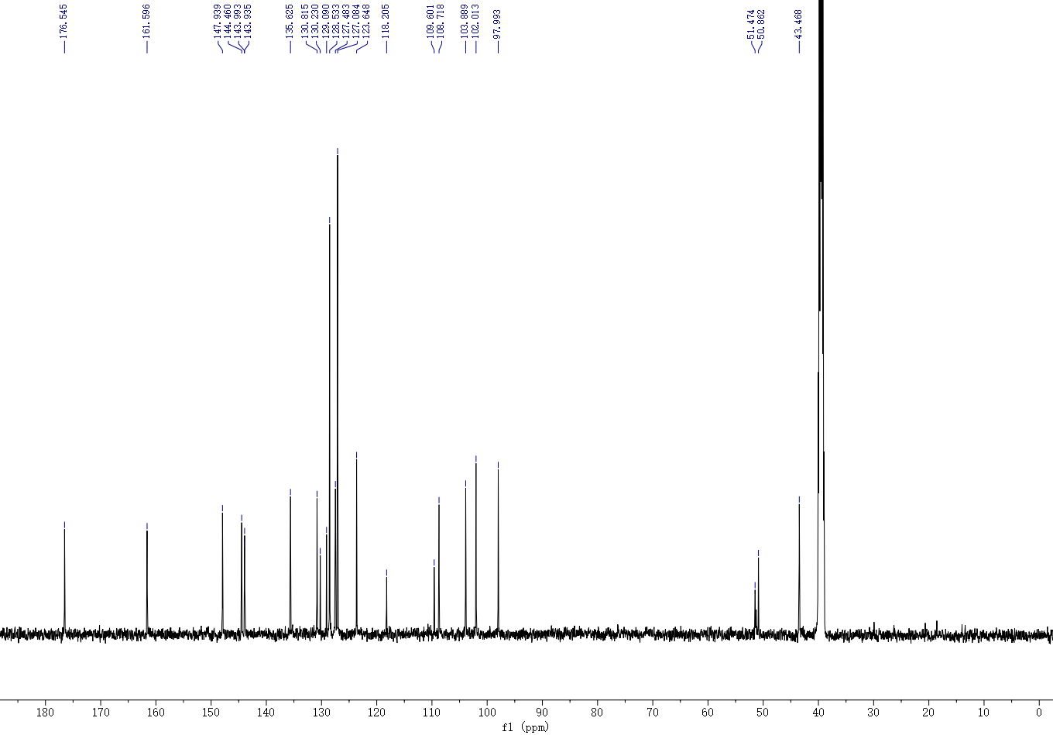
Figure 4. ¹³C NMR spectrum of 3b

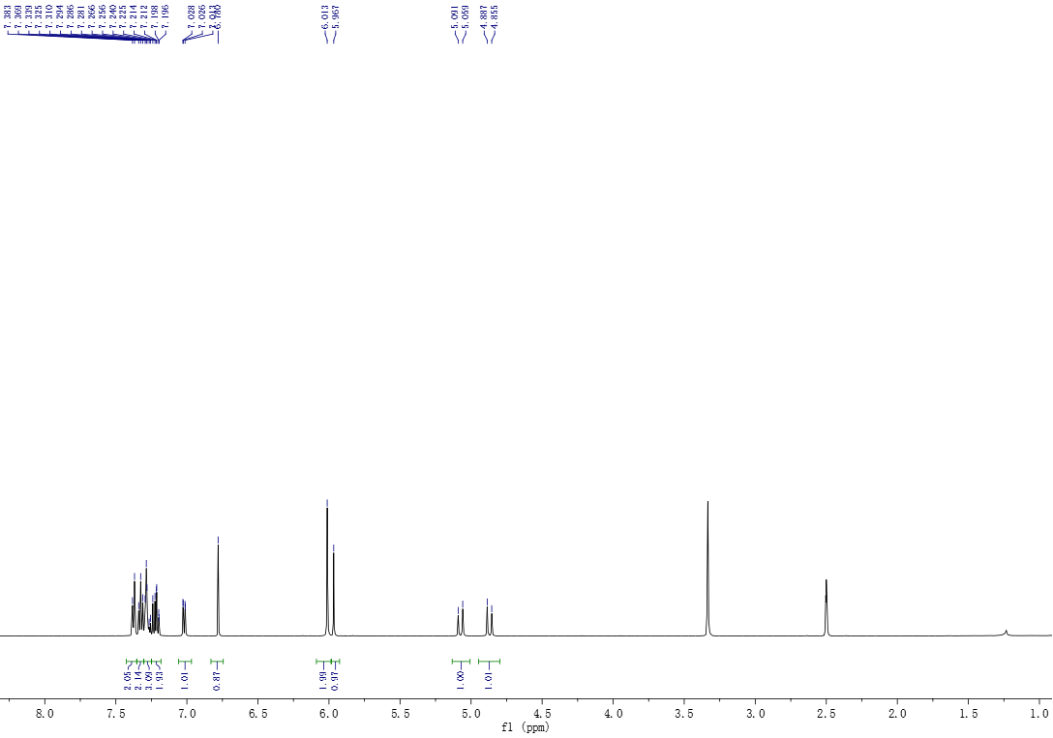
Figure 5. ¹H NMR spectrum of 3c

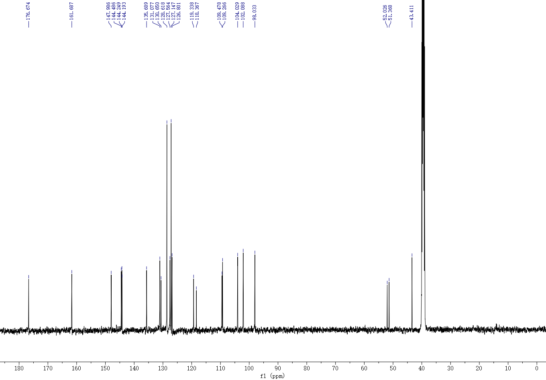

Figure 6. ¹³C NMR spectrum of 3c

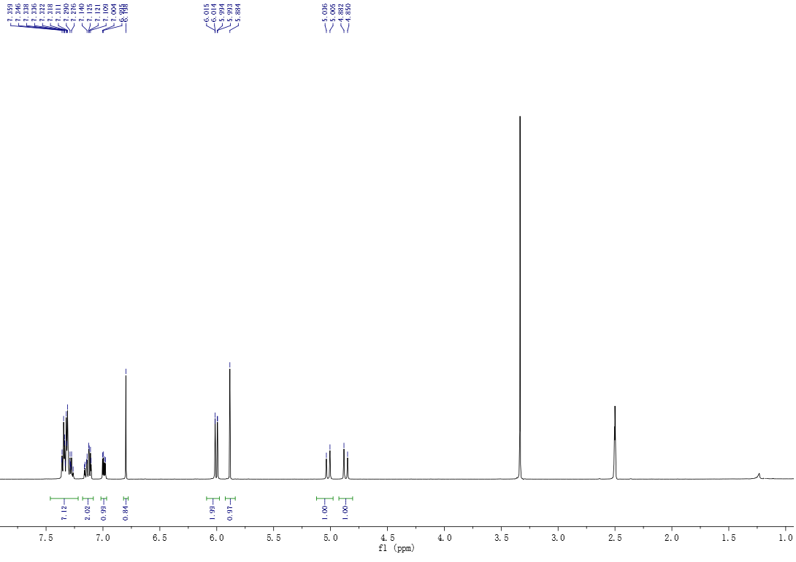

Figure 7. ¹H NMR spectrum of 3d

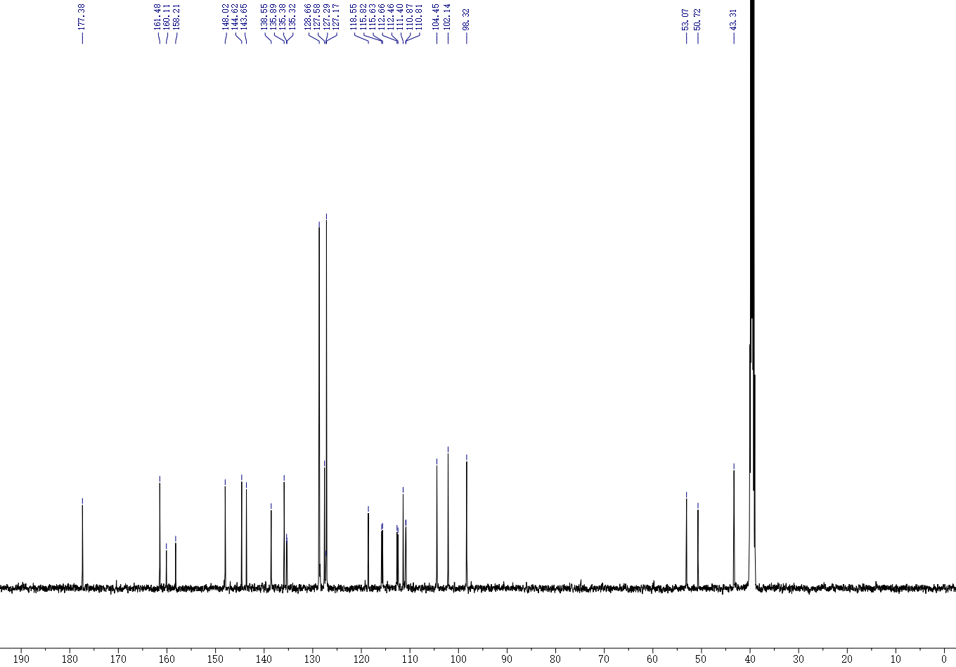
Figure 8. ¹³C NMR spectrum of 3d
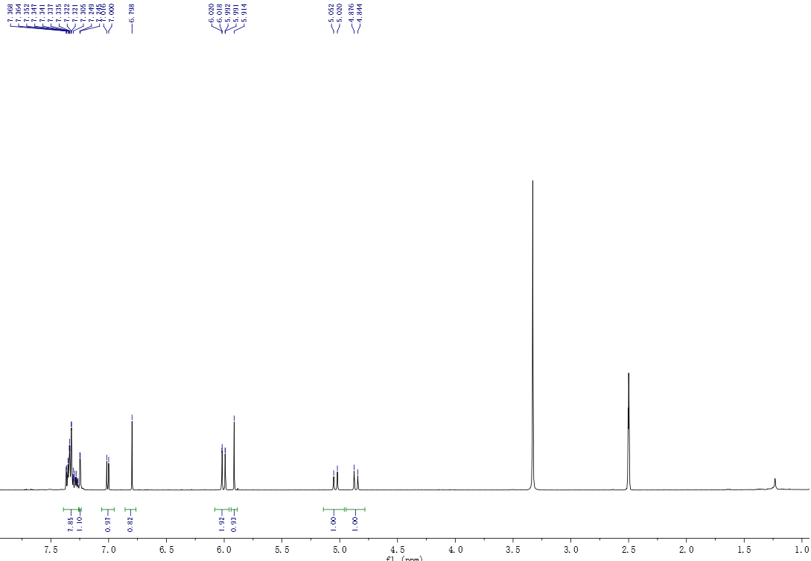
Figure 9. ¹H NMR spectrum of 3e

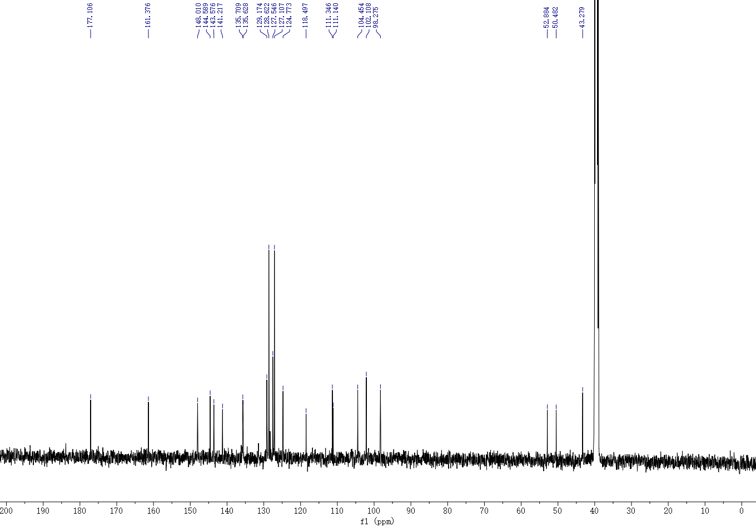Figure 10. ¹³C NMR spectrum of 3e

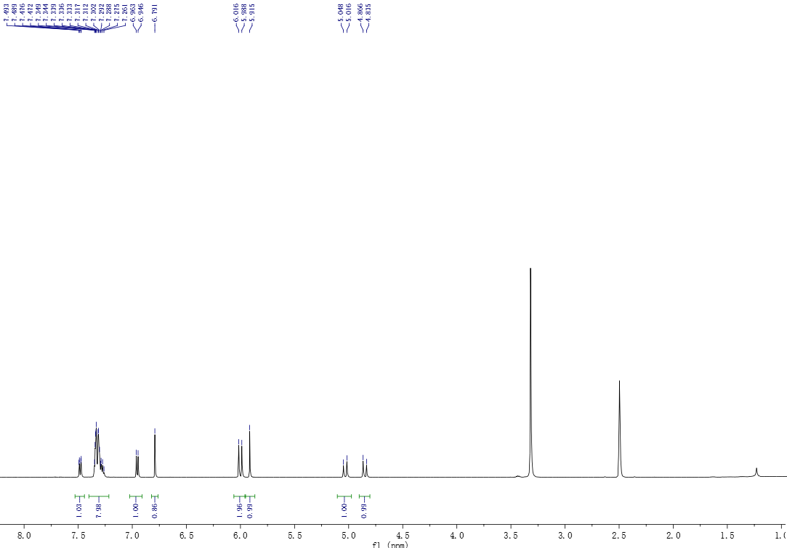Figure 11. ¹H NMR spectrum of 3f

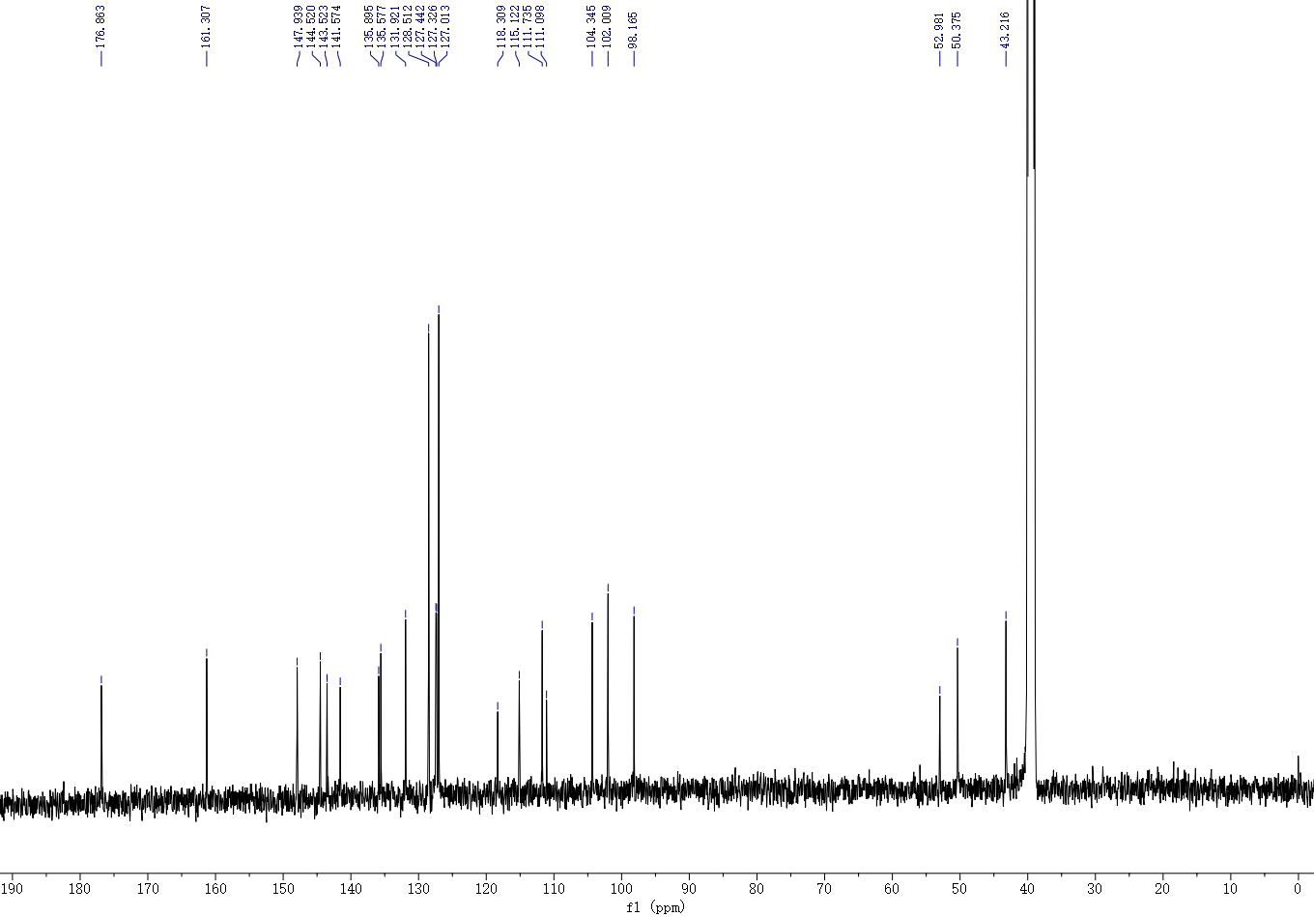
Figure 12. ¹³C NMR spectrum of 3f

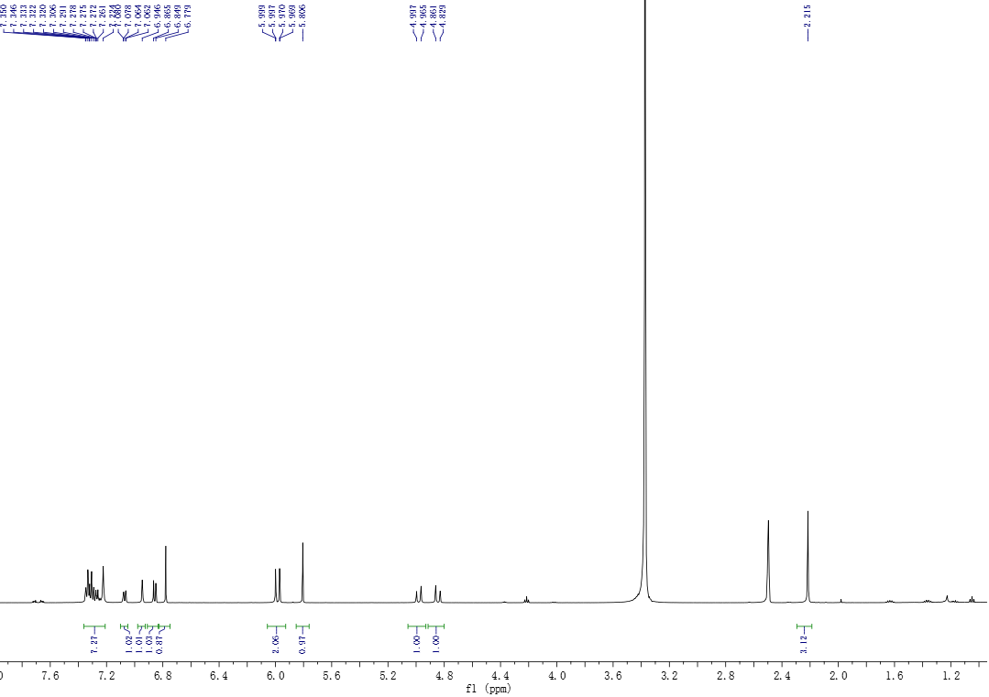
Figure 13 ¹H NMR spectrum of 3g

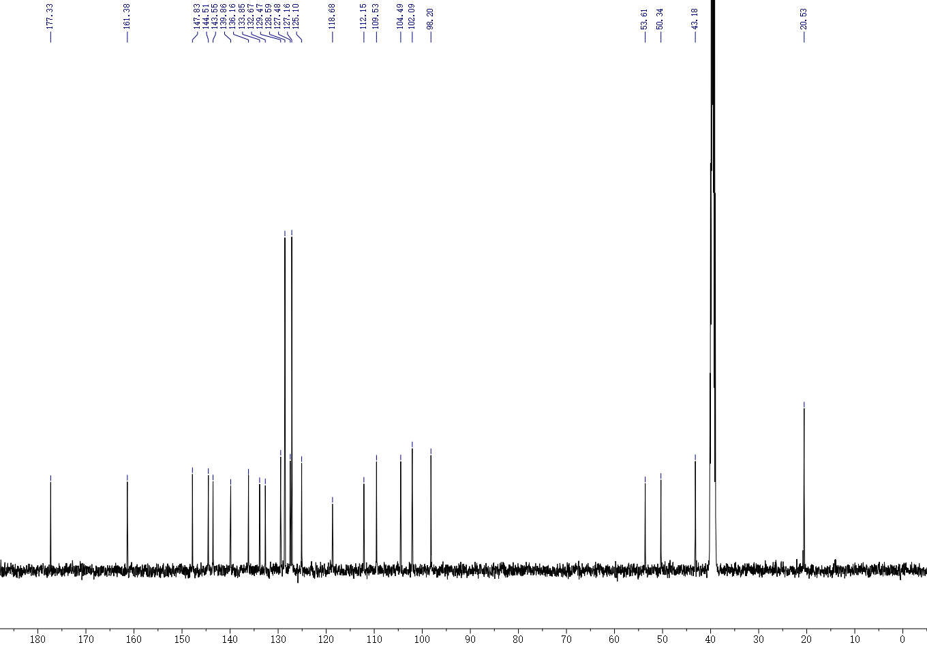
Figure 14. ¹³C NMR spectrum of 3g

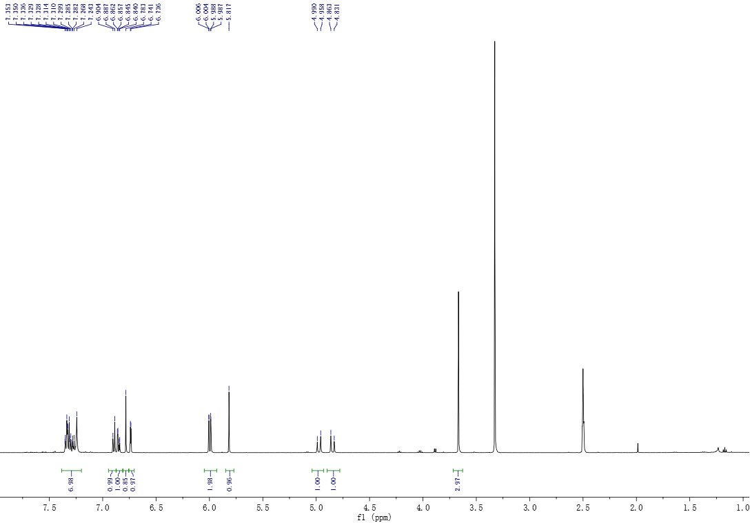
Figure 15. ¹H NMR spectrum of 3h

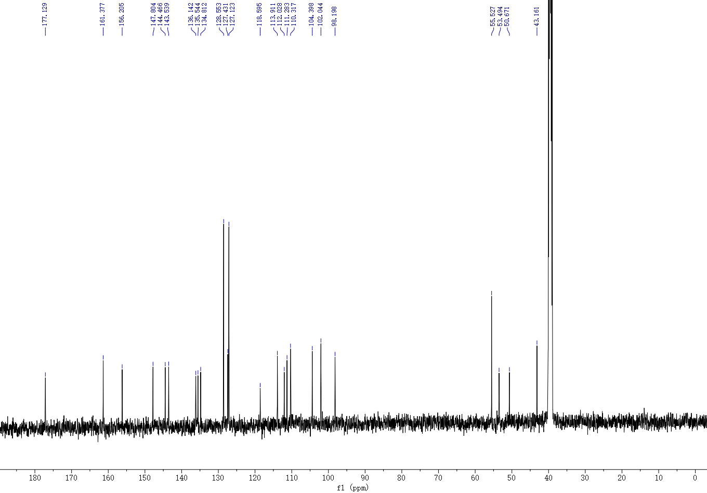

Figure 16. ¹³C NMR spectrum of 3h

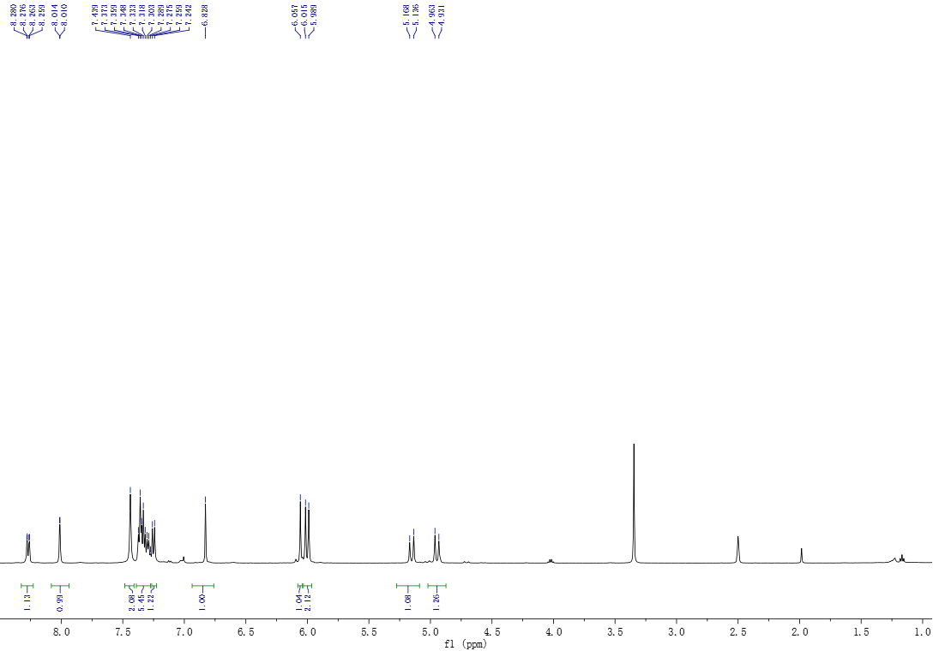
Figure 17. ¹H NMR spectrum of 3i

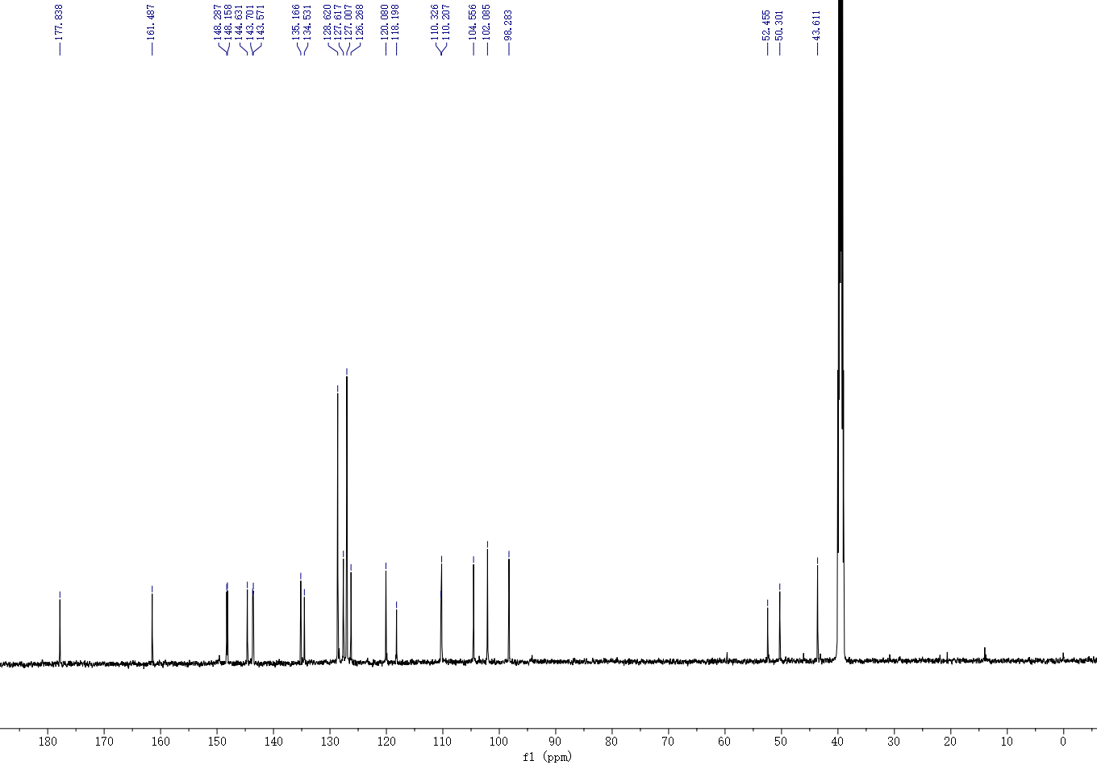

Figure 18. ¹³C NMR spectrum of 3i

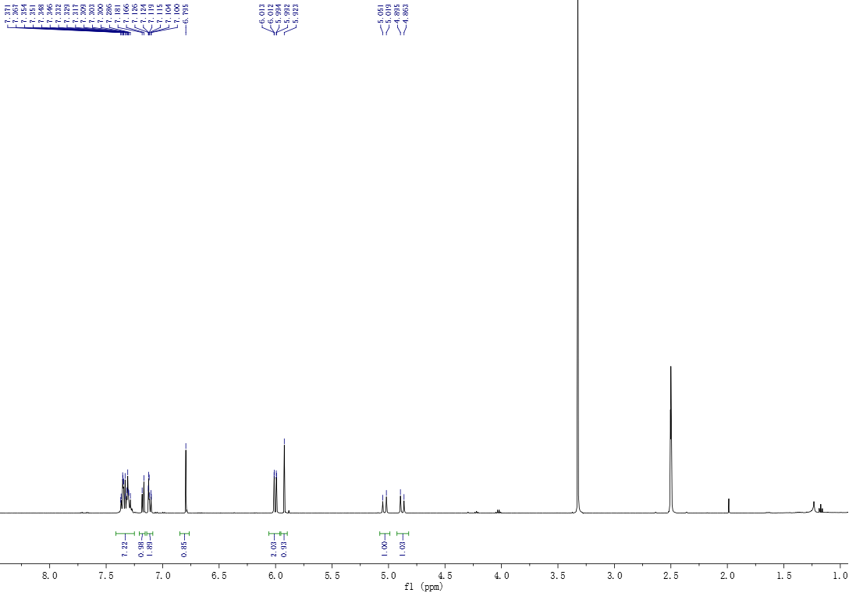
Figure 19. ¹H NMR spectrum of 3j

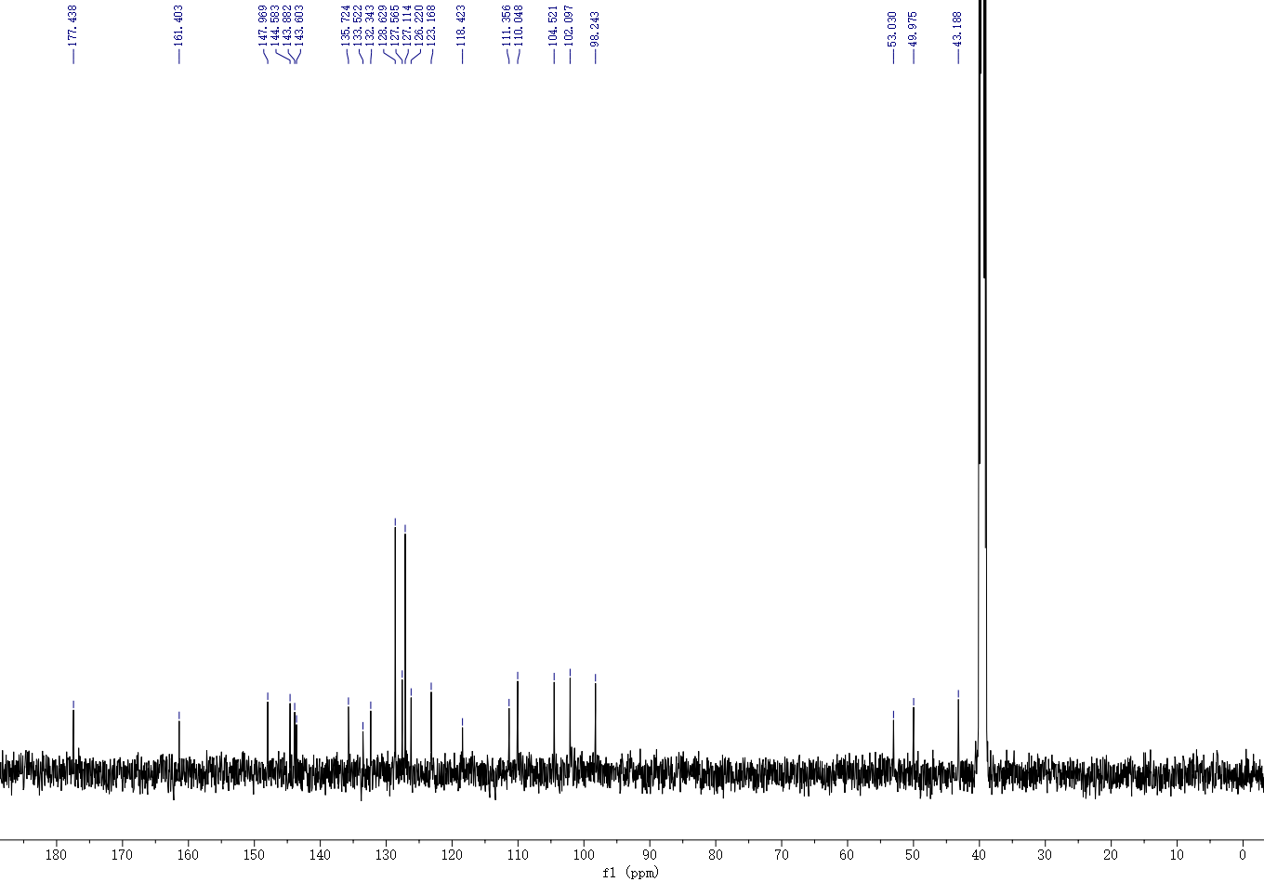
Figure 20. ¹³C NMR spectrum of 3j

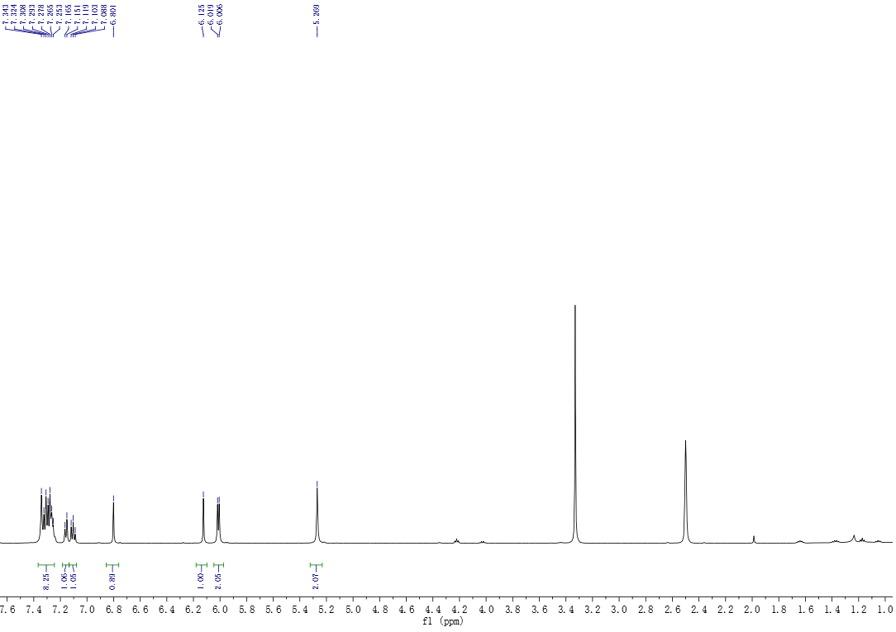
Figure 21. ¹H NMR spectrum of 3k

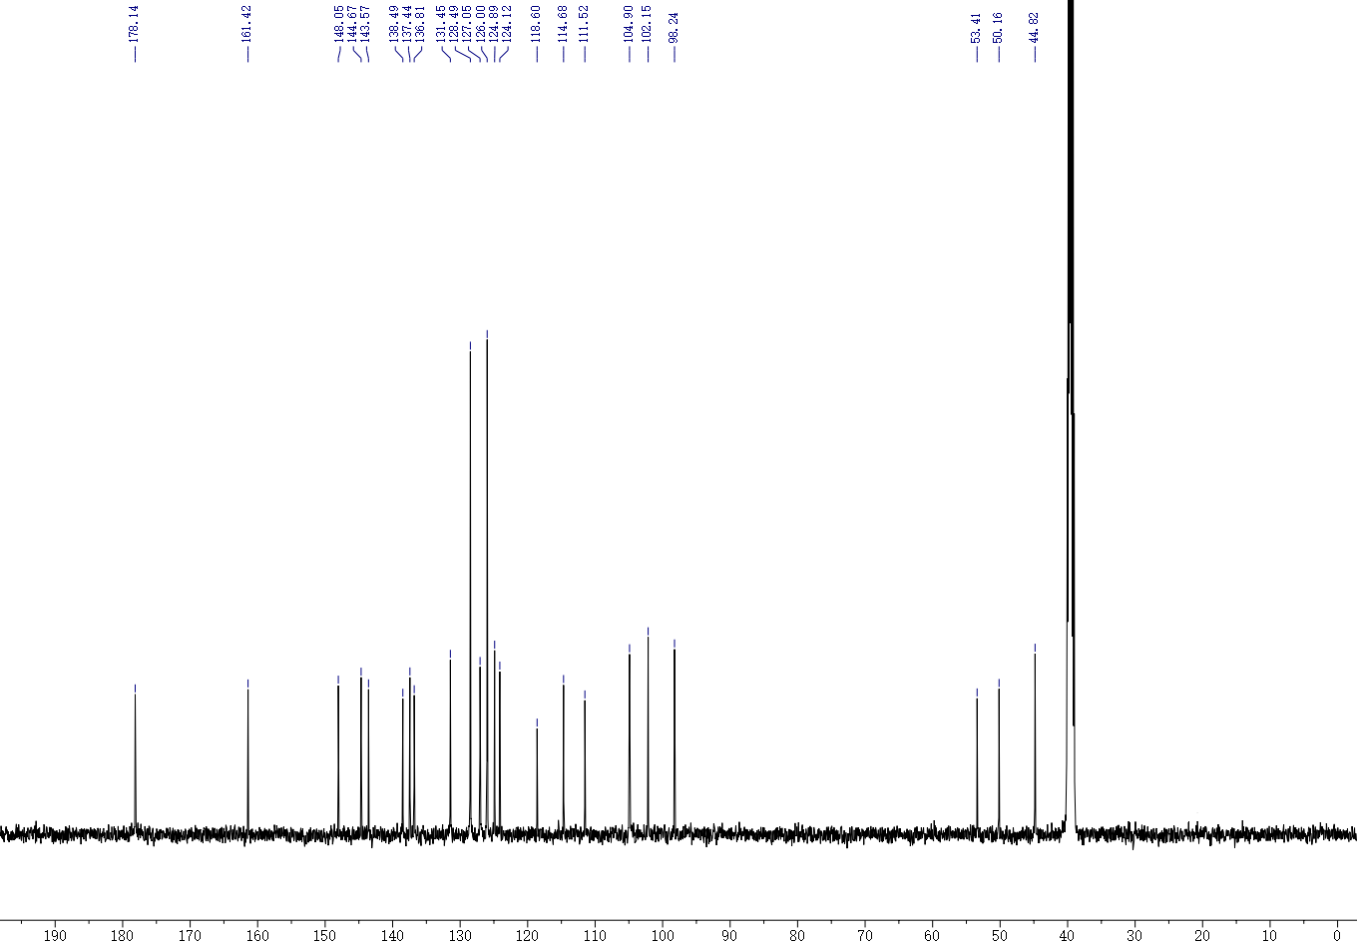

Figure 22. ¹³C NMR spectrum of 3k

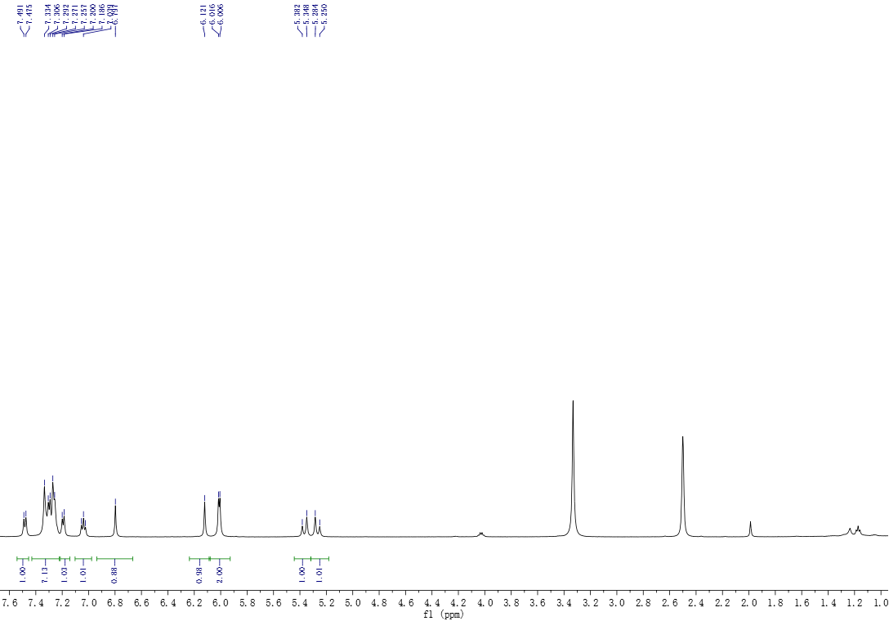
Figure 23. ¹H NMR spectrum of 3l

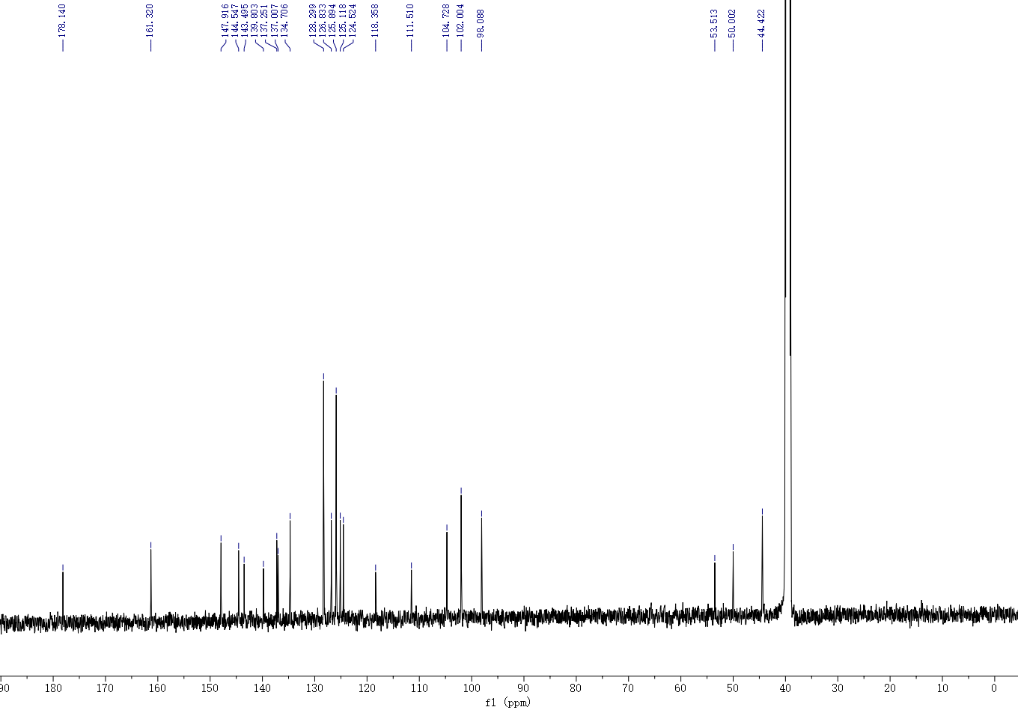
Figure 24. ¹³C NMR spectrum of 3l

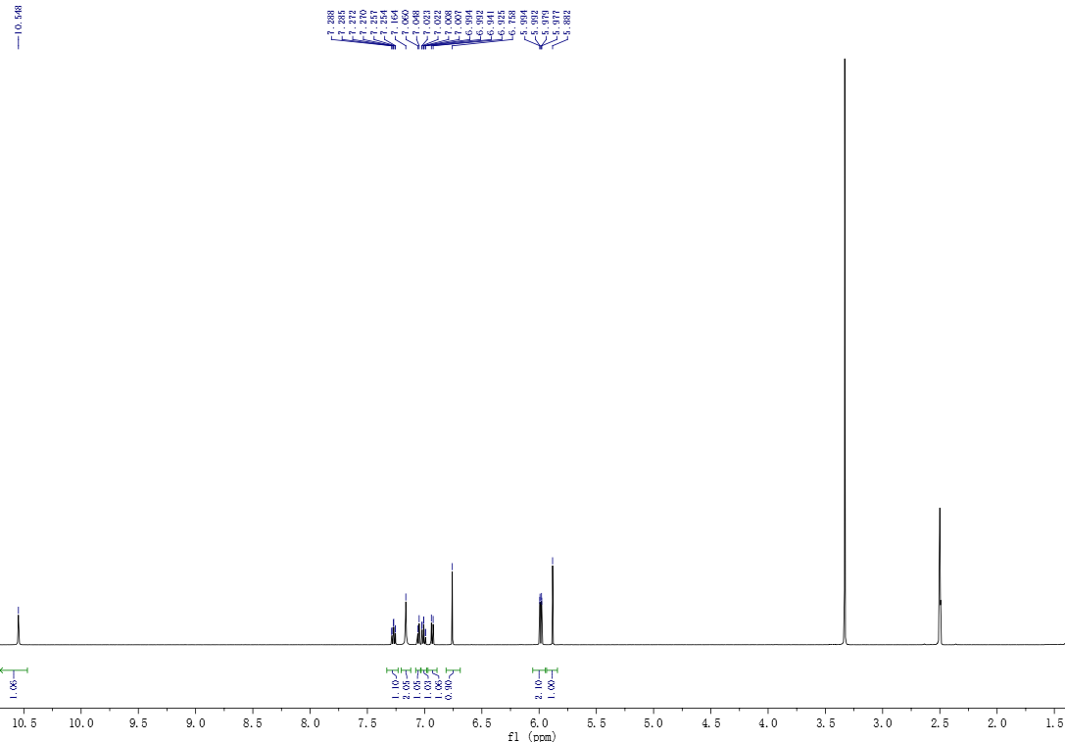
Figure 25¹H NMR spectrum of 3m

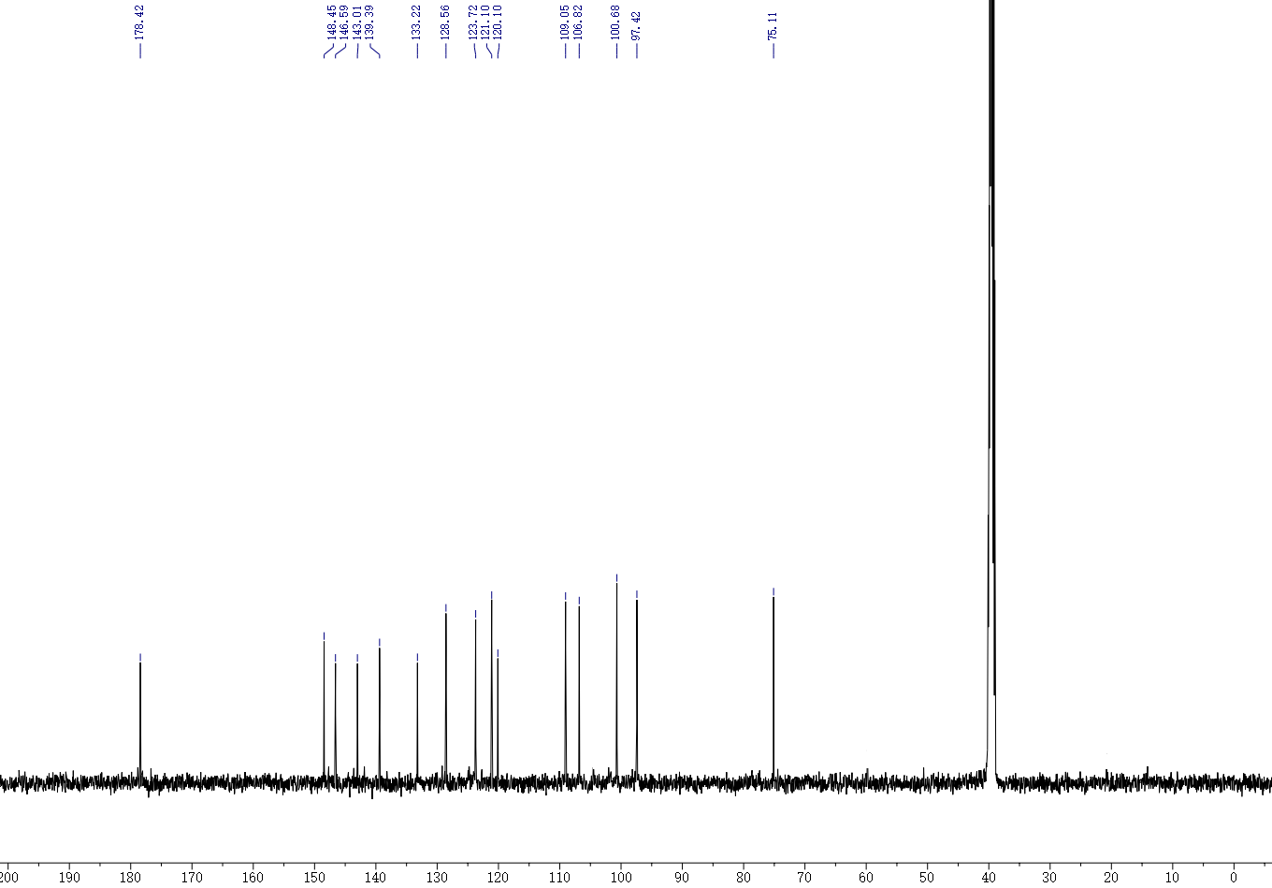

Figure 26. ¹³C NMR spectrum of 3m
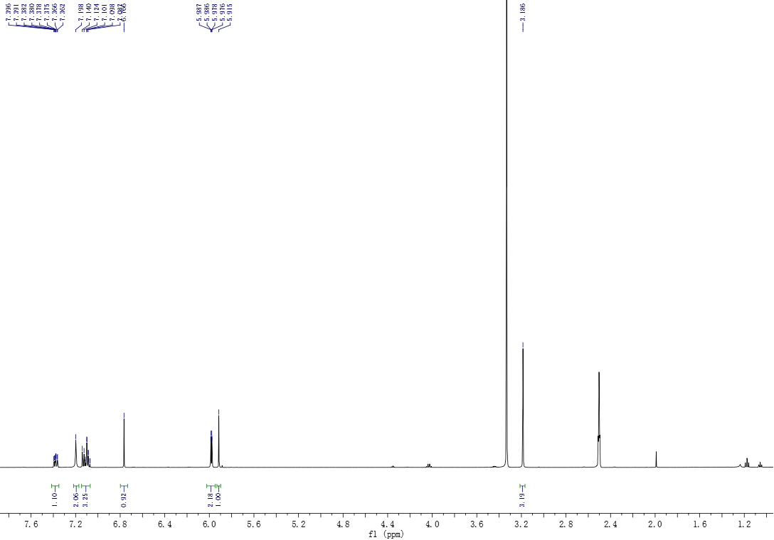
Figure 27 ¹H NMR spectrum of 3n

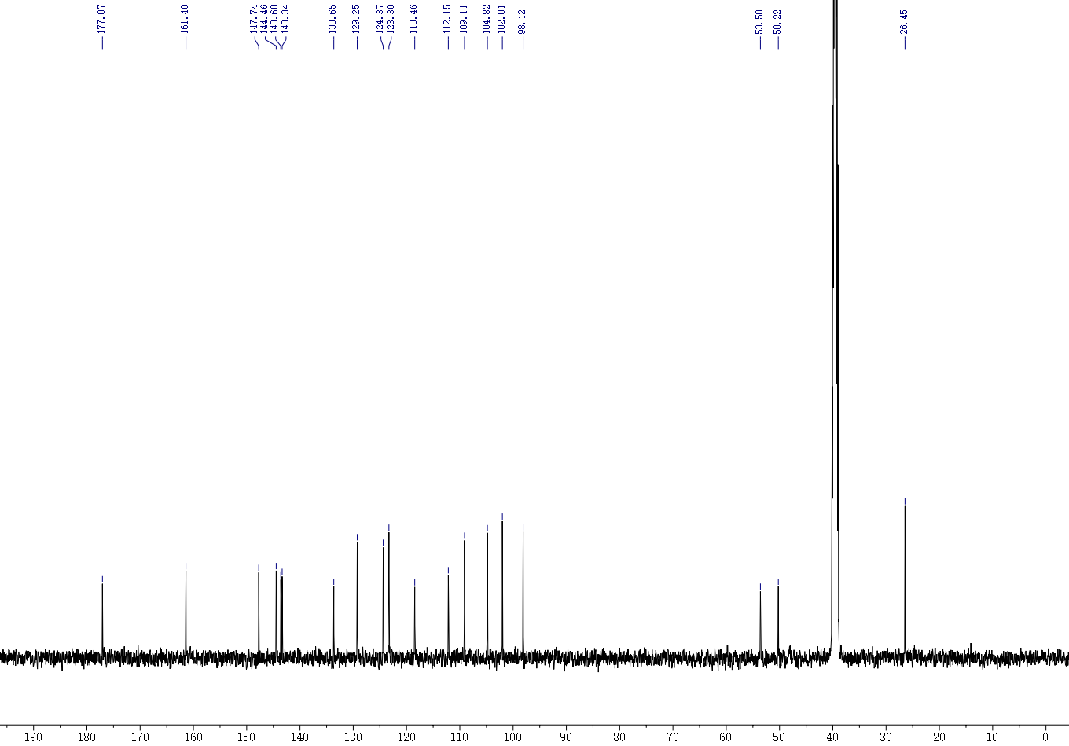
Figure 28. ¹³C NMR spectrum of 3n

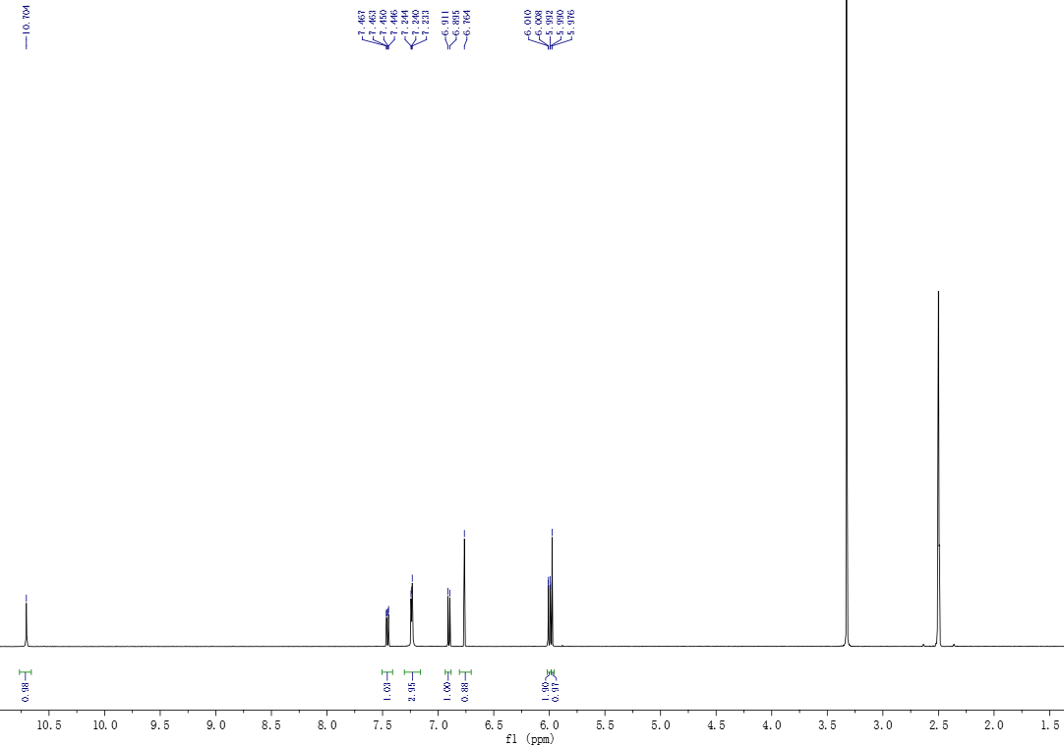
Figure 29 ¹H NMR spectrum of 3o

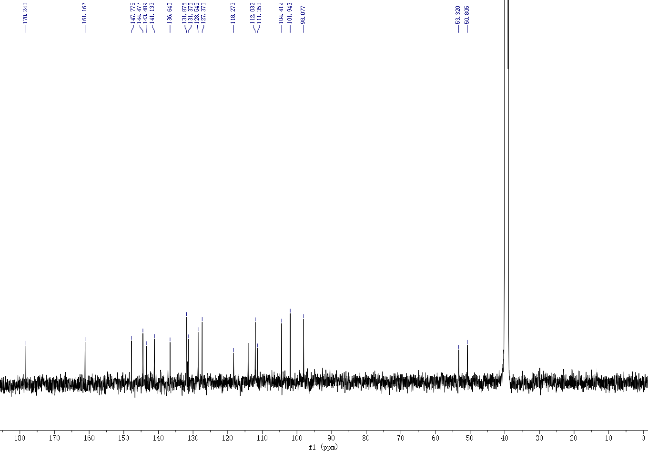
Figure 30 ¹³C NMR spectrum of 3o

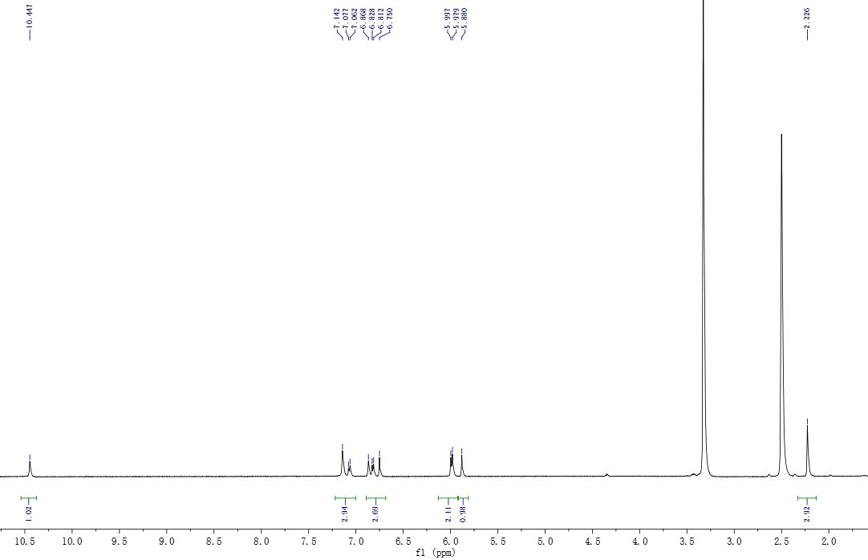
Figure 31 ¹H NMR spectrum of 3p

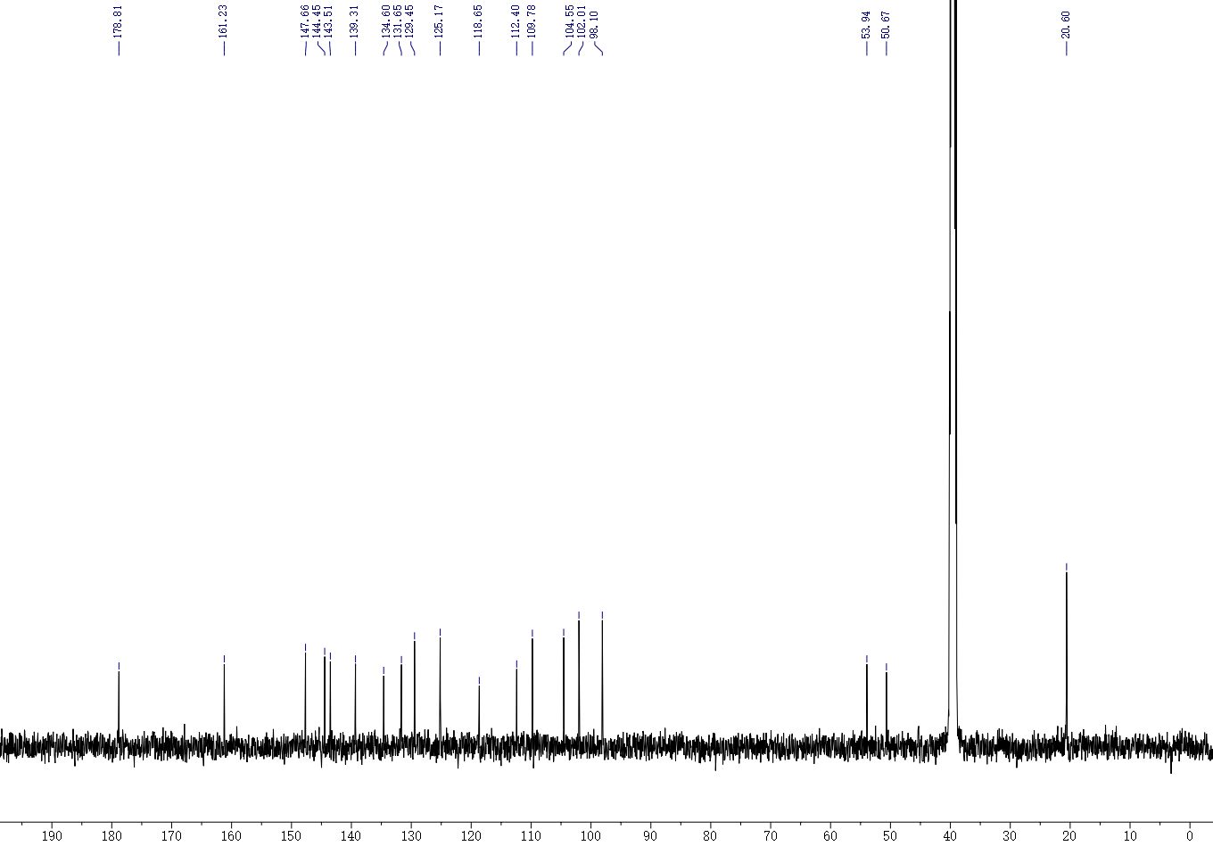

Figure 32 ¹³C NMR spectrum of 3p

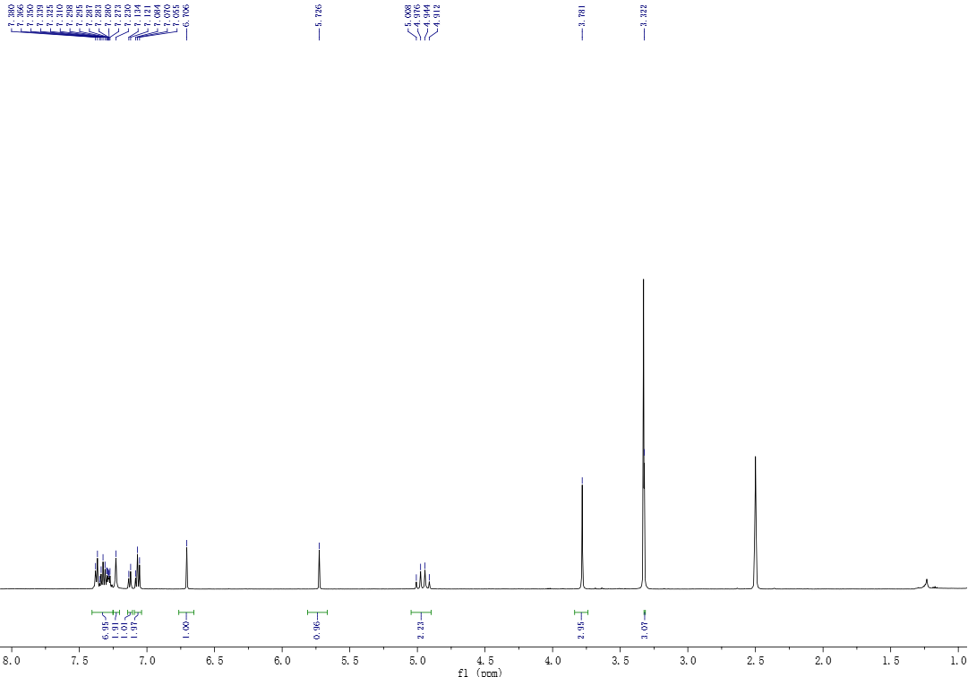

Figure 33 ¹H NMR spectrum of 4

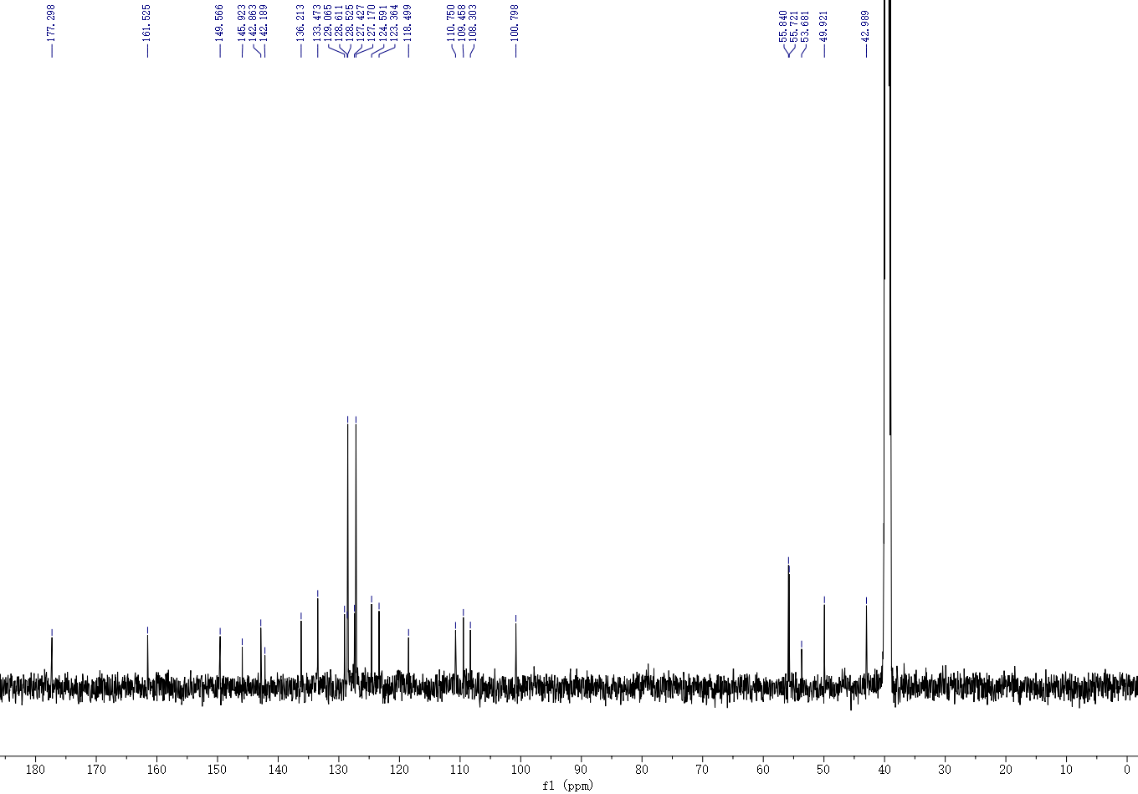
Figure 34 ¹³C NMR spectrum of 4

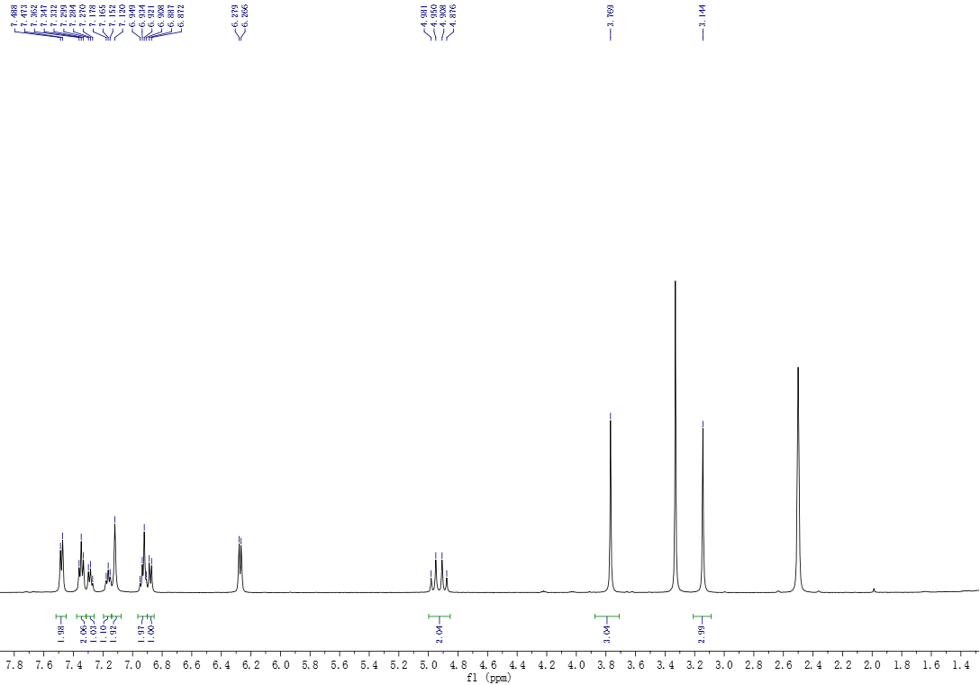
Figure 35 ¹H NMR spectrum of 5

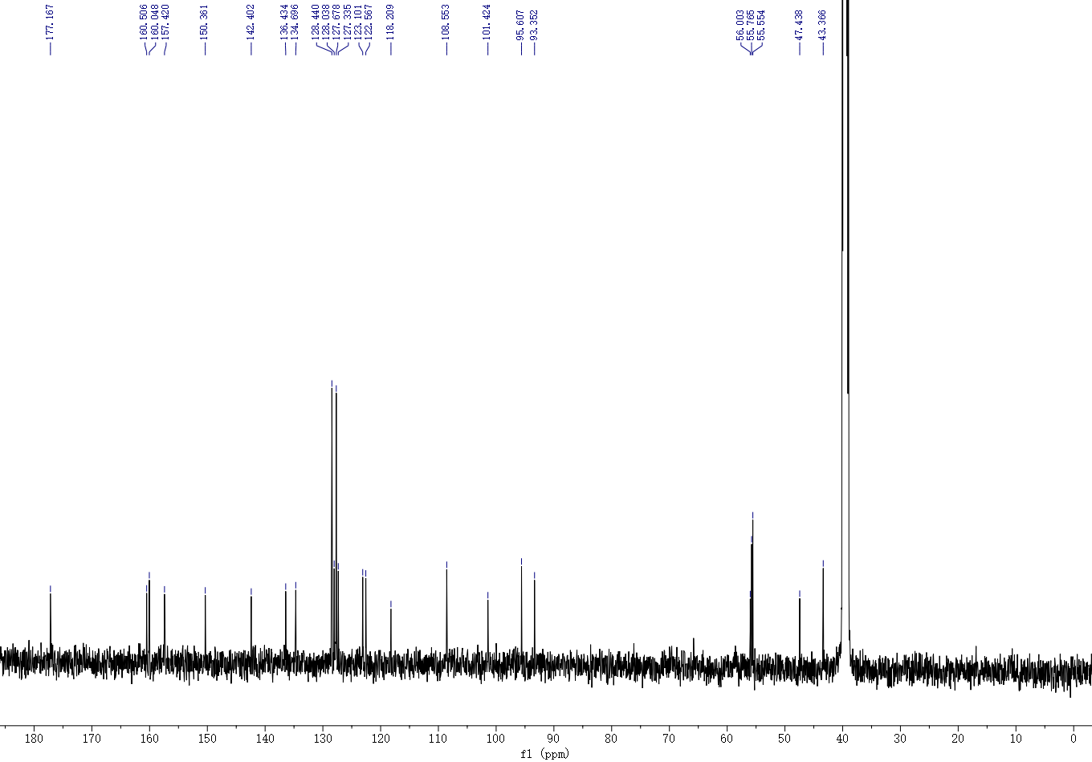

Figure 36 ¹³C NMR spectrum of 5

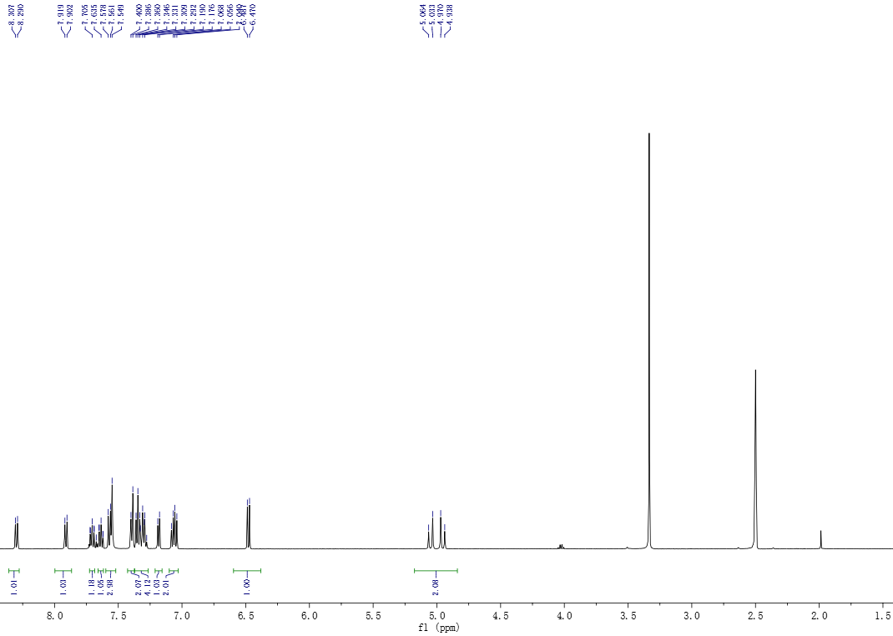
Figure 37 ¹H NMR spectrum of 6

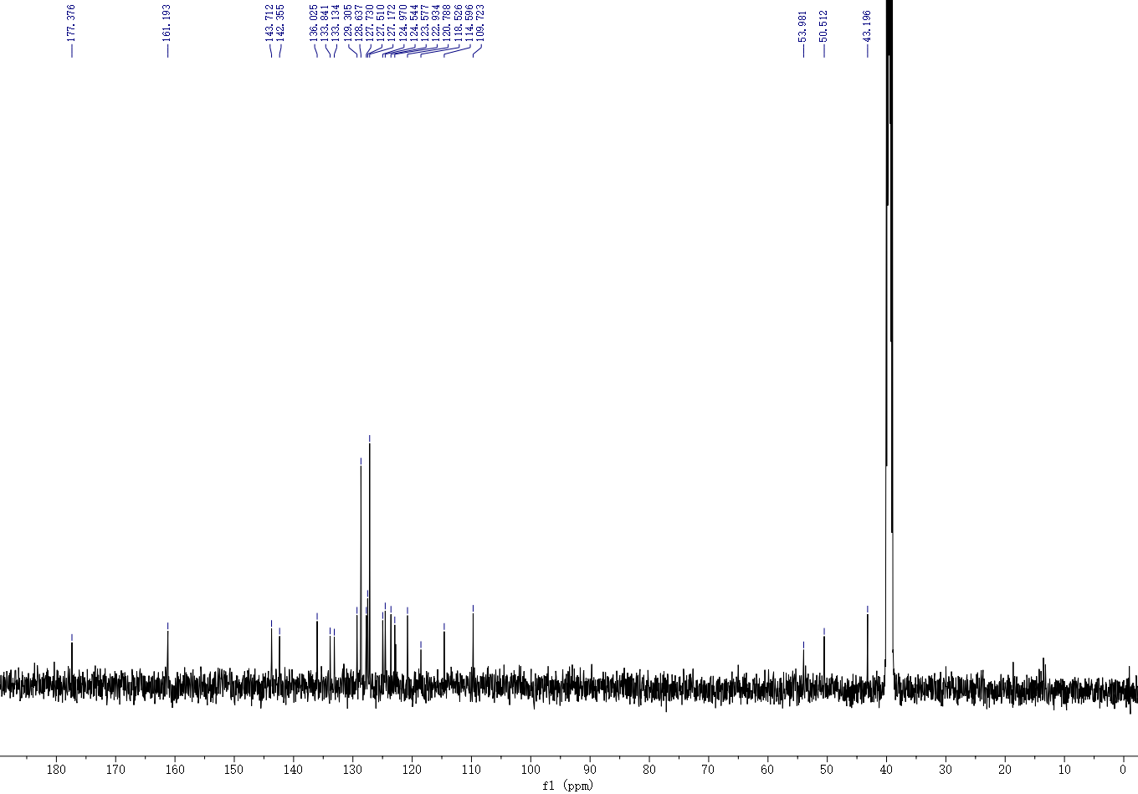
Figure 38 ¹³C NMR spectrum of 6

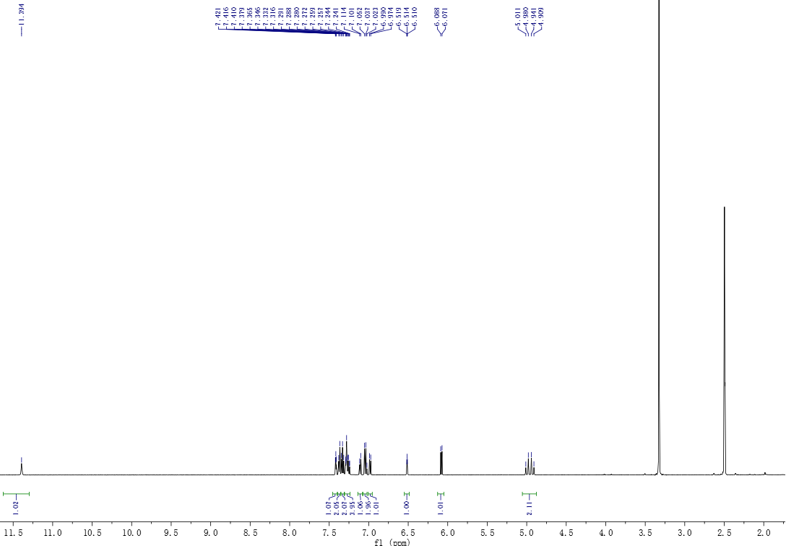

Figure 39 ¹H NMR spectrum of 7

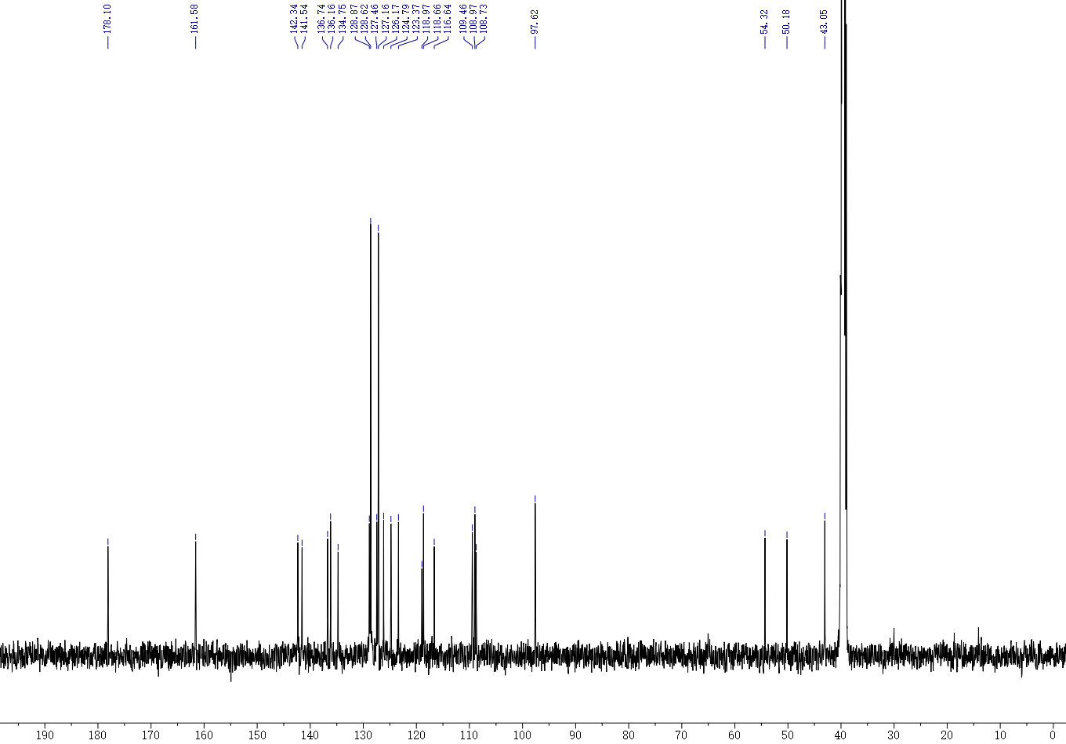

Figure 40 ¹³C NMR spectrum of 7

HPLC trace
3a
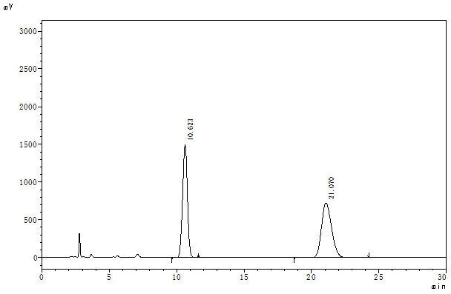
Figure 41. HPLC trace of racemic 3a

 | Retention Time | Area | Height | Area%
1 | 10.623 | 37492069 | 1496472 | 49.869
2 | 21.070 | 37689745 | 723931 | 50.131
Total |  | 75181814 | 2220402 | 100.000

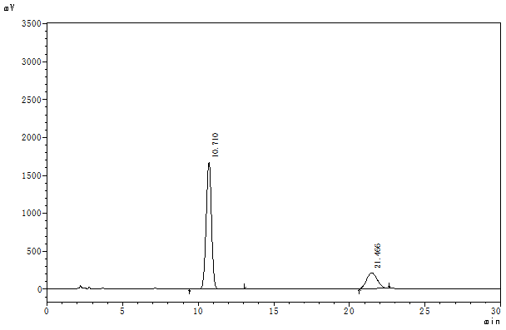
Figure 42. HPLC trace of enantiomeric 3a

 | Retention Time | Area | Height | Area%
1 | 10.710 | 41296201 | 1671675 | 80.449
2 | 21.466 | 10035661 | 206371 | 19.551
Total |  | 51331862 | 1878046 | 100.000

3b
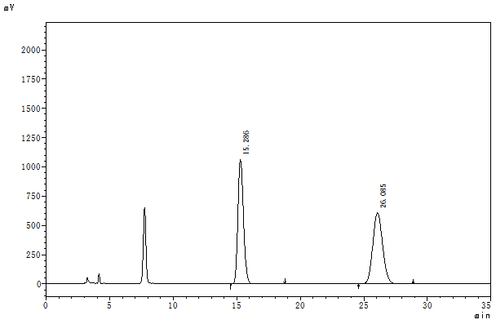
Figure 43. HPLC trace of racemic 3b

 | Retention Time | Area | Height | Area%
1 | 15.286 | 32435506 | 1063242 | 49.856
2 | 26.085 | 32622937 | 607935 | 50.144
Total |  | 65058443 | 1671177 | 100.000

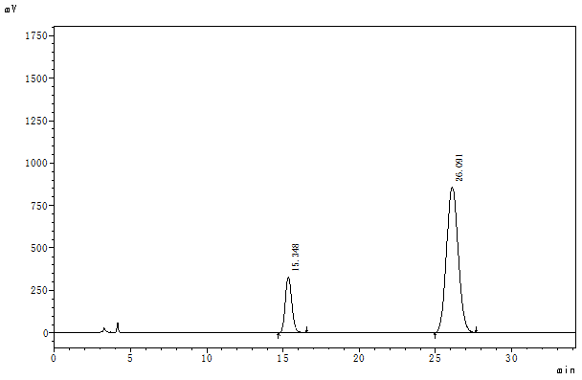
Figure 44. HPLC trace of enantiomeric 3b

 | Retention Time | Area | Height | Area%
1 | 15.348 | 9833749 | 326542 | 17.672
2 | 26.091 | 45812104 | 857394 | 82.328
Total |  | 55645854 | 1183937 | 100.000

3c
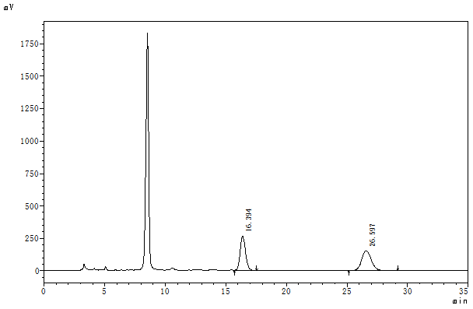
Figure 45. HPLC trace of racemic 3c

 | Retention Time | Area | Height | Area%
1 | 16.394 | 8298092 | 265808 | 50.077
2 | 26.597 | 8272419 | 153106 | 49.923
Total |  | 16570511 | 418913 | 100.000

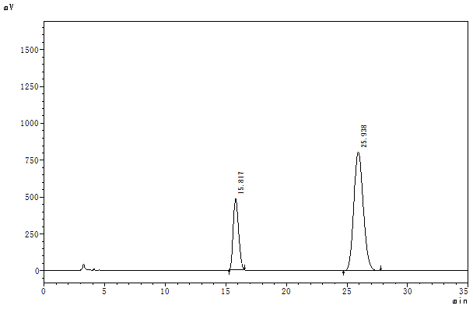
Figure 46. HPLC trace of enantiomeric 3c

 | Retention Time | Area | Height | Area%
1 | 15.817 | 14914990 | 480511 | 25.400
2 | 25.938 | 43805339 | 805352 | 74.600
Total |  | 58720329 | 1285863 | 100.000
3d
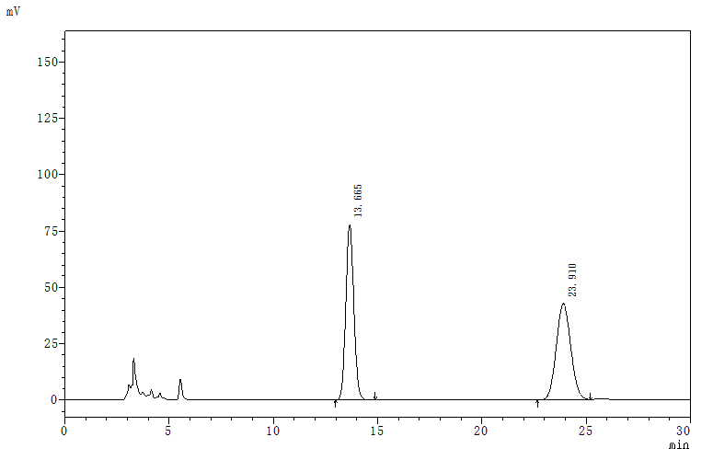
Figure 47. HPLC trace of racemic 3d

 | Retention Time | Area | Height | Area%
1 | 13.665 | 2078568 | 77743 | 49.961
2 | 23.910 | 2081806 | 42826 | 50.039
Total |  | 4160374 | 120569 | 100.000

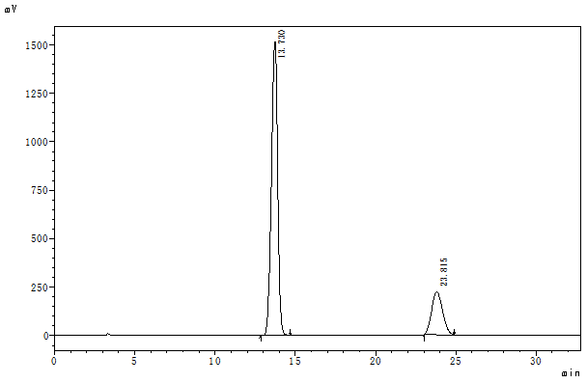
Figure 48. HPLC trace of enantiomeric 3d

 | Retention Time | Area | Height | Area%
1 | 13.730 | 41232394 | 1517889 | 79.724
2 | 23.815 | 10486569 | 221946 | 20.276
Total |  | 51718962 | 1739835 | 100.000
3e
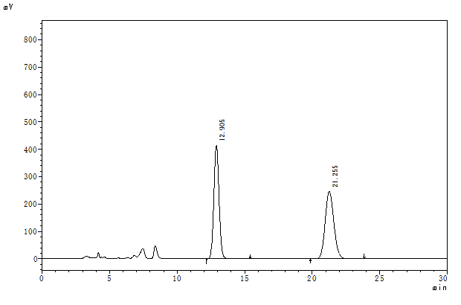
Figure 49. HPLC trace of racemic 3e

 | Retention Time | Area | Height | Area%
1 | 12.905 | 11116688 | 414345 | 50.183
2 | 21.255 | 11035638 | 246505 | 49.817
Total |  | 22152326 | 660850 | 100.000

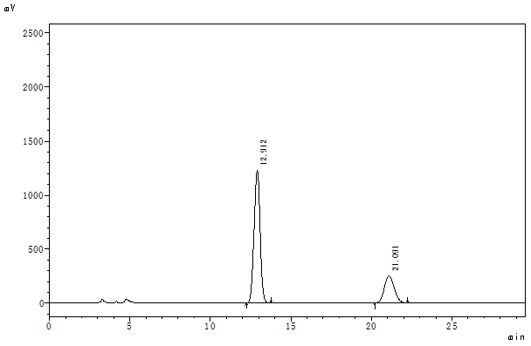
Figure 50. HPLC trace of enantiomeric 3e

 | Retention Time | Area | Height | Area%
1 | 12.912 | 32048047 | 1228926 | 74.679
2 | 21.091 | 10866457 | 251249 | 25.321
Total |  | 42914504 | 1480175 | 100.000
3f
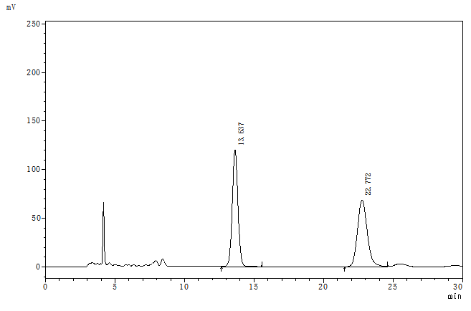
Figure 51. HPLC trace of racemic 3f

 | Retention Time | Area | Height | Area%
1 | 13.637 | 3451833 | 120105 | 50.686
2 | 22.772 | 3358429 | 68544 | 49.314
Total |  | 6810263 | 188649 | 100.000

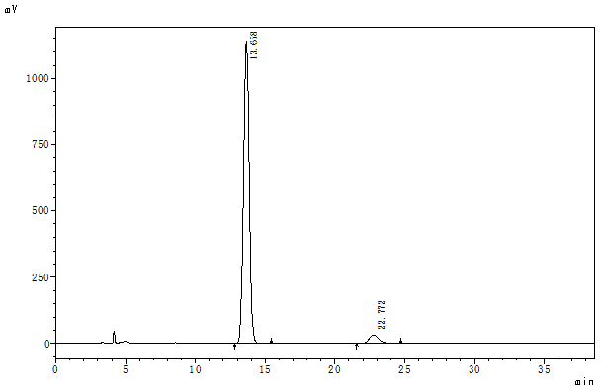
Figure 52. HPLC trace of enantiomeric 3f

 | Retention Time | Area | Height | Area%
1 | 13.658 | 32096090 | 1136190 | 95.022
2 | 22.772 | 1681413 | 32796 | 4.978
Total |  | 33777503 | 1168986 | 100.000
3g
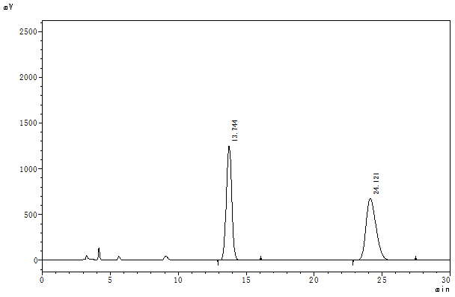
Figure 53. HPLC trace of racemic 3g

 | Retention Time | Area | Height | Area%
1 | 13.744 | 34665264 | 1247873 | 49.913
2 | 24.121 | 34786407 | 675499 | 50.087
Total |  | 69451672 | 1923371 | 100.000

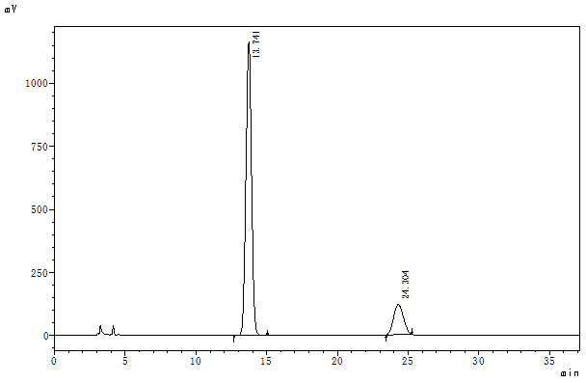
Figure 54. HPLC trace of enantiomeric 3g

 | Retention Time | Area | Height | Area%
1 | 13.741 | 32270523 | 1166350 | 84.729
2 | 24.304 | 5816344 | 120521 | 15.271
Total |  | 38086867 | 1286871 | 100.000
3h
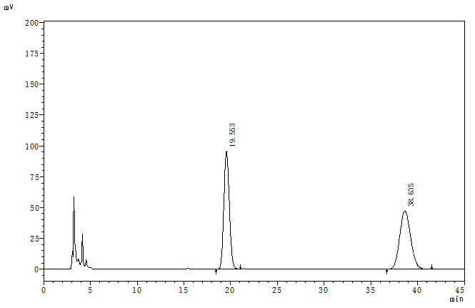
Figure 55. HPLC trace of racemic 3h

 | Retention Time | Area | Height | Area%
1 | 19.553 | 3876801 | 95723 | 50.056
2 | 38.635 | 3868176 | 47244 | 49.944
Total |  | 7744977 | 142967 | 100.000

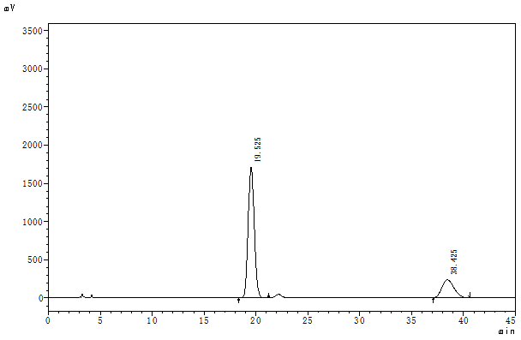
Figure 56. HPLC trace of enantiomeric 3h

 | Retention Time | Area | Height | Area%
1 | 19.525 | 70237855 | 1710652 | 78.551
2 | 38.425 | 19178961 | 236751 | 21.449
Total |  | 89416816 | 1947403 | 100.000
3i
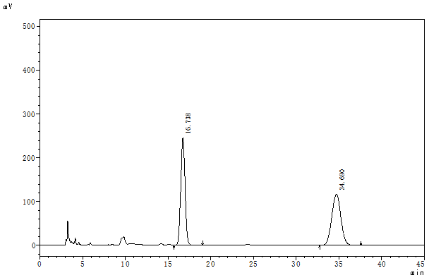
Figure 57. HPLC trace of racemic 3i

 | Retention Time | Area | Height | Area%
1 | 16.738 | 8677665 | 245786 | 50.050
2 | 34.690 | 8660371 | 116453 | 49.950
Total |  | 17338036 | 362240 | 100.000

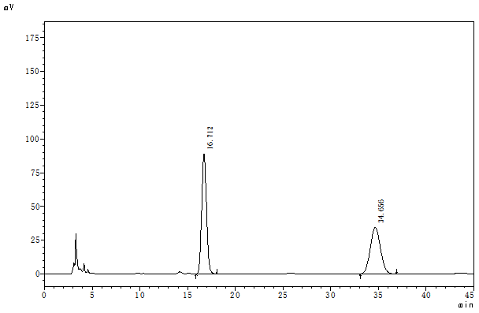
Figure 58. HPLC trace of enantiomeric 3i

 | Retention Time | Area | Height | Area%
1 | 16.712 | 3112570 | 88788 | 54.951
2 | 34.656 | 2551649 | 34395 | 45.049
Total |  | 5664219 | 123183 | 100.000
3j
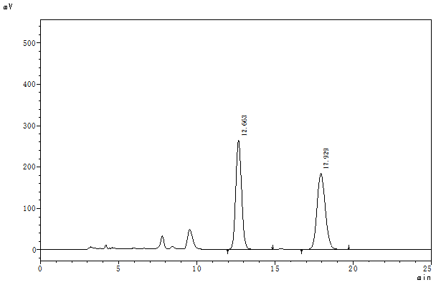
Figure 59. HPLC trace of racemic 3j

 | Retention Time | Area | Height | Area%
1 | 12.663 | 6781606 | 263562 | 50.124
2 | 17.929 | 6747966 | 182981 | 49.876
Total |  | 13529572 | 446543 | 100.000
3j
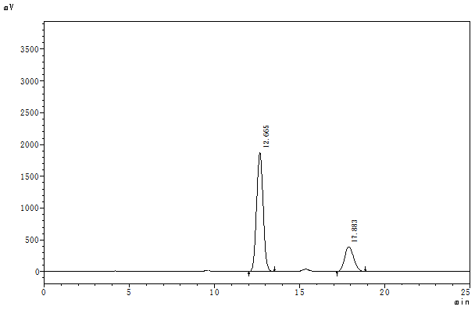
Figure 60. HPLC trace of enantiomeric 3j

 | Retention Time | Area | Height | Area%
1 | 12.665 | 49971405 | 1872607 | 77.578
2 | 17.883 | 14442900 | 389017 | 22.422
Total |  | 64414305 | 2261624 | 100.000
3k
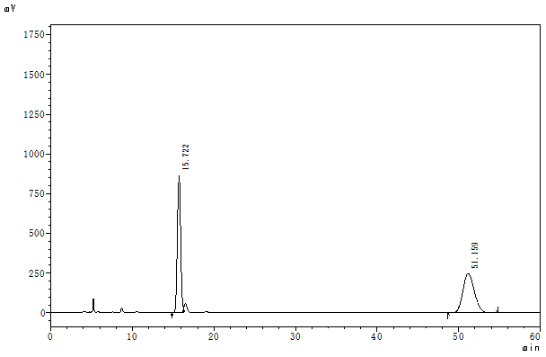
Figure 61. HPLC trace of racemic 3k

 | Retention Time | Area | Height | Area%
1 | 15.722 | 24079454 | 862839 | 49.922
2 | 51.159 | 24154274 | 248595 | 50.078
Total |  | 48233728 | 1111434 | 100.000

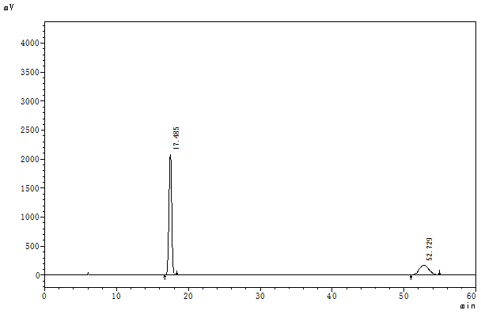
Figure 62. HPLC trace of enantiomeric 3k

 | Retention Time | Area | Height | Area%
1 | 17.485 | 54352310 | 2077891 | 77.319
2 | 52.729 | 15944277 | 169599 | 22.681
Total |  | 70296587 | 2247489 | 100.000
3l
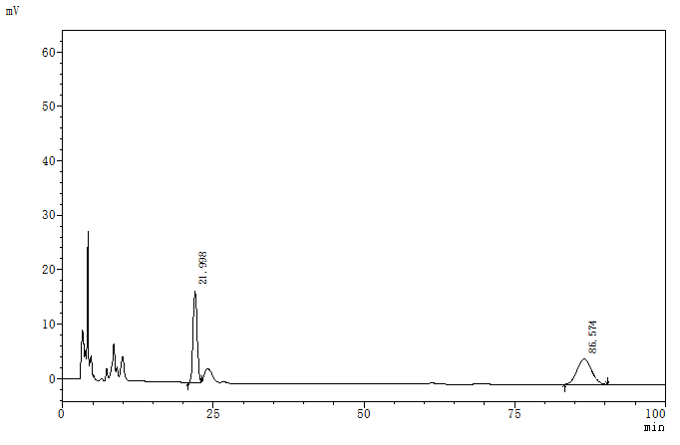
Figure 63. HPLC trace of racemic 3l

 | Retention Time | Area | Height | Area%
1 | 21.998 | 792211 | 16842 | 50.545
2 | 86.574 | 775135 | 4664 | 49.455
Total |  | 1567345 | 21505 | 100.000

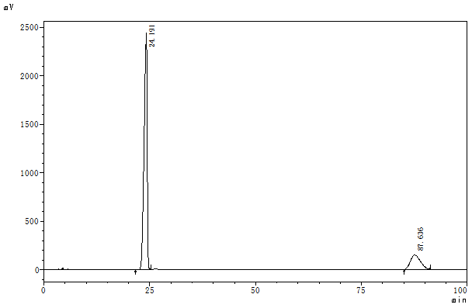
Figure 64. HPLC trace of enantiomeric 3l

 | Retention Time | Area | Height | Area%
1 | 24.191 | 122255711 | 2439253 | 83.332
2 | 87.636 | 24453785 | 148816 | 16.668
Total |  | 146709496 | 2588068 | 100.000
3m
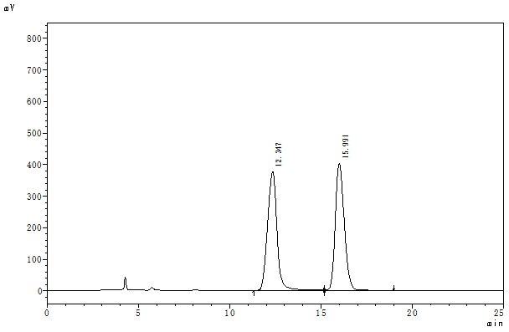
Figure 65. HPLC trace of racemic 3m

 | Retention Time | Area | Height | Area%
1 | 12.347 | 13508577 | 375754 | 49.669
2 | 15.991 | 13688556 | 401831 | 50.331
Total |  | 27197133 | 777585 | 100.000

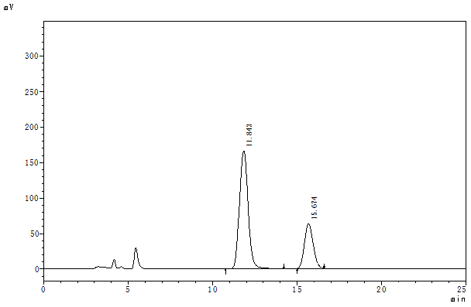
Figure 66. HPLC trace of enantiomeric 3m

 | Retention Time | Area | Height | Area%
1 | 11.843 | 5936773 | 166098 | 72.478
2 | 15.674 | 2254412 | 63076 | 27.522
Total |  | 8191185 | 229175 | 100.000
3n
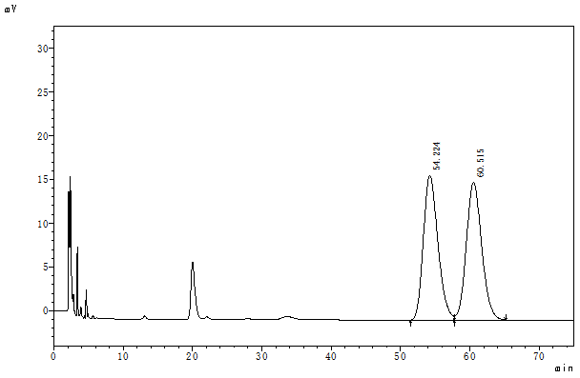
Figure 67. HPLC trace of racemic 3n

 | Retention Time | Area | Height | Area%
1 | 54.224 | 2417987 | 16523 | 49.844
2 | 60.515 | 2433170 | 15727 | 50.156
Total |  | 4851158 | 32250 | 100.000

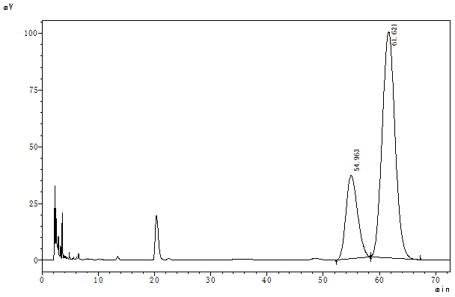
Figure 68. HPLC trace of enantiomeric 3n

 | Retention Time | Area | Height | Area%
1 | 54.963 | 5228268 | 36668 | 24.871
2 | 61.621 | 15793017 | 99598 | 75.129
Total |  | 21021285 | 136266 | 100.000
3o
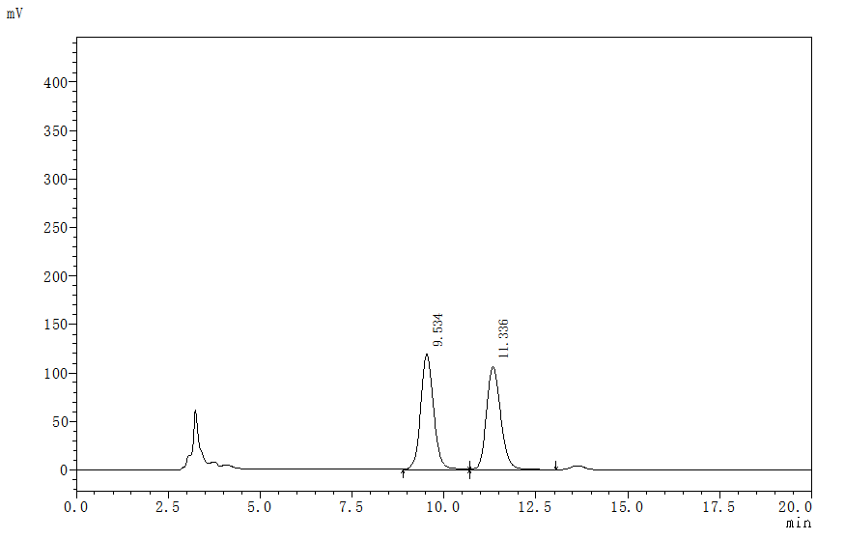
Figure 69. HPLC trace of racemic 3o

 | Retention Time | Area | Height | Area%
1 | 9.534 | 2969799 | 119595 | 50.482
2 | 11.336 | 2913055 | 106703 | 49.518
Total |  | 5882854 | 226298 | 100.000

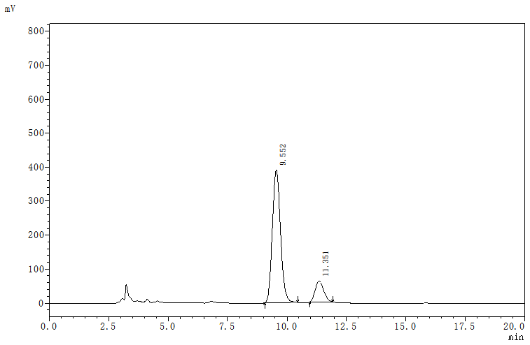
Figure 70. HPLC trace of enantiomeric 3o

 | Retention Time | Area | Height | Area%
1 | 9.552 | 9338796 | 390241 | 85.965
2 | 11.351 | 1524712 | 61040 | 14.035
Total |  | 10863508 | 451281 | 100.000
3p
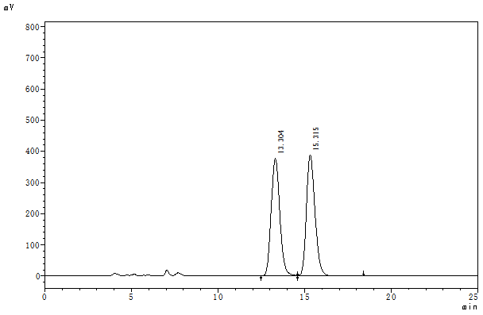
Figure 71. HPLC trace of racemic 3p

 | Retention Time | Area | Height | Area%
1 | 13.304 | 13199972 | 376529 | 49.618
2 | 15.315 | 13403126 | 388170 | 50.382
Total |  | 26603098 | 764698 | 100.000

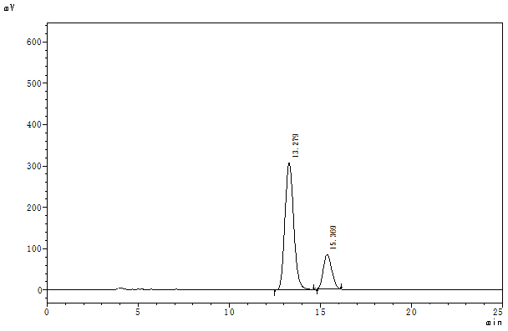
Figure 72. HPLC trace of enantiomeric 3p

 | Retention Time | Area | Height | Area%
1 | 13.279 | 10380576 | 307498 | 79.232
2 | 15.369 | 2720863 | 83717 | 20.768
Total |  | 13101438 | 391215 | 100.000
4
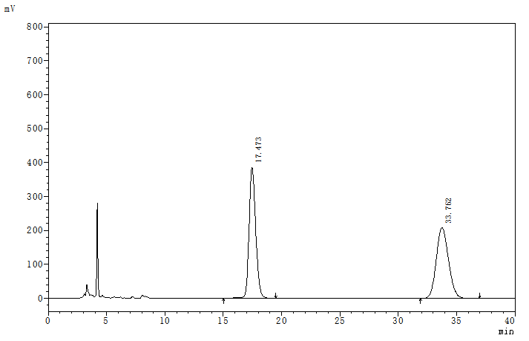
Figure 73. HPLC trace of racemic 4

 | Retention Time | Area | Height | Area%
1 | 17.473 | 15279611 | 385690 | 50.241
2 | 33.762 | 15132823 | 208071 | 49.759
Total |  | 30412434 | 593760 | 100.000

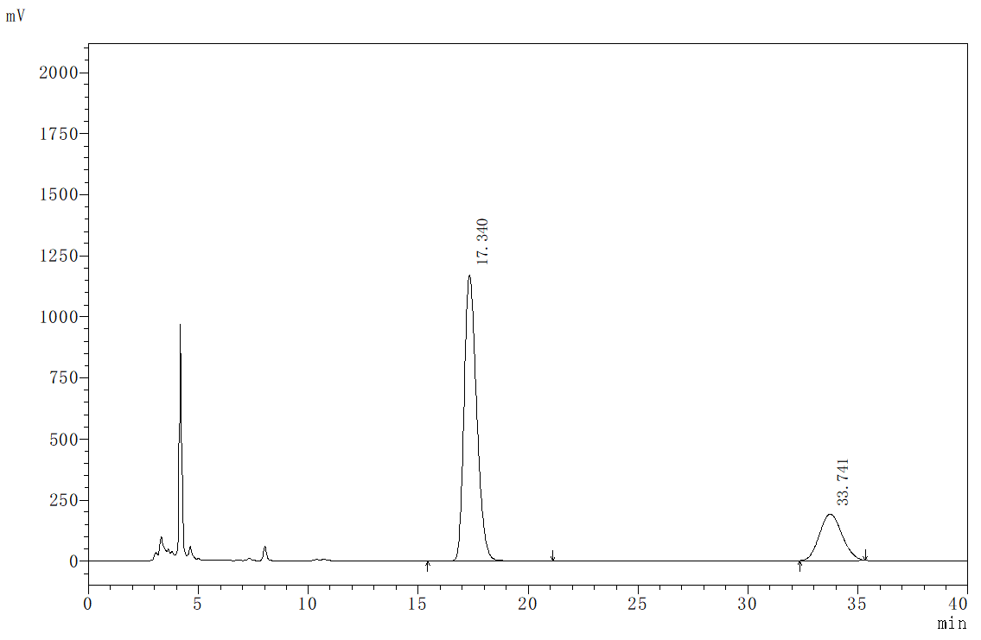
Figure 74. HPLC trace of enantiomeric 4

 | Retention Time | Area | Height | Area%
1 | 17.340 | 46201545 | 1172933 | 77.314
2 | 33.741 | 13557029 | 189801 | 22.686
Total |  | 59758573 | 1362734 | 100.000
5
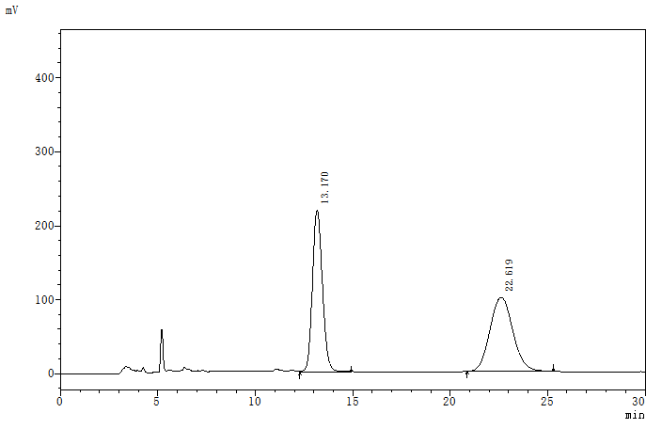
Figure 75. HPLC trace of racemic 5

 | Retention Time | Area | Height | Area%
1 | 13.170 | 7922922 | 219983 | 49.114
2 | 22.619 | 8208709 | 100075 | 50.886
Total |  | 16131632 | 320057 | 100.000

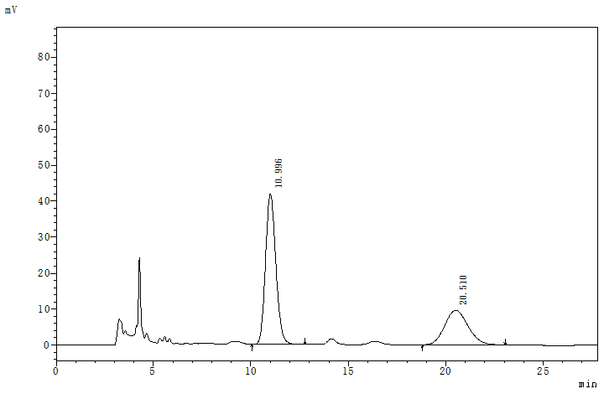
Figure 76. HPLC trace of enantiomeric 5

 | Retention Time | Area | Height | Area%
1 | 10.996 | 1552755 | 41942 | 65.969
2 | 20.510 | 801006 | 9619 | 34.031
Total |  | 2353761 | 51561 | 100.000
6
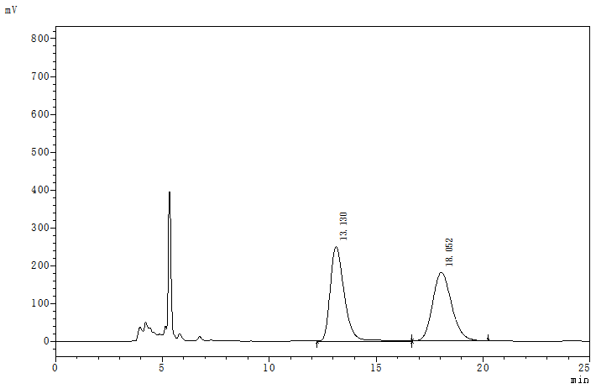
Figure 77. HPLC trace of racemic 6

 | Retention Time | Area | Height | Area%
1 | 13.130 | 11414299 | 250160 | 50.464
2 | 18.052 | 11204580 | 180938 | 49.536
Total |  | 22618879 | 431098 | 100.000

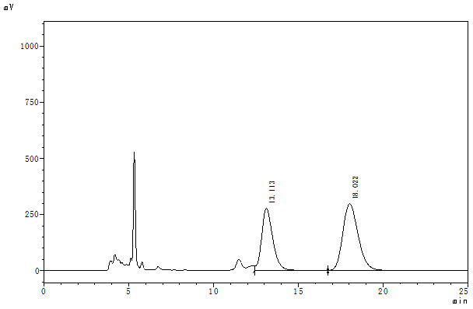
Figure 78. HPLC trace of enantiomeric 6

 | Retention Time | Area | Height | Area%
1 | 13.113 | 13004424 | 276790 | 40.385
2 | 18.022 | 19196691 | 297683 | 59.615
Total |  | 32201115 | 574473 | 100.000
7
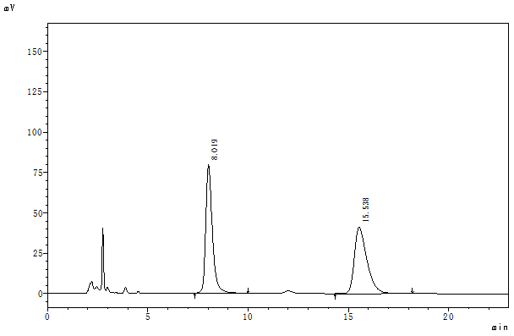
Figure 79. HPLC trace of racemic 7

 | Retention Time | Area | Height | Area%
1 | 8.019 | 1837960 | 79526 | 50.514
2 | 15.538 | 1800547 | 41357 | 49.486
Total |  | 3638507 | 120883 | 100.000

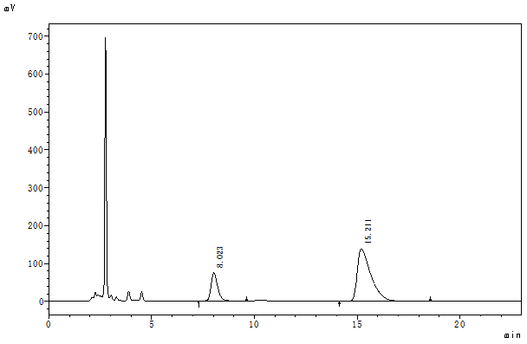
Figure 80. HPLC trace of enantiomeric 7

 | Retention Time | Area | Height | Area%
1 | 8.023 | 1821900 | 75834 | 22.022
2 | 15.211 | 6451092 | 138396 | 77.978
Total |  | 8272992 | 214230 | 100.000
X-Ray crystal data of compound 3f
Table 1 Crystal data and structure refinement for 3f
Identification code | 3f
Empirical formula | C25H16BrN3O4
Formula weight | 502.32
Temperature/K | 173.0
Crystal system | triclinic
Space group | P-1
a/Å | 9.5405(6)
b/Å | 10.5930(6)
c/Å | 11.7435(7)
α/° | 74.825(3)
β/° | 81.589(3)
γ/° | 73.759(3)
Volume/Å3 | 1096.31(12)
Z | 2
ρcalcg/cm3 | 1.522
μ/mm‑1 | 2.881
F(000) | 508.0
Crystal size/mm3 | 0.301 × 0.287 × 0.285
Radiation | CuKα (λ = 1.54178)
2Θ range for data collection/° | 7.824 to 127.626
Index ranges | -11 ≤ h ≤ 11, -12 ≤ k ≤ 12, -13 ≤ l ≤ 13
Reflections collected | 20277
Independent reflections | 3600 [Rint = 0.0347, Rsigma = 0.0254]
Data/restraints/parameters | 3600/0/306
Goodness-of-fit on F2 | 1.139
Final R indexes [I>=2σ (I)] | R1 = 0.0303, wR2 = 0.0735
Final R indexes [all data] | R1 = 0.0352, wR2 = 0.0758
Largest diff. peak/hole / e Å-3 | 0.39/-0.40

