Supplementary Materials:
Figure S1: Box-Whisker-Plot of worst eye visual acuity vs age group and sex at baseline. Note: Distribution of worst eye visual acuity (VA): Study eye=69.6%, Partner eye=30.4%. Horizontal lines show median, boxes indicate the interquartile range (IQR) with whiskers providing 1.5xIQR and black dots showing outlier values.

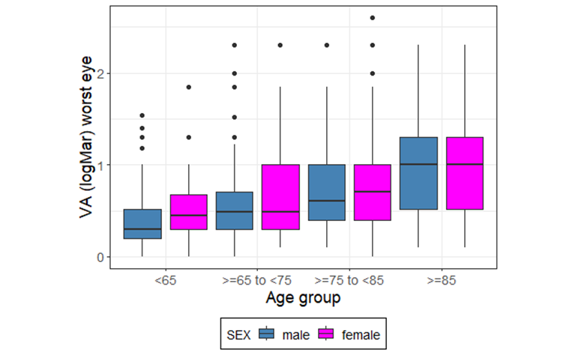

Figure S2: Heat maps showing correlation of disease- and treatment distress at baseline [A], final visit [B] and change from baseline to final visit [C] for the overall population. Numbers indicate patients with a distinct combination of distress perception. Shadings show frequencies. The darker the color, the higher the frequency.
A | 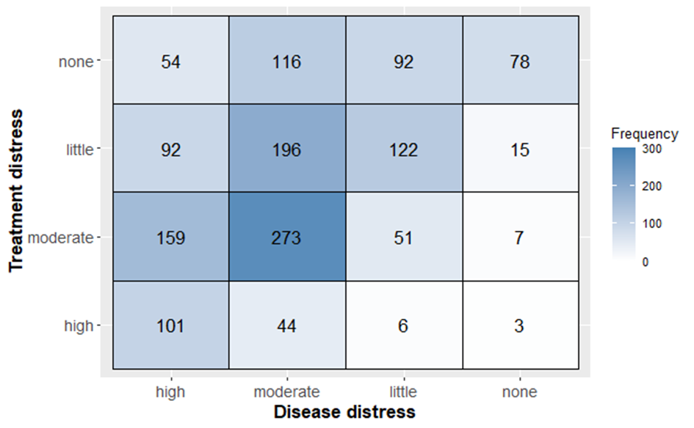
B | 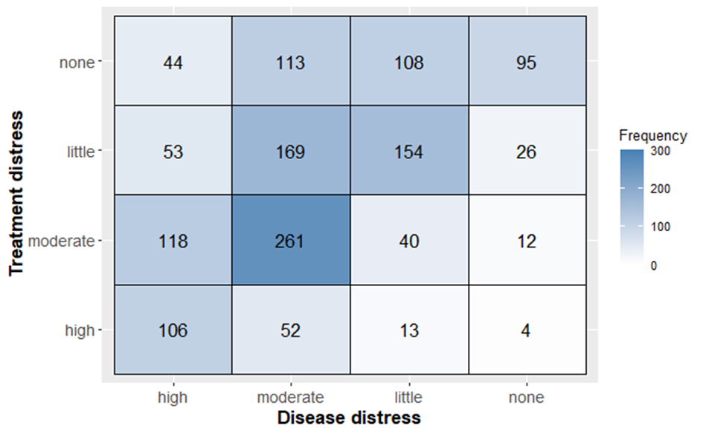
C | 