Supplementary material

Characterization of nanoprecipitated PET nanoplastics by ¹H NMR and impact of residual ionic surfactant on viability of human primary mononuclear cells and hemolysis of erythrocytes

Milica Djapovic¹, Danijela Apostolovic², Vojislava Postic¹, Tamara Lujic¹, Vesna Jovanovic¹, Dragana Stanic-Vucinic¹, Marianne van Hage^{w}, Veselin Maslak¹* and Tanja Cirkovic Velickovic^{1,3}*

¹University of Belgrade - Faculty of Chemistry, Studentski trg 16, Belgrade, Serbia
²Immunology and Allergy Division, Center for Molecular Medicine, Department of Medicine
Solna, Karolinska Institutet, Stockholm, Sweden
³Serbian Academy of Sciences and Arts, Knez Mihajlova 35, Belgrade, Serbia

*Corresponding author
E-mail address: tcirkov@chem.bg.ac.rs (T Cirkovic Velickovic); vmaslak@chem.bg.ac.rs (V. Maslak)

Preparation of PET NPs

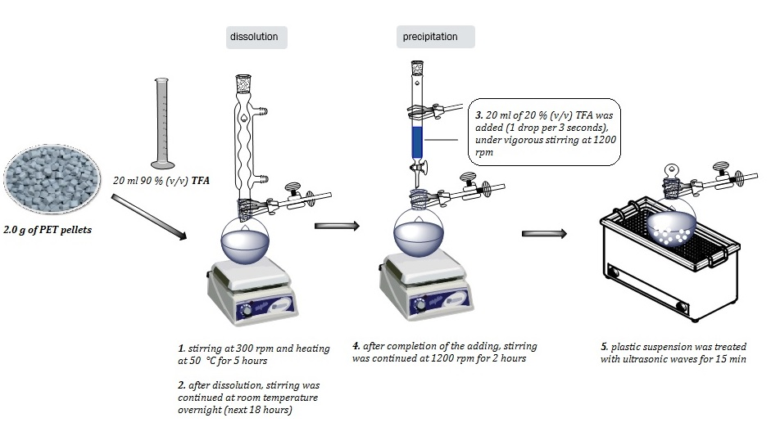
Figure S1. Overall scheme of nPET production procedure. First, 2.0 g of PET pellets was dissolved in 20.0 mL of TFA in Mili-Q water (v/v) with stirring at 300 rpm for five hours at 50 °C and next 18h at room temperature. Then, 20 mL of 20% TFA in Milli-Q water (v/v) was added dropwise during 110 min (1 drop of 10 μL per 3 s), under vigorous stirring at 1200 rpm using a dropping funnel. Stirring of suspension was continued for an additional 2 hours, before being sonicated in an ultrasonic bath for 15 min.

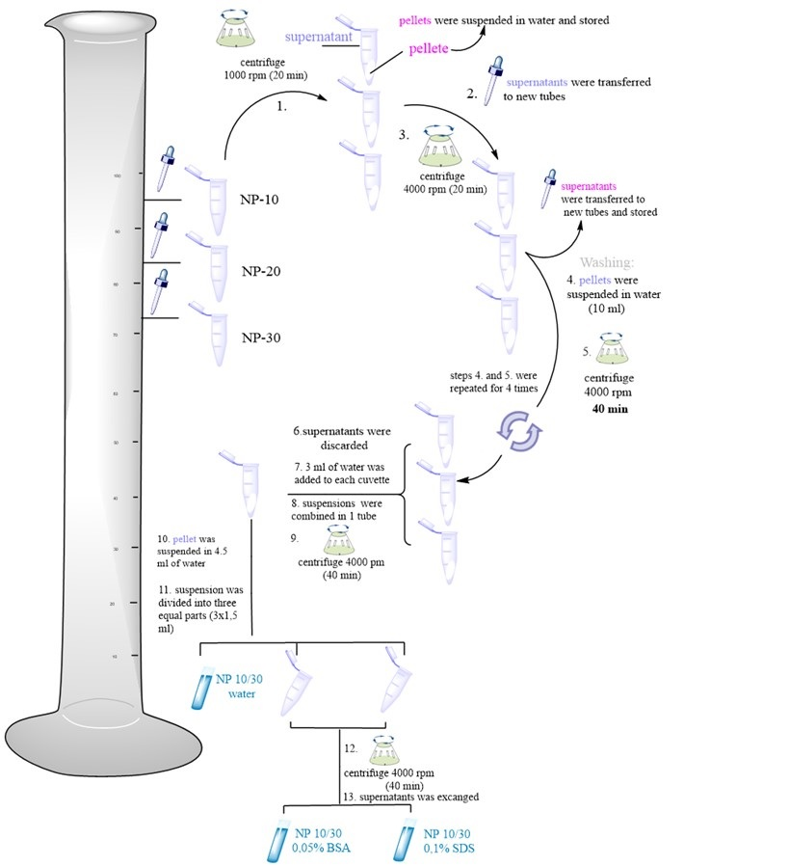
Figure S2. Schematic illustration of washing and size separation processes of the first three fractions (each 10 mL), denoted NP-10, NP-20 and NP-30.

Characterization of PET NPs

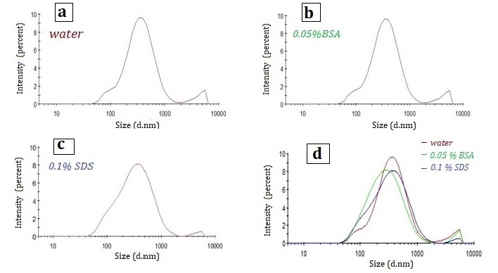
Figure S3. Size distributions (by intensity percentage) of NPs washed suspended in different dispersants: water, BSA (0.05%) and SDS (0.1 %) are presented. Size distributions are shown for NPs obtained from combinated fractions: NP-10, NP-20 and NP-30.
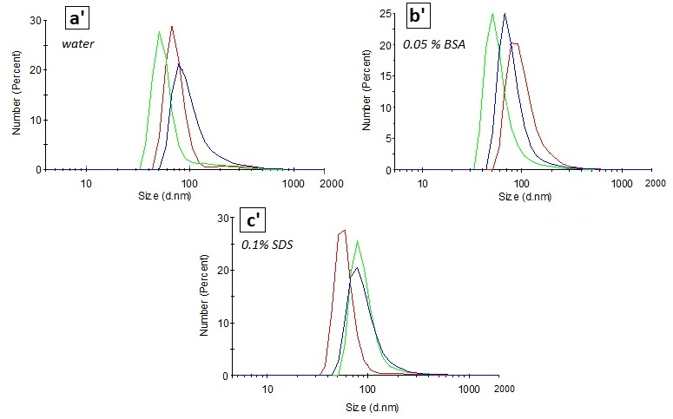
Figure S4. Size distributions (by number percentage) of NPs washed suspended in different dispersants: water, BSA (0.05%) and SDS (0.1 %) are presented. Distributions are shown for NPs obtained from combinated fractions: NP-10, NP-20 and NP-30. Additionally multiple consecutive measurements (lines with different colors) are presented.

Table S1. Hydrodynamic diameter (d.nm) and polydispersity index of NPs washed obtained from combined fractions: NP-10, NP-20 and NP-30 (denoted NP-10+NP-20+NP-30); NP-40, NP-50 and NP-60 (denoted NP-40+NP-50+NP-60); NP-70, NP-80 and NP-90 (denoted NP-70+NP-80+NP-90) dispersed in different dispersants: water, 0.05% BSA and 0.1% SDS.
 | dispersant | NPS washed
 |  | NP-10+NP-20+NP+  NP-30 | NP-40+NP-50+  NP-60 | NP-70+NP-80+  NP-90
Z-Average  (d.nm) | water | 311.7 ± 4.4 | 182.3 ± 3.4 | 262.5 ± 9.6
 | 0.05% BSA | 243.5 ± 1.3 | 264.6 ± 7.2 | 230.7 ± 1.1
 | 0.1 % SDS | 265.7 ± 5.9 | 256.8 ± 3.3 | 215.6 ± 1.6
Polydispersity index | water | 0.375 ± 0.026 | 0.309 ± 0.034 | 0.540 ± 0.073
 | 0.05% BSA | 0.352 ± 0.037 | 0.271 ± 0.010 | 0.269 ± 0.011
 | 0.1 % SDS | 0.351 ± 0.041 | 0.336 ± 0.026 | 0.260 ± 0.050

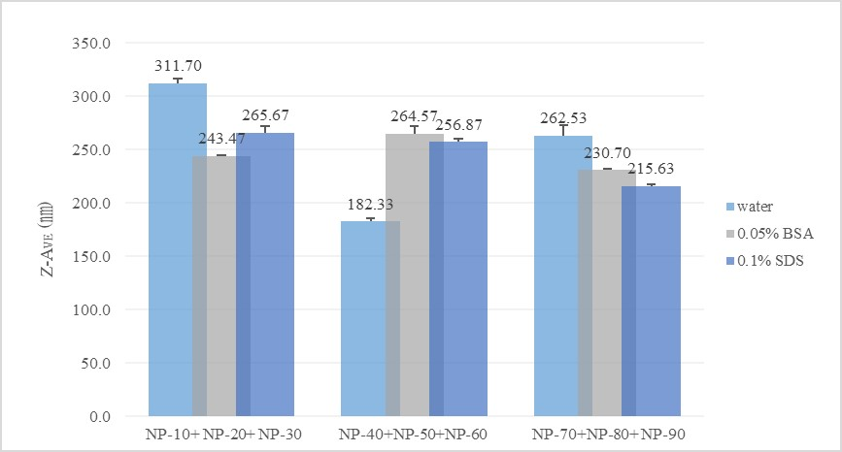Figure S5. Hydrodynamic diameter (d.nm) of NPs washed obtained from combined fractions: NP-10, NP-20 and NP- 30 (denoted NP-10+NP-20+NP-30); NP-40, NP-50 and NP-60 (denoted NP-40+NP-50+NP-60); NP-70, NP-80 and NP-90 (denoted NP-70+NP-80+NP-90) dispersed in different dispersants: water, 0.05% BSA and 0.1% SDS.
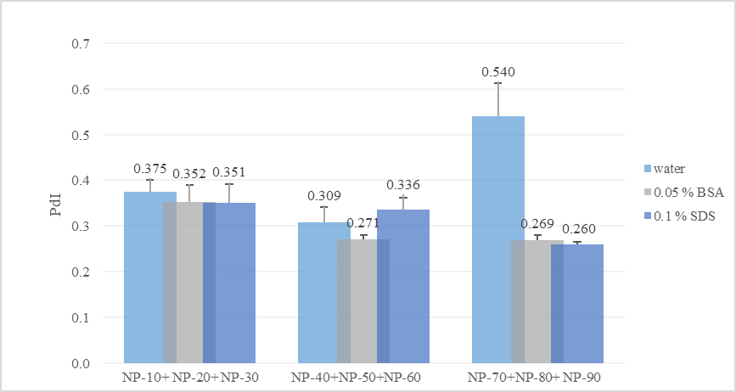
Figure S6. Polydispersity index of NPs washed obtained from combined fractions: NP-10, NP-20 and NP- 30 (denoted NP-10+NP-20+NP-30); NP-40, NP-50 and NP-60 (denoted NP-40+NP-50+NP-60); NP-70, NP-80 and NP-90 (denoted NP-70+NP-80+NP-90) dispersed in different dispersants: water, 0.05% BSA and 0.1% SDS.
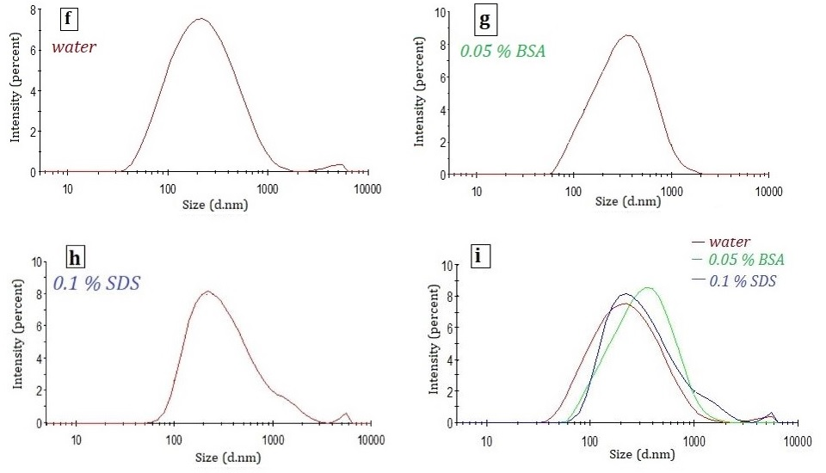
Figure S7. Size distributions (by intensity percentage) of NPs washed suspended in different dispersants: water, BSA (0.05%) and SDS (0.1 %) are presented. Size distributions are shown for NPs obtained from combinated fractions: NP-40, NP-50 and NP-60.
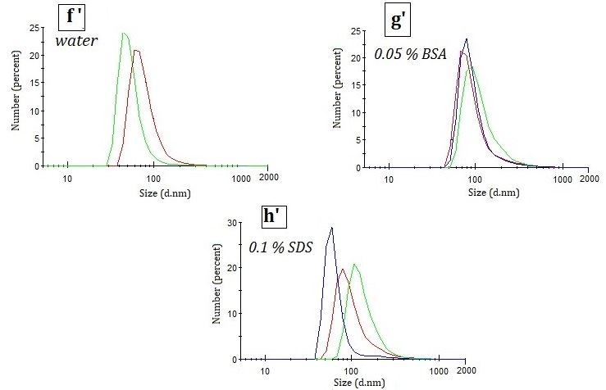
Figure S8. Size distributions (by number percentage) of NPs washed suspended in different dispersants: water, BSA (0.05%) and SDS (0.1 %) are presented. Distributions are shown for NPs obtained from combinated fractions: NP-40, NP-50 and NP-60. Additionally multiple consecutive measurements (lines with different colors) are presented.
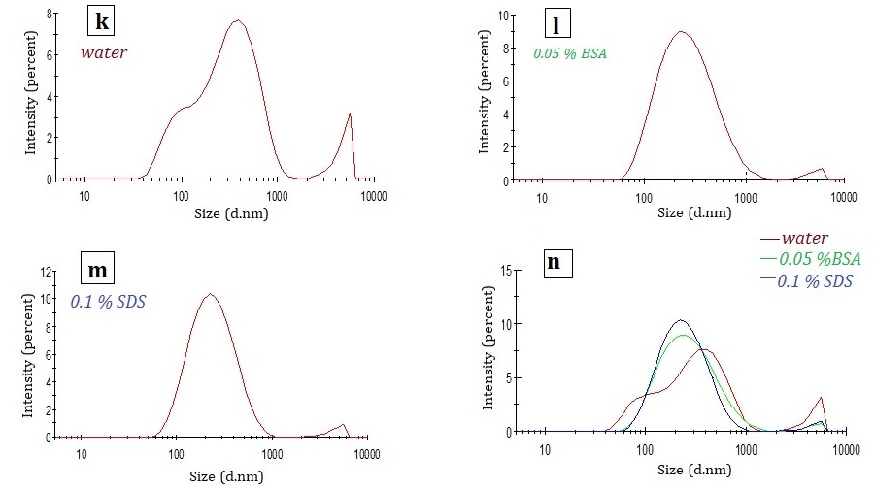
Figure S9. Size distributions (by intensity percentage) of NPs washed suspended in different dispersants: water, BSA (0.05%) and SDS (0.1 %) are presented. Size distributions are shown for NPs obtained from combinated fractions: NP-70, NP-80 and NP-90.
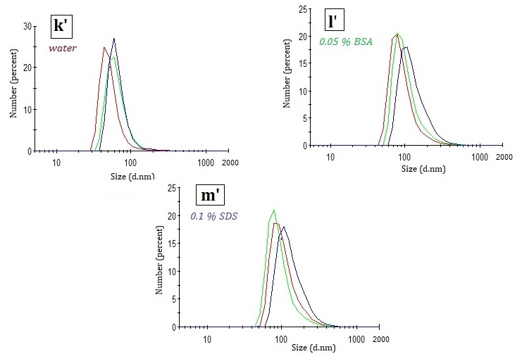Figure S10. Size distributions (by number percentage) of NPs washed suspended in different dispersants: water, BSA (0.05%) and SDS (0.1 %) are presented. Distributions are shown for NPs obtained from combinated fractions: NP-70, NP-80 and NP-90. Additionally multiple consecutive measurements (lines with different colors) are presented.
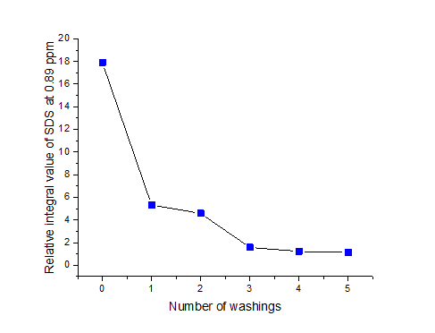
Figure S11. Relative quantification of SDS contamination in relation to PET signal in NMR.
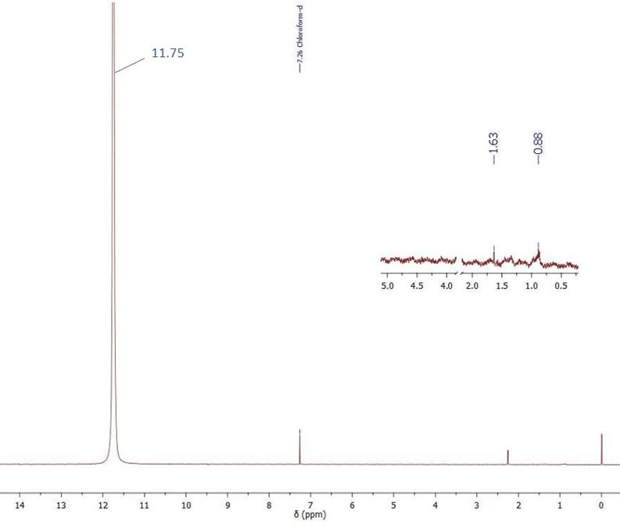Figure S12. ¹H NMR spectrum (400 MHz) of trifluoroacetic acid (TFA) recording with addition of deuterated chloroform (CDCl₃) in the ratio 4:1 (v,v, respectively). Region importance for process monitoring of washing process of NPs (0.5- 2.0 ppm and 4.0- 5 .0 ppm) is zoomed. Signal at 11.75 ppm originates from TFA; signals with chemical shifts values 0.88 and 1.63 ppm indicate the presence of impurities in very low concentrations.

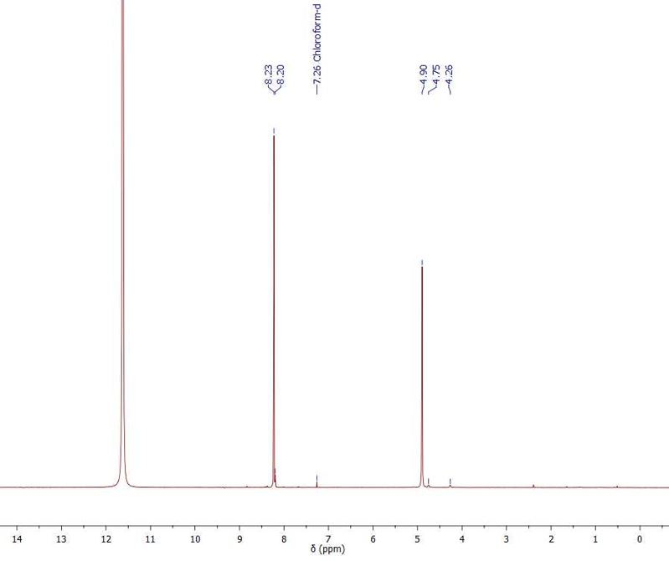
Figure S13. ¹H NMR spectrum (400 MHz) of PET pellet (starting material) recorded in the mixture of TFA and CDCl₃ in the ratio 4:1 (v/v). The use of this mixture containing the fluorinated solvent is advantageous, since it allows room temperature spectra [1]. Characteristic signals at 8.20- 8.23 (aromatic protons), 4.90 (internal methylene groups), and low intensity signals at 4.75 and 4.26 ppm (the methylene protons adjacent to the hydroxyl end functions) are consistent with reported literature data [2,3].

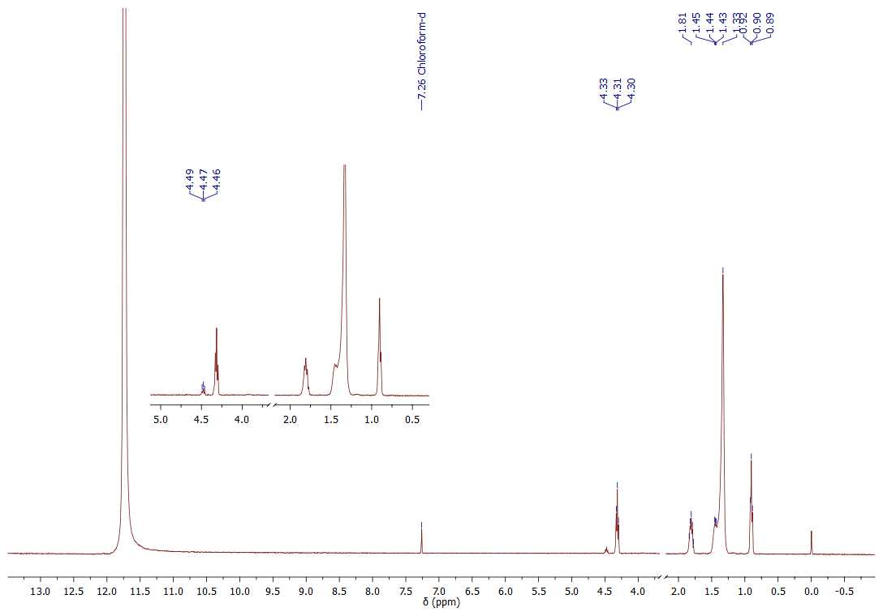
Figure S14. ¹H NMR spectrum (400 MHz) of sodium dodecyl sulfate (SDS) recorded in the mixture of TFA and CDCl₃ in the ratio 4:1 (v/v). The peaks at regions 0.89-0.92, 1.33-1.45, 1.81 and 4.30-4.33 ppm originate from SDS. In the magnified part of the spectrum a low intensity signal with chemical shift of 4.46-4.49 ppm is visible. The intensity of this impurity decreases during the washing process of NPs from SDS; already after third washing, this peak is not visible in the NMR spectrum (Figure 1B).

References:
- Fox, B.; Moad, G.; Van Diepen, G.; Willing, I.; Cook, W. D. Characterization of poly(ethylene terephthalate) and poly(ethylene terephthalate) blends. Polymer, 1997, 38(12), 3035-3043, doi:10.1016/s0032-3861(96)00872-5.
- El Mejjatti, A.; Harit, T.; Riahi, A.; Khiari, R.; Bouabdallah, I.; Malek, F. Chemical recycling of poly(ethylene terephthalate). Application to the synthesis of multiblock copolyesters. EXPRESS Polym. Lett. 2014, 8, 544553, doi: doi:10.3144/expresspolymlett.2014.58.
- Saint-Loup, R.; Jeanmaire, T.; Robin, J.J.; Boutevin, B. Synthesis of (polyethylene terephthalate/polyϵ-caprolactone) copolyesters. Polymer, 2003, 44, 3437-3449, doi: 10.1016/S0032-3861(03)00257-X.

