Table S1: Examples of Apps used in Anesthesia
App name | App type | Clinical Area | Description | Cost | URL
General clinical support

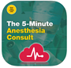  5 Minute Anesthesia Consult | Healthcare provider decision support  Drug references, medication management  Reference texts/journals, training and education  Patient centred app | Pre-operative setting  General anesthesia  Surgical specialty | Thorough pathology-based app extending from pre-operative management to intra-operative management | Free  In-app purchase $119.99 | https://apps.apple.com/us/app/5-minute-anesthesia-consult/ id1102384412
AAGBI (Association of Anaesthetists of Great Britain and Ireland) | Healthcare provider decision support  Drug references, medication management  Reference texts/ journals, training and education  Medical calculators  Healthcare provider communication/ referral coordination | Pre-operative setting  General anesthesia  Surgical specialty  Regional anesthesia | Centralised hub for interaction between anaesthetists, guidelines, and education | Free | https://apps.apple.com/us/app/association-of-anaesthetists/id913194458
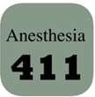  Anesthesia 411 | Healthcare provider decision support  Drug references, medication management  Reference texts/journals, training and education | General anesthesia  Surgical specialty | Specific procedures and the integral information for anaesthetists to perform them safely | $3.99 | https://apps.apple.com/us/app/anesthesia-411/id449473295
Anesthesia Central | Healthcare provider decision support  Drug references, medication management  Reference texts/ journals, training and education | General anesthesia  Surgical specialty | Combination resource allowing for multiple uses across several domains | Free  In-app purchases $99.99 - $169.99 | https://apps.apple.com/us/app/anesthesia-central/id347656772
App name | App type | Clinical Area | Description | Cost | URL
ASRA Coags | Healthcare provider decision support  Drug references, medication management  Patient centred app | Pre-operative  Regional anesthesia  Pain medicine | Guidelines provided for regional anesthesia and pain management | $3.99 | https://apps.apple.com/us/app/asra-coags/id858796572
Anesthesia Pre-Op | Healthcare provider decision support  Patient centred app | Pre-operative setting | Provides checklist for pre-operative patient assessment | Free | https://play.google.com/store/apps/details?id=com.mobincube.anesthesia_ pre_op.sc_HNMR4H
MyATLS | Healthcare provider decision support  Drug references, medication management  Medical calculators  Reference texts/journals, training and education | General anesthesia  Surgical specialty | Easy to access trauma based clinical decision support tool | $1.22 - $9.77 per item | https://play.google.com/store/apps/details?id=com.echo.myatls
Regional Anesthesia Reference | Drug references, medication management  Medical calculators  Reference texts/journals, training and education | Regional anesthesia | Provides education about regional anesthesia, recommended analgesia and calculator | Free | https://play.google.com/store/apps/details?id=com.awalters. regionalanestheiaatlas
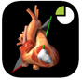  TTE Standard Views | Reference texts/journals, training and education | Pre-operative | Provides 3-dimensional context for images viewed in transthoracic echocardiography | $4.99 | https://apps.apple.com/us/app/tte-standard-views/id660856485
ECHO Views - Transesophageal Echocardiography | Reference texts/journals, training and education | Pre-operative | Transesophageal Echocardiography educational resource | $9.99 | https://apps.apple.com/us/app/echo-views-transesophageal-echocardiography/id447218400
App name | App type | Clinical Area | Description | Cost | URL
iTIVA Anesthesia | Reference texts/journals, training and education | General anesthesia | Simulation based learning of TIVA | Free  In-app purchase $9.99 | https://apps.apple.com/us/app/itiva-anesthesia/id635652167
Medscape | Healthcare provider decision support  Reference texts/ journals, training and education | Pre-operative  General anesthesia  Paediatric setting  Surgical specialty  Regional anesthesia; Pain | Search engine database | Free | https://play.google.com/store/apps/details?id=com.medscape.android
Drug References/ Medication Management
Anaesthetic Drugs | Drug references, medication management | General anesthesia  Pain medicine | Provides doses for common medications used in anesthesia | Free | https://play.google.com/store/apps/details?id=com.mobincube.anesthetic_ drugs.sc_HC5XV7
Anesthesia Drugs Fast | Drug references, medication management | General anesthesia  Paediatric setting  Pain medicine | Provides doses, ranges, calculations for a wide variety of anaesthetic medications | $1.35 | https://play.google.com/store/apps/details?id=com.hofficer. anesthesiadrugsfast
Epocrates | Healthcare provider decision support  Drug references, medication management  Medical calculators | General anesthesia  Paediatric setting  Pain medicine | Provides easy access to drug doses, monographs, drug calculators | Free  In-app purchases $24.99 - $349.99 | https://play.google.com/store/apps/details?id=com.epocrates&hl=en_AU
Medical Calculators
Calculate by QxMD | Healthcare provider decision support  Drug references, medication management  Medical Calculator | Pre-operative  General anesthesia  Surgical specialty | Centralised location for clinical point of care tools | Free | https://apps.apple.com/us/app/calculate-by-qxmd/id361811483
App name | App type | Clinical Area | Description | Cost | URL
Opioid Calculator | Drug references, medication management | Pain medicine | Calculates oral morphine equivalents | Free | https://apps.apple.com/ca/app/opioid-calculator/id1039219870
Pedi-Anesth | Healthcare provider decision support  Drug references, medication management  Medical calculators | Paediatric setting | Combination resource providing multiple aids | Free | https://apps.apple.com/us/app/pedi-anesth/id1019040157
Reference Texts
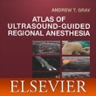  Atlas of Ultrasound Anesthesia | Reference texts/journals, training and education | Regional anesthesia | In depth teaching of ultrasound guided regional anesthesia techniques | Free  In-app purchases $64.99 - $129.99 | https://play.google.com/store/apps/details?id=com. mobisystems. msdict.embedded.wireless.elsevier.augra
Anaesthesiology -Paediatric & Clinical  Anaesthesiology | Reference texts/journals | General anesthesia  Paediatric setting  Surgical specialty  Regional anesthesia  Pain medicine | Textbook | Free | https://play.google.com/store/apps/details?id=com. andromo.dev658544.app945759
BLOCKJOCKS  Regional Anesthesia | Reference texts/journals, training and education | Regional anesthesia | Regional anesthesia educational resource | Free  In-app purchase $19.99 - $169.99. | https://apps.apple.com/us/app/blockjocks/id1232060664
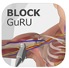  Block GuRU Lite | Reference texts/journals, training and education | Regional anesthesia | Regional anesthesia educational resource | $9.99 | https://apps.apple.com/us/app/block-guru-lite/id829739487
App name | App type | Clinical Area | Description | Cost | URL
Case Files Anaesthesiology | Reference texts/journals, training and education | General anesthesia  Surgical specialty  Regional anesthesia  Pain medicine | Case-based learning, with exam-based questions | Free  In-app purchase $29.99 | https://apps.apple.com/us/app/case-files-anesthesiology-1e/id461592758
Echocardiography pocketcards | Reference texts/journals, training and education | Pre-operative | Flashcard based education | $3.99 | https://apps.apple.com/us/app/echocardiography-pocketcards/id359676863
Read by QxMD | Reference texts/ journals, training and education | Multiple | Access to up-to-date and new journal articles, can be filtered to fit specific interests | Free | https://apps.apple.com/us/app/read-by-qxmd/id574041839
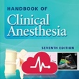  Handbook of Clinical Anesthesia | Reference texts/journals, training and education  Drug references, medication management  Medical calculators | Pre-operative  General anesthesia  Surgical specialty  Regional anesthesia | Provides comprehensive guidelines, recommendations, information for practicing anaesthetists | Free  In-app purchases $52.99 - 104.99 | https://play.google.com/store/apps/details?id=com.medpresso. Lonestar.clinanes
Anesthesia by Dr. Swati Singh | Reference texts/journals, training and education | Pre-operative  General anesthesia  Surgical specialty  Regional anesthesia | Study tool for anesthetics topics | Free | https://play.google.com/store/apps/details?id=com.prepladder.anesthesia
Morgan & Mikhail's Clinical Anaesthesiology Flashcards | Reference texts/journals, training and education | General anesthesia  Surgical specialty  Regional anesthesia | Flashcard based learning focusing on anesthetics core knowledge | Free  In-app purchase $44.99 | https://apps.apple.com/us/app/morgan-mikhails-clinical-anesthesiology-flashcards/id916009564
App name | App type | Clinical Area | Description | Cost | URL
Communication
AIRS mobile app | Communication | General anesthesia | Online patient safety reporting system | Free | https://qualityportal.aqihq.org/AIRSMain/AIRSCaseEntry
Electronic Medical Record
Powerchart Touch | Electronic medical record | General anesthesia | Mobile access to patient notes, pathology results, clinical photography for users within Cerner network | Free (with eligible Cerner systems) | https://www.cerner.com/solutions/powerchart-touch
TIVA: Total intravenous anesthesia.

Figure S2. Worked Example
“I am a predominantly adult anaesthetist but work in a rural/ regional centre and must occasionally anaesthetise children. I am not the most technologically literate but use an iPhone.”

- Identify needs
I have considered aspects of my practice that would be augmented by technology, and have decided Paediatric dose calculations are something I frequently double check, and would be improved with an app.
- Research available apps
I have discussed with paediatric anaesthetic colleagues, registrars and collated a list of potential apps, as well as used the Google Search engine and Apple App store to identify further options.

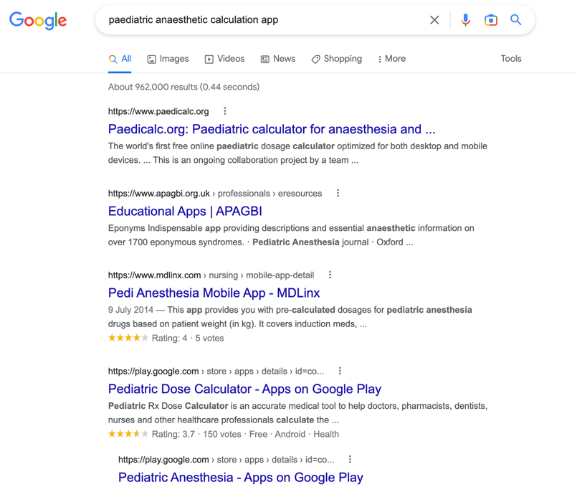
Additionally, I have looked up the most promising apps in journals and websites such as iMedical Apps, and looked at reviews.
- Trial app in a non-clinical setting
From the searches and reviews above, I have narrowed the choice down to around 3 potential apps, and downloaded these onto my phone. Using the provided Table 1, it looks as though app functionality and cost will be my two main criteria. Evaluating the provided apps using Table 1, there is one app I think will be most suited to my needs.
- Preliminary selection
After conferring with colleagues and reading reviews more carefully for the selected app, I agree that this app is one I will trial.
- Use in clinical practice
I will use the app in theatre, noting the aspects of my work it improves, and areas where the app perhaps falls short.
- Re-evaluate the app
After a period (I will select a month), I will take out some concious time and evaluate the app, and evaluate using the rubric in Table 1 whether I will continue to use the app.

