SUPLEMENTARY MATERIAL:

Picture 1: Image showing the position of the ultrasound probe at the cranial right injection point. The foal was position in dorsal recumbency, and the needle was inserted in a medio-lateral direction with an in plane technique.

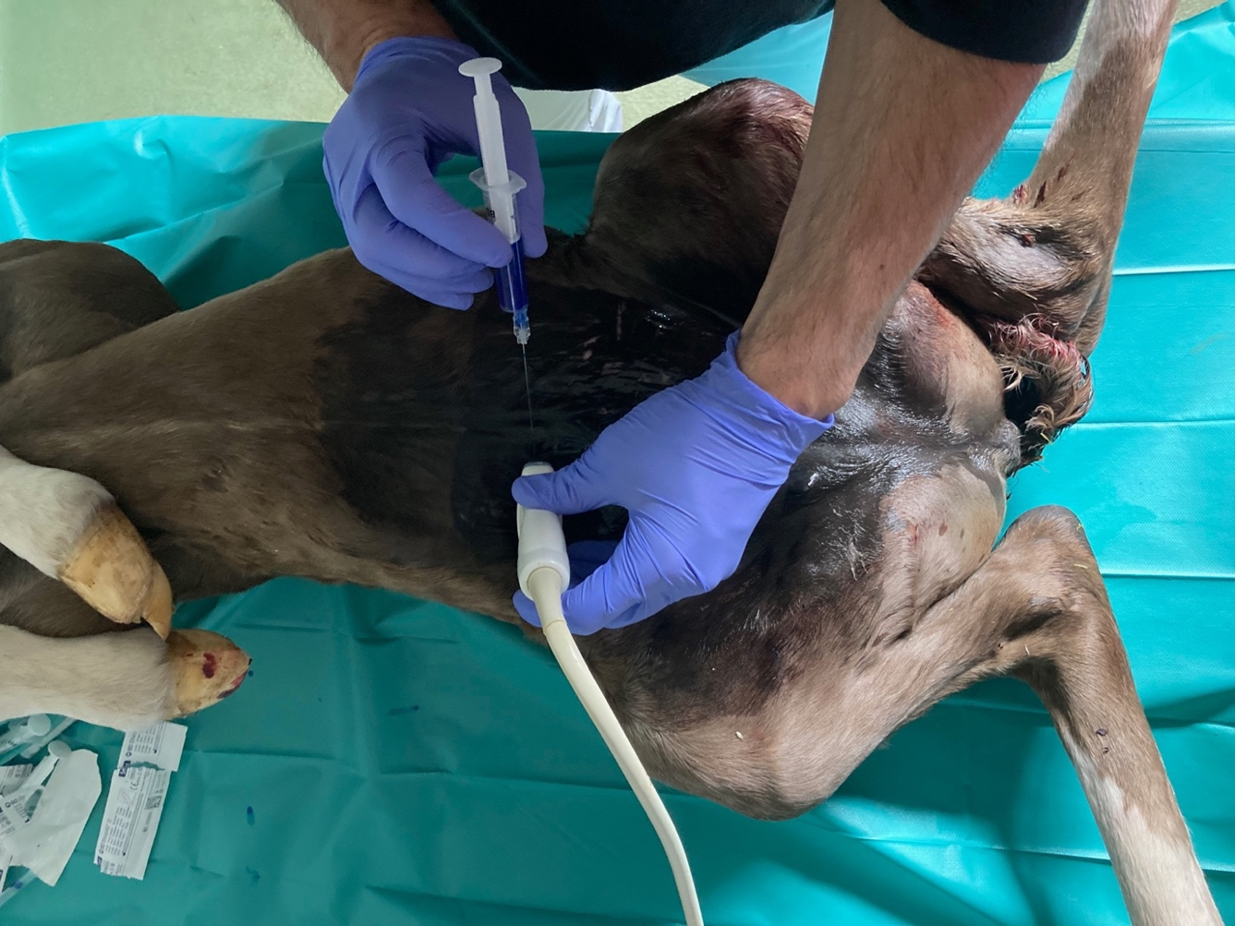

Picture 2: Image showing the needle as it passed through the rectus abdominis muscle and created a pocket by hydro dissection between this muscle and the aponeurosis of the transversus abdominis muscle and peritoneum (double line).

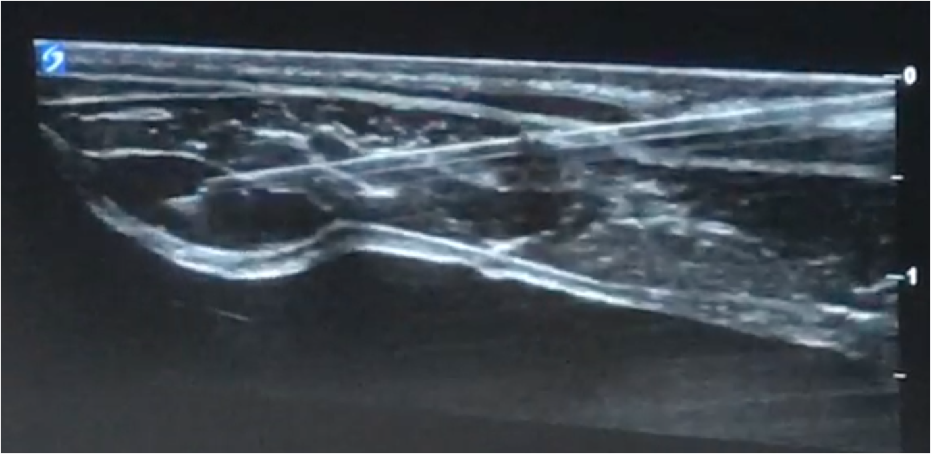
Picture 3: Image showing the dissection of the abdominal wall of a foal. The ventral branches of the spinal nerves are identified, running over the surface of the transversus abdominis muscle and piercing the rectus abdominis muscle in the most ventral aspect.

