Supplementary Material
Supplementary Table 1. Number of marker values used at each of the time points from the 314 participants
 | Vaccination schedule times
Response | T1ª | T2^{b} | T3^{c} | T4^{d}
nAbs WD614G  Overall  LCD4  ICD4  HCD4 | 172  35  59  78 | 314  56  120  138 | 195  40  80  75 | 135  27  60  48
nAbs Omicron BA.1  Overall  LCD4  ICD4  HCD4 | 79  25  30  24 | 103  33  37  33 | 103  34  36  33 | 80  25  31  24
IFN-gamma  Overall  LCD4  ICD4  HCD4 | 130  27  39  64 | 299  53  116  130 | 188  41  76  71 | 108  24  42  42

- One month after II dose
- Pre III dose
- Two weeks after III dose
- Six months after III dose or before IV dose

Supplementary Figure 1A.
Adjusted absolute mean Omicron BA.1 nAbs values over T1-T4 from fitting a mixed linear model (left panel) and box-plots (right panel) of the raw data by CD4 count groups. Y-axis reports nAbs values expressed in Log₂ (cut off 5.32 log₂);X-axis T1-T4 timepoints . The timepoints are: T1: 2 months after PVC , T2: 4 months after PVC , T3: 2 weeks after 3rd dose , T4: 5 months after 3rd dose.

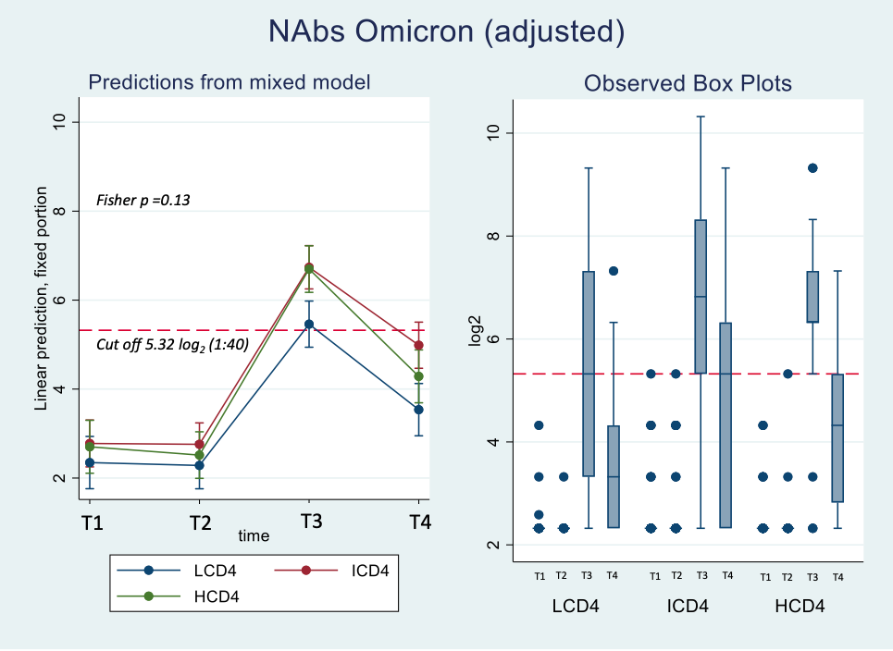

Supplementary Table 2A. Adjusted absolute mean Omicron BA.1 nAbs values over T1-T4 from fitting a mixed linear model (left panel) and mean differences (right panel) by CD4 count groups.
 | Adjusted means |  |  |  | Adjusted difference in means
Response
 | T1  95% CI | T2  95% CI | T3  95% CI | T4  95% CI | T1  95% CI | T2  95% CI | T3  95% CI  p-value | T4  95% CI  p-value | p-value*
NAbs Omicron
CD4 group |  |  |  |  |  |  |  |  | 0.125
HCD4 | 2.7 (2.1, 3.3) | 2.5 (2.0, 3.0) | 6.7 (6.2, 7.2) | 4.3 (3.7, 4.8) | 0 | 0 | 0 | 0
ICD4 | 2.8 (2.2, 3.3) | 2.7 (2.3, 3.2) | 6.8 (6.3, 7.2) | 5.0 (4.5, 5.5) | 0.0 (-0.7, 0.8) | 0.2 (-0.5, 0.9) | 0.1 (-0.7, 0.8) | 0.7 (-0.1, 1.5)
 |  |  |  |  | 0.918 | 0.540 | 0.888 | 0.076
LCD4 | 2.4 (1.8, 2.9) | 2.3 (1.8, 2.8) | 5.5 (4.9, 6.0) | 3.5 (2.9, 4.1) | -0.4 (-1.2, 0.5) | -0.2 (-1.0, 0.5) | -1.2 (-2.0, -0.5) | -0.7 (-1.6, 0.1)
 |  |  |  |  | 0.399 | 0.551 | 0.001 | 0.093
*F-test type 3 interaction p-value
&Adjusted for gender age and CD4 count nadir

Supplementary Table 2B. Adjusted mean changes from T2 in Omicron BA.1 nAbs values over T1-T4 from fitting a mixed linear model (left panel) and mean differences (right panel) by CD4 count groups.
 | Adjusted& mean changes from T2$ |  |  |  | Adjusted& difference in mean changes from T2$
Response
 | T1  95% CI | T2  95% CI | T3  95% CI | T4  95% CI | T1  95% CI  p-value | T3  95% CI  p-value | T4  95% CI  p-value | p-value*
NAbs Omicron
CD4 group |  |  |  |  |  |  |  | 0.162
HCD4 | 0.4 (-0.2, 0.9) | REF | 4.3 (3.8, 4.8) | 1.9 (1.4, 2.5) | 0 | 0 | 0
ICD4 | 0.1 (-0.4, 0.6) | REF | 4.0 (3.5, 4.5) | 2.1 (1.6, 2.6) | -0.3 (-1.1, 0.4) | -0.3 (-1.0, 0.4) | 0.2 (-0.5, 1.0)
 |  |  |  |  | 0.395 | 0.401 | 0.576
LCD4 | -0.1 (-0.6, 0.5) | REF | 3.1 (2.6, 3.6) | 1.2 (0.6, 1.7) | -0.4 (-1.3, 0.4) | -1.2 (-1.9, -0.5) | -0.8 (-1.6, 0.0)
 |  |  |  |  | 0.276 | <.001 | 0.063
$One month after 3rd vaccine dose
*F-test type 3 interaction p-value
&Adjusted for gender age and CD4 count nadir

