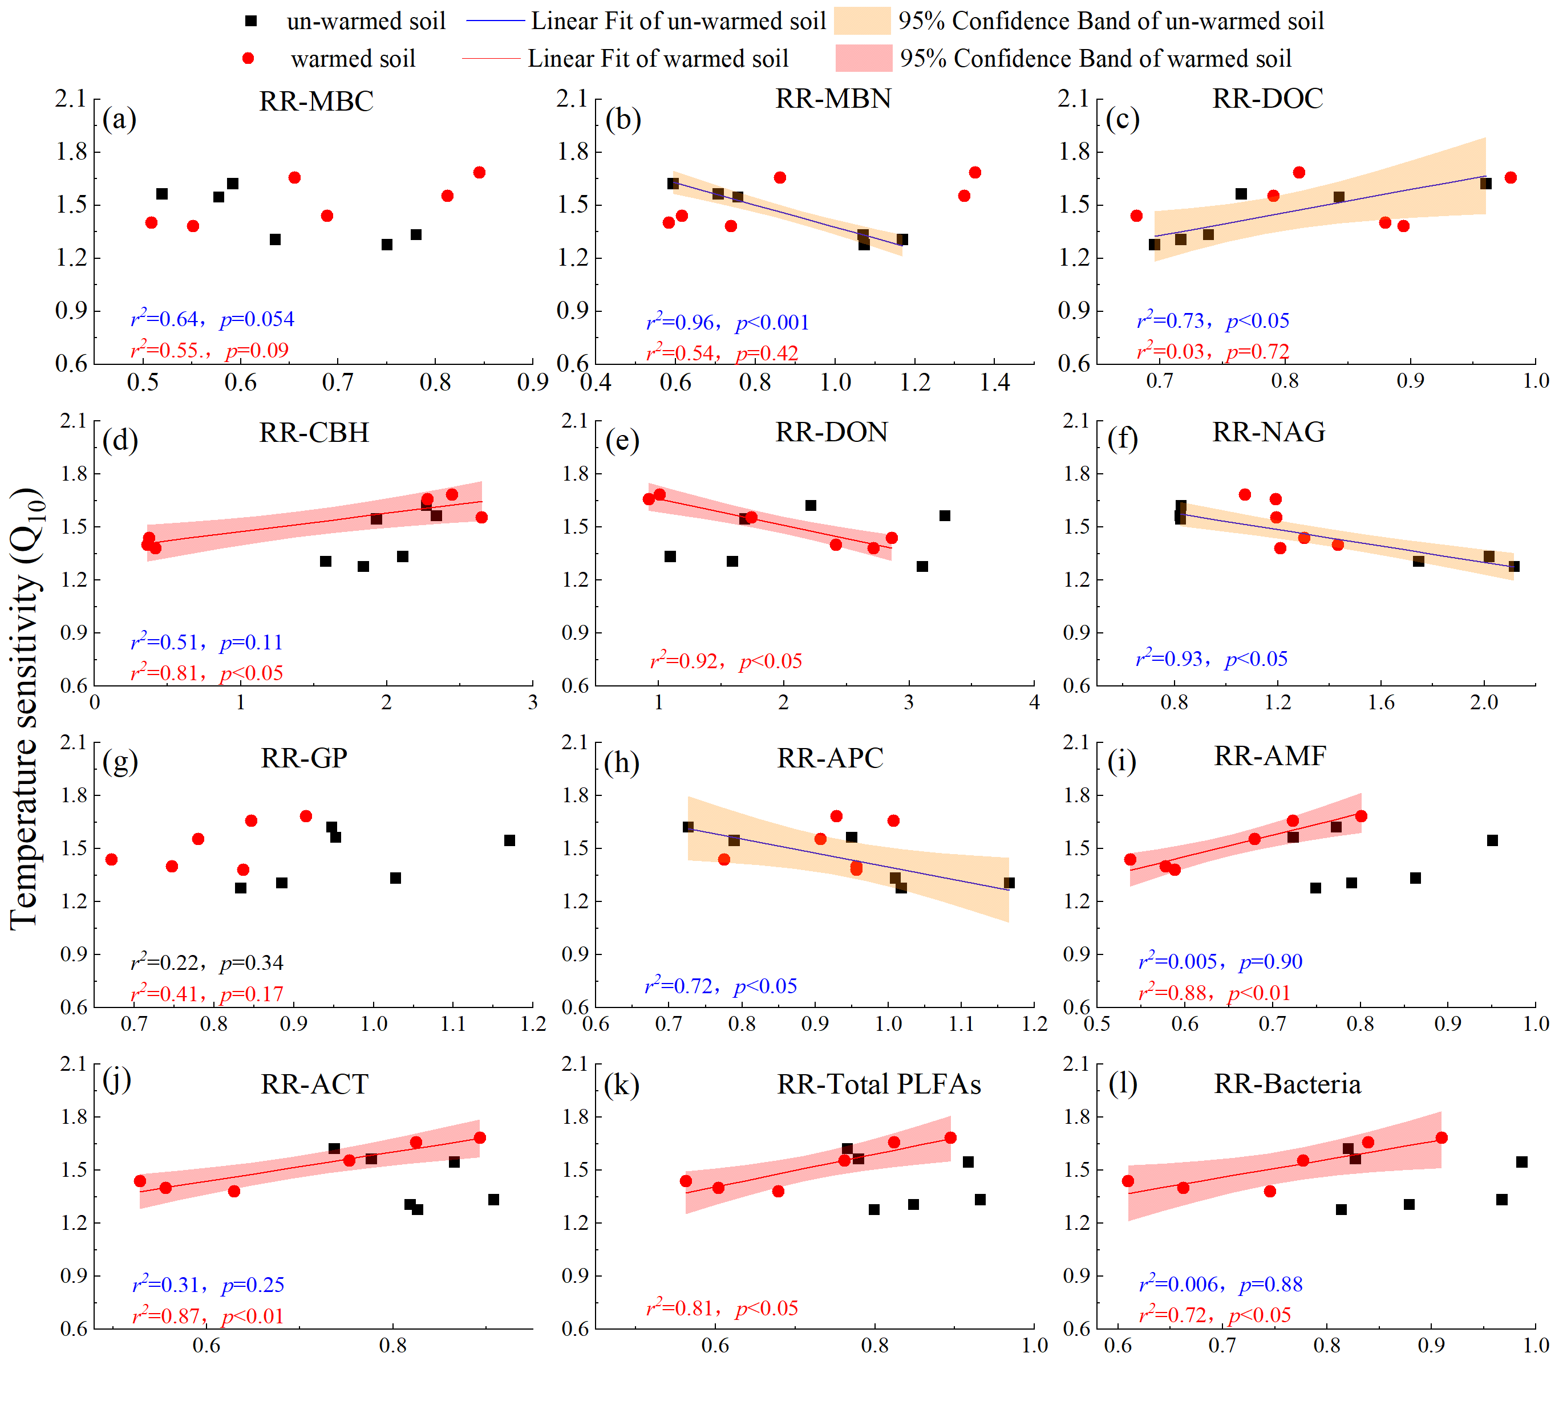
Fig. S1. Relationships between temperature sensitivity (Q₁₀) over two temperature ranges (20-30 ℃ (QT20) and 30-40 ℃ (QT30)) and the response ratios (RRs) of MBC (a), MBN (b), DOC (c), CBH (d), DON (e), NAG (f), GP (g), APC (h), AMF(i), ACT (j), Total PLFAs (k) and Bacteria (l). Black square and red point represent correlations in un-warmed and warmed soil, respectively. Blue and red lines represent relationships in un-warmed soil and warmed soil, respectively. Orange and red ranges represent 95% confidence interval in un-warmed soil and warmed soil, respectively.

