Supporting Information
Aminocyclopropenium as a new class of hydrogen bonding catalyst in Friedel–Crafts alkylation
Xuesuo Maª, Jiaxi Xu^{b}, Jingjing Liu^{b}, Jun He^{b}, Tong Chang^{b}, Qingbiao Yang^{b}, Ning Li^{b}, Dong Qian^{b} and Zhenjiang Li^{b,*}
ª Hangzhou Seemore New Material Technology Co., Ltd. 1589 Xinggang Road, Hangzhou 311300, China
^{b} State Key Laboratory Materials-Oriented Chemical Engineering, College of Biotechnology and Pharmaceutical Engineering, Nanjing Tech University, 30 Puzhu Road South, Nanjing 211816, China
*Corresponding Author
E-mail: zjli@njtech.edu.cn (Zhenjiang Li)

Table of Contents
General Information 2
Characterization Data 2
NMR Spectra of Compounds 5
X-ray crystal structure of TPAC·Cl 14

General Information
Organic solutions were concentrated using Buchi rotary evaporator or IKA rotary evaporator. ¹H NMR spectra were recorded on a Bruker-AV-400 (400 MHz) at ambient temperature, using the chemical shift of a residual protic solvent (CHCl₃ at 7.26 ppm or DMSO at 2.50 ppm) as an internal reference. ¹³C NMR spectra were recorded on a Bruker AV-400 (100 MHz) using the central resonance of the triplet of CHCl₃ at δ 77.16 ppm or DMSO at δ 39.52 ppm as an internal reference.
All operations were performed using standard Schlenk techniques with an argon atmosphere to reduce exposure to water. Dichloromethane was distilled over CaH₂ under an argon atmosphere, and further dried over 3 Å molecular sieve pellets for 48 h before use. Benzene was purified by refluxing on sodium under an argon atmosphere, and further dried over 3 Å molecular sieve pellets for 48 h before use.

Characterization Data
3-(2-Nitro-1-phenylethyl)-1H-indole 3aa
A colorless oil was obtained after purification by flash column chromatography (n-hexane-EtOAc, 10:1): 0.21 g, 78 % yield; ¹H NMR (400 MHz, CDCl₃) δ 8.02 (brs, 1H), 7.37(d, J = 8.0 Hz, 1H), 7.29-7.18 (m, 6H), 7.12 (m, 1H), 7.02 – 6.95 (m, 2H), 5.12 (t, J = 7.9 Hz, 1H), 4.99 (dd, J = 12.5, 7.6 Hz, 1H), 4.89 (dd, J = 12.5, 8.4 Hz, 1H); ¹³C NMR (100 MHz, CDCl₃) δ 139.3, 136.6, 129.0, 127.9,127.7, 126.2, 122.8, 121.7, 120.0, 119.0, 114.5, 111.5, 79.6, 41.7; HRMS (ESI-TOF) m/z: [M + H]⁺ calcd for C₁₆H₁₄N₂O₂H 267.1128; Found 267.1127.
2-Methyl-3-(2-nitro-1-phenylethyl)-1H-indole 3ba
A colorless oil was obtained after purification by flash column chromatography (n-hexane-EtOAc, 9:1): 0.24 g, 86 % yield; ¹H NMR (400 MHz, CDCl₃) δ 7.80 (brs, 1H), 7.32 (d, J = 7.9 Hz, 1H), 7.29 – 7.16 (m, 6H), 7.08 – 7.04 (m, 1H), 6.99 – 6.96 (m, 1H), 5.20 – 5.12 (m, 2H), 5.10 – 5.04 (m, 1H), 2.34 (s, 3H). ¹³C NMR (100 MHz, CDCl₃) δ 139.6, 135.3, 132.9, 128.9, 127.4, 127.2, 127.0, 121.5, 119.9, 118.7, 110.8, 109.0, 78.8, 40.6, 12.2; HRMS (ESI-TOF) m/z: [M + H]⁺ calcd for C₁₇H₁₆N₂O₂H 281.1285; Found 281.1274.
5-Methoxy-3-(2-nitro-1-phenylethyl)-1H-indole 3ca
A white solid was obtained after purification by flash column chromatography (n-hexane-EtOAc, 9:1): 0.26 g, 88 % yield; m.p. 138.2 – 140.1 °C; ¹H NMR (400 MHz, CDCl₃) δ 7.92 (brs, 1H), 7.27 – 7.15 (m, 6H), 6.92-6.91 (m, 1H), 6.79 – 6.76 (m, 2H), 5.06 (t, J = 7.9 Hz, 1H), 4.97 (dd, J = 12.4, 7.5 Hz, 1H), 4.86 (dd, J = 12.4, 8.4 Hz, 1H), 3.69 (s, 3H); ¹³C NMR (100 MHz, CDCl₃) δ 154.3, 139.3, 131.7, 129.1, 127.9, 127.7, 126.7, 122.4, 114.3, 112.9, 112.2, 101.0, 79.6, 56.0, 41.7; HRMS (ESI-TOF) m/z: [M + H]⁺ calcd for C₁₇H₁₆N₂O₃H 297.1234; Found 297.1267.
5-Chloro-3-(2-nitro-1-phenylethyl)-1H-indole 3da
A colorless oil was obtained after purification by flash column chromatography (n-hexane-EtOAc, 9:1): 0.16 g, 52% yield; ¹H NMR (400 MHz, CDCl₃) δ 8.08 (brs, 1H), 7.32 (d, J = 1.6 Hz, 1H), 7.30 – 7.19 (m, 6H), 7.08 (dd, J = 8.6, 1.9 Hz, 1H), 7.03 (d, J = 2.1 Hz, 1H), 5.07 (t, J = 8.0 Hz, 1H), 4.99 – 4.94 (m, 1H), 4.89 – 4.84 (m, 1H); ¹³C NMR (100 MHz, CDCl₃) δ 138.9, 135.0, 129.2, 127.9, 127.8, 127.4, 125.9, 123.3, 123.0, 118.6, 114.3, 112.5, 79.5, 41.5; HRMS (ESI-TOF) m/z: [M + H]⁺ calcd for C₁₆H₁₃ClN₂O₂H 301.0738; Found 301.0765.
7-Methyl-3-(2-nitro-1-phenylethyl)-1H-indole 3ea
A colorless oil was obtained after purification by flash column chromatography (n-hexane-EtOAc, 9:1): 0.16 g, 57 % yield; ¹H NMR (400 MHz, CDCl₃) δ 7.92 (brs, 1H), 7.28 – 7.17 (m, 6H), 6.96 – 6.93 (m, 3H), 5.13-5,09 (m, 1H), 4.99 (dd, J = 12.5, 7.6 Hz, 1H), 4.87 (dd, J = 12.5, 8.3 Hz, 1H), 2.38 (s, 3H); ¹³C NMR (100 MHz, CDCl₃) δ 139.4, 136.2, 129.0, 127.9, 127.6, 125.8, 123.3, 121.4, 120.7, 120.3, 116.8, 115.0, 79.7, 41.8, 16.6; HRMS (ESI-TOF) m/z: [M + H]⁺ calcd for C₁₇H₁₆N₂O₂H 281.1285; Found 281.1276.
3-(2-nitro-1-(p-tolyl)ethyl)-1H-indole 3ab
A colorless oil was obtained after purification by flash column chromatography (n-hexane-EtOAc, 9:1): 0.09 g, 33 % yield; ¹H NMR (400 MHz, CDCl₃) δ 8.09 (brs, 1H), 7.51 (dd, J = 8.0, 1.0 Hz, 1H), 7.39 – 7.37 (m, 1H), 7.29 – 7.22 (m, 3H), 7.18 – 7.11 (m, 3H), 7.04 (m, 1H), 5.20 (t, J = 8.0 Hz, 1H), 5.09 (dd, J = 12.4, 7.6 Hz, 1H), 4.96 (dd, J = 12.4, 8.4 Hz, 1H), 2.36 (s, 3H); ¹³C NMR (100 MHz, CDCl₃) δ 137.3, 136.6, 136.3, 129.7, 127.7, 126.2, 122.8, 121.7, 120.0, 119.1, 114.7, 111.5, 79.8, 41.3, 21.2; HRMS (ESI-TOF) m/z: [M + H]⁺ calcd for C₁₇H₁₆N₂O₂H 281.1285; Found 281.1274.
3-(1-(4-methoxyphenyl)-2-nitroethyl)-1H-indole 3ac
A white solid was obtained after purification by flash column chromatography (n-hexane-EtOAc, 9:1): 0.16 g, 55 % yield; m.p. 148.2 – 150.1 ºC; ¹H NMR (400 MHz, CDCl₃) δ 8.08 (brs, 1H), 7.44 (dd, J = 7.9, 1.1 Hz, 1H), 7.36 (dt, J = 8.2, 1.0 Hz, 1H), 7.26 – 7.18 (m, 3H), 7.10 – 7.02 (m, 2H), 6.86 – 6.84 (m, 1H), 5.14 (t, J = 8.0 Hz, 1H), 5.05 (dd, J = 12.2, 7.5 Hz, 1H), 4.90 (dd, J = 12.2, 8.4 Hz, 1H), 3.78 (s, 3H); ¹³C NMR (100 MHz, CDCl₃) δ 159.1, 136.7, 131.3, 129.0, 126.3, 122.8, 121.6, 120.1, 119.2, 115.0, 114.4, 111.5, 79.9, 55.4, 41.0; HRMS (ESI-TOF) m/z: [M + H]⁺ calcd for C₁₇H₁₆N₂O₃H 297.1234; Found 297.1267.
3-(2-Nitro-1-thiophen-2-yl-ethyl)-1H-indole 3ad
A colorless oil was obtained after purification by flash column chromatography (n-hexane-EtOAc, 9:1): 0.19 g, 71 % yield; ¹H NMR (400 MHz, CDCl₃) δ 8.14 (br s, 1H), 7.61 – 7.59 (m, 1H), 7.41-7.39 (m, 1H), 7.32 – 7.18 (m, 3H), 7.09 – 7.00 (m, 3H), 5.53 (t, J = 7.9 Hz, 1H), 5.12-5.02 (m, 2H); ¹³C NMR (100 MHz, CDCl₃) δ 143.1, 136.5, 127.1, 125.8, 125.4, 125.0, 122.9, 122.1, 120.2, 118.9, 114.2, 111.6, 80.1, 37.1; HRMS (ESI-TOF) m/z: [M + H]⁺ calcd for C₁₄H₁₂N₂O₂SH 273.0692; Found 273.0645.

NMR Spectra of Compounds
Copies of NMR spectra of catalysts
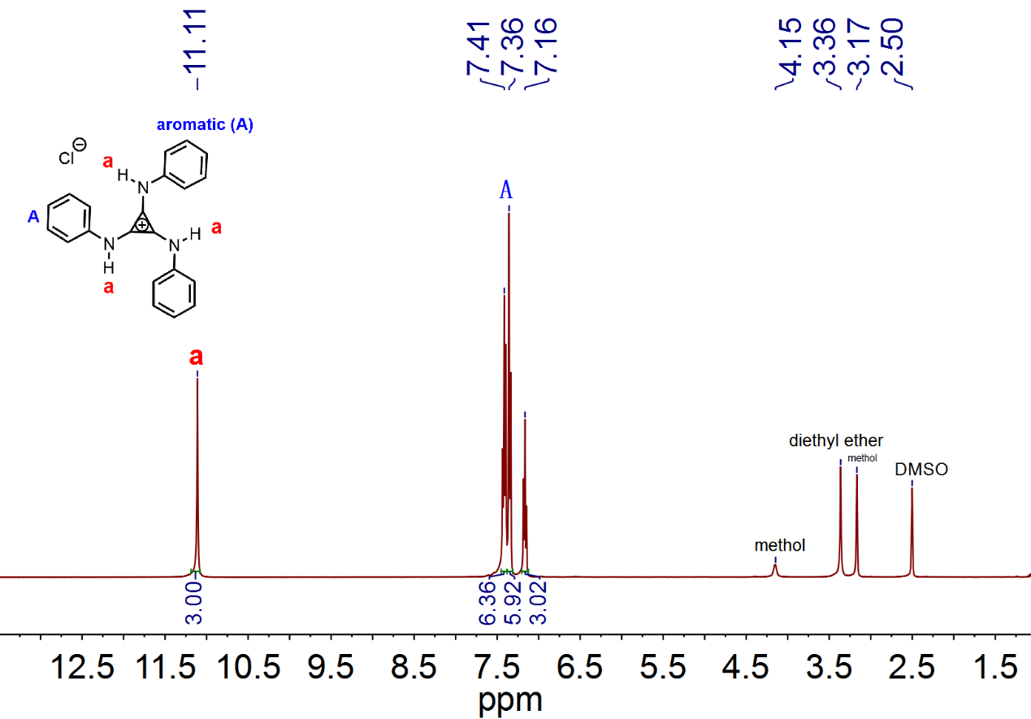¹H NMR Spectrum of Compound TPAC·Cl

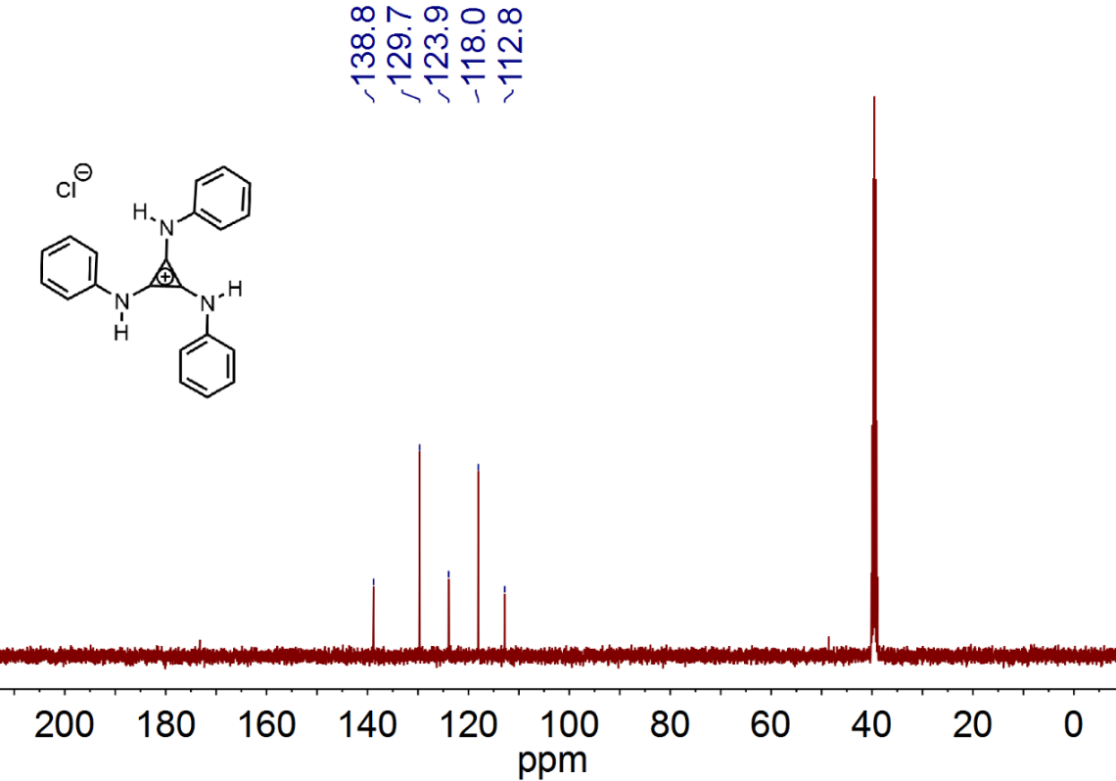
¹³C NMR Spectrum of Compound TPAC·Cl
Copies of NMR spectra of products
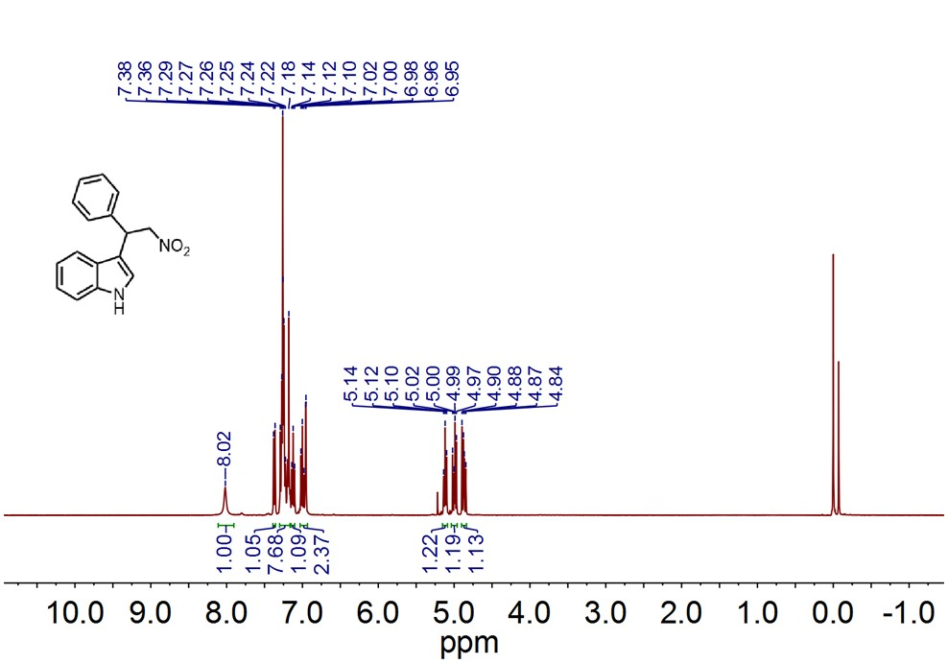
¹H NMR Spectrum of Compound 3aa

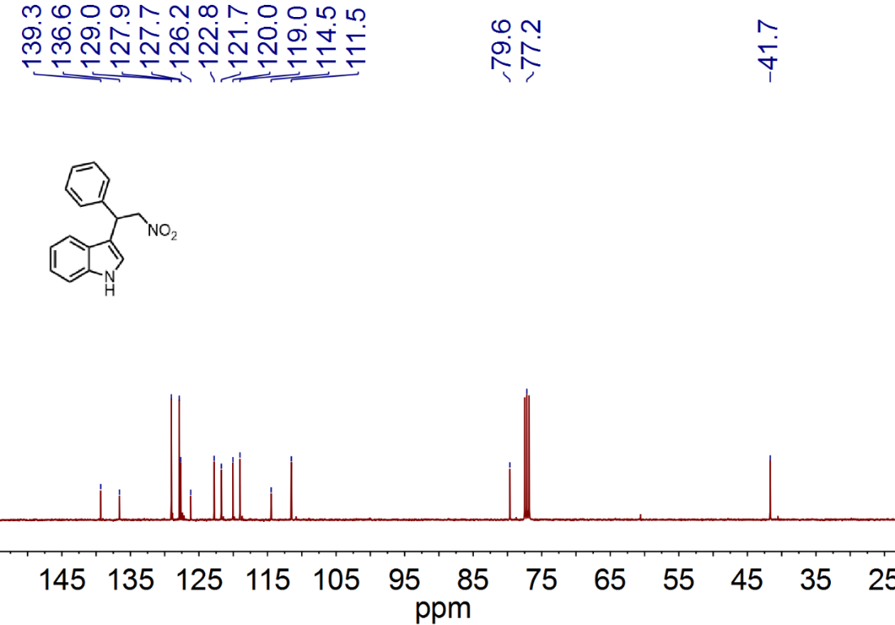
¹³C NMR Spectrum of Compound 3aa

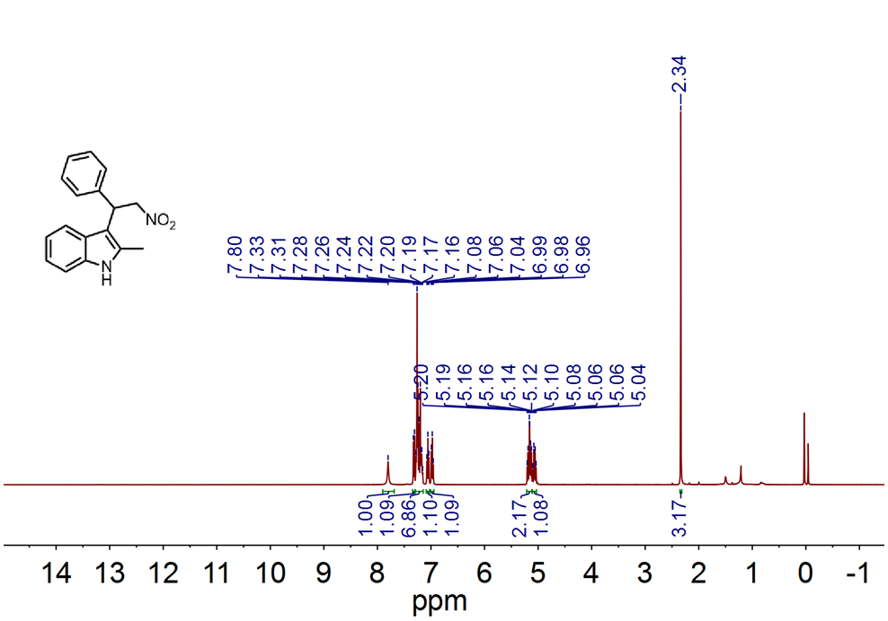
¹H NMR Spectrum of Compound 3ba

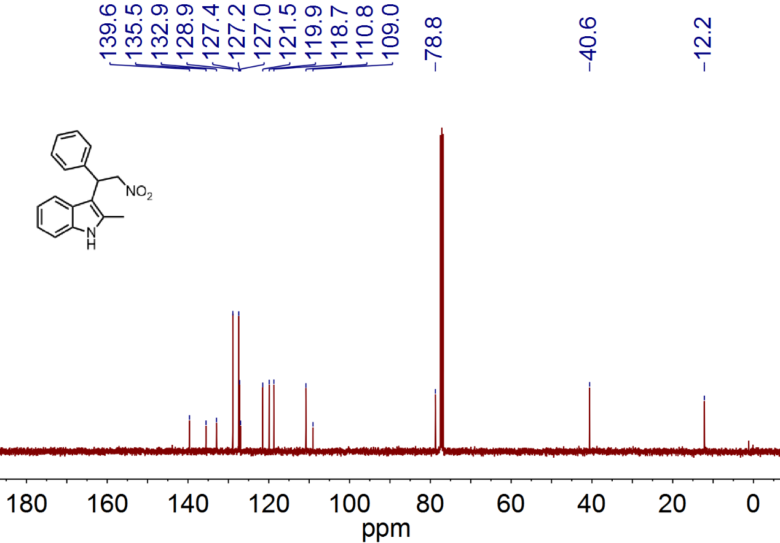
¹³C NMR Spectrum of Compound 3ba
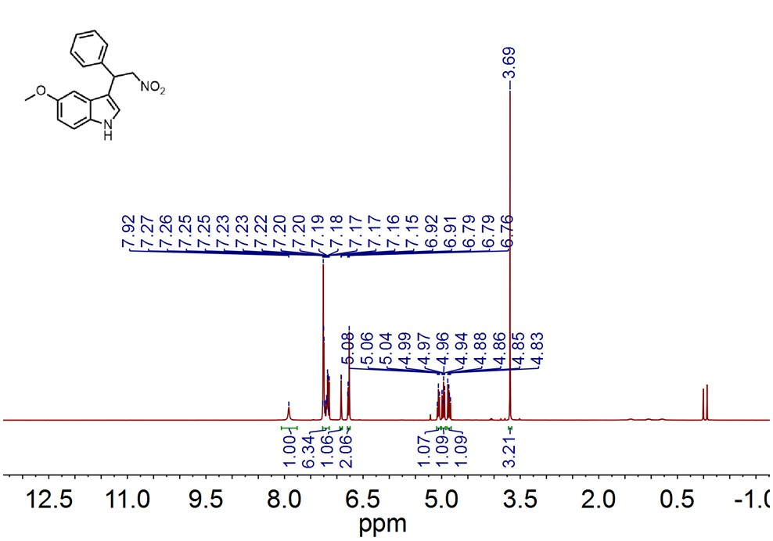
¹H NMR Spectrum of Compound 3ca

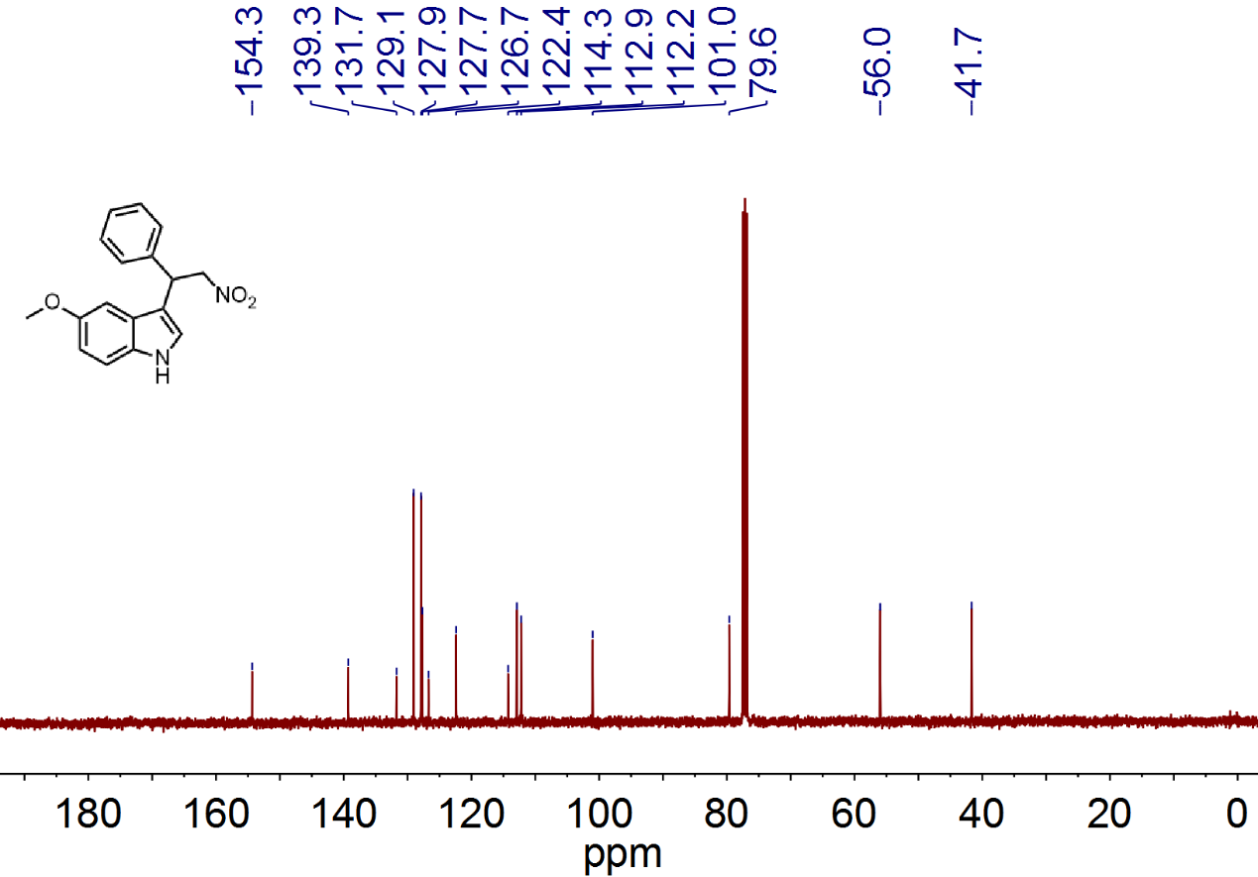
¹³C NMR Spectrum of Compound 3ca
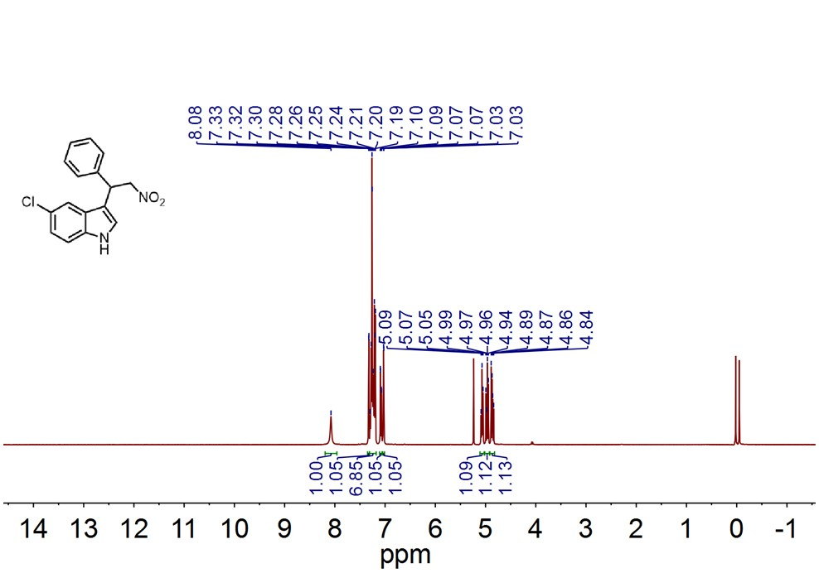
¹H NMR Spectrum of Compound 3da
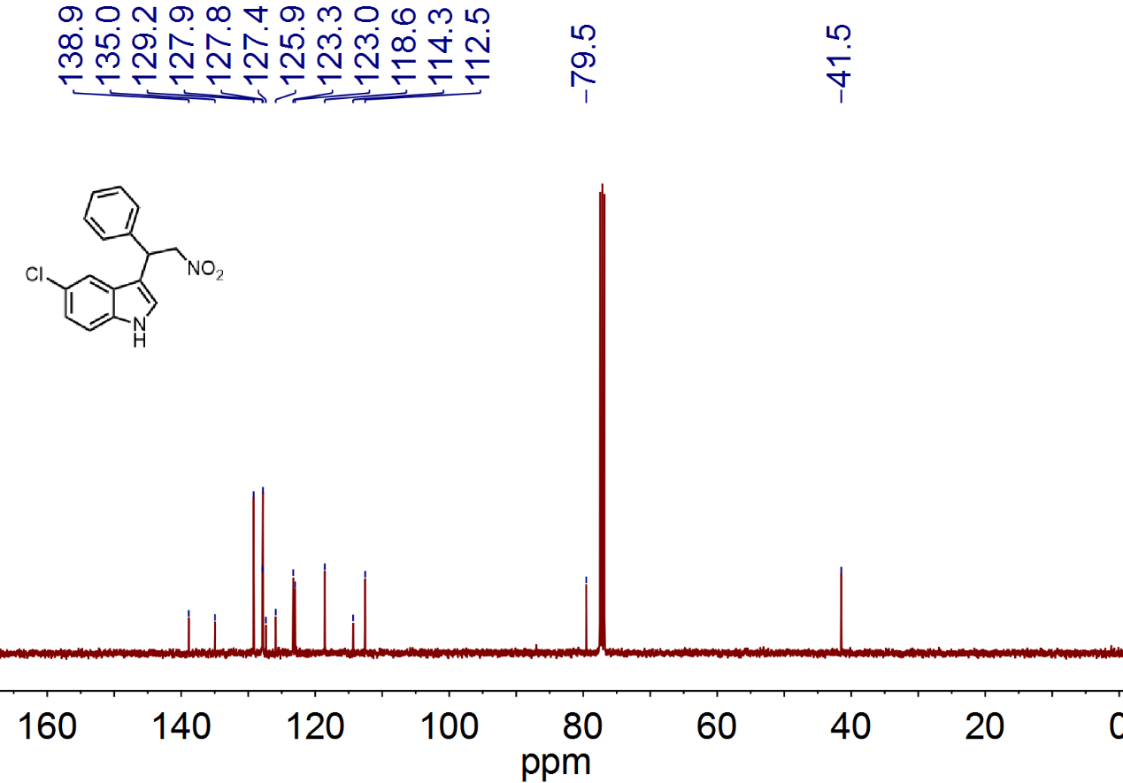
¹³C NMR Spectrum of Compound 3da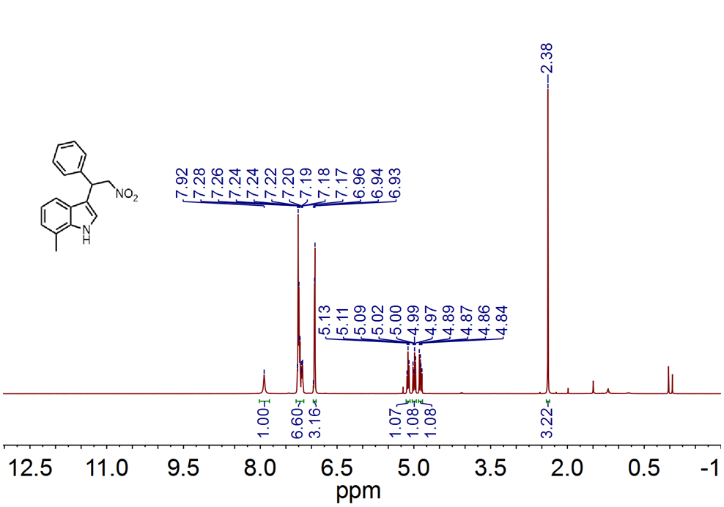
¹H NMR Spectrum of Compound 3ea
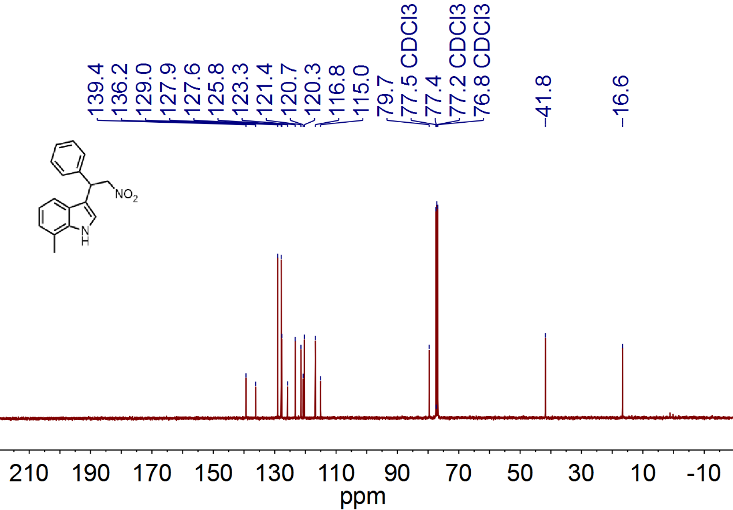
¹³C NMR Spectrum of Compound 3ea
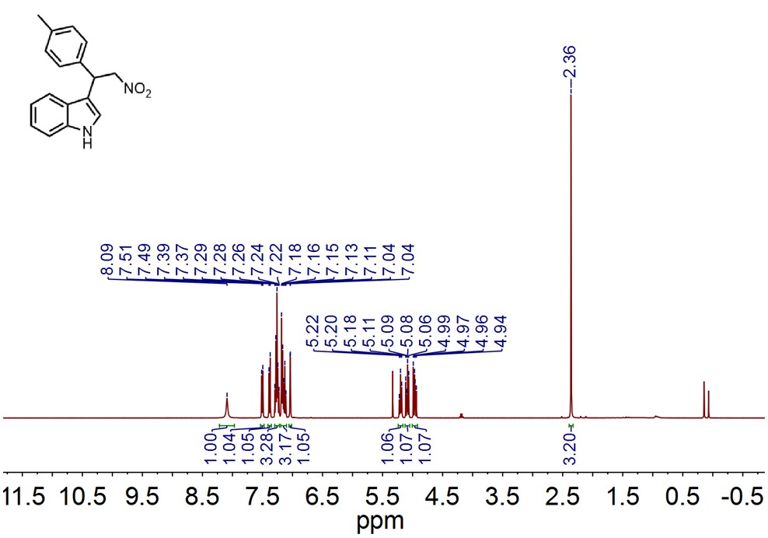
¹H NMR Spectrum of Compound 3ab

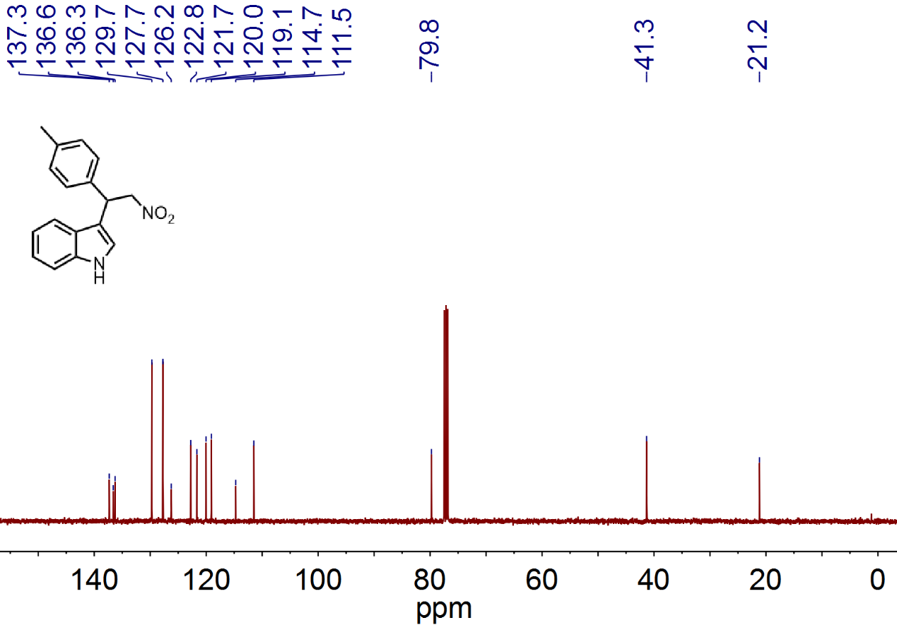
¹³C NMR Spectrum of Compound 3ab
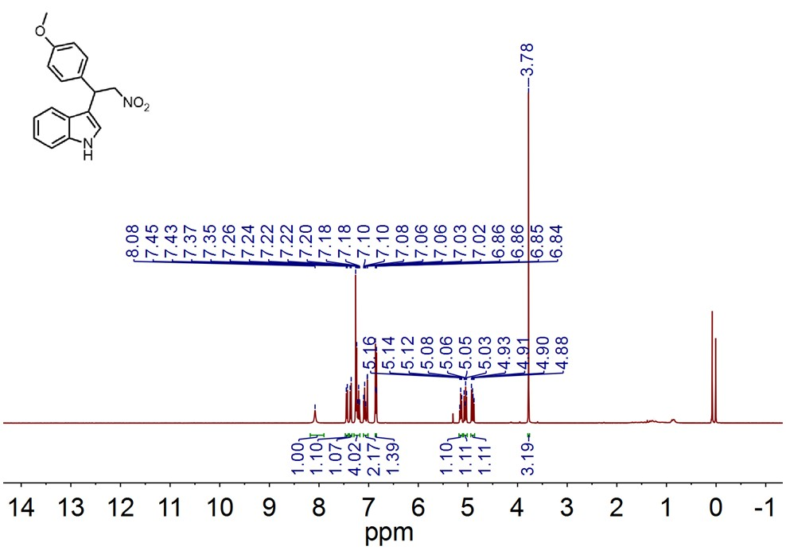
¹H NMR Spectrum of Compound 3ac

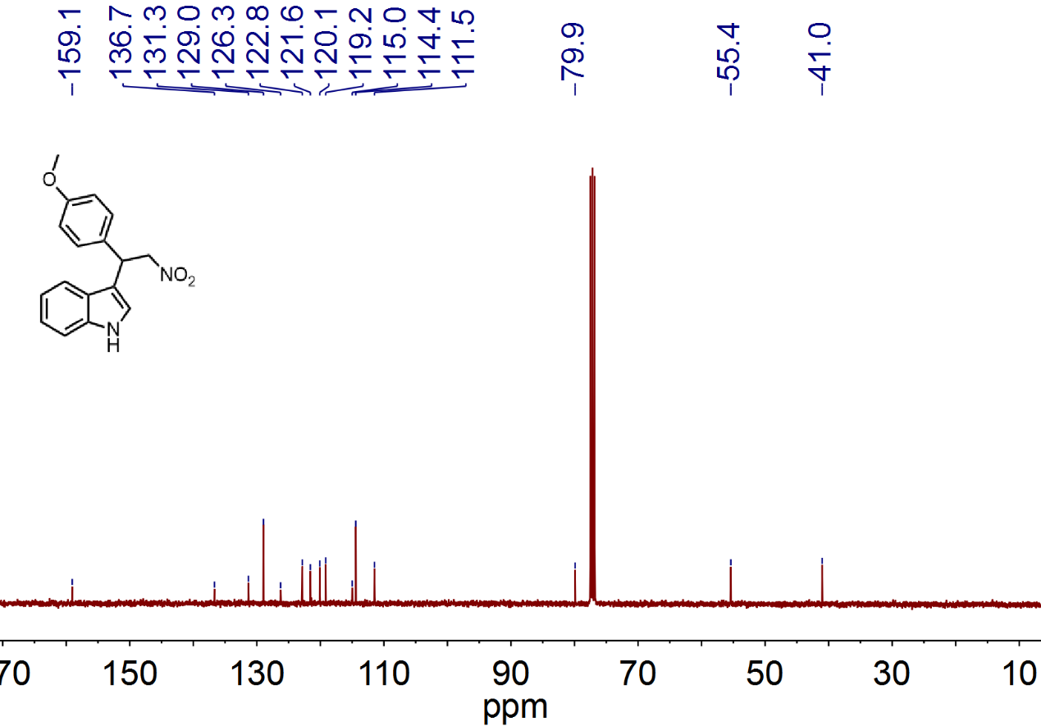
¹³C NMR Spectrum of Compound 3ac
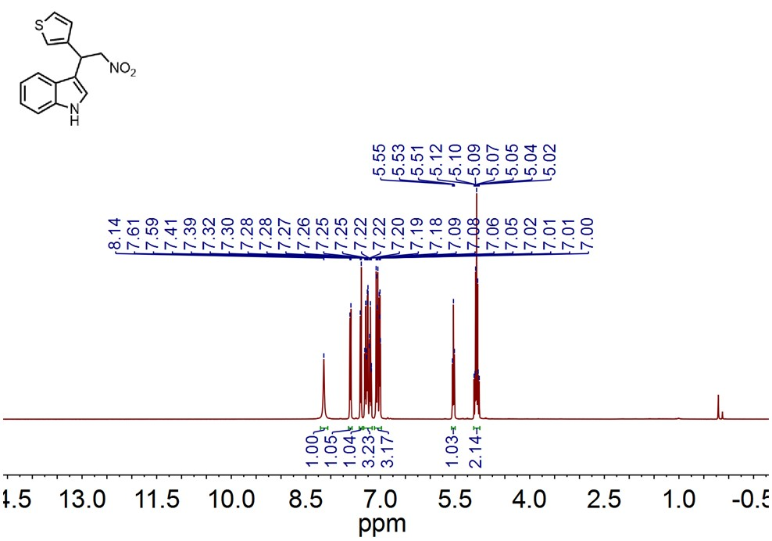
¹H NMR Spectrum of Compound 3ad
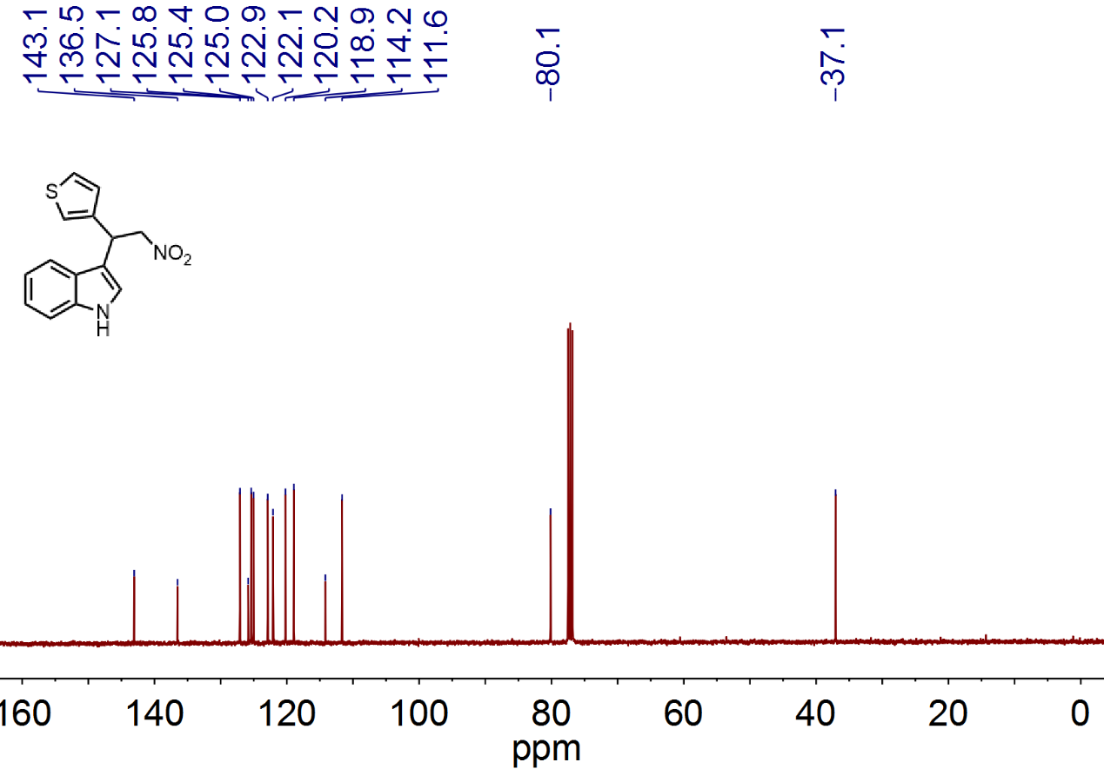
¹³C NMR Spectrum of Compound 3ac

X-ray crystal structure of TPAC·Cl
Table 1. Crystal data and structure refinement for TPAC·Cl
complex | 1
Formula | C21H18ClN3
Formula weight | 347.83
Crystal system | Cubic
space group | P213
a (Å) | 13.484(8)
b (Å) | 13.484(8)
c (Å) | 13.484(8)
α (º) | 90
β (º) | 90
γ (º) | 90
Volume(Å³) | 2451.6(4)
Z | 4
T (K) | 296(2)
D_{calcd} (g/m³) | 1.573
F(000) | 728
Reflections collected | 2045
Unique reflections | 1846
Goof | 1.140
R₁[I> 2σ(I)] | 0.1082
wR₂[I>2σ(I)]  CCDC NO. | 0.3079ª  1509942
ª w =1/[σ²(F₀)²+(0.1820P)² +3.4136P], where P = (F₀² + 2F_{c}²)/3;

