Supplementary information
Effect of terminal substituents of 2-aminobenzimidazoles on non-covalent molecular interactions in their transition metal coordination compounds. Evaluation of their biological activity.
David Colorado-Solís¹, Rodrigo Castro-Ramírez¹, Francisco Sánchez-Bartéz², Isabel Gracia-Mora², Norah Barba-Behrens¹*
Table S1. Crystallographic data of sfabz, seabz and compound 1.
Compounds | sfabz | seabz | 1
Chemical formula | C₁₅H₁₅N₃O₂S | C₁₁H₁₅N₃O₂S | NiC₃₀H₃₀N₆O₄S₂Cl₂
Formula weight (g mol⁻¹) | 301.36 | 253.32 | 732.33
Crystal size (mm) | 0.5x0.09x0.01 | 0.48x0.21x0.19 | 0.39x0.18x0.07
Crystal color | Colourless | Colopurless | Blue
Crystal system | Monoclinic | Monoclinic | Triclinic
Space group | P 21/n | P 21/n | P-1
a (Å) | 9.9313(12) | 5.6408(8) | 9.5656(13)
b (Å) | 5.4217(5) | 18.453(3) | 9.9837(9)
c (Å) | 26.904(3) | 11.1532(15) | 17.3370(19)
α (°) | 90 | 90 | 83.852(9)
β (°) | 99.497(12) | 97.747(13) | 87.640(10)
γ (°) | 90 | 90 | 78.220(10)
V (Å³) | 1428.8(3) | 1150.3(3) | 1611.2(3)
Z | 4 | 4 | 2
D_{calc} (mg cm⁻³) | 1.401 | 1.463 | 1.51
μ (mm⁻¹) | 0.235 | 0.275 | 0.944
F(000) | 632 | 536 | 756
Temp. (K) | 130(2) | 130(2) | 130(2)
θ range (°) data collection | 3.836-29.631 | 3.687-29.73 | 3.417-29.598
Index range
h | -13-13 | -6-7 | -12-13
k | -7-7 | -25-25 | -13-13
l | -35-35 | -15-14 | -22-23
Measured reflections | 18416 | 6496 | 21425
Independent reflections | 3697 | 2754 | 7779
Reflections observed [I>2σ(I)] | 2836 | 1922 | 5740
R_{int} | 0.0494 | 0.0629 | 0.0627
Parameters | 196 | 155 | 406
R [F² > 2σ(F²)] | 0.0445 | 0.0527 | 0.0549
wR₂ (F²) | 0.102 | 0.1255 | 0.1495
S | 1.068 | 1.078 | 1.072
(Δ/σ)_{max} | 0.001 | 0 | 0.001
Δρ_{max} (eÅ⁻³) | 0.403 | 0.424 | 1.024
Δρ_{min} (eÅ⁻³) | -0.454 | -0.593 | -0.514

Table S2. Crystallographic data of 2, 3 and 5.
Compounds | 2 | 3 | 5
Chemical formula | Ni₂C₆₃H₆₄N₁₂O₉S₄Br₄ | NiC₂₂H₃₀N₆O₄S₂Cl₂ | CuC₃₀H₃₀N₆O₄S₂Cl₂
Formula weight (g mol⁻¹) | 1698.56 | 636.25 | 737.16
Crystal size (mm) | 0.42x0.38x0.23 | 0.49x0.21x0.13 | 0.242x0.192x0.089
Crystal color | Dark green | Blue | Green
Crystal system | Triclinic | Monoclinic | Triclinic
Space group | P-1 | P 21/c | P-1
a (Å) | 10.6925(6) | 16.9816(12) | 10.365(2)
b (Å) | 11.1876(6) | 15.3376(8) | 11.384(2)
c (Å) | 14.4961(9) | 10.2625(7) | 13.918(3)
α (°) | 76.685(5) | 90 | 100.833(4)
β (°) | 89.622(5) | 100.987(7) | 94.543(4)
γ (°) | 89.579(4) | 90 | 97.599(4)
V (Å³) | 1687.39(17) | 2623.9(3) | 1589.8(5)
Z | 1 | 4 | 2
D_{calc} (mg cm⁻³) | 1.672 | 1.611 | 1.540
μ (mm⁻¹) | 3.115 | 1.145 | 1.033
F(000) | 858 | 1320 | 758
Temp. (K) | 130(2) | 130(2) | 298(2)
θ range (°) data collection | 3.452-30.163 | 3.61-29.496 | 1.498-26.022
Index range
h | -14-14 | -16-23 | -12-12
k | -15-14 | -21-19 | -14-14
l | -19-20 | -13-10 | -17-17
Measured reflections | 24487 | 13678 | 39236
Independent reflections | 8685 | 6288 | 6231
Reflections observed [I>2σ(I)] | 7059 | 4365 | 3167
R_{int} | 0.032 | 0.0518 | 0.1178
Parameters | 433 | 336 | 620
R [F² > 2σ(F²)] | 0.0334 | 0.0486 | 0.0682
wR₂ (F²) | 0.0781 | 0.1035 | 0.1744
S | 1.034 | 1.048 | 0.96
(Δ/σ)_{max} | 0.002 | 0.001 | 0
Δρ_{max} (eÅ⁻³) | 0.567 | 0.592 | 0.501
Δρ_{min} (eÅ⁻³) | -0.593 | -0.501 | -0.0435

Table S3. Crystallographic data of 9 and 10.
Compounds | 9 | 10
Chemical formula | ZnC₃₀H₃₀N₆O₄S₂Cl₂ | ZnC₃₂H₃₂N₆O₅S₂Br₂
Formula weight (g mol⁻¹) | 738.99 | 869.94
Crystal size (mm) | 0.433x0.248x0.070 | 0.28x0.25x0.19
Crystal color | colourless | Colourless
Crystal system | Triclinic | Triclinic
Space group | P-1 | P-1
a (Å) | 10.367(11) | 10.6872(5)
b (Å) | 10.928(12) | 11.2000(5)
c (Å) | 14.556(15) | 14.5708(7)
α (°) | 78.18(2) | 76.451(4)
β (°) | 89.19(2) | 89.503(4)
γ (°) | 85.37(2) | 89.511(4)
V (Å³) | 1609(3) | 1695.44(14)
Z | 2 | 2
D_{calc} (mg cm⁻³) | 1.526 | 1.704
μ (mm⁻¹) | 1.105 | 5.342
F(000) | 760 | 876
Temp. (K) | 150(2) | 130(2)
θ range (°) data collection | 2.432-26.414 | 4.060-73.656
Index range
h | -12-12 | -13-13
k | -13-13 | -13-13
l | -18-18 | -18-18
Measured reflections | 33661 | 36795
Independent reflections | 6549 | 6720
Reflections observed [I>2σ(I)] | 3903 | 5824
R_{int} | 0.1339 | 0.0435
Parameters | 418 | 433
R [F² > 2σ(F²)] | 0.0586 | 0.0394
wR₂ (F²) | 0.1087 | 0.1106
S | 1.022 | 1.081
(Δ/σ)_{max} | 0 | 0.001
Δρ_{max} (eÅ⁻³) | 0.449 | 0.637
Δρ_{min} (eÅ⁻³) | -0.619 | -1.329

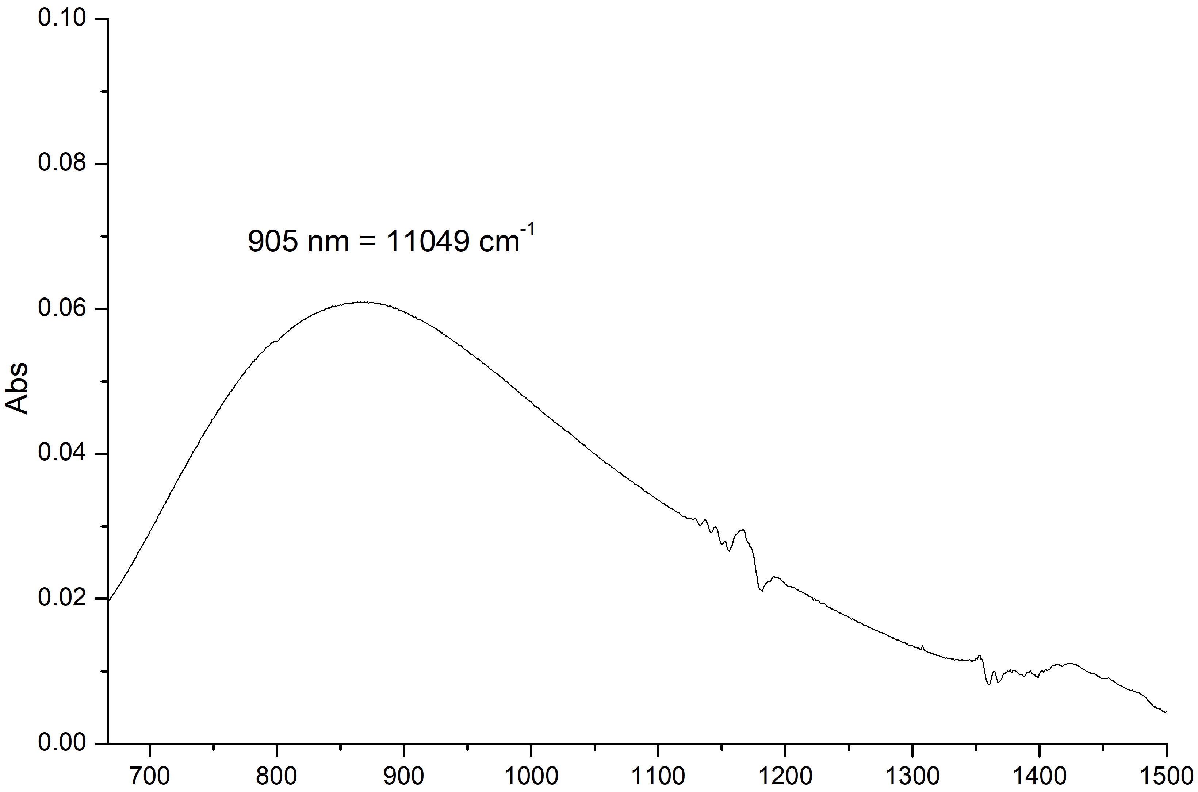nm
Figure S1. Solution spectrum of [Cu(sfabz)₂Cl₂] in DMSO, 1x10⁻³ M.
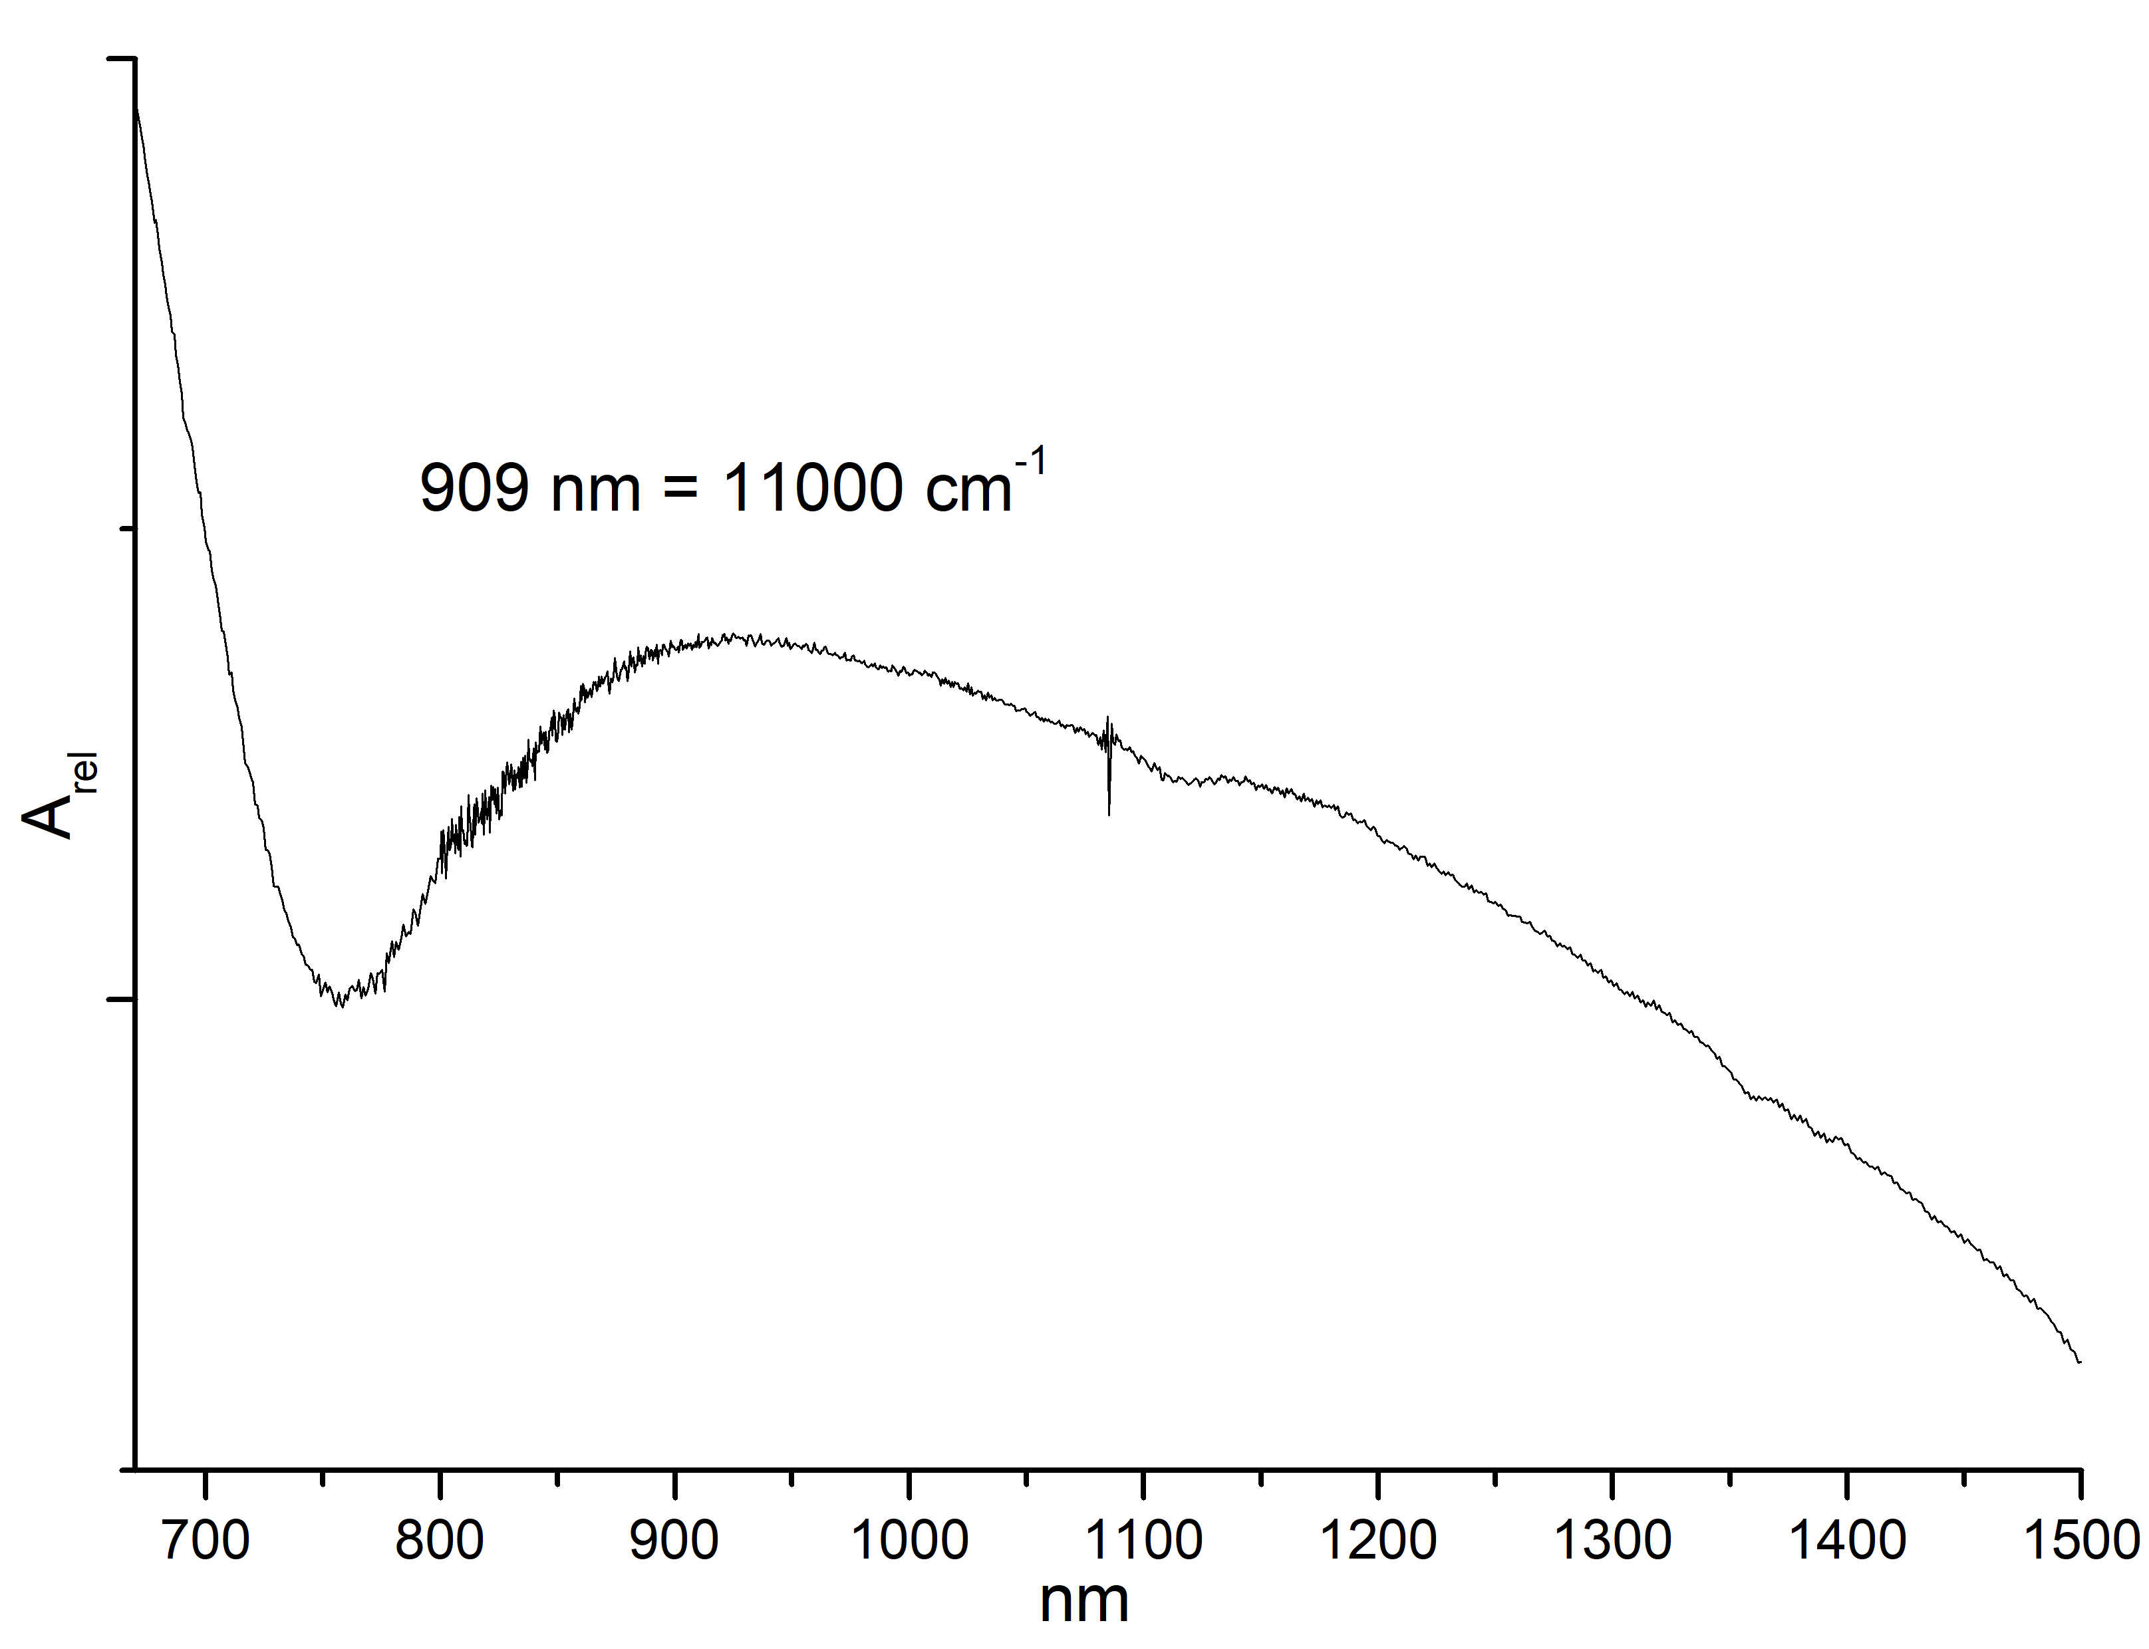nm
Figure S2. Diffuse reflectance spectrum of [Cu(sfabz)₂Cl₂].

Table S4. ¹H-NMR for sfabz and its coordination compounds (DMSO d⁶).
Signal | sfabz | [Zn(sfabz)₂Cl₂] (9) | [Zn(sfabz)₂Br₂] (10) | [Cd(sfabz)₂Cl₂] (13) | [Hg(sfabz)₂Cl₂] (15)
4 | 7.05 ppm (d) | 7.21 ppm (s, broad) | 7.23 ppm (d) | 7.22 ppm (d) | 7.22 ppm (d)
5 | 6.89 ppm (t) | 6.94 ppm (m) | 6.94 ppm (t) | 6.92 ppm (t) | 6.98 ppm (m)
6 | 6.79 ppm (t) | 6.92 ppm (m) | 6.92 ppm (m) | 6.85 ppm (t) | 6.94 ppm (m)
7 | 6.74 ppm (d) | 6.92 ppm (m) | 6.92 ppm (m) | 6.82 ppm (d) | 6.94 ppm (m)
10 (2H) | 6.43 ppm (s, broad) | 7.21 ppm (s, broad) | 7.10 ppm (s, broad) | 6.75 ppm (s, broad) | 7.12 ppm (s, broad)
11 (2H) | 4.28 ppm (t) | 4.40 ppm (t) | 4.40 ppm (t) | 4.32 ppm (t) | 4.39 ppm (t)
12 (2H) | 3.72 ppm (t) | 3.81 ppm (t) | 3.81 ppm (t) | 3.74 ppm (t) | 3.81 ppm (t)
17 (2H) | 7.86 ppm (d) | 7.84 ppm (m) | 7.84 ppm (d) | 7.85 ppm (d) | 7.85 ppm (d)
18 (2H) | 7.58 ppm (t) | 7.55 ppm (m) | 7.56 ppm (t) | 7.58 ppm (t) | 7.52 ppm (t)
19 | 7.71 ppm (t) | 7.67 ppm (m) | 7.68 ppm (t) | 7.69 ppm (t) | 7.63 ppm (t)

Table S5. ¹³C-NMR for sfabz and its coordination compounds (DMSO d⁶).
Signal | sfabz | [Zn(sfabz)₂Cl₂] (9) | [Zn(sfabz)₂Br₂] (10) | [Cd(sfabz)₂Cl₂] (13) | [Hg(sfabz)₂Cl₂] (15)
2 | 154.82 ppm | 154.92 ppm | 154.76 ppm | 154.97 ppm | 155.06 ppm
4 | 115.27 ppm | 114.62 ppm | 114.81 ppm | 115.43 ppm | 114.36 ppm
5 | 121.10 ppm | 122.24 ppm | 122.16 ppm | 121.54 ppm | 122.21 ppm
6 | 118.66 ppm | 120.62 ppm | 120.55 ppm | 119.62 ppm | 120.57 ppm
7 | 107.73 ppm | 108.98 ppm | 108.90 ppm | 108.25 ppm | 109.08 ppm
8 | 133.91 ppm | 132.33 ppm | 132.43 ppm | 133.09 ppm | 132.49 ppm
9 | 142.92 ppm | 139.08 ppm | 139.10 ppm | 140.91 ppm | 139.29 ppm
11 | 36.08 ppm | 36.37 ppm | 36.36 ppm | 36.21 ppm | 36.58 ppm
12 | 53.18 ppm | 52.54 ppm | 52.59 ppm | 52.86 ppm | 52.52 ppm
16 | 136.17 ppm | 138.70 ppm | 138.87 ppm | 139.10 ppm | 139.05 ppm
17 (2C) | 127.96 ppm | 127.80 ppm | 127.83 ppm | 127.91 ppm | 127.73 ppm
18 (2C) | 129.84 ppm | 129.83 ppm | 129.86 ppm | 129.88 ppm | 129.78 ppm
19 | 134.44 ppm | 134.49 ppm | 134.51 ppm | 134.50 ppm | 134.43 ppm

Table S6. ¹H-NMR for seabz and its coordination compounds (d⁶ DMSO).
Signal | seabz | [Zn(seabz)₂Cl₂] (11) | [Zn(seabz)₂Br₂] (12) | [Cd(seabz)₂Cl₂] (14) | [Hg(seabz)₂Cl₂] (16)
4 | 7.13 ppm (dd, overlapped) | 7.28 ppm (m, overlapped) | 7.28 ppm (dd, overlapped) | 7.33 ppm (dd) | 7.29 ppm (m, overlapped)
5 | 6.88 ppm (td) | 7.01 ppm (m, overlapped) | 6.99 ppm (m, overlapped) | 6.98 ppm (m, overlapped) | 7.02 ppm (m, overlapped)
6 | 6.94 ppm (td) | 6.99 ppm (m, overlapped) | 7.02 ppm (m, overlapped) | 6.97 ppm (m, overlapped) | 7.02 ppm (m, overlapped)
7 | 7.15 ppm (dd, overlapped) | 7.26 ppm (m, overlapped) | 7.29 ppm (dd, overlapped) | 7.22 ppm (dd) | 7.28 ppm (m, overlapped)
10 (2H) | 6.48 ppm (s, broad) | 7.32 ppm (s, broad) | 7.18 ppm (s, broad) | 6.86 ppm (s, broad) | 7.13 ppm (s, broad)
11 (2H) | 4.39 ppm (t) | 4.49 ppm (t) | 4.49 ppm (t) | 4.42 ppm (t) | 4.46 ppm (t)
12 (2H) | 3.46 ppm (t) | 3.55 ppm (t) | 3.55 ppm (t) | 3.48 ppm (t) | 3.52 ppm (t)
16 (2H) | 3.08 ppm (q) | 3.14 ppm (q) | 3.14 ppm (q) | 3.12 ppm (q) | 3.13 ppm (q)
17 (3H) | 1.15 ppm (t) | 1.17 ppm (t) | 1.17 ppm (t) | 1.16 ppm (t) | 1.16 ppm (t)

Table S7. ¹³C-NMR for seabz and its coordination compounds (d⁶ DMSO).
Signal | seabz | [Zn(seabz)₂Cl₂] (11) | [Zn(seabz)₂Br₂] (12) | [Cd(seabz)₂Cl₂] (14) | [Hg(seabz)₂Cl₂] (16)
2 | 155.05 ppm | 155.10 ppm | 154.92 ppm | 155.12 ppm | 155.25 ppm
4 | 115.40 ppm | 114.65 ppm | 114.84 ppm | 115.59 ppm | 114.57 ppm
5 | 121.17 ppm | 122.37 ppm | 122.29 ppm | 121.70 ppm | 122.20 ppm
6 | 118.78 ppm | 120.81 ppm | 120.74 ppm | 119.92 ppm | 120.55 ppm
7 | 108.12 ppm | 109.36 ppm | 109.29 ppm | 108.70 ppm | 109.26 ppm
8 | 134.05 ppm | 132.45 ppm | 132.55 ppm | 133.11 ppm | 132.78 ppm
9 | 143.19 ppm | 138.81 ppm | 138.99 ppm | 140.74 ppm | 139.78 ppm
11 | 35.60 ppm | 35.78 ppm | 35.78 ppm | 35.70 ppm | 35.91 ppm
12 | 49.62 ppm | 49.04 ppm | 49.07 ppm | 49.30 ppm | 49.16 ppm
16 | 47.29 ppm | 47.34 ppm | 47.35 ppm | 47.31 ppm | 47.32 ppm
17 | 6.34 ppm | 6.28 ppm | 6.30 ppm | 6.32 ppm | 6.30 ppm

