Mechanisms and adsorption capacities of natural and eco-friendly nanoparticles for heavy metals and phosphate ions from water using DSD approach

Autors: Jovana Jokić Govedaricaª, Dragana Tomašević Pilipović^{a*}, Vesna Gvoić^{b}, Đurđa Kerkezª, Anita Leovac Maćerakª, Nataša Slijepčevićª, Milena Bečelić-Tominª

ª University of Novi Sad, Faculty of Sciences, Department of Chemistry, Biochemistry and Environmental Protection, Trg Dositeja Obradovića 3, 21000, Novi Sad, Serbia
^{b} University of Novi Sad, Faculty of Technical Sciences, Department of Graphic Engineering and Design, Trg Dositeja Obradovića 6, 21000, Novi Sad, Serbia
*Corresponding author: Dragana Tomašević Pilipović, Phone: +381 21 485 27 34; Fax: +381 21 454 065; e-mail address: dragana.tomasevic@dh.uns.ac.rs; Postal address: Trg Dositeja Obradovica 3, 21000 Novi Sad, Serbia

List of Figure Captions
Figure S1. Diagnostic plots: a) cadmium - Actual vs Predicted; b) cadmium - Residual by Predicted; c) phosphate - Actual vs Predicted; d) phosphate - Residual by Predicted
Figure S2: Pareto chart for: a) cadmium removal; b) phosphate removal
Figure S3. Diagnostic plots: a) nickel - Actual vs Predicted; b) nickel - Residual by Predicted; c) phosphate - Actual vs Predicted; d) phosphate - Residual by Predicted
Figure S4: Pareto chart for: a) nickel removal; b) phosphate removal
Figure 5. a) effect of reaction time on adsorption of Cd (II) and Ni (II) in the presence of phosphate on oak-nZVI b) kinetic model pseudo-first-order c) kinetic model pseudo-second-order

Figure S1. Diagnostic plots: a) cadmium - Actual vs Predicted; b) cadmium - Residual by Predicted; c) phosphate - Actual vs Predicted; d) phosphate - Residual by Predicted

Figure S2: Pareto chart for: a) cadmium removal; b) phosphate removal

Figure S3. Diagnostic plots: a) nickel - Actual vs Predicted; b) nickel - Residual by Predicted; c) phosphate - Actual vs Predicted; d) phosphate - Residual by Predicted

Figure S4: Pareto chart for: a) nickel removal; b) phosphate removal
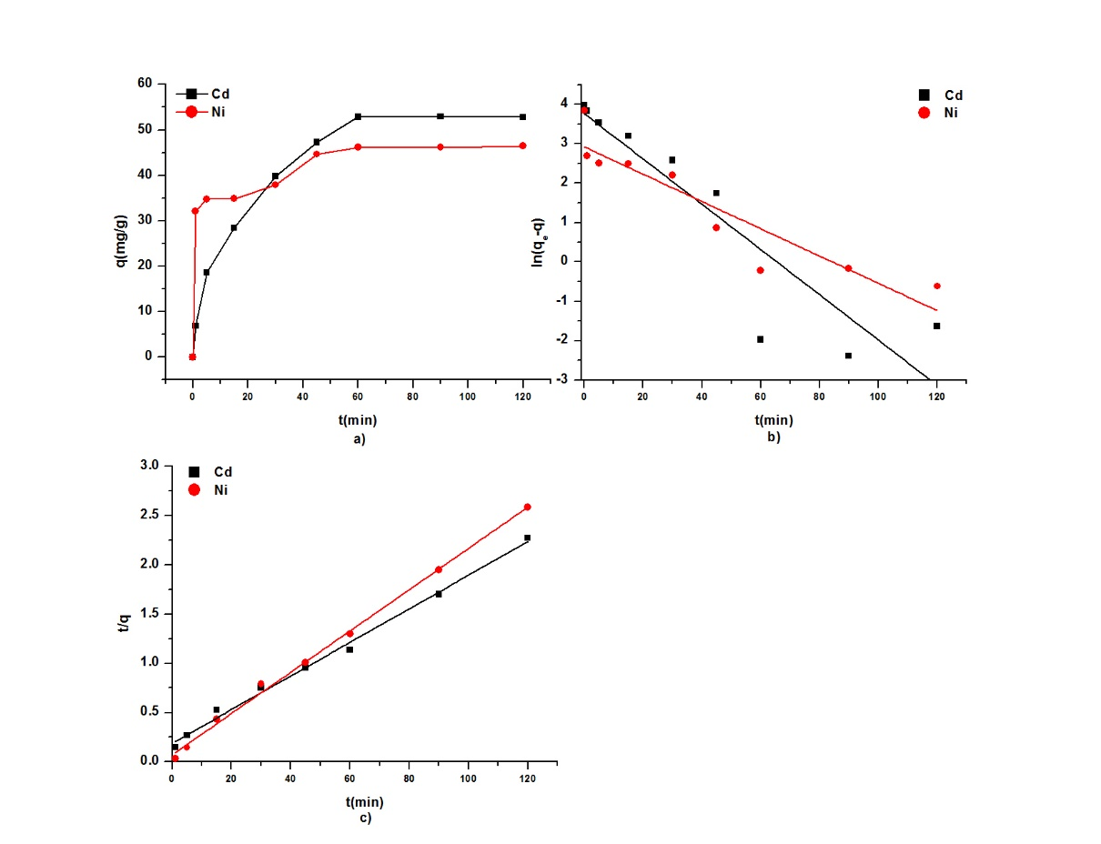
Figure S5: a) effect of reaction time on adsorption of Cd (II) and Ni (II) in the presence of phosphate on oak-nZVI b) kinetic model pseudo-first-order c) kinetic model pseudo-second-order

List of Tables
Table S1. Process variables with experimental levels
Table S2. DSD experimental design layout
Table S3. Adsorption efficiency (%) for the removal of cadmium and phosphate
Table S4. Standard selection criteria for the regression models (cadmium and phosphate)
Table S5. ANOVA and "Lack of fit "test (cadmium and phosphate)
Table S6. Experimental verification of optimized processes for cadmium and phosphate removal
Table S7. Adsorption efficiency (%) for the removal of nickel and phosphate
Table S8. Standard selection criteria for the regression models (nickel and phosphate)
Table S9. ANOVA and "Lack of fit"test – nickel and phosphate removal
Table S10. Experimental verification of optimized processes
Table S11. Parameters of kinetic models for describing the adsorption of cadmium and nickel in the presence of phosphate on oak-nZVI

Table S1. Process variables with experimental levels
Variables | Unit | Symbol coded | Levels
 |  |  | -1 | 0 | +1
Metal concentration | mgL⁻¹ | X₁ | 1 | 5 | 9
Ion concentation | mgL⁻¹ | X₂ | 1 | 5 | 9
pH | - | X₃ | 2 | 6 | 10
oak-nZVI concentration | ml | X₄ | 2 | 9 | 16

Table S2. DSD experimental design layout
Run | Metal concentration | Ion concentration | pH | oak-nZVI concentration
1 | 9 | 9 | 10 | 9
2 | 1 | 1 | 2 | 9
3 | 1 | 5 | 10 | 16
4 | 9 | 5 | 2 | 2
5 | 5 | 1 | 2 | 16
6 | 5 | 9 | 10 | 2
7 | 1 | 9 | 6 | 16
8 | 9 | 1 | 6 | 2
9 | 9 | 9 | 2 | 16
10 | 1 | 1 | 10 | 2
11 | 9 | 1 | 10 | 16
12 | 1 | 9 | 2 | 2
13 | 5 | 5 | 6 | 9
14 | 9 | 9 | 10 | 9
15 | 1 | 1 | 2 | 9
16 | 1 | 5 | 10 | 16
17 | 9 | 5 | 2 | 2
18 | 5 | 1 | 2 | 16
19 | 5 | 9 | 10 | 2
20 | 1 | 9 | 6 | 16
21 | 9 | 1 | 6 | 2
22 | 9 | 9 | 2 | 16
23 | 1 | 1 | 10 | 2
24 | 9 | 1 | 10 | 16
25 | 1 | 9 | 2 | 2
26 | 5 | 5 | 6 | 9
27 | 5 | 5 | 6 | 9
28 | 5 | 5 | 6 | 9

Table S3. Adsorption efficiency (%) for the removal of cadmium and phosphate
Run | Cadmium | Phosphate
1 | 91.06 | 64.67
2 | 90.02 | 82.00
3 | 96.63 | 29.00
4 | 85.94 | 71.56
5 | 57.54 | 75.00
6 | 95.86 | 81.40
7 | 98.96 | 73.00
8 | 26.02 | 76.22
9 | 91.90 | 66.89
10 | 15.44 | 97.00
11 | 24.85 | 81.00
12 | 99.01 | 69.00
13 | 89.61 | 83.20
14 | 92.59 | 64.22
15 | 90.47 | 87.00
16 | 96.71 | 34.00
17 | 86.09 | 71.89
18 | 59.56 | 76.40
19 | 95.64 | 79.80
20 | 98.91 | 69.00
21 | 39.83 | 76.89
22 | 91.90 | 66.33
23 | 91.13 | 91.00
24 | 33.14 | 79.00
25 | 98.87 | 65.00
26 | 91.95 | 81.80
27 | 91.47 | 82.60
28 | 92.19 | 82.20

Table S4. Standard selection criteria for the regression models (cadmium and phosphate)
Descriptive factor | Cadmium | Phosphate
R² | 0.823 | 0.737
R² adj | 0.761 | 0.626
AIC | 241.184 | 223.199
BIC | 243.174 | 223.580
RMSE | 12.886 | 8.779

Table S6. ANOVA and "Lack of fit "test (cadmium and phosphate)
Source | ªDF | ^{b}SS | ^{c}MS | F parameter
 | Cadmium
Model | 7 | 15480.632 | 2211.520 | 13.318
Error | 20 | 3321.069 | 166.050 | Prob>F
C. Total | 27 | 18801.701 | - | <0.0001
Lack of Fit | 5 | 319.399 | 63.880 | 0.319
Pure Error | 15 | 3001.669 | 200.111 | Prob>F
Total Error | 20 | 3321.069 | - | 0.894
 | Phosphate
Model | 8 | 4107. 143 | 513.393 | 6.661
Error | 19 | 1464.501 | 77.079 | Prob>F
C. Total | 27 | 5571.644 | - | 0.0003
Lack of Fit | 4 | 1399.634 | 349.908 | 80.9137
Pure Error | 15 | 64.867 | 4.324 | Prob>F
Total Error | 19 | 1464.501 | - | 0.966
ªDegrees of freedom;^{b}The sum of square; ^{c}Variance (mean of square)

Table S6. Experimental verification of optimized processes for cadmium and phosphate removal
Run | Cadmium | Phosphate
1 | 98.90 | 89.28
2 | 99.66 | 87.38
3 | 98.98 | 87.42
4 | 98.77 | 87.92
5 | 98.93 | 88.02
6 | 99.08 | 87.16
7 | 99.09 | 87.66
8 | 98.99 | 87.44
95% confidence interval | 98.83 - 99.27% | 87.29 - 87.86%

Table S7. Adsorption efficiency (%) for the removal of nickel and phosphate
Run | Nickel | Phosphate
1 | 92.08 | 95.76
2 | 13.96 | 49.40
3 | 91.35 | 58.00
4 | 91.59 | 95.99
5 | 67.39 | 75.20
6 | 85.98 | 63.02
7 | 87.59 | 71.90
8 | 60.31 | 97.70
9 | 76.55 | 80.84
10 | 76.32 | 75.50
11 | 65.18 | 90.34
12 | 76.16 | 13.10
13 | 93.69 | 83.58
14 | 85.39 | 95.73
15 | 87.09 | 48.70
16 | 89.03 | 56.10
17 | 93.05 | 95.93
18 | 90.50 | 74.14
19 | 87.01 | 63.86
20 | 88.93 | 71.20
21 | 66.93 | 97.66
22 | 79.99 | 80.74
23 | 97.38 | 80.30
24 | 71.32 | 90.82
25 | 79.69 | 13.30
26 | 94.69 | 83.52
27 | 95.11 | 83.50
28 | 94.86 | 83.28

Table S8. Standard selection criteria for the regression models (nickel and phosphate)

Descriptive factor | Nickel | Phosphate
R² | 0.715 | 0.910
R² adj | 0.546 | 0.872
AIC | 246.007 | 218.047
BIC | 241.194 | 218.428
RMSE | 11.286 | 8.008

Table S9. ANOVA and "Lack of fit"test – nickel and phosphate removal
Source | DF | SS | MS | F parameter
 | Nickel
Model | 10 | 5421.248 | 542.125 | 4.256
Error | 17 | 2165.324 | 127.372 | Prob>F
C. Total | 27 | 7586.574 | - | 0.0044
Lack of Fit | 15 | 2165.235 | 144.39 | 3234.107
Pure Error | 2 | 0.089 | 0.045 | Prob>F
Total Error | 17 | 2165.324 | - | 0.906
 | Phosphate
Model | 8 | 12307.914 | 1538.49 | 23.993
Error | 19 | 1218.335 | 64.12 | Prob>F
C. Total | 27 | 13526.249 | - | <0.0001
Lack of Fit | 17 | 1218.299 | 71.665 | 4041.240
Pure Error | 2 | 0.0355 | 0.018 | Prob>F
Total Error | 19 | 1218.3347 | - | 0.925

Table S10. Experimental verification of optimized processes
Run | Nickel | Phosphate
1 | 93.77 | 96.20
2 | 94.85 | 96.92
3 | 95.14 | 96.82
4 | 94.65 | 96.75
5 | 93.73 | 97.12
6 | 94.02 | 97.06
7 | 94.56 | 97.03
8 | 94.45 | 96.41
95% confidence interval | 93.97 - 94.83% | 96.51-97.06%

Table S11. Parameters of kinetic models for describing the adsorption of cadmium and nickel in the presence of phosphate on oak-nZVI
Pseudo-first order
Metal | R² | q_{e}  (mg/g) exp | k₁  (min⁻¹) | q_{e} (mg/g) cal¹
Cd | 0.815 | 53 | 0.96 | 43.3
Ni | 0.839 | 47 | 0.977 | 18.6
Pseudo-second order
Metal | R² | q_{e} (mg/g) exp | k₂ ·10⁻³  (q mg⁻¹ min⁻¹) | q_{e} (mg/g) cal²
Cd | 0.957 | 53 | 1.89 | 55.1
Ni | 0.996 | 47 | 6.48 | 47.7

