Title: Elucidating the effect of Biochar-bentonite composite-based Seed balls for the Remediation of coal mining impacted Heavy metals contaminated Soil

Supplementary Material

Figures:

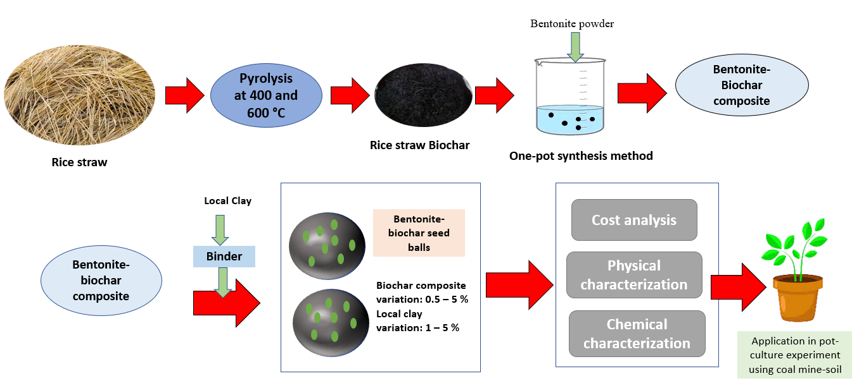
Figure S1: Methodology for the development of seed balls from rice-straw waste derived bentonite biochar composite and kaolinite to be implemented in the pot-culture study

Figure S2: Correlation matrix among soil enzymes, DTPA-extractable heavy metals, and SFI

Figure S3: Correlation diagram among total chlorophyll, proline, glutathione, and translocation factor of heavy metals

Tables
Table S1: Physicochemical characteristics of the kaolinite clay
Parameters | Values
pH | 7.78
Cation exchange capacity (CEC) (cmol kg⁻¹) | 13.89
Zn (mg/kg) | 47.85
SSA (m²/g) | 28
Organic Matter % | 0.89
Exchangeable Mg (mg/kg) | 38.39
Exchangeable K (mg/kg) | 59.68
Exchangeable Ca (mg/kg) | 118.42
Available P (mg/kg) | 6.89

Table S2: Physicochemical characteristics of bentonite-biochar composite
Parameter | Values
Carbon (%) | 41.67
Hydrogen (%) | 2.12
Nitrogen (%) | 2.16
Oxygen (%) | 17.87
Volatile Matter (%) | 47.58
Fixed Carbon (%) | 11.48
Mineral Matter (%) | 32.12
BET Surface area (m²/g) | 126.87
pH | 8.50
CEC (cmol kg⁻¹) | 56.46
Exchangeable K (g kg⁻¹) | 7.62
Exchangeable Ca (g kg⁻¹) | 3.18
Exchangeable Mg (mg kg⁻¹) | 213.60
Exchangeable Na (mg kg⁻¹) | 344.20

Table S3: Physicochemical characteristics of the seeds balls developed through the combination of biochar-bentonite composite and kaolinite
Items | pH | Exchangeable-K (mg kg⁻¹) | Exchangeable-Ca (mg kg⁻¹) | Exchangeable-Mg (mg kg⁻¹) | Available P (mg kg⁻¹) | Organic carbon % | CEC (cmol kg⁻¹)
0.5B1C | 7.29 | 83.46 | 91.53 | 30.27 | 7.83 | 1.53 | 14.66
1B1C | 7.68 | 90.28 | 97.26 | 35.56 | 9.29 | 1.89 | 16.43
3B1C | 8.24 | 98.44 | 107.39 | 37.44 | 10.35 | 2.34 | 18.29
5B1CB | 8.76 | 108.21 | 118.24 | 40.21 | 12.36 | 2.68 | 23.22
0.5B3C | 7.69 | 94.76 | 102.38 | 33.47 | 8.31 | 1.77 | 17.24
1B3C | 8.13 | 104.33 | 114.76 | 36.51 | 9.58 | 2.31 | 19.43
3B3C | 8.42 | 110.81 | 122.39 | 41.39 | 11.32 | 2.42 | 24.73
5B3C | 8.89 | 123.21 | 129.72 | 44.57 | 13.46 | 2.83 | 26.89
0.5B5C | 8.06 | 98.77 | 108.63 | 37.82 | 10.11 | 2.04 | 18.33
1B5C | 8.42 | 109.43 | 116.29 | 43.72 | 14.26 | 2.38 | 22.32
3B5C | 8.84 | 118.37 | 124.78 | 48.24 | 17.29 | 2.56 | 24.47
5B5C | 9.07 | 128.38 | 133.43 | 54.39 | 19.88 | 2.88 | 26.44

Table S4: Post-pot-culture concentrations and variations of total heavy metals content in the amended soil (n = 3, mean ± S.D.)

Ni  (mg kg⁻¹) | Cu  (mg kg⁻¹) | Zn  (mg kg⁻¹) | Co  (mg kg⁻¹) | Pb  (mg kg⁻¹) | Cr  (mg kg⁻¹) | Cd  (mg kg⁻¹)
40.29±4.71 | 17.24±0.59 | 56.24±1.81 | 19.32±0.79 | 21.49±0.61 | 124.38±3.55 | 1.02±0.026
38.23±1.37 | 16.43±0.67 | 52.35±1.28 | 16.44±0.41 | 18.76±0.66 | 120.66±4.16 | 0.96±0.018
35.14±1.35 | 13.2±0.37 | 46.33±1.33 | 13.86±0.53 | 16.28±0.70 | 115.29±3.21 | 0.93±0.029
33.19±1.37 | 11.16±0.48 | 41.57±1.29 | 11.29±0.35 | 13.14±0.51 | 111.32±3.98 | 0.88±0.022
36.47±1.33 | 16.12±0.54 | 52.16±1.18 | 17.48±0.63 | 17.26±0.66 | 121.39±3.53 | 0.95±0.026
32.26±0.83 | 13.25±0.36 | 47.38±1.63 | 14.54±0.47 | 15.44±0.50 | 116.44±2.46 | 0.89±0.024
27.45±0.72 | 11.69±0.43 | 42.64±1.10 | 10.19±0.38 | 11.16±0.31 | 111.28±2.20 | 0.82±0.015
21.38±0.67 | 8.67±0.21 | 37.31±1.24 | 8.76±0.24 | 8.35±0.24 | 106.73±1.91 | 0.74±0.013
33.28±1.31 | 14.24±0.52 | 49.36±1.33 | 15.44±0.33 | 14.48±0.46 | 116.81±2.47 | 0.87±0.018
28.64±1.10 | 11.23±0.35 | 43.38±1.59 | 11.38±0.30 | 10.33±0.39 | 111.39±2.30 | 0.81±0.19
23.19±0.72 | 7.64±0.24 | 38.44±1.26 | 7.28±0.23 | 7.14±0.21 | 105.24±1.98 | 0.74±0.017
20.33±0.67 | 5.22±0.14 | 32.17±0.84 | 5.26±0.14 | 4.22±0.16 | 99.77±1.79 | 0.66±0.019
49.97±1.93 | 20.3±0.79 | 62.19±2.40 | 22.11±0.86 | 24.82±0.82 | 133.82±3.82 | 1.14±0.033

Table S5: Heavy metals in shoot and root parts of the Shorgham grass
Samples | Ni_{shoot}  (mg kg⁻¹) | Cu_{shoot} (mg kg⁻¹) | Zn_{shoot}  (mg kg⁻¹) | Co_{shoot} (mg kg⁻¹) | Pb_{shoot}  (mg kg⁻¹) | Cr_{shoot}  (mg kg⁻¹) | Cd_{shoot} (mg kg⁻¹)
0.5B1C | 2.04 | 2.31 | 5.24 | 1.68 | 2.14 | 7.21 | 0.096
1B1C | 1.9 | 2.15 | 4.89 | 1.53 | 1.83 | 6.42 | 0.083
3B1C | 1.72 | 1.89 | 4.67 | 1.32 | 1.61 | 4.76 | 0.065
5B1CB | 1.55 | 1.64 | 4.33 | 1.12 | 1.36 | 3.21 | 0.044
0.5B3C | 1.91 | 2.03 | 4.91 | 1.52 | 1.96 | 6.44 | 0.078
1B3C | 1.68 | 1.77 | 4.62 | 1.28 | 1.64 | 4.89 | 0.061
3B3C | 1.51 | 1.52 | 4.18 | 1.1 | 1.32 | 3.26 | 0.042
5B3C | 1.24 | 1.28 | 3.91 | 0.84 | 1.06 | 2.54 | 0.03
0.5B5C | 1.16 | 1.71 | 4.43 | 1.21 | 1.52 | 4.38 | 0.063
1B5C | 1.21 | 1.33 | 3.95 | 0.94 | 1.19 | 3.17 | 0.036
3B5C | 0.94 | 1.12 | 3.45 | 0.62 | 0.85 | 2.34 | 0.024
5B5C | 0.76 | 0.82 | 2.92 | 0.48 | 0.54 | 1.59 | 0.016
Control | 3.97 | 3.26 | 7.43 | 2.2 | 2.76 | 10.28 | 0.15
Heavy metals in the Root part
 | Ni_{root}  (mg kg⁻¹) | Cu_{root}  (mg kg⁻¹) | Zn_{root}  (mg kg⁻¹) | Co_{root}  (mg kg⁻¹) | Pb_{root}  (mg kg⁻¹) | Cr_{root}  (mg kg⁻¹) | Cd_{root}  (mg kg⁻¹)
0.5B1C | 2.88 | 2.59 | 6.11 | 2.06 | 2.44 | 11.43 | 0.126
1B1C | 2.61 | 2.29 | 5.73 | 1.73 | 2.17 | 9.77 | 0.115
3B1C | 2.53 | 2.1 | 5.54 | 1.63 | 1.92 | 7.24 | 0.097
5B1CB | 2.39 | 1.95 | 5.26 | 1.41 | 1.76 | 6.32 | 0.073
0.5B3C | 2.62 | 2.36 | 5.84 | 1.77 | 2.29 | 9.45 | 0.11
1B3C | 2.31 | 2.11 | 5.5 | 1.48 | 1.94 | 7.33 | 0.092
3B3C | 2.11 | 1.85 | 5.17 | 1.31 | 1.7 | 6.21 | 0.065
5B3C | 1.92 | 1.64 | 4.86 | 1.02 | 1.42 | 5.19 | 0.054
0.5B5C | 2.34 | 2.17 | 5.42 | 1.51 | 1.79 | 6.74 | 0.087
1B5C | 1.95 | 1.78 | 5.1 | 1.06 | 1.53 | 5.22 | 0.063
3B5C | 1.56 | 1.61 | 4.69 | 0.82 | 1.17 | 4.16 | 0.042
5B5C | 1.32 | 1.48 | 4.2 | 0.66 | 0.88 | 3.34 | 0.02
Control | 3.76 | 3.13 | 7.68 | 2.65 | 3.31 | 28.26 | 0.2

