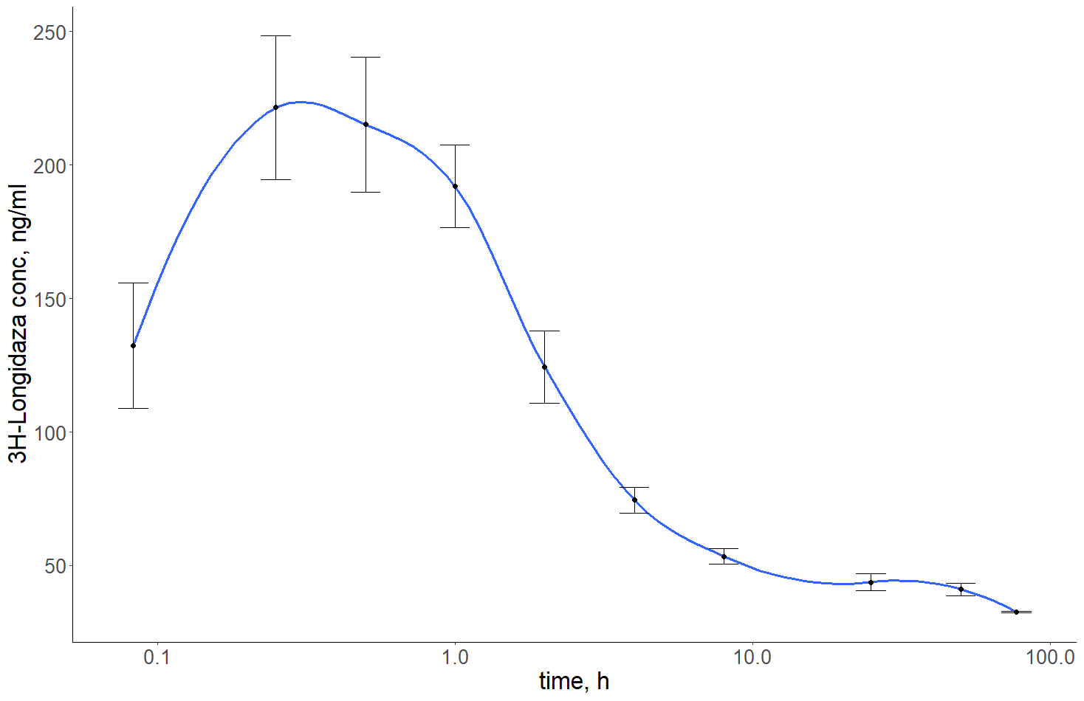
Figure S1. Graph of the Longidaza concentration (ng/ml) versus time after intramuscular injection.

