Supplementary materials
Network Toxicology and Molecular Docking to Investigate the non-AChE Mechanisms of Organophosphate-Induced
Neurodevelopmental Toxicity
Juliana Alves da Costa Ribeiro Souza^{1,2}, Terezinha Souza², Isadora Louise Alves da Costa Ribeiro Quintans³ and Davi Farias^{1,2 *}
Table S1. - Topological measurements of nodes in the PPI network of diazinon oxon-induced developmental neurotoxicity.
Protein | Node | k | Clustering Coefficient | BC | ASPL | CC
Epidermal growth factor receptor | EGFR | 14 | 0.1648 | 0.2748 | 2.1429 | 0.4667
Proto-oncogene tyrosine kinase SRC | SRC | 13 | 0.2179 | 0.1544 | 2.2857 | 0.4375
Heat shock protein HSP 90-alpha | HSP90AA1 | 11 | 0.1091 | 0.1543 | 2.4286 | 0.4118
Histone acetyltransferase p300 | EP300 | 9 | 0.0278 | 0.3026 | 2.4898 | 0.4016
Phosphatidylinositol 3-kinase regulatory subunit alpha | PIK3R1 | 9 | 0.2500 | 0.2378 | 2.4082 | 0.4153
Signal transducer and activator of transcription 3 | STAT3 | 8 | 0.1786 | 0.1418 | 2.3265 | 0.4298
Estrogen receptor | ESR1 | 7 | 0.1905 | 0.2018 | 2.2449 | 0.4455
Calmodulin-1 | CALM1 | 7 | 0.0000 | 0.1683 | 2.6531 | 0.3769
Tyrosine-protein phosphatase non-receptor type 11 | PTPN11 | 7 | 0.4286 | 0.0164 | 2.7143 | 0.3684
Insulin-like growth factor 1 receptor | IGF1R | 6 | 0.1333 | 0.0556 | 2.5918 | 0.3858
Mitogen-activated protein kinase1 | MAPK1 | 6 | 0.2000 | 0.0520 | 3.0612 | 0.3267
Signal transducer and activator of transcription 1-alpha/beta | STAT1 | 5 | 0.5000 | 0.0375 | 2.4694 | 0.4050
Presenilin | PSEN1 | 4 | 0.5000 | 0.5333 | 1.3333 | 0.7500
Nicastrin | NCSTN | 4 | 0.8333 | 0.0667 | 1.5000 | 0.6667
Gamma-secretase subunit APH-1A | APH1A | 4 | 0.8333 | 0.0667 | 1.5000 | 0.6667
Gamma-secretase subunit PEN-2 | PSENEN | 4 | 0.8333 | 0.0667 | 1.5000 | 0.6667
Tyrosine-protein phosphatase non-receptor type 1 | PTPN1 | 4 | 0.5000 | 0.0036 | 2.8980 | 0.3451
Platelet-derived growth factor receptor beta | PDGFRB | 4 | 0.6667 | 0.0030 | 2.8163 | 0.3551
Hepatocyte growth factor receptor | MET | 4 | 0.8333 | 0.0002 | 2.9184 | 0.3427
Cell division control protein 42 homolog | CDC42 | 3 | 0.0000 | 0.1556 | 3.2245 | 0.3101
Poly [ADP-ribose] polymerase 1 | PARP1 | 3 | 0.0000 | 0.1178 | 3.3469 | 0.2988
Mitogen-activated protein kinase14 | MAPK14 | 3 | 0.3333 | 0.0312 | 2.9592 | 0.3379
Androgen receptor | AR | 3 | 0.3333 | 0.0230 | 2.6939 | 0.3712
Serine/threonine-protein kinase B-raf | BRAF | 3 | 0.3333 | 0.0185 | 3.2449 | 0.3082
Tyrosine-protein kinase ABL1 | ABL1 | 3 | 0.6667 | 0.0079 | 2.7347 | 0.3657
Tyrosine-protein kinase Lck | LCK | 3 | 0.3333 | 0.0037 | 3.0000 | 0.3333
Heat Shock cognate 71 kDa protein | HSPA8 | 3 | 0.6667 | 0.0007 | 2.6939 | 0.3712
Presenilin-2 | PSEN2 | 3 | 1.0000 | 0.0000 | 2.0000 | 0.5000
C-C motif chemokine 5 | CCL5 | 2 | 0.0000 | 1.0000 | 1.0000 | 1.0000
Gamma-aminobutyric acid receptor subunit alpha-1 | GABRA1 | 2 | 0.0000 | 1.0000 | 1.0000 | 1.0000
Glycogen synthase kinase-3 beta | GSK3B | 2 | 0.0000 | 0.3333 | 1.8333 | 0.5455
Mitogen-activated protein kinase8 | MAPK8 | 2 | 0.0000 | 0.0799 | 4.1224 | 0.2426
Glutathione S-transferase P | GSTP1 | 2 | 0.0000 | 0.0408 | 5.0612 | 0.1976
Cyclin-dependent kinase 1 | CDK1 | 2 | 0.0000 | 0.0300 | 3.0408 | 0.3289
Caspase-7 | CASP7 | 2 | 0.0000 | 0.0200 | 4.2857 | 0.2333
Caspase-3 | CASP3 | 2 | 0.0000 | 0.0200 | 4.2857 | 0.2333
Cyclin-dependent kinase 2 | CDK2 | 2 | 0.0000 | 0.0134 | 3.3878 | 0.2952
Nitric oxide synthase, endotelial | NOS3 | 2 | 0.0000 | 0.0079 | 3.2041 | 0.3121
Cyclin-A2 | CCNA2 | 2 | 0.0000 | 0.0043 | 3.6122 | 0.2768
Glucocorticoid receptor | NR3C1 | 2 | 0.0000 | 0.0005 | 3.0816 | 0.3245
E3 ubiquitin-protein ligase XIAP | XIAP | 2 | 0.0000 | 0.0004 | 5.2245 | 0.1914
Dual specificity mitogen-activated protein kinase kinase 1 | MAP2K1 | 2 | 1.0000 | 0.0000 | 3.8776 | 0.2579
Receptor tyrosine-protein kinase erbB-4 | ERBB4 | 2 | 1.0000 | 0.0000 | 3.0408 | 0.3289
MAP kinase-activated protein kinase 2 | MAPKAPK2 | 2 | 1.0000 | 0.0000 | 3.5918 | 0.2784
Annexin A5 | ANXA5 | 1 | 0.0000 | 0.0000 | 1.0000 | 1.0000
Arachidonate 5-lipoxygenase-activating protein | ALOX5AP | 1 | 0.0000 | 0.0000 | 1.0000 | 1.0000
Bcl-2-like protein 1 | BCL2L1 | 1 | 0.0000 | 0.0000 | 1.0000 | 1.0000
Retinol-binding protein 4 | RBP4 | 1 | 0.0000 | 0.0000 | 1.0000 | 1.0000
Polyunsaturated fatty acid 5-lipoxygenase | ALOX5 | 1 | 0.0000 | 0.0000 | 1.0000 | 1.0000
Adenosine kinase | ADK | 1 | 0.0000 | 0.0000 | 6.0408 | 0.1655
Aurora kinase A | AURKA | 1 | 0.0000 | 0.0000 | 1.0000 | 1.0000
TGF-beta receptor type-1 | TGFBR1 | 1 | 0.0000 | 0.0000 | 3.4082 | 0.2934
Serine/threonine-protein kinase PLK1 | PLK1 | 1 | 0.0000 | 0.0000 | 1.0000 | 1.0000
Bifunctional purine biosynthesis protein ATIC | ATIC | 1 | 0.0000 | 0.0000 | 1.0000 | 1.0000
Beta-2-microglobulin | B2M | 1 | 0.0000 | 0.0000 | 1.0000 | 1.0000
Histone acetyltransferase KAT2B | KAT2B | 1 | 0.0000 | 0.0000 | 3.4694 | 0.2882
Peroxisome proliferator-activated receptor gamma | PPARG | 1 | 0.0000 | 0.0000 | 3.4694 | 0.2882
Cyclin-dependent kinase 5 activator 1 | CDK5R1 | 1 | 0.0000 | 0.0000 | 1.0000 | 1.0000
Triosephosphate isomerase | TPI1 | 1 | 0.0000 | 0.0000 | 1.0000 | 1.0000
Apoptotic protease-activating factor 1 | APAF1 | 1 | 0.0000 | 0.0000 | 1.0000 | 1.0000
Transthyretin | TTR | 1 | 0.0000 | 0.0000 | 1.0000 | 1.0000
Fibroblast growth factor receptor 1 | FGFR1 | 1 | 0.0000 | 0.0000 | 3.3878 | 0.2952
Gamma-aminobutyric acid receptor subunit gamma-2 | GABRG2 | 1 | 0.0000 | 0.0000 | 1.5000 | 0.6667
Gamma-aminobutyric acid receptor subunit beta-3 | GABRB3 | 1 | 0.0000 | 0.0000 | 1.5000 | 0.6667
Adenine phosphoribosyltransferase | APRT | 1 | 0.0000 | 0.0000 | 1.0000 | 1.0000
Alanine--glyoxylate aminotransferase | AGXT | 1 | 0.0000 | 0.0000 | 1.0000 | 1.0000
Cyclin-dependent kinase 5 | CDK5 | 1 | 0.0000 | 0.0000 | 1.0000 | 1.0000
Death-associated protein kinase 1 | DAPK1 | 1 | 0.0000 | 0.0000 | 3.6327 | 0.2753
Insulin-like growth factor I | IGF1 | 1 | 0.0000 | 0.0000 | 3.5714 | 0.2800
Peroxisome proliferator-activated receptor alpha | PPARA | 1 | 0.0000 | 0.0000 | 3.4694 | 0.2882
Serine/threonine-protein kinase PAK 6 | PAK6 | 1 | 0.0000 | 0.0000 | 4.2041 | 0.2379
Protein S100-A9 | S100A9 | 1 | 0.0000 | 0.0000 | 1.0000 | 1.0000
Vascular endothelial growth factor receptor 2 | KDR | 1 | 0.0000 | 0.0000 | 3.2653 | 0.3062
C-C chemokine receptor type 1 | CCR1 | 1 | 0.0000 | 0.0000 | 1.5000 | 0.6667
Nitric oxide synthase, inducible | NOS2 | 1 | 0.0000 | 0.0000 | 3.6327 | 0.2753
RAC-beta serine/threonine-protein kinase | AKT2 | 1 | 0.0000 | 0.0000 | 2.6667 | 0.3750
Albumin | ALB | 1 | 0.0000 | 0.0000 | 1.0000 | 1.0000
Voltage-dependent L-type calcium channel subunit alpha-1C | CACNA1C | 1 | 0.0000 | 0.0000 | 3.6327 | 0.2753
C-C chemokine receptor type 5 | CCR5 | 1 | 0.0000 | 0.0000 | 1.5000 | 0.6667
Vitamin D3 receptor | VDR | 1 | 0.0000 | 0.0000 | 3.2653 | 0.3062
Nitric oxide synthase, brain | NOS1 | 1 | 0.0000 | 0.0000 | 3.6327 | 0.2753
Table S2. - Topological measurements of nodes in the PPI network of chlorpyrifos oxon-induced developmental neurotoxicity.
Protein | Node | k | Clustering coefficient | BC | ASPL | CC
Heat shock protein HSP 90-alpha | HSP90AA1 | 11 | 0.109 | 0.382 | 2.034 | 0.492
Epidermal growth factor receptor | EGFR | 8 | 0.179 | 0.276 | 2.172 | 0.460
Estrogen receptor | ESR1 | 7 | 0.143 | 0.269 | 2.103 | 0.475
Proto-oncogene tyrosine kinase SRC | SRC | 6 | 0.400 | 0.071 | 2.276 | 0.439
Histone acetyltransferase p300 | EP300 | 5 | 0.000 | 0.308 | 2.552 | 0.392
Calmodulin-1 | CALM1 | 5 | 0.000 | 0.158 | 2.414 | 0.414
Mitogen-activated protein kinase1 | MAPK1 | 5 | 0.100 | 0.095 | 3.172 | 0.315
Tyrosine-protein phosphatase non-receptor type 1 | PTPN1 | 4 | 0.500 | 0.017 | 2.759 | 0.363
Poly [ADP-ribose] polymerase 1 | PARP1 | 3 | 0.000 | 0.135 | 3.379 | 0.296
Mitogen-activated protein kinase14 | MAPK14 | 3 | 0.333 | 0.090 | 2.862 | 0.349
Androgen receptor | AR | 3 | 0.333 | 0.088 | 2.448 | 0.408
Heat Shock cognate 71 kDa protein | HSPA8 | 3 | 0.667 | 0.008 | 2.379 | 0.420
Hepatocyte growth factor receptor | MET | 3 | 1.000 | 0.000 | 2.793 | 0.358
Adenosine receptor A2a | ADORA2A | 2 | 0.000 | 1.000 | 1.000 | 1.000
Cyclin-dependent kinase 1 | CDK1 | 2 | 0.000 | 0.057 | 2.828 | 0.354
Tyrosine-protein kinase Lck | LCK | 2 | 0.000 | 0.044 | 2.759 | 0.363
Serine/threonine-protein kinase B-raf | BRAF | 2 | 0.000 | 0.044 | 2.759 | 0.363
Cyclin-dependent kinase 2 | CDK2 | 2 | 0.000 | 0.032 | 3.276 | 0.305
Cyclin-A2 | CCNA2 | 2 | 0.000 | 0.025 | 3.310 | 0.302
Nitric oxide synthase, endotelial | NOS3 | 2 | 0.000 | 0.014 | 2.793 | 0.358
Insulin-like growth factor 1 receptor | IGF1R | 2 | 0.000 | 0.007 | 2.828 | 0.354
MAP kinase-activated protein kinase 2 | MAPKAPK2 | 2 | 1.000 | 0.000 | 3.690 | 0.271
Aryl hydrocarbon receptor | AHR | 2 | 1.000 | 0.000 | 2.621 | 0.382
Cyclin-dependent kinase 5 | CDK5 | 1 | 0.000 | 0.000 | 1.000 | 1.000
D(2) dopamine receptor | DRD2 | 1 | 0.000 | 0.000 | 1.500 | 0.667
TGF-beta receptor type-1 | TGFBR1 | 1 | 0.000 | 0.000 | 3.000 | 0.333
Glutathione S-transferase P | GSTP1 | 1 | 0.000 | 0.000 | 1.000 | 1.000
Dual specific protein phosphatase 6 | DUSP6 | 1 | 0.000 | 0.000 | 4.138 | 0.242
Cannabinoid receptor 1 | CNR1 | 1 | 0.000 | 0.000 | 1.500 | 0.667
Nitric oxide synthase, inducible | NOS2 | 1 | 0.000 | 0.000 | 3.379 | 0.296
Glucocorticoid receptor | NR3C1 | 1 | 0.000 | 0.000 | 3.000 | 0.333
Peroxisome proliferator-activated receptor gamma | PPARG | 1 | 0.000 | 0.000 | 3.517 | 0.284
Cyclin-dependent kinase 5 activator 1 | CDK5R1 | 1 | 0.000 | 0.000 | 1.000 | 1.000
Nitric oxide synthase, brain | NOS1 | 1 | 0.000 | 0.000 | 3.379 | 0.296
Mitogen-activated protein kinase8 | MAPK8 | 1 | 0.000 | 0.000 | 1.000 | 1.000
Caspase-7 | CASP7 | 1 | 0.000 | 0.000 | 4.345 | 0.230
Caspase-3 | CASP3 | 1 | 0.000 | 0.000 | 4.345 | 0.230
Table S3. - Topological measurements of nodes in the PPI network of paraoxon-induced developmental neurotoxicity.
Protein | Node | k | Clustering coefficient | BC | ASPL | CC
Heat shock protein HSP 90-alpha | HSP90AA1 | 15 | 0.095 | 0.378 | 1.925 | 0.519
Epidermal growth factor receptor | EGFR | 14 | 0.198 | 0.312 | 1.800 | 0.556
Proto-oncogene tyrosine kinase SRC | SRC | 14 | 0.220 | 0.264 | 1.875 | 0.533
Phosphatidylinositol 3-kinase regulatory subunit alpha | PIK3R1 | 10 | 0.289 | 0.180 | 2.150 | 0.465
Tyrosine-protein phosphatase non-receptor type 11 | PTPN11 | 9 | 0.361 | 0.059 | 2.225 | 0.449
Estrogen receptor | ESR1 | 6 | 0.267 | 0.091 | 2.150 | 0.465
Receptor tyrosine-protein kinase erbB-2 | ERBB2 | 6 | 0.667 | 0.026 | 2.100 | 0.476
Calmodulin-1 | CALM1 | 5 | 0.000 | 0.108 | 2.525 | 0.396
Insulin-like growth factor 1 receptor | IGF1R | 5 | 0.200 | 0.054 | 2.550 | 0.392
Mitogen-activated protein kinase1 | MAPK1 | 5 | 0.200 | 0.021 | 3.150 | 0.317
Heat Shock cognate 71 kDa protein | HSPA8 | 5 | 0.400 | 0.021 | 2.350 | 0.426
Presenilin | PSEN1 | 4 | 0.500 | 0.400 | 1.200 | 0.833
Gamma-secretase subunit APH-1A | APH1A | 4 | 0.833 | 0.067 | 1.200 | 0.833
Nicastrin | NCSTN | 4 | 0.833 | 0.067 | 1.200 | 0.833
Gamma-secretase subunit PEN-2 | PSENEN | 4 | 0.833 | 0.067 | 1.200 | 0.833
Signal transducer and activator of transcription 1-alpha/beta | STAT1 | 4 | 0.333 | 0.019 | 2.500 | 0.400
Tyrosine-protein phosphatase non-receptor type 1 | PTPN1 | 4 | 0.500 | 0.009 | 2.450 | 0.408
Platelet-derived growth factor receptor beta | PDGFRB | 4 | 0.667 | 0.003 | 2.575 | 0.388
Hepatocyte growth factor receptor | MET | 4 | 0.833 | 0.001 | 2.450 | 0.408
Mitogen-activated protein kinase14 | MAPK14 | 3 | 0.333 | 0.069 | 2.575 | 0.388
Serine/threonine-protein kinase B-raf | BRAF | 3 | 0.333 | 0.052 | 2.725 | 0.367
Tyrosine-protein kinase ABL1 | ABL1 | 3 | 0.667 | 0.009 | 2.275 | 0.440
Presenilin-2 | PSEN2 | 3 | 1.000 | 0.000 | 1.600 | 0.625
Receptor tyrosine-protein kinase erbB-4 | ERBB4 | 3 | 1.000 | 0.000 | 2.625 | 0.381
Glutathione S-transferase P | GSTP1 | 2 | 0.000 | 1.000 | 1.000 | 1.000
Gamma-aminobutyric acid receptor subunit alpha-1 | GABRA1 | 2 | 0.000 | 1.000 | 1.000 | 1.000
Caspase-3 | CASP3 | 2 | 0.000 | 0.167 | 1.333 | 0.750
Poly [ADP-ribose] polymerase 1 | PARP1 | 2 | 0.000 | 0.167 | 1.333 | 0.750
E3 ubiquitin-protein ligase XIAP | XIAP | 2 | 0.000 | 0.167 | 1.333 | 0.750
Caspase-7 | CASP7 | 2 | 0.000 | 0.167 | 1.333 | 0.750
Fibroblast growth factor receptor 1 | FGFR1 | 2 | 0.000 | 0.097 | 3.025 | 0.331
Fibroblast growth factor 1 | FGF1 | 2 | 0.000 | 0.050 | 3.950 | 0.253
Vascular endothelial growth factor receptor 2 | KDR | 2 | 0.000 | 0.050 | 2.800 | 0.357
Tyrosine-protein kinase Lck | LCK | 2 | 0.000 | 0.013 | 2.750 | 0.364
Nitric oxide synthase, endotelial | NOS3 | 2 | 0.000 | 0.011 | 2.750 | 0.364
Tyrosine-protein kinase JAK1 | JAK1 | 2 | 0.000 | 0.001 | 3.150 | 0.317
Androgen receptor | AR | 2 | 1.000 | 0.000 | 2.525 | 0.396
Dual specificity mitogen-activated protein kinase kinase 1 | MAP2K1 | 2 | 1.000 | 0.000 | 3.600 | 0.278
Macrophage colony-stimulating factor 1 receptor | CSF1R | 2 | 1.000 | 0.000 | 2.675 | 0.374
Leucine-rich repeat serine/threonine-protein kinase 2 | LRRK2 | 2 | 1.000 | 0.000 | 2.875 | 0.348
Heat shock 70 kDa protein 1A | HSPA1A | 2 | 1.000 | 0.000 | 2.875 | 0.348
MAP kinase-activated protein kinase 2 | MAPKAPK2 | 2 | 1.000 | 0.000 | 3.450 | 0.290
Adenosine kinase | ADK | 1 | 0.000 | 0.000 | 1.500 | 0.667
Alanine--glyoxylate aminotransferase | AGXT | 1 | 0.000 | 0.000 | 1.000 | 1.000
Triosephosphate isomerase | TPI1 | 1 | 0.000 | 0.000 | 1.000 | 1.000
Albumin | ALB | 1 | 0.000 | 0.000 | 1.000 | 1.000
Beta-2-microglobulin | B2M | 1 | 0.000 | 0.000 | 1.000 | 1.000
Adenine phosphoribosyltransferase | APRT | 1 | 0.000 | 0.000 | 1.000 | 1.000
Bifunctional purine biosynthesis protein ATIC | ATIC | 1 | 0.000 | 0.000 | 1.000 | 1.000
Aurora kinase A | AURKA | 1 | 0.000 | 0.000 | 1.000 | 1.000
Serine/threonine-protein kinase PLK1 | PLK1 | 1 | 0.000 | 0.000 | 1.000 | 1.000
Nitric oxide synthase, inducible | NOS2 | 1 | 0.000 | 0.000 | 3.500 | 0.286
Death-associated protein kinase 1 | DAPK1 | 1 | 0.000 | 0.000 | 3.500 | 0.286
Cyclin-A2 | CCNA2 | 1 | 0.000 | 0.000 | 1.000 | 1.000
Cyclin-dependent kinase 2 | CDK2 | 1 | 0.000 | 0.000 | 1.000 | 1.000
Protein kinase C alpha type | PRKCA | 1 | 0.000 | 0.000 | 2.775 | 0.360
Prothrombin | F2 | 1 | 0.000 | 0.000 | 1.000 | 1.000
Fibrinogen gamma chain | FGG | 1 | 0.000 | 0.000 | 1.000 | 1.000
Fibroblast growth factor receptor 2 | FGFR2 | 1 | 0.000 | 0.000 | 4.925 | 0.203
Gamma-aminobutyric acid receptor subunit beta-3 | GABRB3 | 1 | 0.000 | 0.000 | 1.500 | 0.667
Gamma-aminobutyric acid receptor subunit gamma-2 | GABRG2 | 1 | 0.000 | 0.000 | 1.500 | 0.667
Glycogen synthase kinase-3 beta | GSK3B | 1 | 0.000 | 0.000 | 2.000 | 0.500
Mitogen-activated protein kinase8 | MAPK8 | 1 | 0.000 | 0.000 | 1.500 | 0.667
Glucocorticoid receptor | NR3C1 | 1 | 0.000 | 0.000 | 2.900 | 0.345
Telomerase reverse transcriptase | TERT | 1 | 0.000 | 0.000 | 2.900 | 0.345
TGF-beta receptor type-1 | TGFBR1 | 1 | 0.000 | 0.000 | 2.900 | 0.345
Insulin-like growth factor I | IGF1 | 1 | 0.000 | 0.000 | 3.525 | 0.284
Vascular endothelial growth factor A | VEGFA | 1 | 0.000 | 0.000 | 3.775 | 0.265
Retinol-binding protein 4 | RBP4 | 1 | 0.000 | 0.000 | 1.000 | 1.000
Transthyretin | TTR | 1 | 0.000 | 0.000 | 1.000 | 1.000
Vitamin D3 receptor | VDR | 1 | 0.000 | 0.000 | 2.850 | 0.351
Table S4. - Binding energies of molecular docking between organophosphates and their respective hub nodes.
Target | PDB entry | Ligand | Docking energy (kJ/mol)
HSP90AA1 | 1UY9 | PU6* | -9.0
 |  | Diazinon oxon | -7.2
 |  | Chlorpyrifos oxon | -6.9
 |  | Paraoxon | -7.0
HSPA8 | 3FZK | 3BK* | -8.5
 |  | Chlorpyrifos oxon | -6.9
ESR1 | 1A52 | EST* | -10.4
 |  | Chlorpyrifos oxon | -6.8
EP300 | 6V8N | QS1* | -12.2
 |  | Chlorpyrifos oxon | -6.6
PIK3R1 | 3ZIM | KKR* | -9.6
 |  | Diazinon oxon | -6.6
 |  | Paraoxon | -6.2
MET | 2RFN | AM7* | -11.1
 |  | Diazinon oxon | -6.2
 |  | Chlorpyrifos oxon | -5.7
 |  | Paraoxon | -6.1
MAPK1 | 1PME | SB2* | -8.4
 |  | Chlorpyrifos oxon | -6.1
EGFR | 1M17 | AQ4* | -7.2
 |  | Diazinon oxon | -6.0
 |  | Chlorpyrifos oxon | -5.9
 |  | Paraoxon | -6.2
APH1A | 5A63 | PC1* | -4.8
 |  | Diazinon oxon | -5.7
 |  | Paraoxon | -5.4
PTPN11 | 3MOW | B2B* | -6.0
 |  | Diazinon oxon | -5.3
 |  | Paraoxon | -5.7
CALM1 | 1CTR | TFP* | -7.5
 |  | Chlorpyrifos oxon | -4.9
STAT3 | 6NUQ | KQV* | -6.7
 |  | Diazinon oxon | -4.8
ERBB2 | 1N8Z | NAG* | -4.9
 |  | Paraoxon | -4.7
SRC | 1O46 | 903* | -7.7
 |  | Diazinon oxon | -4.6
 |  | Chlorpyrifos oxon | -4.2
 |  | Paraoxon | -4.7
NCSTN | 5A63 | NAG* | -4.7
 |  | Diazinon oxon | -4.7
 |  | Paraoxon | -4.5
PSENEN | 6IDF | NAG* | -4.4
 |  | Diazinon oxon | -4.2
 |  | Paraoxon | -4.3
PTPN1 | 1C84 | 761* | -8.1
 |  | Chlorpyrifos oxon | -5.0
*Original ligand
Table S5. - Intermolecular interactions of complexes between HSP90AA1, EGFR, MET, and SRC and the organophosphates.
Complex | Hydrogen bond (HB) interaction | Distance (Å) for HB interaction | Carbon-hydrogen interaction | Pi-sigma interaction | Pi-Alkyl interaction | Pi-Pi interaction
HSP90AA1 – DZO |  |  |  | Trp162, Leu107 | Tyr139 | Phe138
HSP90AA1 – CPO |  |  | Leu103 | Leu107 | Phe22, Phe170, Ala111 | Phe138
HSP90AA1 – PO | Trp162 | 2.66, 5.09,5.78 |  | Leu107 |  | Phe138
EGFR-DZO | Thr830  Thr766 | 1.99  2.26 |  | Leu820 | Met742, Lys721, Leu764, Leu 694, Val702, Ala719
EGFR-CPO | Thr766  Met769 | 2.04  4.63 |  | Val702 | Ala719, Leu768, Leu820, Leu694
EGFR-PO | Lys721  Met769  Thr830 | 1.93  1.96  2.4 | Gly772 | Leu820 | Phe699, Val, 702, Ala719
MET-DZO |  |  |  | Val1092, Met1211, Phe1089 | Tyr1159, Met1160, Ala1108, Leu1140, Ile1084, Leu1157
MET-CPO |  |  |  |  | Ile1145, Leu1142, Phe1124, Met1131, Ala1221, Val1155, Phe1089, Leu1157
MET-PO |  |  |  | Leu1157 | Val1092, Val1155, Leu1112 | Phe1089
SRC-DZO | Lys62  Arg14 | 2.73, 4.52  2.10, 2.82
SRC-CPO | Lys62 | 3.5 |  |  | His60, Cys44
SRC- PO | Leu96  Gly95  Tyr89 | 2.26  2.21  2.87 |  | Ile73 | Tyr61
Figure S1. - Protein-ligand interactions between organophosphates and hub nodes generated using BIOVIA Discovery Studio Visualizer.
HSP90AA1
PU6* | Diazinon oxon
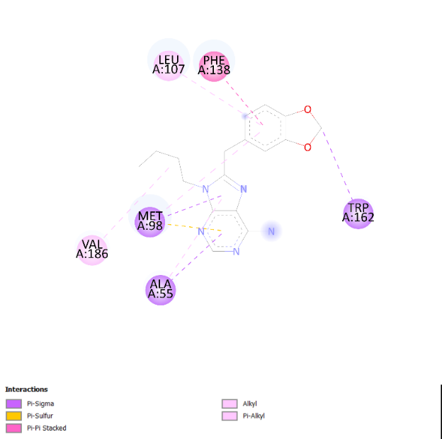 | 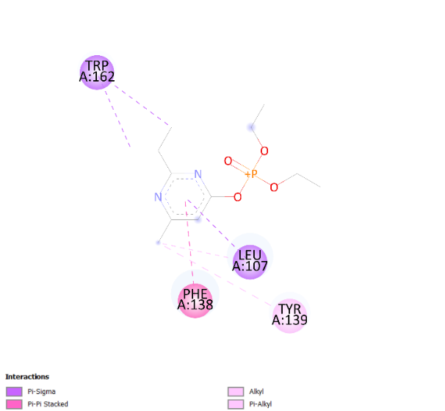
Chlorpyrifos oxon | Paraoxon
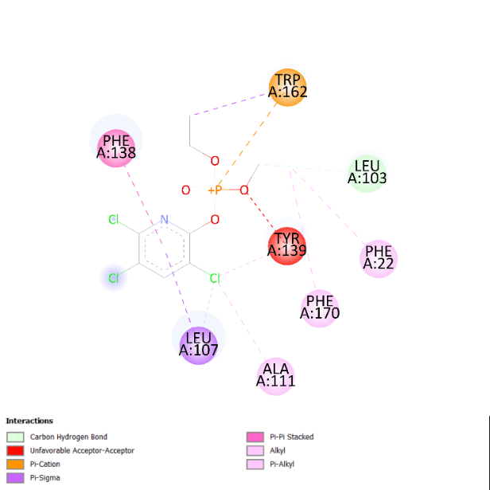 | 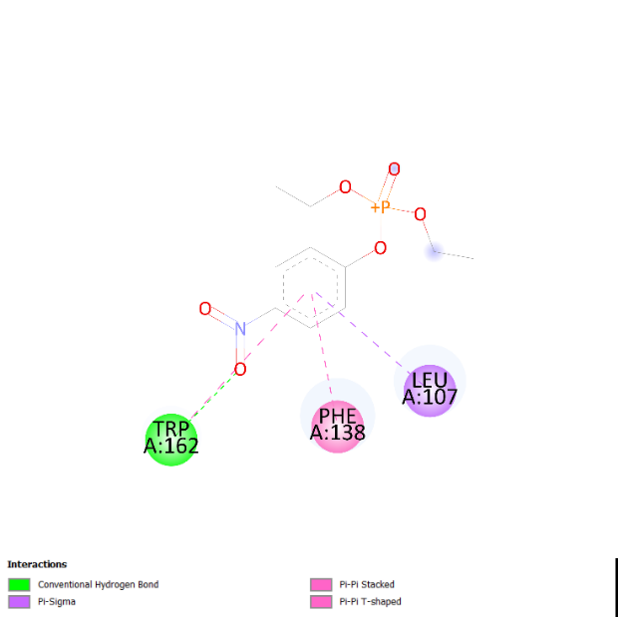
HSPA8
2BK* | Chlorpyrifos oxon
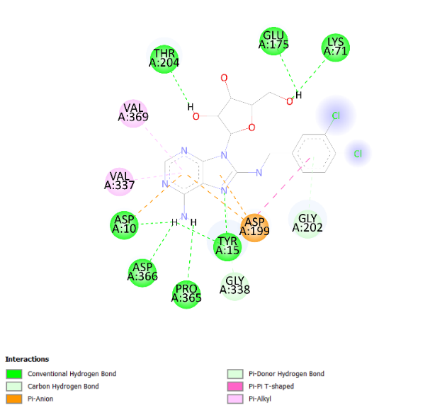 | 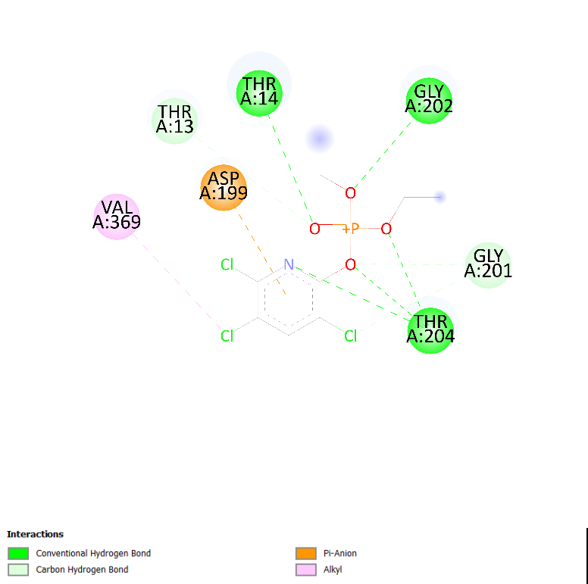
ESR1
EST* | Chlorpyrifos oxon
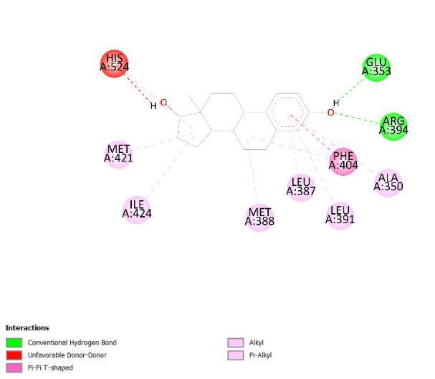 | 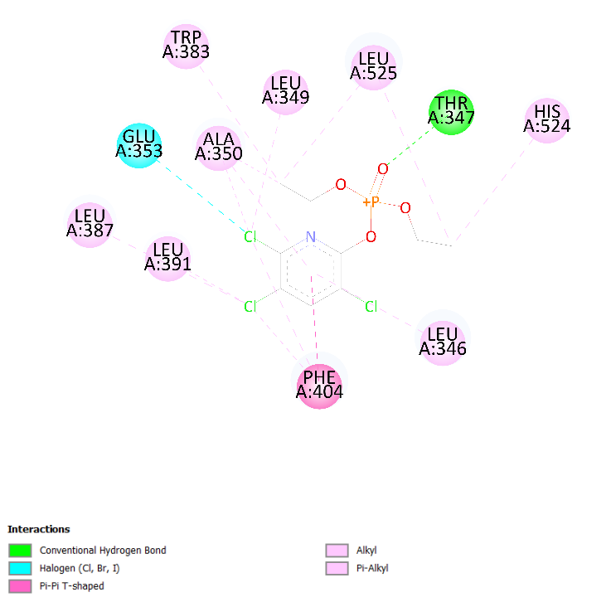
EP300
QS1* | Chlorpyrifos oxon
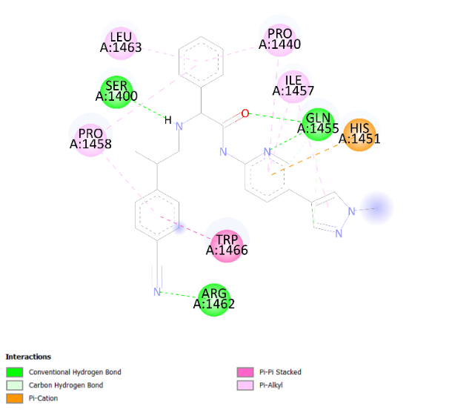 | 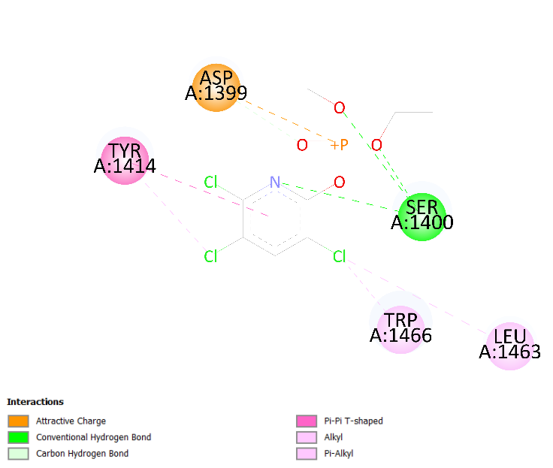
PIK3R1
KKR* | Diazinon oxon
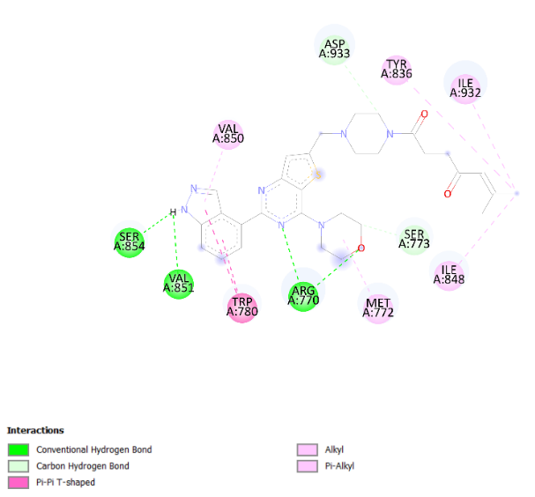 | 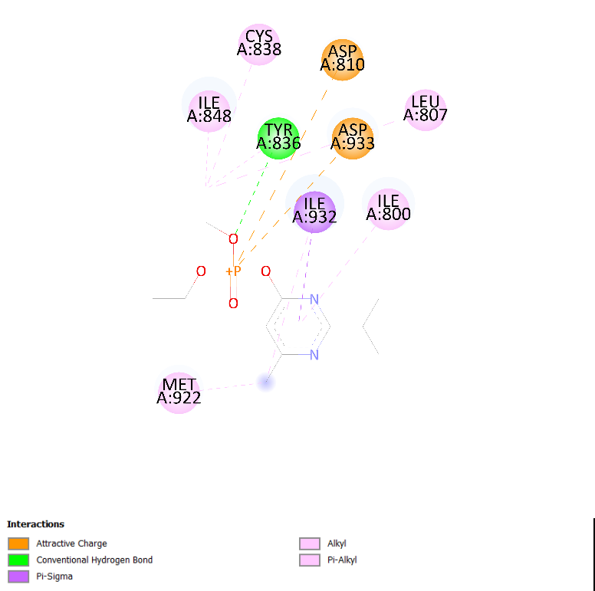
Paraoxon
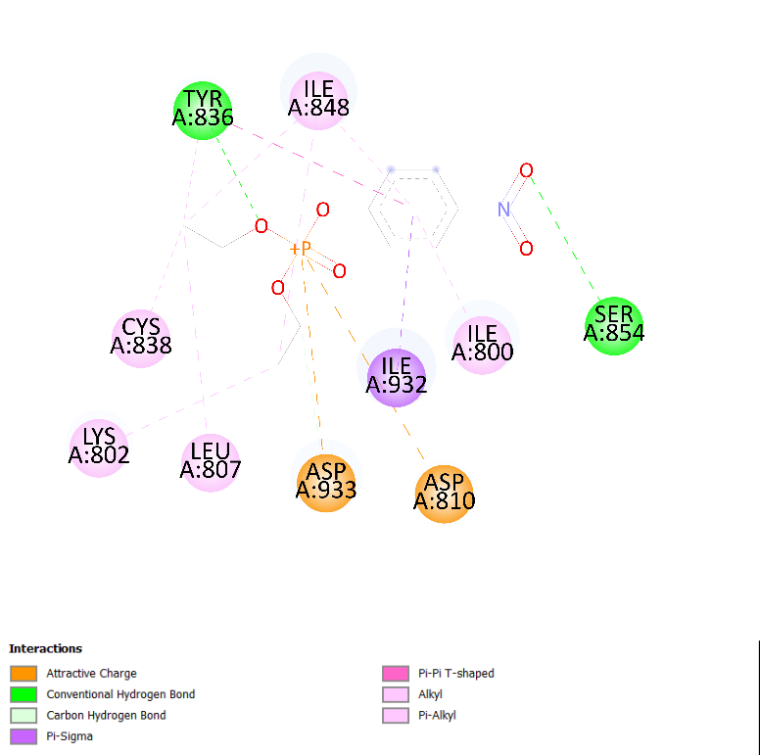
MET
AM7* | Diazinon oxon
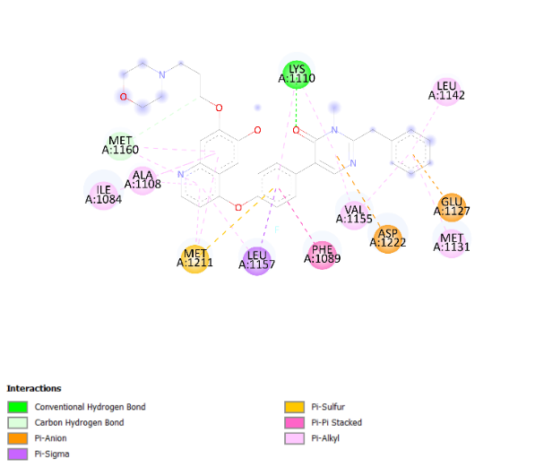 | 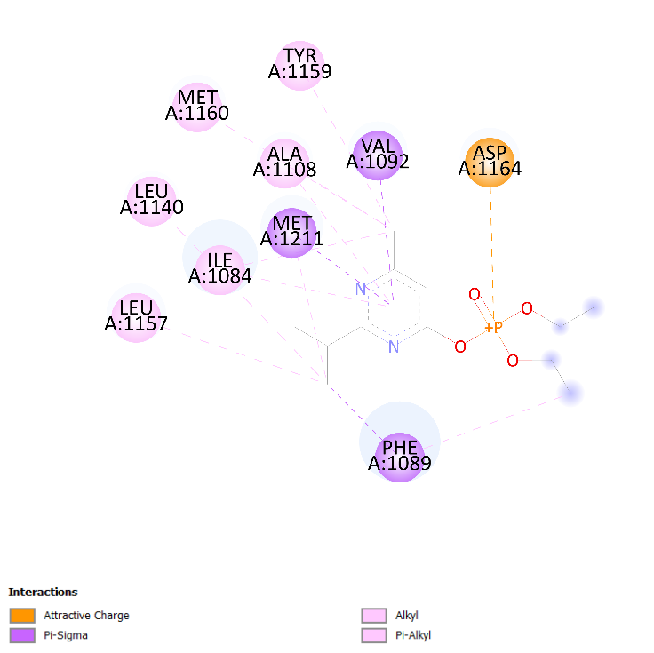
Chlorpyrifos oxon | Paraoxon
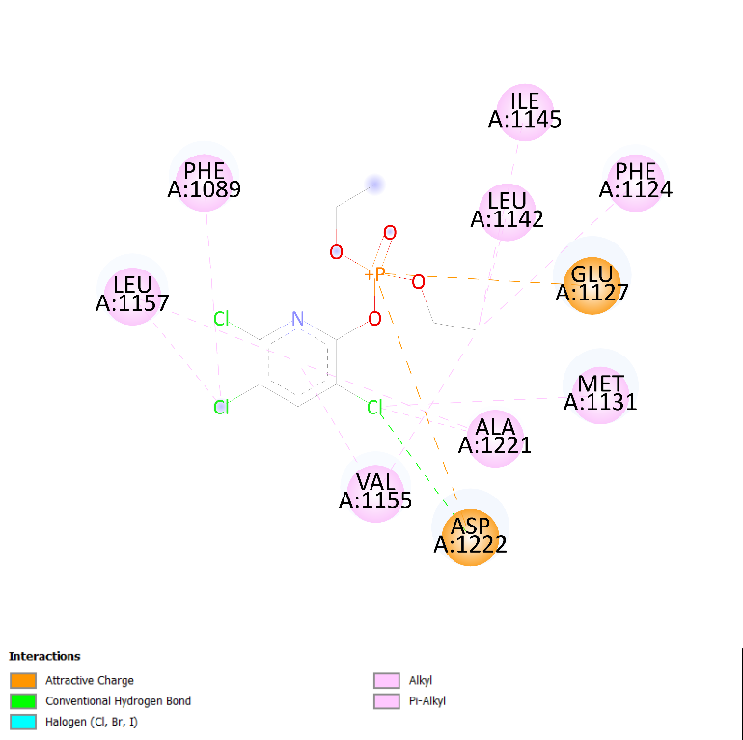 | 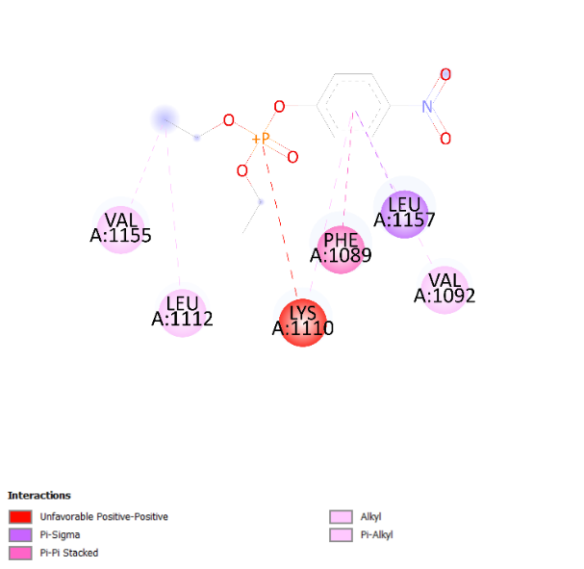
MAPK1
SB2* | Chlorpyrifos oxon
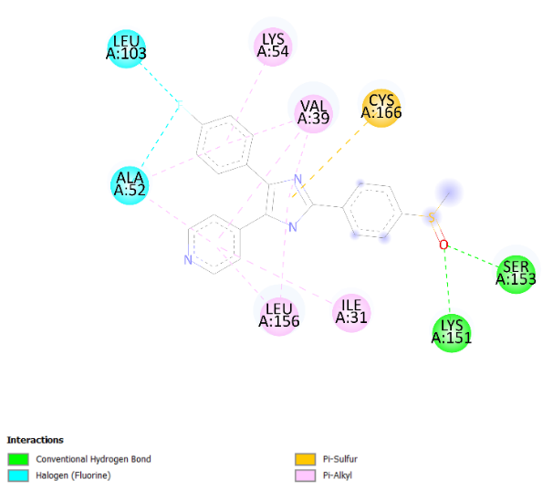 | 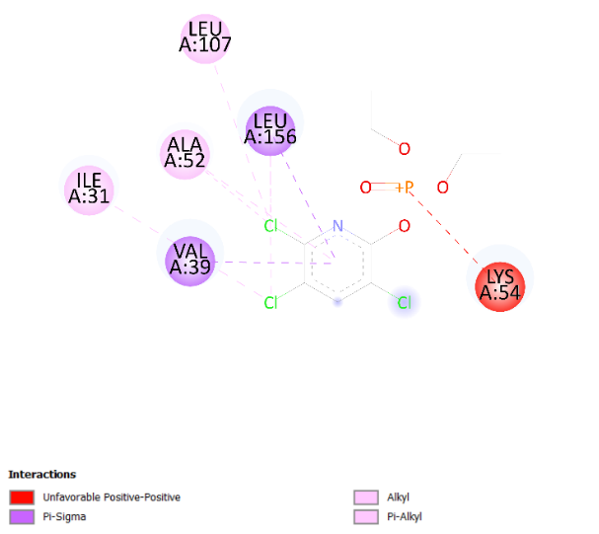
EGFR
AQ4* | Diazinon oxon
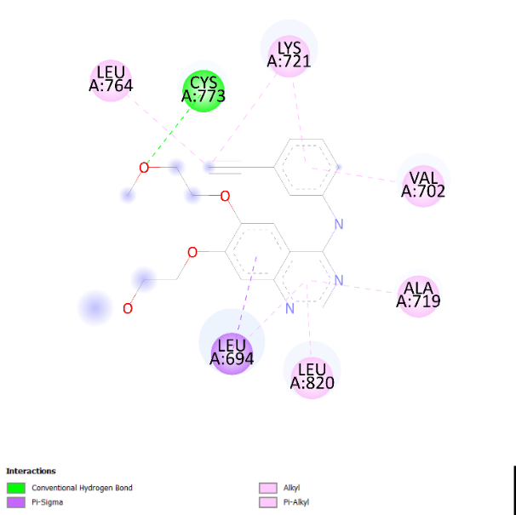 | 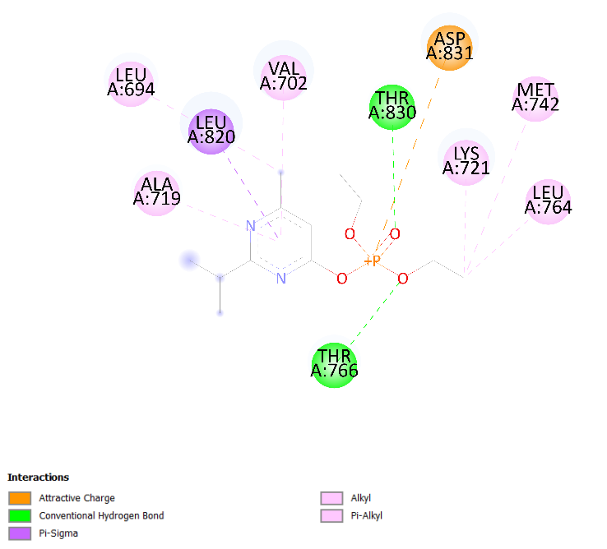
Chlorpyrifos oxon | Paraoxon
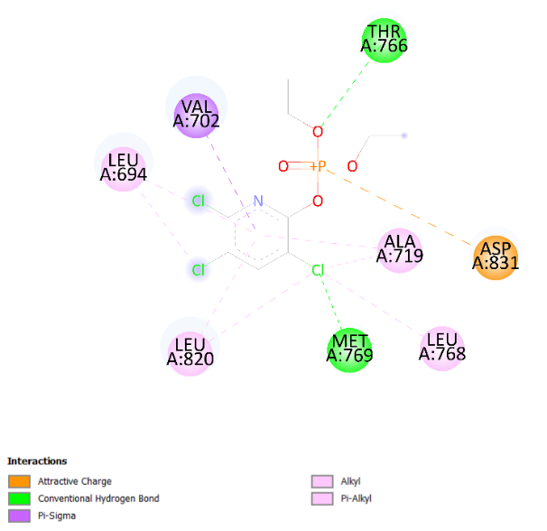 | 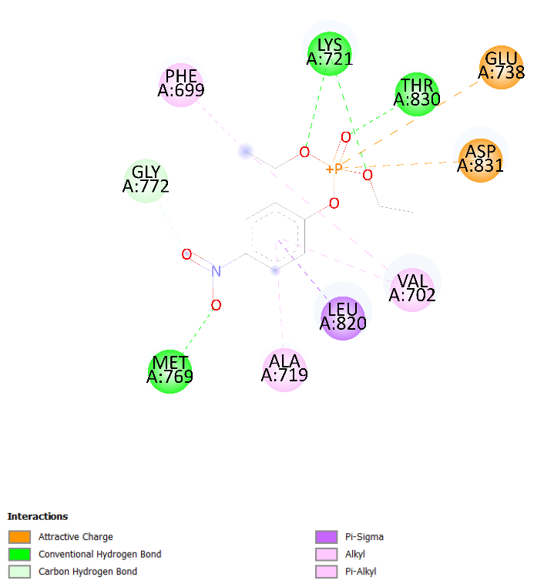
APH1A
PC1* | Diazinon oxon
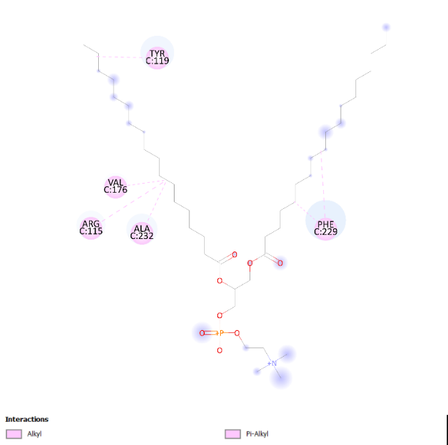 | 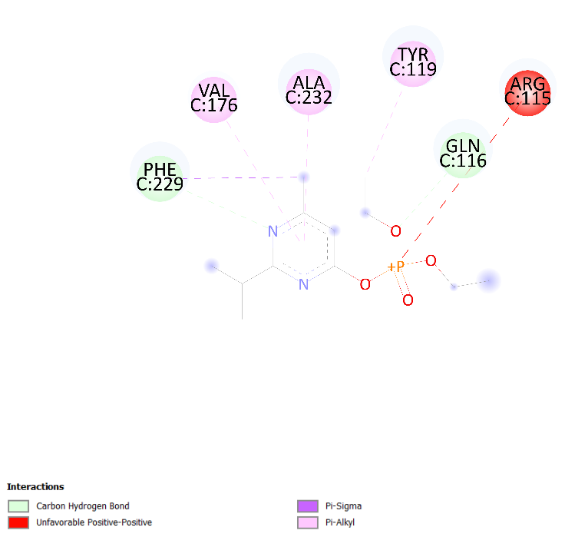
Paraoxon
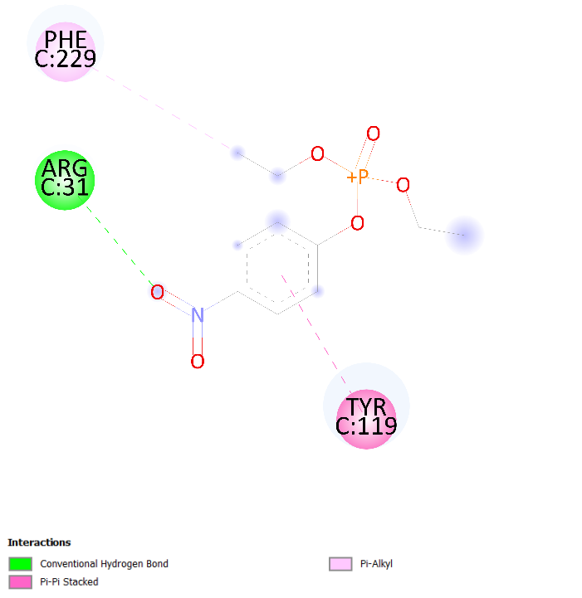
PTPN11
B2B* | Diazinon oxon
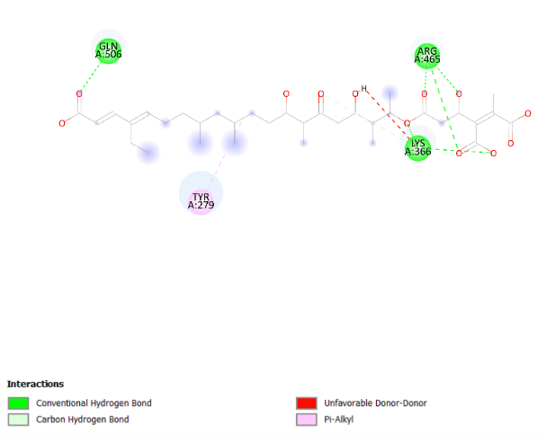 | 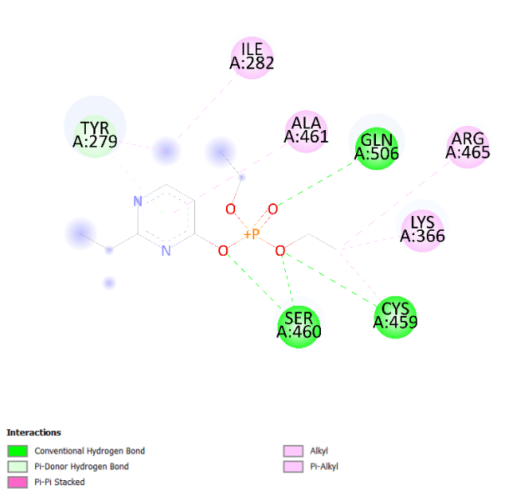
Paraoxon
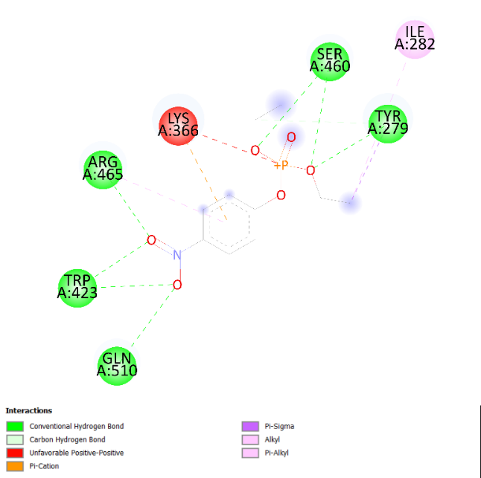
CALM1
TFP* | Chlorpyrifos oxom
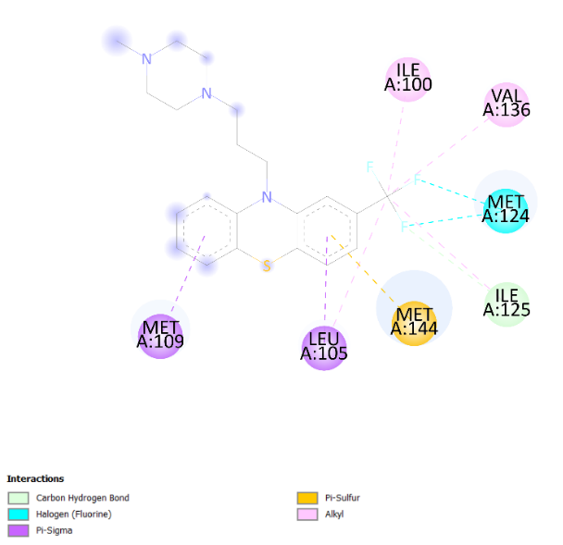 | 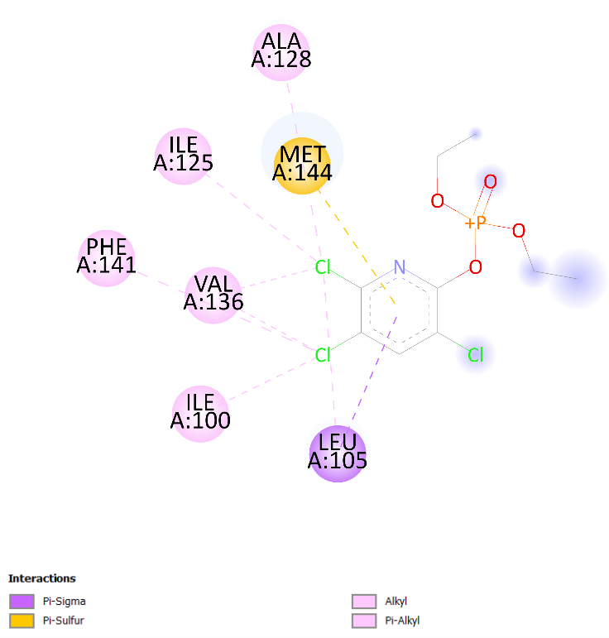
STAT3
KQV* | Diazinon oxon
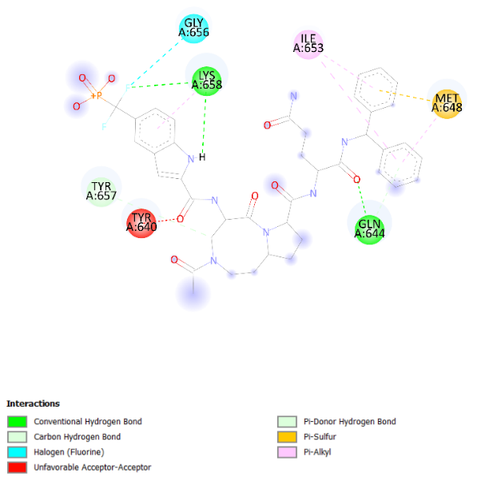 | 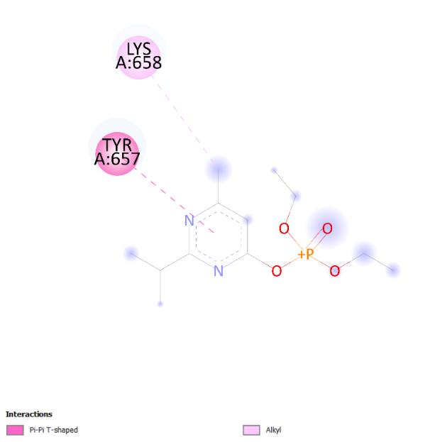
ERBB2
NAG* | Paraoxon
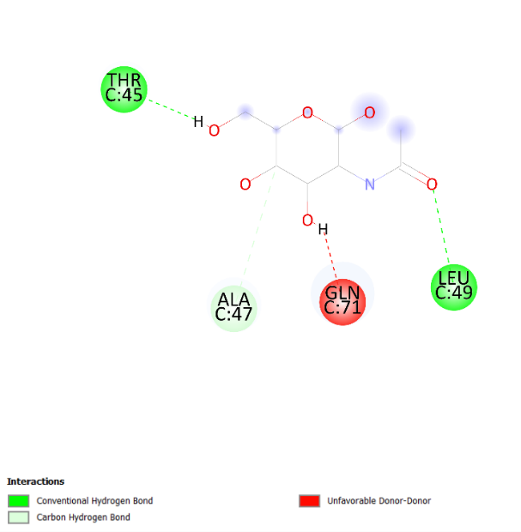 | 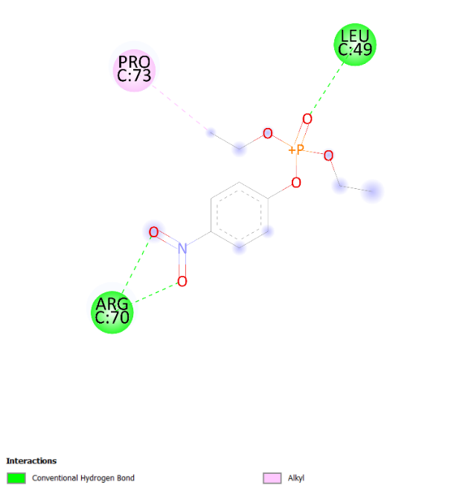
SRC
903* | Diazinon oxon
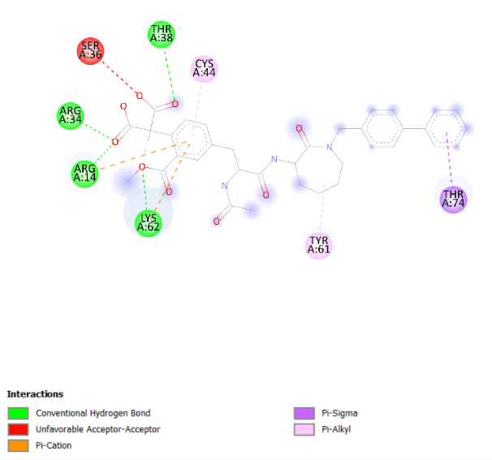 | 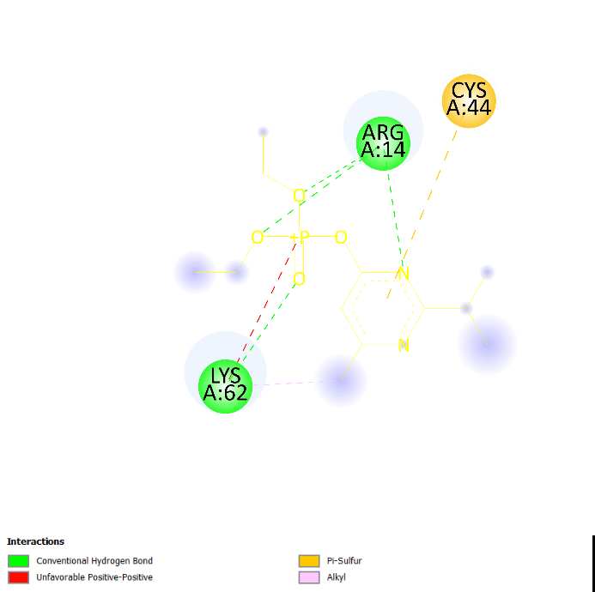
Chlorpyrifos oxon | Paraoxon
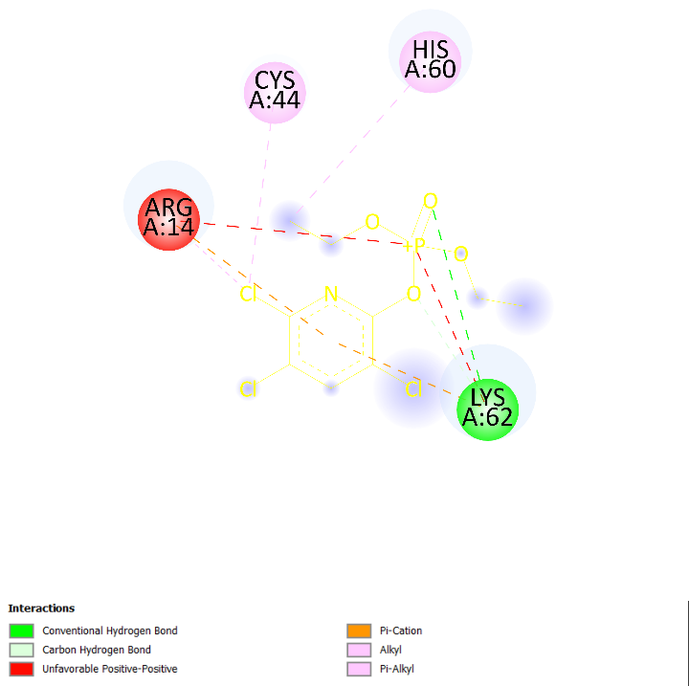 | 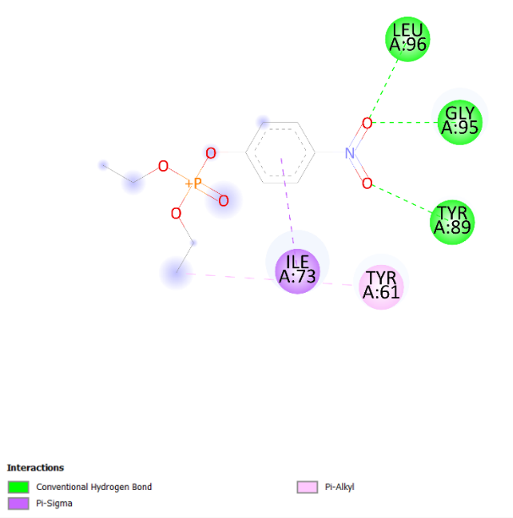
NCSTN
NAG* | Diazinon oxon
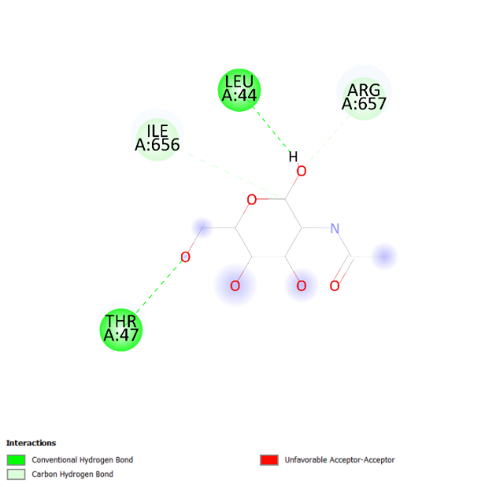 | 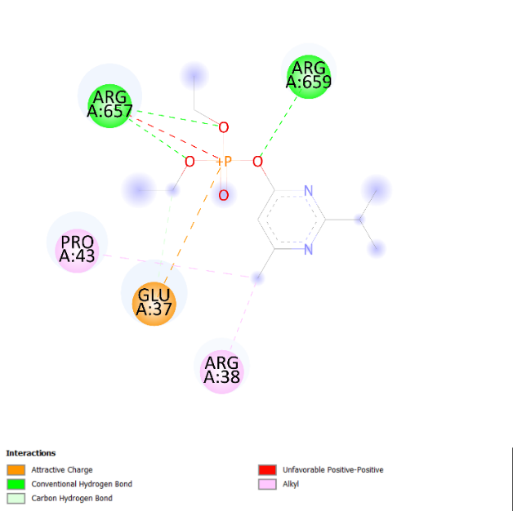
Paraoxon
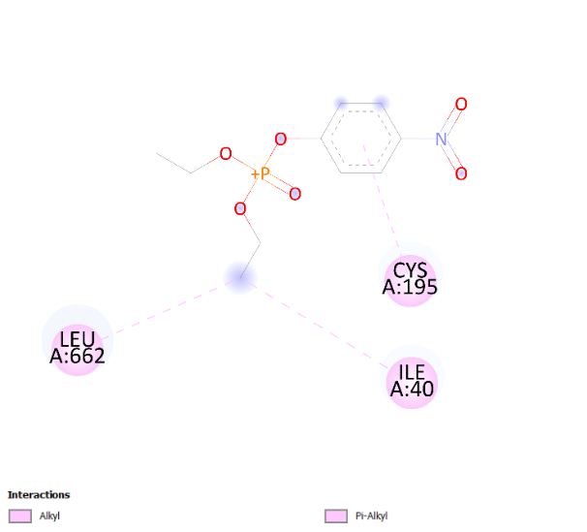
PSENEN
NAG* | Diazinon oxon
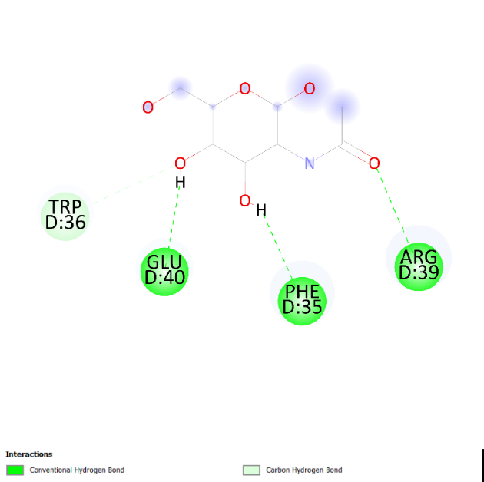 | 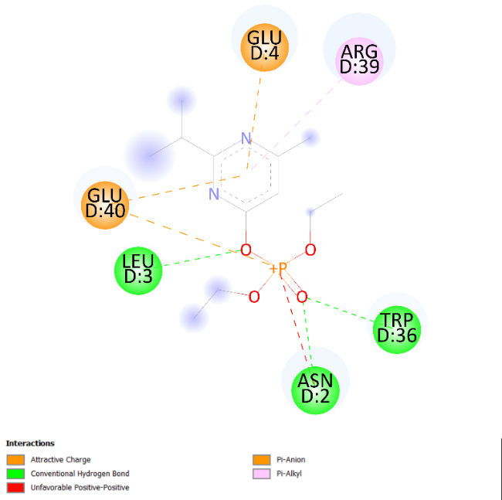
Paraoxon
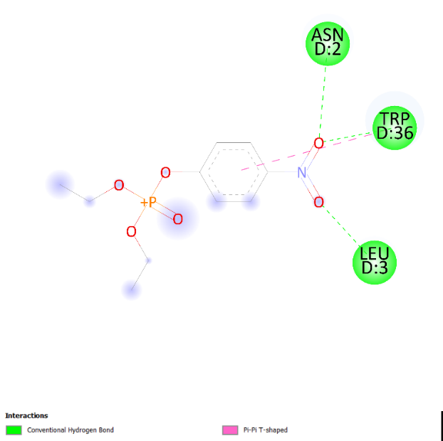
PTPN1
761* | Chlorpyrifos oxon
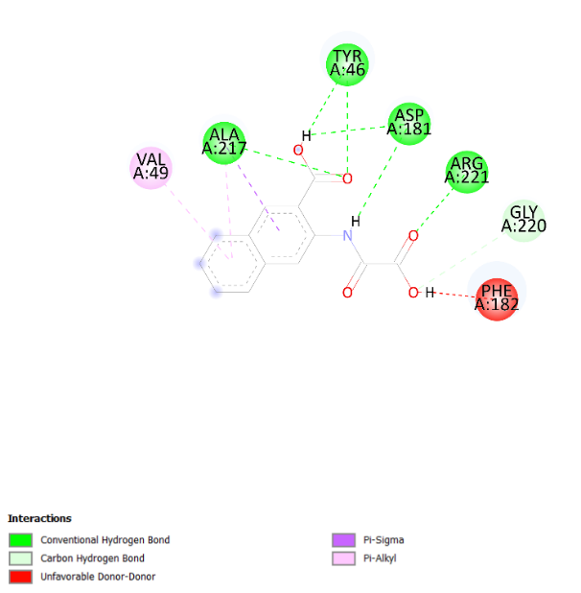 | 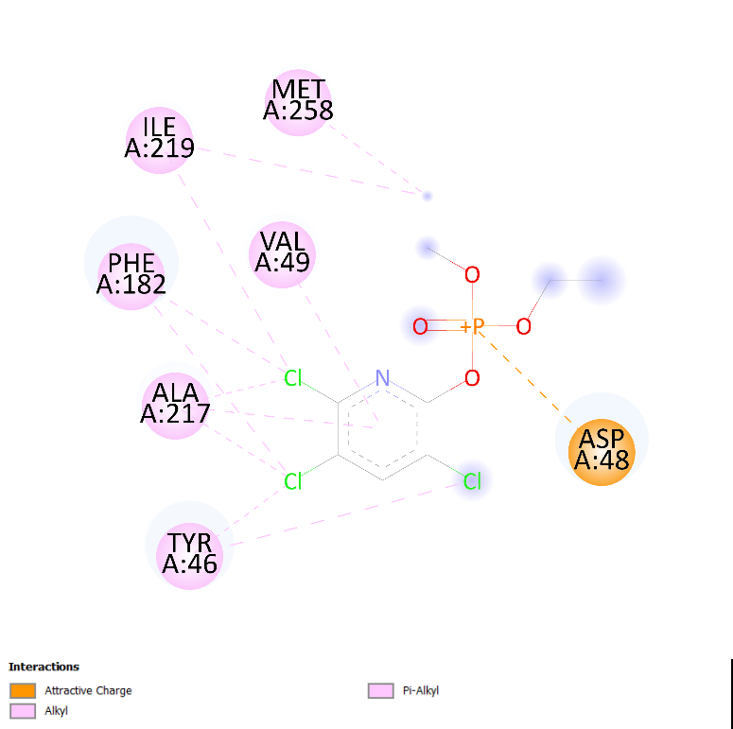
* original ligand

