Supportting information
Jiawen Wang¹, Jixian Li¹, Jun Zhang¹, Shuyue Liu¹, Liqiang Wan¹, Zuozhen Liu^{1,2}, Farong Huang^{1,}*
¹ Key Laboratory for Specially Functional Materials and Related Technology of Ministry of Education, School of Materials Science and Engineering, East China University of Science and Technology, Shanghai 200237, China.
² Huachang Polymers Co. Ltd. East China University of Science and Technology Shanghai 200241, P. R. China
* Correspondence: F. Huang (E-mail: fhuanglab@ecust.edu.cn)

1. Structural characterization of monomers

1.1. Furfuryl glycidyl ether (FGE)
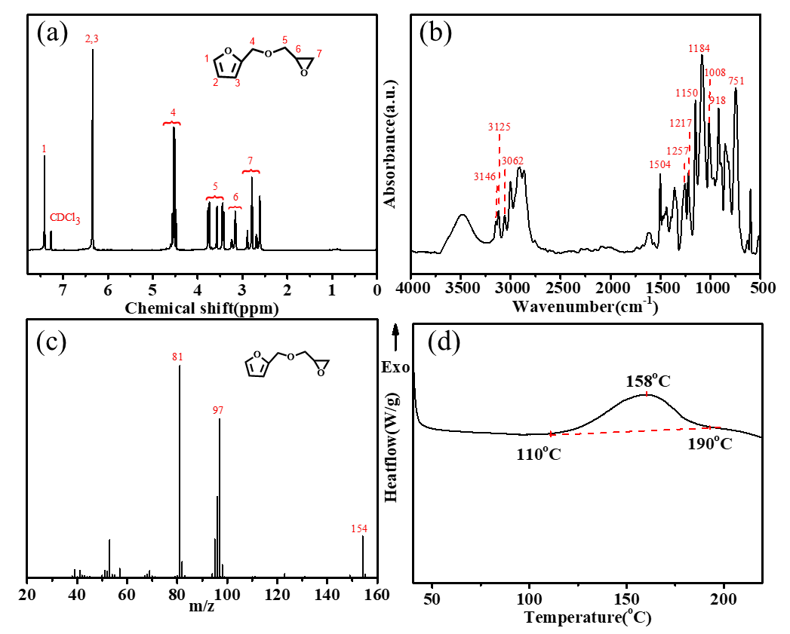
Figure S1. ¹H-NMR spectra (a), FT-IR spectra (b), EI-MS spectra (c), and DSC curve (d).

1.2. N, N'-hexamethylene-bismaleimide (HBMI)
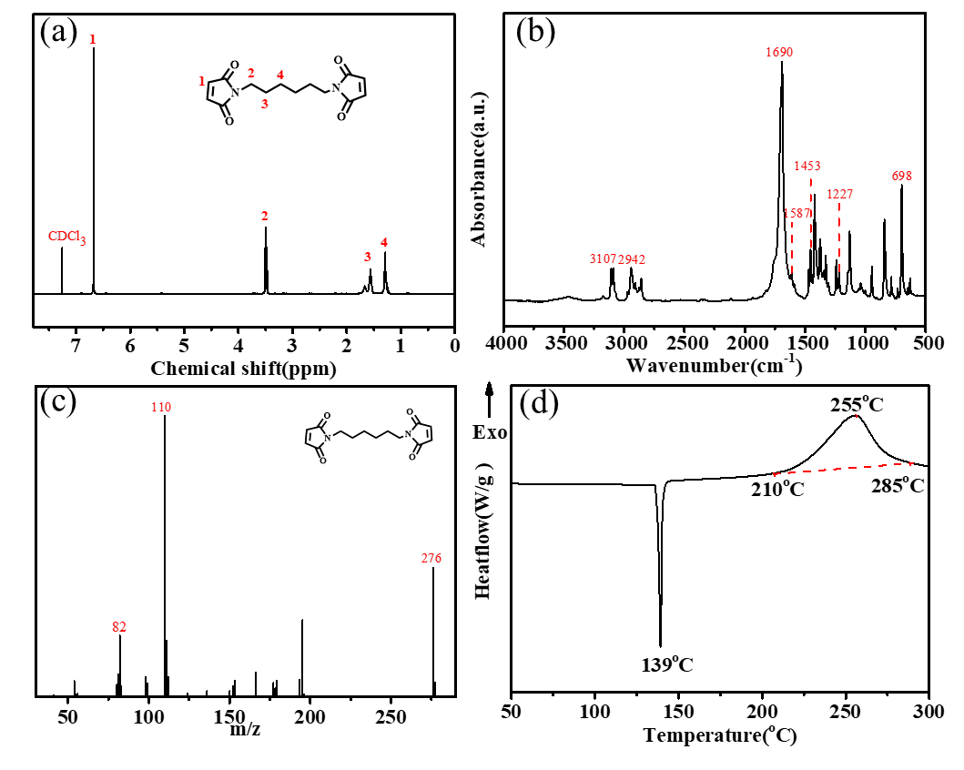
Figure S2. ¹H-NMR spectra (a), FT-IR spectra (b), EI-MS spectra (c), and DSC curve (d).

2. Curing procedures and structural characterization of FGE-ODA-HBMI resin
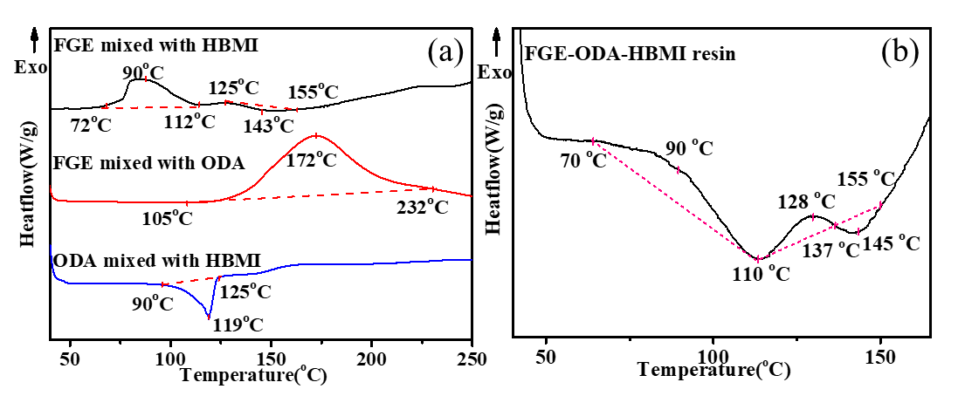
Figure S3. DSC curves of FGE mixed with HBMI, FGE mixed with ODA, ODA mixed with HBMI (a), DSC curves of FGE-ODA-HBMI resin (b).
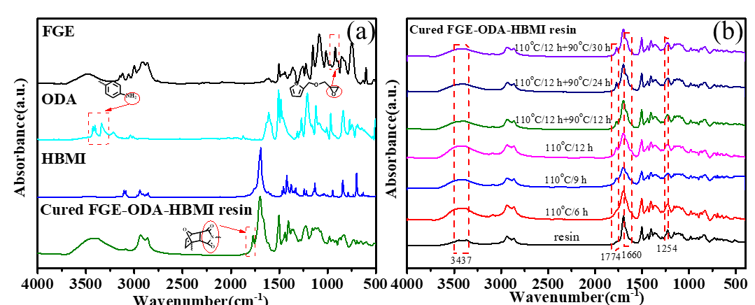
Figure S4. FT-IR spectra of the cured FGE-ODA-HBMI resin and its raw materials(a), and FGE-ODA-HBMI resin at different curing stage (b).

3. The sol-gel transformation process of the cured FGE-ODA-HBMI resin
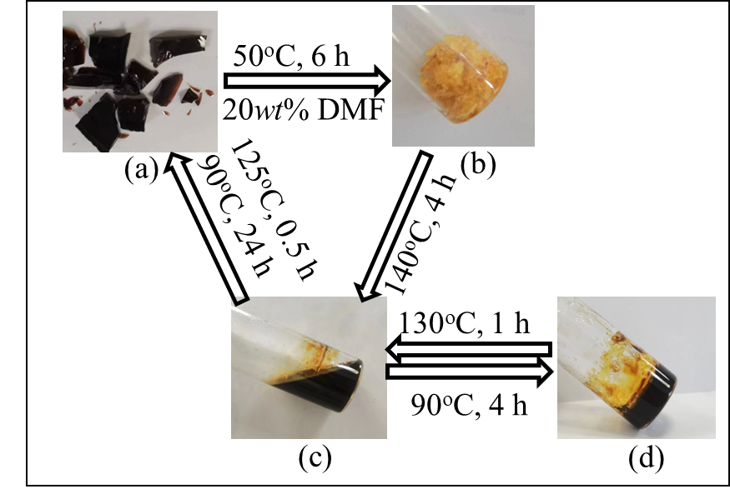
Figure S5. The photos of sol-gel transformation process for the cured FGE-ODA-HBMI resin: the small fragments of cured resin (a), the swelled state of cured resin (b), the dissolved state of cured resin (c), the gel state of cured resin (d).

