Supplementary Information
Preferential orientation effect. Grinding by using a mortar and pestle does not change the theta positions of the X-ray diffraction peaks but has a great impact on the relative intensities of the diffraction peaks.
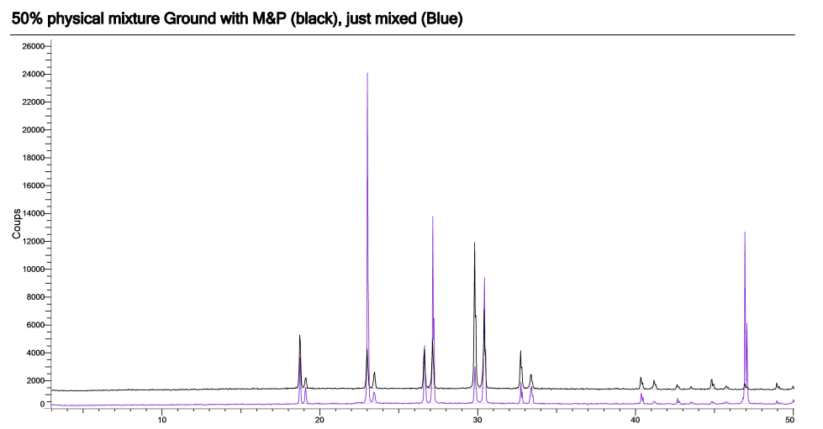

Table SI-1 refined average parameter versus composition of the solid solution obtained by Spray-Drying with protocol 1.

% NaBrO3 | a (Å)
0 | 6,5707
5 | 6,5773
10 | 6,5837
15 | 6,5884
17,5 | 6,5926
20 | 6,5962
25 | 6,6019
30 | 6,6064
35 | 6,615
40 | 6,6147
50 | 6,6297
60 | 6,6374
70 | 6,6503
80 | 6,6725
90 | 6,685
100 | 6,6994

