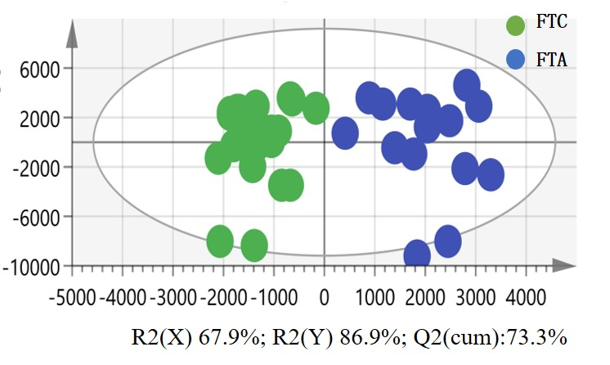
Supplementary Figure 1A
OPLS‐DA score plots based on positive AFAIDESI‐MSI data from FTC and FTA.

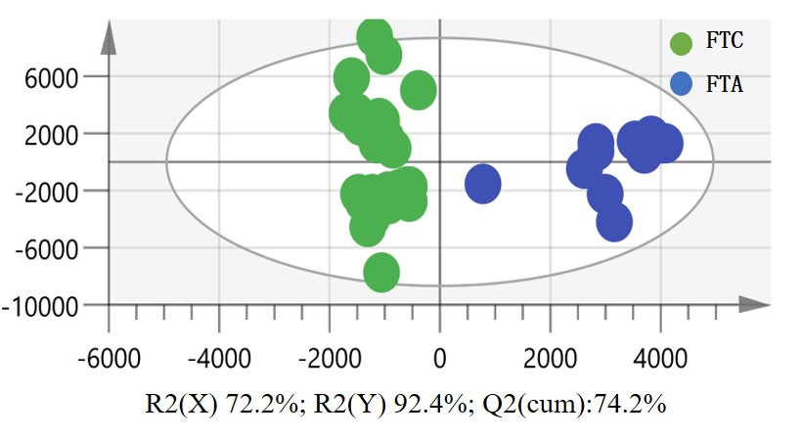
Supplementary Figure 1B
OPLS‐DA score plots based on negative AFAI‐MSI data from FTC and FTA.

Supplementary Table 1 The discriminated meatbolites between FTA and FTC.

Peak（m/z） | Formula | Identification | Ion type
758.5623 | C₄₂H₈₀NO₈P | PC(34:2) | [M+H]⁺
780.5435 | C₄₂H₈₀NO₈P | PC(34:2) | [M+Na]⁺
782.5669 | C₄₂H₈₂NO₈P | PC(34:1) | [M+Na]⁺
784.5823 | C₄₂H₈₄ NO₈P | PC(34:0) | [M+Na]⁺
786.5993 | C₄₄H₈₄NO₈P | PC(36:2) | [M+H]⁺
804.5503 | C₄₆H₇₈NO₈P | PC(38:7) | [M+H]⁺
806.5620 | C₄₄H₈₂NO₈P | PC(36:3) | [M+Na]⁺
808.581 | C₄₄H₈₄NO₈P | PC(36:2) | [M+Na]⁺
96.9677 | H₃PO₄ | Phosphoric acid | [M-H]⁻
309.2038 | C₂₀H₃₈O₂ | FA(20:1) | [M-H]⁻
283.2638 | C₁₈H₃₆O₂ | FA(18:0) | [M-H]⁻
255.2321 | C₁₆H₃₂O₂ | FA(16:0) | [M-H]⁻
329.2383 | C₁₈H₃₄O₅ | 9,10,13-TriHOME | [M-H]⁻
311.2195 | C₁₈H₃₂O₄ | 9,10-DiHODE | [M-H]⁻
215.0308 | C₆H₁₂O₆ | Glucose | [M+Cl]⁻
281.2457 | C₁₈H₃₄O₂ | FA(18:1) | [M-H]⁻
279.2291 | C₁₈H₃₂O₂ | FA(18:2) | [M-H]⁻
121.0279 | C₇H₆O₂ | Hydroxybenzaldehyde | [M-H]⁻
327.2345 | C₂₂H₃₂O₂ | FA(22:6) | [M-H]⁻
293.2008 | C₁₈H₃₀O₃ | 11-oxo-(7E,9E)-octdecadienoic acid | [M-H]⁻

