Supporting Information
New insights into the enhancement effect of exogenous calcium on biochar stability during its aging in farmland soil

Hongyan Nan^{1,2}, Yunqiu Jiang³, Weiqi Zhou⁴, Ling Zhao^{2,5}, Fan Yang^{6,*}

¹School of Chemical Engineering, Zhengzhou University, Henan 450001, China
²School of Environmental Science and Engineering, Shanghai Jiao Tong University, Shanghai 200240, China
³Hydrology and water resources Survey Bureau of the upper reaches of the Yangtze River, Hydrology Bureau of Yangtze River Water Resources Commission, Chongqing 400010, China
⁴Shanghai Investigation, Design & Research Institute Co., Ltd, Shanghai 200050, China
⁵China-UK Low Carbon College, Shanghai Jiao Tong University, Shanghai 201306, China
⁶School of Environment and Architecture, University of Shanghai for Science and Technology, Shanghai 200093, China

*Corresponding author: Fan Yang
E-mail: yangfanusst@usst.edu.cn

Table S1. Main element contents and pore structure parameters of four biochars.
Biochar | Ash  % | C  % | O  % | H  % | N  % | Ca  g·kg⁻¹ | SA-N₂ m²·g^{–1} | PS nm
SSBC | 54.3±1.2 | 24.2±0.1 | 9.28±0.2 | 1.44±0.2 | 3.50±0.1 | 17.8±1.2 | 8.50 | 2.18
Ca-SSBC | 60.1±0.8 | 19.1±0.1 | 6.61±0.1 | 1.46±0.1 | 2.41±0.1 | 96.6±3.2 | 6.04 | 4.22
BDBC | 55.3±0.1 | 17.2±0.7 | 17.0±0.1 | 1.23±0.1 | 2.63±0.1 | 99.4±7.2 | 89.6 | 9.73
Ca-BDBC | 83.8±0.4 | 12.5±0.9 | 13.1±0.2 | 2.47±0.2 | 1.90±0.2 | 153±10.7 | 119.7 | 6.79
SSBC: sewage sludge biochar; Ca-SSBC: CaCl₂+sewage sludge biochar; BD: bone dreg biochar; Ca-BDBC: CaCl₂+bone dreg biochar; SA: BET-N₂ surface area; PS: pore size.

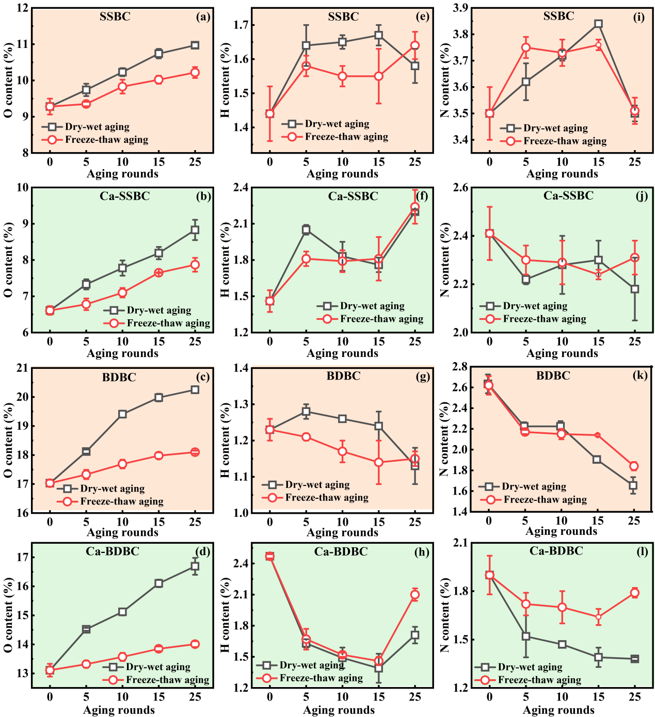
Figure S1. Variations of oxygen (O), hydrogen (H), and nitrogen (N) element contents in pristine biochar and Ca-rich biochar under different aging processes (n=3) (SSBC: sewage sludge biochar; BDBC: bone dreg biochar; Ca-SSBC: CaCl₂+sewage sludge biochar; Ca-BDBC: CaCl₂+bone dreg biochar)

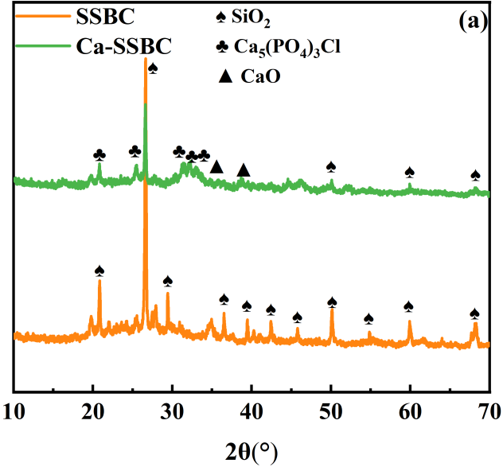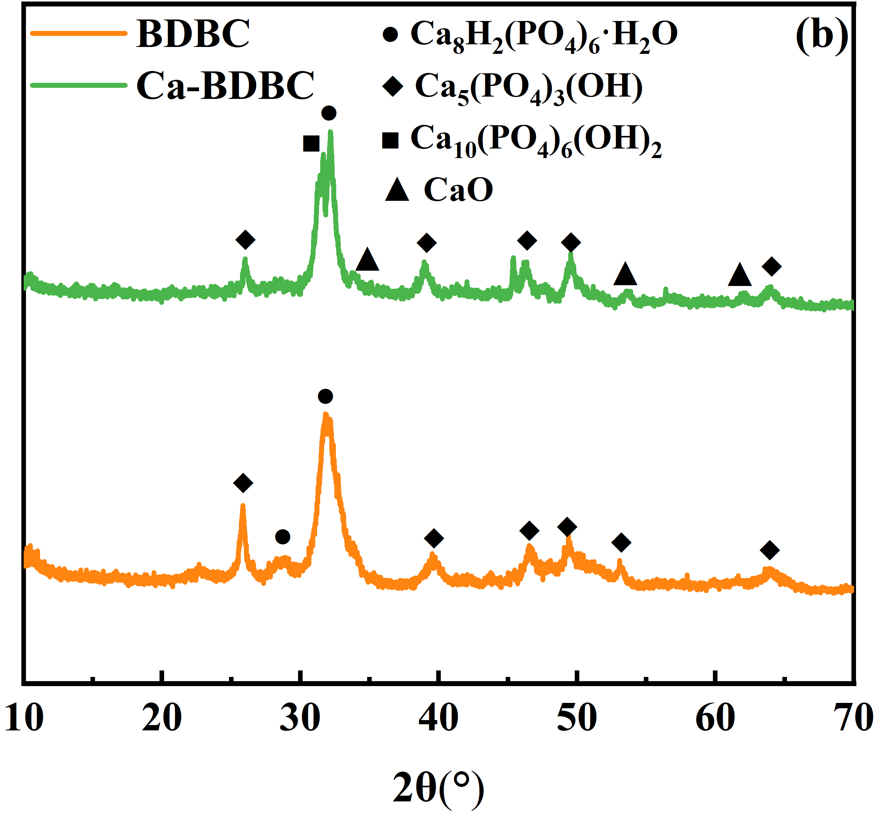
Figure S2. Surface crystals compositions of pristine biochar (SSBC: sewage sludge biochar; BDBC: bone dreg biochar) and Ca-rich biochar (Ca-SSBC: CaCl₂+sewage sludge biochar; Ca-BDBC: CaCl₂+bone dreg biochar).

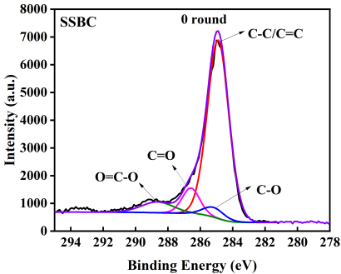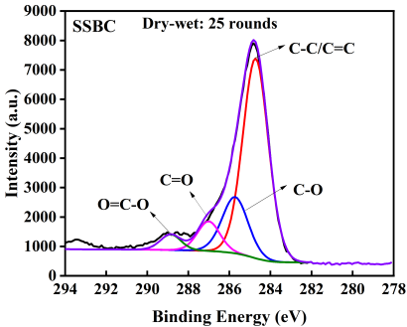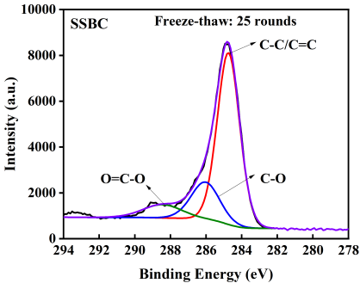
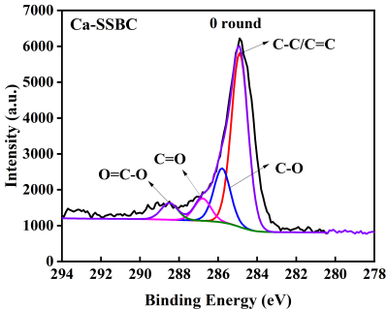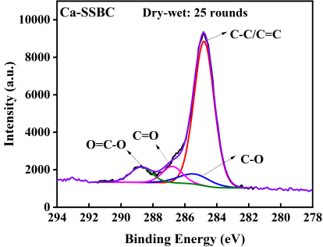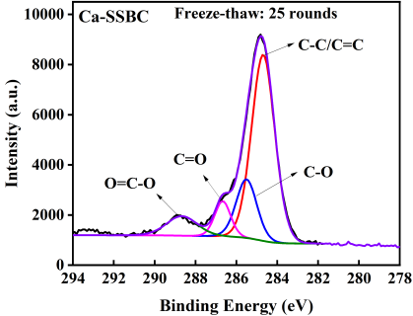
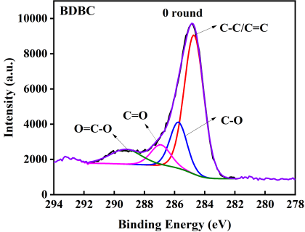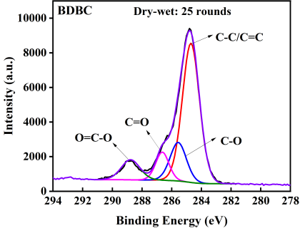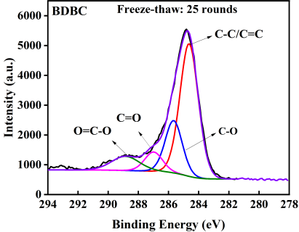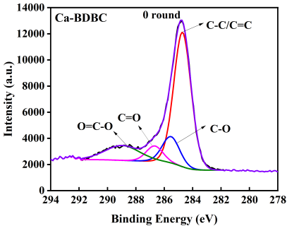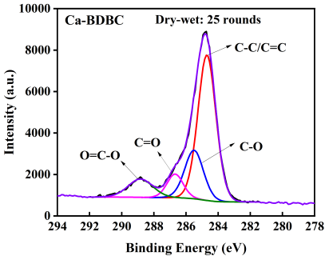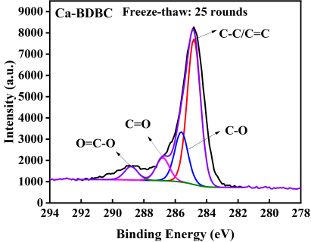
Figure S3. Surface carbon functional groups of pristine biochar and Ca-rich biochar with different aging processes (SSBC: sewage sludge biochar; BDBC: bone dreg biochar; Ca-SSBC: CaCl₂+sewage sludge biochar; Ca-BDBC: CaCl₂+bone dreg biochar)

