Supplementary Information

Supplementary Figures
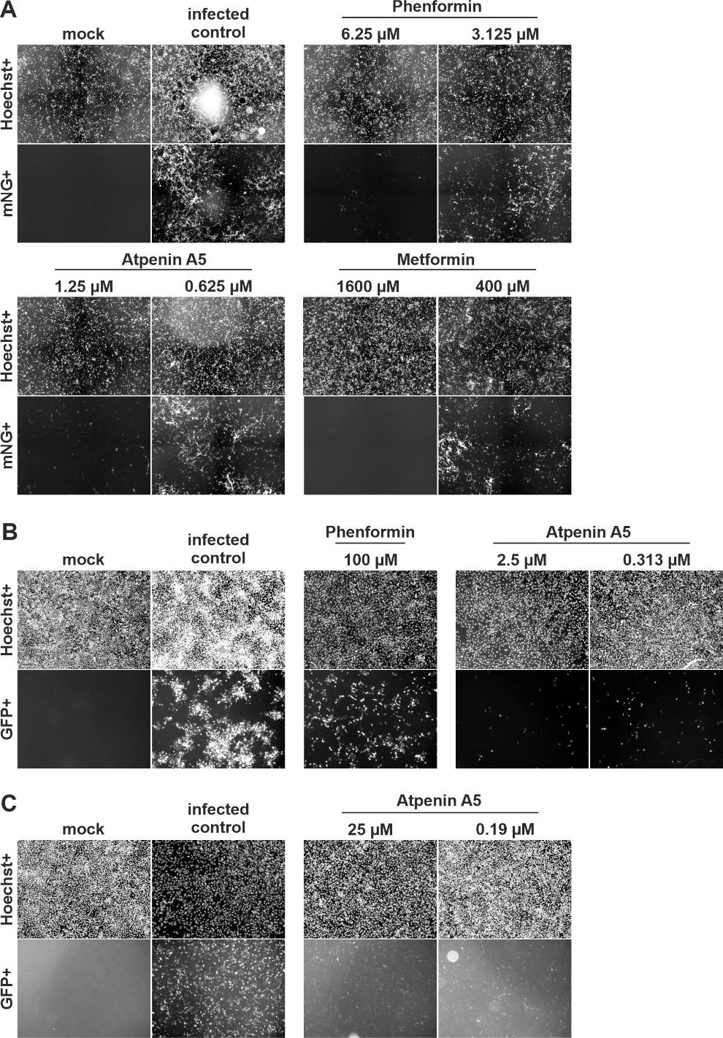

Supplementary Figure 1 | Primary data of infection experiments showing inhibition of SARS-CoV-2, RSV, and IAV by atpenin A5, phenformin, and metformin. Images show A Calu-3 cells infected with icSARS-CoV-2-mNG B A549 cells infected with the respiratory syncytial virus and C A549 cells infected with influenza A virus treated with the indicated compounds and concentrations.

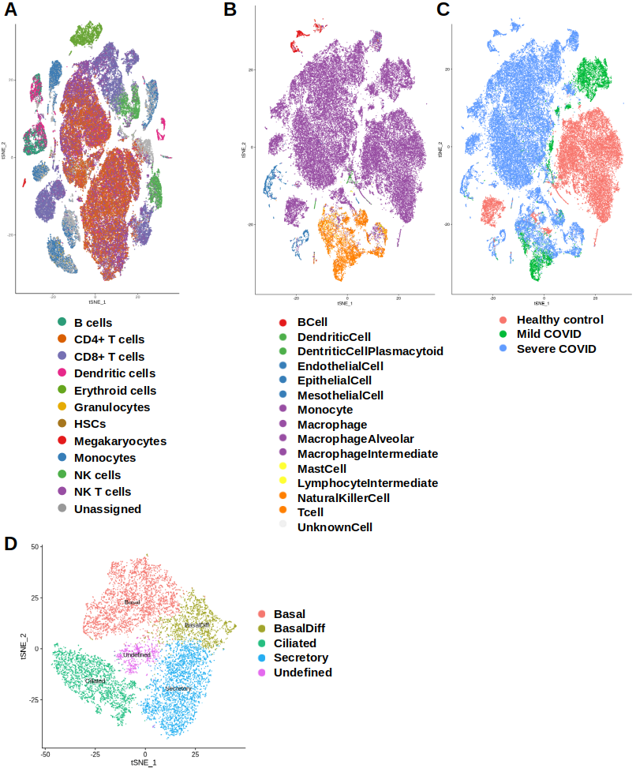
Supplementary Figure 2 | tSNE plots of cell types for the individual single-cell expression datasets of viral infection. Panels show A CHETAH-derived cell type annotation of the dengue dataset, based on a PBMC reference, and B CHETAH-derived cell type annotation of the BALF1 dataset, based on a single cell lung atlas. Panel C shows the same tSNE-plot as B of the BALF1 dataset but color coded for donors’ health or COVID status. D Manual cell type annotation of the influenza H1N1 dataset.
Supplementary Tables
Supplementary Table S1 - Differentially active pathways in SARS-CoV-2 infected individuals
Supplementary Table S2 - Virus-host-interactions
Supplementary Table S3 - High-confidence tier-1 and tier-2 targets (Fig. 3)
Supplementary Table S4 - Frequency of tier-1 targets
Supplementary Table S5 - Broad-spectrum antiviral targets
Supplementary Table S6 - Viral protein copy numbers
Supplementary Table S7 - Viral replication reactions
Supplementary Table S8 - Blood Serum constraints
Supplementary Table S9 - Dengue dataset cell type annotation

Supplementary Data
Supplementary Data S1 - Metabolic map of predicted shared tier-1 targets (blue) and broad-spectrum antiviral targets (red) across human metabolism. The map was created following the SBGN standard (Touré et al., 2021) using Recon2Map (Noronha et al., 2017) based on the MINERVA platform (Gawron et al., 2016).
Supplementary Data S2 - Viral replication rates, predicted tier-1/tier-2 targets and metadata for all reconstructed context-specific models.

