Protocol to analyze Lemanacae area with ilastik software.

- Transform images from Jpeg or other formats to TIFF
- Open ilastik
- Select : pixel classification + object classification
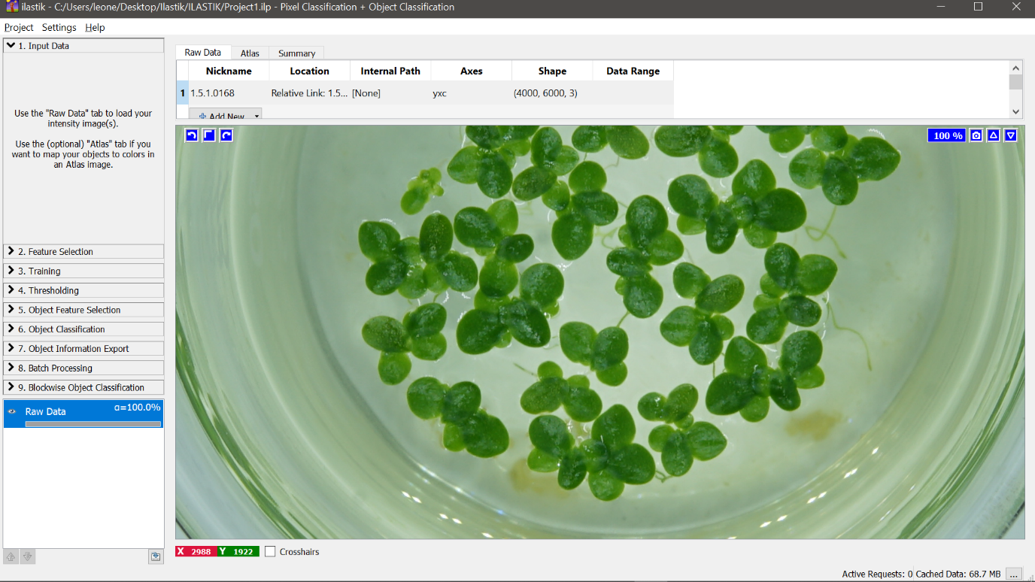
- Input data (select the picture with the highest number of fronds)

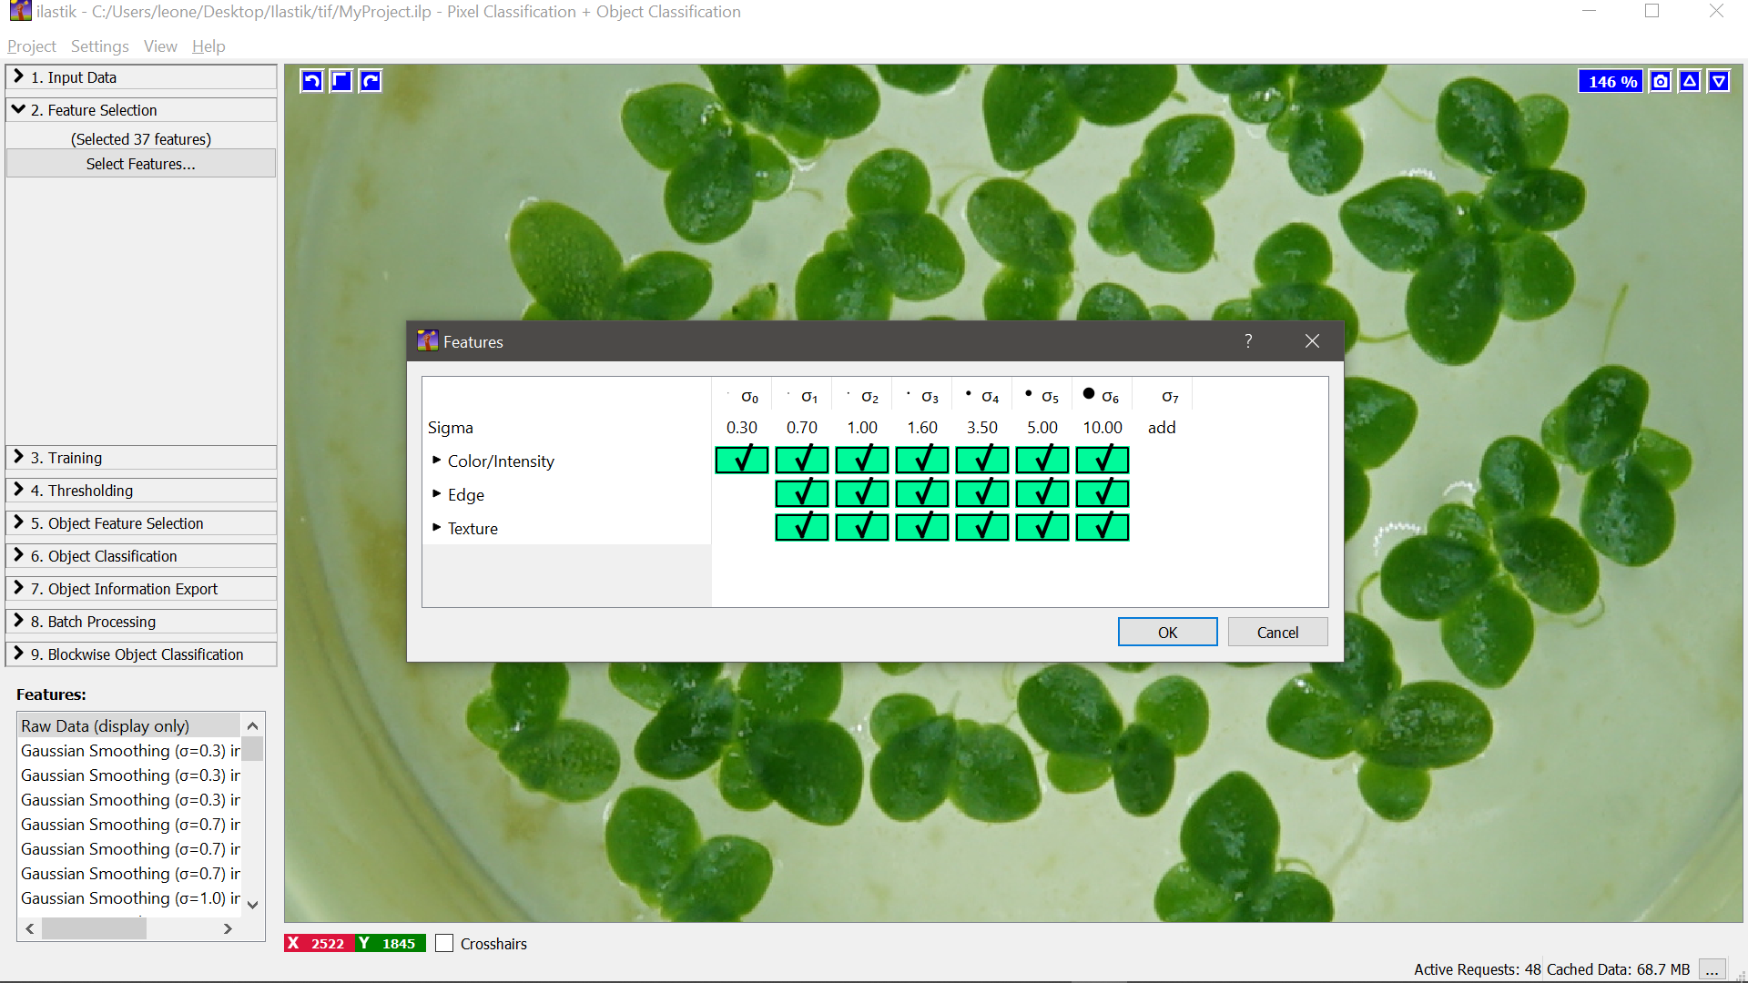
- Feature selection: select αx to αy (note that the higher the number of selected features, the heavier the computational calculation will be in the following steps)

- Training, rename labels by double clicking.
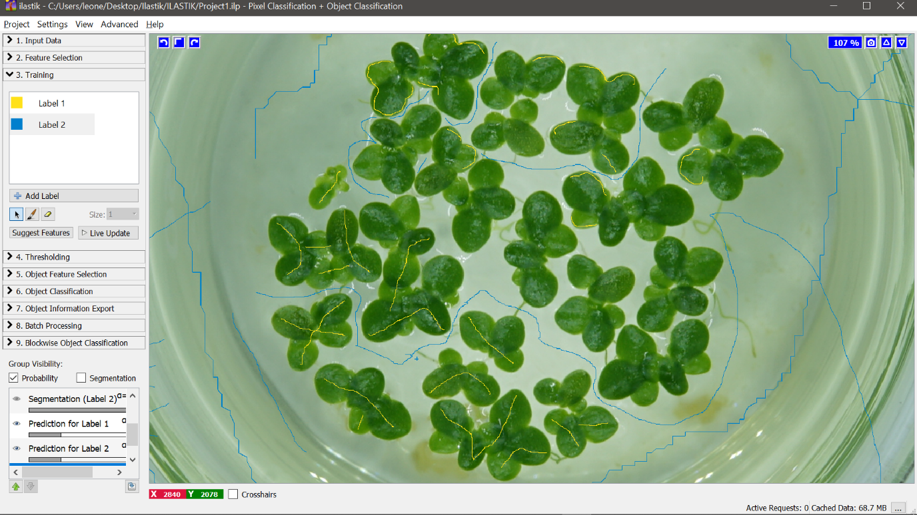

- Suggest features
- Feature selection (choose the most appropriate to the selected once)
- Run feature selection
- Select feature set
- Apply Thresholding (standard)

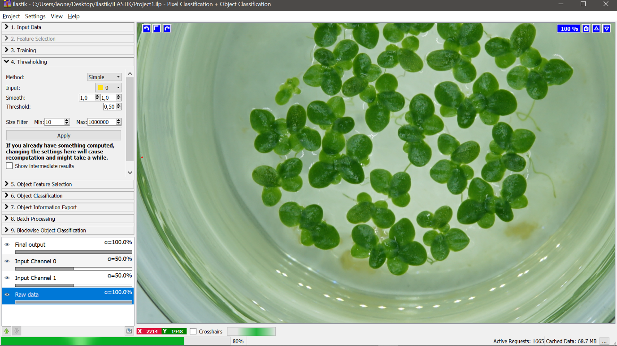

- Object feature selection:
- Select feature: Size in pixle

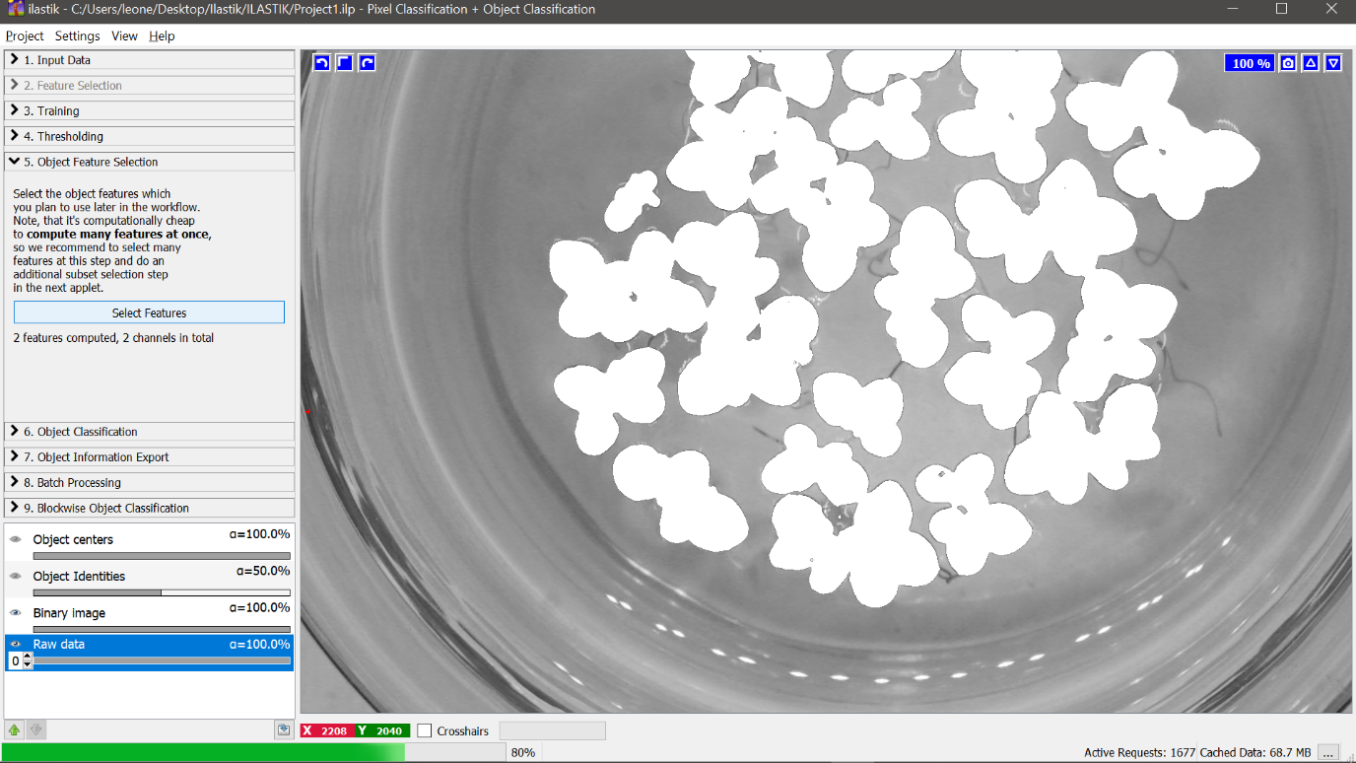
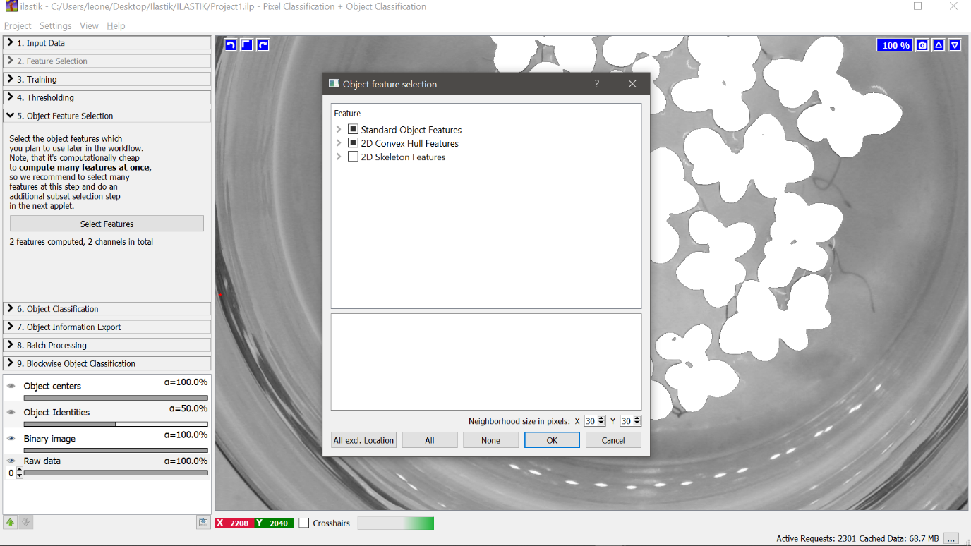

- Object classification: add lable to the white selection
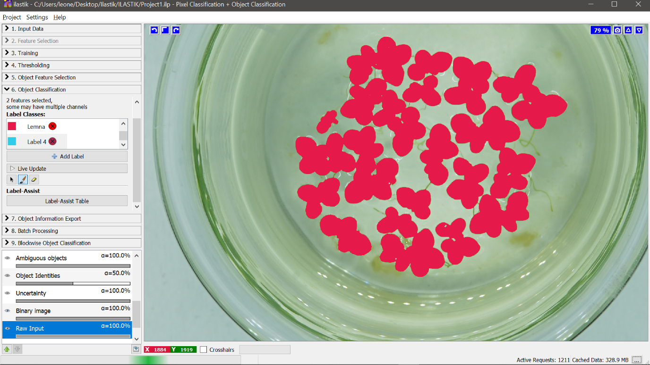

- Object information export
- Source: object probabilities
- Choose export image setting: format .tif
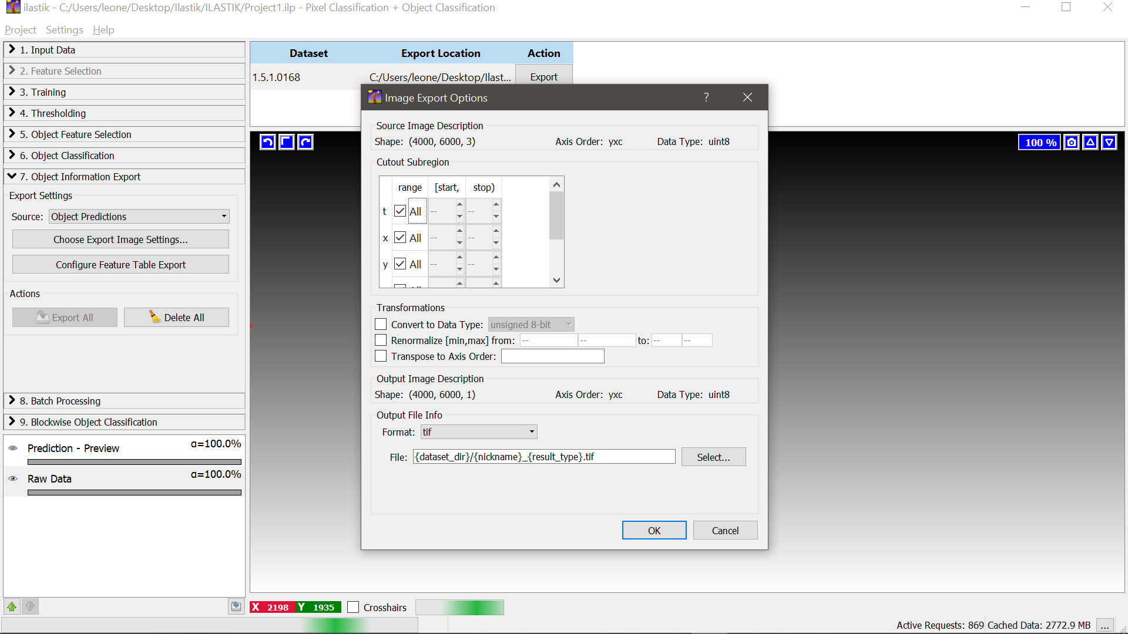
- Configure table export: Format .csv

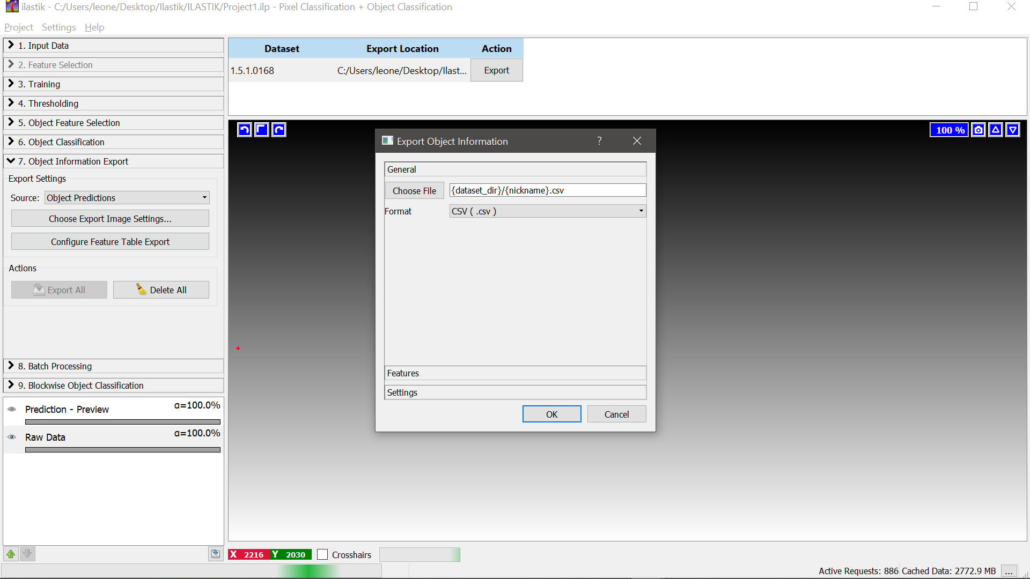

- Batch processing
- Process all files
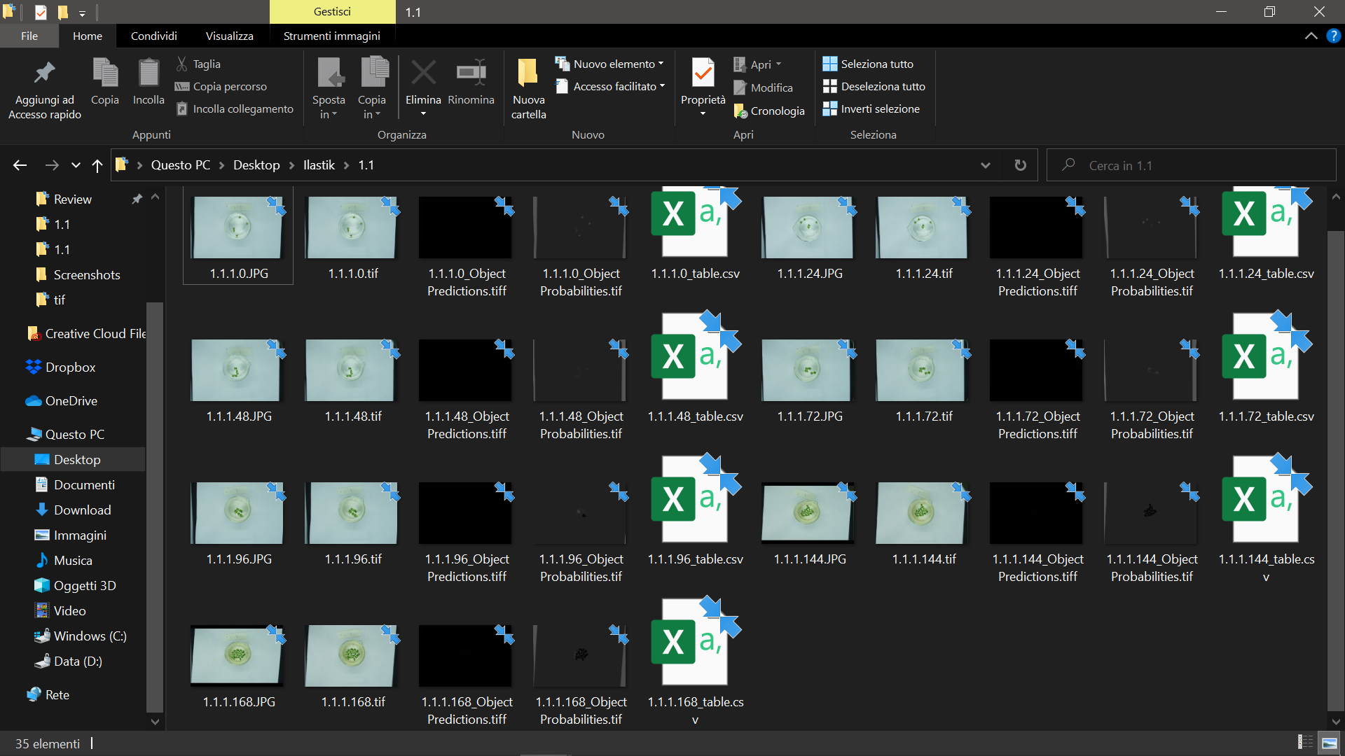
- Output

