Supplementary Figures:
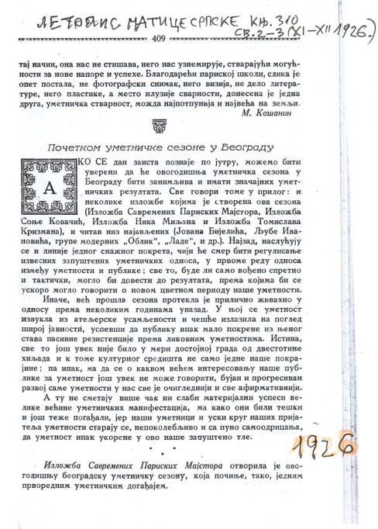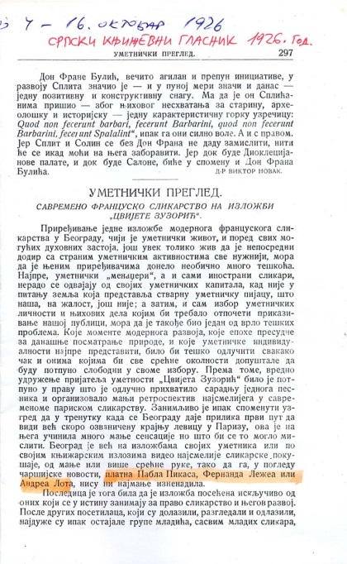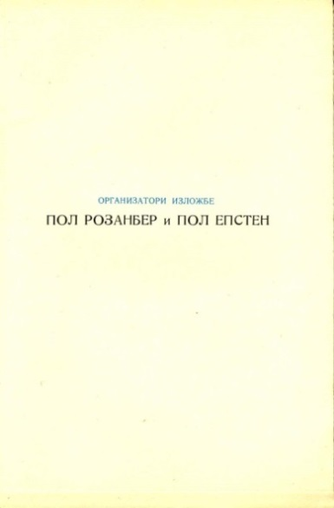

Figure 1S. a.) The archival documents from the prominent culture journals “Letopis Matice Srpske” and “Srpski Narodni Glasnik” published during the 1926 art season in Belgrade, Yugoslavia. (b) A flyer of the art exhibition organized by Paul Rosenberg and Paul Epstein in October 1926, which exhibited the work of Picasso. This exhibition was right before Nikolay Khokhlov’s wedding, and perhaps an opportunity for interactions among Olga’s Paris friends, Khokhlov’s and Hadzic’s.

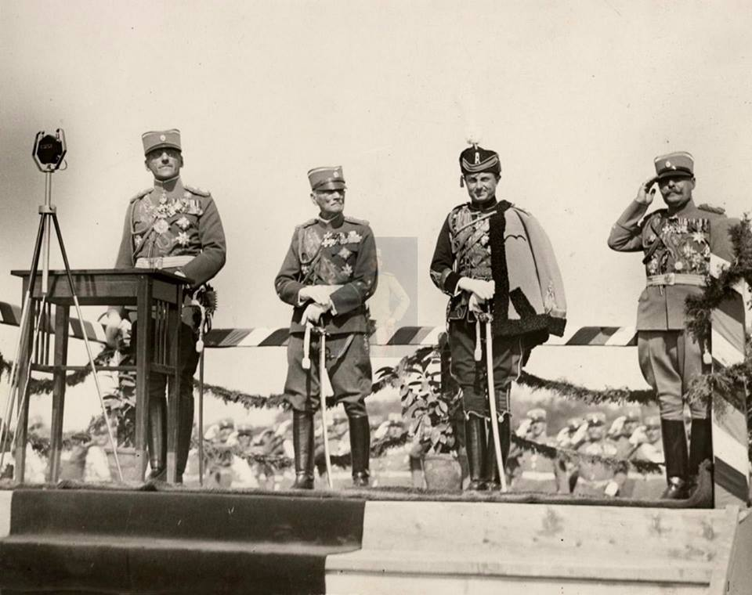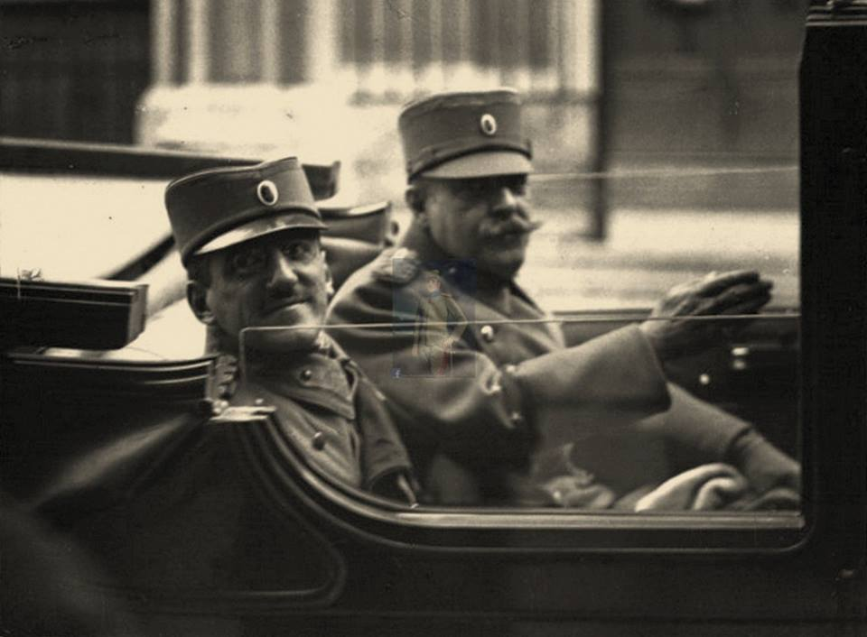
a. b.

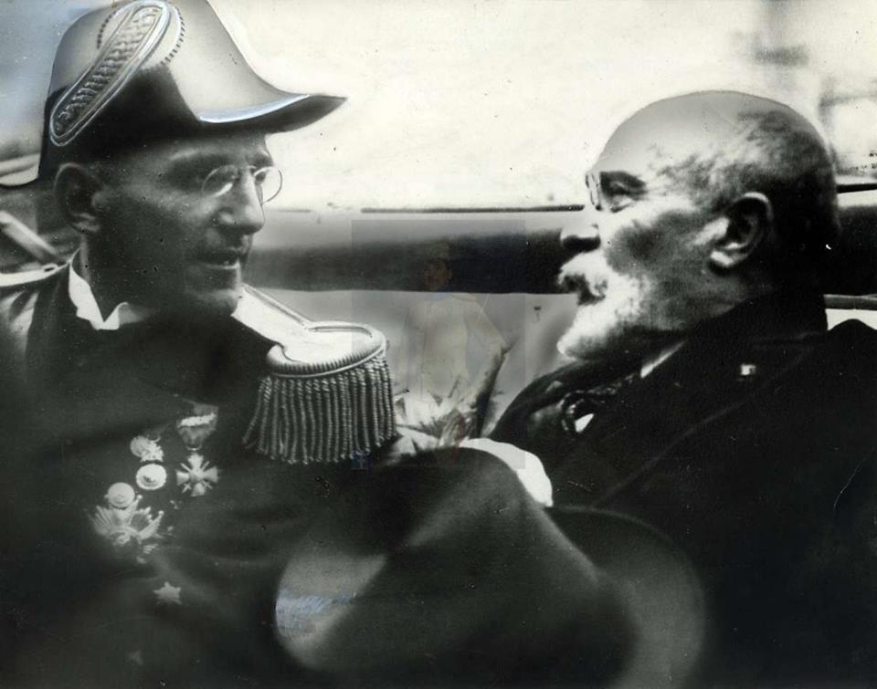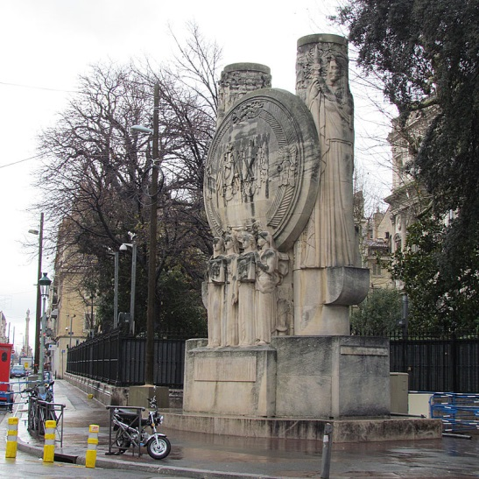
c. d.

Figure 2S. The historic information about the first art owner. a.) General Steven Hadzic, adjutant (personal assistant) of the Yugoslav King Alexander I Karadjordjevic. General Hadzic, first on the right, with the king Alexander, first on the left, and princes Arsen and Pavle; b.) General Hadzic and the King Alexander I in the king’s car. In the early 20th century, there were strong cultural and diplomatic ties between Yugoslavia and France. C.) Shown here is the king Alexander I with French Foreign Minister, Louis Barthou, minutes before his assassination during his official visit to France in Marseilles on October 9, 1934. d.) The monument to King Alexander I in Marseilles. “The film record of Alexander I’s assassination remains one of the most notable pieces of newsreel in existence” (Wikipedia).

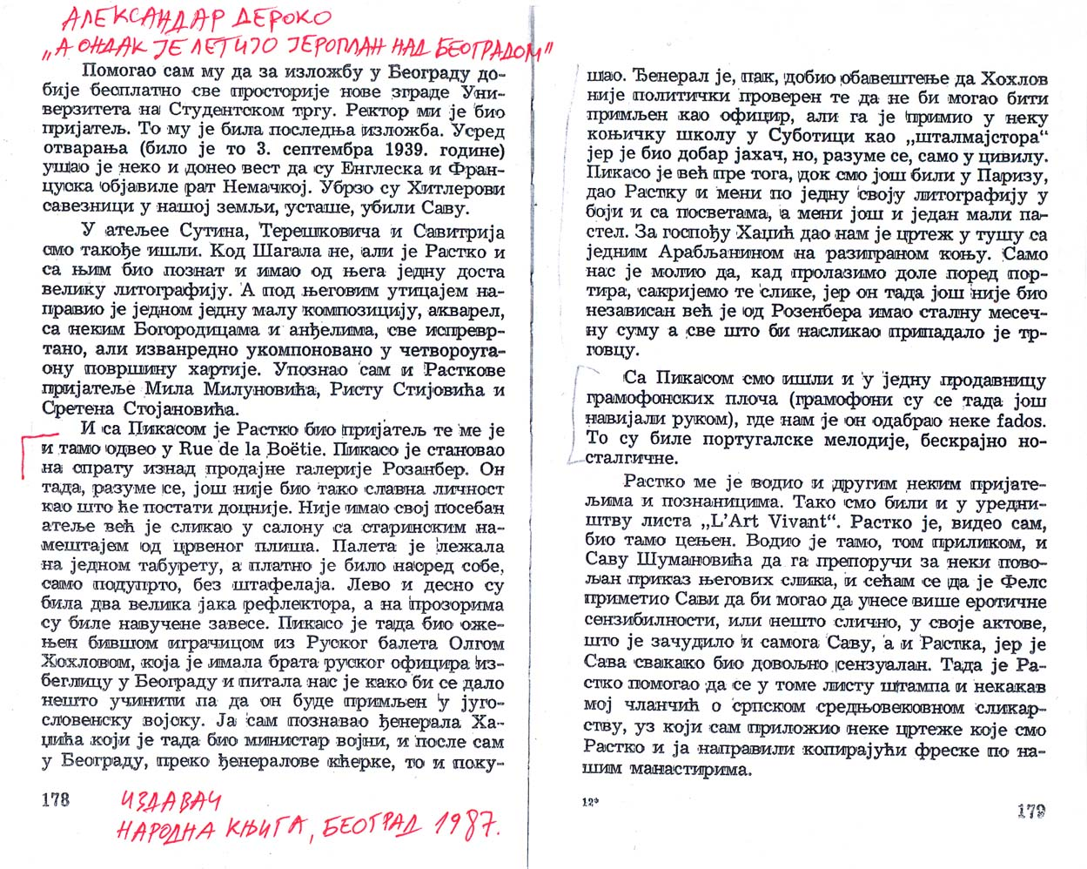
Figure 3S. In his autobiography book “When the plane was flying above Belgrade” (published in 1987 by Narodna Knjiga, Yugoslavia) on pages 178-179, Derocco describes Rue de la Boetle, similarly to what he said in the text ‘At Picasso’ in Fig. 3. He also wrote about his encounter with Olga Picasso, mentioning that “she had a brother, an army officer who was a refugee in Belgrade. Olga asked them (Derocco and Rastko) what could be done for her brother to be accepted in the Yugoslav Army. I (Derocco), knew general Hadzic and his daughter and I indeed intervened. General Hadzic said that Nikolaj was not politically checked and therefore cannot be accepted as an Army officer, however he accepted him to work as a civilian within the equestrian school in Subotica. Before this visit Picasso gave signed, color lithography to both Rastko and me (Derocco) and in addition I (Derocco) received a small pastel. For madam Hadzic we received a drawing in ink of an Arabian man riding a horse. Picasso only asked us not to show the arts to the porter. Picasso was not independent at that time. He received monthly payments from Rosenberg and everything that he produced belonged to the seller. We also went to a music store where Picasso recommended us nostalgic, ‘fados’ melodies from Portugal”. Note: there is no mention of Red guitar in this particular occasion so who from this group of Serbian friends exactly received it and gifted it to Hazdic’ is not known, but it was gifted to Hazdic’s ).

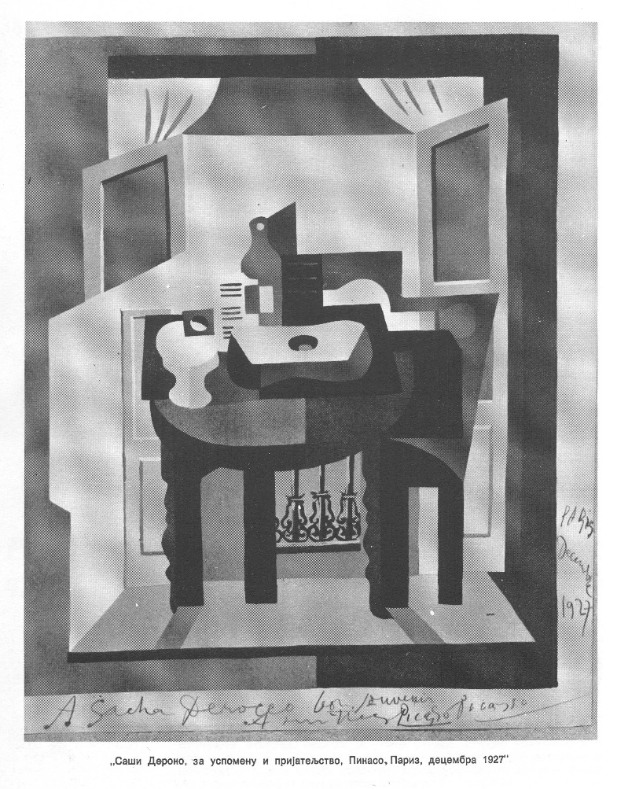a.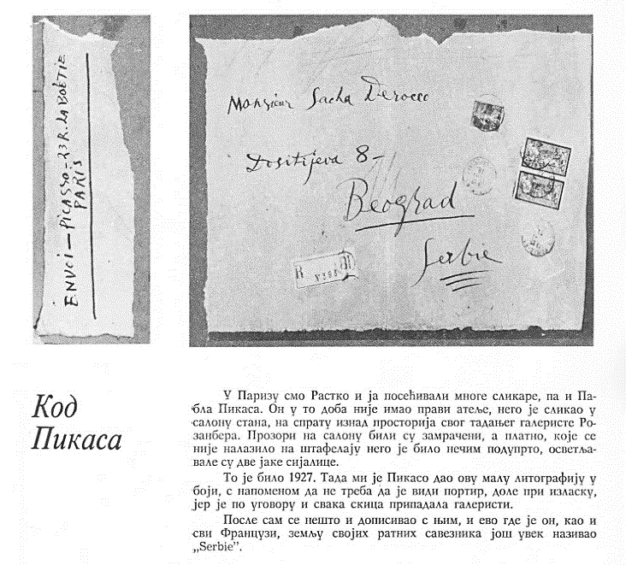 b.
Figure 4S.(a.) A gift from Picasso to Sacha (Alexander) Derocco, in a memory of their friendship, December 1927, .b) One of Picasso’s letter to Derocco written in Serbian, the exact date is not visible. A text “Kod Pikasa” (At Picasso) is written by Derocco: Here, Derocco wrote that he and Rastko (Petrovic) often visited Picasso and other artists in Paris. At that time when he received this small lithograph (1927) Picasso did not have a real atelier. He lived in a flat above his gallerist Rosenberg and painted in a dark saloon, with light lamps and paintings everywhere. Picasso was under contract with Rosenberg, and he advised Derocco not to show any gifts to the porter.

Figure 5S. The X-ray image of Red Guitar. More details are in the main text

- b.

Figure 6S. The UV fluorescence image of Red Guitar. a). The fluorescence in the white area and ground layer are from Zinc white, which presence was confirmed by XRF elemental analysis. The dark blue color is from a cobalt pigment (Co is detected by XRF) and Ultramarine (predicted here but detected in the dark yellow paint by Raman spectroscopy. The lack of fluorescence in other areas agree with the elemental analysis that showed dominance of iron and lead colored pigments, which do not fluoresce (Conservation & Art Materials Encyclopedia Online: http://cameo.mfa.org/wiki/Main_Page.) b. The UV image in ‘ black and white’ showing that the signature and date are intact.

