**Supplemental Table 1.** Characteristics of 55 ST182 *E. hormaechei* WGS assemblies.

|  |  |  |  |  |  |  |
| --- | --- | --- | --- | --- | --- | --- |
| **BIOSAMPLE** | **STRAIN ALIAS** | **CONTINENT** | **COUNTRY** | **YEAR** | ***bla*NDMvariant** | **CLUSTER** |
| SAMD00099782 | M515 | Asia | Myanmar | 2016 | *bla*NDM-1 | A |
| SAMD00194914 | MY196 | Asia | Myanmar | 2016 | *bla*NDM-1 | A |
| SAMD00431577 | SAMD00431577 | Asia | Myanmar | 2016 | *bla*NDM-1 | A |
| SAMEA6368456 | RIVM_C015180 | Europe | Netherlands | 2017 | *bla*NDM-1 | A |
| SAMEA7707283 | RIVM_C019172 | Europe | Netherlands | 2019 | *bla*NDM-1 | A |
| SAMEA7707293 | RIVM_C019489 | Europe | Netherlands | 2019 | *bla*NDM-1 | A |
| SAMEA8581547 | PP301 | Asia | Pakistan | 2016 | *bla*NDM-1 | A |
| SAMEA8581614 | PS171 | Asia | Pakistan | 2016 | *bla*NDM-1 | A |
| SAMN04431002 | GCID_ENTES_00096;SMART_1342 | North America | Guatemala | 2014 | *bla*NDM-1 | A |
| SAMN07355852 | HBY | Asia | China | 2017 | *bla*NDM-1 | A |
| SAMN07501531 | AZ_664 | Asia | Philippines | 2013 | *bla*NDM-1 | A |
| SAMN08932725 | SCEH020080 | Asia | China | 2016 | *bla*NDM-1 | A |
| SAMN10252240 | Sentry-2017-1013030 | South America | Mexico | 2017 | *bla*NDM-1 | A |
| SAMN22068468 | 2021QW-00060 | North America | USA | 2021 | *bla*NDM-1 | A |
| SAMN22377001 | P1 | Asia | Iran | 2012 | *bla*NDM-1 | A |
| SAMN24297073 | 222410 | Europe | UK | 2016 | *bla*NDM-1 | A |
| SAMN24700281 | EC1268 | Asia | Singapore | 2015 | *bla*NDM-1 | A |
| SAMN25161196 | 2021QW-00088 | North America | USA | 2021 | *bla*NDM-1 | A |
| SAMN25161198 | 2021QW-00093 | North America | USA | 2021 | *bla*NDM-1 | A |
| SAMN32638338 | PEER 1096 | Asia | India | 2021 | *bla*NDM-1 | B |
| SAMN04252918 | GCID_ENTES_00038;SMART_598 | Asia | Viet Nam | 2011 | *bla*NDM-1 | C |
| SAMN15904743 | hkcpe74 | Asia | Hong Kong | 2012 | *bla*NDM-1 | C |
| SAMN21590478 | E472 | Asia | Singapore | Uknown | *bla*NDM-1 | C |
| SAMN33955250 | EC-ML559 | Europe | Greece | 2021 | *bla*NDM-1 | C |
| SAMN08436979 | Encl-922 | Europe | Czech Republic | 2012 | *bla*NDM-4 | A |
| SAMN08450112 | Encl-44578 | Europe | Czech Republic | 2016 | *bla*NDM-4 | A |
| SAMN07503715 | ECLO_616294_SO | Africa | Togo | 2016 | *bla*NDM-5 | A |
| SAMN14669245 | 2019GO-00055 | North America | USA | 2019 | *bla*NDM-5 | C |
| SAMEA7707309 | RIVM_C029661 | Europe | Netherlands | 2020 | *bla*NDM-7 | A |
| SAMN22573158 | 2021GN-00156 | North America | USA | 2021 | *bla*NDM-7 | A |
| SAMEA7071344 | H163100552 | Europe | UK | 2016 | None | A |
| SAMEA7962787 | AI2760 | Europe | Spain | 2018 | None | A |
| SAMEA8065826 | AI2747 | Europe | Spain | 2018 | None | A |
| SAMN03283617 | GCID_ENTE_00053 | North America | USA | 2012 | None | A |
| SAMN03283626 | GCID_ENTE_00049 | North America | USA | 2012 | None | A |
| SAMN03283632 | GCID_ENTE_00066 | North America | USA | 2012 | None | A |
| SAMN04252905 | GCID_ENTES_00025; SMART_409 | Europe | Spain | 2011 | None | A |
| SAMN04431017 | GCID_ENTES_00111;SMART_1169 | Africa | Tunisia | 2014 | None | A |
| SAMN14516611 | And2481 | Europe | Germany | 2013 | None | A |
| SAMN16558068 | 1800086 | North America | USA | 2016 | None | A |
| SAMN33748146 | EC84 | Asia | China | 2015 | None | A |
| SAMN35822989 | Eh202_LBHALD | Africa | Senegal | 2018 | None | A |
| SAMN36341330 | Eh8322_LBHALD | Africa | Senegal | 2018 | None | A |
| SAMEA2273150 | MDR0039-sc-1791683 | Europe | UK | 2002 | None | B |
| SAMEA2273329 | MDR0244-sc-1791881 | Europe | UK | 2006 | None | B |
| SAMN03277204 | CIDEIMsCOL17 | South America | Colombia | 2012 | None | B |
| SAMEA4427188 | SCP26-50 | Europe | Netherlands | Uknown | None | B |
| SAMN03283690 | GCID_ENTE_00121; 44527 | South America | Colombia | 2014 | None | B |
| SAMN18207028 | ENCL_547 | North America | USA | 2018 | None | B |
| SAMN20064946 | N1730 | Europe | Switzerland | 2020 | None | B |
| SAMN20967435 | E929 | Asia | Singapore | Uknown | None | B |
| SAMN07610229 | UM_CRE_44 | North America | USA | 2015 | None | B |
| SAMN25226637 | 2021DK-00183 | North America | USA | 2021 | None | C |
| SAMN25226704 | 2021DK-00272 | North America | USA | 2021 | None | C |
| SAMN32262091 | CUVET18-121; Ecl1 | Asia | Thailand | 2018 | None | C |

**Supplemental Table 2.** Characteristics of 30 ST182 *E. hormaecheibla*NDM-carryingWGS assemblies.

|  |  |  |  |  |
| --- | --- | --- | --- | --- |
| **Biosample** | **Strain** | **Accession No;**  **(size, %GC content)** | ***bla*NDM-**  **harboring contig**  **(size)** | ***bla*NDM**  **variant** |
| **pNDM-HN380; X104760 ( IncX3)** | | | | |
| SAMN07355852 | HBY | NMVR01000000.1  (5,790,239 bp; 52.9%) | NMVR01000120.1;  (3,335bp) | *bla*NDM-1 |
| SAMN04431002 | SMART_1342 | LRJK01000000.1  (4,909,094 bp; 55.3%) | NZ_LRJK01000027.1  (13,396bp) | *bla*NDM-1 |
| SAMN04252918 | SMART_598 | LPPQ01000000.1  (5,090,561 bp; 55.1%) | LPPQ01000025  (11,228bp) | *bla*NDM-1 |
| SAMN07501531 | AZ 664 | DACOIW010000000  (5,171,314 bp, 55.1%) | 1. DACOIW010000076   (9,086bp)  2. DACOIW010000145  (8,220 bp) | *bla*NDM-1 |
| SAMN07503715 | ECLO_616294_SO | NRJJ00000000.1  (4,822,414bp; 53.21%) | NZ_NRJJ01000307.1  (5,630bp) | *bla*NDM-1 |
| SAMD00099782 | [M515](https://cge.food.dtu.dk/cgi-bin/webface.fcgi?jobid=6469B0600000443DE26AC6AA#Ga0597695_60) | PDT000431889_1  (5,209,379 bp; 54.88%) | 1. DACOQQ010000041.1   (8,852bp)   1. DACOQQ010000093.1 (6,231bp) | *bla*NDM-1 |
| SAMD00194914 | [MY196](https://cge.food.dtu.dk/cgi-bin/webface.fcgi?jobid=6469B0600000443DE26AC6AA#Ga0597695_09) | PDT001202126  (5,023,457 bp; 54.93%) | 1. DAFILT010000050.1   (8,948bp)  2. DAFILT010000085.1  (1,539bp) | *bla*NDM-1 |
| SAMN08932725 | SCEH020080 | SRR7026274  (5,116,489bp; 54.9%) | SAMN08932725_NODE_32 (8,106bp) | *bla*NDM-1 |
| SAMN15904743 | hkcpe74 | SRR12517442  ( 5,184,472bp; 54.7%) | SAMN15904743_NODE_222 (1,237bp) | *bla*NDM-1 |
| SAMEA7707293 | RIVM_C019489 | ERR4977540  (5065033bp; 55.3%) | SAMEA7707293_NODE_34 (13,230bp) | *bla*NDM-1 |
| SAMD00431577 | SAMD00431577 | DRR334946  (4,992692bp; 54.9%) | SAMD00431577_NODE_48 (9,044bp) | *bla*NDM-1 |
| SAMN08436979 | [Encl-922](https://cge.food.dtu.dk/cgi-bin/webface.fcgi?jobid=6469B0600000443DE26AC6AA#Ga0597695_26) | NZ_PQXG01000000.1  (4,884,183; 56.27%) | MG252892  (53,683bp) | *bla*NDM-4 |
| SAMN08450112 | Encl-44578 | NZ_QBPF01000000.1  (4,832,725; 53.35% | NZ_QBPF01000054.1  (5,798bp) | *bla*NDM-4 |
| SAMN14669245 | 2019GO-00055 | SRR11594612 (4,868,786bp; 55.3%) | SAMN14669245_NODE_19 (4,6873bp) | *bla*NDM-5 |
| SAMN22573158 | 2021GN-00156 | SRR16609045  (4,920,998bp; 55.2%) | SAMN22573158_NODE_34  (5,661bp) | *bla*NDM-7 |
| SAMEA7707309 | RIVM_C029661 | ERR4977554  (5,060,221bp; 55.1%) | SAMEA7707309_NODE_43  (5,615bp) | *bla*NDM-7 |
| **pKOX_NDM-1; NC_021501.1 ( IncFII)** | | | | |
| SAMN22377001 | [P1](https://cge.food.dtu.dk/cgi-bin/webface.fcgi?jobid=6469B0600000443DE26AC6AA#Ga0597695_39) | JAJCVN000000000.1  (5,015,83bp; 52.54%) | NZ_JAJCVN010000041.1 (18,792bp) | *bla*NDM-1 |
| SAMN24297073 | 222410 | SRR17308905  (5,001,248bp; 55.2%) | SAMN24297073_NODE_45  (19,412bp) | *bla*NDM-1 |
| SAMN24700281 | EC1268 | SRR17519753  (5,016,482bp; 55.3%) | SAMN24700281_NODE_31 (15,288bp) | *bla*NDM-1 |
| SAMN25161196 | 2021QW-00088 | SRR17696410 (5,132,726bp; 55.1%) | SAMN25161196_NODE_28 (21,092bp) | *bla*NDM-1 |
| SAMN25161198 | 2021QW-00093 | SRR17696408  (5,142,242bp; 55.1%) | SAMN25161198_NODE_26 (21,092bp) | *bla*NDM-1 |
| SAMEA7707283 | RIVM_C019172 | ERR4977532 (5,006,535bp;55.2%) | SAMEA7707283_NODE_34 (17,894bp) | *bla*NDM-1 |
| SAMN10252240 | Sentry-2017-1013030 | SRR8306302 (4,988,526bp; 55.2%) | SAMN10252240_NODE_24 (77,041bp) | *bla*NDM-1 |
| SAMN22068468 | 2021QW-00060 | SRR16212278 (5,033,415bp; 55.2%) | SAMN22068468_NODE_26  (19,874bp) | *bla*NDM-1 |
| **pGUE-NDM; JQ364967.1 (IncFII)** | | | | |
| SAMN32638338 | [PEER1096](https://cge.food.dtu.dk/cgi-bin/webface.fcgi?jobid=6469B0600000443DE26AC6AA#Ga0597695_23) | PubMLST id: 1351; (4,713,253 bp; 55.35%) | Peer1096spades_contig_16 (Length: 9918bp, 56.9%) | *bla*NDM-1 |
| SAMEA8581547 | PP301 | ERR5751977 (5,108,989bp; 55.0%) | SAMEA8581547_NODE_52_l(72,96bp) | *bla*NDM-1 |
| SAMEA8581614 | PS171 | ERR5751910 (5041435bp; 55.2%) | SAMEA8581614_NODE_28 (16,238bp) | *bla*NDM-1 |
| **pKPX-1 AP012055.1 (IncFII)** | | | | |
| SAMN33955250 | [EC-ML559](https://cge.food.dtu.dk/cgi-bin/webface.fcgi?jobid=6469B0600000443DE26AC6AA#Ga0597695_44) | PubMLST id: 1241; JARUPS000000000.1 (4,958,007 bp; 55.07%) | JARUPS010000023.1  (61,729bp; 53.7%) | *bla*NDM-1 |
| **pM214_AC2; AP018143.1(IncA/C)** | | | | |
| SAMEA6368456 | RIVM_C015180 | ERR3712849 (5,004,082bp; 55.2%) | SAMEA6368456_NODE_54  (7,959bp) | *bla*NDM-1 |
| **pJN24NDM1; MK368725.1 (IncN2)** | | | | |
| SAMN21590478 | E472 | SRR16079366  (5,176,427bp;54.8%) | SAMN21590478_NODE_37  (20,112bp) | *bla*NDM-1 |

**Supplemental Table 3.** *In silico* prediction of contig Inc types, antimicrobial resistance and virulence genes in 30 *bla*NDM-harbouring ST182 *E. hormaechei*WGS assemblies.

|  |  |  |  |  |
| --- | --- | --- | --- | --- |
| **Biosample accession** | **Genomic Cluster** | **Contig Inc types** | **Antimicrobial resistance genes** | **Virulence genes** |
| SAMD00099782 | A | IncHI2,IncHI2A,IncR, IncFII(K)/repB(R1701) | ***bla*ACT-16, *bla*NDM-1,*bla*TEM-1, *bla*SFO-1, *bla*NDM-1, *bla*CTX-M-15,** *aph(6)-Id, aac(3)-IId, aadA, aadA16, aph(3')-Ia, aac(6')-Ib-cr, aph(3'')-Ib, mcr-9* | *nlpI, terC,*  *traT* |
| SAMD00194914 | A | IncHI2,IncHI2A,IncR, IncFII(K),repB(R1701) | ***bla*ACT-16, *bla*NDM-1,*bla*TEM-1, *bla*NDM-1,** *aph(6)-Id,aadA1, aph(3'')-Ib,mcr-9, formA,qacE,OqxA,OqxB,*  *fosA,catA2,sul1,dfrA12* | *nlpI, terC,*  *traT* |
| SAMD00431577 | A | IncHI2,IncHI2A,IncR, repB(R1701) | ***bla*ACT-16, ,*bla*NDM-1,*bla*TEM-1,*bla*NDM-1,***aph(6)-Id,aadA1,aph(3'')-Ib,mcr-9,formA qacE,OqxA, OqxB,fosA,catA2,sul1* | *nlpI, terC,*  *traT* |
| SAMEA6368456 | A | IncFIB(pECLA)/IncFII(pECLA),IncFII,IncR Col(pHAD28) | ***bla*ACT-16, *bla*NDM-1,*bla*TEM-1,** *aph(6)-Id aadA1, aph(3'')-Ib,mcr-9, formA, qacE OqxA, OqxB,fosA, catA2,sul1,dfrA12* | *nlpI, terC,*  *traT* |
| SAMEA7707283 | A | IncFIB(pECLA)/IncFII(pECLA), IncFII(Yp),Col(pHAD28), | ***bla*ACT-16, *bla*NDM-1, *bla*OXA-1,*bla*TEM-1, *bla*CTX-M-15** ,*aph(6)-Id, rmtC, aac(6')-Ib-cr, aph(3'')-Ib,aac(3)-Iia,OqxA, OqxB, fosA, mph(A) ,catB3 ,qnrB1 sul1,sul2, tet(D), dfrA14* | *nlpI, terC* |
| SAMEA7707293 | A | IncFIB(pECLA)/IncFII(pECLA),IncFIA(pBK30683), IncM1,IncR, repB(R1701) | ***bla*ACT-16,*bla*NDM-1,*bla*OXA-1,*bla*OXA-48,*bla*TEM-1,*bla*GES-5,*bla*LAP-2, *bla*CTX-M-15**,*aph(6)-Id,aph(3'')-Ib,aph(3'')-Ib,aac(6')-Ib,aadA1,aph(3')-VIb,aac(3)-IIa,qacE,OqxA,OqxB,*  *fosA,catB3,qnrS1,sul1,sul2,tet(A),dfrA1,dfrA14* | *nlpI, terC* |
| SAMEA8581547 | A | IncFIB (pECLA),IncFIB (pHCM2),IncFIA(pBK30683),  IncM1(pKPC_NDM3594),ColRNAI | ***bla*ACT-16,*bla*NDM-1,*bla*OXA-1,*bla*OXA-10,***aadA1,aac(6')-Ib-cr,qacE,OqxA,OqxB,fosA,catB3,ARR-3,sul1,dfrA27,dfrA14* | *nlpI, terC,shiB* |
| SAMEA8581614 | A | IncFIB(pECLA)/IncFII(pECLA),IncFIB(pHCM2),  IncFII(Yp), IncFIB(pB171) | ***bla*ACT-16,*bla*NDM-1,*bla*OXA-1, *bla*TEM-1,*bla*CTX-M-15**,  *aph(6)-Id,rmtC,aac(6')-Ib-cr,aph(3'')-Ib,aac(3)IIa, fosA,catB3,*  *OqxA,OqxB,qnrB1,sul1,sul2,tet(A),tet(D),dfrA14* | *nlpI, terC* |
| SAMN04431002 | A | IncFIB(pECLA),IncFII(pECLA),IncX3 | ***bla*ACT-16, *bla*NDM-1, *bla*TEM-1B,*bla*CTX-M-15, *bla*SHV-12**,*aadA2b, aph(6)-Id, aph(3'')-Ib, fosA, ant(2'')-Ia, qacE, sul1, sul2, qnrA1,dfrA14,* | *nlpI, terC* |
| SAMN07355852 | A | IncFIB(pHCM2), IncFII(Yp), IncHI2A, IncHI2, IncX3 | ***bla*ACT-16, *bla*NDM-1,*bla*TEM-1,*bla*CTX-M-3, *bla*DHA-1, *bla*KPC-2,***msr(E), aadA1, aac(6')-Ib-cr, armA, qacE, fosA, sul1, qnrB4, mcr-9* | *nlpI, terC* |
| SAMN07501531 | A | IncFII(pECLA)/IncFIB(pECLA),  IncX3, IncN | ***bla*ACT-16,*bla*NDM-1,*bla*CTX-M-15,*bla*OXA-1, *bla*TEM-1, *bla*SHV-12**,*aac(3)-IIa, aac(6')-Ib-cr, aph(3'')-Ib, aph(6)-Id, tet(A), dfrA14, fosA, catB3, sul2, OqxA, OqxB, qnrB1, qnrS1* | *nlpI, terC* |
| SAMN08932725 | A | IncFIB(pB171),IncFII(Yp),IncHI2,IncHI2A,IncX3,Col(pHAD28) | ***bla*ACT-16,*bla*NDM-1,*bla*CTX-M-9,*bla*TEM-1,*bla*SHV-12,***aph(6)-Id,ant(2'')-Ia,aac(3)-IId,aadA2,aph(3'')-Ib,qacE,OqxA,OqxB,*  *fosA,mph(A),qnrA1,sul1,sul2,tet(A),dfrA12* | *nlpI, terC* |
| SAMN10252240 | A | IncFIB(pECLA)/IncFII(pECLA),IncFII(Yp), IncFIB(pB171) | ***bla*ACT-16,*bla*NDM-1, *bla*OXA-1,*bla*TEM-104,blaCTX-M-15,***aph(3')-VI,aph(6)-Id,rmtC,aac(6')-Ib-cr,aph(3'')-Ib,formA*  *,OqxA,OqxB,fosA,catB3,floR,qnrB1, sul1, sul2, tet(A), dfrA14* | *nlpI, terC* |
| SAMN22068468 | A | IncFIB(pECLA)/IncFII(pECLA),IncFII(Yp),IncFIB(pB171), Col(pHAD28) | ***bla*ACT-16,*bla*NDM-1,*bla*OXA -1,** *aac(6')-Ib-cr,aac(3)-IIa,rmtC,OqxA,OqxB,fosA,catB3,qnrB1sul1,tet(A),dfrA14* | *nlpI, terC* |
| SAMN22377001 | A | IncFII(pECLA)/IncFIB(pECLA), IncFII(Yp), IncFIB(pB171) | ***bla*ACT-16, *bla*NDM-1, *bla*CTX-M-15,*bla*OXA-1, *bla*TEM-1,**  *aph(6)-Id, aac(6')-Ib-cr, aph(3'')-Ib,aac(3)-IIa, OqxA, OqxB, rmtC, fosA, catB3, tet(D), sul1, sul2, dfrA14, qnrB1* | *nlpI, terC* |
| SAMN24297073 | A | IncFIB(pECLA)/IncFII(pECLA),IncFII(Yp), IncFIB(pB171), Col440I | ***bla*ACT-16,*bla*NDM-1,*bla*OXA-1,*bla*TEM-1,*bla*CTX-M-15,**  *aph(6)-Id,rmtC,aac(6')-Ib-cr_1,aph(3'')-Ib,aac(3)-IIa,*  *OqxA,OqxB,fosA,catB3,qnrB1,sul1,sul2,tet(A),tet(D),dfrA14* | *nlpI, terC* |
| SAMN24700281 | A | IncFIB(pECLA)/IncFII(pECLA),IncFII(Yp),IncFIB(pB171),  Col440I | ***bla*ACT-16,*bla*NDM-1,*bla*OXA-1,*bla*TEM-1,*bla*CTX-M-15**,*aph(6)-Id,aadA2,rmtC,aac(6'),aph(3'')-Ib,aac(3)-IIa,qacE_1,OqxA,OqxB,fosA,mph(A),catB3,qnrB1,sul1,sul2,tet(A),tet(D),dfrA12,dfrA14* | *nlpI, terC* |
| SAMN25161196 | A | IncFIB(pECLA)/IncFII(pECLA),IncFII(Yp),IncFIA(pBK30683),IncFIB(pB171),IncN,IncR,Col(pHAD28) | ***bla*ACT-16,*bla*NDM-1,*bla*OXA-1,*bla*TEM-1,*bla*CTX-M-3,***aac(6')-Ib3,rmtC,aac(3)-IIa,OqxA,OqxB,fosA,catB3,ARR-3,sul1,dfrA14* | *nlpI, terC,*  *mrkA, astA* |
| SAMN25161198 | A | IncFIB(pECLA)/IncFII(pECLA),IncFIA(pBK30683),IncFII(Yp),IncFIB(pB171),IncN,IncR,Col(pHAD28) | ***bla*ACT-16,*bla*NDM-1,*bla*OXA-1,*bla*TEM-1,*bla*CTX-M-3**,*aac(3)-IIa*, *aac(6')-Ib3,rmtC,OqxA,OqxB,fosA,catB3,qnrB1,ARR-3,sul1,tet(A),dfrA14,* | *nlpI, terC,*  *mrkA, astA* |
| SAMN08436979 | A | IncFII(pECLA)/IncFIB(pECLA), IncX3 | ***bla*ACT-16, *bla*NDM-4, *bla*OXA-1,*bla*TEM-1, *bla*CTX-M-15**  *aac(3)-IIa, aac(6')-Ib-cr, aph(6)-Id, aph(3'')-Ib, fosA, catB3, sul2, tet(A), dfrA14, OqxA, OqxB, qnrB1* | *nlpI, terC* |
| SAMN08450112 | A | IncFII(pECLA)/IncFIB(pECLA), IncX3 | ***bla*ACT-16, *bla*NDM-4, *bla*OXA-1,*bla*TEM-1, *bla*CTX-M-15**  *aac(6')-Ib-cr, aph(3'')-Ib, aac(3)-IIa, aph(6)-Id, tet(A),fosA, dfrA14,*  *catB3, sul2, qnrB1* | *nlpI, terC* |
| SAMN07503715 | A | IncFIB(pECLA)/IncFII(pECLA), IncX3 | ***bla*ACT-16, *bla*NDM-5, *bla*TEM-1,***aph(6)-Id, aph(3'')-Ib, aac(6')-Ib-cr, aac(3)-IIa, catB3, tet(D), tet(A), dfrA14, fosA, sul2,qnrB1* | *nlpI, terC* |
| SAMEA7707309 | A | IncFIB(pECLA)/IncFII(pECLA),IncFII(Yp),IncX3,Col(pHAD28) | ***bla*ACT-16,*bla*NDM-7,*bla*OXA-1,*bla*TEM-1,*bla*CTX-M-15**,*aph(6)-Id,aadA2,armA,aac(6')-Ib-cr,aph(3'')-Ib,aac(3)-IIa,qacE,*  *OqxA,OqxB,fosA,msr(E),mph(E),catB3,qnrB1,sul1,sul2,tet(D)*  *dfrA12,dfrA14* | *nlpI, terC* |
| SAMN22573158 | A | IncFIB(pECLA)/IncFII(pECLA),IncX3 | ***bla*ACT-16,*bla*NDM-7,*bla*OXA-1,*bla*TEM-1,*bla*CTX-M-15**,  *aph(6)-Id,aac(6')-Ib-cr,aph(3'')-Ib,aac(3)-IIa,OqxA_1,OqxB,fosA,catB3,qnrB1,sul2,tet(A),tet(D),dfrA14* | *nlpI, terC* |
| SAMN32638338 | B | IncFIB(K),Col440I, Col440II | ***bla*ACT-16, blaNDM-1, blaCTX-M-15,***aac(6')-Ib,aadA1, aadA2,OqxA,OqxB, fosA, qacE, sul1, dfrA12,qnrS1* | *nlpI* |
| SAMN04252918 | C | IncFIB(pECLA)/IncFII(pECLA),Col(pHAD28),IncFII(Yp) | ***bla*ACT-16, *bla*NDM-1, *bla*TEM-1,***aph(6)-Id, aph(3'')-Ib, tet(D), mph(A), rmtB, dfrA14, catA2 sul2* | *nlpI, terC,*  *mrkA* |
| SAMN15904743 | C | IncFIB(K),IncHI2,IncHI2A,IncR,IncX3,IncN3,Col(pHAD28, Col440I | ***bla*ACT-16,*bla*NDM-1,*bla*CTX-M-13,*bla*OXA-1,*bla*TEM-1,*bla*SFO-1,*bla*SHV-12,***aph(6)-Id,aph(3')-Ia,aac(3)-II,aadA2,armA,aac(6')-Ib-cr,aph(3'')-Ib,mcr-9,qacE,OqxA,OqxB,*  *fosA,erm(B),msr(E),mph(A),mph(E),catB3,ARR-3,sul1,dfrA19,dfrA12* | *nlpI, terC, kpsM_K11* |
| SAMN21590478 | C | IncFIB(pECLA),IncFII(pECLA),IncHI2,IncHI2A,IncN2,Col440I | ***bla*ACT-16,*bla*NDM-1,*bla*OXA-1,*bla*TEM-1,*bla*CTX-M-15,**  *aph(6)-Id,aadA1,aac(6')-Ib-cr,aph(3'')-Ib,aac(3)-IIa,*  *OqxA,OqxB,fosA,catB3,floR,catA1,qnrB1,qnrS1,sul2,tet(A),tet(D),dfrA1,dfrA14* | *nlpI, terC* |
| SAMN33955250 | C | IncFII(pECLA)/IncFIB(pECLA), IncFII(pKPX1), IncR,Col440I | ***bla*ACT-16, *bla*NDM-1, *bla*TEM-1, *bla*OXA-1**  *aph(3')-Ia, aph(3'')-Ibaph(6)-Id, aac(6')-Ib3, aac(6')-Ib-cr, ARR-3, fosA, mph(A), catB3, qacE, sul1, sul2, tet(D), OqxA, OqxB, qnrB19* | *nlpI, terC* |
| SAMN14669245 | C | IncFIB(pECLA)/IncFII(pECLA),IncQ1,IncR,IncX3 | ***bla*ACT-16,*bla*DHA-1,*bla*OXA-1,*bla*TEM-1,*bla*NDM-5,***aph(6)-Id,aac(6')-Ib-cr_2,aph(3'')-Ib, qacE,OqxA,OqxB,*  *fosA,mph(A),catB3,catA2,qnrB4,ARR-3,sul1,sul2,tet(D),dfrA14* | *nlpI, terC* |

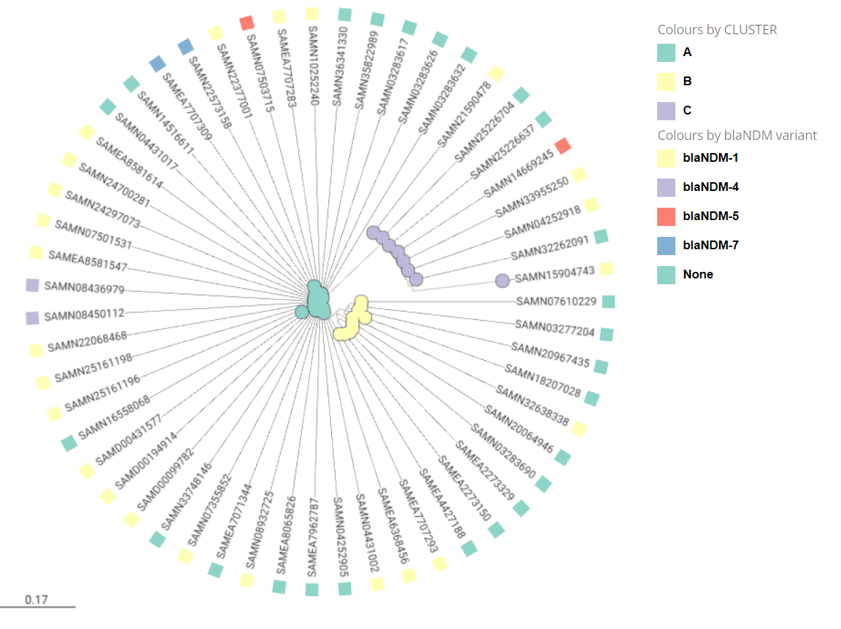

**Supplemental Figure 1.** Evolutionary relationships of ST182 *E.hormaechei* WGS assemblies.Singe-nucleotide polymorphisms (SNPs) were extracted using the Galaxy Server the aligned set of orthologous sites obtained by **REALPHY.** Evolutionary analyses were conducted by modules incorporated MEGA11 [1-5]. **The nucleotide sequences of the SNPs were aligned by MUSCLE [2].** The evolutionary distances were computed using the Kimura 2-parameter method [3] and are in the units of the number of base substitutions per site. This analysis involved 55 nucleotide sequences. Codon positions included were 1st+2nd+3rd+Noncoding. All ambiguous positions were removed for each sequence pair (pairwise deletion option). There were a total of 4554 positions in the final dataset. The evolutionary history was inferred using the Neighbor-Joining method [4,5].The optimal tree is shown.The phylogenetic tree, the genomic clusters (sublineages) and the *bla*NDM variants were visualized using the Microreact software.

1. Tamura K., Stecher G., and Kumar S. (**2021**). MEGA 11: Molecular Evolutionary Genetics Analysis Version 11. *Molecular Biology and Evolution* <https://doi.org/10.1093/molbev/msab120>
2. Edgar RC. MUSCLE: multiple sequence alignment with high accuracy and high throughput. Nucleic Acids Res. 2004 Mar 19;32(5):1792-7. doi: 10.1093/nar/gkh340. PMID: 15034147; PMCID: PMC390337.
3. Kimura M. (**1980**). A simple method for estimating evolutionary rate of base substitutions through comparative stud.ies of nucleotide sequences. *Journal of Molecular Evolution* **16**:111-120.
4. Saitou N. and Nei M. (**1987**). The neighbor-joining method: A new method for reconstructing phylogenetic trees. *Molecular Biology and Evolution* **4**:406-425.
5. Felsenstein J. (**1985**). Confidence limits on phylogenies: An approach using the bootstrap. *Evolution* **39**:783-791.

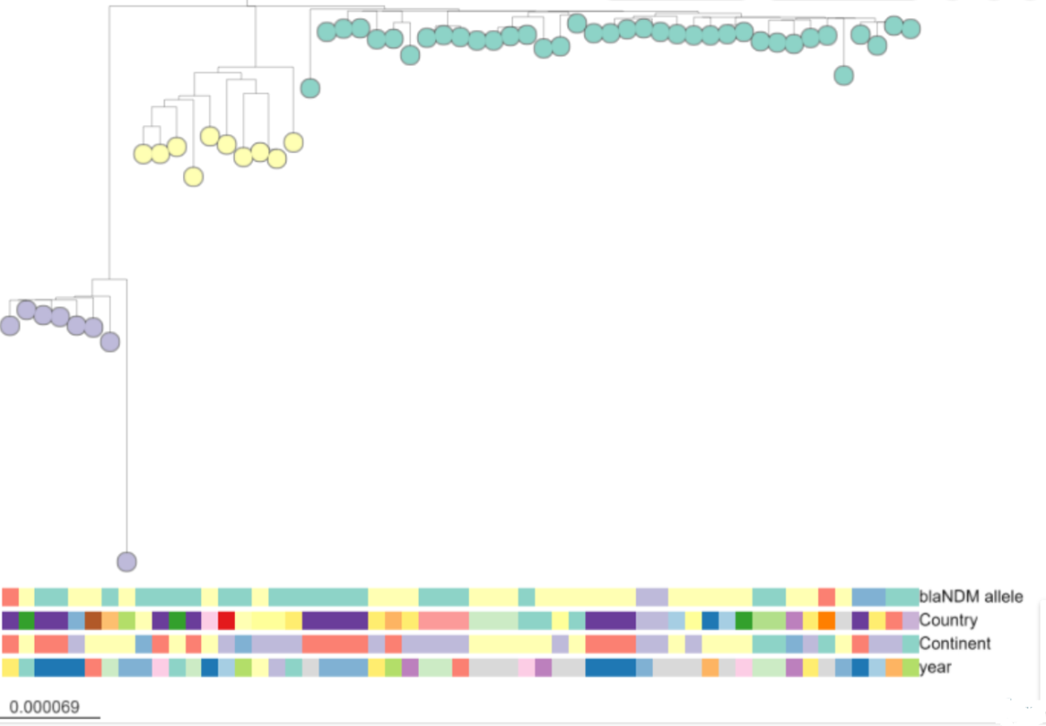

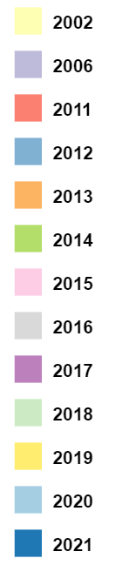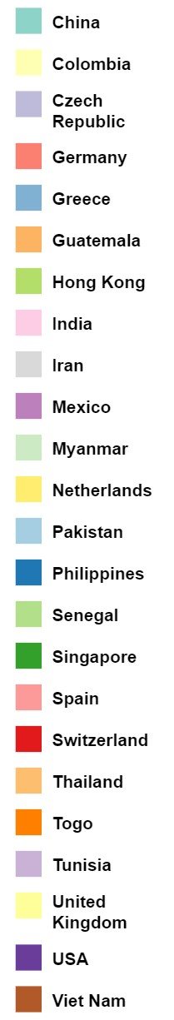

**Cluster Year Country**

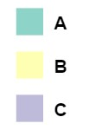

***bla* NDM  variant**

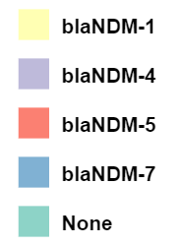

**Continent**

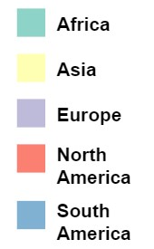

**Supplemental Figure 2.** Genomic clusters, *bla*NDM variants, country, continent and year of isolation of 55 ST182 *E. hormaechei* WGS assemblies.

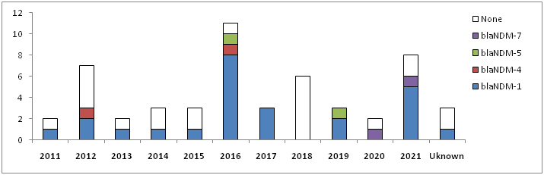**a**

**b.**

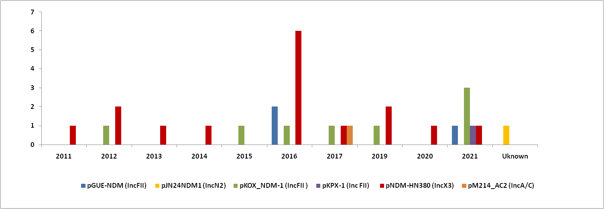

**Supplemental Figure 3.** Yearly distribution of ST182 *E. hormaechei* (a) *bla*NDM variants and (b) plasmid types of *bla*NDM-carrying WGS assemblies during 2011-2021.

**4a. pNDM-HN380-like (IncX3) contigs**



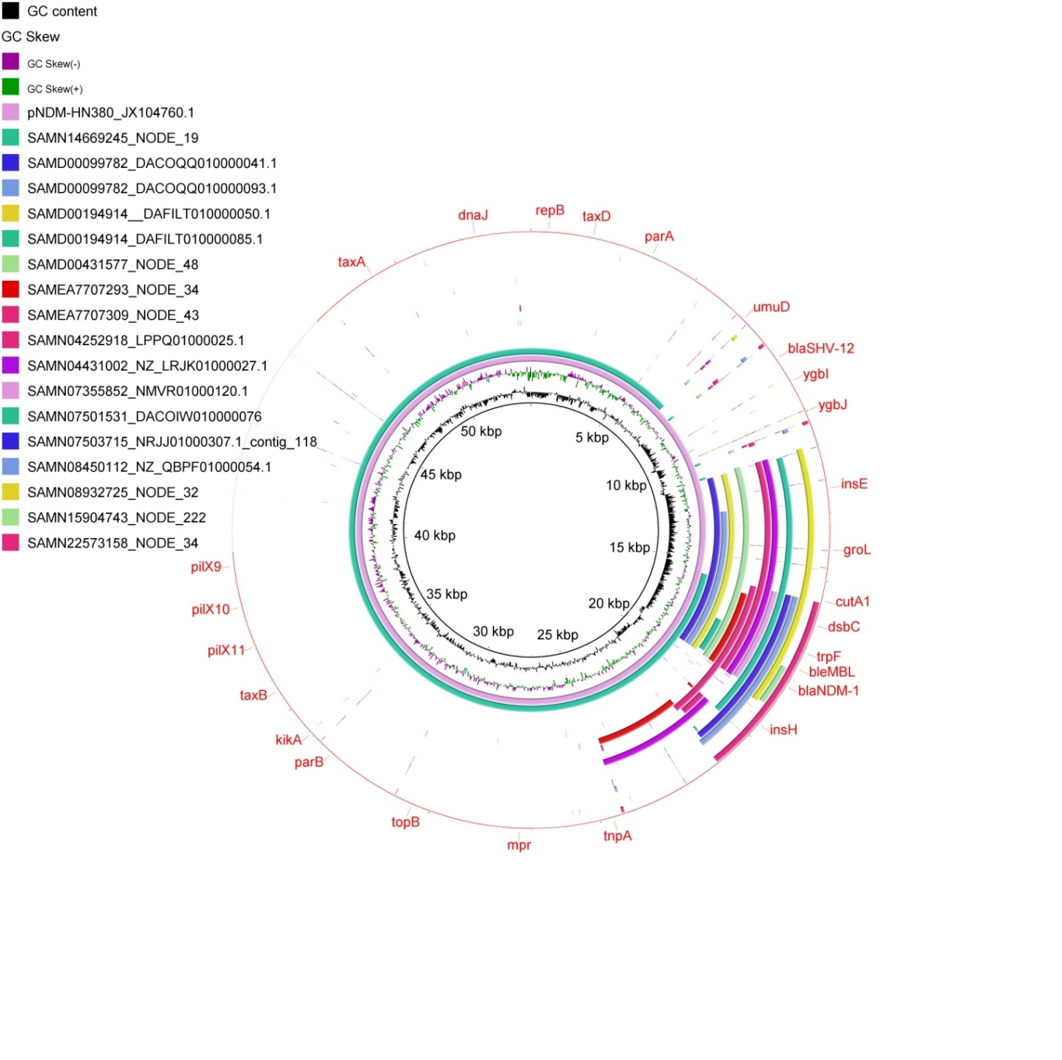

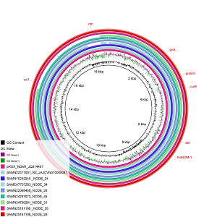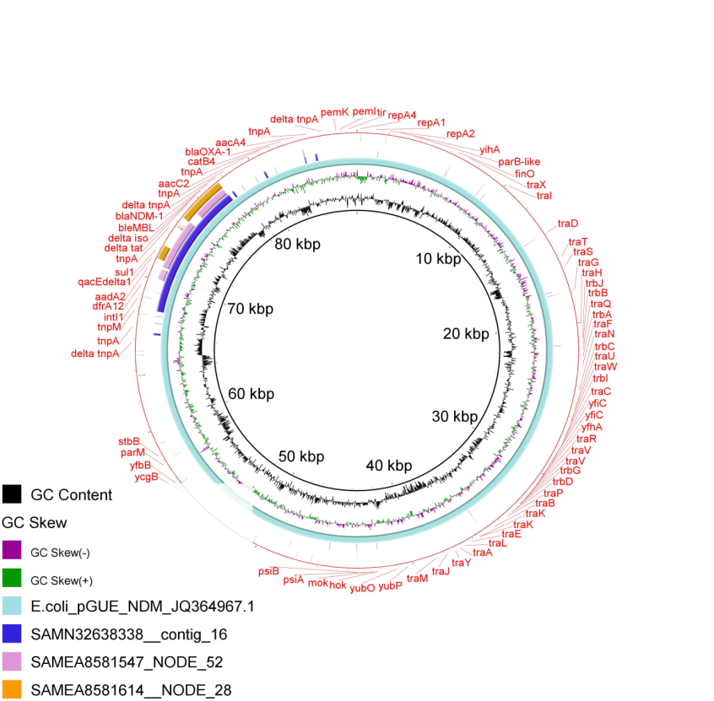**4b. pGUE-NDM-like (IncFII) contigs 4c. pKOX_NDM-1-like (IncFII) contigs**

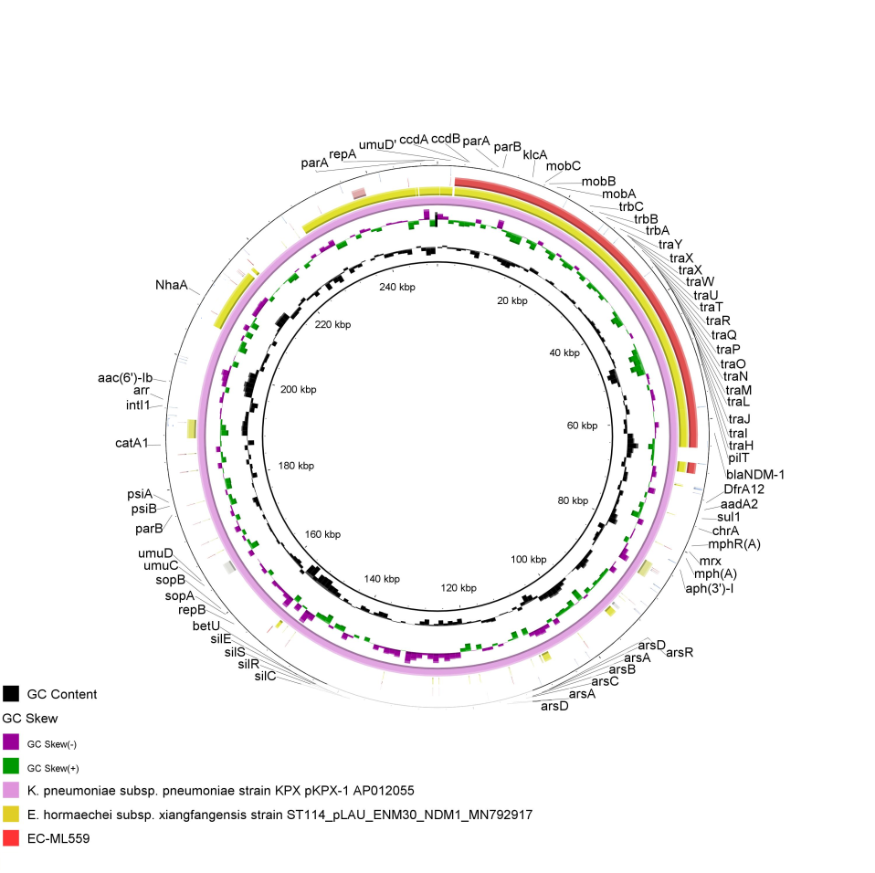

**4d. pKPX-1-like (IncFII) contigs**

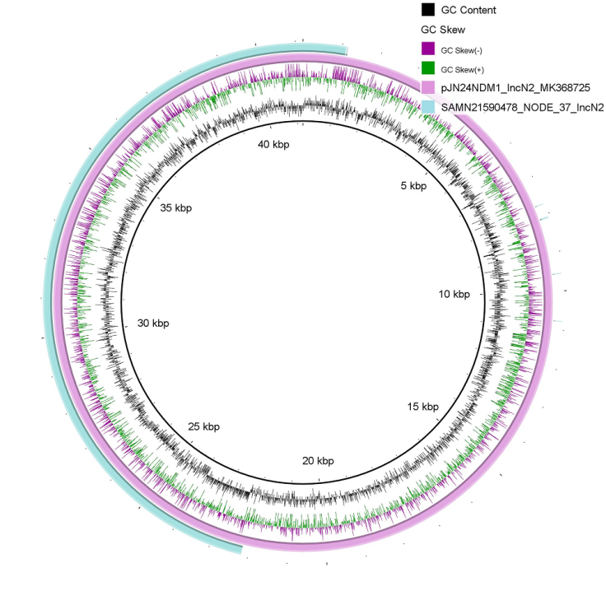**4e. pJN24NDM1-like (IncN2) contigs**

**4f. pM214_AC2-like (IncA/C2) contigs**

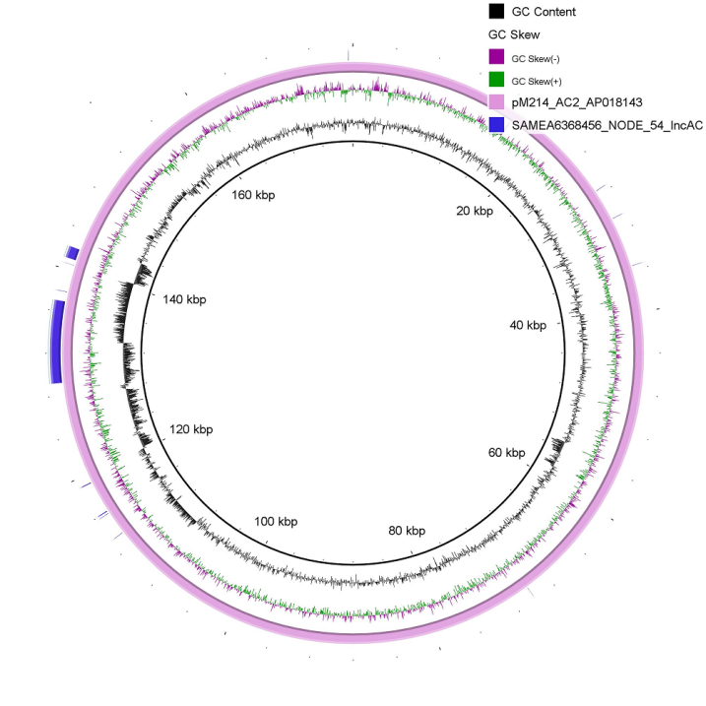

**Supplemental Figure 4.** BlastN comparisons, of the nucleotide sequences of *bla*NDM-harbouring contigs: (4a) pNDM-HN380-like (IncX3) contigs, (4b)pGUE-NDM-like (IncFII) contigs, (4c) pKOX_NDM-1-like (IncFII) contigs, (4d) pKPX-1-like (IncFII) contigs, 4E) pJN24NDM1-like (IncN2) contigs, 4F) pM214_AC2-like (IncA/C2) contigs.