Supplementary data
Techniques and methods of study
Appendix.1

Clay fraction X-Ray diffraction (XRD) analysis
The system was equipped with a Ni-filter and Cu-radiation (ג = 1.542 A°) at 40 K.V. and 30 m.A. The scanning speed used was 0.02°/S. The reflection peaks within the angular range of 2Ɵ = 4° to 70° were acquired for the study without orientation. The identification of the powder samples is established by means of qualitative and semi-quantitative examination. The d-spacing and relative intensities (I/I°) were determined and compared to the standard values from the ICDD/2010 files using the APD program. The interpretation was conducted with APD and PDF software, which incorporate powder diffraction and PDf-2 Database Sets 1–45.
A dispersed sample weighing approximately 5 grams and 100 milliliters of distilled water were combined in a labeled beaker and thoroughly mixed. The concoction was transferred into a blender and vigorously stirred for a duration of 2 to 3 minutes. The sample was reintroduced into the beaker and allowed to undergo sedimentation overnight in order to facilitate the disintegration of the fragment. Subsequently, the specimen was re-suspended in the blender and subjected to centrifugation at a speed of 2000 revolutions per minute for a duration of 3 minutes. The water was poured out, and the clay was scattered again using fresh distilled water. To re-agitate the sample in the blender for 2–3 minutes, a little amount of dispersant, such as sodium pyrophosphate or sodium hexametaphosphate (Calgon), was added.
The samples were divided into multiple labeled 50 ml centrifuge tubes and then subjected to centrifugation at a speed of 1000 rpm for a duration of 2 minutes and 7 seconds. The liquid portion was poured out into a new, clearly marked container in order to create slides with a specific orientation. A minute portion of the scattered sample, measuring less than 2 μm, was collected by employing a funnel, a 0.22 μm filter, and a vacuum created by water. The filter paper was extracted, flipped onto a pristine, labeled slide, and delicately rotated using a sterile glass rod. The filter paper was extracted, and the clay fraction was affixed to the glass slide. The slides were permitted to air-dry at ambient temperature. The percentage with particles less than 2 μm was subjected to several conditions: dried in air, solvated in ethylene glycol, and treated with heat. The initial measurement was conducted on samples that had been dried in the air. The scanning range was set between 2 and 35° 2θ, with a step size of 0.04 and a scanning speed of 2.4° per minute. Upon finishing the air run, the glass slide was retrieved and positioned with the top side facing upwards inside the desiccators. The liquid in the reservoir beneath the plate contains ethylene glycol. The warming oven was set to a temperature of 60°C and left for a duration of at least 8 hours.
An X-ray analysis was conducted immediately after the removal from the desiccators. Following analysis, the sample was kept exposed to the air overnight to achieve a state of equilibrium and facilitate the evaporation of ethylene glycol. The identical specimen was subjected to an hour-long exposure in an oven set at a temperature of 375 °C. Subsequently, X-ray analysis was promptly conducted upon its removal from the oven.
Appendix.2.
Measured vitrinite reflectance
Vitrinite preparation and organic petrography under reflected white light (RWL) microscopy
Approximately 10 grams of Sample 7 (Depth: 4614.1m) were crushed into small particles measuring 840 μm and mixed with a combination of epoxy resin Epo Thin and a hardener. The pellets were pulverized using 320 and 600 μm cloths, and subsequently polished using alumina powder of 0.3 and 0.05 μm diameters, together with water. To obtain additional information, the reader may refer to the ISO standards (ISO 7404-2, 7404-5, 2009) and ASTM D7708-14 (2014). The pellets were subsequently examined using reflectance white light (RWL) technique, employing a Zeiss Axio Imager® A2m microscope fitted with a stable current white halogen light source (12 V/100 W). Prior to conducting reflectance measurements, calibration was performed using a sapphire reference with a Ro value of 0.47%.
Figure 11 in the main manuscript shows the VRo value that was obtained from the cutting interval (Sample 7 at a depth of 4615.7 m). It shows an average value that is very close to the estimated LOM value that was derived from the Henderson petrophysics conversion graph, which is ~1.33%.
Appendix.3.
Rock-Eval pyrolysis and total organic carbon (TOC) content
Samples were washed with distilled water and then with a dichloromethane (DCM) solution (dichloromethane:methanol, 9:1 vol) several times to remove mud drilling additives. A fraction of each sample (0.5 gm) was analysed with LECO C230 instrument to determine the total organic carbon (TOC wt%) content. All samples were found to have TOC wt% > 0.5, and thus Rock-Eval data including Tmax and HI are believed to be accurate and reliable. Thus, another fraction of the pulverized samples underwent an open system programmed Bulk Rock-Eval pyrolysis using the Rock-Eval 6® Pyro-Analyzer. Both types of analyses were made at STRATOCHEM Services (SCS), Cairo, Egypt. More details on the Rock-Eval pyrolysis are described in Behar et al. (2001). All pyrograms were checked carefully for good S2 peak developments for quality control.
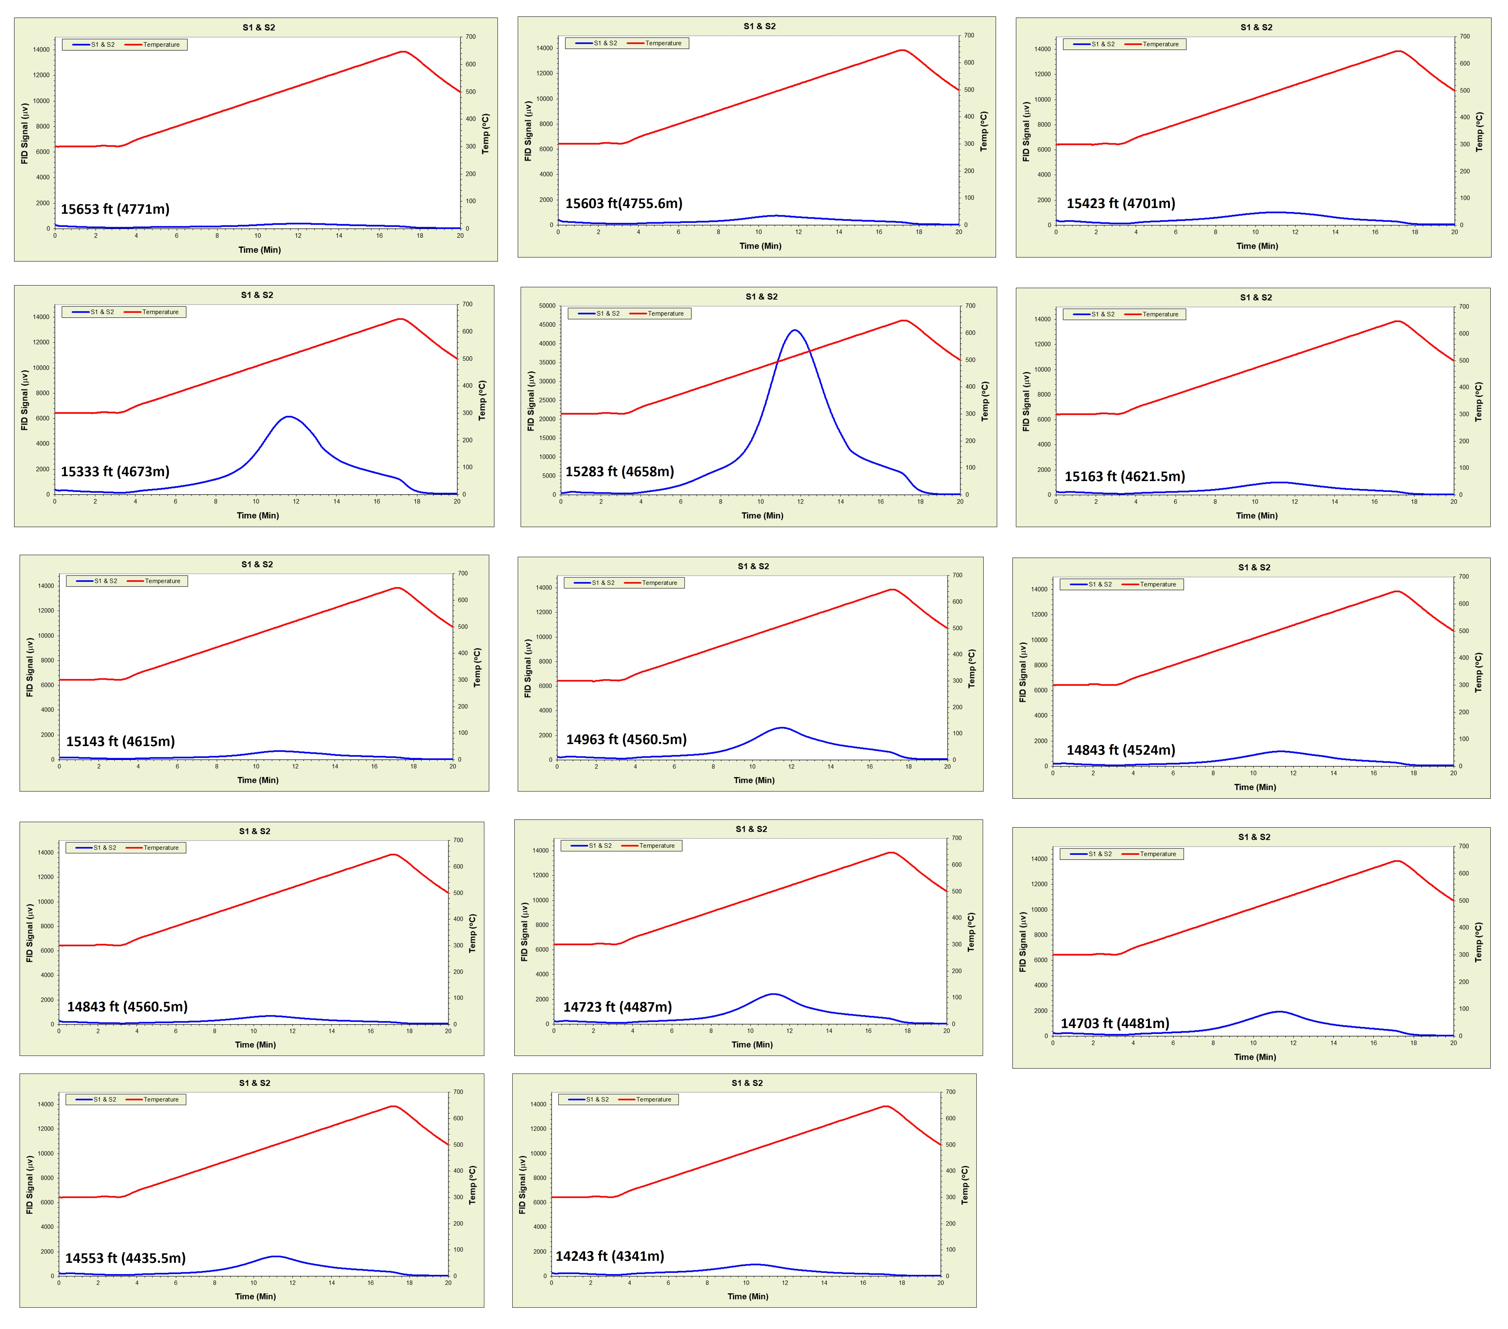
Fig. 1. The Rock-Eval 6 pyrograms of drilling mud-cleaned samples of the Khatatba Formation in the Imhotep W-1X well analysed in Laboratory (Stratochem, Cairo) showing normal S1-S2 and Tmax curves and with the very organic-rich coaly samples 4 and 5 exhibit high S2 peaks.

However, by checking pyrograms is it was found that the S1-S2 and Tmax curves show abnormal patterns. Therefore, a second pyrolysis analysis was made at Lab (SCS, Cairo), where samples were cleaned from drilling mud. The pyrograms were checked again and found to show normal patterns (Fig. 1), and thus the gleaned geochemical data is deemed here as reliable and suitable for the current work. Various parameters were determined, these include S1 (mg HC/g Rock, represents free hydrocarbons), S2 (mg HC/g Rock, represents non-soluble hydrocarbons with organic solvents, mostly kerogen), S3 (mg CO2/g Rock, represents CO2 released from hydrocarbon during pyrolysis). Hydrogen index (HI; S2/TOC; mg HC/g TOC) and Oxygen index (OI; S3/TOC; mg CO2/g TOC) were also calculated as common parameters to identify types of the organic facies.

