**Supplementary Materials**



**Figure S1.** IR spectrum of compound **1**.



**Figure S2.** IR spectrum of compound **2**.



**Figure S3.** IR spectrum of compound **3**.



**Figure S4.** IR spectrum of compound **5**.



**Figure S5.** IR spectrum of compound **6**.



**Figure S6.** IR spectrum of compound **7**.



**Figure S7.** IR spectrum of compound **8**.



**Figure S8.** IR spectrum of compound **9**.



**Figure S9.** IR spectrum of compound **10**.

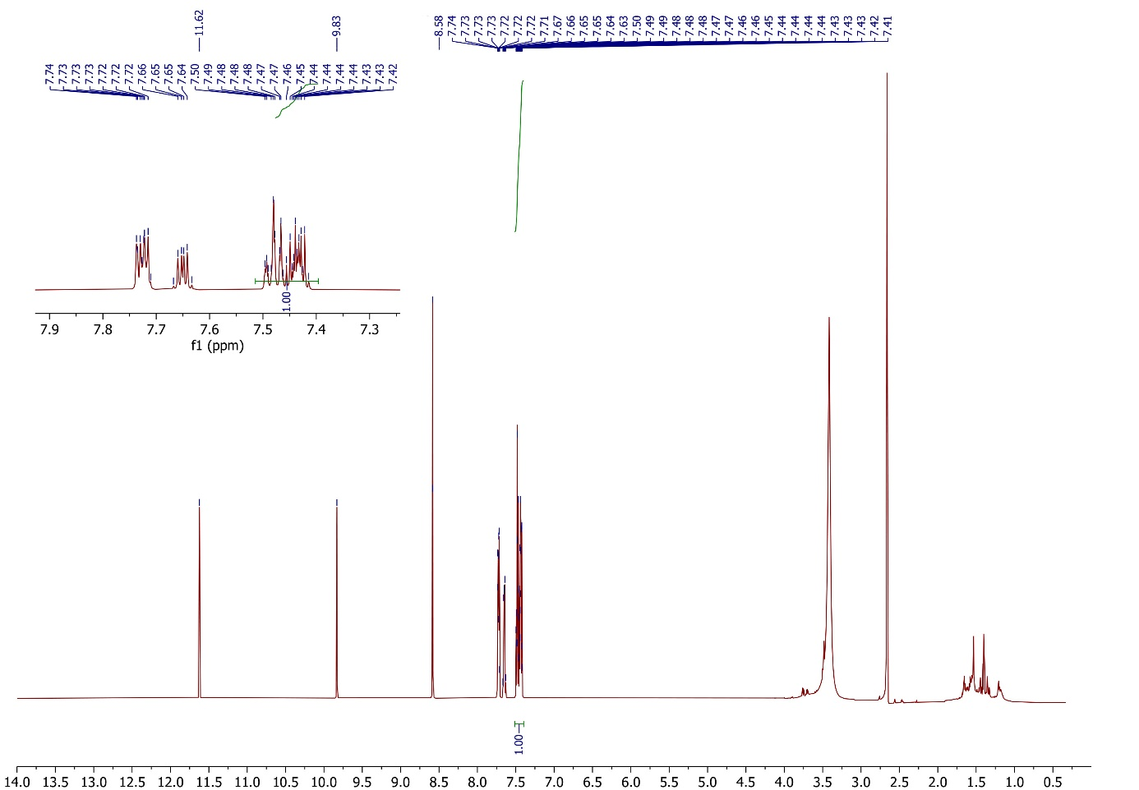

**Figure S10.** 1H NMR spectrum of compound **1**.

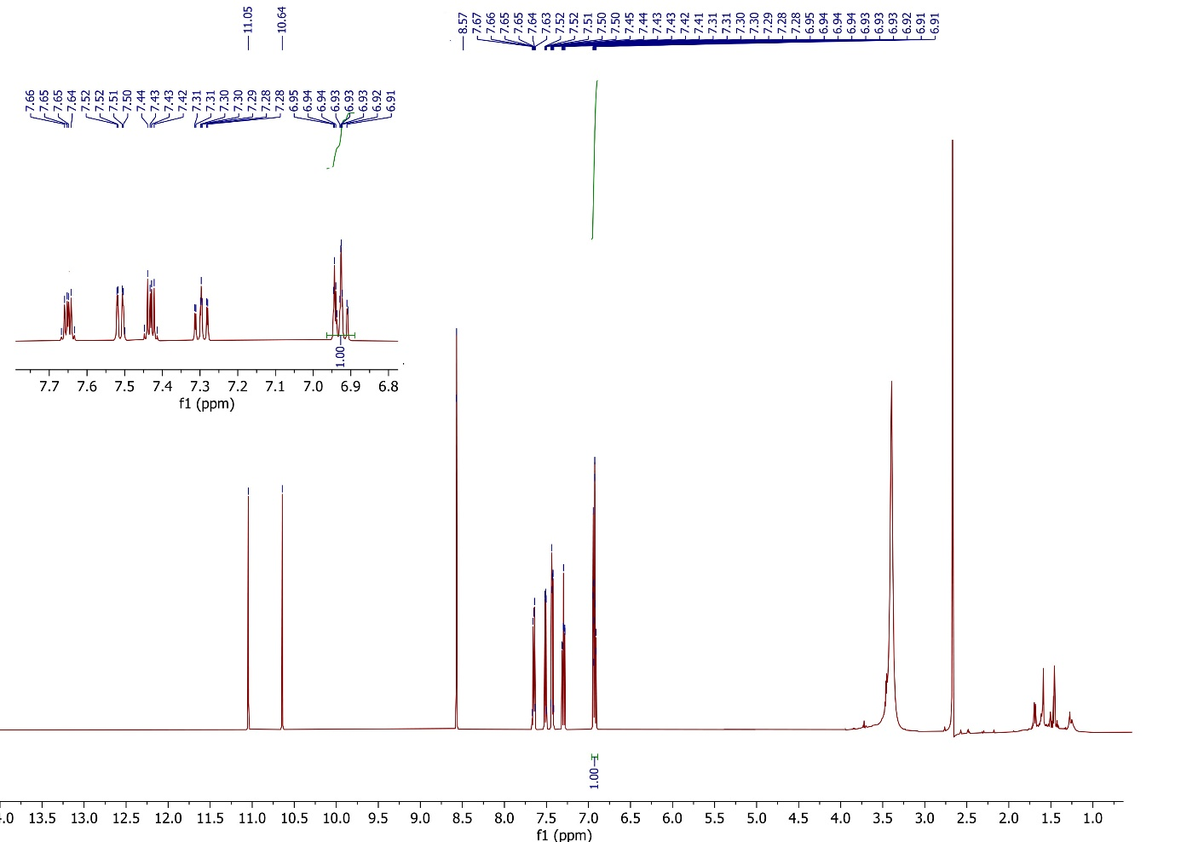

**Figure S11**. 1H NMR spectrum of compound **2**.

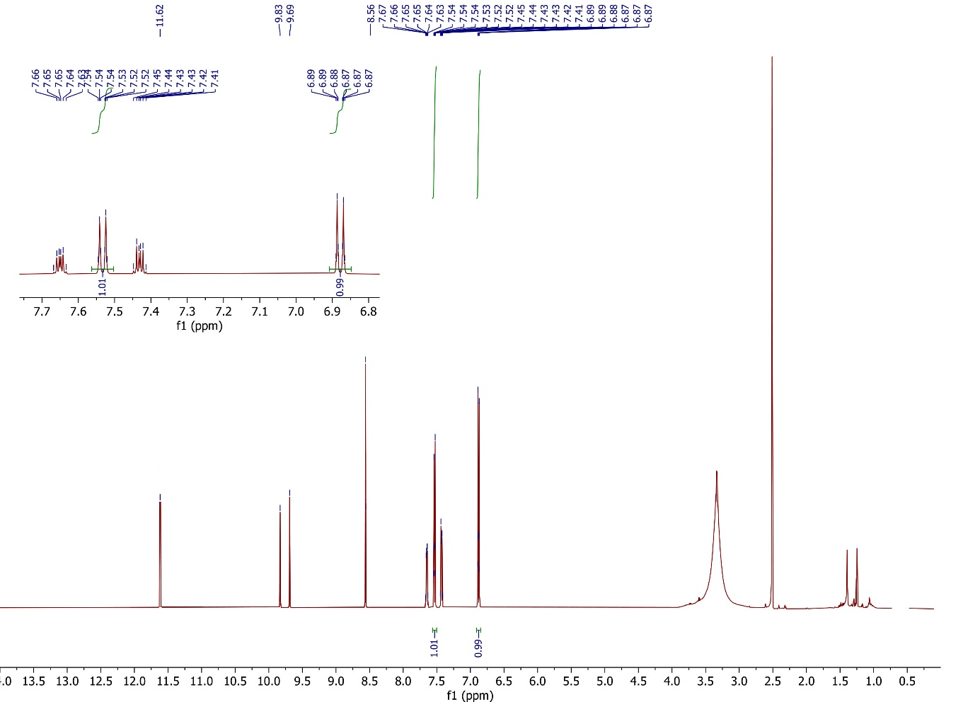

**Figure S12**. 1H NMR spectrum of compound **3**.

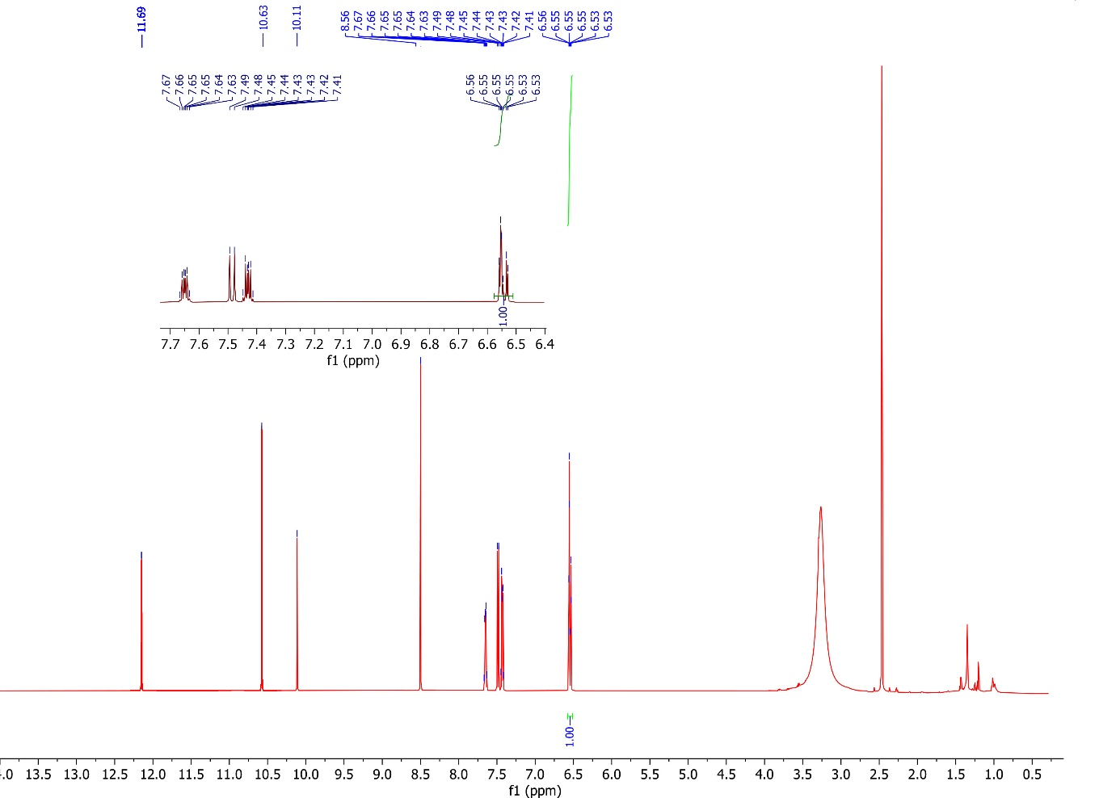

**Figure S13**. 1H NMR spectrum of compound **5**.

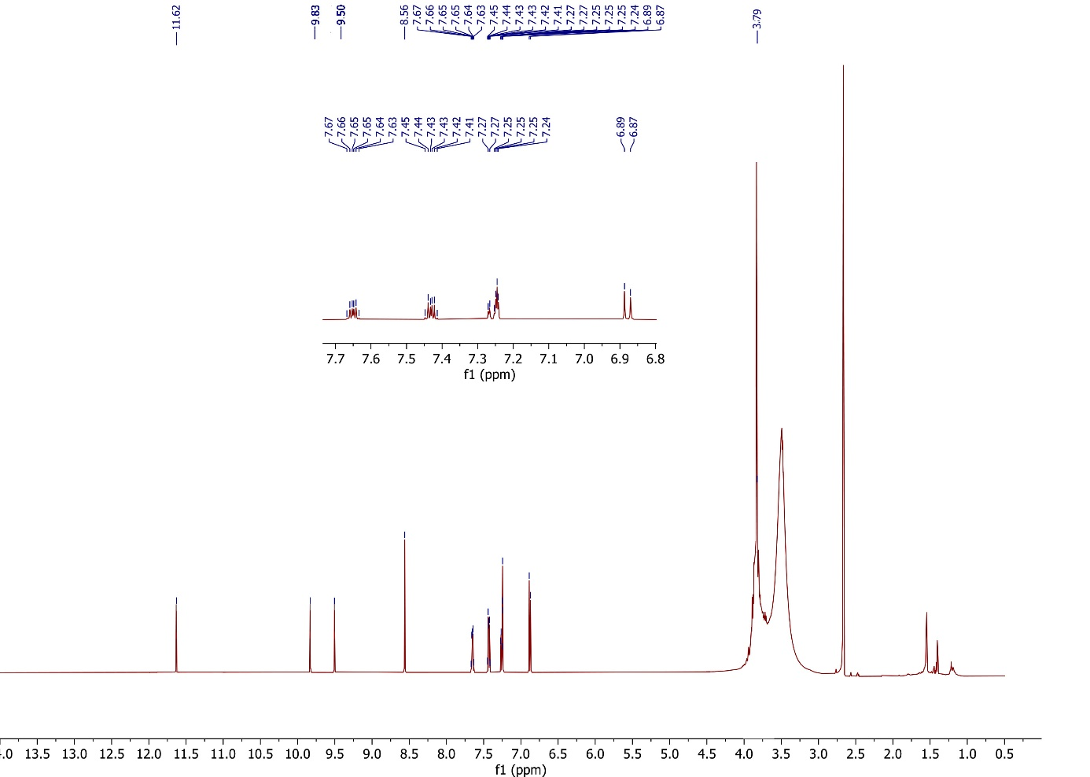

**Figure S14**. 1H NMR spectrum of compound **6**.

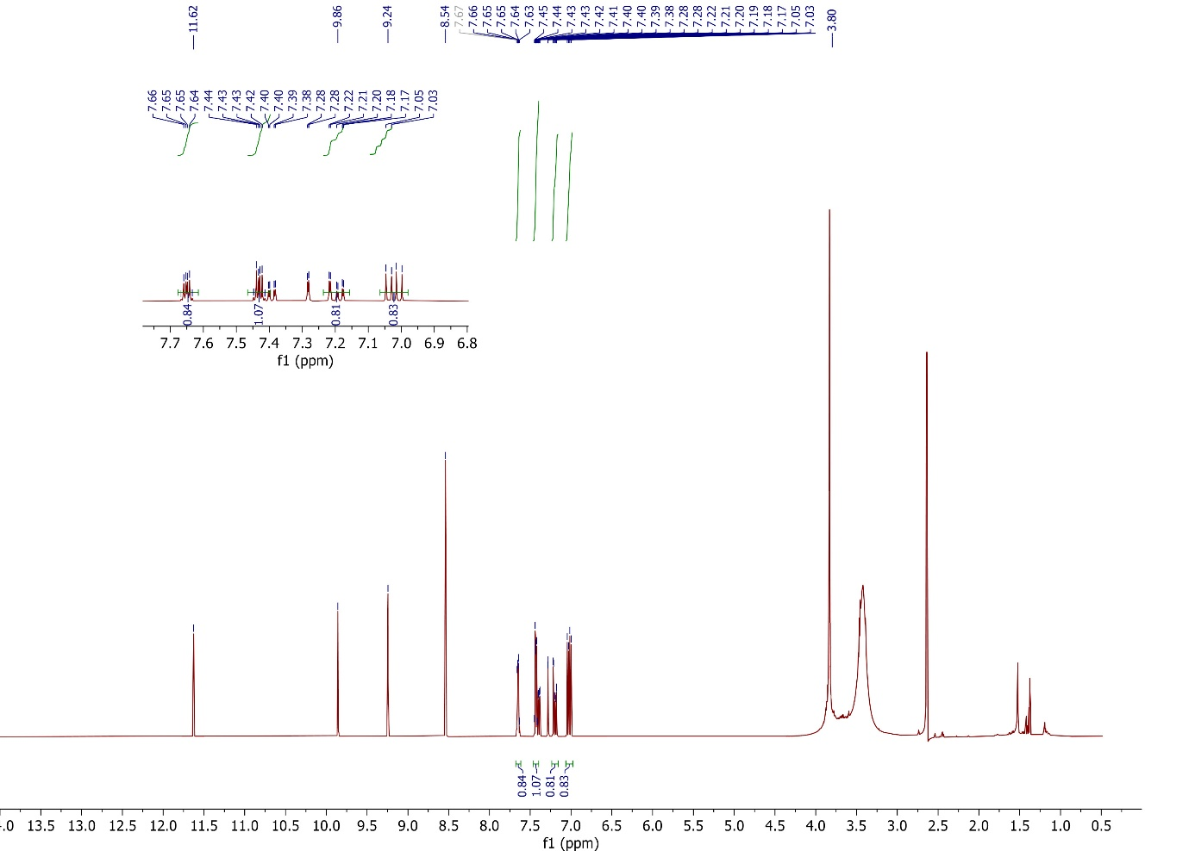

**Figure S15**. 1H NMR spectrum of compound **7**.

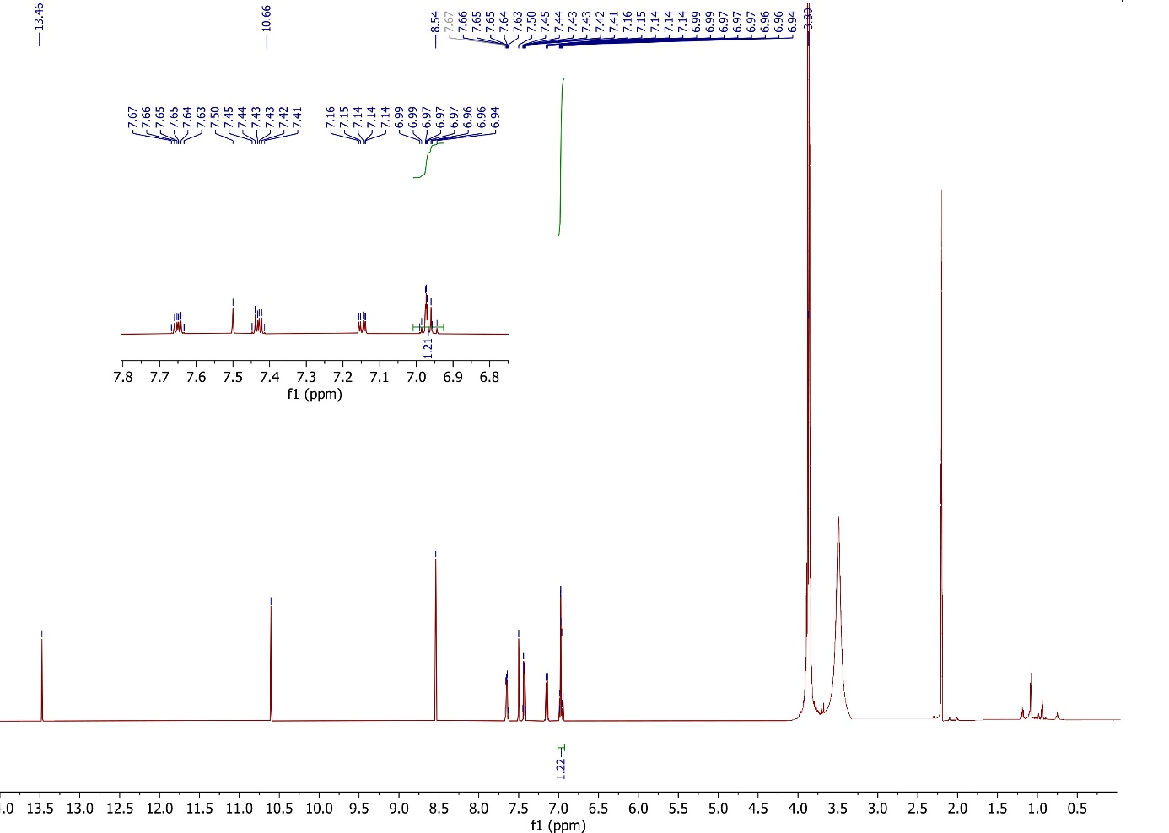

**Figure S16**. 1H NMR spectrum of compound **8**.

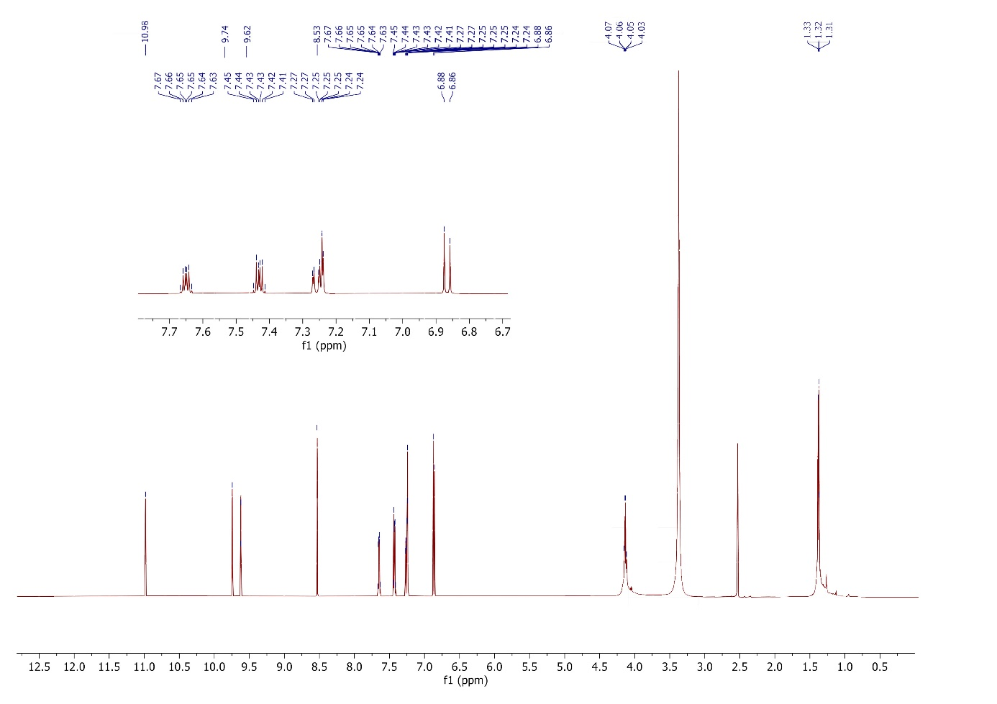

**Figure S17**. 1H NMR spectrum of compound **9**.

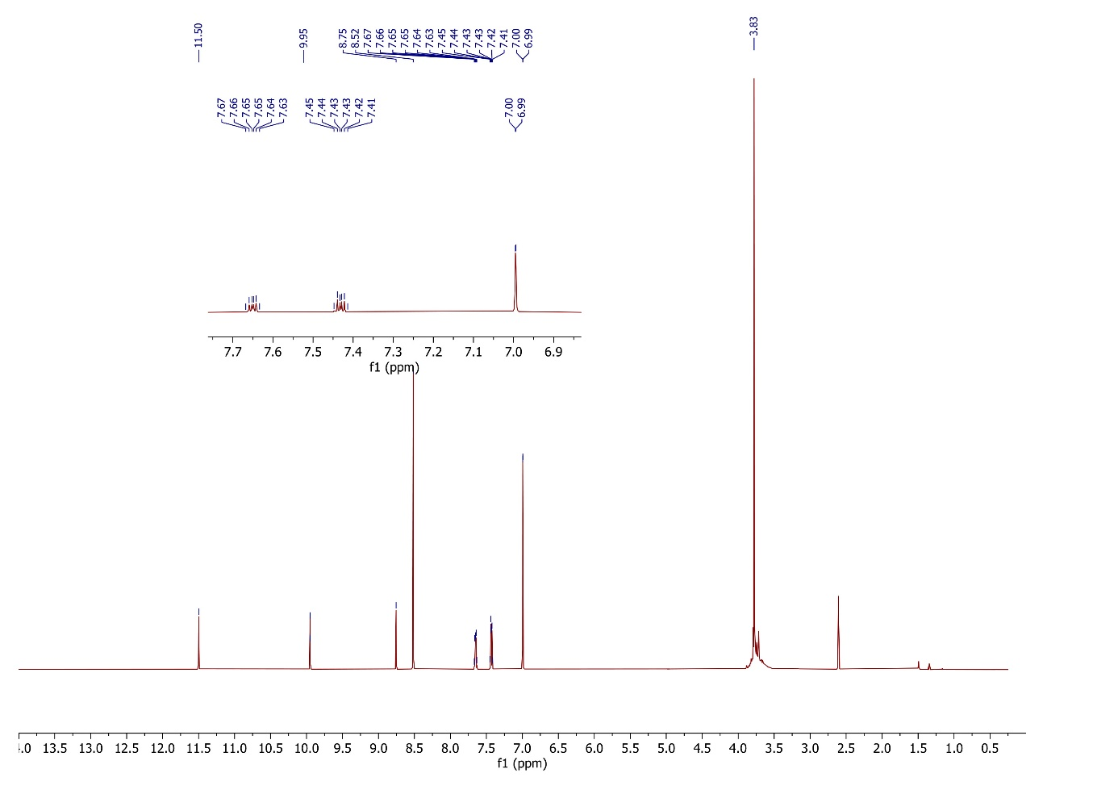

**Figure S18**. 1H NMR spectrum of compound **10**.

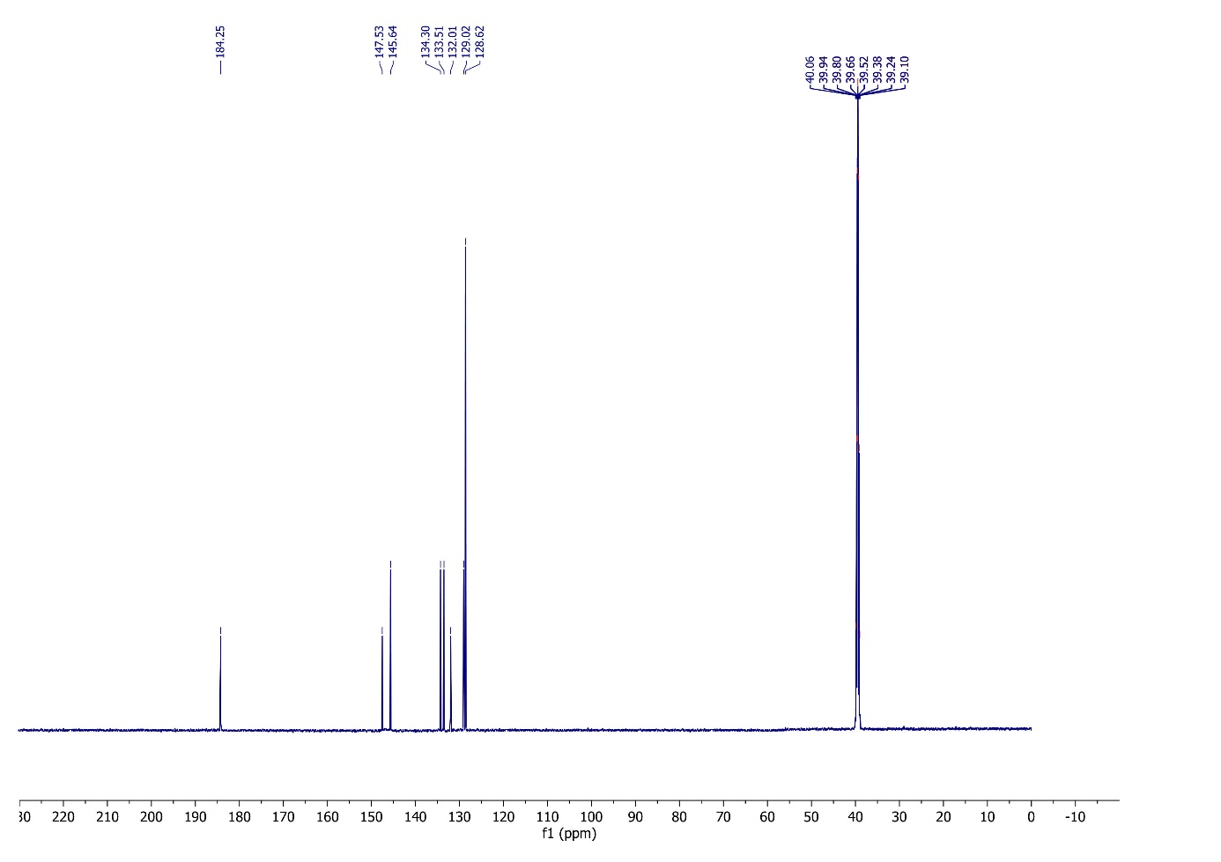

**Figure S19.** 13C NMR spectrum of compound **1**.

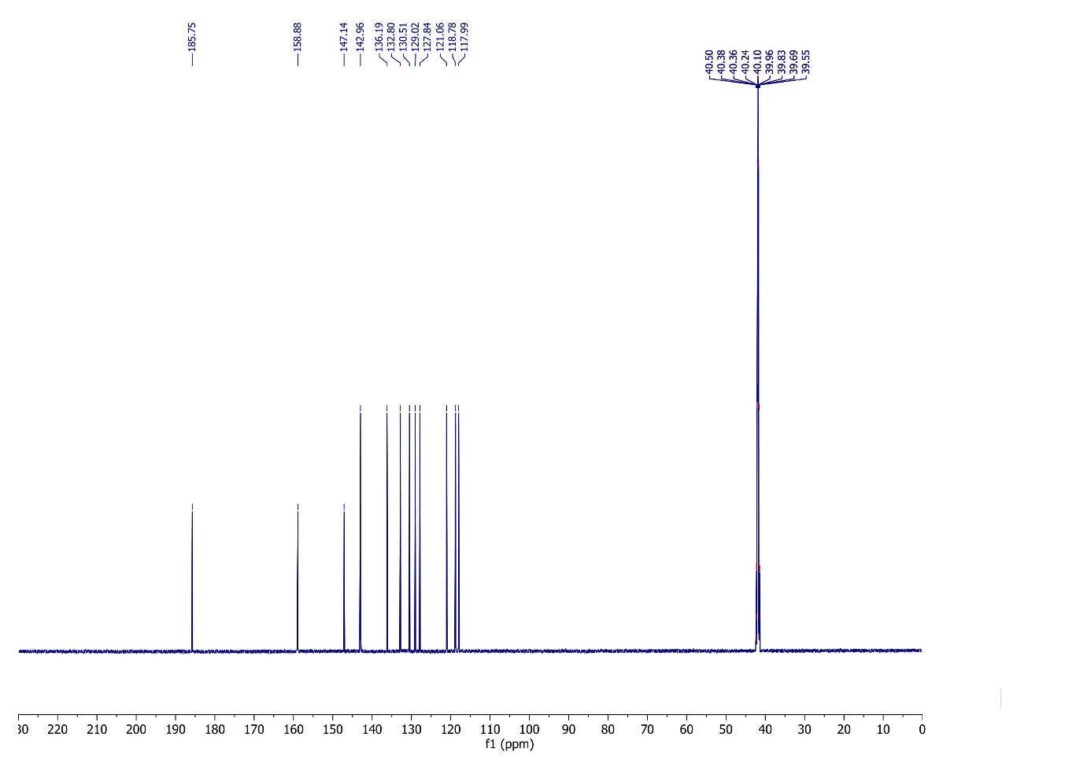

**Figure S20.** 13C NMR spectrum of compound **2**.

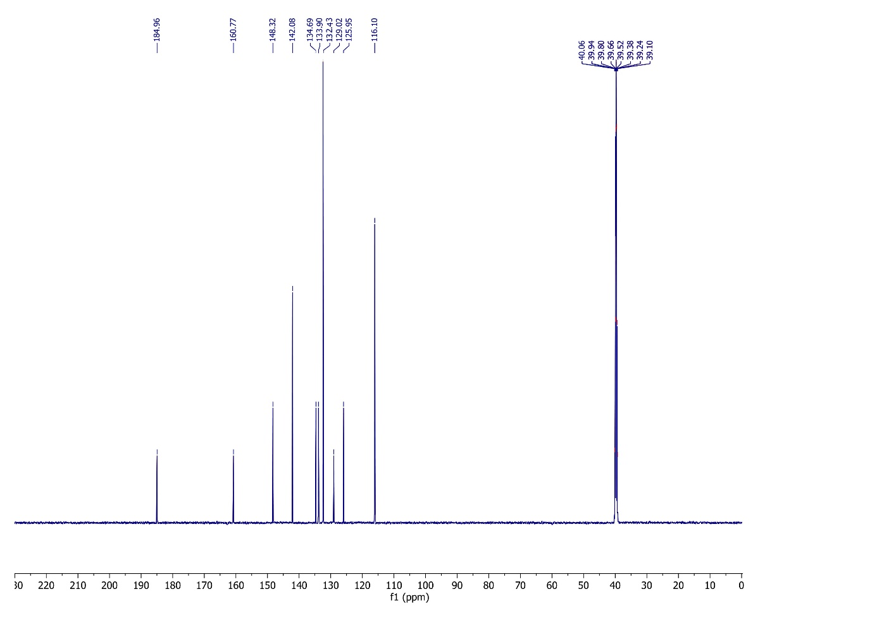

**Figure S21.** 13C NMR spectrum of compound **3**.

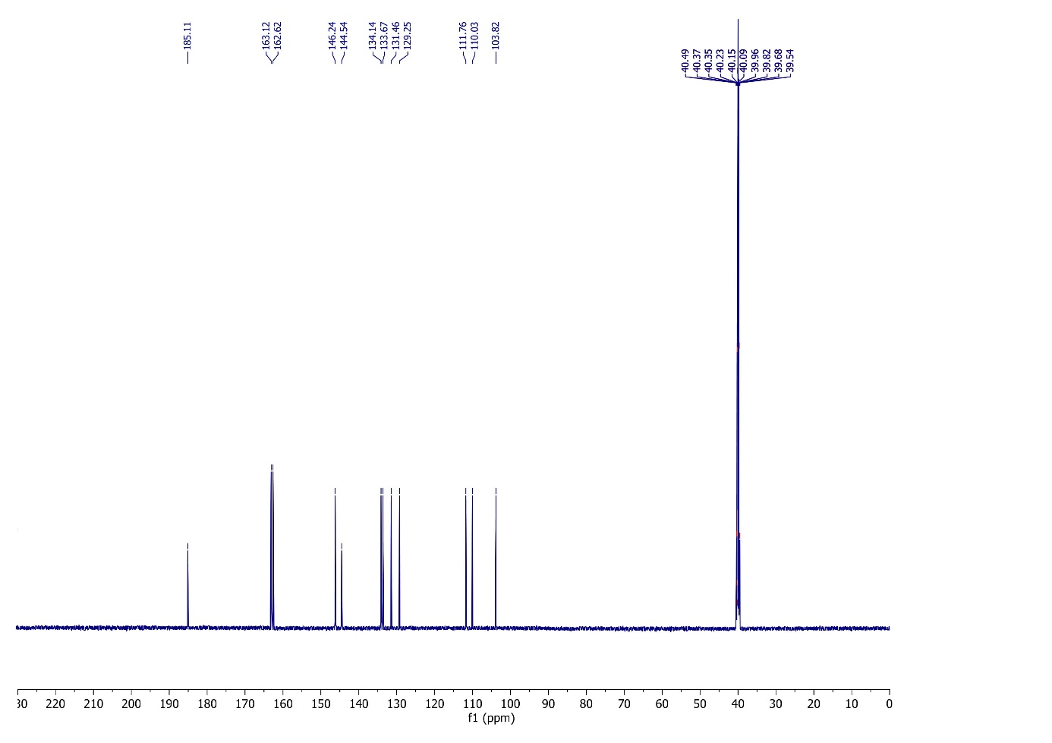

**Figure S22.** 13C NMR spectrum of compound **5**.

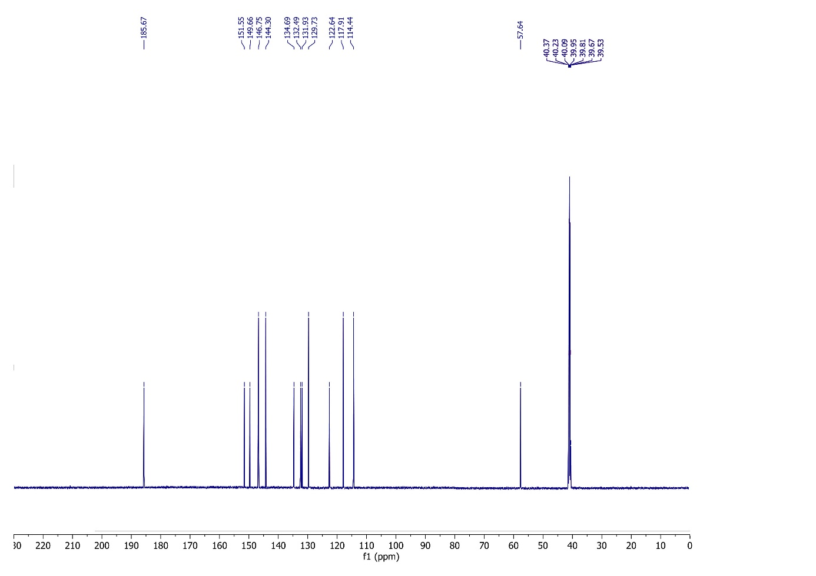

**Figure S23.** 13C NMR spectrum of compound **6**.

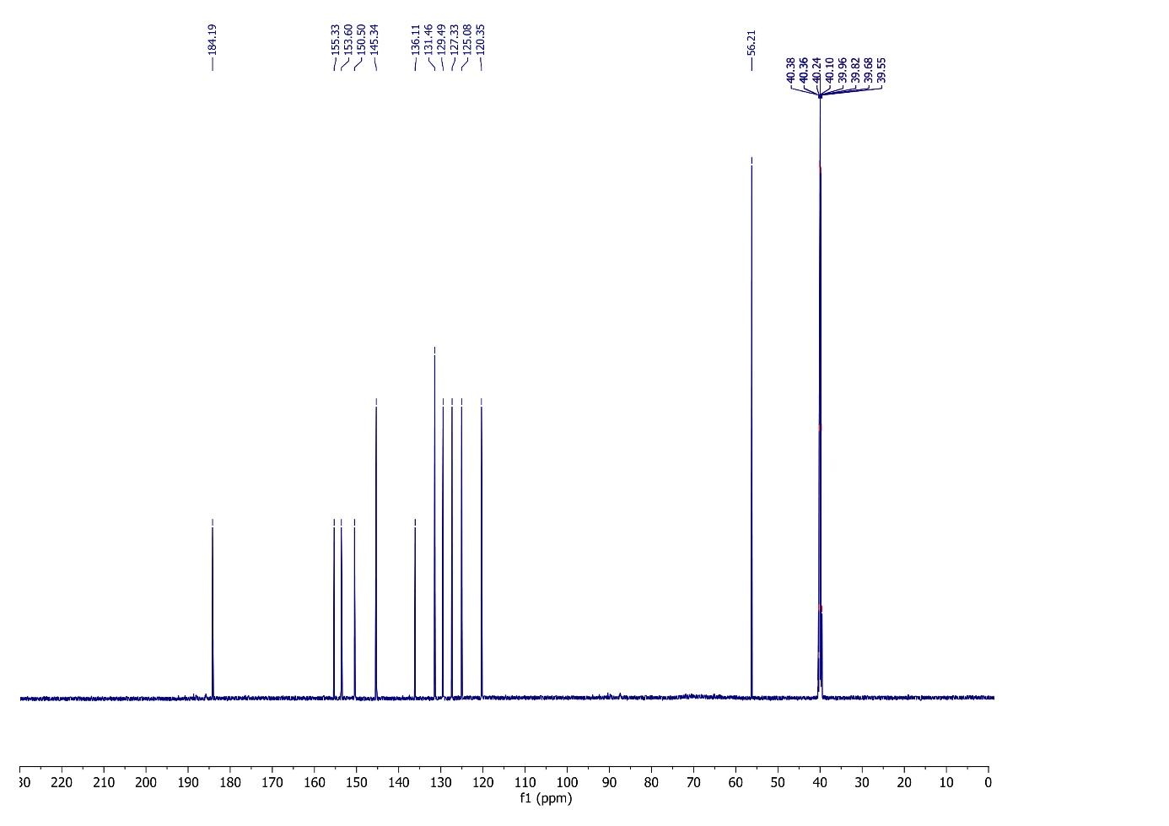

**Figure S24.** 13C NMR spectrum of compound **7**.

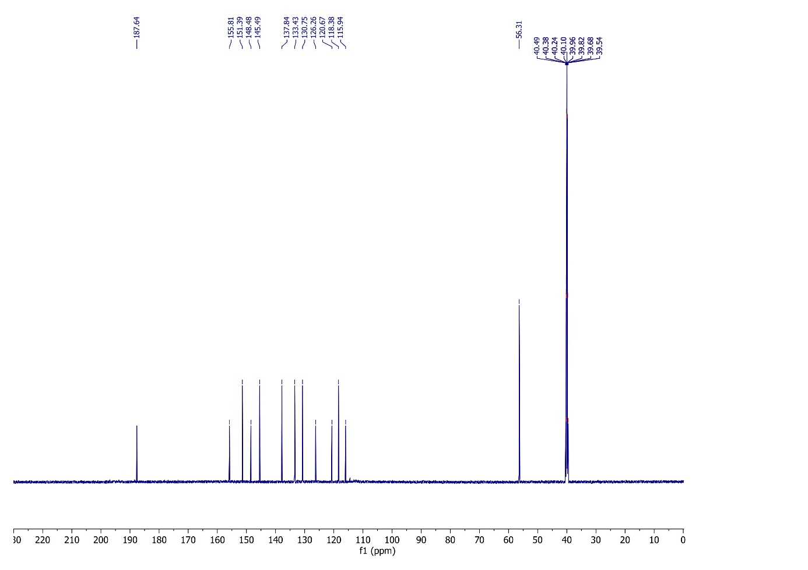

**Figure S25.** 13C NMR spectrum of compound **8**.

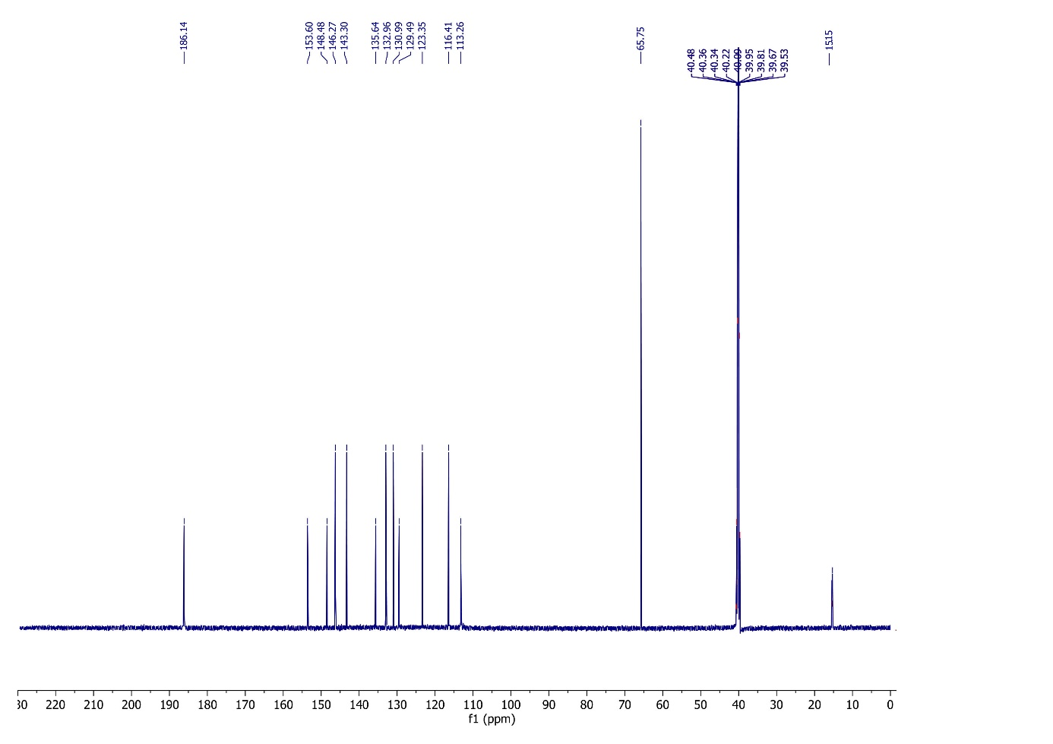

**Figure S26.** 13C NMR spectrum of compound **9**.

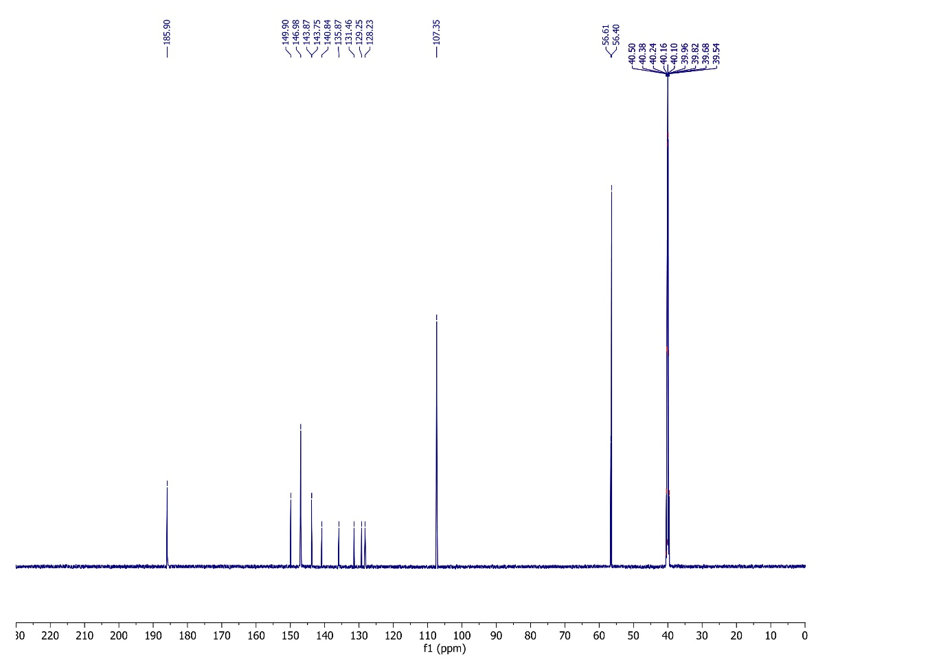

**Figure S27.** 13C NMR spectrum of compound **10**.



**Figure S28.** UV-Vis spectrum of compound **1** in DMSO.



**Figure S29.** UV-Vis spectrum of compound **2** in DMSO.



**Figure S30.** UV-Vis spectrum of compound **3** in DMSO.



**Figure S31.** UV-Vis spectrum of compound **5** in DMSO.



**Figure S32.** UV-Vis spectrum of compound **6** in DMSO.



**Figure S33.** UV-Vis spectrum of compound **7** in DMSO.



**Figure S34.** UV-Vis spectrum of compound **8** in DMSO.



**Figure S35.** UV-Vis spectrum of compound **9** in DMSO.



**Figure S36.** UV-Vis spectrum of compound **10** in DMSO.



**Figure S37.** TGA and DSC curvesfor synthesized compound **1**.



**Figure S38.** TGA and DSC curvesfor synthesized compound **2**.



**Figure S39.** TGA and DSC curvesfor synthesized compound **3**.



**Figure S40.** TGA and DSC curvesfor synthesized compound **5**.



**Figure S41.** TGA and DSC curvesfor synthesized compound **6**.



**Figure S42.** TGA and DSC curvesfor synthesized compound **7**.



**Figure S43.** TGA and DSC curvesfor synthesized compound **8**.



**Figure S44.** TGA and DSC curvesfor synthesized compound **9**.



**Figure S45.** TGA and DSC curvesfor synthesized compound **10**.