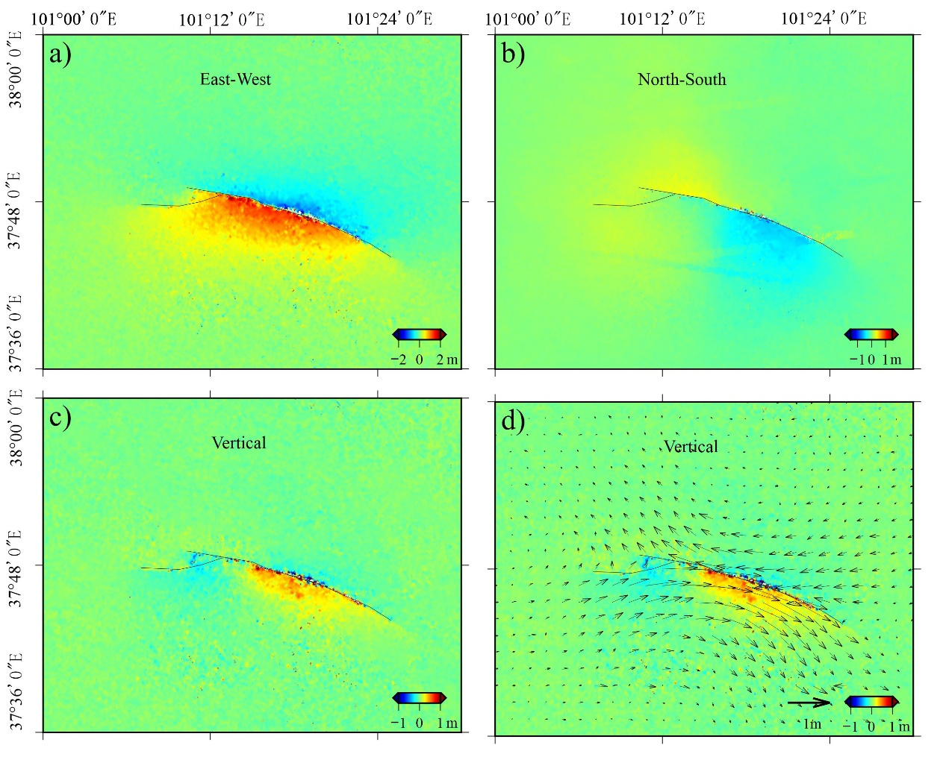
Figure S1. The surface three-dimensional deformation fields resolved with InSAR data. (a) The east-west direction displacement. (b) The north-south direction displacement. (c) The vertical displacements. (d) The base map was the vertical displacement, and the arrows were the horizontal displacements synthesized from east-west and north-south displacements.
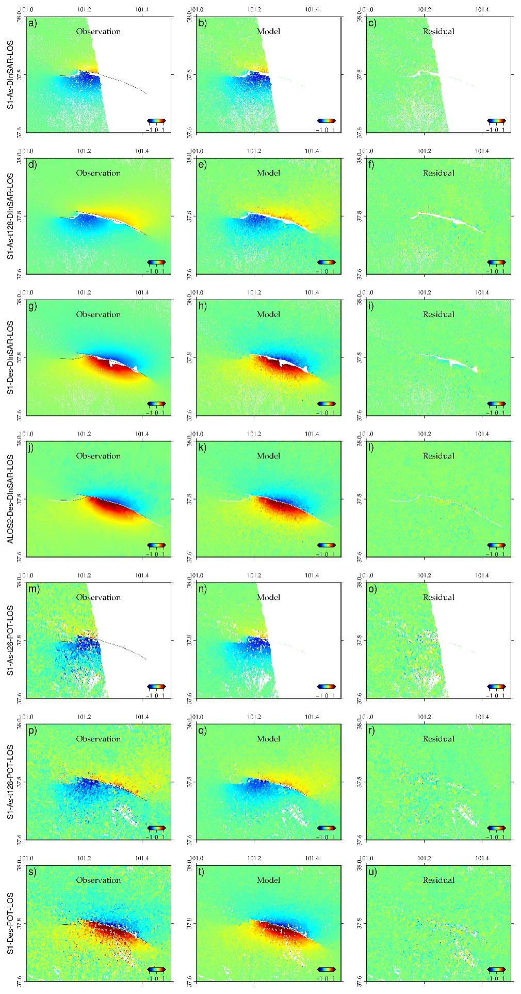
Figure S2. The deformation maps of InSAR raw data (a, d, g, j, m, p, s), simulated data (b, e, h, k, n, q, t) and residuals (c, f, i, l, o, r, u) for surface three-dimensional deformation fields calculation with only InSAR data.
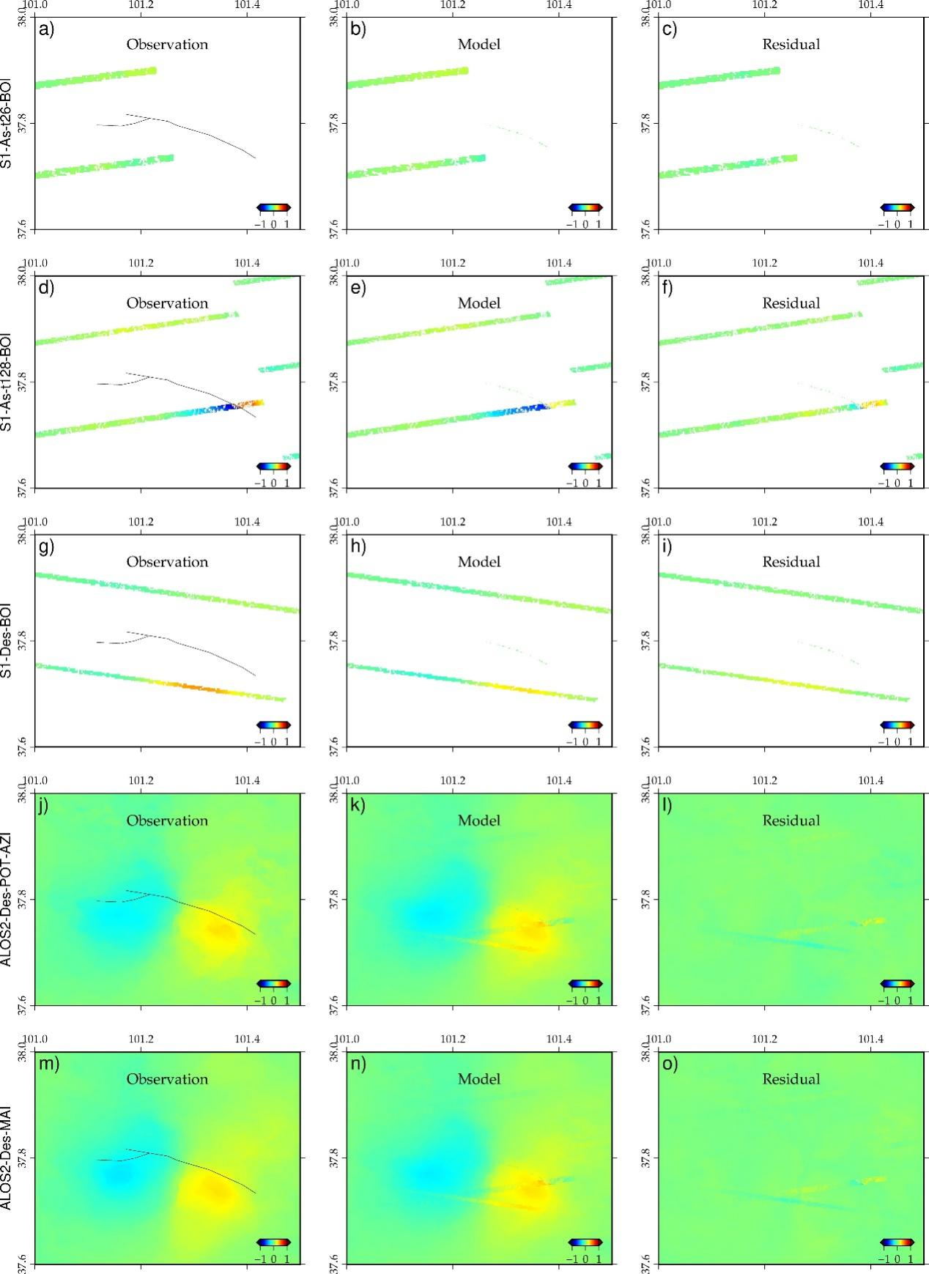
Figure S3. The deformation maps of InSAR raw data (a, d, g, j, m), simulated data (b, e, h, k, n) and residuals (c, f, i, l, o) for surface three-dimensional deformation fields calculation with only InSAR data.
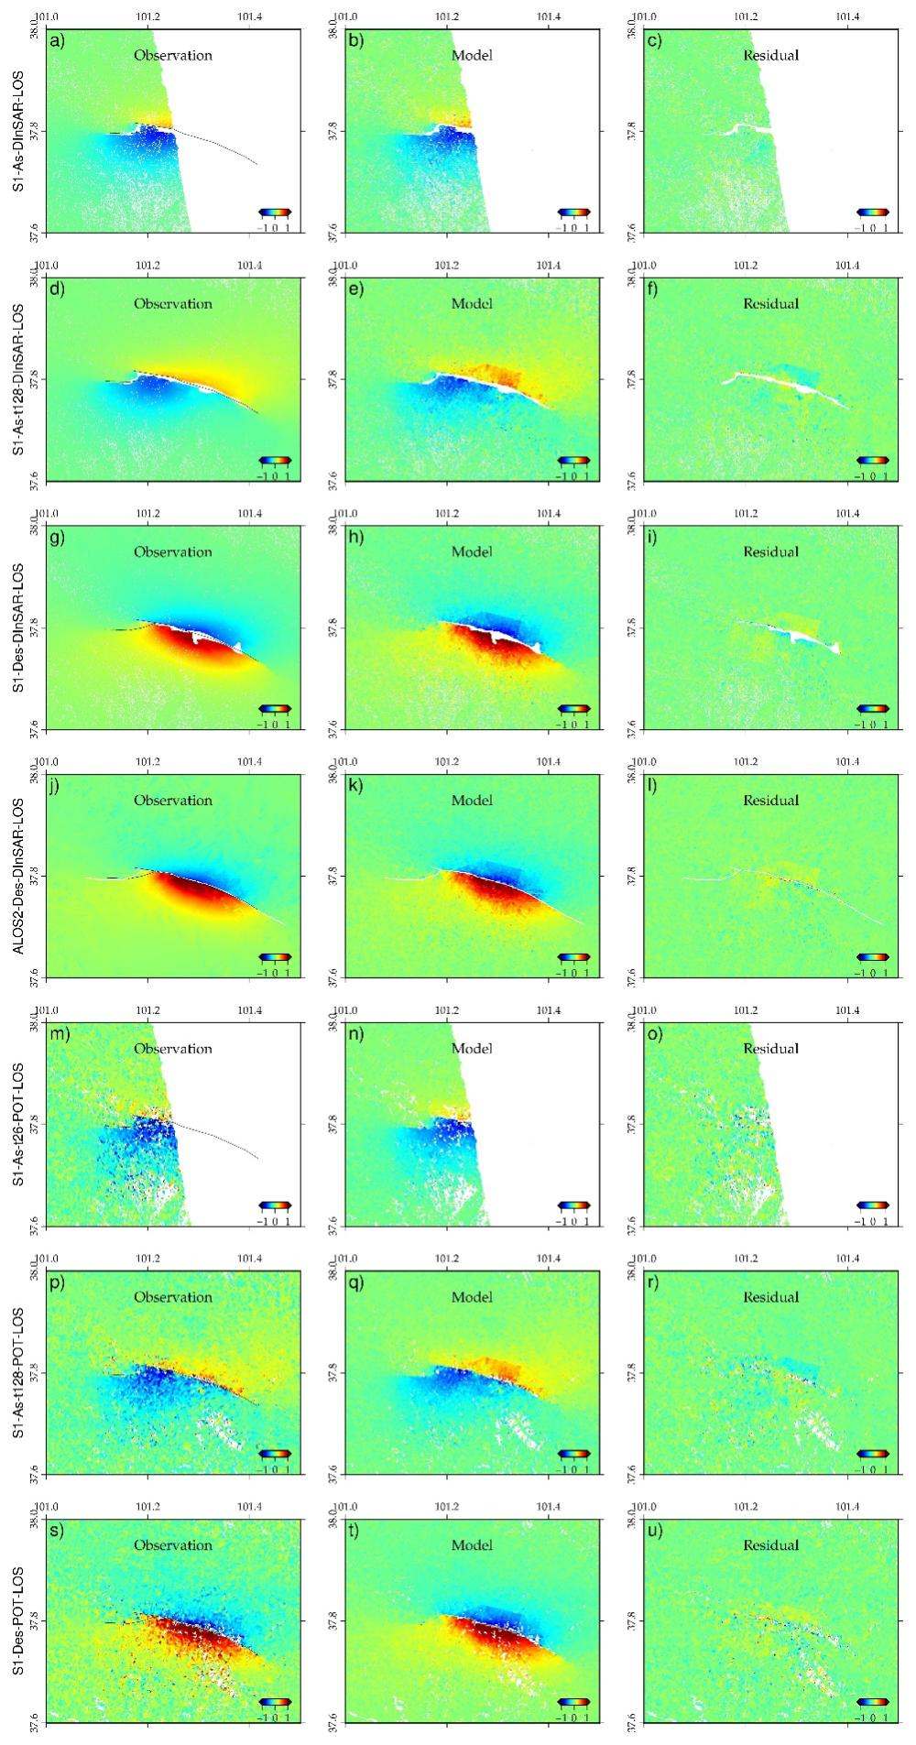
Figure S4. The deformation maps of InSAR raw data (a, d, g, j, m, p, s), simulated data (b, e, h, k, n, q, t) and residuals (c, f, i, l, o, r, u) for surface three-dimensional deformation fields calculation with InSAR, optical pixel correlation and DEM difference data.
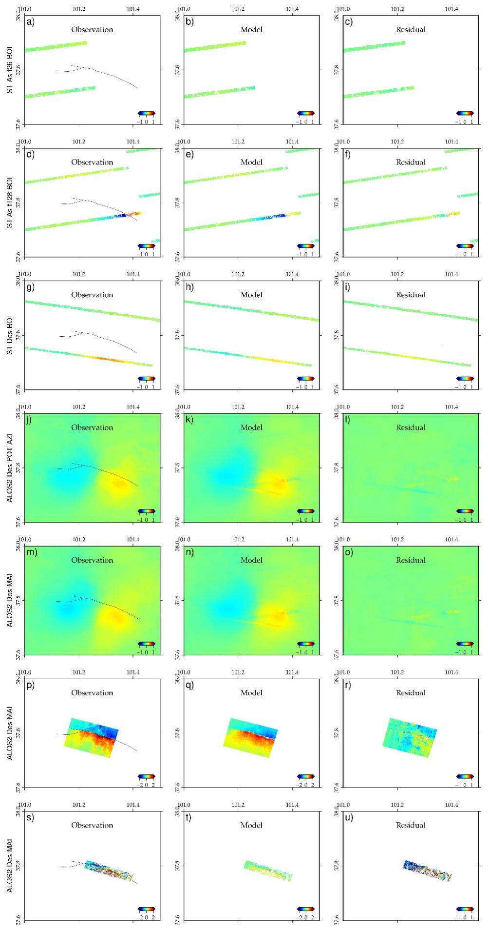
Figure S5. The deformation maps of InSAR, optical pixel correlation and DEM difference raw data (a, d, g, j, m, p, s), simulated data (b, e, h, k, n, q, t) and residuals (c, f, i, l, o, r, u) for surface three-dimensional deformation fields calculation with InSAR, optical pixel correlation and DEM difference data.

