Supplementary Information
Robust photocatalytic MICROSCAFS® with interconnected macropores for sustainable solar-driven water purification
by Mário Vale, Beatriz T. Barrocas, Rita Serôdio, M. Conceição Oliveira, José M. Lopes, Ana C. Marques

Figure S1. Transmission spectrum of the silica quartz window employed in the continuous flow reactor, and also to cover the batch reactor.

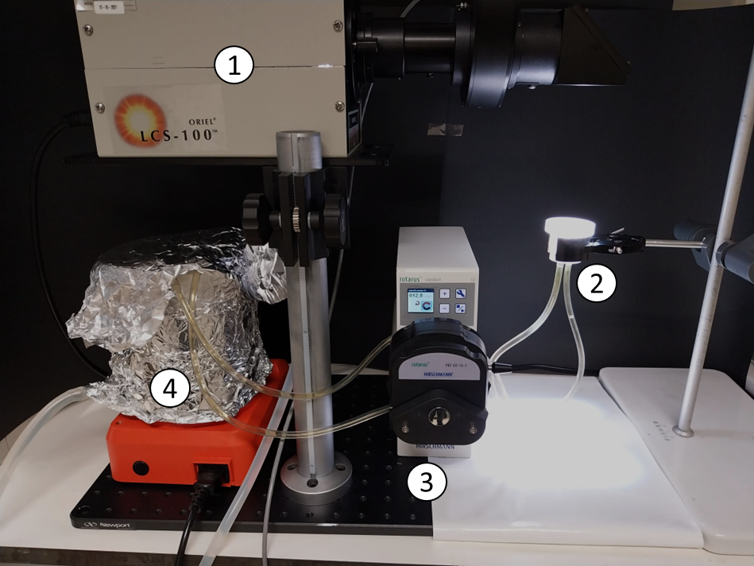
Figure S2. Continuous flow reactor with total recirculation to a tank. 1 – Solar simulator;
2 – Sample chamber (solar reactor); 3 – Peristaltic pump; 4 – MO solution stirred tank.

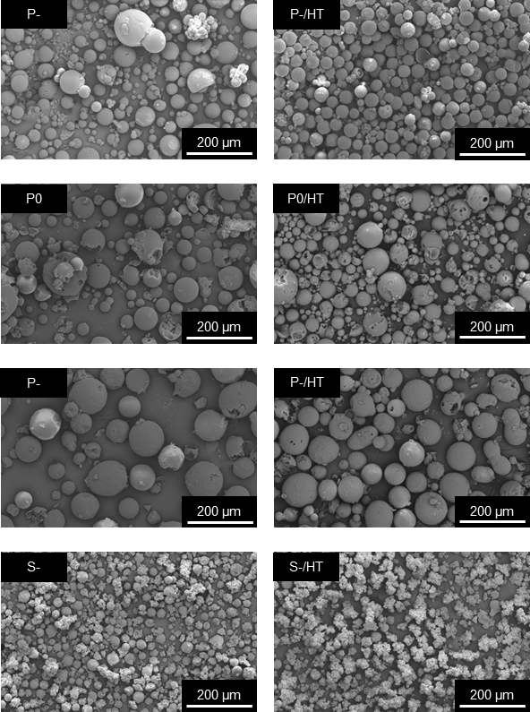
Figure S3. SEM images of the MICROSCAFS® used for the particle size distributions, before (left column) and after (right column) being heat treated at 900 °C for 30 minutes.

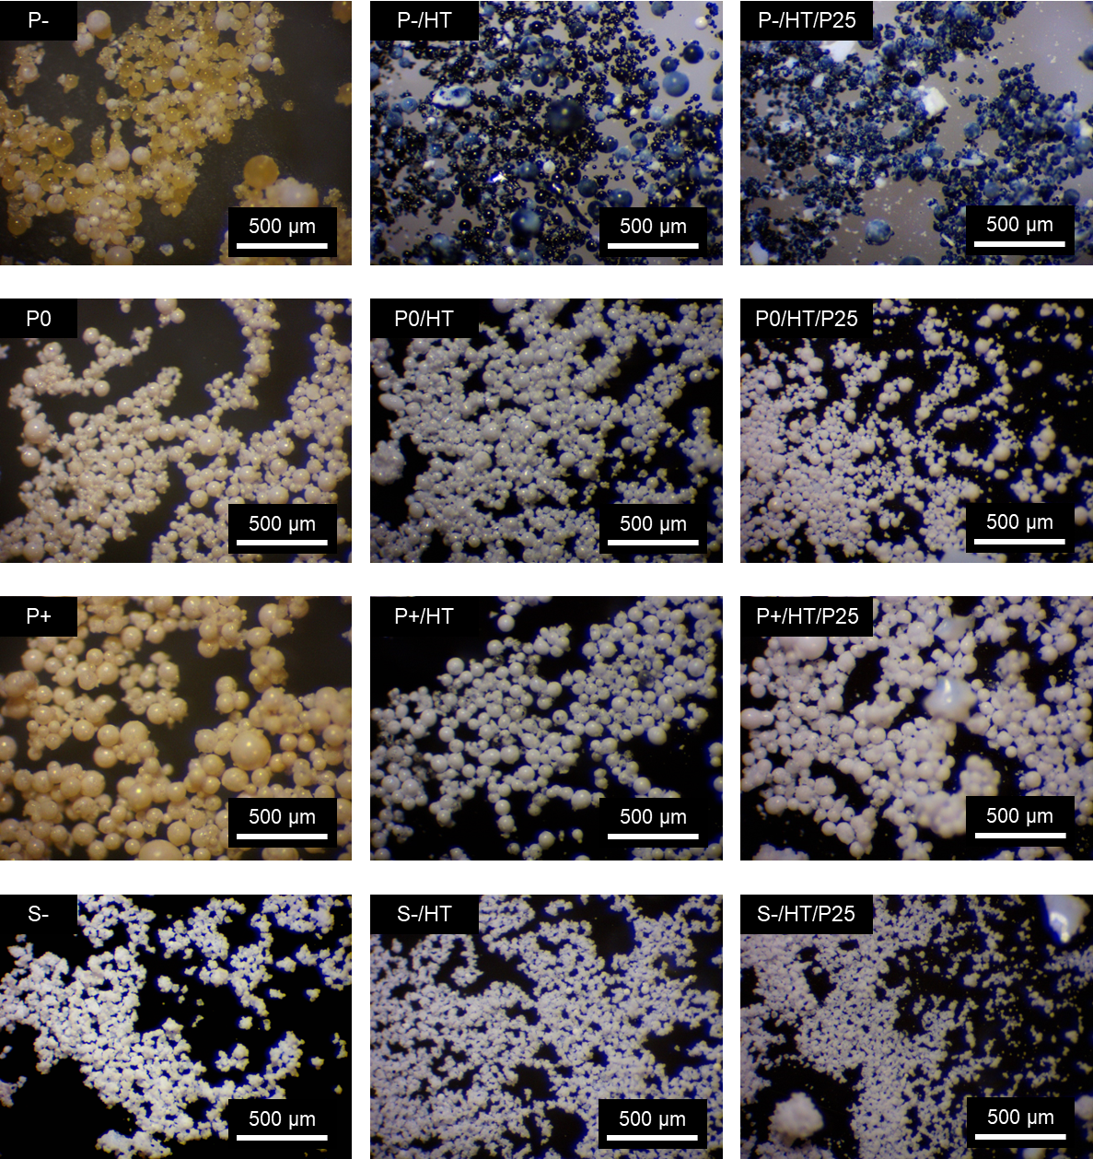
Figure S4. Optical microscopy photographs of the MICROSCAFS® in three subsequent stages: 1 (first column) – dried MICROSCAFS®; 2 - (second column) MICROSCAFS® after being heat treated at 900 °C for 30 minutes; 3 (third column) – MICROSCAFS® after being loaded with the P25 TiO₂ NPs.

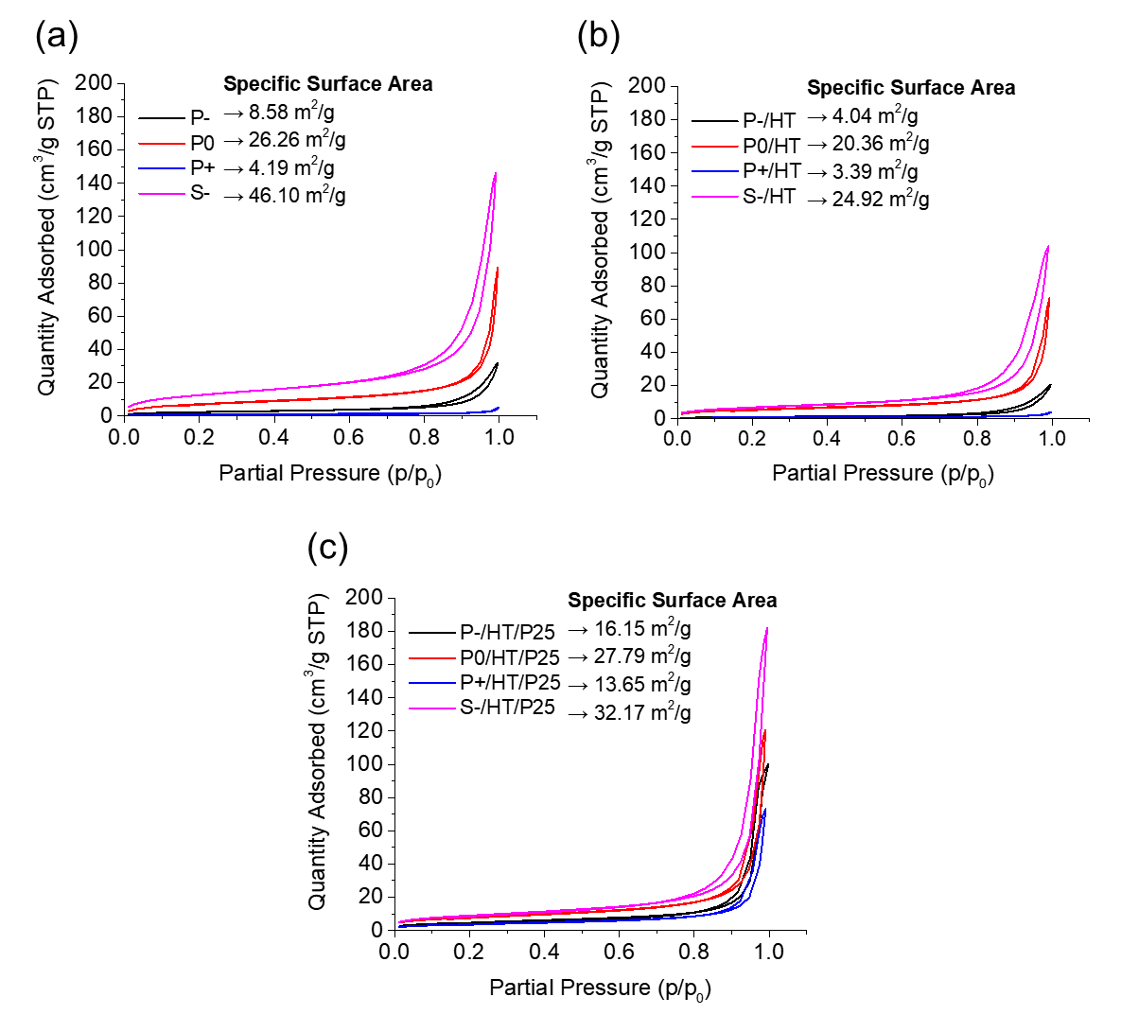
Figure S5. N₂ adsorption-desorption isotherms of the MICROSCAFS® (a) dried at 45 °C, (b) heat-treated at 900 °C and (c) loaded with P25 TiO2 NPs.

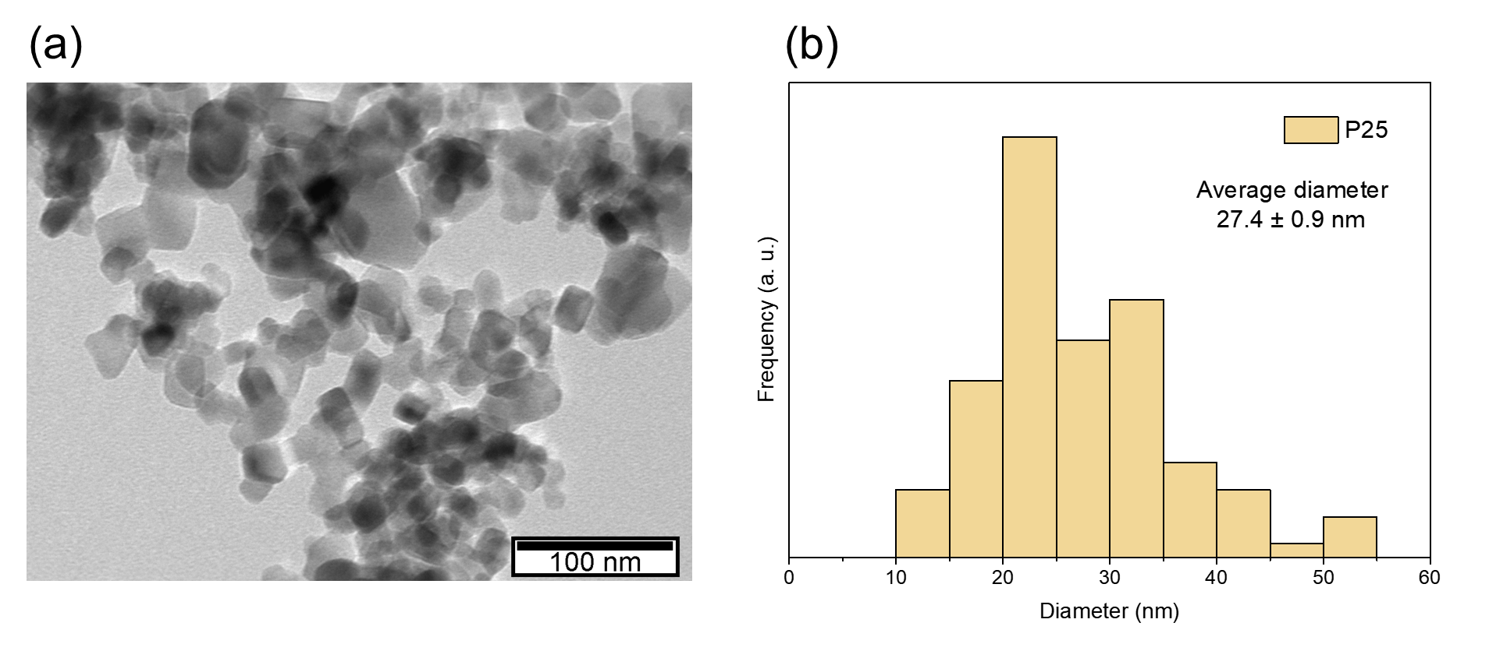
Figure S6. (a) TEM image of the P25 TiO₂ NPs; (b) their respective particle size distribution.

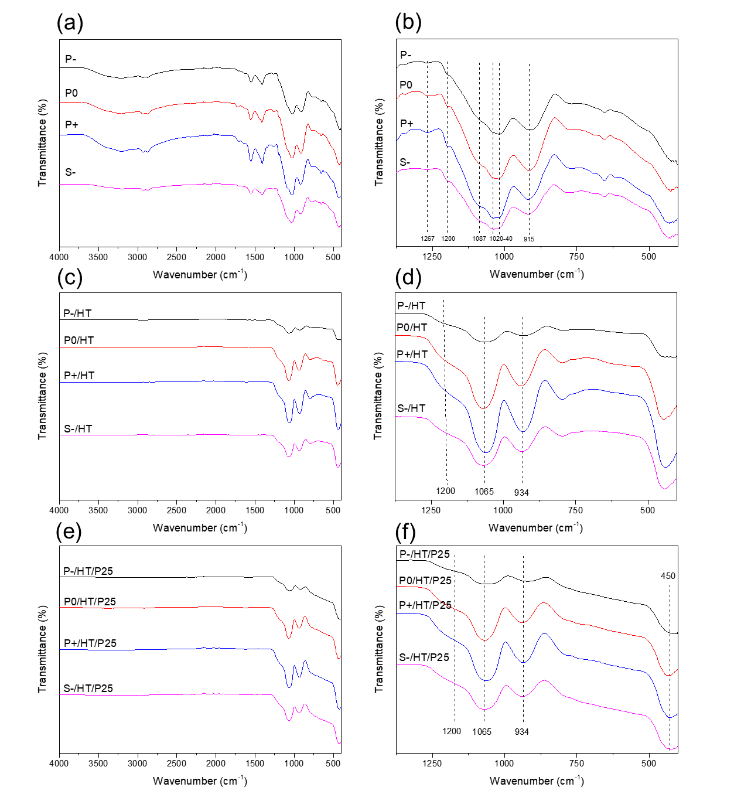
Figure S7. ATR-FTIR spectra of all the MICROSCAFS® (a, c and e) and respective magnification in the range of 1500 to 400 cm⁻¹ (b, d and f).

Figure S8. Kubelka-Munk transformed UV-Vis DRS absorption spectra of the P25 TiO₂ NPs loaded MICROSCAFS® and P25 TiO₂ NPs.

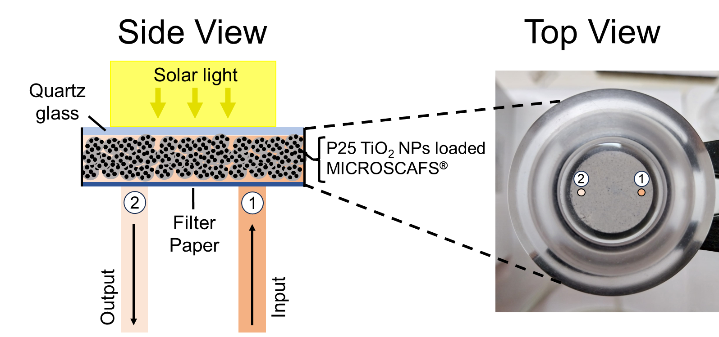
Figure S9. Side and top views of the continuous flow reactor’s sample chamber.

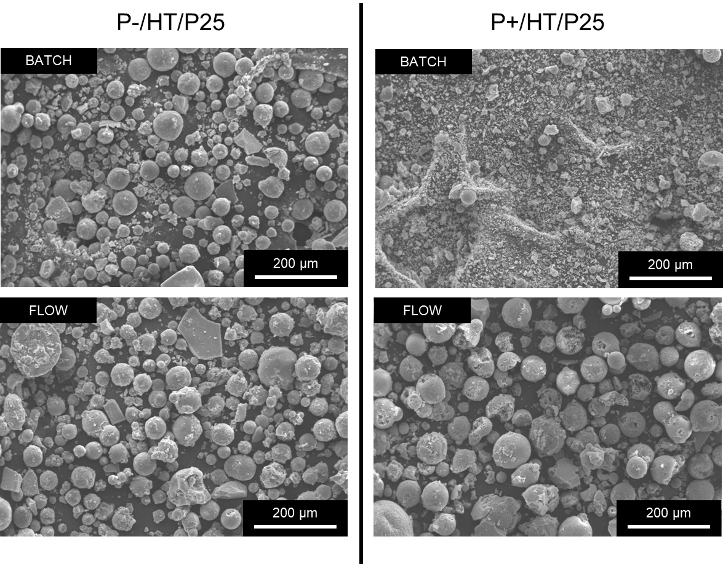
Figure S10. SEM images of the P-/HT/P25 (left column) and P+/HT/P25 (right column) photocatalytic MICROSCAFS® after one cycle in batch and in flow.

Figure S11. Proposed fragmentation mechanism for the precursor ion m/z 304.0770, t_{R} 9.5 min, assigned to the deprotonated molecule of MO.

Figure S12. Proposed fragmentation mechanism for the precursor ion m/z 320.0712, t_{R} 10.9 min, attributed to the deprotonated molecule of TP320-a.

Figure S13. Proposed fragmentation mechanism for the precursor ion m/z 306.0562, t_{R} 9.0 min, attributed to the deprotonated molecule of TP306.

Figure S14. Proposed fragmentation mechanism for the precursor ion m/z 290.0614, t_{R} 7.8 min, attributed to the deprotonated molecule of TP290.

Figure S15. Proposed fragmentation mechanism for the precursor ion m/z 276.0453, t_{R} 5.8 min, attributed to the deprotonated molecule of TP276.
Figure S16. Proposed fragmentation mechanism for the precursor ion m/z 320.0712, t_{R} 3.9 min, assigned to the deprotonated molecule of TP320-b.

Table S1. Particle size distribution data of the treated and non-heat-treated MICROSCAFS®.
Sample acronym | D (0.1), µm | D (0.5), µm | D (0.9), µm | Span
P- | 20.16 | 29.61 | 50.56 | 1.03
P0 | 22.58 | 33.99 | 65.36 | 1.26
P+ | 43.68 | 72.29 | 107.52 | 0.88
S- | 19.02 | 24.50 | 34.13 | 0.62
P-/HT | 18.62 | 34.29 | 72.86 | 1.58
P0/HT | 16.24 | 26.23 | 50.99 | 1.32
P+/HT | 31.88 | 56.12 | 83.87 | 0.93
S-/HT | 14.29 | 17.90 | 25.07 | 0.60

Table S2. EDS atomic concentration data of the MICROSCAFS®. Ti/Si is the atomic % ratio.
Sample acronym | EDS atomic concentration (%) |  |  |  | Ti/Si
Sample acronym | O | Si | Ti |  | Ti/Si
P- | 67.37 ± 0.59 | 25.68 ± 0.73 | 6.94 ± 0.31 |  | 0.272 ± 0.017
P0 | 67.53 ± 0.44 | 25.0 4± 0.60 | 7.43 ± 0.31 |  | 0.298 ± 0.018
P+ | 63.95 ± 0.35 | 27.94 ± 0.27 | 8.11 ± 0.10 |  | 0.290 ± 0.002
S- | 62.00 ± 0.35 | 34.4 ± 0.2 | 3.6 ± 0.2 |  | 0.106 ± 0.005
P-/HT | 61.22 ± 0.23 | 30.50 ± 0.08 | 8.28 ± 0.26 |  | 0.272 ± 0.009
P0/HT | 60.32 ± 0.03 | 30.38 ± 0.07 | 9.29 ± 0.05 |  | 0.306 ± 0.002
P+/HT | 60.25 ± 0.19 | 30.31 ± 0.21 | 9.43 ± 0.14 |  | 0.311 ± 0.006
S-/HT | 60.24 ± 0.20 | 32.97 ± 0.07 | 6.78 ± 0.005 |  | 0.206 ± 0.005
P-/HT/P25 | 70.26 ± 0.84 | 12.51 ± 0.57 | 17.17 ± 0.89 |  | 1.40 ± 0.11
P0/HT/P25 | 69.05 ± 0.30 | 16.52 ± 0.29 | 14.44 ± 0.30 |  | 0.88 ± 0.03
P+/HT/P25 | 71.17 ± 0.26 | 18.00 ± 0.75 | 10.84 ± 0.73 |  | 0.62 ± 0.07
S-/HT/P25 | 74.31 ± 0.57 | 17.79 ± 0.61 | 7.89 ± 0.27 |  | 0.45 ± 0.03

Table S3. FTIR peak intensity ratio $\frac{I_{Ti-O-Ti}}{I_{Si-O-Si}}$
Sample | $$\frac{I_{450{ cm}^{-1}}}{I_{1065 {cm}^{-1}}}$$
P-/HT | 1.04
P0/HT | 0.80
P+/HT | 1.28
S-/HT | 1.20
P-/HT/P25 | 3.60
P0/HT/P25 | 1.60
P+/HT/P25 | 1.48
S-/HT/P25 | 1.87

