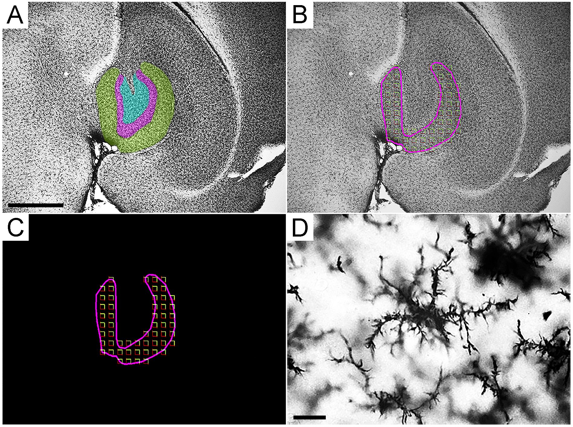
Figure S1. Stereological Sampling: Low-power photomicrographs (A and B) displaying the molecular layer of the dentate gyrus, the area of interest, alongside the sampling grid (C). Additionally, a high-power photomicrograph (D) showcases IBA-1 immunolabeled microglia (the object of interest). Scale bar: A - 250µm, and D: 25µm.
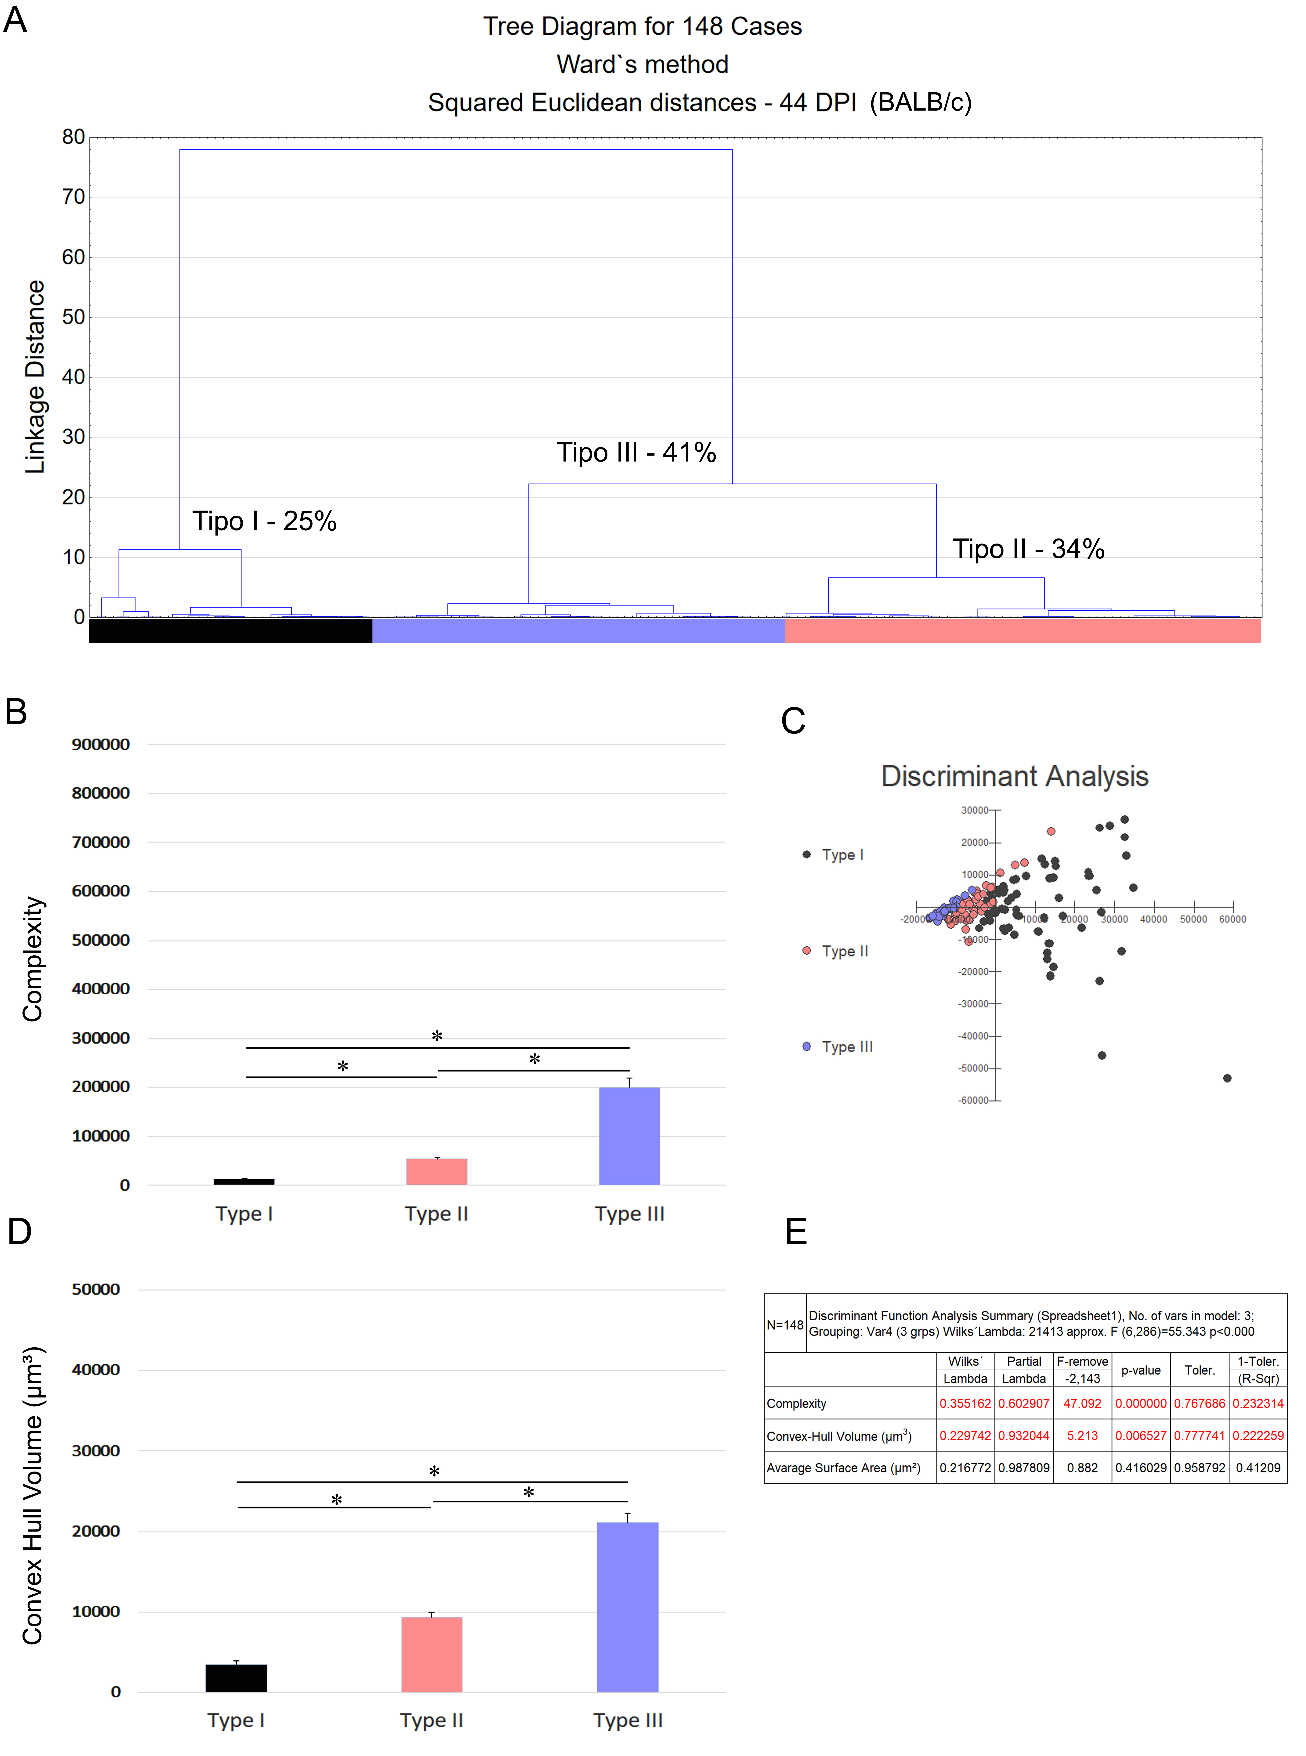
Figure S2. The recovery of BALB/c microglia in the molecular layer of dentate gyrus was observed 43 days after infection. At this point, only minor morphological changes were observed, and all the morphological changes induced by T. gondii infection at 22 dpi have disappeared. The analysis methods used included hierarchical cluster analysis (A), discriminant function analysis (C and E), morphological complexity (B), and convex hull volume (D).

