Table S1. Primers used in this study
Name | Primers (5'-3') | Purpose
QWx-1 | AAGCTTACTTAGTCTCGATCTGACGTGGTG | Gene amplification, sequencing, and construction of transgenic vectors
QWx-2 | CGCCTGCAAAGAACACAAGAACACAACATT
QWx-3 | AACAATTCAATTCAGTGCAGAGATCTTCCA
QWx-4 | CTCCACAGCCATAAGCCACACCAACT
QWx-5C-F | CACTGGAGTTGATCACAAAGACAACC
QWx-5C-R | GGTTGTCTTTGTGATCAACTCCAGTG
maWx-F | ATTCCTTCAGTTCTTTGTCTATCTCA | RT-qPCR detection
maWx-R | ATGGTGGTTGTCTAGCTGTTGC
Actin01-F | CCAAGGCCAATCGTGAGAAGA
Actin01-R | AATCAGTGAGATCACGCCCAG
SPS-F | TTGCGCCTGAACGGATAT | RT-qPCR detection of Wx copy number
SPS-R | CGGTTGATCTTTTCGGGATG
WxN-F | AACTGGATGAAGGCCGGAAT
WxN-R | TGTACTTGTCCTTGCTGGGAT

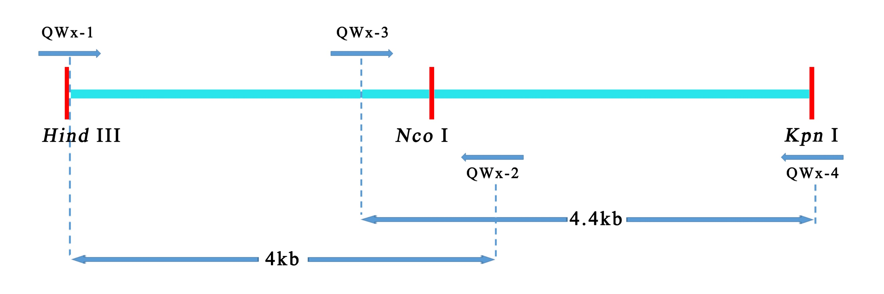
Fig. S1. The schematic diagram of Wx gene structure and the primers used for plasmids construction.

Fig. S2. Phenotype of the transgenic rice plants.

