Supporting information

Fig. S-1 showed the initial S.H., the meshed S.h. powder and typical CQDs under natural light irradiation and under ultraviolet light irradiation. As can be seen from Fig.1, aqueous solution of CQDs was brown under natural light irradiation, and emitted a bright blue-green fluorescence at a wavelength of 360 nm under UV light irradiation.

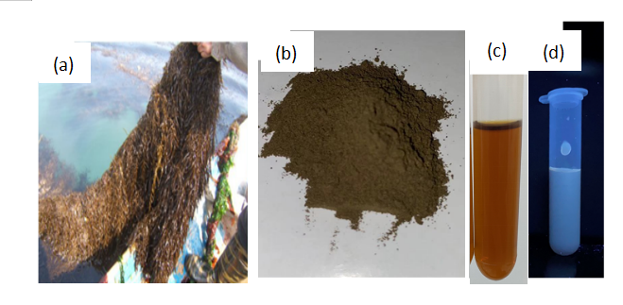

**Fig. S-1 (a) *Sargassum Horneri*; (b) CQ*Sargassum Horneri powder;* (c) CQDs under natural light irradiation; (d) CQDs under ultraviolet light irradiation**

Different hydrothermal conditions showed 200 oC is the best hydrothermal temperature for CQDs synthesis (Fig.S-2, S-3). Further investigation showed that 3% H2SO4 is the best pretreatment method both from CQDs yield view or floorescence , almost 10 times CQDs colud be achieved compared with no H2SO4 addition (Fig.S-4 and Table S-1).



**Fig.S-2 Fluorescence spectra of S.H. CQDs with different hydrothermal temperature**



**Fig.S-3 Fluorescence spectra of S.H. CQDs with H2SO4 pre-treatment after 200 °C hydrothermal treatment**



**Fig. S-4 CQDs (a) UV-Vis spectrum and (b) fluorescence response spectrum**







**Fig. S-5 Kinetic model fitting curves**



**Fig. S-6 Effect of cycle times on photocatalytic on naphthalen**

**Compound conditions (a) neutral (b) weak acid**