Advanced voltametric characterization of polyphenols in wine using a modified carbon paste electrode with TiO₂ nanoparticles
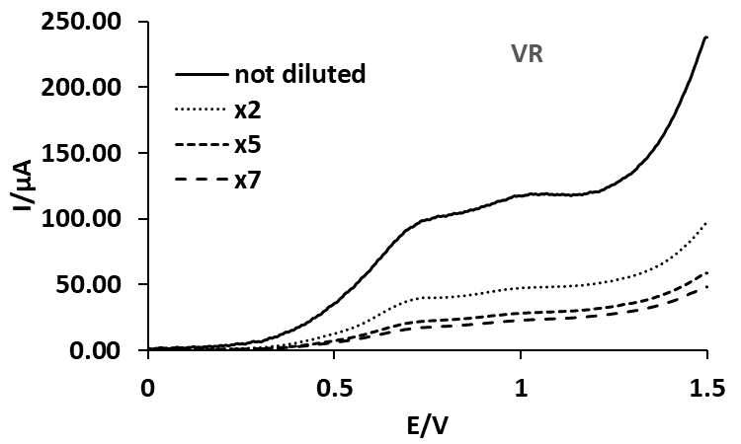 | 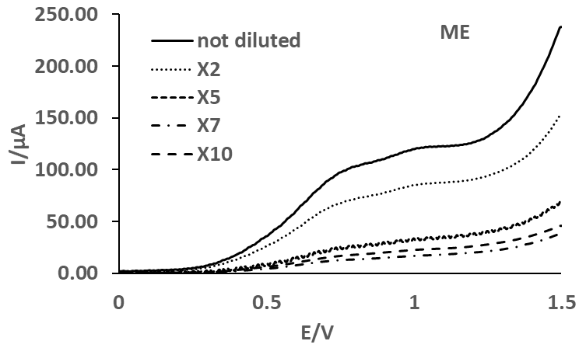
(a) | (b)
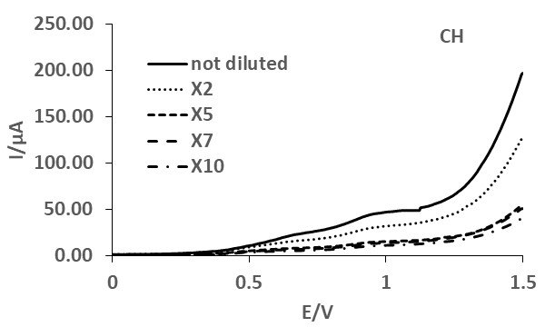 | 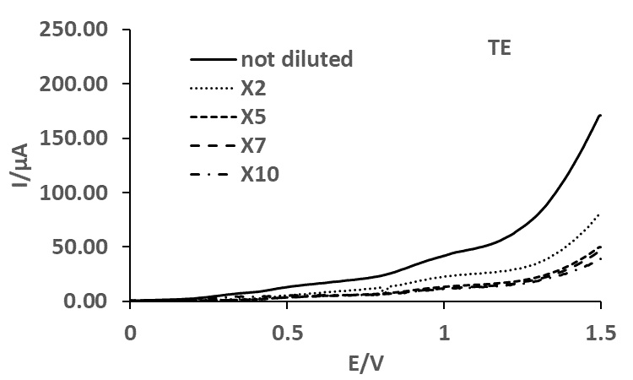
(c) | (d)
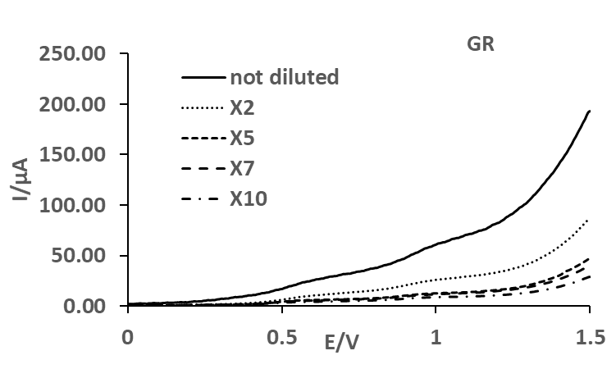 | 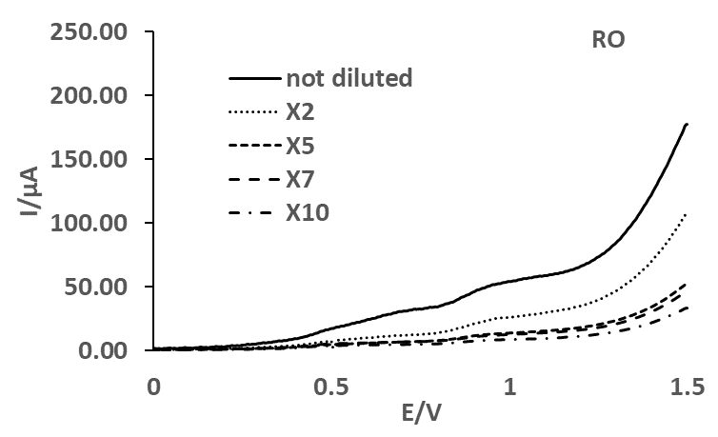
(e) | (f)
Figure S1. Anodic branch of the cyclic voltammograms recorded in undiluted and diluted (x2, x5, x7, x10) real wine samples: (a) VR; (b) ME; (c) CH; (d) TE; (e) GR and (f) RO on MCPE/np TiO₂ electrode.
Table S1. pK_{a} constants for GA, RE, QV, CT and CA.

Poliphenol | pK_{a1} | pK_{a2} | pK_{a3} | pK_{a4} | pK_{a5}
GA | 4.26 | 8.69 | 11.45
RE | 9.16 | 9.77 | 10.55
QV | 7.17 | 8.26 | 10.13
CT | 9.50 | 8.90 | 8.20-8.60 | 10.30-11.02 | 13.20-14.80
CA | 4.80 | 8.60

