*Article*

**A New Quinazolinone Alkaloid from *Rhodiola tibetica* endophytic fungus *Penicillium* sp. HJT-A-6**

**Dongliang Xiao 1,†, Yan Wang 1,†, Congcong Gao 1, Xuemei Zhang 1, Weixing Feng 1, Xuan Lu 1,*, Baomin Feng 1,\***

**1** College of life and health, Dalian University, Dalian 116622, China; xdl120318@163.com (D.X.); WangYan_9910@163.com (Y.W.); gcc1125@163.com (C.G.); 2472103706@qq.com (X.Z.); fwx_0910@163.com (W.F.);

**\*** Correspondence: luxuan_232@163.com (X.L.); fbmdlu@163.com (B.F.)

**†** These authors contributed equally to this work.

**Supplementary Materials**

**Table of Contents**

|  |  |
| --- | --- |
| **Figure S1**. Positive mode HRESIMS spectrum of **1** | **3** |
| **Figure S2**. UV spectrum of **1** | **3** |
| **Figure S3**. 1H NMR (DMSO-*d*6, 500 MHz) spectrum of **1** | **4** |
| **Figure S4**. 1H NMR (DMSO-*d*6, 500 MHz) spectrum of **1a** | **4** |
| **Figure S5**. 1H NMR (DMSO-*d*6, 500 MHz) spectrum of **1b** | **5** |
| **Figure S6**. 13C NMR (DMSO-*d*6, 125 MHz) spectrum of **1** | **5** |
| **Figure S7**. HSQC (DMSO-*d*6, 500 MHz) spectrum of **1** | **6** |
| **Figure S8**. HMBC (DMSO-*d*6, 500 MHz) spectrum of **1** | **6** |
| **Figure S9**. 1H-1H COSY (DMSO-*d*6, 500 MHz) spectrum of **1** | **7** |
| **Figure S10**. NOESY (DMSO-*d*6, 500 MHz) spectrum of **1** | **7** |
| **Figure S11**. CD spectrum of **1** | **8** |
| **Figure S12**. 1H NMR (DMSO-*d*6, 500 MHz) spectrum of **2** | **9** |
| **Figure S13**. 13C NMR (DMSO-*d*6, 125 MHz) spectrum of **2** | **9** |
| **Figure S14**. 1H NMR (DMSO-*d*6, 500 MHz) spectrum of **3** | **10** |
| **Figure S15**. 13C NMR (DMSO-*d*6, 125 MHz) spectrum of **3** | **10** |
| **Figure S16**. 1H NMR (DMSO-*d*6, 500 MHz) spectrum of **4** | **11** |
| **Figure S17**. 13C NMR (DMSO-*d*6, 125 MHz) spectrum of **4** | **11** |
| **Figure S18**. 1H NMR (DMSO-*d*6, 500 MHz) spectrum of **5a/5b** | **12** |
| **Figure S19**. 13C NMR (DMSO-*d*6, 125 MHz) spectrum of **5a/5b** | **12** |
| **Figure S20**. 1H NMR (DMSO-*d*6, 500 MHz) spectrum of **6** | **13** |
| **Figure S21**. 13C NMR (DMSO-*d*6, 125 MHz) spectrum of **6** | **13** |
| **Figure S22**. 1H NMR (DMSO-*d*6, 500 MHz) spectrum of **7** | **14** |
| **Figure S23**. 13C NMR (DMSO-*d*6, 125 MHz) spectrum of **7** | **14** |
| **Figure S24**. 1H NMR (DMSO-*d*6, 500 MHz) spectrum of **8** | **15** |
| **Figure S25**. 13C NMR (DMSO-*d*6, 125 MHz) spectrum of **8** | **15** |
| **Figure S26**. 1H NMR (DMSO-*d*6, 500 MHz) spectrum of **9** | **16** |
| **Figure S27**. 1H NMR (DMSO-*d*6, 500 MHz) spectrum of **10** | **17** |
| **Figure S28**. 13C NMR (DMSO-*d*6, 125 MHz) spectrum of **10** | **17** |
| **Figure S29**. 1H NMR (DMSO-*d*6, 500 MHz) spectrum of **11** | **18** |
| **Figure S30**. 13C NMR (DMSO-*d*6, 125 MHz) spectrum of **11** | **18** |
| **Figure S31**. 1H NMR (DMSO-*d*6, 500 MHz) spectrum of **12** | **19** |
| **Figure S32**. 13C NMR (DMSO-*d*6, 125 MHz) spectrum of **12** | **19** |

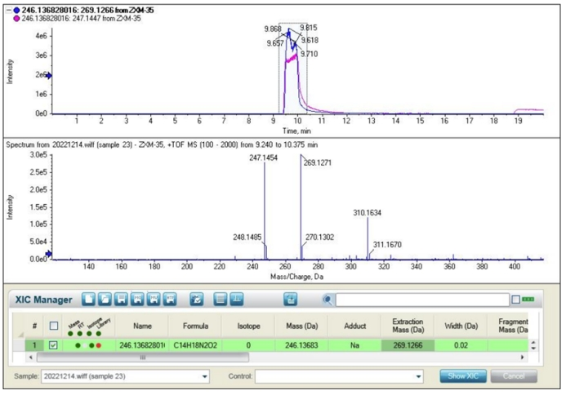

**Figure S1.** Positive mode HRESIMS spectrum of **1**

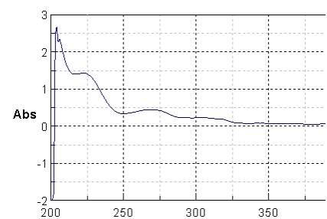

**Figure S2.** UV spectrum of **1**

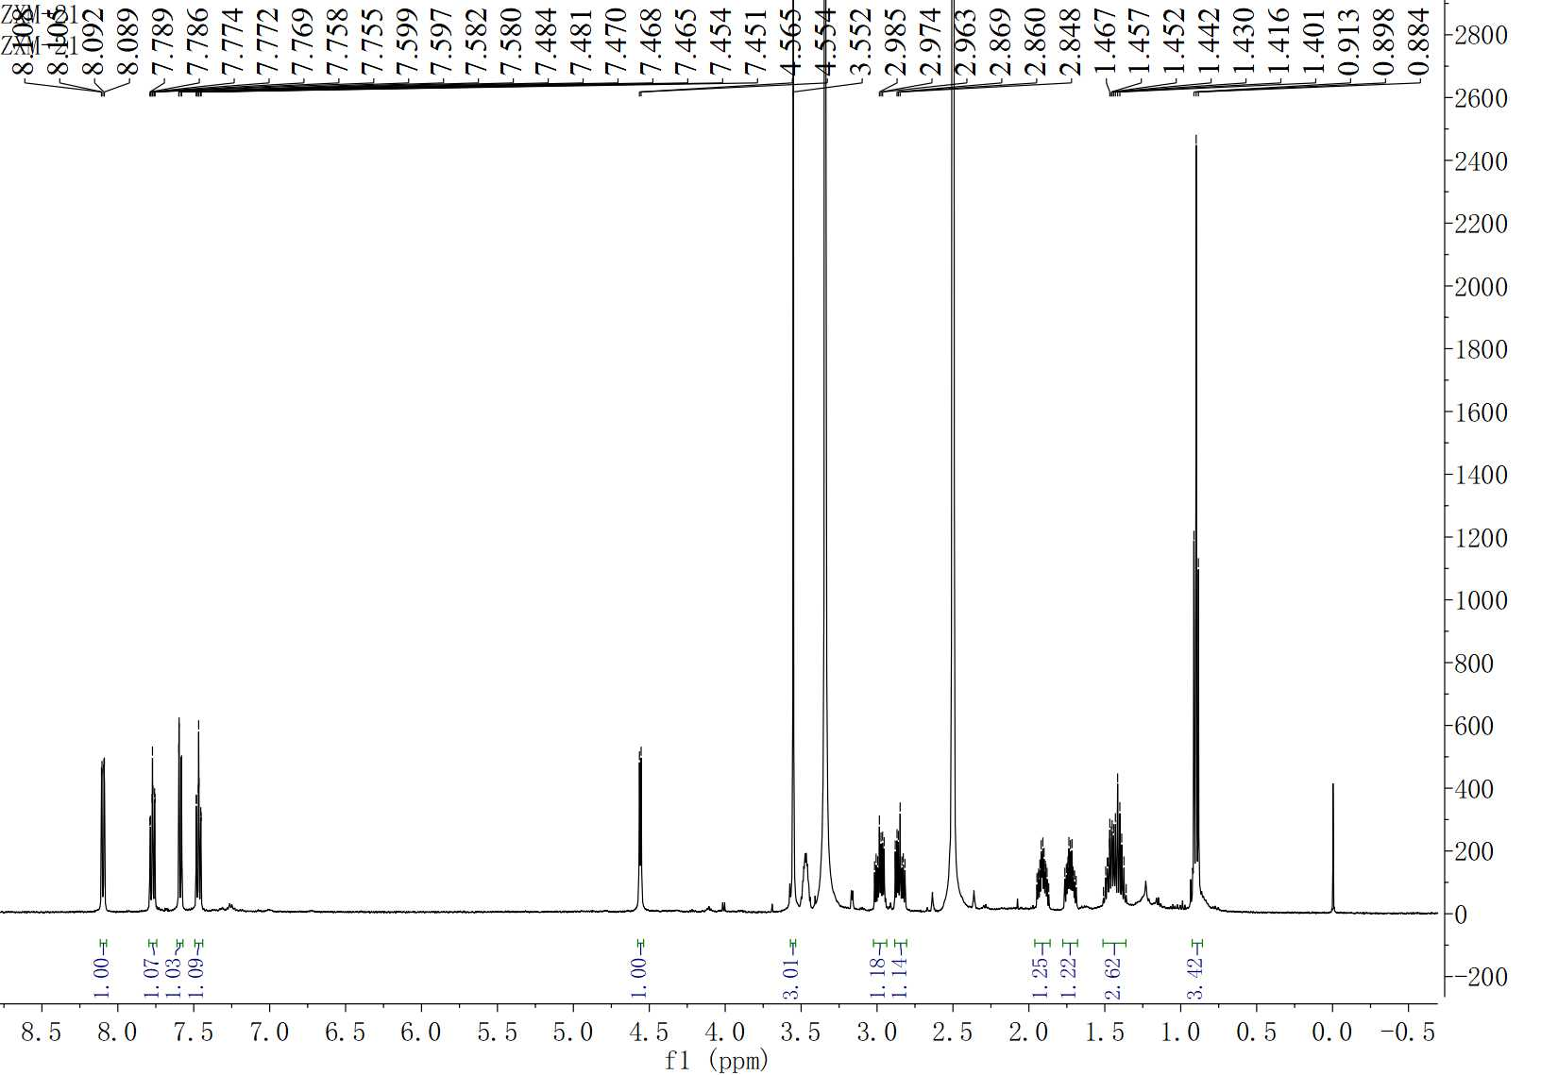

**Figure S3.** 1H NMR (DMSO-*d*6, 500 MHz) spectrum of **1**

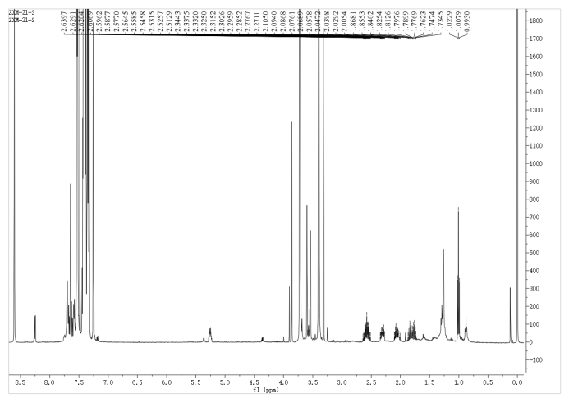

**Figure S4.** 1H NMR (DMSO-*d*6, 500 MHz) spectrum of **1a**

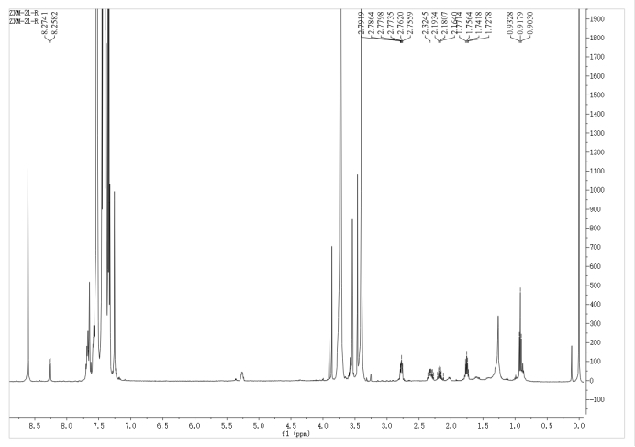

**Figure S5.** 1H NMR (DMSO-*d*6, 500 MHz) spectrum of **1b**

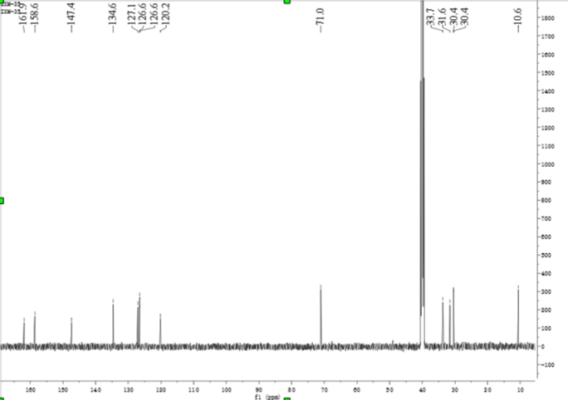

**Figure S6.** 13C NMR (DMSO-*d*6, 125 MHz) spectrum of **1**

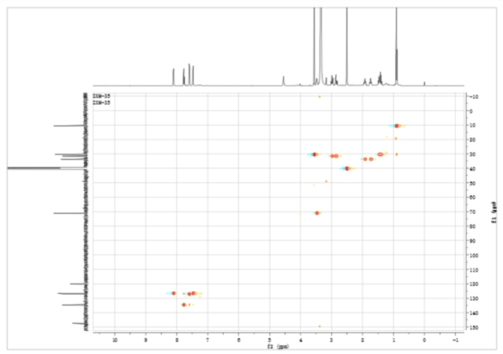

**Figure S7.** HSQC (DMSO-*d*6, 500 MHz) spectrum of **1**

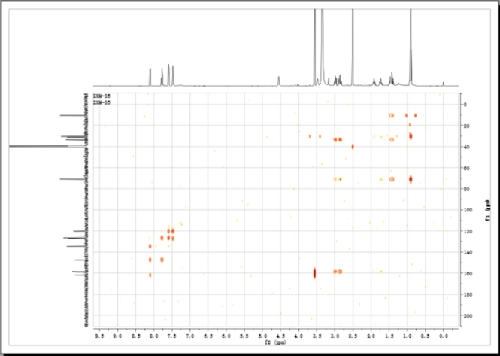

**Figure S8.** HMBC (DMSO-*d*6, 500 MHz) spectrum of **1**

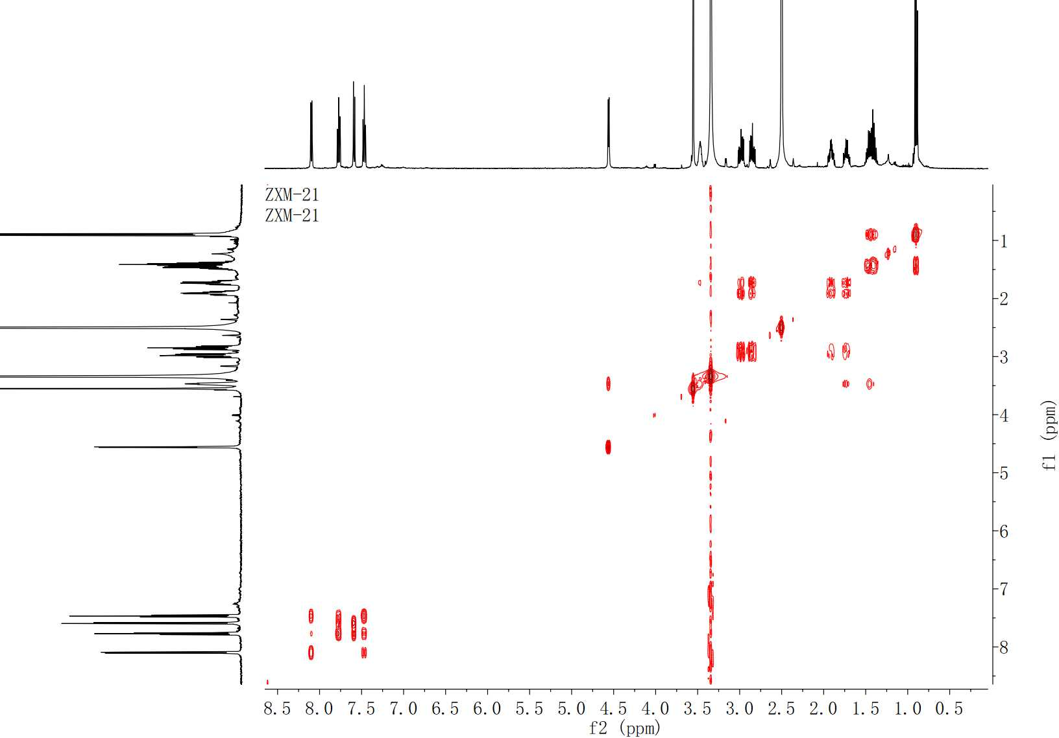

**Figure S9.** 1H-1H COSY (DMSO-*d*6, 500 MHz) spectrum of **1**

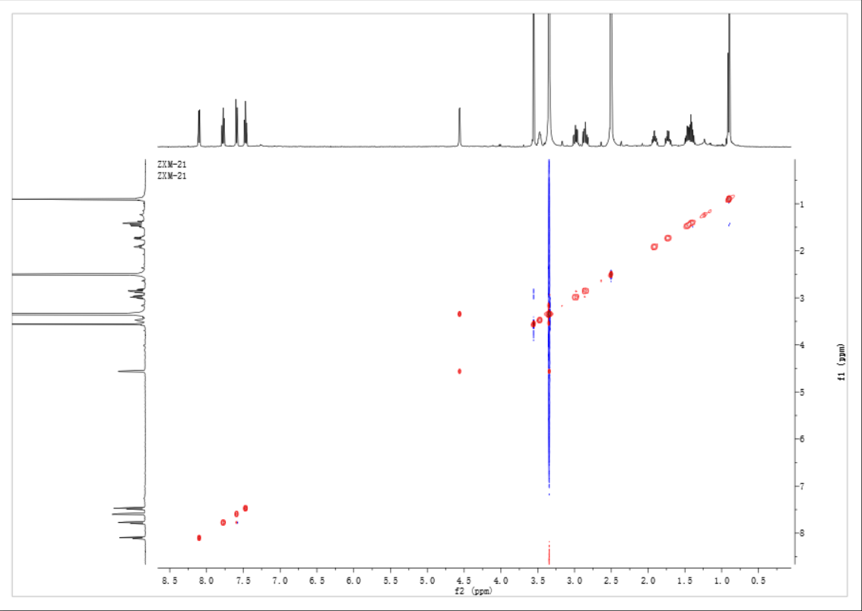

**Figure S10.** NOESY (DMSO-*d*6, 500 MHz) spectrum of **1**



**Figure S11.** CD spectrum of **1**

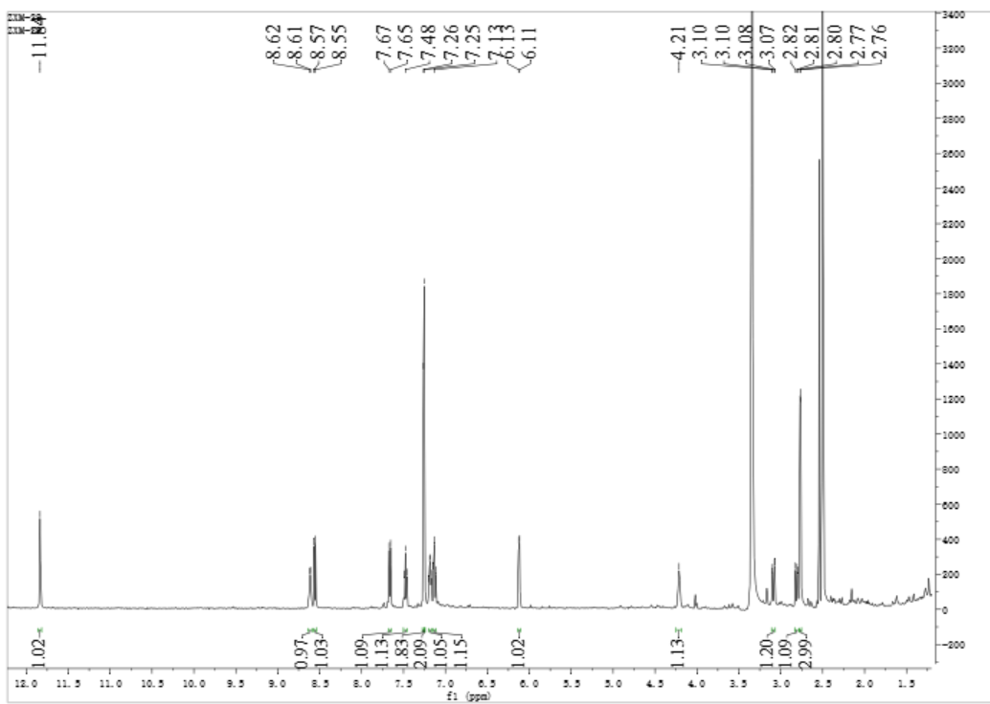

**Figure S12.** 1H NMR (DMSO-*d*6, 500 MHz) spectrum of **2**

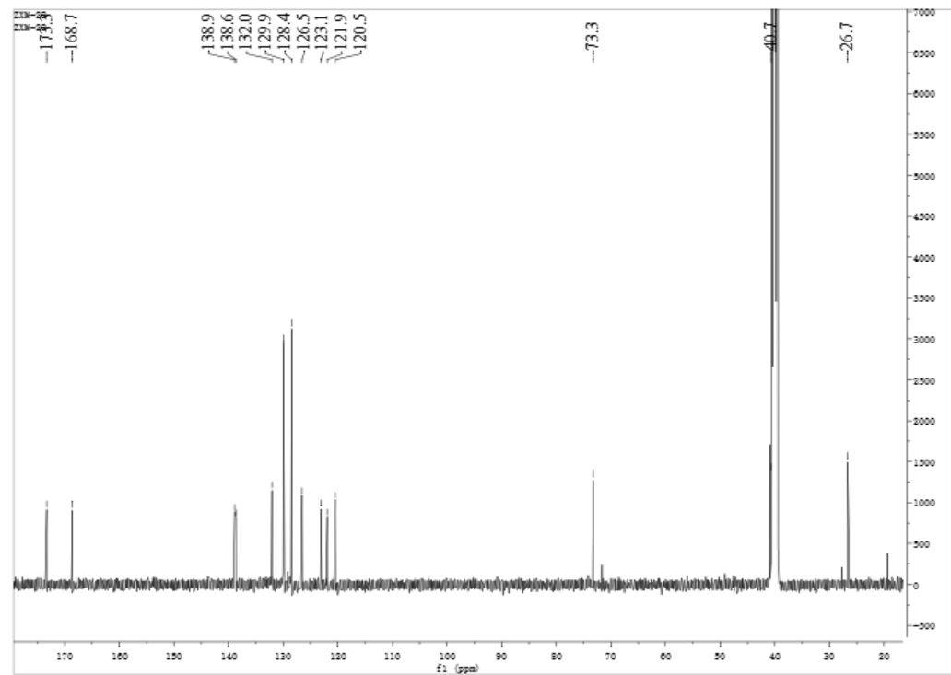

**Figure S13.** 13C NMR (DMSO-*d*6, 125 MHz) spectrum of **2**

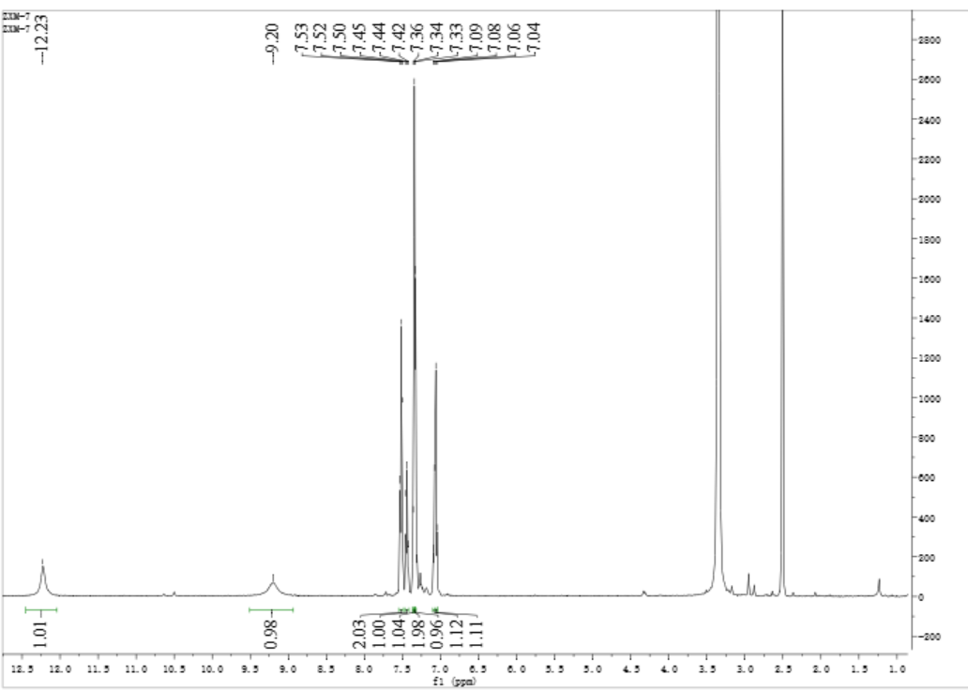

**Figure S14.** 1H NMR (DMSO-*d*6, 500 MHz) spectrum of **3**

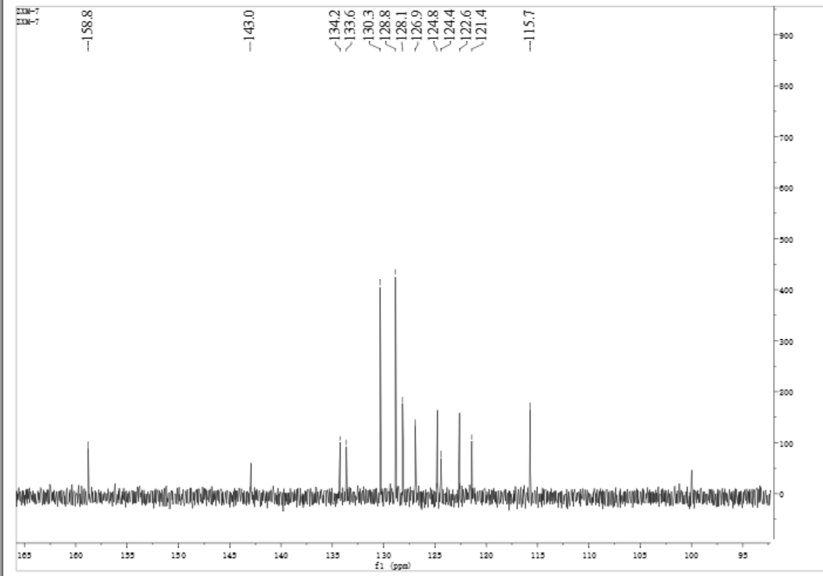

**Figure S15.** 13C NMR (DMSO-*d*6, 125 MHz) spectrum of **3**

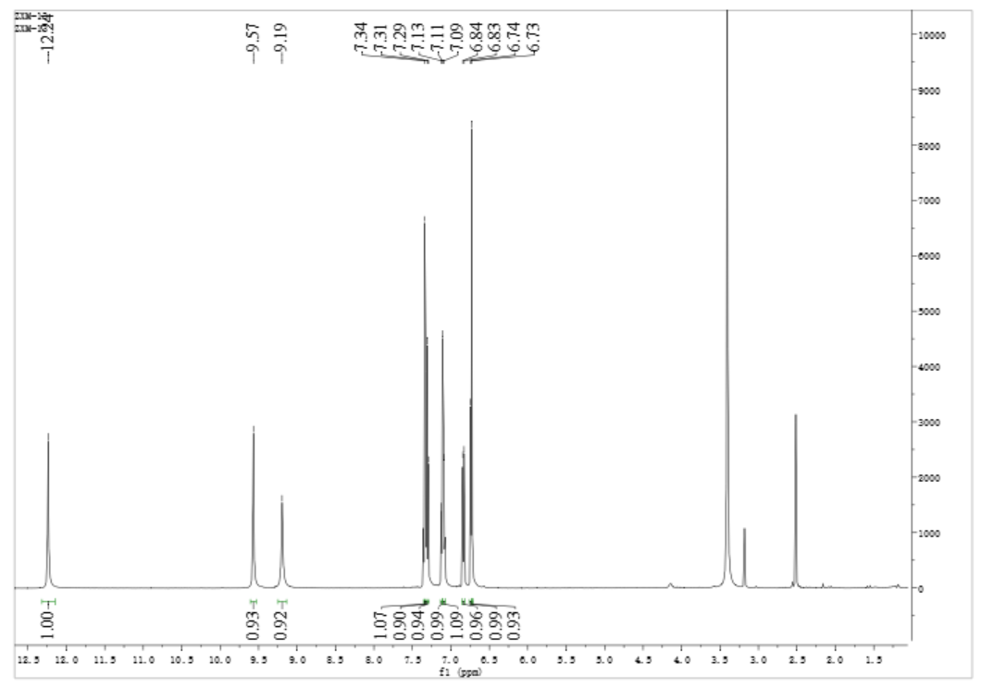

**Figure S16.** 1H NMR (DMSO-*d*6, 500 MHz) spectrum of **4**

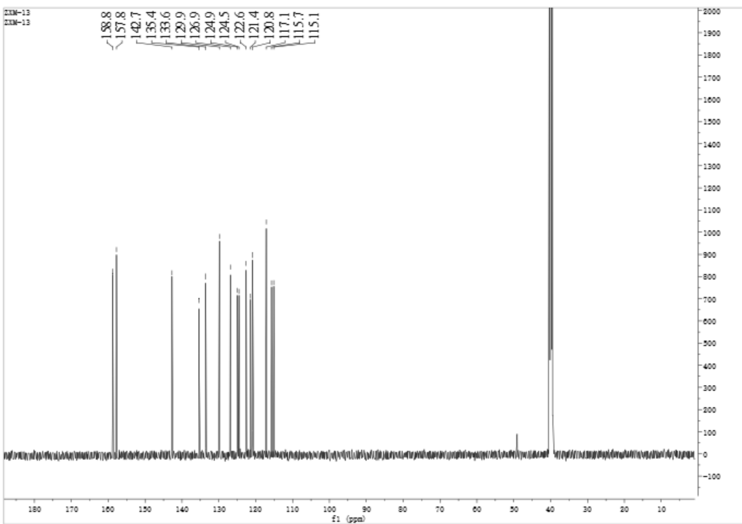

**Figure S17.** 13C NMR (DMSO-*d*6, 125 MHz) spectrum of **4**

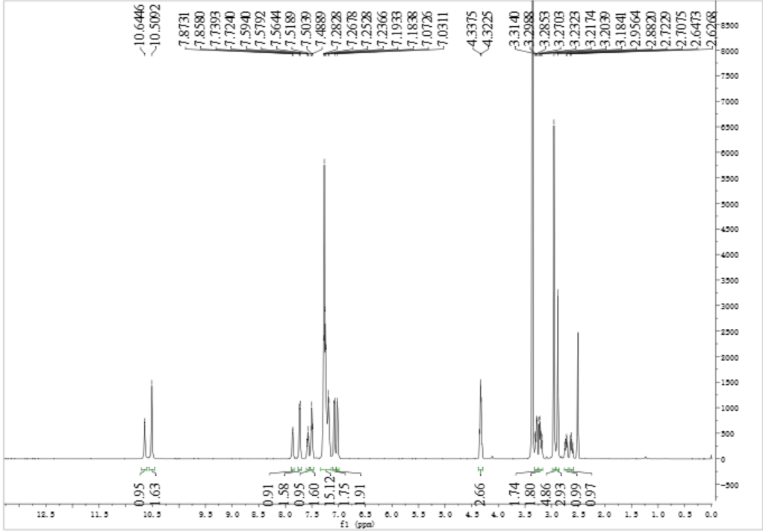

**Figure S18.** 1H NMR (DMSO-*d*6, 500 MHz) spectrum of **5a/5b**

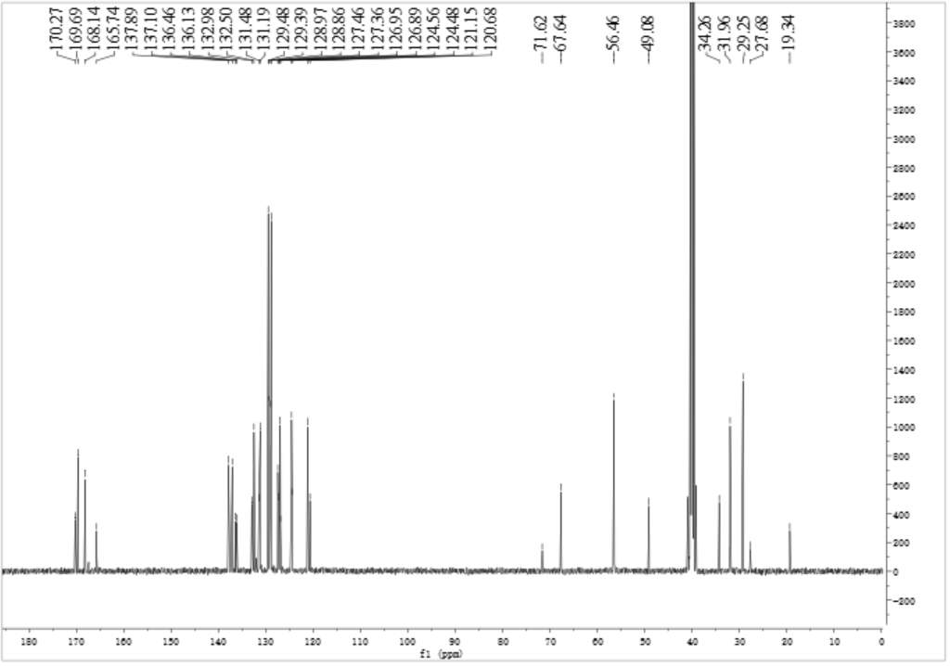

**Figure S19.** 13C NMR (DMSO-*d*6, 125 MHz) spectrum of **5a/5b**

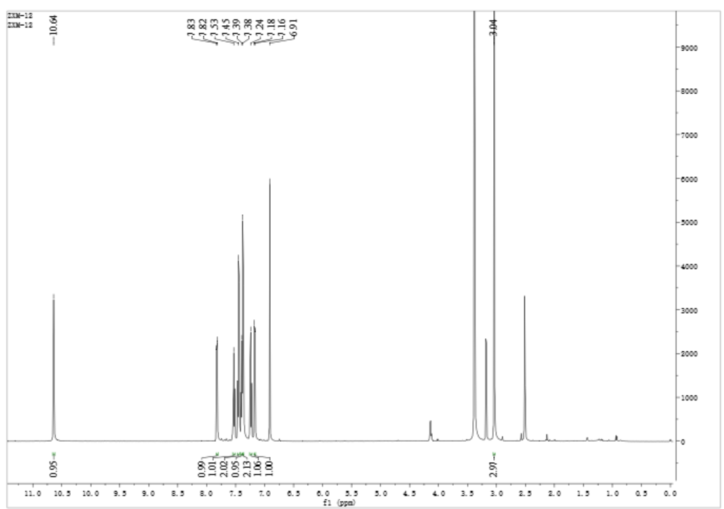

**Figure S20.** 1H NMR (DMSO-*d*6, 500 MHz) spectrum of **6**

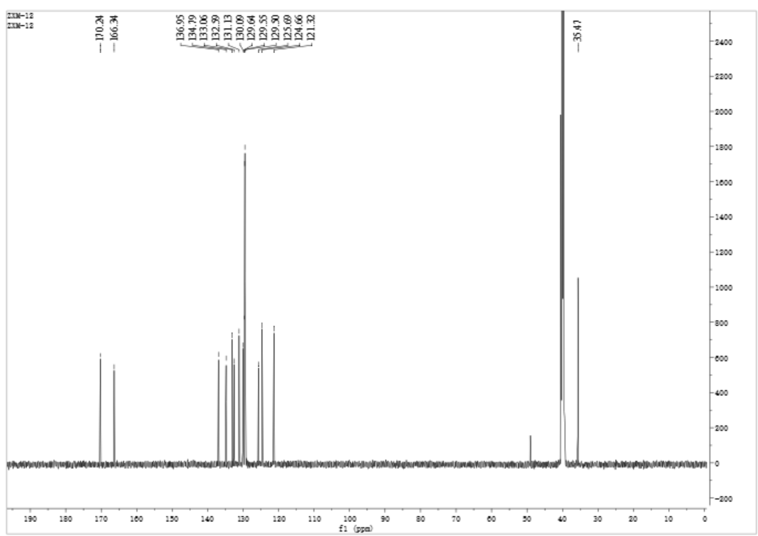

**Figure S21.** 13C NMR (DMSO-*d*6, 125 MHz) spectrum of **6**

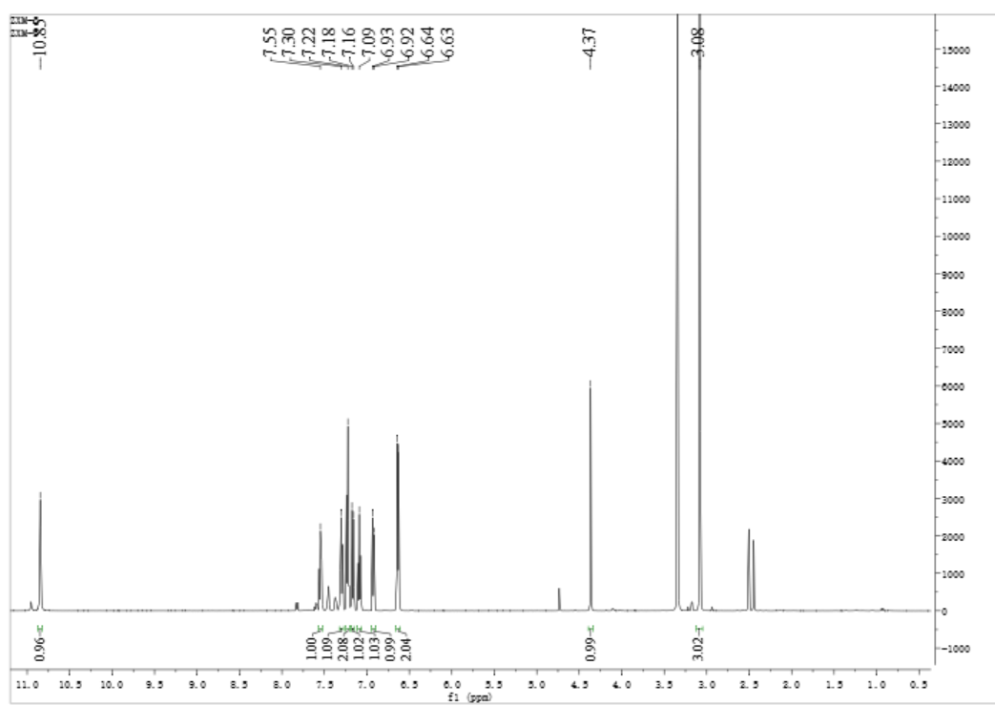

**Figure S22.** 1H NMR (DMSO-*d*6, 500 MHz) spectrum of **7**

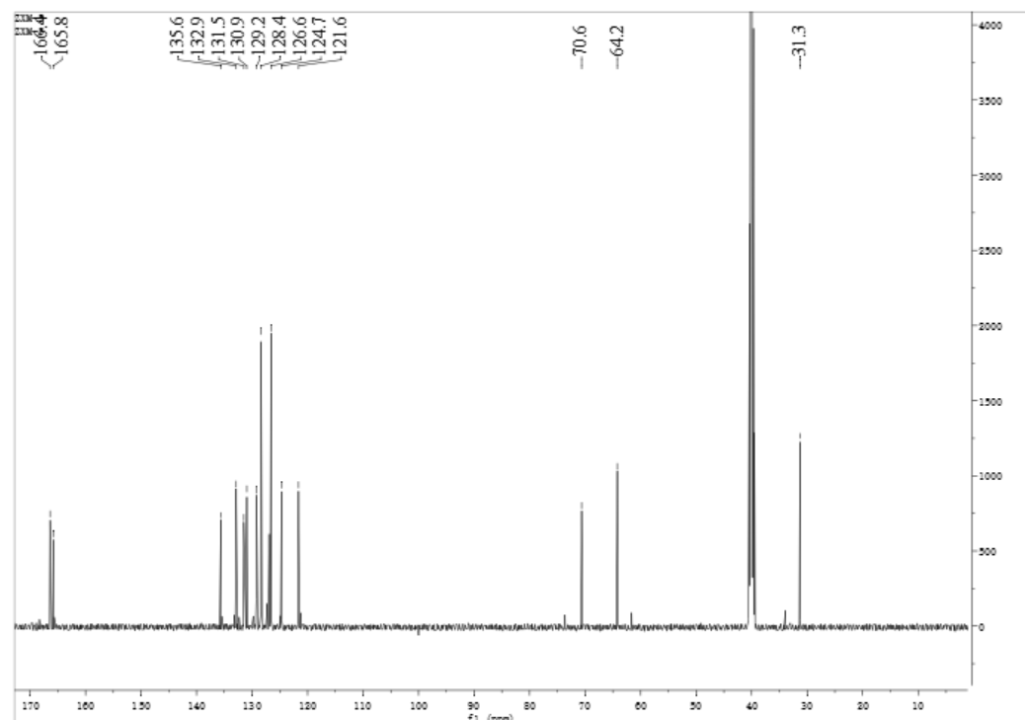

**Figure S23.** 13C NMR (DMSO-*d*6, 125 MHz) spectrum of **7**

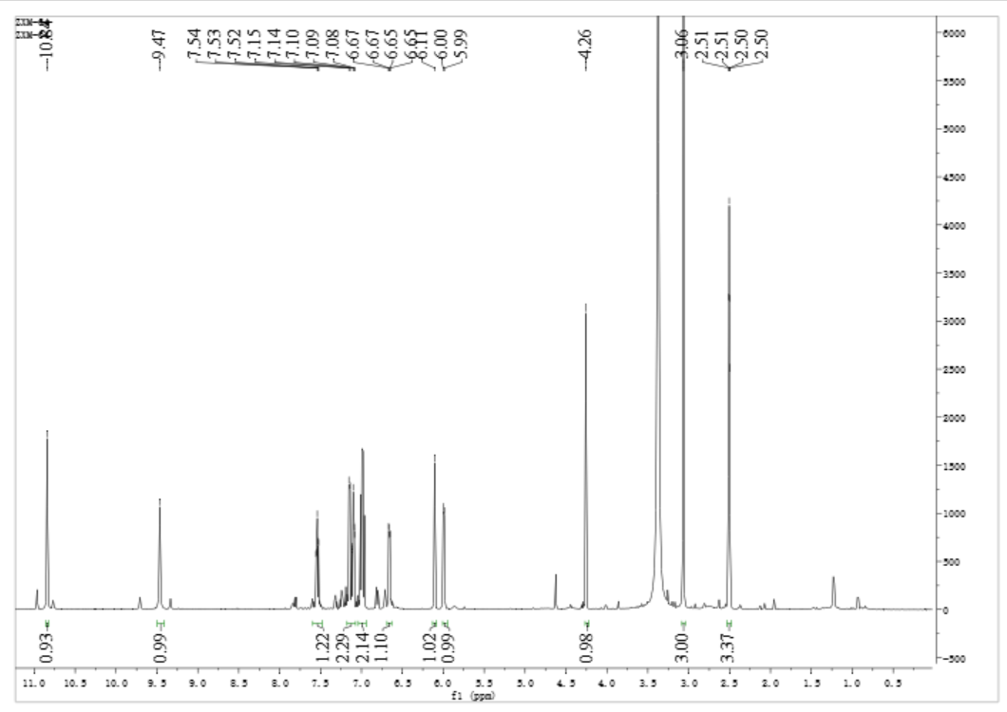

**Figure S24.** 1H NMR (DMSO-*d*6, 500 MHz) spectrum of **8**

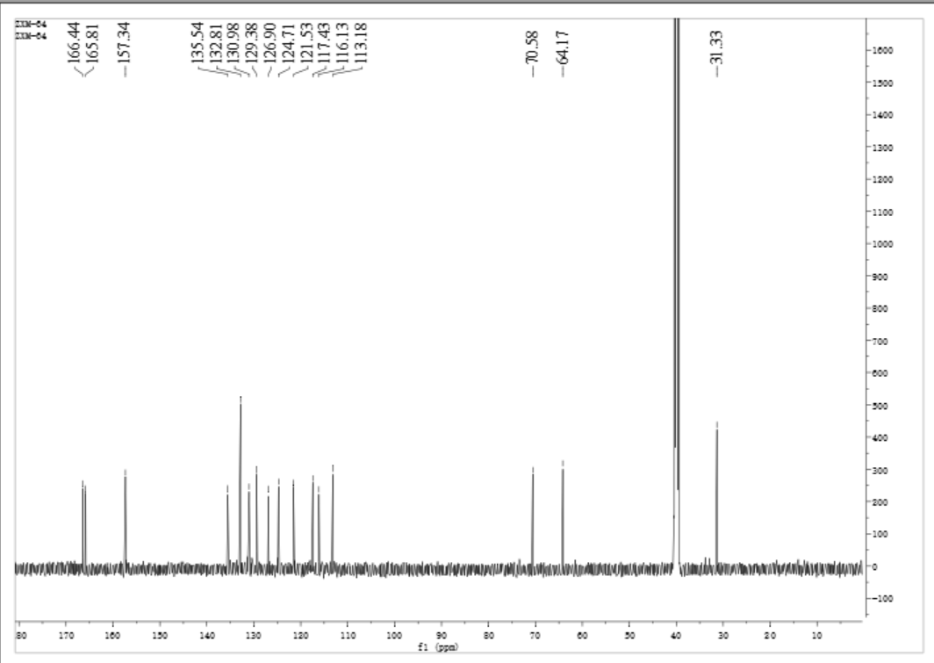

**Figure S25.** 13C NMR (DMSO-*d*6, 125 MHz) spectrum of **8**

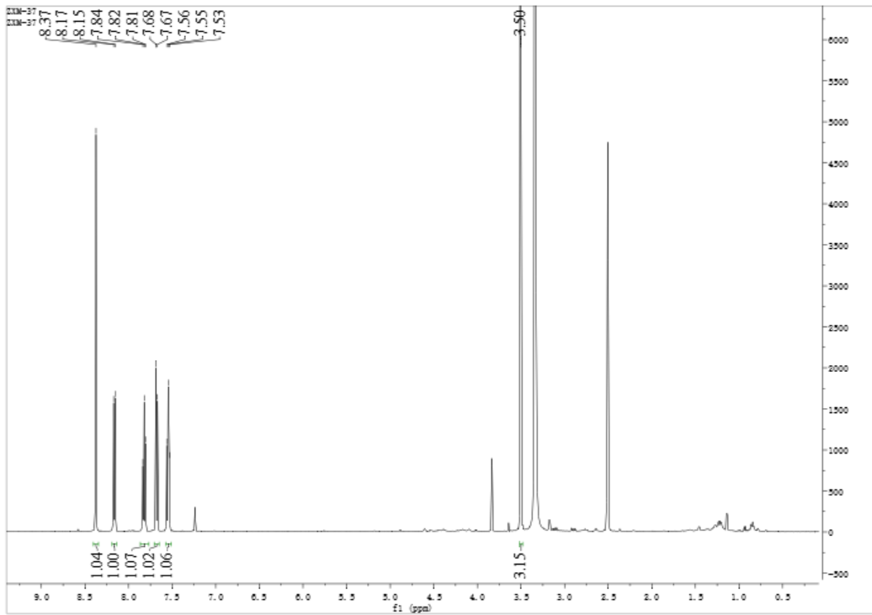

**Figure S26.** 1H NMR (DMSO-*d*6, 500 MHz) spectrum of **9**

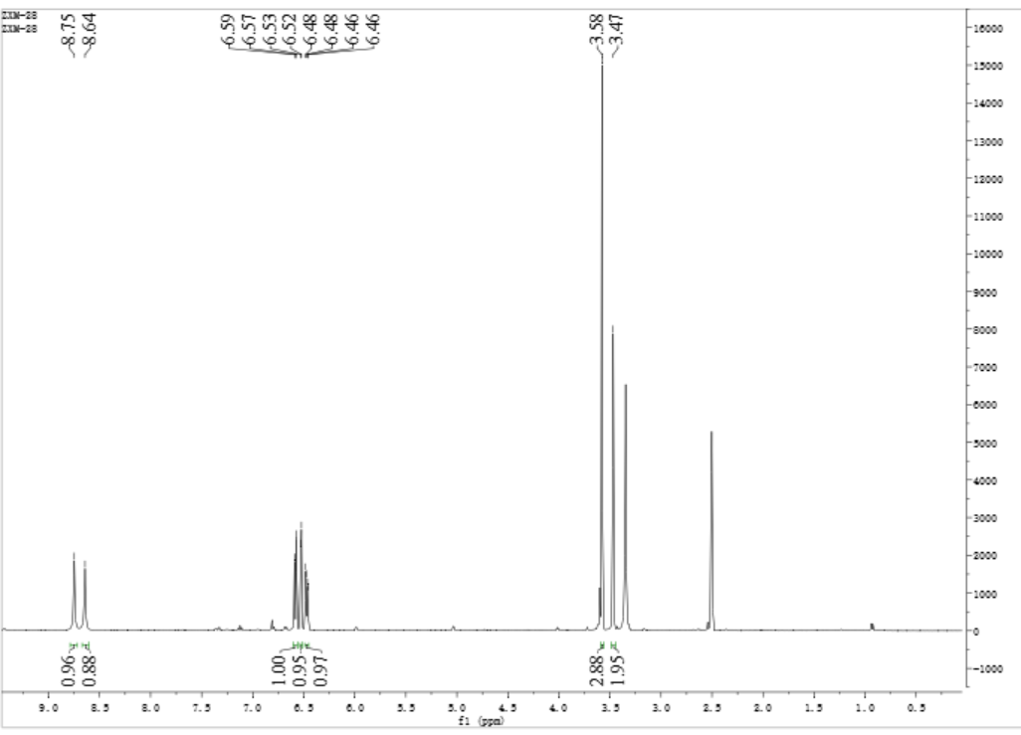

**Figure S27.** 1H NMR (DMSO-*d*6, 500 MHz) spectrum of **10**

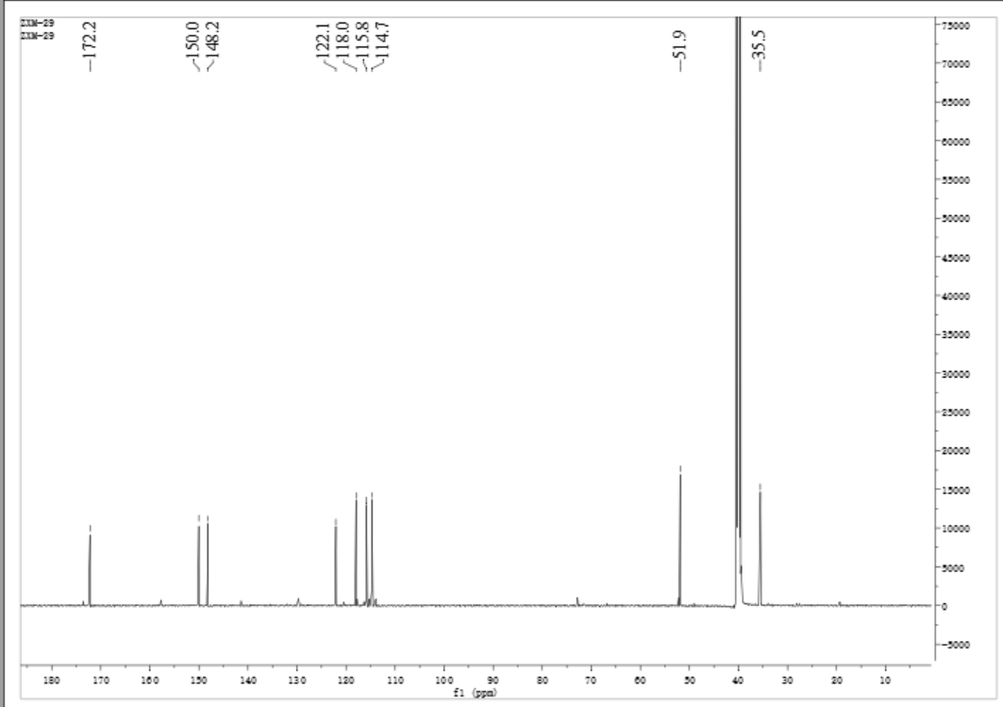

**Figure S28.** 13C NMR (DMSO-*d*6, 125 MHz) spectrum of **10**

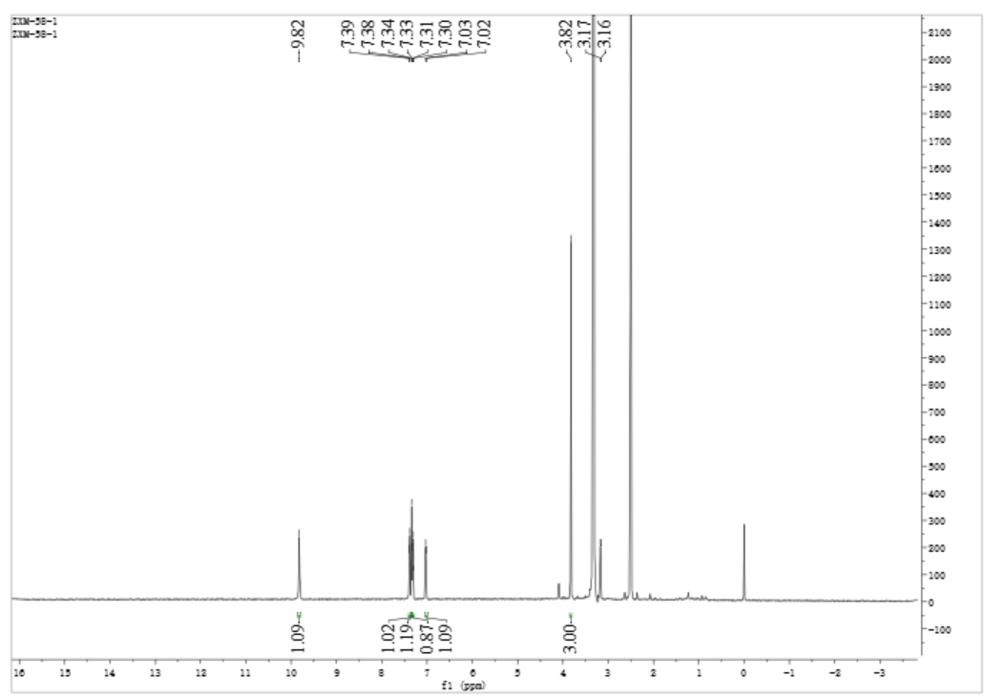

**Figure S29.** 1H NMR (DMSO-*d*6, 500 MHz) spectrum of **11**

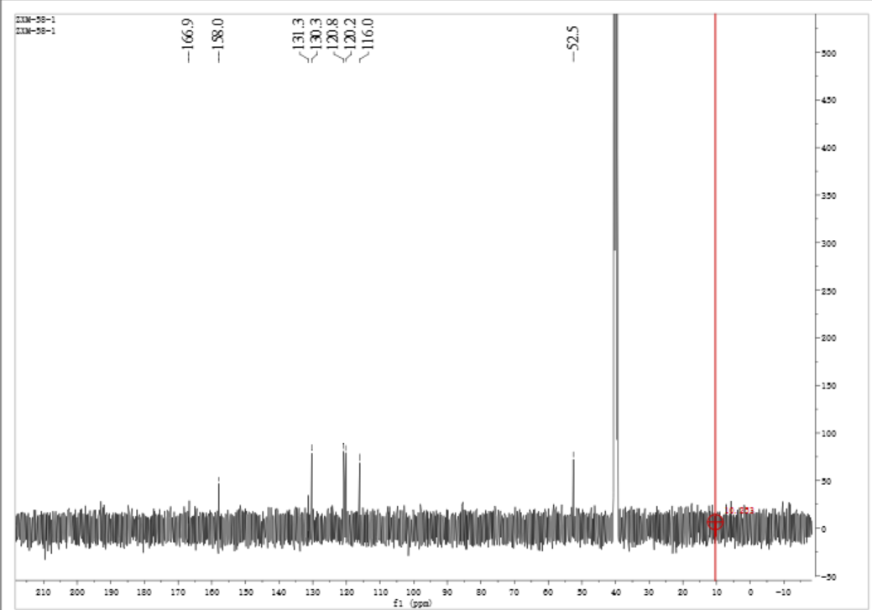

**Figure S30.** 13C NMR (DMSO-*d*6, 125 MHz) spectrum of **11**

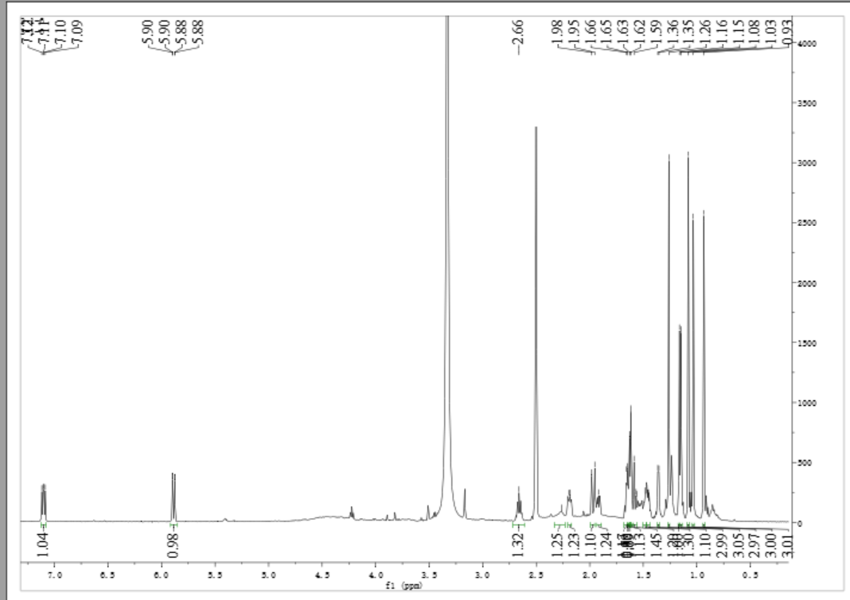

**Figure S31.** 1H NMR (DMSO-*d*6, 500 MHz) spectrum of **12**

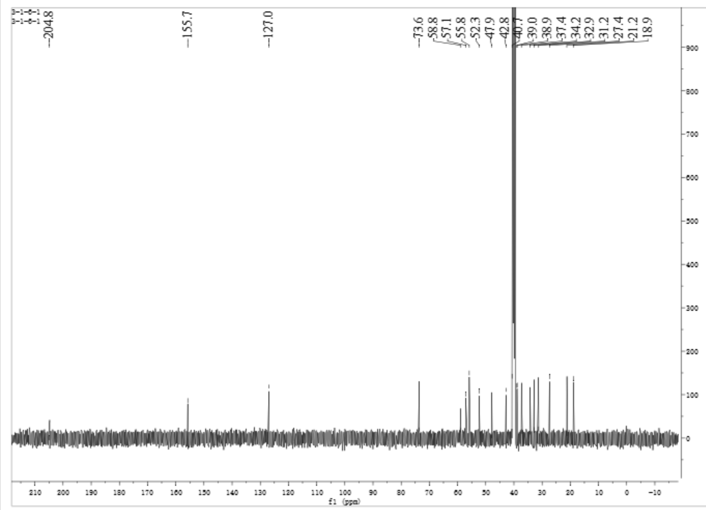

**Figure S32.** 13C NMR (DMSO-*d*6, 125 MHz) spectrum of **12**