Supporting information
Article
Quasi-Solid Composite Electrolytes of Poly-(Dioxolane) & Garnet LLZO Nanofibers Enable High Energy Efficiency Lithium-Metal Batteries
Zhengqiang Li ¹ and Dr David Salem ^{1,2,3,4}
¹ Department of Nanoscience and Nanoengineering (NANO), South Dakota School of Mines and Technology, Rapid City, SD 57701, USA
² Composites and Polymer Engineering Laboratory (CAPE), South Dakota School of Mines and Technology, Rapid City, SD 57701, USA
³ Materials and Metallurgical Engineering (MET), South Dakota School of Mines and Technology, Rapid City, SD 57701, USA
⁴ Karen M. Swindler Department of Chemical and Biological Engineering, South Dakota School of Mines and Technology, Rapid City, SD 57701, USA

Content
- Figure S1 G0 (1M-LiFSI PDOL) IR spectrum;
- Figure S2 IR spectrum of PDOL with 1 M LiFSI, 2M LiFSI and 3.5 M LiFSI;
- Figure S3 Optical images of As-spun electro-spun nanofibers and c-LLZO nanofibers;
- Figure S4 SEM of G5 composite electrolyte (5 % c-LLZO in 1M LiFSI-PDOL);
- Figure S5 One -S-F asymmetric vibration mode in HFSI molecules at 733 cm⁻¹, calculated with DFT- B3LYP/6-311++G(d,p) basis set using Gaussain 09W;
- Figure S6 Infrared spectra of composite electrolytes G0, G1, G5 and G10;
- Figure S7 The optical images of G0, G1, G5 and G10 samples in air before and after 80 ºC overnight-heating.
- Figure S8 Optical images of composite electrolytes G0, G1, G5 and G10 before and after 80 ºC overnight heating in air.
- Figure S9 The conductivity of G0, G1, G5 and G10 at 25 ºC
- Figure S10 One -SO₂- asymmetric vibration mode in HFSI molecules at 1187 cm⁻¹, calculated with DFT- B3LYP/6-311++G(d,p) basis set;
- Figure S11 One -SO₂- symmetric vibration mode in HFSI molecules at 1465 cm⁻¹, calculated with DFT- B3LYP/6-311++G(d,p) basis set
- Figure S12 One -SO₂- symmetric vibration mode in HFSI molecules at 1466 cm⁻¹
- Figure S13 One -S-N-S- asymmetric vibration mode in HFSI molecules at 838 cm⁻¹
- Figure S14 IR spectrum of HFSI molecules, calculated with DFT- B3LYP/6-311++G(d,p) basis set using Gaussian 09W;
- Figure S15 Chemical structure of HFSI and LiFSI;
- Figure S16 I-t curve of Li/G5/Li 10 mV polarization (1) and Nyquist plots of Li/G5/Li symmetric cells before and after polarization. Li-ion transference number calculated to be 61.5% based on tLi⁺¹=I_{s}/I_{o}.

Figure S1 InfraRed spectra of DOL-monomer and PDOL with LiFSI (G0) (Enlarged Figure 1d)
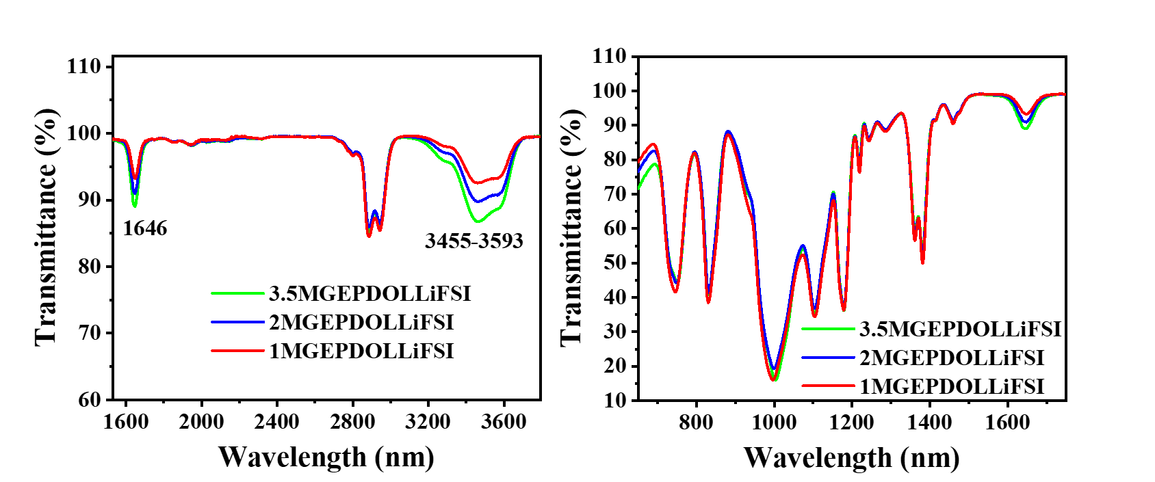
Figure S2 InfraRed spectra of PDOL initiated with 1 M, 2 M and 3.5 M LiFSI.
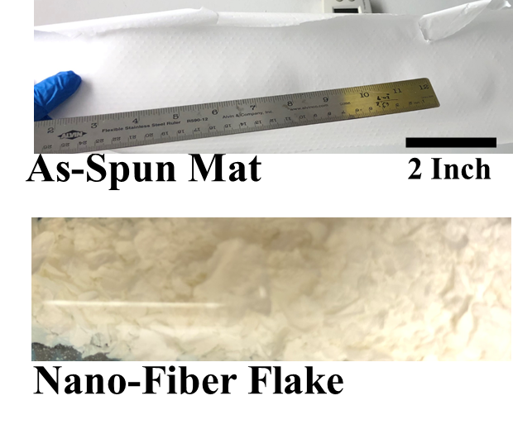
Figure S3 Optical image of as-spun precursor mat over 20 inch² large and after-sintered c-LLZO nanofibers in one vial.

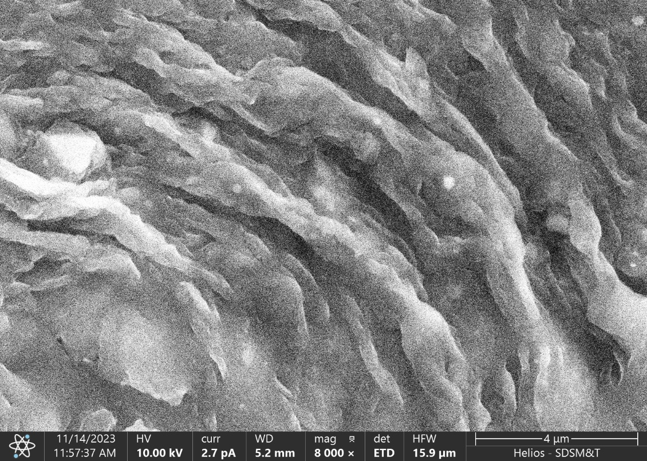
4 µm
Figure S4 SEM of G5 composite electrolyte (5 % c-LLZO in 1M LiFSI-PDOL)
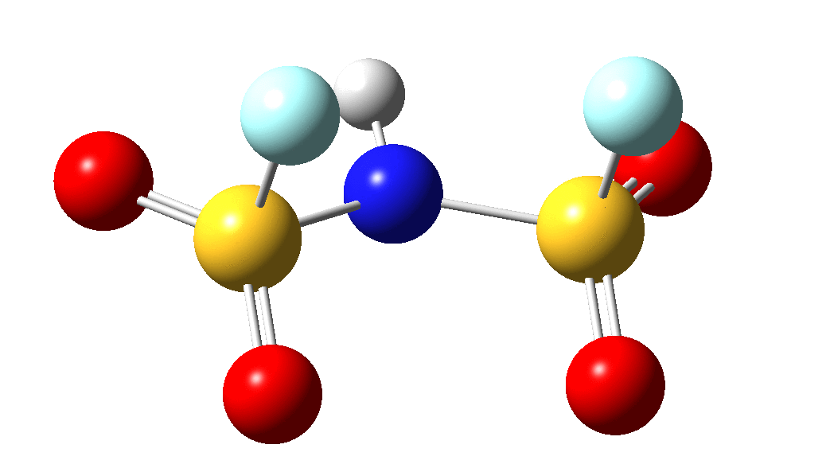
Figure S5 One -S-F asymmetric vibration mode in HFSI molecules at 733 cm⁻¹, showing one -S-F group (Pale-Blue-balls: fluorine atoms ; yellow-balls: sulfur atoms) stretching while the other one contraction, calculated with DFT- B3LYP/6-311++G(d,p) basis set.
Figure S6 Infrared spectra of composite electrolytes of G0, G1, G5 and G10
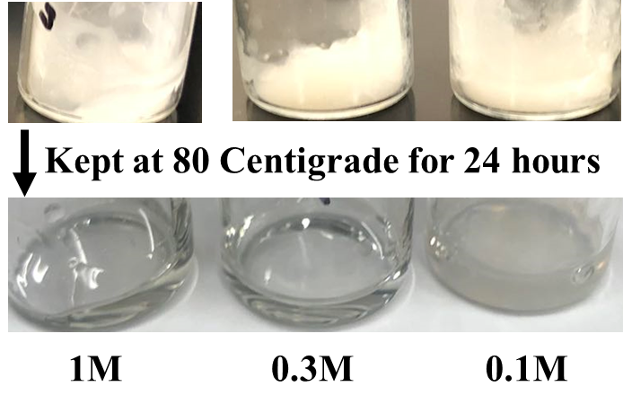
Figure S7 The optical images of G0, G1, G5 and G10 samples in air before and after 80 ºC overnight-heating.
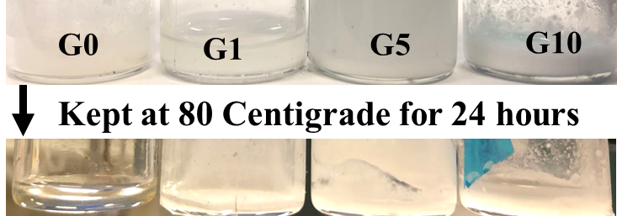
Figure S8 Optical images of composite electrolytes G0, G1, G5 and G10 80 ºC overnight heating in air.

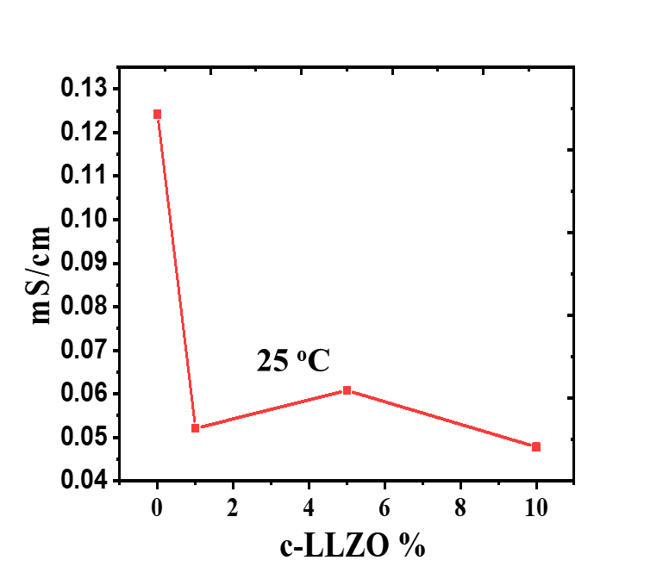
Figure S9 The conductivity of G0, G1, G5 and G10 at 25 ºC

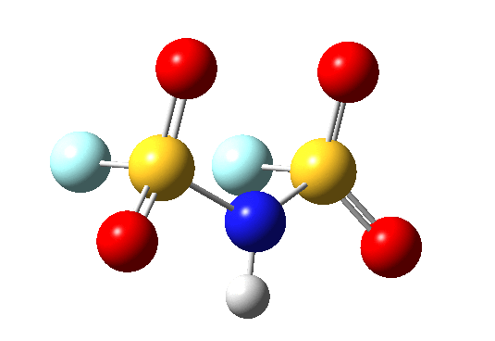
Figure S10 One -SO₂- asymmetric vibration mode in HFSI molecules at 1187 cm⁻¹, showing one -SO₂- group (Red-balls: oxygen atoms; yellow-balls: sulfur atoms) stretching while the other one contraction, calculated with DFT- B3LYP/6-311++G(d,p) basis set.
Figure S11 One -SO₂- symmetric vibration mode in HFSI molecules at 1465 cm⁻¹(Red-ball: oxygen; yellow-ball: sulfur; Blue ball: Nitrogen;), calculated with DFT- B3LYP/6-311++G(d,p) basis set.
Figure S12 One -SO₂- symmetric vibration mode in HFSI molecules at 1466 cm⁻¹ (Red-ball: oxygen; yellow-ball: sulfur; Blue: Nitrogen; White:Hydrogen), calculated with DFT- B3LYP/6-311++G(d,p) basis set.
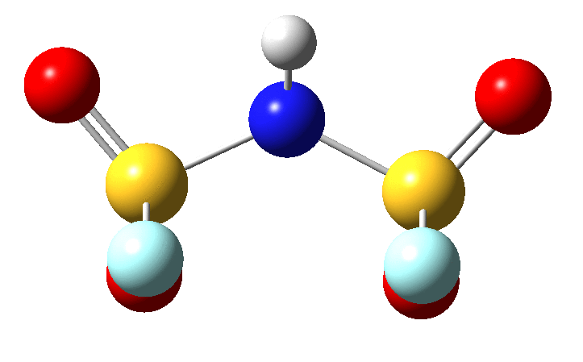
Figure S13 One -S-N-S- asymmetric vibration mode in HFSI molecules at 838 cm⁻¹(Red-ball: oxygen; yellow-ball: sulfur; Blue: Nitrogen; White: Hydrogen), calculated with DFT- B3LYP/6-311++G(d,p) basis set.

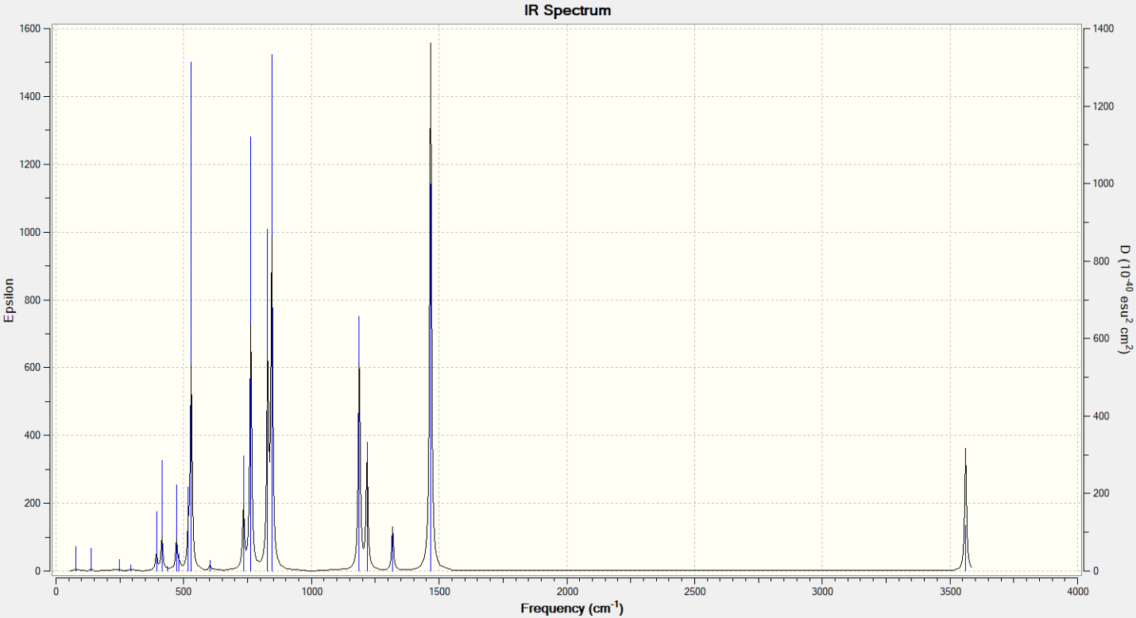 Figure S14 Stimulated IR spectrum of HFSI molecules, calculated with DFT-B3LYP/6-311++G(d,p) basis set.
Figure S15 Chemical structure of HFSI and LiFSI molecules.
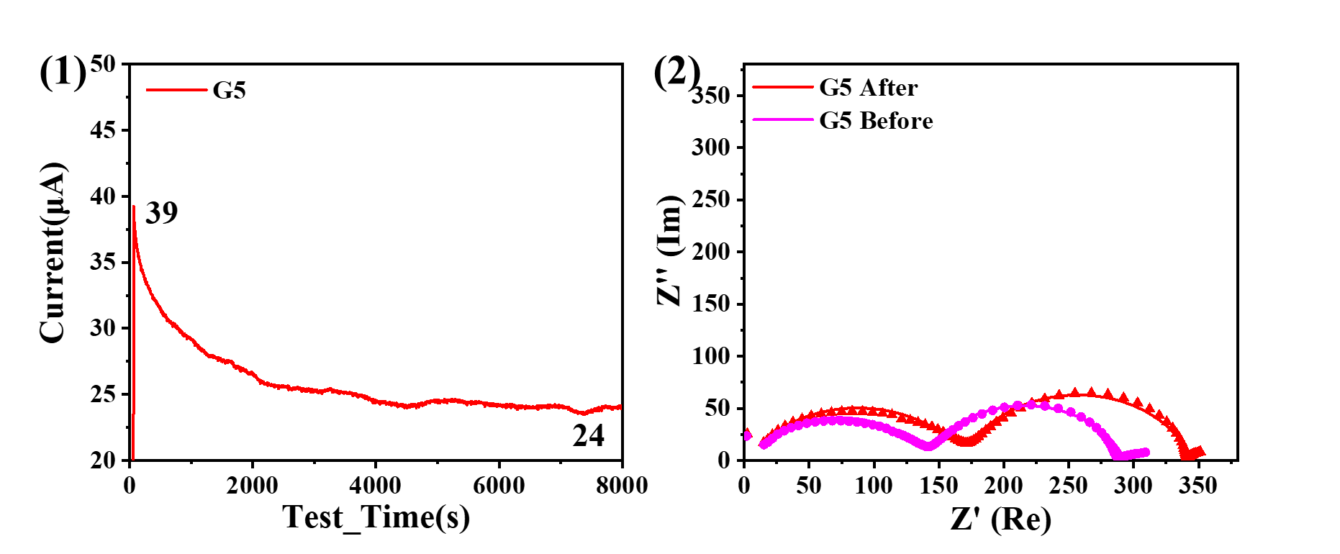
Figure S16 Current-time curve of Li/G5/Li 10 mV polarization (1) and Nyquist plots of Li/G5/Li before and after polarization. Li-ion transference number calculated to be 61.5% based on t_{Li+1}=I_{s}/I_{o}.

