Supplementary Materials
Electronic Nose and GC-MS analysis to detect Mango Twig Tip Dieback in mango (Mangifera indica) and Panama disease (TR4) in banana (Musa acuminata)
Wathsala L. Ratnayake ¹, Stanley E. Bellgard ¹, Hao Wang ² and Vinuthaa Murthy ^{2,}*
- Biosecurity and Animal Welfare Branch, Agriculture, Fisheries and Biosecurity Division, Department of Industry, Tourism and Trade (DITT), Northern Territory Government, Australia
Wathsala.Ratnayake@nt.gov.au (W.L.R.); Stanley.Bellgard@nt.gov.au (S.E.B.)
- Chemistry Division, Faculty of Science and Technology, Charles Darwin University, Northern Territory, Australia
vinuthaa.murthy@cdu.edu.au (V.M.); Hao.Wang@cdu.edu.au (H.W.)

* Correspondence: vinuthaa.murthy@cdu.edu.au; Tel.: +61 8 89466794

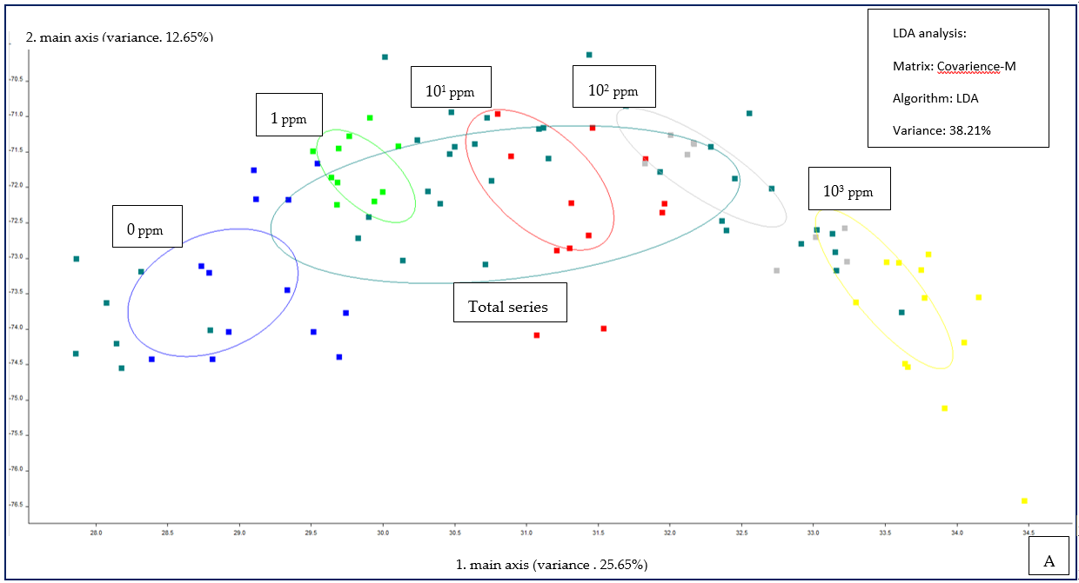

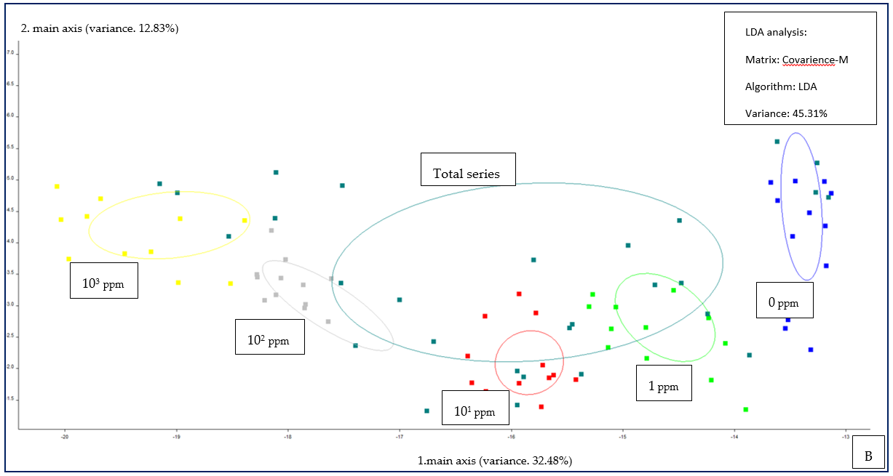

Figure S1. Linear Discriminant Analysis plot for individual classes of concentration and total concentration series data obtained from PEN 3 device . (A) 3-Methyl-2-butanol, (B) Isoamyl isovalerate.

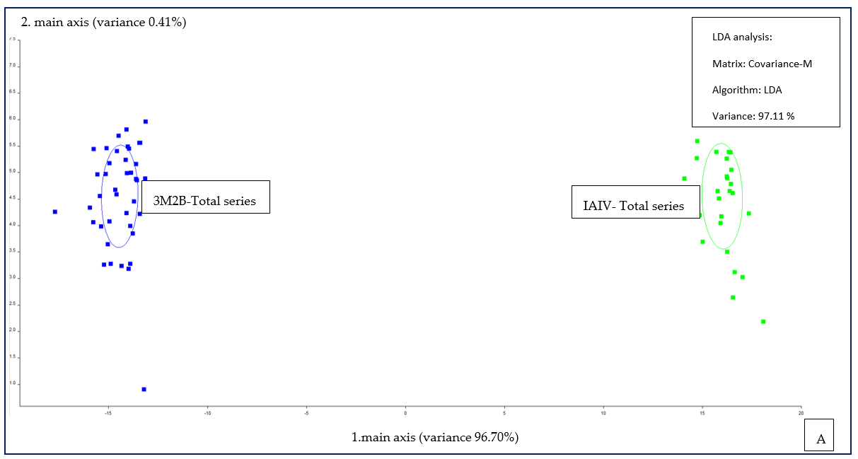

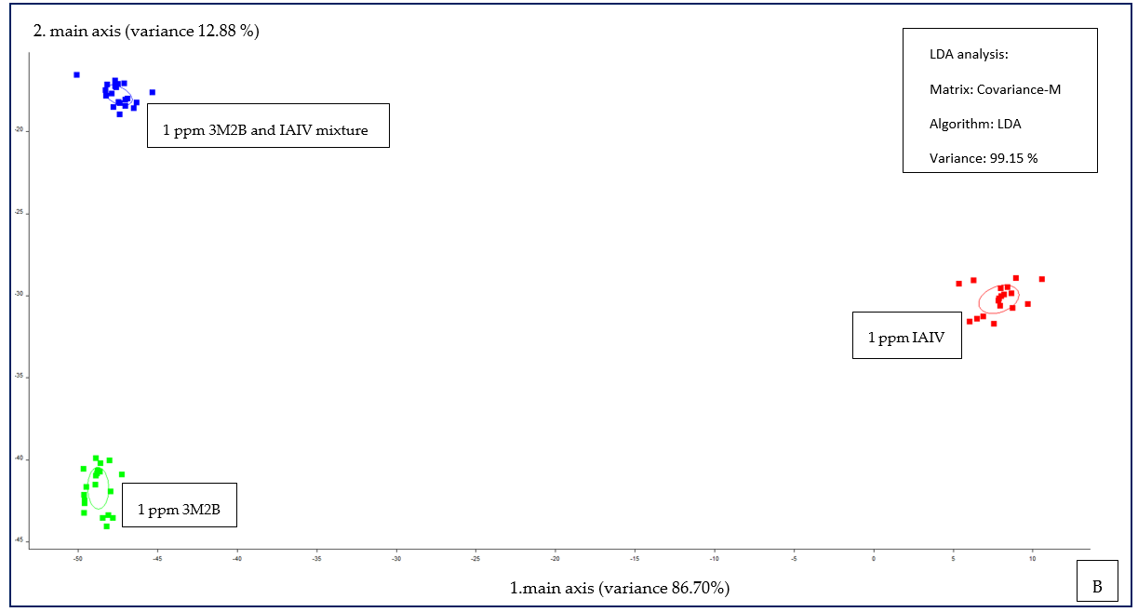

Figure S2. Linear Discriminant Analysis Plots of data obtained from the PEN 3 device. (A) 3M2B total series vs IAIV total series, (B) Mixture of 1 ppm 3M2B and IAIV against pure 3M2B and IAIV of 1 ppm.

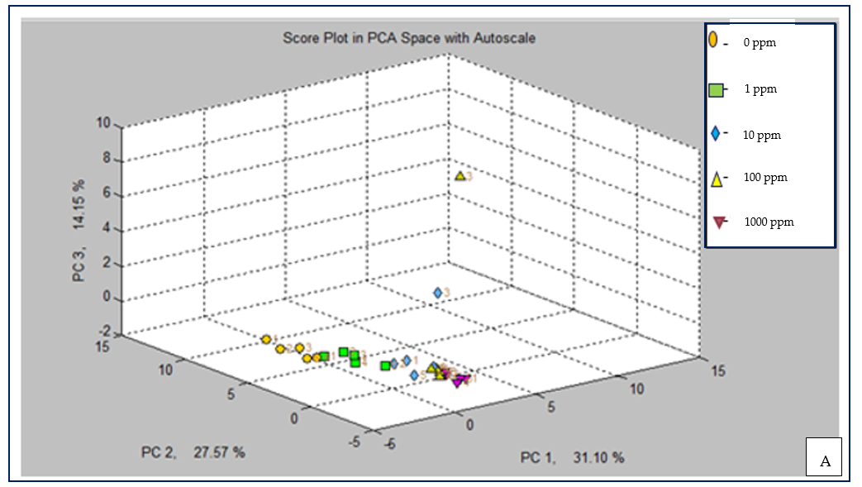

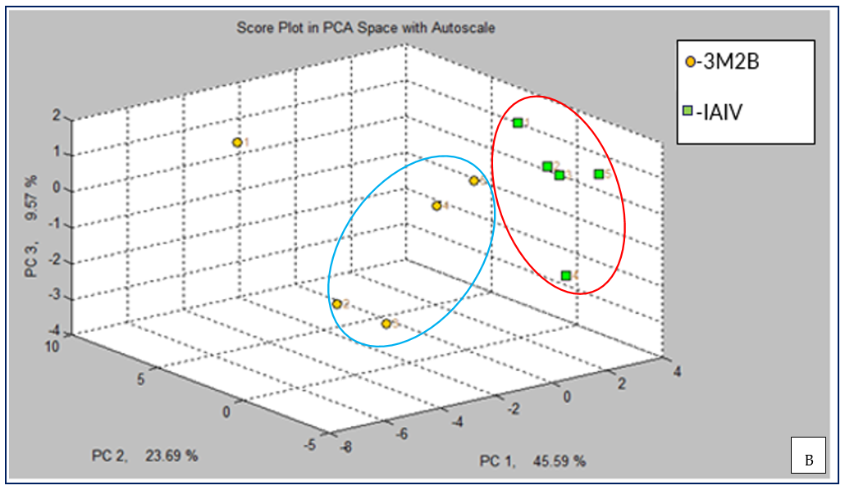

Figure S3. CD analysis score plots in PCA of data obtained from MSEM 160 device. (A) 3-Methyl-2-butanol total concentration series, (B) Mixture of 1ppm 3M2B and IAIV.

