Supplementary material

Table S1. Adjusted HRs* and 95% CIs for the MMSE scores with all-cause mortality, stratified by lifestyle behaviors
Lifestyle behaviors |  | HR (95% CI)  for 1-point increase | P for interaction
Smoking status | Unhealthy | 0.970 (0.955-0.984) | 0.121
 | Healthy | 0. 961 (0.952-0.970)
Alcohol consumption | Unhealthy | 0. 965 (0.950-0.979) | 0.783
 | Healthy | 0. 963 (0.954-0.972)
Physical activity | Unhealthy | 0. 964 (0.955-0.974) | 0.983
 | Healthy | 0. 962 (0.950-0.975)
Diet | Unhealthy | 0. 969 (0.959-0.979) | 0.003
 | Healthy | 0. 956 (0.944-0.967)
BMI | Unhealthy | 0. 970 (0.959-0.981) | 0.189
 | Healthy | 0. 956 (0.946-0.967)
* Adjusted for age, sex, education, residence, marital status, living pattern, self-rated of economic status, ADL in disability, and history of chronic disease (diabetes, heart diseases, cancer and stroke). MMSE, Mini-Mental State Examination; HR, hazard ratio; CI, confidence interval; ADL, activities of daily living; BMI, body mass index.

Figure S1. Flow chart of the included CLHLS participants

2117 participants were excluded:
- 3699 participants lost to follow-up or died before 2014
- 57 younger than 65 years old
- 67 participants with self-reported dementia at baseline
- 818 with missing data on cognitive function or lifestyle

2506 participants survived to 2018
1461 participants died during 2014-2018
1157 participants lost to follow-up during 2014-2018
5124 participants were successfully followed-up and survived to 2014
Total 9765 participants from CLHLS survey in 2011

Figure S2. Associations of the MMSE scores with mortality stratified by lifestyles.
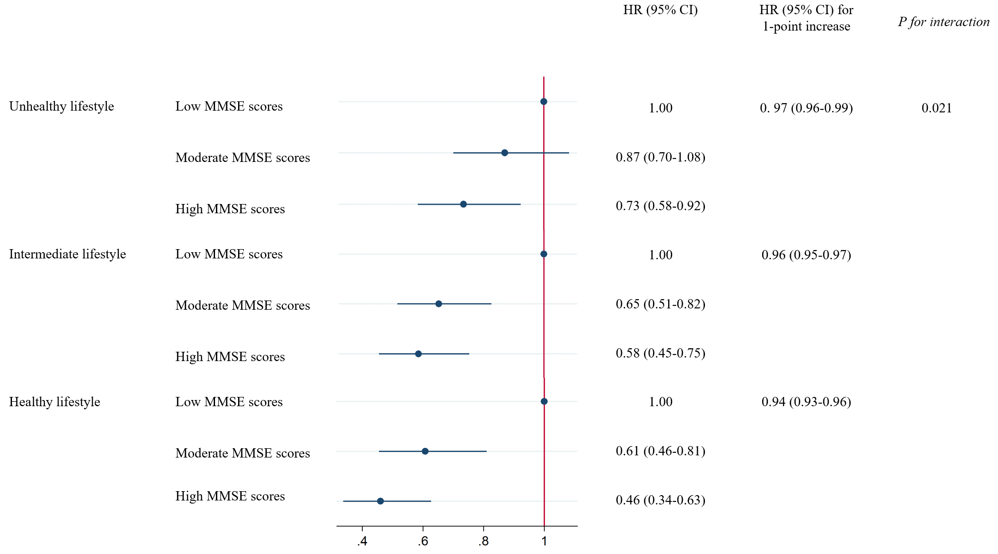
Figure 1—Associations between MMSE scores and all-cause mortality stratified by lifestyles. Results were adjusted for age, sex, education, residence, marital status, living pattern, self-rated of economic status, ADL in disability and history of chronic disease (diabetes, heart diseases, cancer and stroke). MMSE, Mini-Mental State Examination; HR, hazard ratio; CI, confidence interval.

