Supplementary Materials
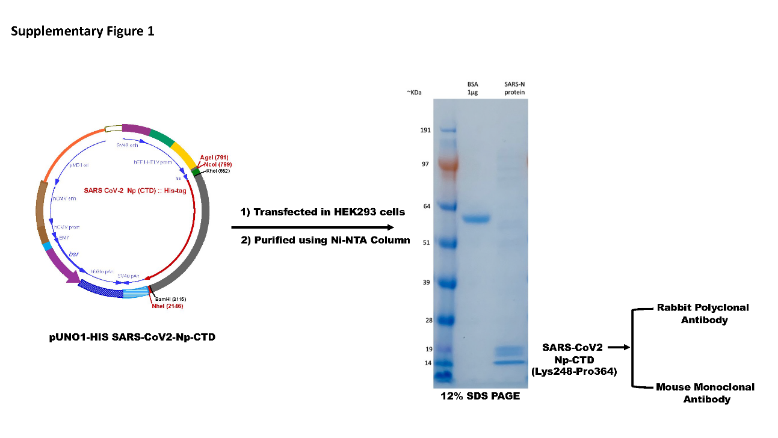
Sup Figure 1. Cloning, Expression, and purification of Nucleoprotein (Np) C-terminal domain (CTD): The ORF corresponding to the Np-CTD (Lys248- Pro364) was cloned into the vector pUNO1-HIS vector. The cloned vector pUNO1-HIS SARS-CoV-2-Np-CTD was transfected to the mammalian HEK293 cells for protein expression. The Histidine-tagged Np-CTD protein secreted in the cell-conditioned media was purified using Ni-NTA columns. The purified proteins were resolved on the SDS-PAGE to check the purity and yield of the Np-CTD. A major polypeptide band corresponding to the molecular weight of 14 kDa was detected on the Coomassie-stained SDS-PAGE gels; the higher migrating bands are the post-translational modified Np-CTD.
Purified Np-CTD was injected in rabbits and mice to produce polyclonal and monoclonal antibodies.
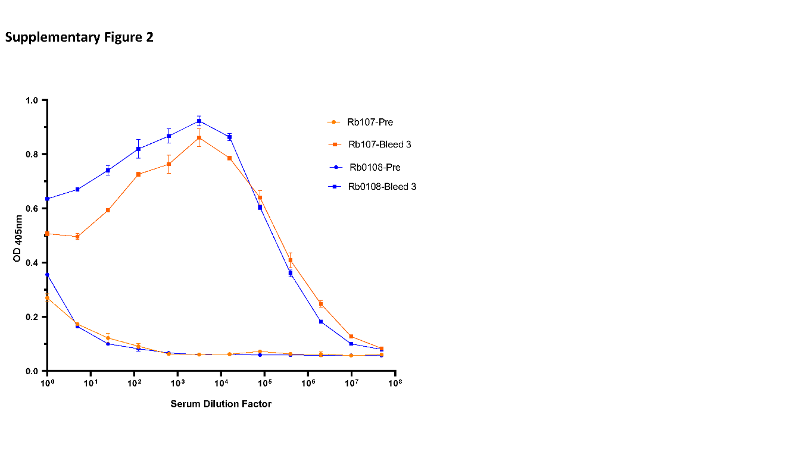
Sup Figure 2. Production of Np-CTD rabbit polyclonal antibody: The purified Np-CTD antigen was injected into two rabbits (Rb 107 and 108) to produce the polyclonal antibodies. The serum collected pre- and post-immunization (Bleed 3) from the animals was tested by ELISA using the purified Np-CTD proteins. Both Rb-107 and Rb-108 demonstrated very high antibody titer compared to the pre-immunized serum. Rb-108 polyclonal Ab was selected to develop the subsequent sandwich ELISA.
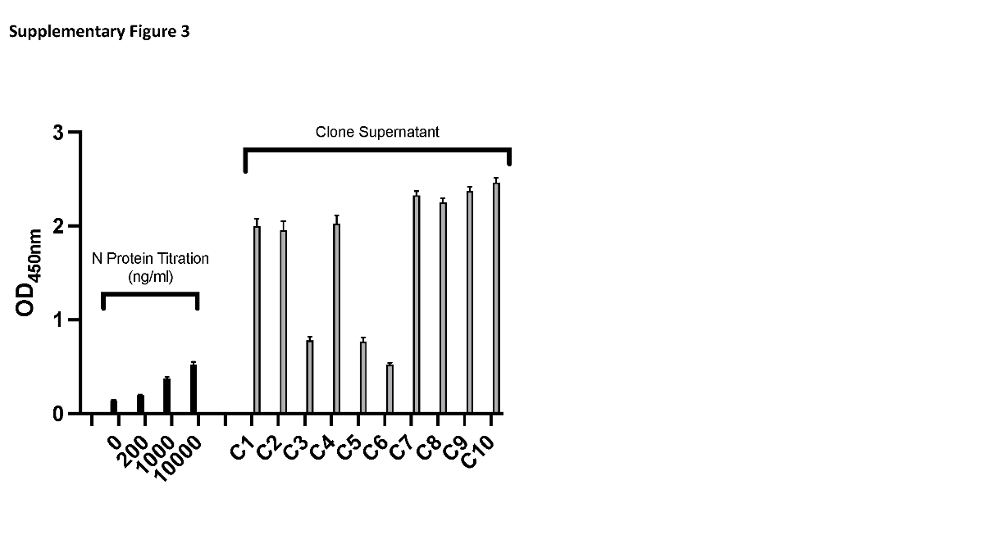
Sup Figure 3. Production of Np-CTD mouse monoclonal antibody: The hybridoma clones’ supernatant (C1-C10) obtained from the mouse injected with the purified Np-CTD antigen was tested by ELISA using the purified Np proteins. Clones 9 and 10 demonstrated the highest reactivity in ELISA, and the purified monoclonal antibodies mAb 9 and mAb 10 from these clones were selected to develop the subsequent sandwich ELISA. The purified Np was titrated at the indicated concentrations (ng/ml) in parallel for positive control.
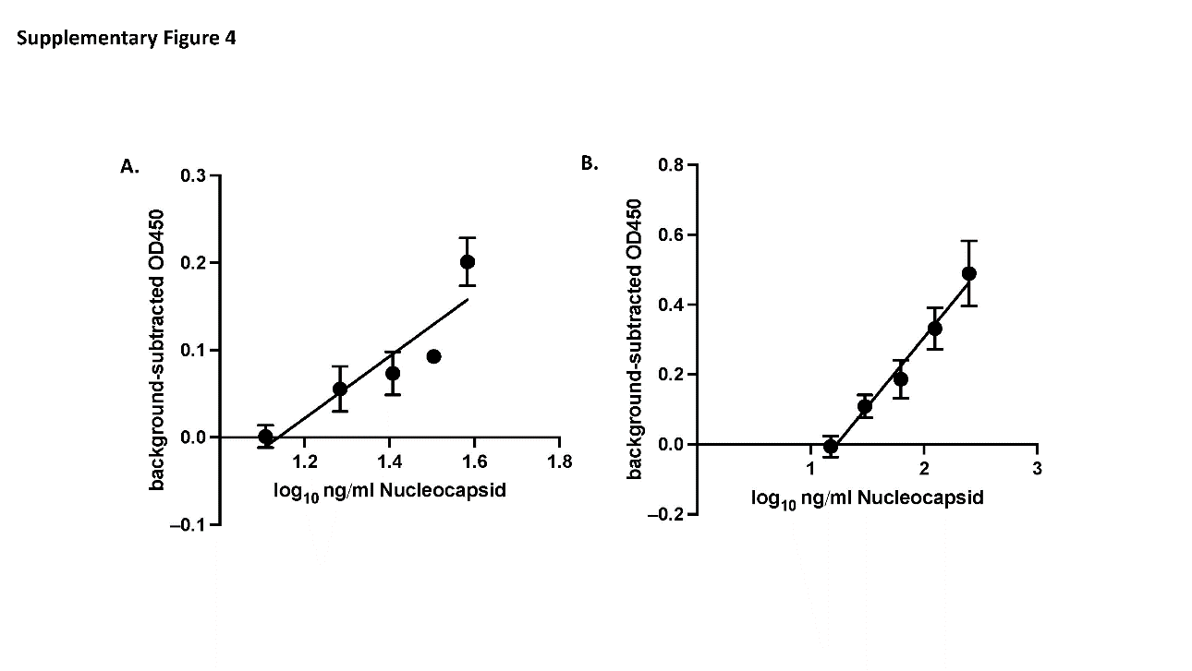
Sup Figure 4. Estimating ELISA's Limit of Detection (LoD) for UV-inactivated SARS-CoV-2 XBB.1.5: A dilution series of UV-inactivated SARS-CoV-2 XBB.1.5 was prepared in viral transport media and stored at -80°C. A. Samples were prepared in triplicate and measured by ELISA using antibodies by a blinded experimenter. B. Recombinant N protein was serially diluted and included in the ELISA in A. Graphs are mean +/- SD of triplicate samples. OD values of blanks were subtracted, and the best-fit line was calculated on log-transformed concentrations in GraphPad Prism 10.
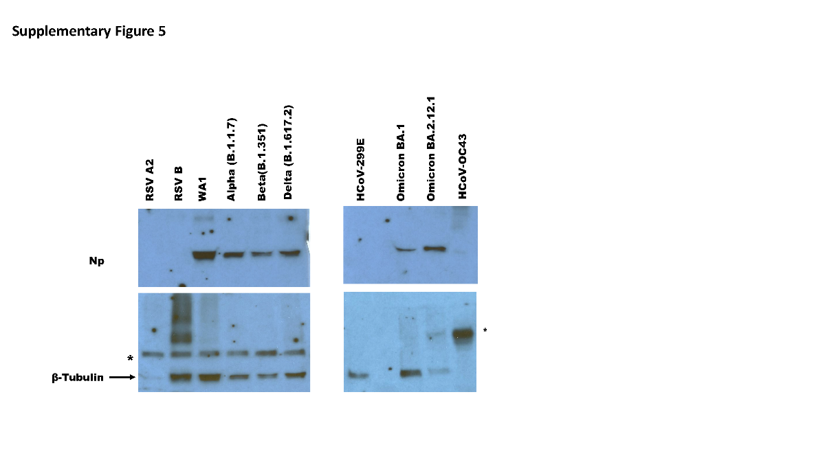
Sup Figure 5. Western blot to check the specificity of the antibody: The UV-inactivated SARS-CoV-2 variants (WA1, B.1.1.7, B.1.351, B.1.617.2, BA.1, BA.2.12.1) and other distractor respiratory viruses (HCoV-OC43, HCoV-299E, RSV A2, RSV B) were resolved in SDS-PAGE and subjected to the Western blot assay using mAb10. Single polypeptide bands corresponding to the molecular weight of Np (~45 kDa) were only detected with the SARS-CoV-2 variants. No bands were detected for the distractor viruses. Beta-tubulin was used as the loading control; the higher migrating bands indicated by Asterix are the tubulin dimer.

