**SUPPORTING INFORMATIONS**

**Tailoring Alginate-Gelatin Hydrogels to Precisely Modulate Osteogenesis in Dental Pulp Stem Cells While Preserving Other Cellular Behaviors**

Zied Ferjaoui1, Roberto López-Muñoz2, Soheil Akbari3, Fatiha Chandad1, Diego Mantovani2,Mahmoud Rouabhia1 and Roberto Fanganiello1

1 Oral Ecology Research Group, Faculté de Médecine Dentaire, Université Laval, Québec City, Canada

2 Laboratory for Biomaterials and Bioengineering, CHU de Québec, Université Laval, Québec City, Canada

3 Département de génie chimique, Université Laval, Québec, QC G1V 0A6, Canada



**Figure SI 1**: XPS analysis of Low Alg-Gel scaffolds with CaCl2.

|  |  |
| --- | --- |
|  |  |

**Figure SI2**: Equilibrium swelling studies (a) and Degradation test (b) of Low and High Alg-Gel hydrogels. *p< 0.05, **p< 0.01.

|  |  |
| --- | --- |
|  |  |

**Figure SI 3:** Cytotoxicity assay of LDH release from DPSCs (a) and MG-63 cells (b) grown on hydrogels.

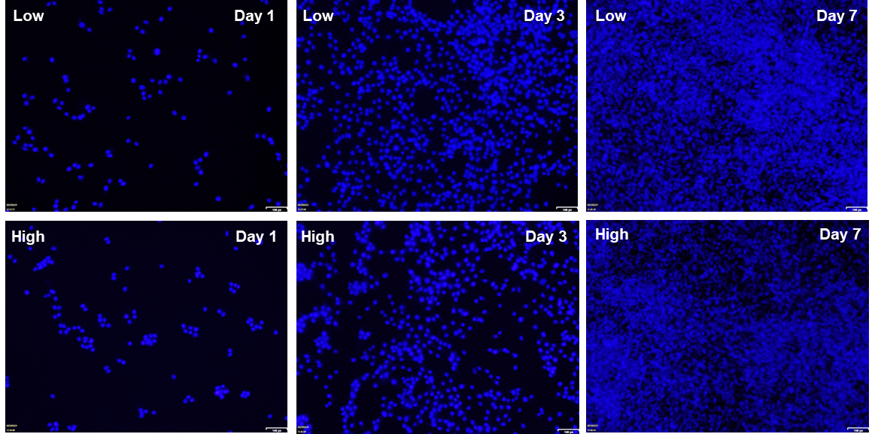

**Figure SI 4:** MG-63 cells cultured for 1, 3 and 7 days on Low and High Alg/Gel scaffolds and stained with Hoechst dye.

|  |  |
| --- | --- |
|  |  |

**Figure SI 5:** The growth curves of MG-63 cells on scaffolds (a). The control group and the test group were monitored by MTT assay (b). Each point represents the average absorbance readings of three scaffolds.

|  |  |
| --- | --- |
|  |  |

**Figure SI 6**: The growth curves of DPSC cells that were grown on scaffolds (a). The control group and the test group were monitored by MTT assay (b). Each point represents the average absorbance readings of three scaffolds.