Supplementary Materials
Enhancing Alginate Hydrogels as Possible Wound Healing Patches: The Synergistic Impact of Reduced Graphene Oxide and Tannins on Mechanical and Adhesive Properties
Sebastián Carrasco ¹, Luisbel González ¹, Mauricio Tapia ¹, Bruno F. Urbano ², Claudio Aguayo ³, Katherina Fernández ^{1,*}
¹ Laboratorio de Biomateriales, Departamento de Ingeniería Química, Facultad de Ingeniería, Universidad de Concepción, Concepción, Chile.scarrasco2017@udec.cl luisbgonzalez@udec.cl mtapia2017@udec.cl kfernandeze@udec.cl
² Departamento de Polímeros, Facultad de Ciencias Químicas, Universidad de Concepción, Concepción, Chile. burbano@udec.cl
³ Departamento de Bioquímica Clínica e Inmunología, Facultad de Farmacia, Universidad de Concepción, Concepción, Chile. caguayo@udec.cl
* Correspondence: kfernandeze@udec.cl

1. Materials and Methods
1.1. Materials
Graphite powders (Flake, mesh 325) were bought from Asbury Online (Asbury Carbons, N.J., USA). Potassium permanganate powder (KMnO₄, 99.9%), sulfuric acid (H₂SO₄, 98%), phosphoric acid (H₃PO₄, 85%), hydrochloric acid (HCl, 37%), ferric chloride (FeCl₃-6H₂O≥99.0%) and Tris(hydroxymethyl)aminomethane were purchased from Merck (Darmstadt, Germany). Hydrogen peroxide (H₂O₂), sodium tetraborate decahydrate (B₄Na₂O₇-10H₂O ≥ 99.5%) and glycerol were purchased from Furet (Concepción, Chile). Dopamine hydrochloride (DA-HCl ≥ 98.0%) and alginic acid sodium salt from brown algae with medium viscosity were purchased from Merck (Santiago, Chile). These chemicals were used as received without further purification. Milli-Q water was used throughout the study. For the sonication treatments, sonicator equipment (Elmasonic E60H model) was used for various sonication times as described below.

1.2. Synthesis of Graphene Oxide (GO)
GO synthesis was performed by oxidation of natural graphite powder using the modified Hummers method. 26 2.25 g of graphite were added to a mixture of 30 ml of H₃PO₄ and 270 ml of H₂SO₄. Once dissolved, 13.5 g of KMnO4 were slowly added and heated for 1 hour at 40°C. The mixture was then cooled to 25°C, and the oxidation was stopped by adding H₂O₂ (60% v/v) until a color change from black to dark green was observed, without the presence of foam. Subsequently, it was centrifuged at 5000 rpm for 20 min and the precipitate was washed with HCl (10% v/v) until a light brown color was achieved. After washing with acid, three Milli-Q water washes were carried out, and it was centrifuged at 9000 rpm for 20 min. In this stage, the absence of chlorides was verified using AgNO₃. Then, a wash with ethanol and several washes with Milli-Q water were carried out to eliminate traces of alcohol. The solution was then dialyzed for 72 hours in 12 kDa dialysis bags and in 5L of Milli-Q water, with water changes every 24 hours. The dialyzed solution was placed in a cryogenic bath for 2 hours at -40°C and lyophilized for 72 hours.15

1.3. Synthesis of reduced Graphene Oxide (rGO)
GO reduction was performed by the method proposed by Xu.17 A solution of 0.24 g of tris(hydroxymethyl)aminomethane in 200 mL of Milli-Q water was prepared, to which 0.05 g of DA and 0.1 g of GO were added. Once the GO dispersion was achieved, the pH was the sample was filtered through Whatman® No.1 filter paper and the retained solid was adjusted to 8.5 with HCl (5%) and sonicated for 20 min in an ice bath. Then, it was heated at 60 °C for 24 h with constant and gentle stirring to favor the reduction process. Subsequently, the sample was filtered through Whatman® No.1 filter paper and the retained solid was dialyzed in Milli-Q water for 72 h, with water changes every 24 hours. When dialysis was finished, the sample was filtered and dried at room temperature.

2. Imagens
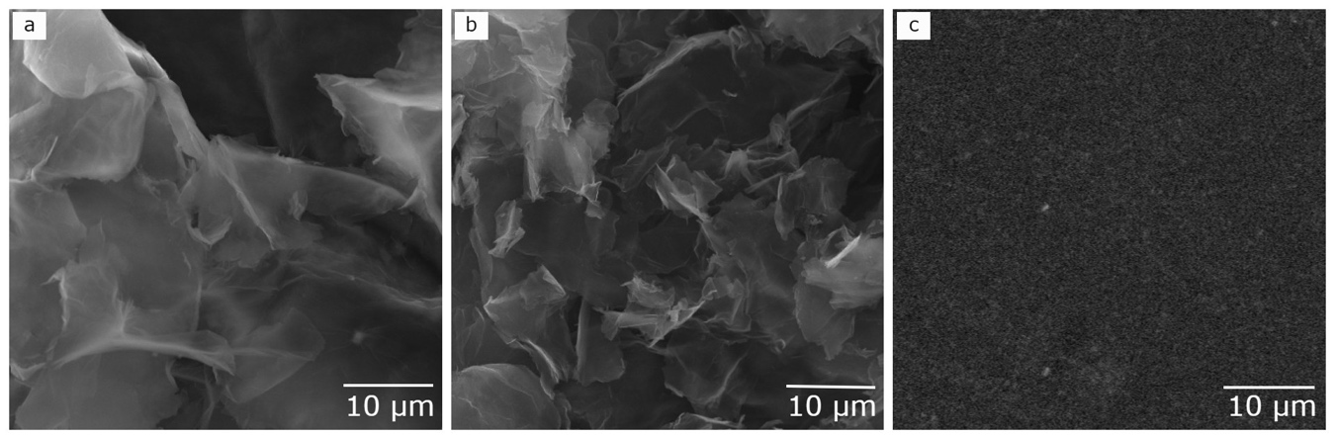

Figure 1S. Scanning electron microscopy (SEM) images a) GO, b) rGO, c) Alg

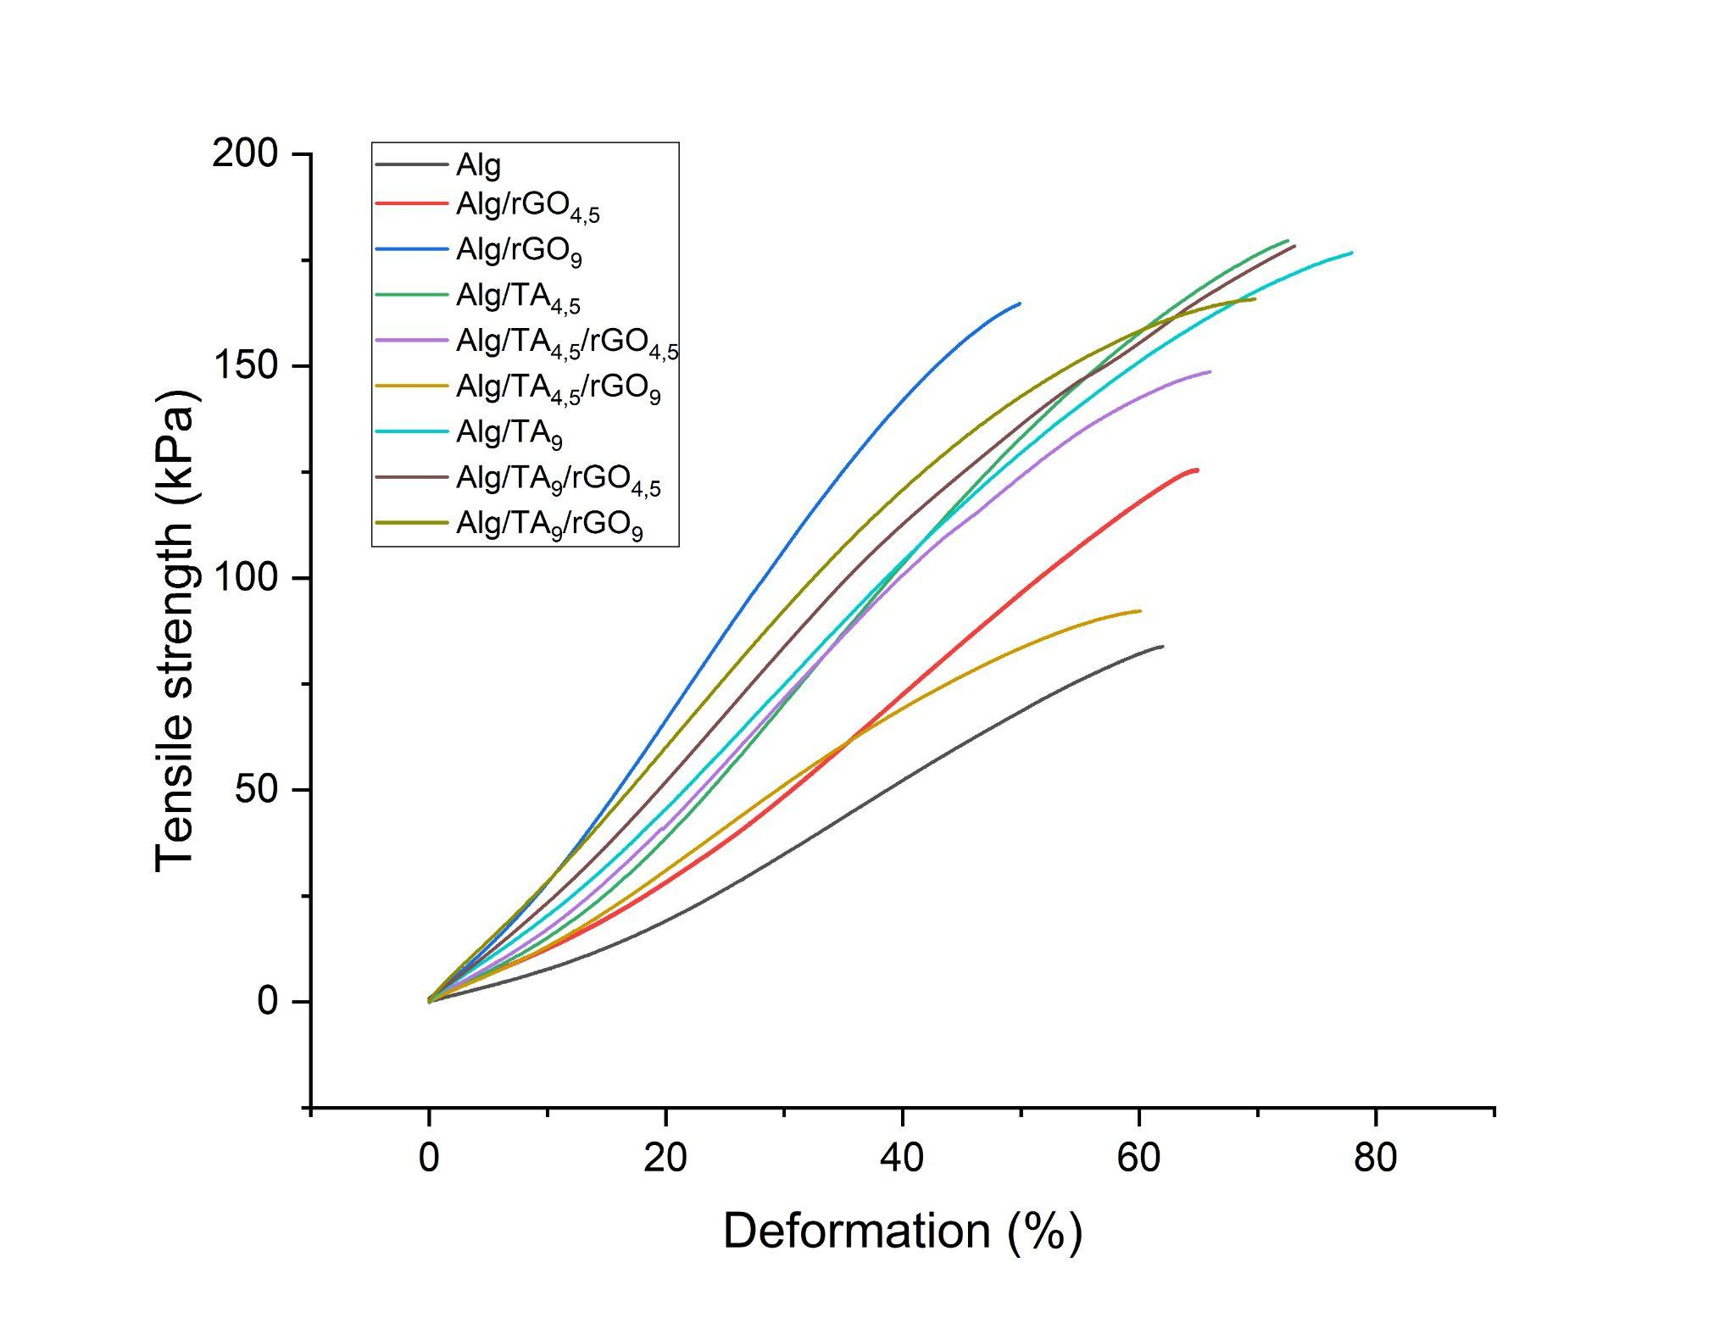
Figure 2S. Tensile-deformation curves

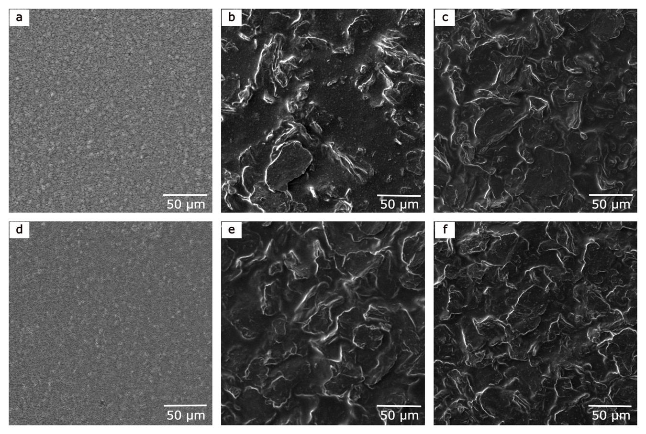

Figure 3S. Scanning electron microscopy (SEM) images a) Alg/TA_{4.5}, b) Alg/rGO_{4.5}/TA_{4.5}, c) Alg/rGO₉/TA_{4.5}, d) Alg/TA₉, e) Alg/rGO_{4.5}/TA₉, f) Alg/rGO9/TA₉

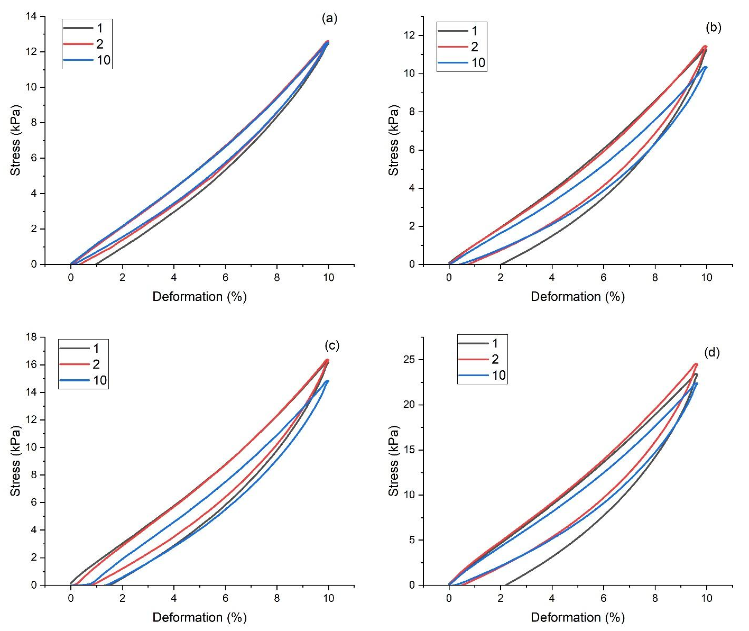

Figure 4S. Cyclic tensile curves of (a) Alg, (b) Alg/rGO₉, (c) Alg/TA₉ and (d) Alg/rGO_{4.5}/TA₉

Table 1S. Interplanar distance of samples determined by XRD.
 | 2θ (°) | d (Å)
GO | 8.65 | 10.22
rGO | 21.72 | 4.09
Alg | 21.20 | 4.19
Alg/rGO9 | 21.50 | 4.13
Alg/TA9 | 21.50 | 4.13
Alg/rGO/TA9 | 21.70 | 4.10

