Supplementary information
Aging Mechanism of Mn-based Prussian Blue Cathode Materi-al by Synchrotron 2D X-ray Fluorescence
Mariam Maisuradze ¹, Min Li ¹, Ilaria Carlomagno ², Mattia Gaboardi ², Giuliana Aquilanti ², Jasper Rikkert Plaisier ² and Marco Giorgetti ^{1,}*

Table S1. The list of samples analyzed with PXRD technique.
30%NiMnHCF Samples | Description
Pristine | Fresh electrode
C1 | Charged after 1st cycle
D1 | Discharged after 1st cycle
C2 | Charged after 2nd cycle
D2 | Discharged after 2nd cycle
C10 | Charged after 10th cycle
D10 | Discharged after 10th cycle
C50 | Charged after 50th cycle
D50 | Discharged after 50th cycle
C100 | Charged after 100th cycle
D100 | Discharged after 100th cycle

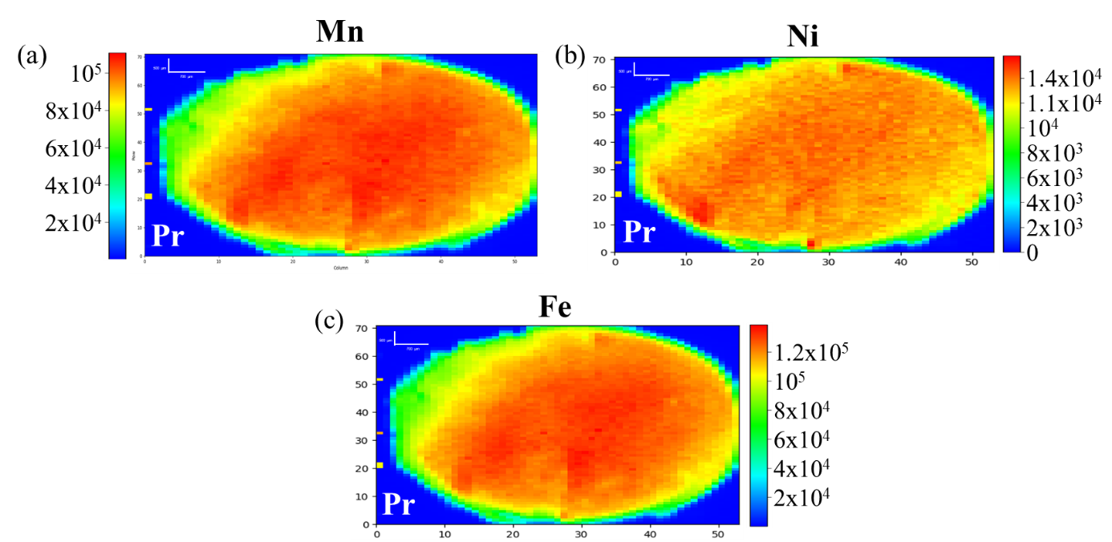
Figure S1. 2D-XRF maps of Pristine sample of 10%NiMnHCF: (a) Mn, (b) Ni and (c) Fe.

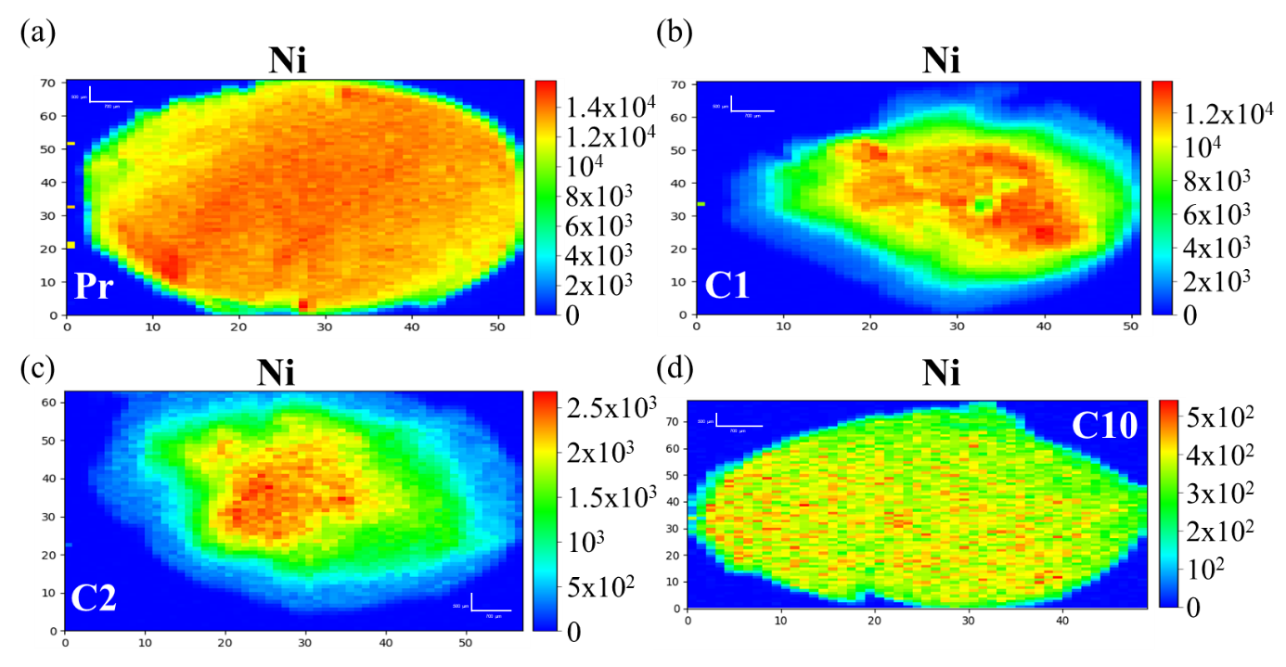
Figure S2. 2D-XRF maps of Ni contribution of 10%NiMnHCF samples: (a) Pristine, (b), C1, (c) C2 and (d) C10.

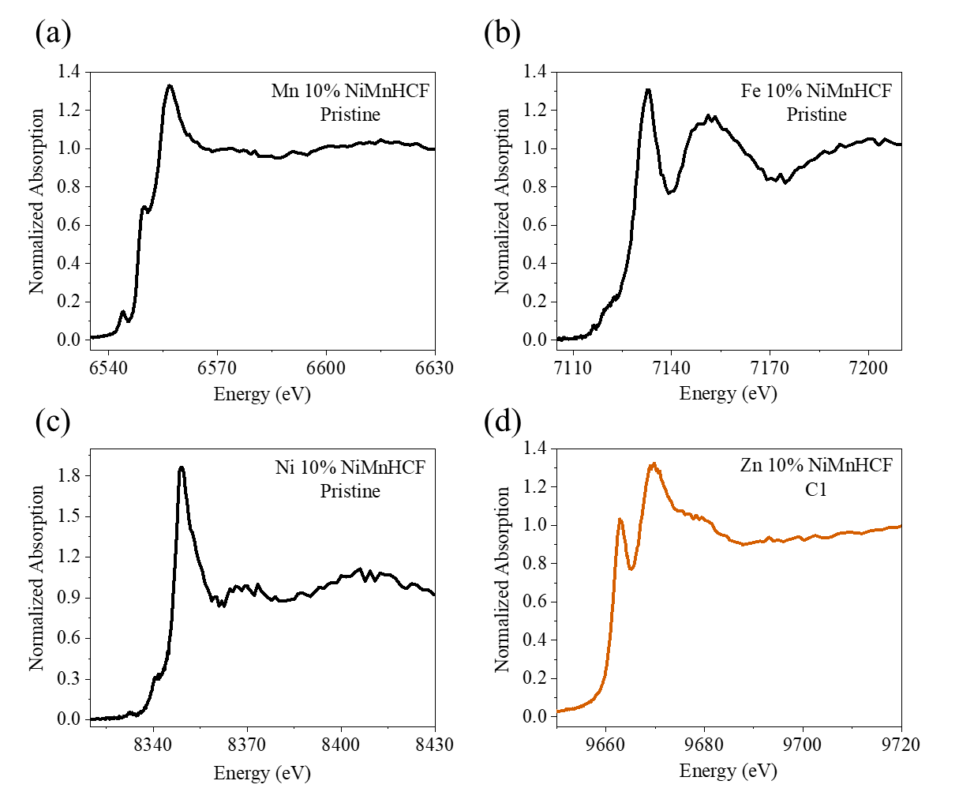
Figure S3. XANES of 10%NiMnHCF samples: (a) Mn K-edge of Pristine, (b), Fe K-edge of Pristine, (c) Ni K-edge of Pristine and (d) Zn K-edge of C1.
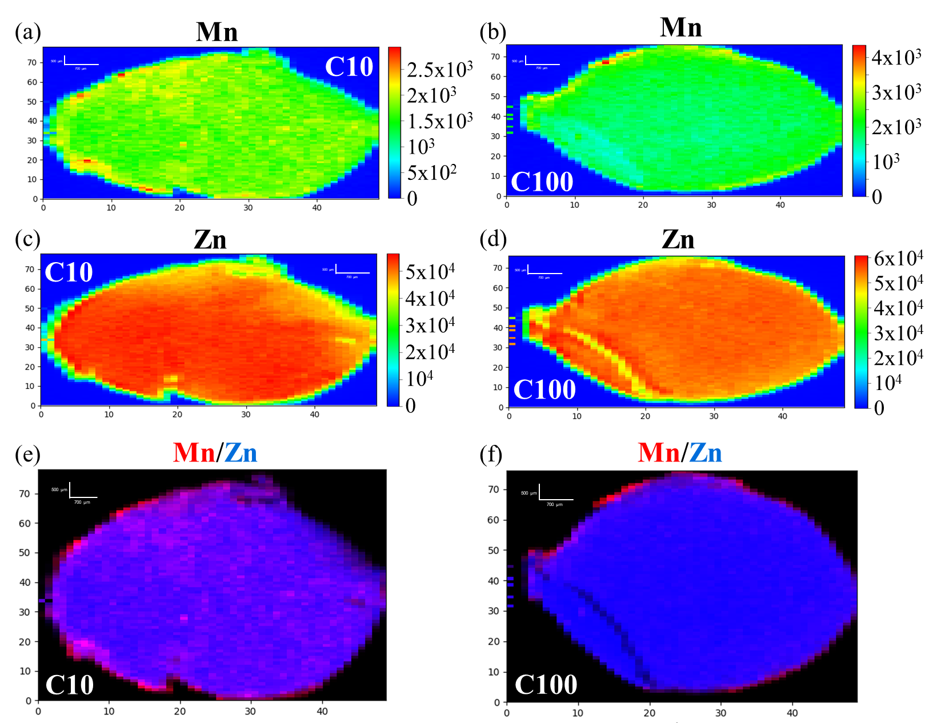
Figure S4. 2D-XRF maps of 10%NiMnHCF samples: (a) C10 Mn, (b), C100 Mn, (c) C10 Zn, (d) C100 Zn, (e) C10 Mn/Zn overlay and (f) C100 Mn/Zn overlay.
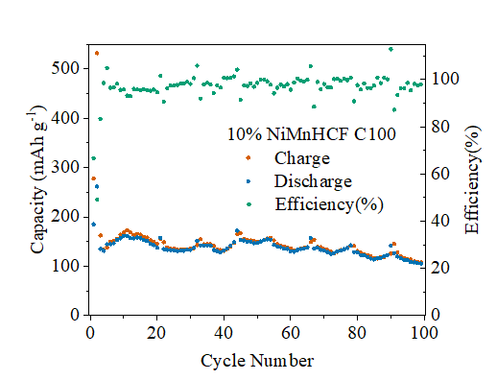
Figure S5. GCPL data of C100 of 10%NiMnHCF: stability and efficiency test.

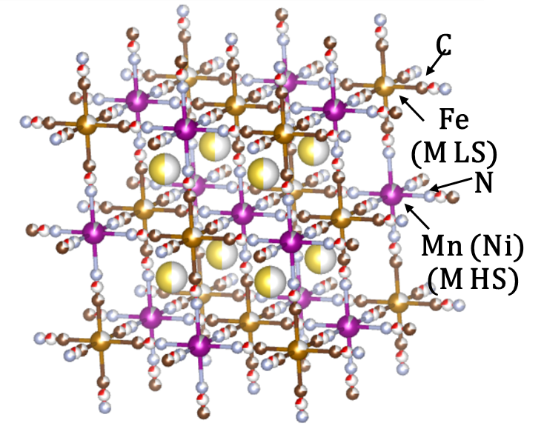
Figure S6. F m-3m structure of 30%NiMnHCF.

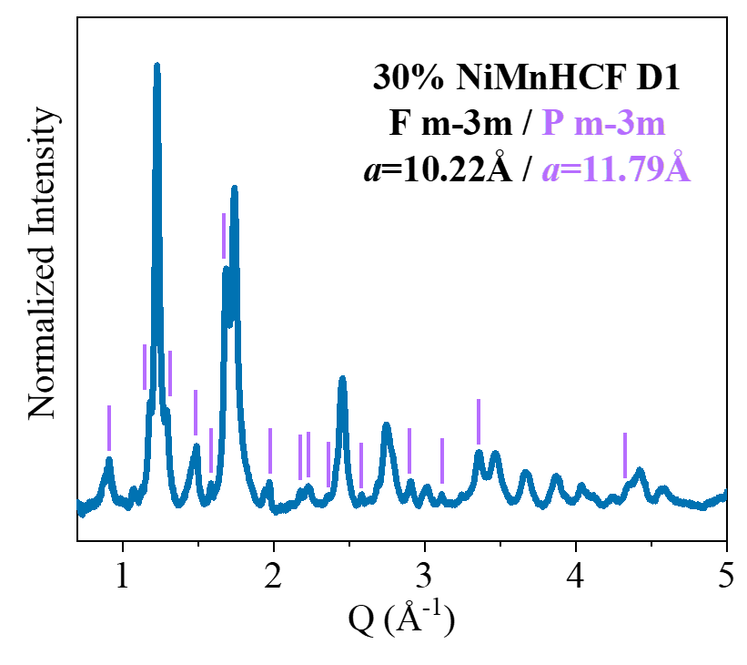
Figure S7. PXRD measurement result of D1 of 30%NiMnHCF.

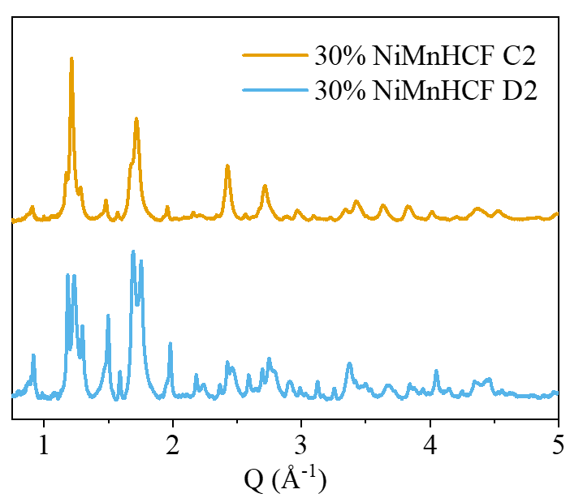
Figure S8. PXRD measurement results of C2 and D2 of 30%NiMnHCF.

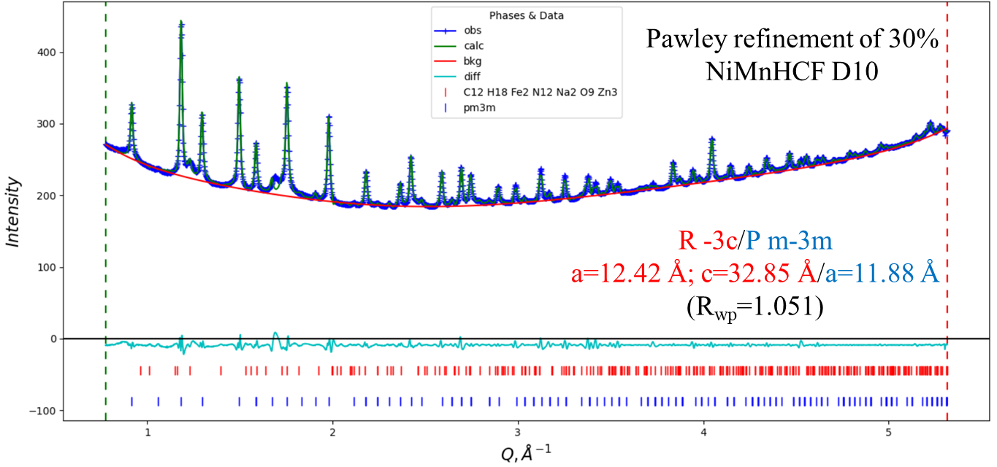
Figure S9. Pawley refinement of D10 of 30%NiMnHCF.

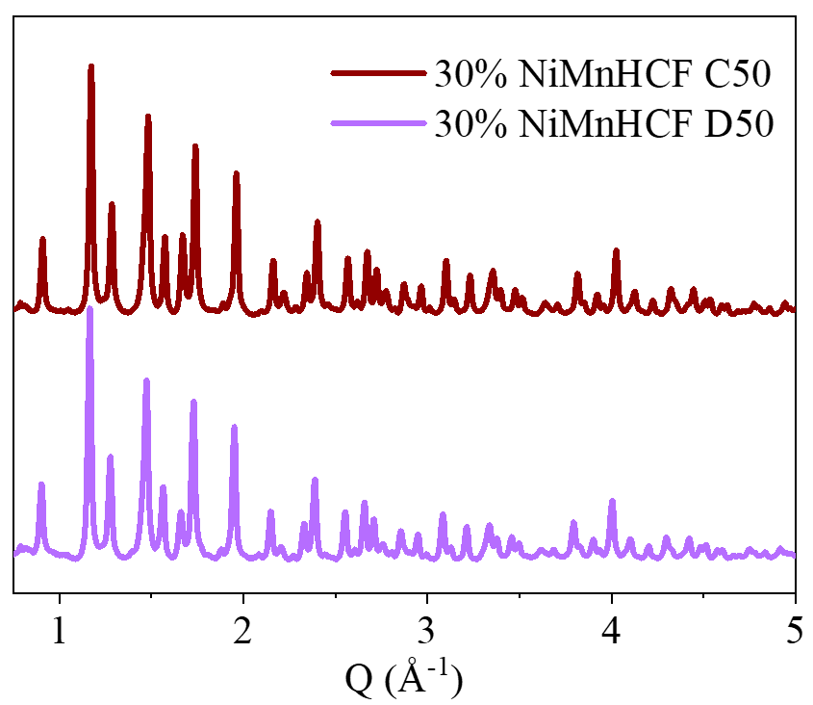
Figure S10. PXRD measurement results of C50 and D50 of 30%NiMnHCF.
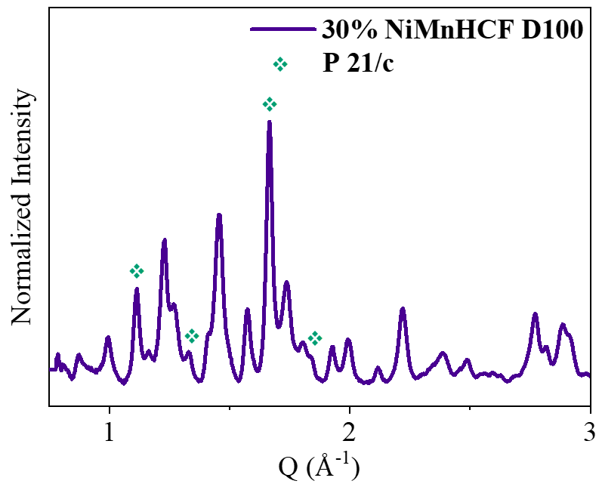
Figure S11. PXRD measurement result of D100 of 30%NiMnHCF.
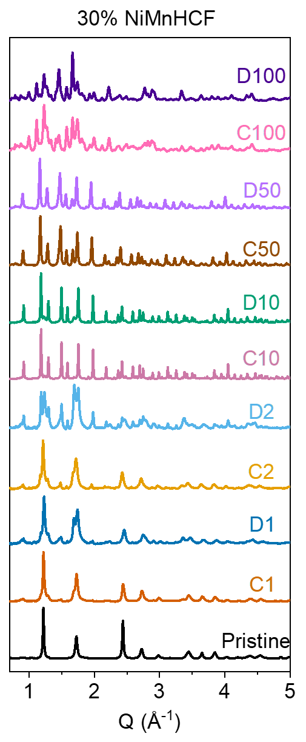
Figure S12. PXRD measurement result of D100 of 30%NiMnHCF.
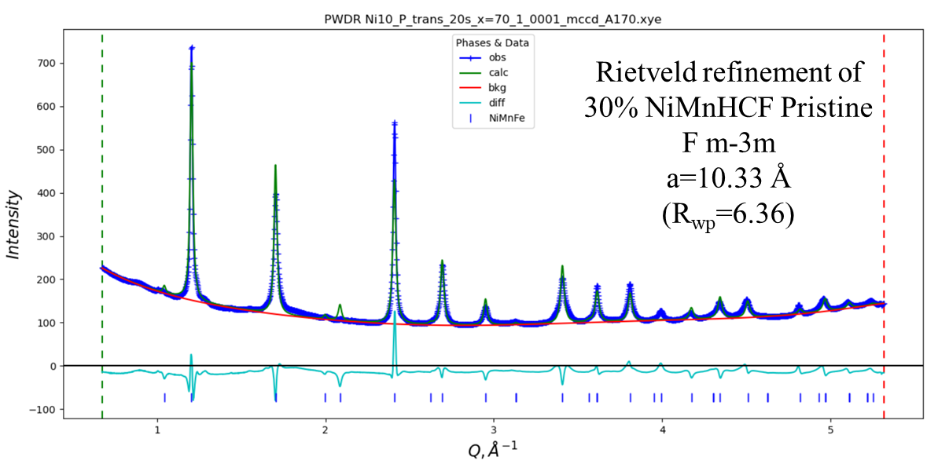
Figure S13. Rietveld refinement of Pristine of 30%NiMnHCF.

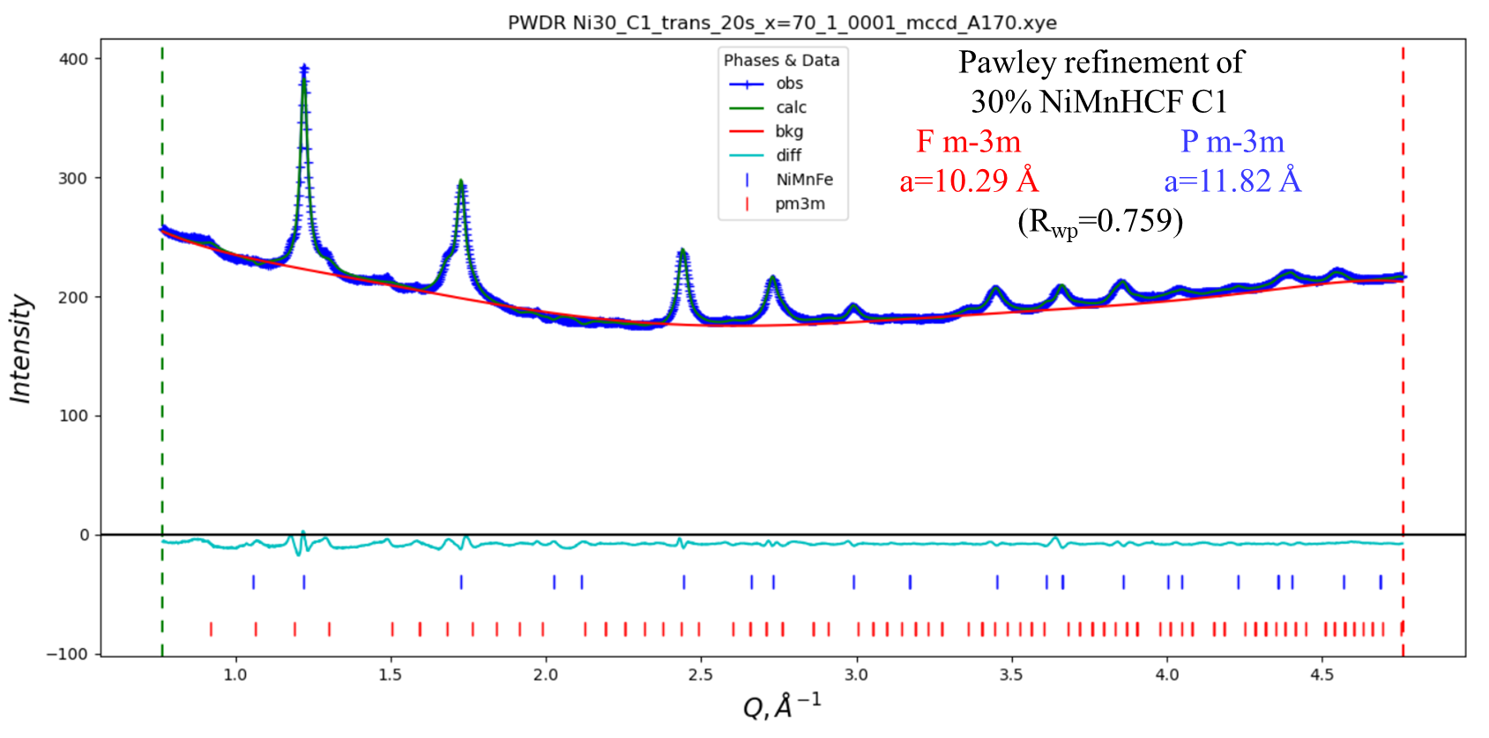
Figure S14. Pawley refinement of C1 of 30%NiMnHCF.

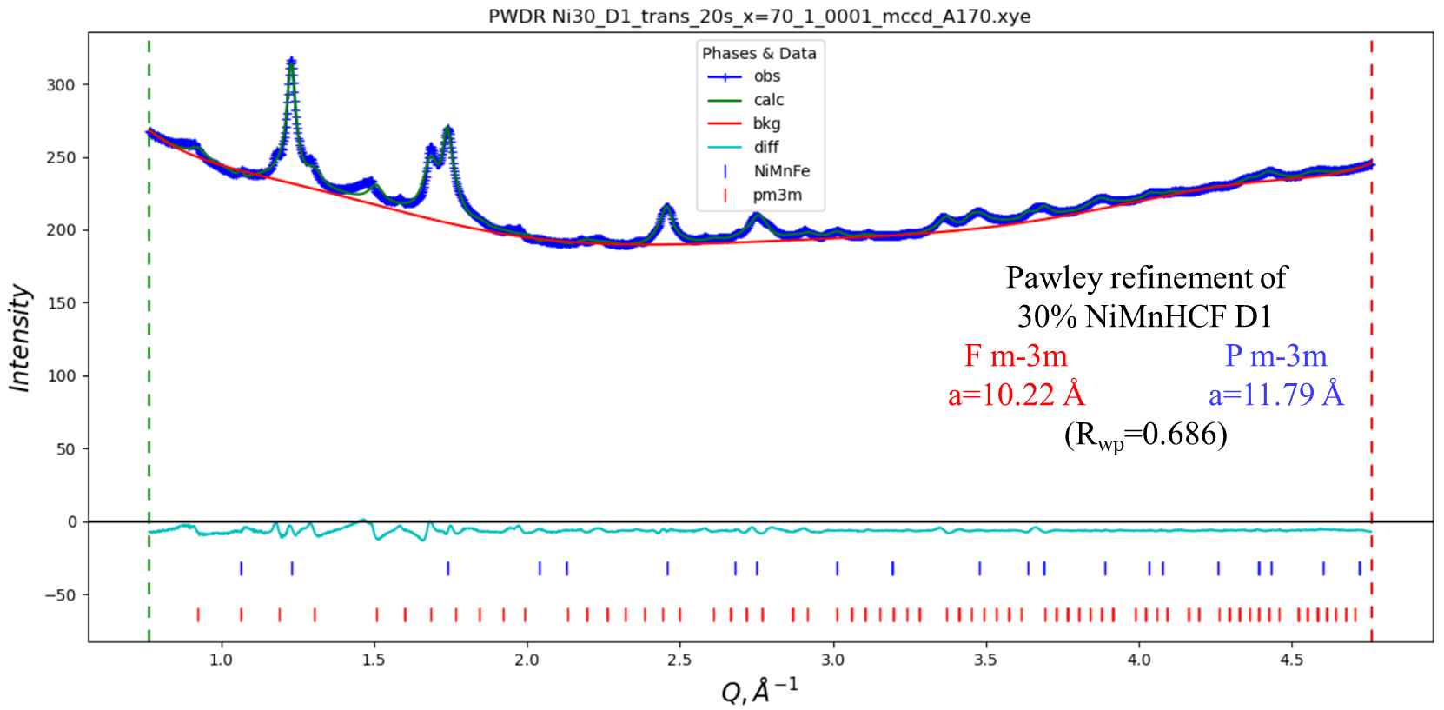
Figure S15. Pawley refinement of D1 of 30%NiMnHCF.

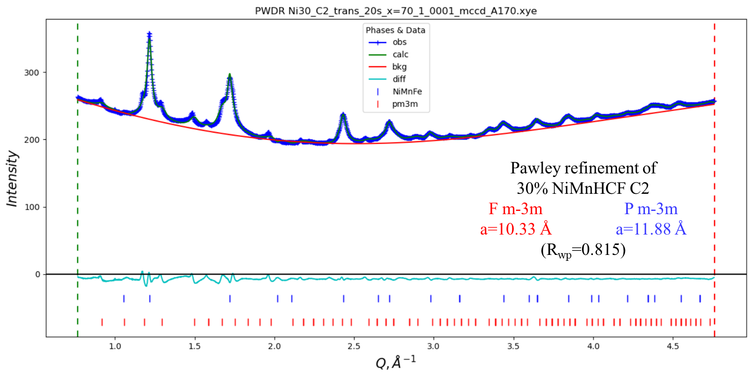
Figure S16. Pawley refinement of C2 of 30%NiMnHCF.

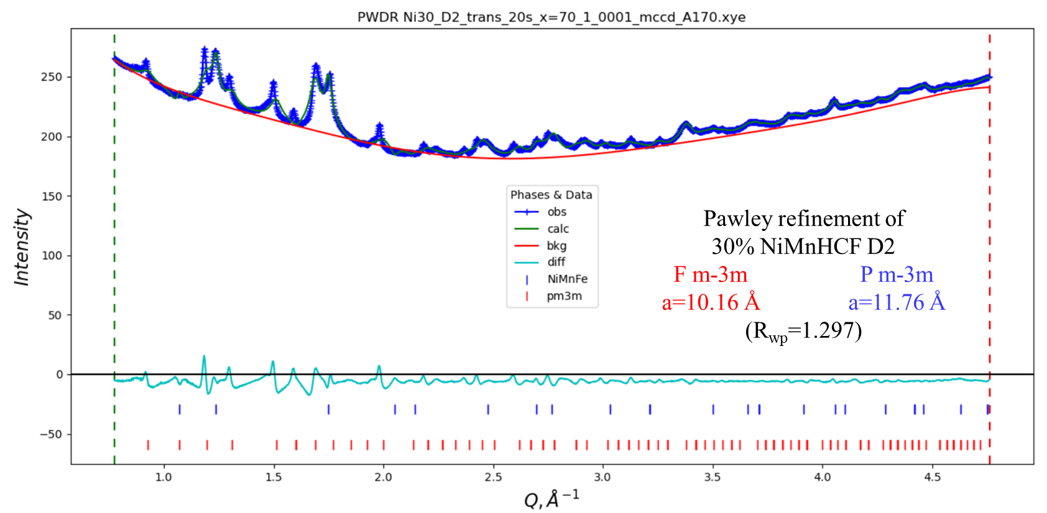
Figure S17. Pawley refinement of D2 of 30%NiMnHCF.

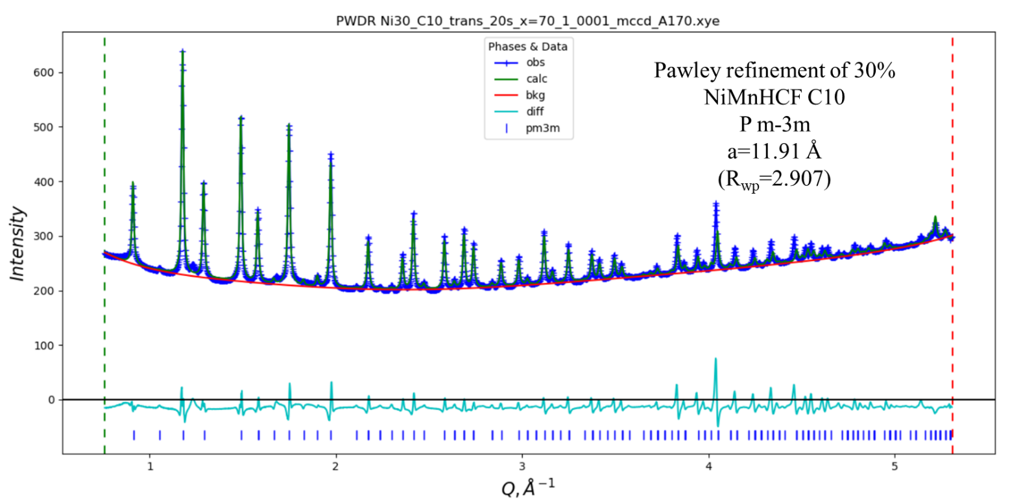
Figure S18. Pawley refinement of C10 of 30%NiMnHCF.

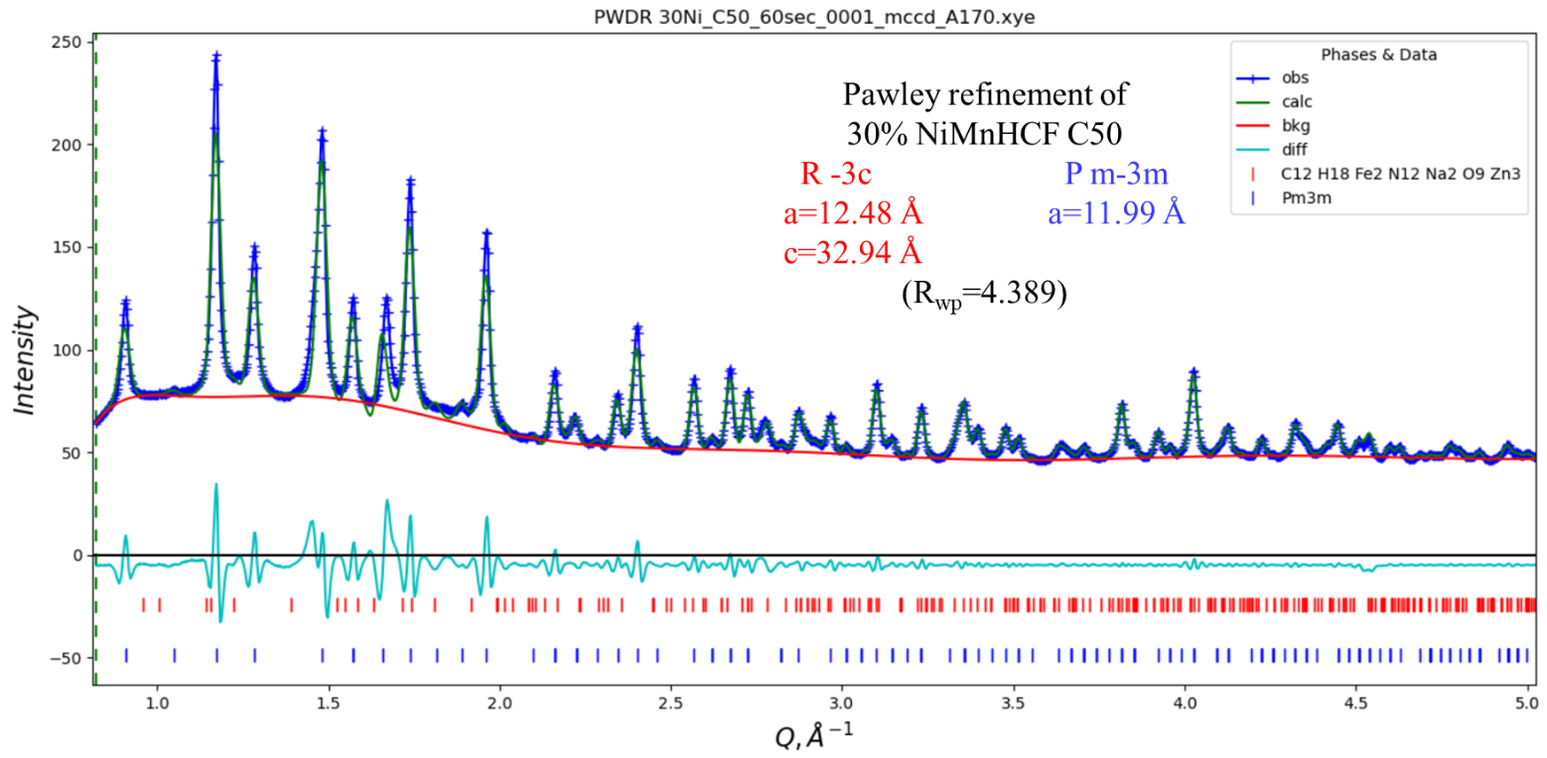
Figure S19. Pawley refinement of C50 of 30%NiMnHCF.

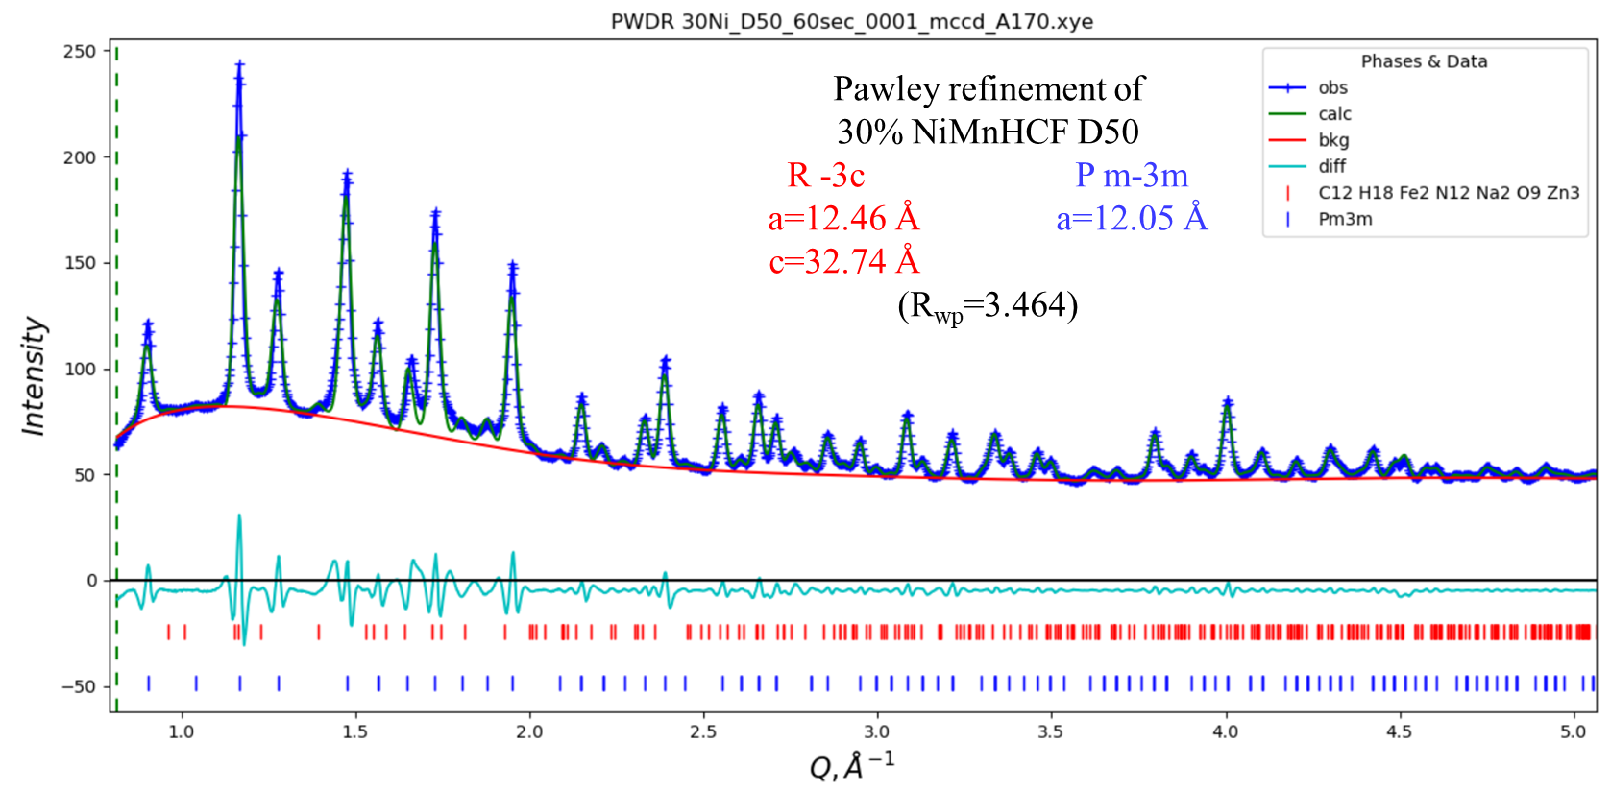
Figure S20. Pawley refinement of D50 of 30%NiMnHCF.

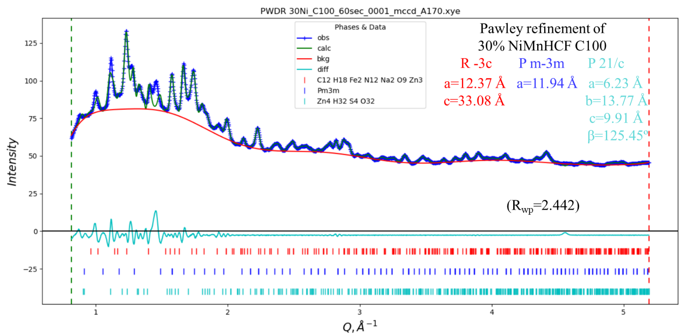
Figure S21. Pawley refinement of C100 of 30%NiMnHCF.

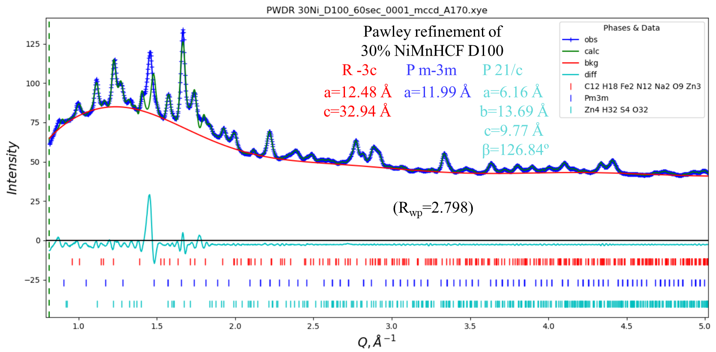
Figure S22. Pawley refinement of D100 of 30%NiMnHCF.

