Supplementary materials
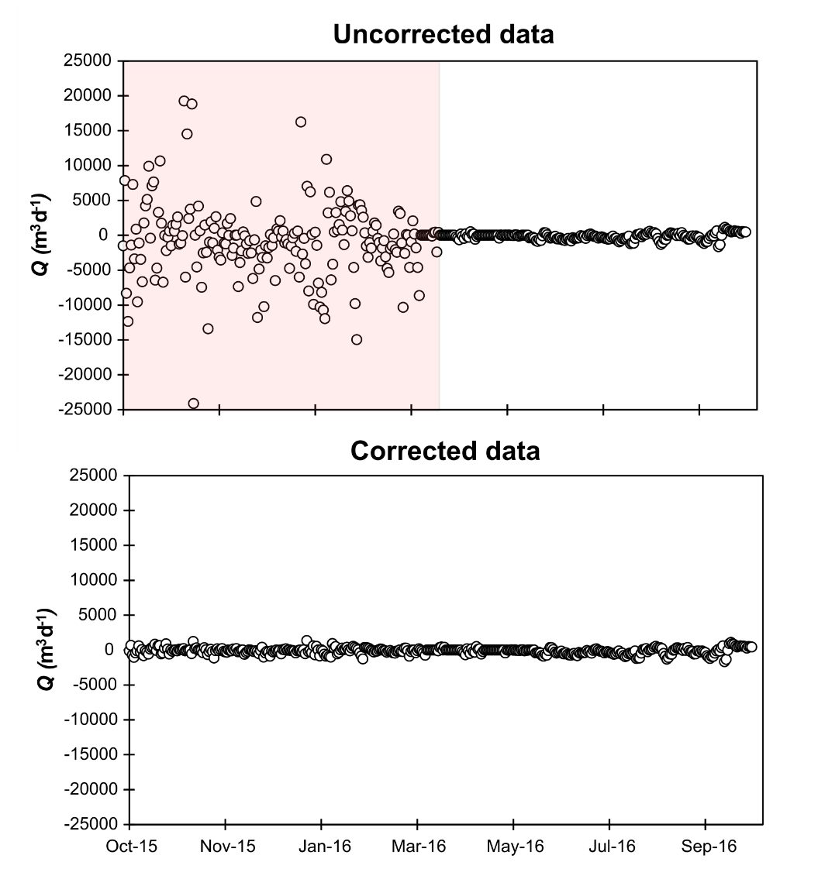

Figure S1: Scatterplots of discharge from Canal 3 before correction (pink area; top) and after correction (bottom). Standard deviation of high noise data was compared to low noise data (post-Sontek error correction) and the ratio was used has a devisor for the high noise data set.

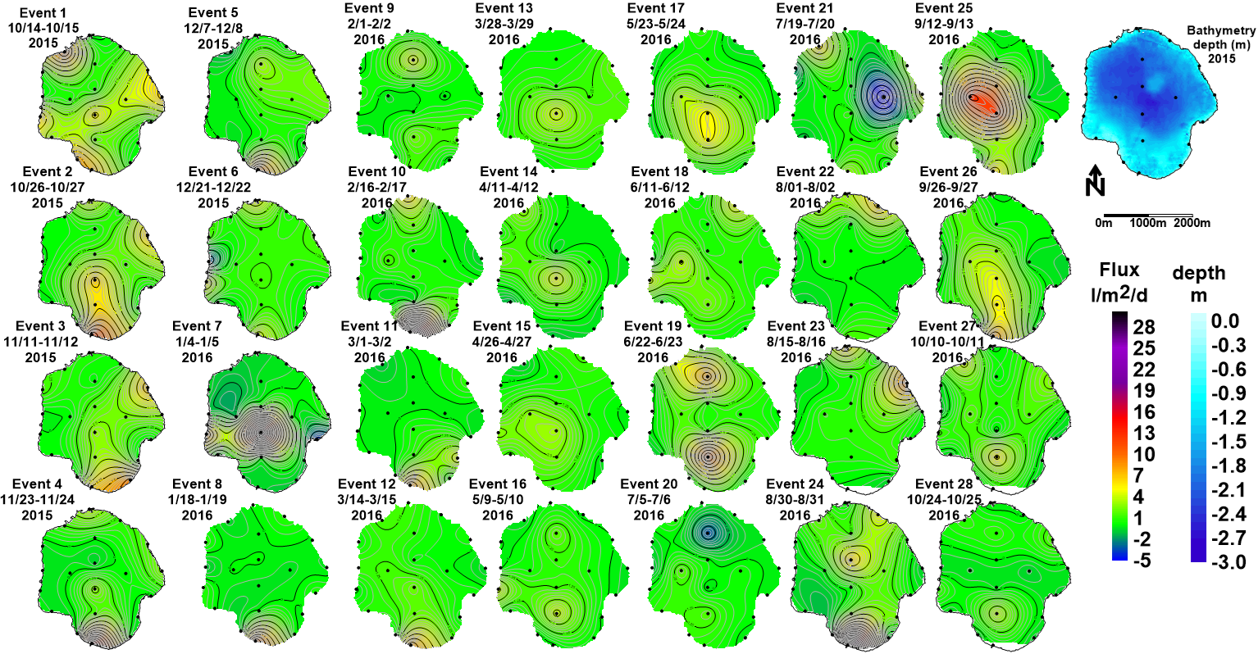
Figure S2: Maps of interpolated groundwater discharge for all 28 events. The bathymetry of Lake Trafford (top right) is also provided.
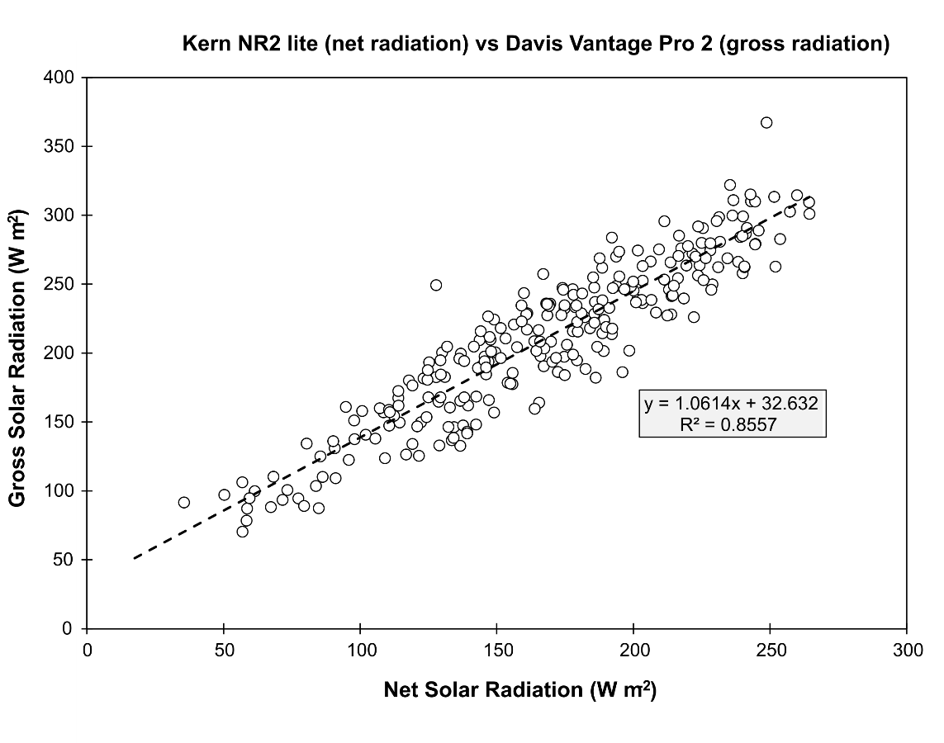
Figure S3: Scatterplot of daily averages of gross solar radiation from the Davis weather station and net solar radiation from the Kern NR2 Lite.

