SUPPLEMENTARY INFORMATION
Eu³⁺:YF₃ and Eu³⁺, Nd³⁺:YF₃ nanoparticles for optical temperature sensing: the influence of annealing on temperature dependence of the spectral-kinetic characteristics
*Ekaterina I. Oleynikova¹, Oleg. A. Morozov^{1,2}, Stella L. Korableva¹, and **Maksim S. Pudovkin¹
¹Kazan Federal University, Institute of physics, Department of quantum electronics and radiospectroscopy, 18 Kremlyovskaya str, Kazan, 420008, Russian Federation
²FRC Kazan Scientific Center of RAS, Sibirsky Trakt str. 10, 420029, Kazan, Russia
Corresponding author:
Ekaterina I. Oleynikova, kate15-05@mail.ru
Maksim S. Pudovkin, jaz7778@list.ru
Full postal address: 18th Kremlyovskaya street. Kazan 420008, Russian Federation, Institute of physics, Department of quantum electronics and radiospectroscopy, office 168
Keywords
Lifetime thermometry, Nd³⁺/Yb³⁺, Nd³⁺/Yb³⁺:YF₃, down-conversion, optical temperature sensors, thermal expansion
YF₃: Eu³⁺

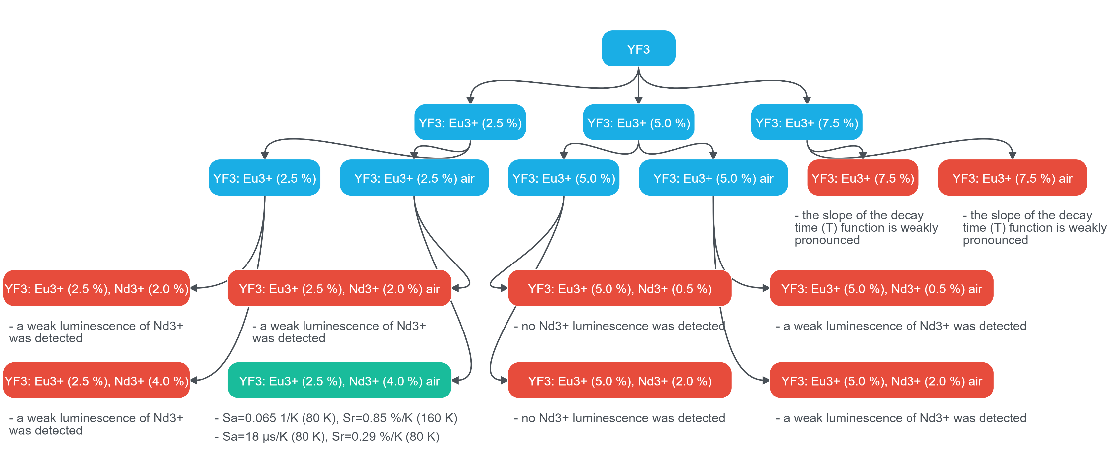
Table S1. The sample classification (the only “green” sample Eu³⁺ (2.5%), Nd³⁺(4.0%) :YF₃ was chosen for further investigation

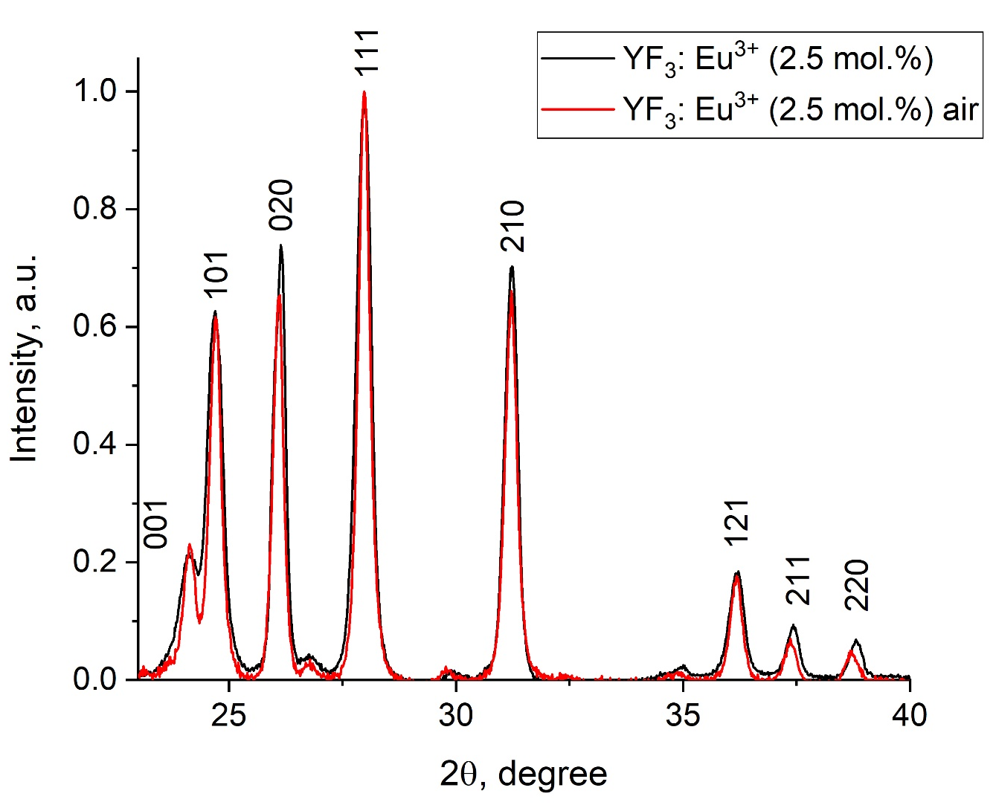
Figure 1. XRD patterns of YF₃: Eu³⁺ (2.5 mol.%) nanoparticles before and after annealing in air (400 °C, 4 hours)

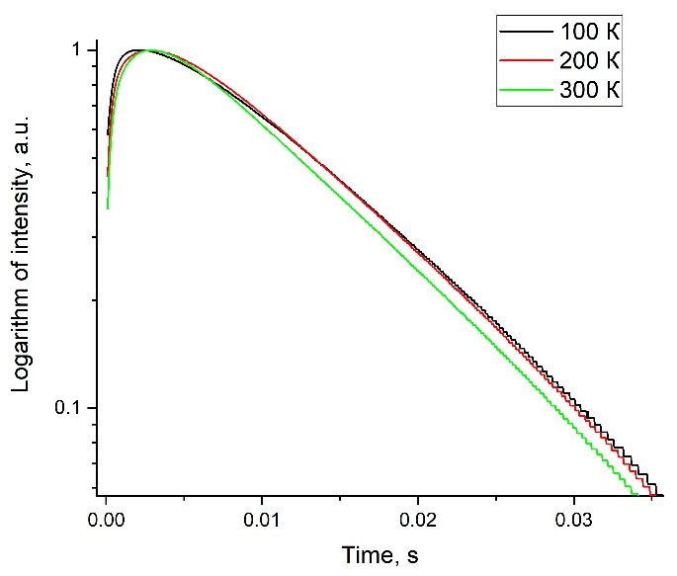 | 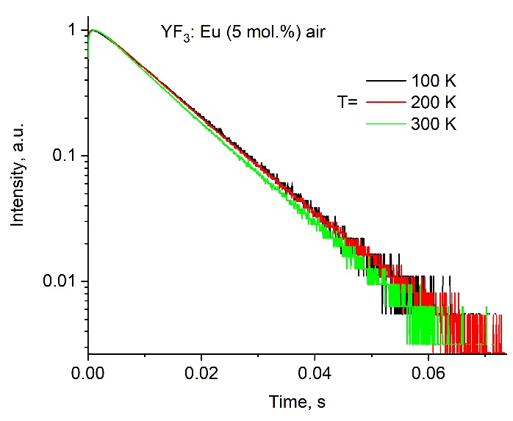
(a) | (b)
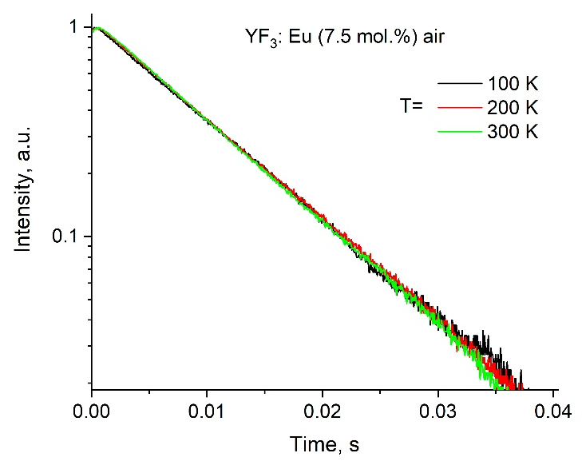
Figure S2. Luminescence decay curves at 589.5 nm (⁵D₀ – ⁷F₁ transition) for YF₃: Eu³⁺ (a) 2.5; b) 5.0 and c) 7.5 mol.%) samples annealed in air in the temperature range 80-320 K

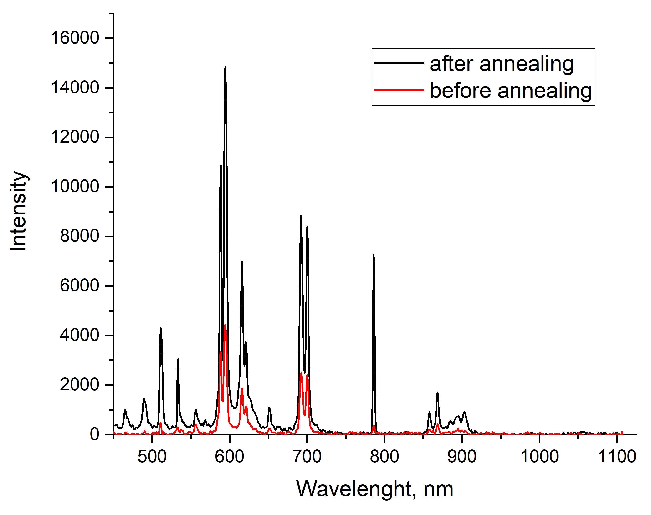 | 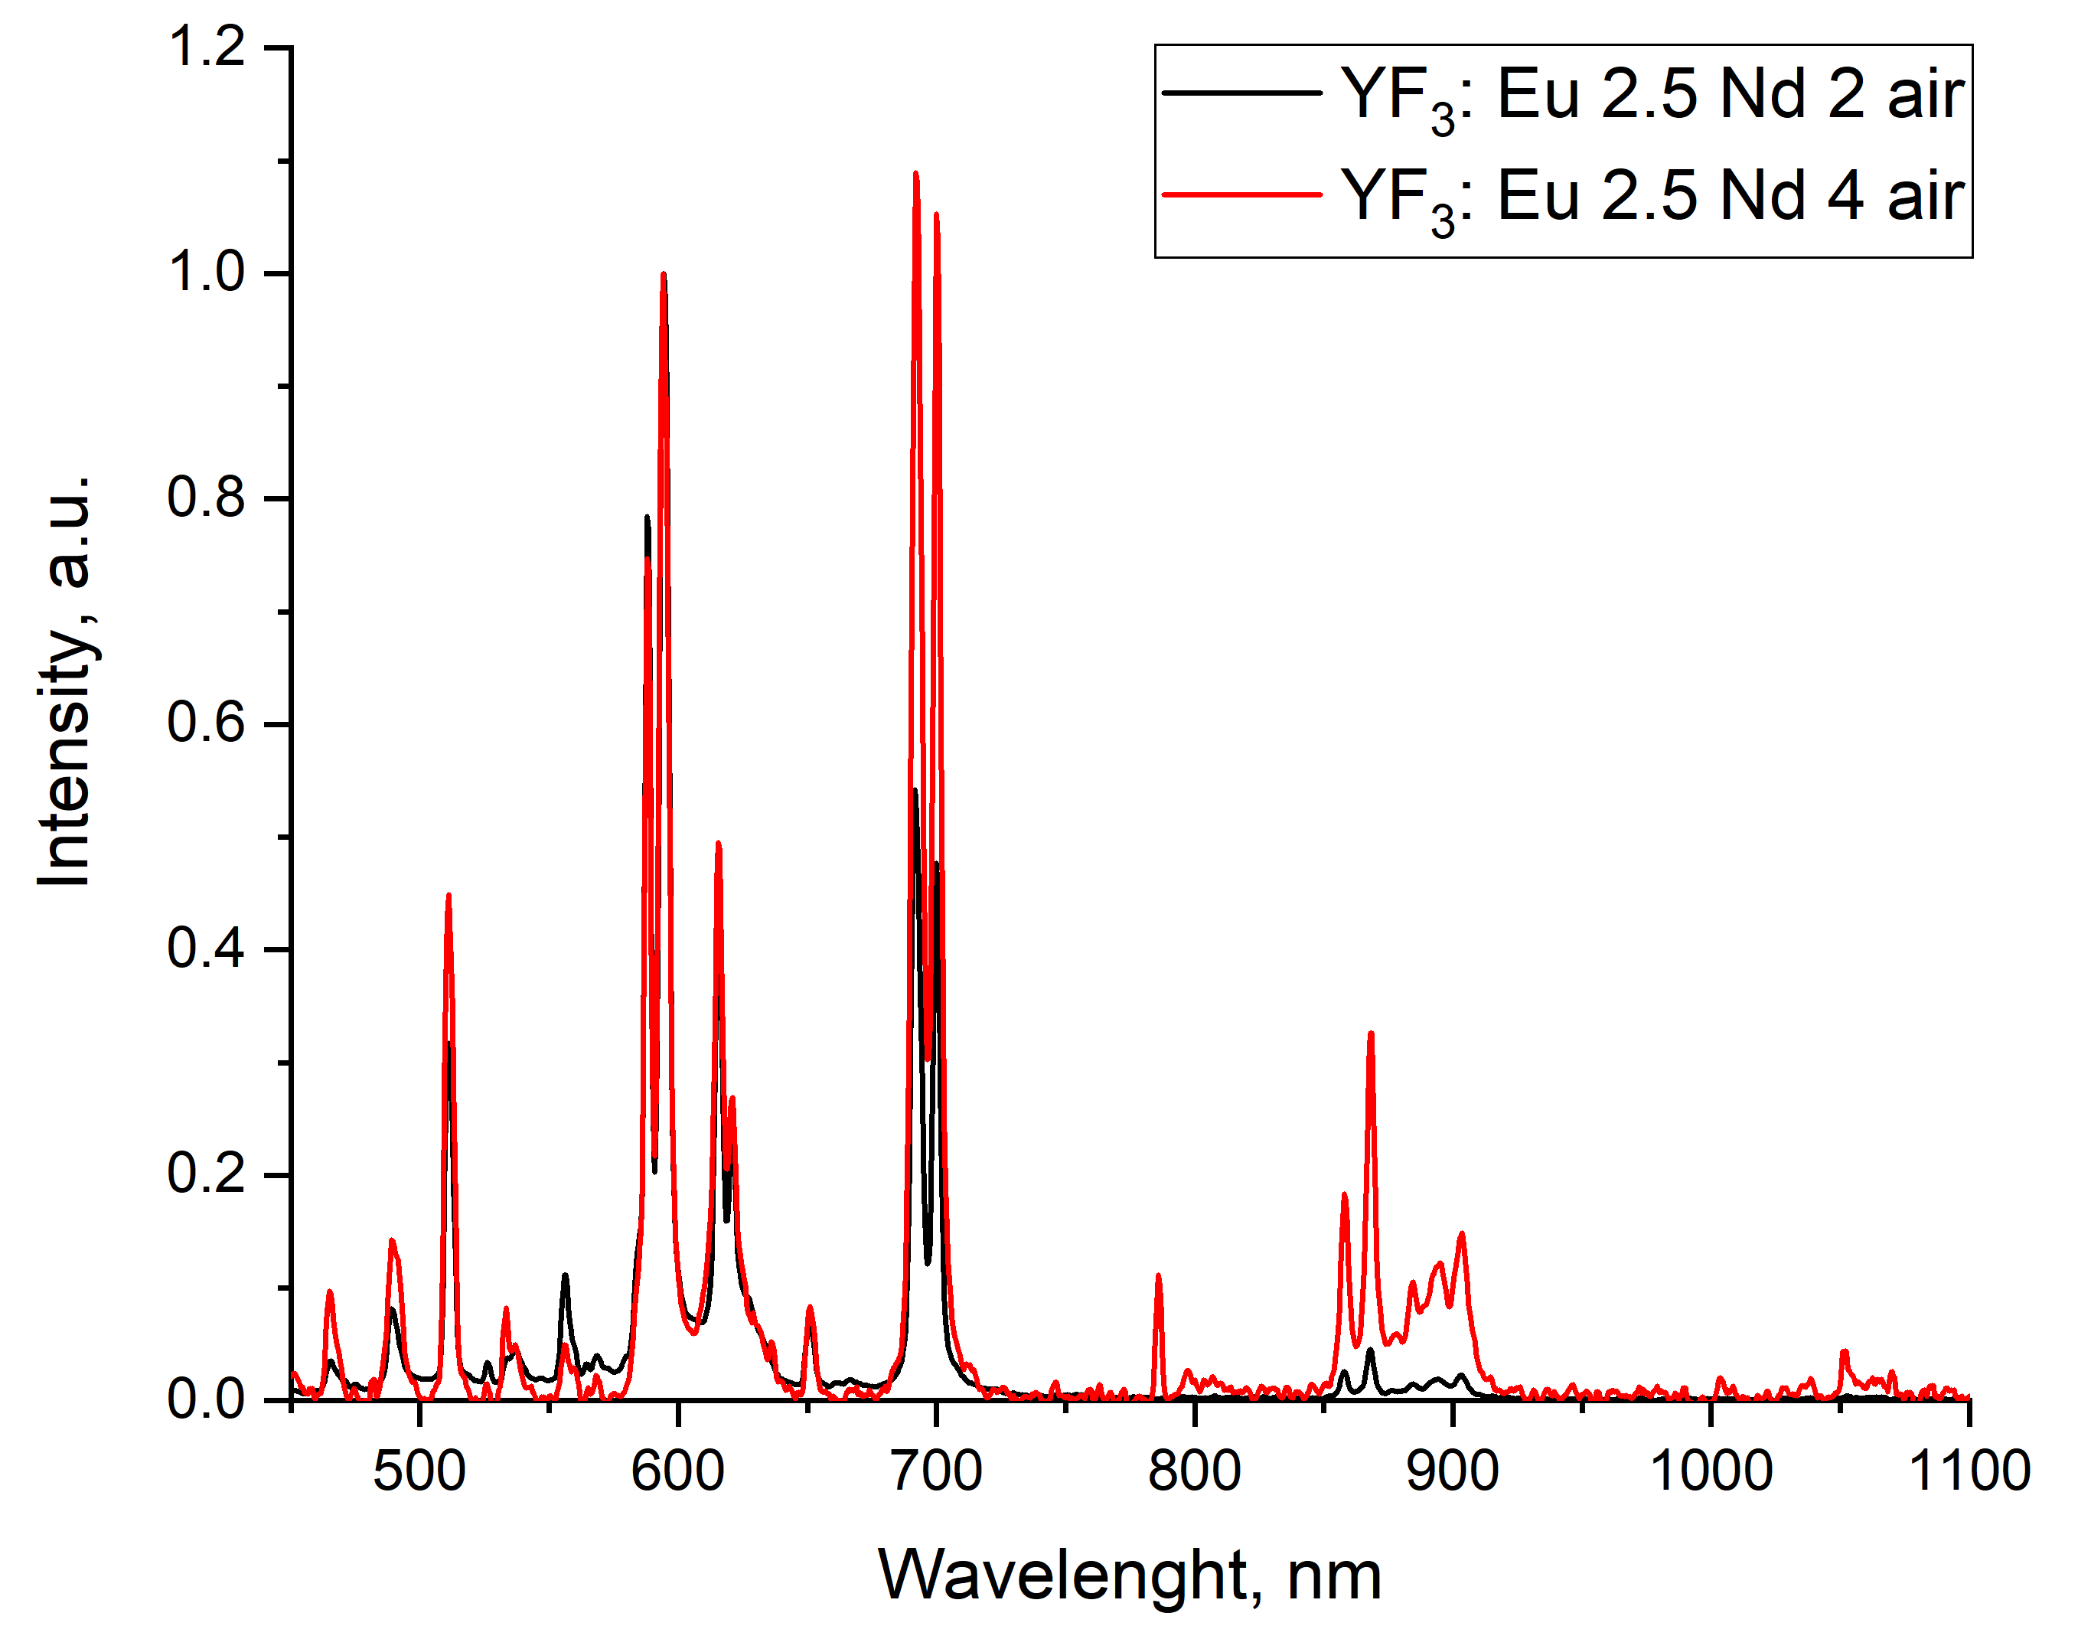
(a) | (b)
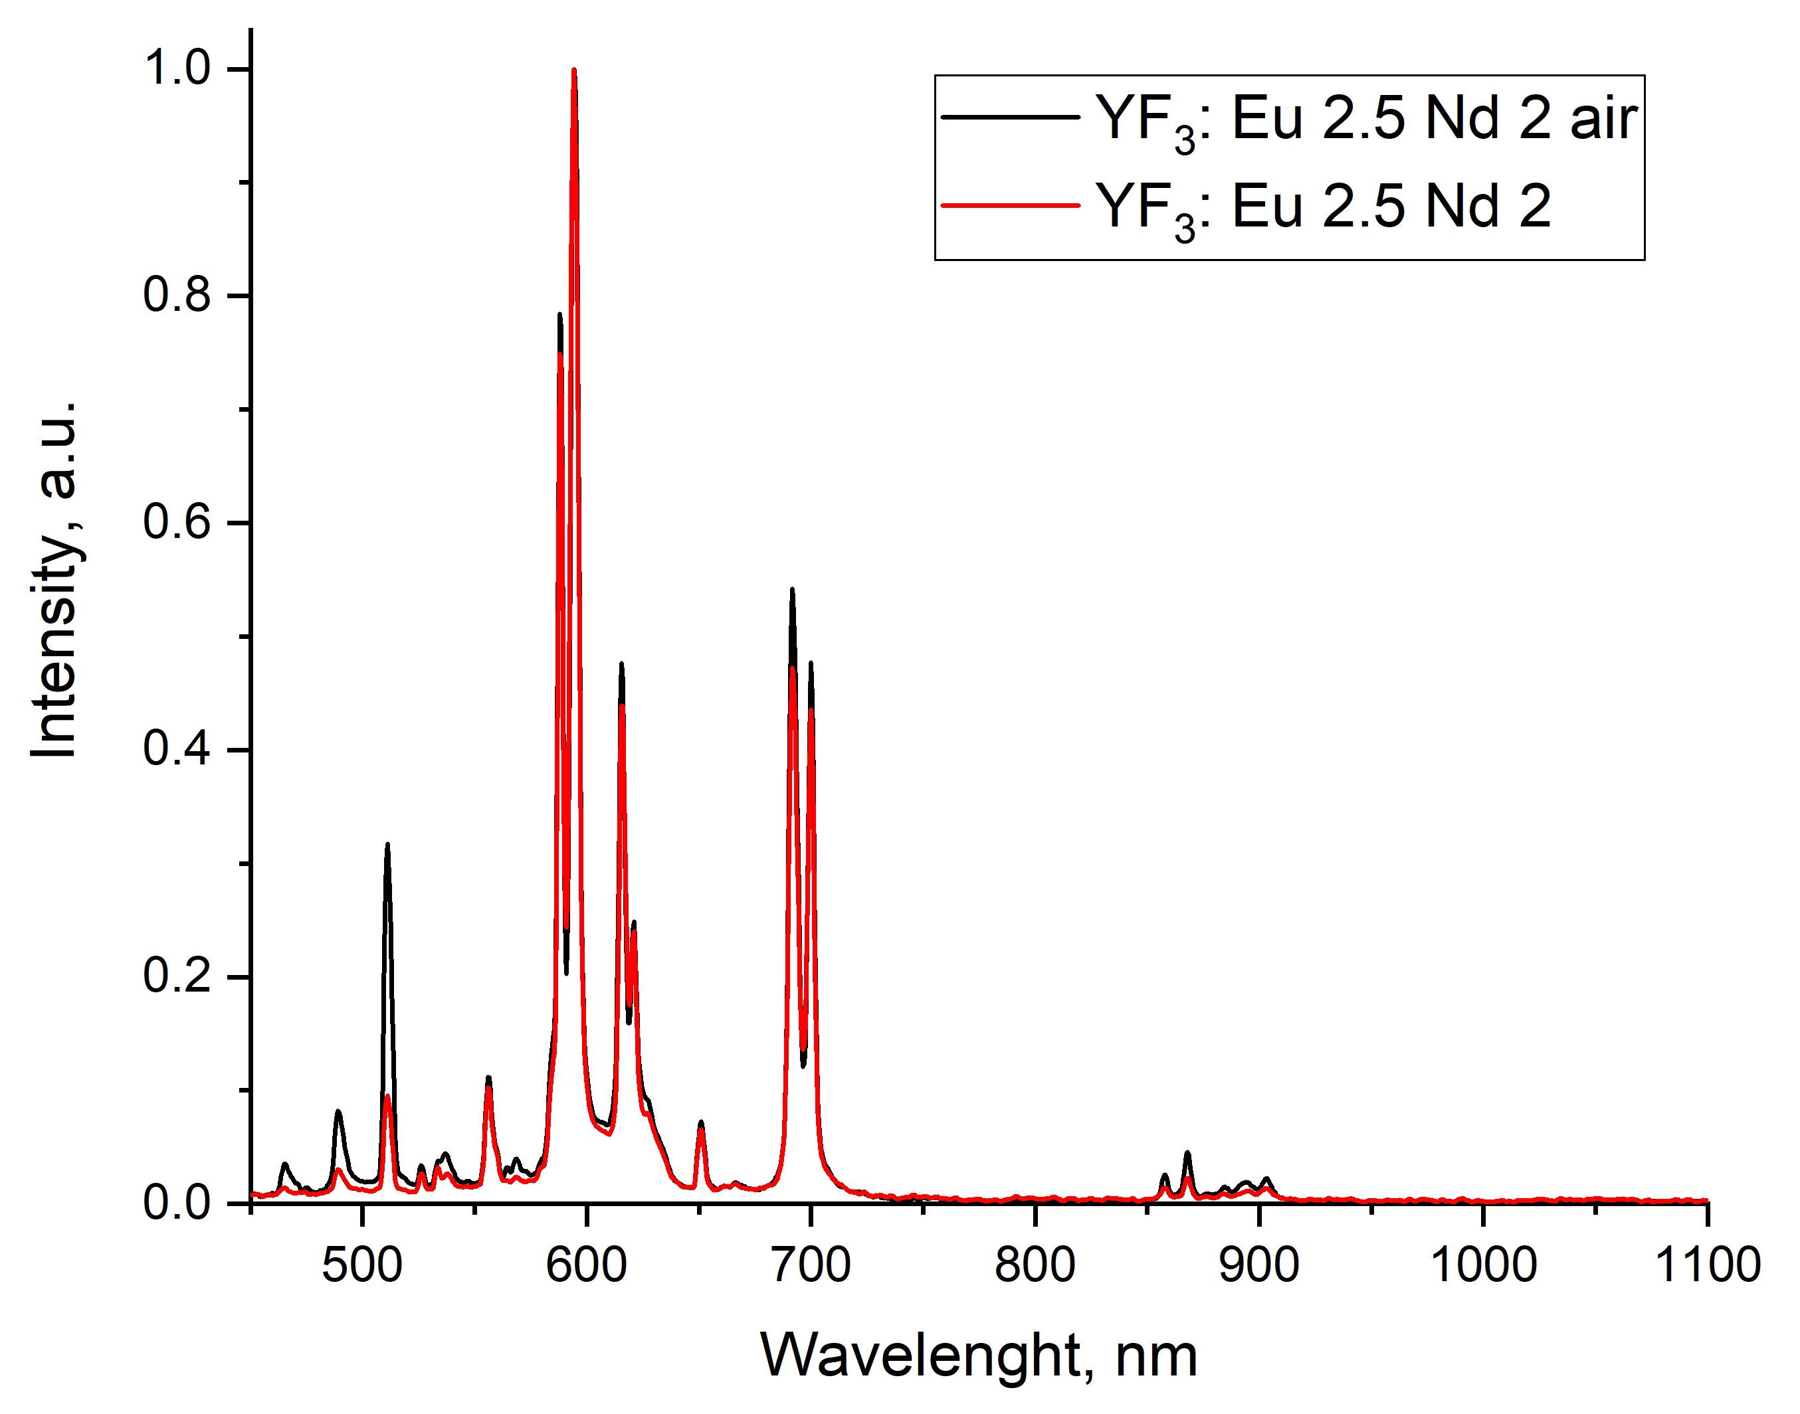
(c)

Figure S3.

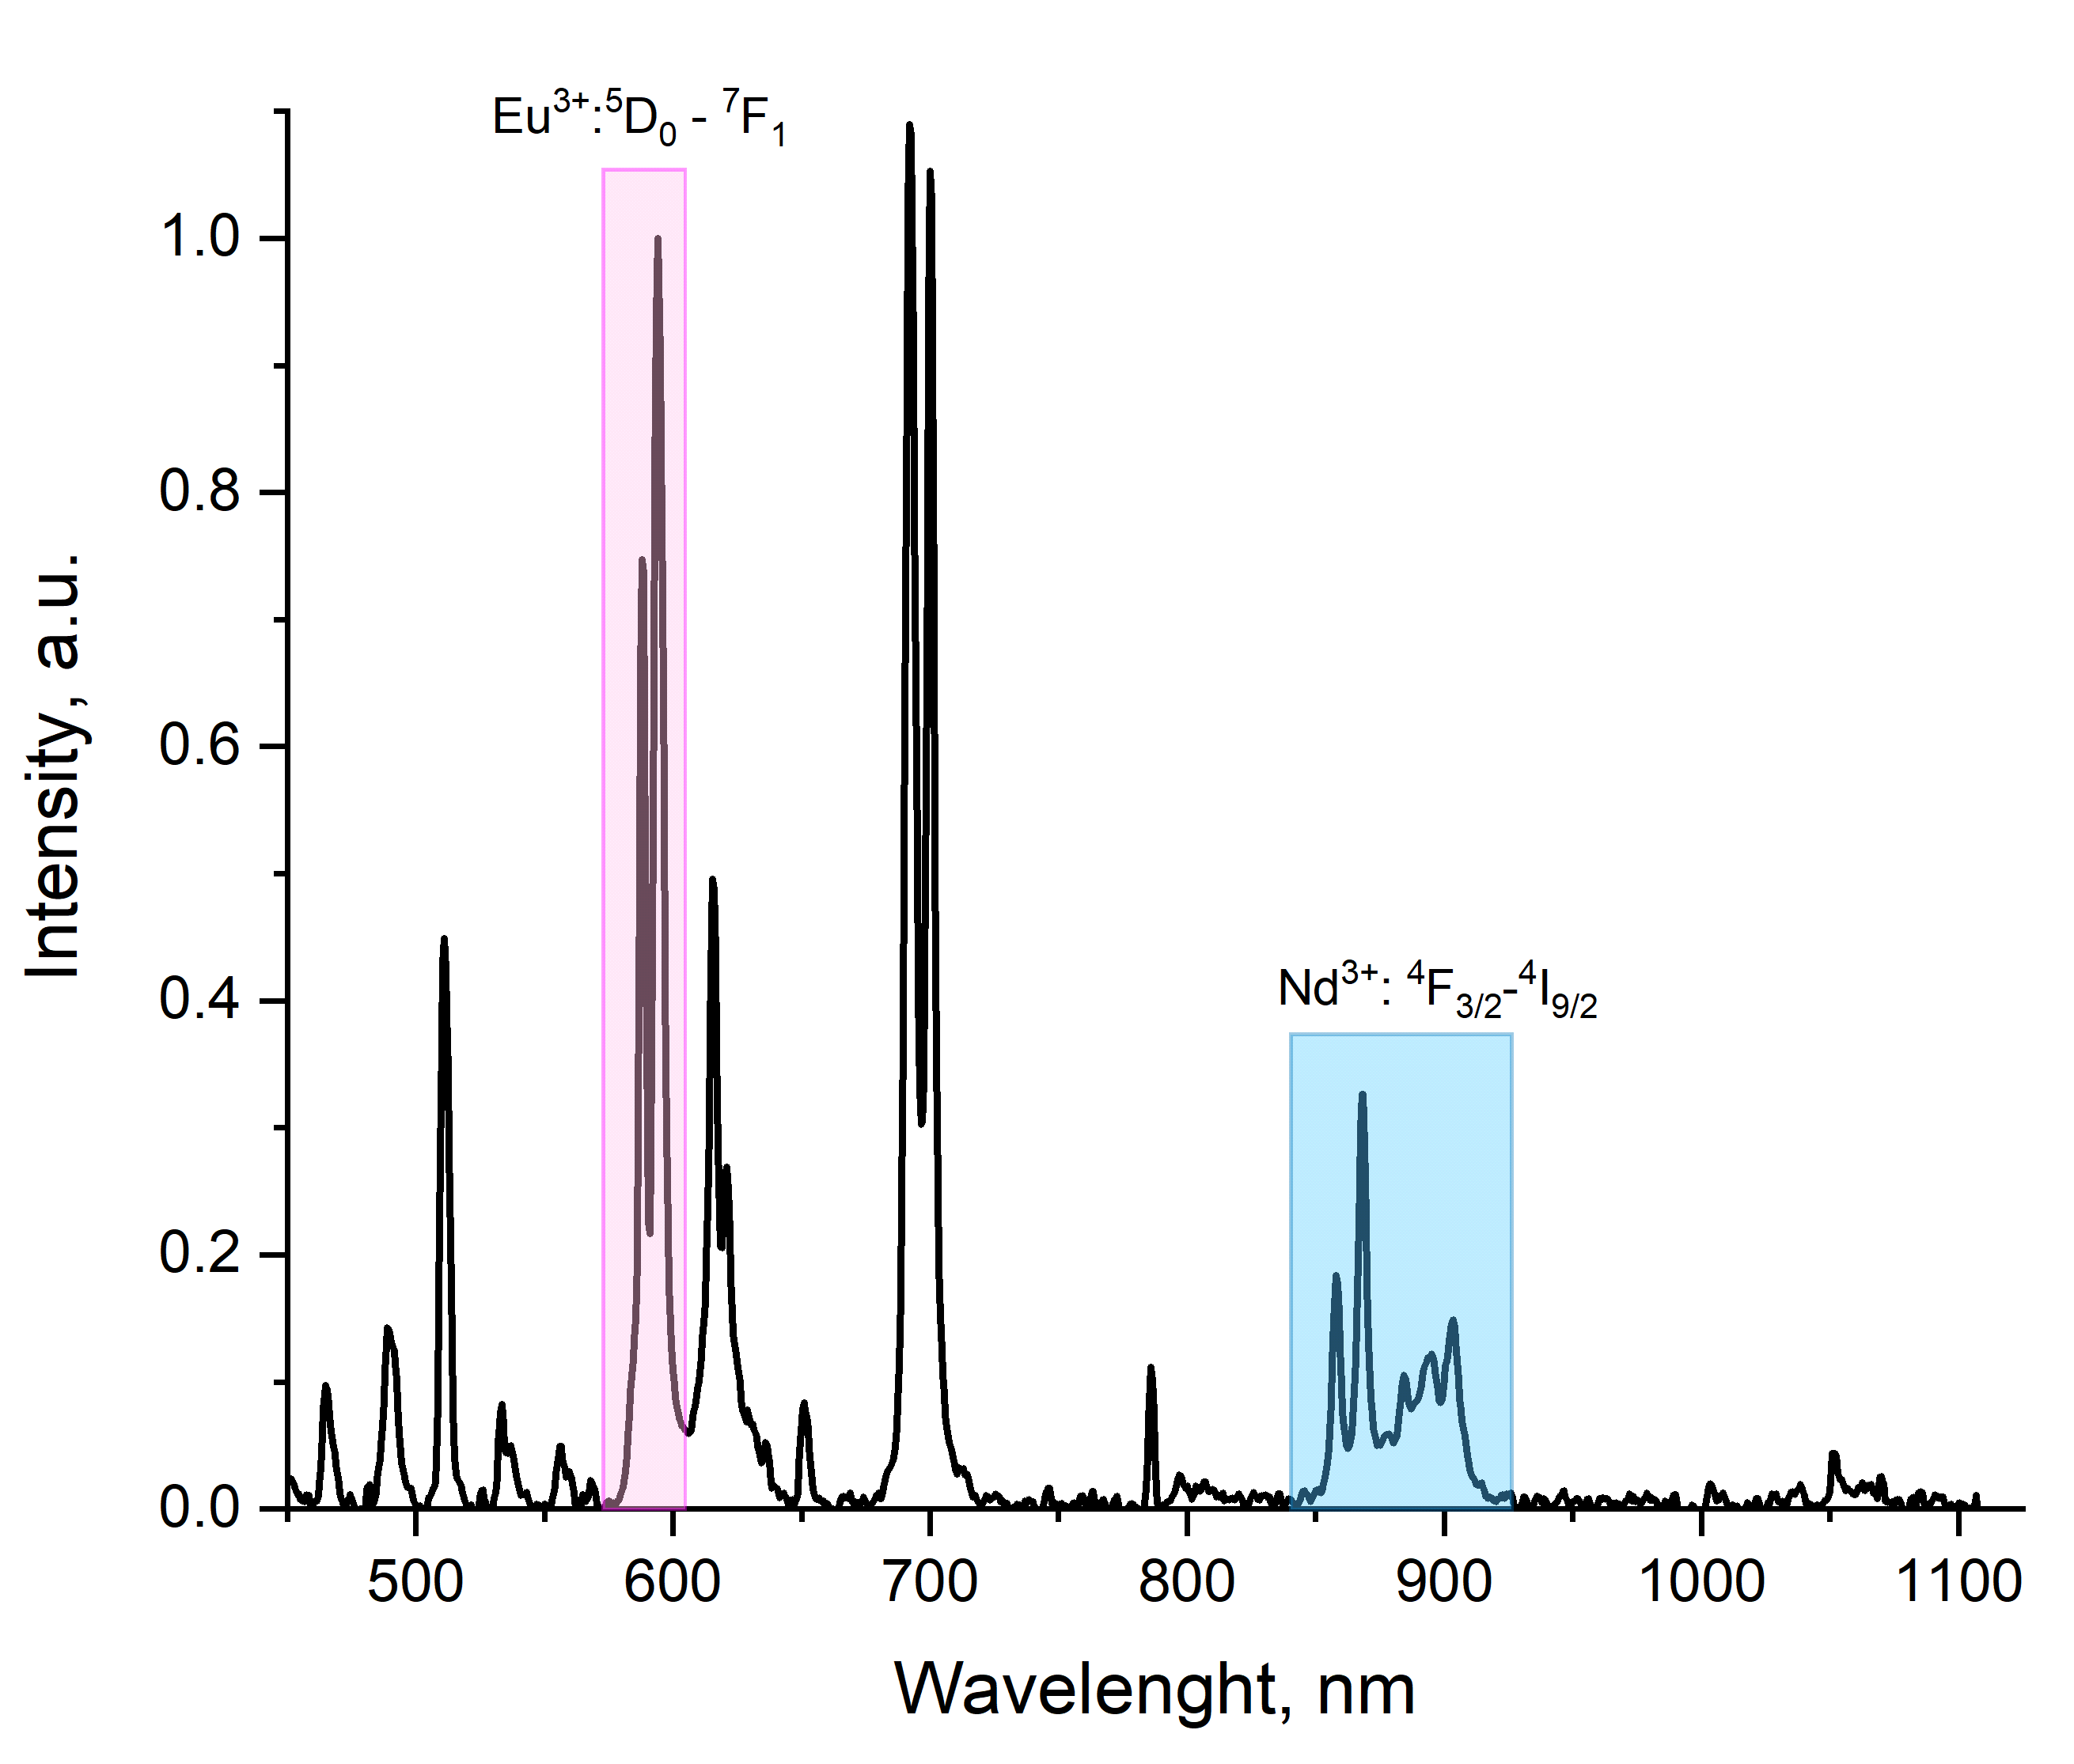
Figure S4. The schematic representation of LIR choice

