3.1 Downregulation of p62 RNA expression in SCA3 patients

Supplementary Figure S1. Total RNA expression profile of important autophagic marker genes. Total RNA expression levels of ATG7, ATG12, ATG16L12, LAMP2 and RAB1A and RAB7A determined in cerebella post-mortem brain using RNA sequencing. TPM = transcript per million reads. ** p<0.01

Supplementary Figure S2. p62 isoform expression in human cerebellar post-mortem brain samples. RNA sequencing revealed that some isoforms were not expressed in any of the brain samples, whereas others are only found in one or two samples, independently from the genotype. TPM = transcript per million reads.

Supplementary Table S1. RNA expression of autophagic genes in SCA3 304Q ki mice at 2 and 12 months and in human SCA3 post-mortem brain samples comparing controls to SCA3 disease mice or patients. For discovering aging effect, regulation of autophagic genes were evaluated by comparing young (2 months) vs old mice within the respective genotype (WT or 304Q; 12 months). All data from RNA sequencing data from cerebellum, all n=5-6 per genotype and age, all from male mice/subjects, M = months. Negative values implicate a downregulation in SCA3 contrasts and positive values an up-regulation always compared to controls.
 | SCA3 304Q  2 months  compared to WT | SCA3 304Q  12 months  compared to WT | aged WT  2M vs. 12M  aging WT | aged SCA3 304Q  2M vs. 12M  aging knockin | human SCA3  post-mortem  compared to CNTR
ATG7 | logFC = -0.0463 | logFC = 0.172 | logFC = 0.368 | logFC = 0.330 | logFC = 0.086
ATG7 | p = 0.61 | p = 0.065 | p = 3.16E-06 | p = 2.01E-05 | p = 0.45
ATG12 | logFC = -0.0058 | logFC = -0.157 | logFC = -0.201 | logFC = -0.323 | logFC = -0.035
ATG12 | p = 0.93 | p = 0.027 | p = 0.0014 | p = 0.0014 | p = 0.76
ATG16L2 | logFC = 0.068 | logFC = 0.066 | logFC = 0.665 | logFC = 1.111 | logFC = 0.152
ATG16L2 | p = 0.60 | p = 0.96 | p = 0.0001 | p = 8.78E-09 | p = 0.48
LAMP2 | logFC = 0.002 | logFC = 0.0263 | logFC = 0.556 | logFC = 0.282 | logFC = -0.926
LAMP2 | p = 0.97 | p = 0.70 | p = 1.12E-06 | p = 0.0071 | p = 0.0008
RAB1A | logFC = 0.057  p = 0.23 | logFC = 0.084  p = 0.08 | logFC = 0.140  p = 0.0069 | logFC = 0.048  p = 0.33 | logFC = -0.199  p = 0.19
RAB1A | logFC = 0.051  p = 0.15 | logFC = 0.015  p = 0.66 | logFC = -0.022  p = 0.54 | logFC = -0.316  p = 0.39 | logFC = -0.240  p = -0.016

3.3 Aggregation and co-localization of ATXN3- and p62-positive aggregates in SCA3 mice

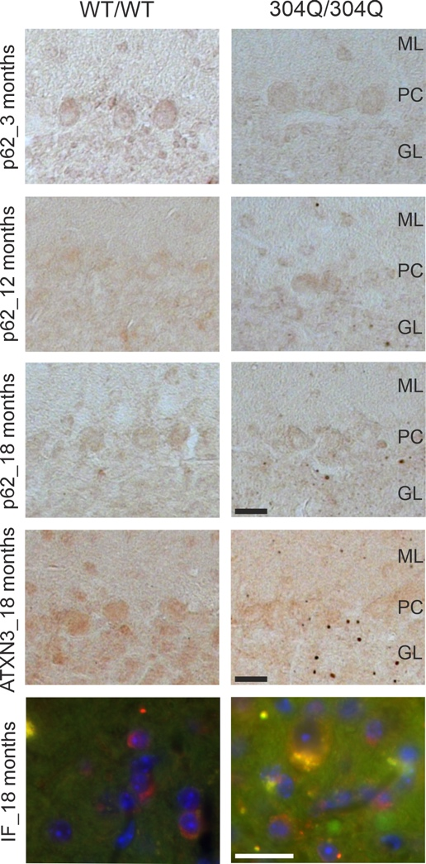
Supplementary Figure S3. Co-localized aggregation of ATXN3- and p62-positive accumulations in the cerebellum of SCA3 mice. First three rows show IHC staining of 3- and 18-months old WT and 304Q/304Q SCA3 mice cerebellum sections. Staining was performed against ATXN3 or p62. Last row represents double IF staining of 18 months old SCA3 and WT/WT mice cerebellum sections labeled with antibodies against ATXN3 and p62. Green = ATXN3, red = p62, orange = ATXN3 and p62. Scale bar indicates 20 µm. ML = molecular layer, PC = purkinje cells; GL = granular layer

