SUPPLEMENTARY MATERIAL
Composition and bioactivity from the essential oil of Tetradenia riparia in pathogenic bacteria, Aedes aegypti L. (Diptera: Culicidae), and toxicological evaluation of Mus musculus (Rodentia: Muridae)
Érica de M. Rabelo ¹, Rosany L. Martins ¹, Alex Bruno L. Rodrigues ², Ridelley de S. de Sousa ¹, Ana Luzia F. Farias ¹, Allan Kardec R. Galardo ³, Patrick de C. Cantuária ⁴, Rosana Tomazi ⁵ and Sheylla Susan M. da S. de Almeida ¹*

1 Department of Biological and Health Sciences, Federal University of Amapa, Macapa´, Amapa´, Brazil; ericamrabelo@gmail.com (E.R.); rosyufpa@gmail.com (R.M.); analuziafarias.quimica@outlook.com (A.F)
2 Department of Exact and Technological Sciences, Federal University of Amapa´, Macapa´, Amapa´, Brazil; alexrodrigues.quim@gmail.com (A.R.)
3 Laboratory of Medical Entomology, Institute of Scientific and Technological Research of the State of Amapa´, Macapa´, Amapa´, Brazil; allangalardo@gmail.com (A. G.)
4 Institute of Scientific and Technological Research of the State of Amapá, Macapa´, Amapa´, Brazil; patrickcantuaria@gmail.com (P. C.)
5 Federal Institute of Amapá, Macapa´, Amapa´, Brazil; rosana.tomazi@ifap.edu.br (R.T)

* Correspondence: sheyllasusan@yahoo.com.br
ABSTRACT
Objective: In this work, we evaluated the chemical composition by chromatography coupled to mass spectrometry, antimicrobial and insecticidal activity of essential oils (TrEO) and nanoeffusion (NTrEO) of oil from Tetradenia riparia leaves. We also evaluated the acute toxicity in Mus musculus. The results showed that S. aureus showed greater susceptibility to TrEO, with a minimum inhibitory concentration (MIC) of 125 µg.mL⁻¹, when compared to P. aeruginosa, E. coli, which presented a MIC of 250 µg.mL⁻¹. There was a greater toxic effect on TrEO (LC50 = 630.29 µg.mL⁻¹) and NTrEO (LC50 = 713.68 µg.mL⁻¹) larvae, effect on pupae (LC50 = 630.29 µg.mL⁻¹) and NTrEO (LC50 = 713.68 µg.mL⁻¹) and ovicide (LC50 = 631.184 µg.mL⁻¹) and NTrEO (LC50 = 146.701 µg.mL⁻¹) of Ae. aegypti after 24 h of exposure, when compared to other exposure periods. Chemical analysis revealed 20 components, aromadendrene oxide (23.47%) being the main component. Female and male mice were used to assess toxicity and oral administration of NTrEO to mice did not result in acute toxicity. Thus, the essential oil of T. riparia and its nanoemulsion have insecticidal and antimicrobial potential for Ae. aegypti, S. aureus, E. coli, P. aeruginosa, and has a high toxicological safety threshold at the concentrations evaluated in this study.

List of supplementary materials
 | Page
Fig. S1 Chromatogram of the essential oil of T. riparia | 2
Table S2. Physical parameters of T. riparia nano-emulsions in different hydrophilic-lipophilic balance values at 0, 7, 14 and 21 days. | 11
Doc. S3 Approved by the Ethics Committee of Federal University of Amapa, Macapa- UNIFAP | 12

Fig. S1 Chromatogram of the essential oil of T. riparia
Cromatogram of essential oil from Tetradenia riparia
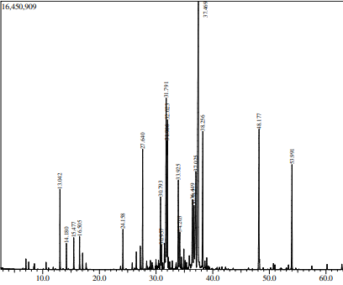

R_{T} = 13.040 L-Fenchone
Compound mass spectrum
Mass spectral library

R_{T} = 14.180 Fenchol
Compound mass spectrum
Mass spectral library

R_{T} = 15.477 Camphor
Compound mass spectrum
Mass spectral library

R_{T} = 16.505 (+) -Borneol
Compound mass spectrum
Mass spectral library

R_{T} = 24.158 γ-Elemene
Compound mass spectrum
Mass spectral library

R_{T} = 27.640 Isocaryophyllene
Compound mass spectrum
Mass spectral library

R_{T} = 30.793 Germacrene B
Compound mass spectrum
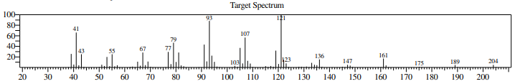
Mass spectral library
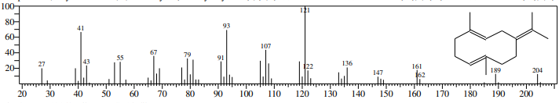

R_{T} = 30.957 α-Muurolene
Compound mass spectrum
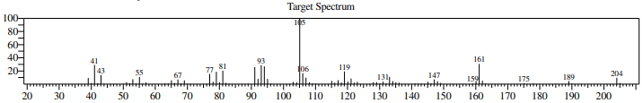
Mass spectral library
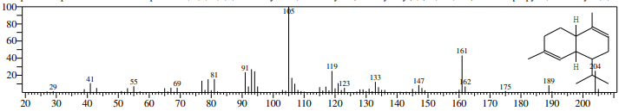

R_{T} = 31.791 Isogeraniol
Compound mass spectrum
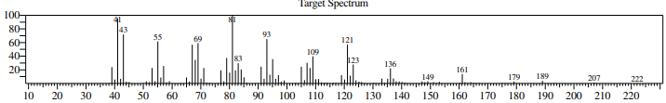
Mass spectral library
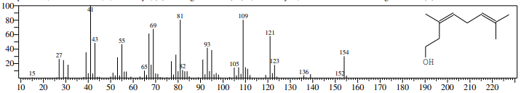

R_{T} = 31.996 Δ-Cadinene
Compound mass spectrum
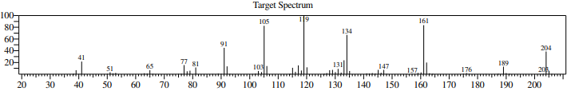
Mass spectral library
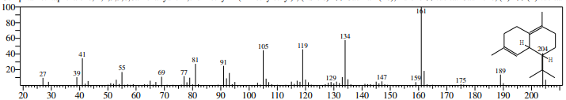

R_{T} = 32.023 6-epi-shyobunol
Compound mass spectrum
Mass spectral library

R_{T} = 33.925 Germacrene D-4-ol
Compound mass spectrum
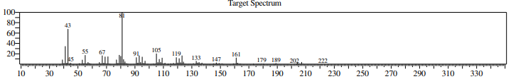
Mass spectral library
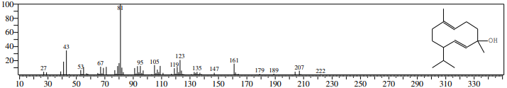

R_{T} = 34.203 Viridiflorol
Compound mass spectrum
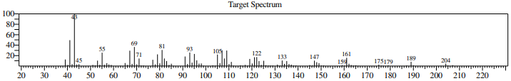
Mass spectral library
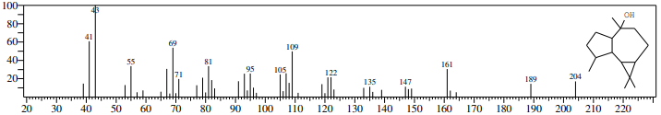

R_{T} = 36.449 τ-Muurolol
Compound mass spectrum
Mass spectral library

R_{T} = 36.712 β-Bisabolene
Compound mass spectrum
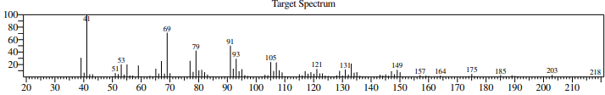
Mass spectral library
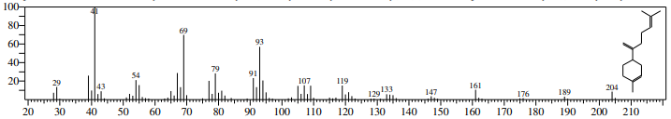

R_{T} = 37.025 α-Cadinol
Compound mass spectrum
Mass spectral library

R_{T} = 37.469 Aromadendrene oxide
Compound mass spectrum
Mass spectral library

R_{T} = 38.256 Shyobunol
Compound mass spectrum
Mass spectral library

R_{T} = 48.177 Ledol
Compound mass spectrum
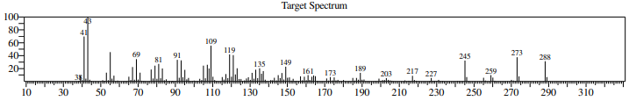
Mass spectral library
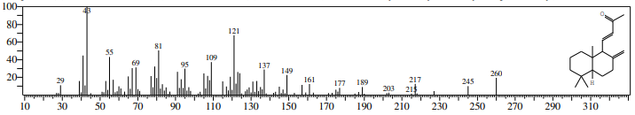

R_{T} = 48.177 Ledol
Compound mass spectrum
Mass spectral library

Table S2. Physical parameters of T. riparia nano-emulsions in different hydrophilic-lipophilic balance values at 0, 7, 14, and 21 days.
 | Dia 0
HLB | PS | ±PS | PdI | ±PdI | ZP | ±ZP
10 | 188.70 | 0.31 | 0.33 | 0.01 | -37.63 | 0.86
11 | 185.17 | 0.32 | 0.30 | 0.00 | -34.57 | 0.75
12 | 181.03 | 0.21 | 0.26 | 0.01 | -31.43 | 0.25
13 | 176.33 | 0.35 | 0.23 | 0.01 | -28.57 | 0.65
14 | 167.93 | 0.36 | 0.23 | 0.02 | -27.00 | 0.26
14.5 | 159.57 | 0.59 | 0.23 | 0.01 | -25.50 | 0.47
15 | 155.67 | 0.26 | 0.13 | 0.02 | -16.50 | 0.24
15.5 | 100.93 | 0.76 | 0.26 | 0.00 | -20.13 | 1.60
16 | 158.57 | 0.26 | 0.19 | 0.00 | -29.30 | 0.17
 | Dia 07
HLB | PS | ±PS | PdI | ±PdI | ZP | ±ZP
10 | 164.93 | 0.64 | 0.42 | 0.00 | -49.00 | 0.42
11 | 163.10 | 0.35 | 0.24 | 0.01 | -38.37 | 0.47
12 | 148.00 | 0.24 | 0.24 | 0.00 | -38.37 | 0.37
13 | 134.47 | 0.47 | 0.23 | 0.00 | -37.57 | 0.13
14 | 144.60 | 0.35 | 0.17 | 0.00 | -16.97 | 0.46
14.5 | 153.83 | 0.30 | 0.28 | 0.01 | -30.00 | 0.13
15 | 153.83 | 0.23 | 0.18 | 0.01 | -37.37 | 0.43
15.5 | 85.22 | 0.45 | 0.26 | 0.00 | -34.87 | 0.58
16 | 180.20 | 0.43 | 0.10 | 0.10 | -28.13 | 0.51
 | Dia 14
HLB | PS | ±PS | PdI | ±PdI | ZP | ±ZP
10 | 156.60 | 0.13 | 0.40 | 0.00 | -12.20 | 0.44
11 | 159.43 | 0.22 | 0.26 | 0.01 | -43.13 | 0.46
12 | 140.83 | 0.16 | 0.24 | 0.00 | -40.97 | 0.25
13 | 134.57 | 0.12 | 0.24 | 0.00 | -35.97 | 0.43
14 | 146.83 | 0.12 | 0.18 | 0.01 | -28.77 | 0.46
14.5 | 147.60 | 0.12 | 0.28 | 0.00 | -39.90 | 0.30
15 | 153.63 | 0.35 | 0.18 | 0.00 | -33.93 | 0.52
15.5 | 86.17 | 0.31 | 0.26 | 0.01 | -32.73 | 0.69
16 | 178.67 | 0.54 | 0.12 | 0.01 | -37.23 | 0.23
 | Dia 21
HLB | PS | ±PS | PdI | ±PdI | ZP | ±ZP
10 | 155.43 | 0.32 | 0.39 | 0.00 | -9.71 | 0.43
11 | 170.67 | 0.12 | 0.26 | 0.01 | -39.27 | 0.25
12 | 139.43 | 0.65 | 0.24 | 0.00 | -36.27 | 0.61
13 | 135.43 | 0.21 | 0.24 | 0.01 | -38.40 | 0.34
14 | 138.97 | 0.34 | 0.20 | 0.00 | -35.53 | 0.29
14.5 | 159.07 | 0.25 | 0.36 | 0.00 | -45.17 | 0.37
15 | 149.27 | 0.36 | 0.21 | 0.00 | -34.27 | 0.39
15.5 | 81.12 | 0.17 | 0.25 | 0.00 | -44.17 | 0.70
16 | 188.07 | 0.11 | 0.09 | 0.01 | -40.07 | 0.40

Doc. S3 Approved by the Ethics Committee of Federal University of Amapa, Macapa- UNIFAP
