Table S1. Primer sequences of the genes for ddPCR, genotyping and sequencing used in this study.
Primer name |  | Primer sequence (5'-3')
ddPCR primers
ZmLOX5gsp-L | CTCCATATGAGCCTGGGCAGATTG
ZmLOX5gsp-R | CAAGCGTGGACTCCTCTCTC
α-Tubulin-F | GCTATCCTGTGATCTGCCCTG
α-Tubulin-R | CGCCAAACTTAATAACCCAGTA
Genotyping primers
9242 | AGAGAAGCCAACGCCAWCGCCTCYA
lox5-3F | TGCCGGACCAGTCAAGCCCATAT
lox5-3R | GGCCCCTTCCGGTTCTTCAAGTC
Sequencing primers
ZmLOX5gDL-L | GCGGTGATCGAGCCGTTCGTAATC
ZmLOX5gDL-R | CAAGCGTGGACTCCTCTCTC
Table S2. Primer sequences for qRT-PCR tests in this study.
Primer name | Primer (5'-3') | Tm (ºC) | Product size (bp)
ZmLOX5-F | GGGCAGATTGTGTCTCGTAGTA | 62 | 140
ZmLOX5-R | ATATTCAAGCGTGGACTCCTCT | 60 | 140
ZmLOX8-F | CAGTACCGACAGACAGCCAT | 60 | 163
ZmLOX8-R | GTTTCGGACCACCAAATCAA | 57 | 163
ZmLOX10-F | ATCCTCAGCATGCATTAGTCC | 59 | 139
ZmLOX10-R | AGTCTCAAACGTGCCTCTTGT | 59 | 139
ZmJAR1a-F | TCTATCCGCCAAGCTGTTTC | 58 | 150
ZmJAR1a-R | CCCCGTCATAATGCCATAGATG | 61 | 150
Zmα-Tubulin-F | GCTATCCTGTGATCTGCCCTG | 62 | 139
Zmα-Tubulin-R | CGCCAAACTTAATAACCCAGTA | 59 | 139

Table S3. Sequencing results of LOX5-CNV1 and LOX5-CNV2 showing several SNPs found in Exons 9 and 10 relative to the reference sequence of ZmLOX5 (Zm00001eb216870) of B73-REFERENCE-NAM-5.0 genome).
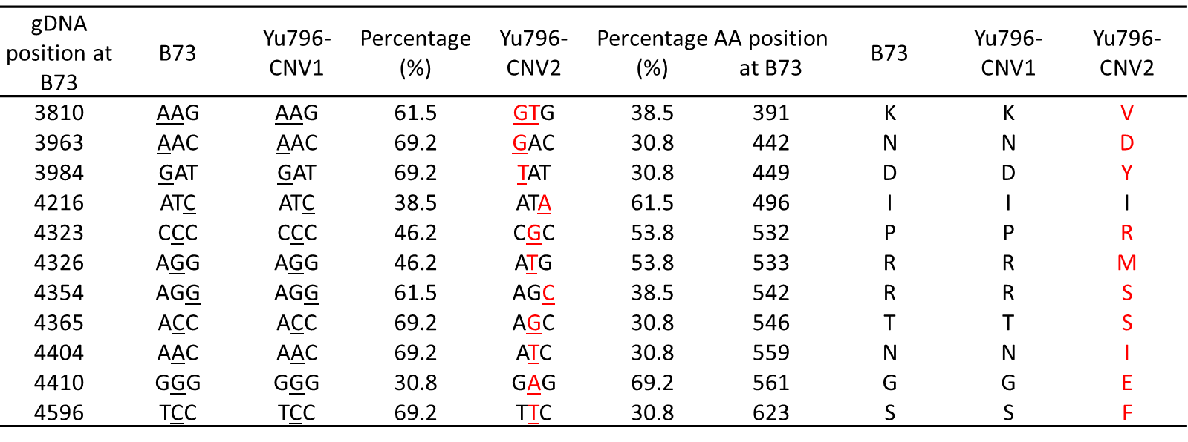
The Table presents the SNPs found in the coding sequence of Yu796 -2×LOX5 compared to the B73-LOX5 locus and the respective changes on the amino acid (AA) sequences. % represents the frequency of specific SNP occurrence in the sequenced PCR amplification products (n=13).

