A comparison of β-Phenyl elimination in Nickel and Palladium alkyl complexes, a potentially relevant process in the Mizoroki-Heck Reaction.

Jorge A. López, Diego A. Cabo, Pilar Palma and Juan Cámpora.*

Instituto de Investigaciones Químicas, CSIC – Universidad de Sevilla.
Centro de Investigaciones Científicas “Isla de la Cartuja”
C/ Américo Vespucio, 49, 41092, Sevilla

SUPPLEMENTARY INFORMATION
Detail of Computational Results: Energy Components and Molecular Structures (Ball and Spoke Molecular views and Fractional Coordinates) for optimized stationary point geometries.

CONTENTS Page
- Effect of the steric bulk of diphosphine ligands on the π-arene
interaction in cationic diphosphine neophyl-nickel and Palladium complexes.
Figure S1. Tube molecular views and
distances in nickel and palladium σ,π-complexes ……………………………………………...3
Table S1. Fractional coordinates for the DiPPE and DtBPE Ni complexes……………….……3

2. Conformational isomers of the neophyl-nickel DMPE triflate species [Ni(CH₂CMe₂Ph)(DMPE)OTf]

Table S2. Energies and relative stability of
DMPE-stabilized neophylnickel-triflate conformational isomers…………………………………………………………………………………………4

3. Energy Components, and Optimized Geometries for all stationary points
involeved in β-Ph Elimination and Hydrolyses Reactions.

Table S3. SCF, ZPE, and Gº Energies for species involved in
β-Ph eliminations and hydrolysis reactions……………………………………………………7

Table S4. Molecular structures and fractional coordinates of the
species involved in β-Ph elimination and hydrolysis………………………………………….9

1. Effect of the steric bulk of diphosphine ligands on the π-arene interaction in cationic diphosphine neophyl-nickel and Palladium complexes.

Figure S1. Tube molecular views and distances in nickel and palladium σ,π-complexes (H-atoms omitted for clarity.

Table S1. Fractional coordinates for the DiPPE and DtBPE Ni complexes (for DMPE derivatives, see Table S3)
.
[Ni(CH₂CMe₂Ph)(DiPPE)]

72

H -4.257631 -0.052475 -1.079159
C -0.187083 -2.465014 -1.683587
C -0.185653 -2.601669 -3.200395
C 0.025335 -3.801716 -0.986107
H 2.618101 -3.345205 -2.503262
H -0.899437 -3.383623 -3.490505
H 0.793613 -2.892333 -3.598874
H -0.694232 -4.533434 -1.374517
H -0.130398 -3.740534 0.095966
H 1.028424 -4.209518 -1.166213
H -1.014874 -3.229586 2.676118
H 0.886512 -2.798343 4.333042
C -2.645213 1.366897 -0.832108
C -1.018500 4.071156 -1.495154
C 2.682241 -1.830312 -0.918244
C 3.193487 -2.462044 -2.205309
C 1.047221 0.136313 -2.346260
C -0.312484 3.156048 -0.507868
C 3.622762 -0.738134 -0.420875
C -3.362289 2.084276 0.299187
C -3.163911 -0.055834 -0.984269
C -0.253965 0.918657 -2.363698
C 1.202648 3.267700 -0.616133
H 0.943588 -2.644688 1.403243
H -0.677907 5.105488 -1.351762
H -2.107968 4.068026 -1.373908
H -0.793264 3.803995 -2.536558
H 4.233684 -2.785147 -2.066846
H 3.186853 -1.749684 -3.041295
H 1.890914 0.789910 -2.086541
H 1.278107 -0.304688 -3.325423
H -0.495576 -1.681195 -3.708197
H 4.595387 -1.171158 -0.156196
H 3.234150 -0.218331 0.464895
H 3.807044 0.015458 -1.198384
H -4.417726 2.231361 0.035261
H -2.939251 3.069849 0.530454
H -3.338611 1.487210 1.218390
H -2.913433 -0.662276 -0.100928
H -2.765749 -0.564868 -1.870696
H -1.055591 0.319420 -2.816583
H -0.167210 1.824266 -2.978434
H 1.534241 4.280383 -0.353164
H 1.540082 3.076063 -1.644665
H 1.722686 2.560458 0.045518
Ni 0.234756 -0.152849 0.726798
P 0.966783 -1.150320 -1.035394
P -0.795247 1.366762 -0.644085
C 0.998412 -1.619920 1.782535
C 0.882665 1.023779 2.677560
C -0.217372 0.152287 2.878728
C 0.721278 2.412983 2.753146
C 0.038613 -1.362921 2.938611
C -1.245886 -2.158407 2.721626
C -0.528129 2.957470 3.021728
C 0.649677 -1.726356 4.295163
C -1.480172 0.733732 3.105525
C -1.628935 2.112803 3.191580
H 2.046061 -1.399685 2.028662
H 1.890486 0.619292 2.581051
H 1.587049 3.062341 2.616274
H -1.741412 -1.883652 1.778385
H -1.966960 -2.015810 3.536070
H -0.651671 4.039170 3.092395
H 1.577377 -1.169040 4.475942
H -0.048279 -1.502935 5.114979
H -2.352179 0.093434 3.243351
H -2.614857 2.537338 3.384893
H -2.826258 1.912517 -1.773603
H 2.614443 -2.610948 -0.144346
H -1.178699 -2.090134 -1.383386
H -0.611905 3.443185 0.511263

[Ni(CH₂CMe₂Ph)(DtBPE)]

84

H -4.518756 2.157569 -1.649987
C 0.324196 -2.907208 -1.593856
C -1.142945 -2.931382 -1.163119
C 0.370447 -3.052561 -3.115834
C 1.046369 -4.099953 -0.969095
H -1.576411 -3.906659 -1.425506
H -1.275017 -2.787477 -0.083935
H 3.318891 -2.913899 -2.416186
H 0.000392 -4.053234 -3.377925
H 1.379800 -2.960234 -3.531856
H 0.501429 -5.012594 -1.247216
H 1.077895 -4.066536 0.124582
H 2.069913 -4.214219 -1.341329
H 3.056410 -3.164165 0.278526
H -1.920255 -2.757691 2.497685
H -0.074243 -2.999106 4.250362
C -2.816818 1.333317 -0.629349
C -0.351481 3.603673 -2.295087
C 2.963581 -1.317541 -0.948407
C 3.526718 -1.848647 -2.266436
C 0.774822 -0.094461 -2.456836
C -0.203141 3.019801 -0.892221
C 3.472863 0.107981 -0.719019
C -3.349179 -0.080092 -0.878686
C 3.478183 -2.158113 0.219245
C -0.858808 3.949964 0.124884
C -3.425132 2.269636 -1.669152
C -0.619778 0.501872 -2.387366
C -3.259942 1.729139 0.777710
C 1.289085 2.935230 -0.568939
H 0.203991 -2.801114 1.414923
H 0.021630 4.637673 -2.284411
H -1.386376 3.636435 -2.650120
H 0.249110 3.060755 -3.035043
H -1.734092 -2.171759 -1.684423
H 4.619691 -1.734347 -2.253180
H 3.155611 -1.296733 -3.139039
H 1.532607 0.694382 -2.404537
H 0.946808 -0.607460 -3.410287
H -0.281177 -2.331604 -3.623243
H 4.547850 0.060676 -0.498756
H 2.981895 0.586837 0.140168
H 3.358834 0.755079 -1.594776
H -4.417072 -0.104190 -0.622841
H -2.848715 -0.829580 -0.252472
H -3.266728 -0.394546 -1.924851
H 4.565632 -2.267088 0.106682
H 3.309071 -1.655844 1.177259
H -0.307171 4.900519 0.141290
H -0.829050 3.539637 1.140605
H -1.898362 4.186607 -0.124853
H -3.093924 2.031858 -2.688351
H -3.210487 3.325315 -1.472472
H -1.368213 -0.284872 -2.532069
H -0.785211 1.225697 -3.194425
H -4.358073 1.762746 0.806291
H -2.894830 2.706458 1.104657
H -2.937872 0.983612 1.513907
H 1.712271 3.949891 -0.554363
H 1.848047 2.370660 -1.321820
H 1.476124 2.480274 0.409899
Ni 0.119078 -0.281565 0.682555
P 1.068365 -1.239310 -1.027769
P -0.919242 1.258679 -0.723211
C 0.537669 -1.832636 1.798765
C 1.126462 0.749947 2.708996
C -0.154989 0.213306 2.964308
C 1.389607 2.109495 2.914562
C -0.367736 -1.310128 2.908369
C -1.820958 -1.669902 2.598545
C 0.389777 2.953371 3.379367
C 0.025713 -1.905535 4.267039
C -1.151232 1.091430 3.431368
C -0.885122 2.437825 3.638282
H 1.578630 -1.925746 2.120376
H 1.955558 0.094445 2.443448
H 2.391425 2.496427 2.722861
H -2.160866 -1.221756 1.652668
H -2.513236 -1.350813 3.386706
H 0.597240 4.011624 3.545057
H 1.064878 -1.662226 4.520818
H -0.622815 -1.515109 5.064421
H -2.144092 0.705206 3.661288
H -1.675021 3.094590 4.006182

2. Conformational isomers of the neophyl-nickel DMPE triflate species [Ni(CH₂CMe₂Ph)(DMPE)OTf]

Table S2. Energies and relative stability of DMPE-stabilized neophylnickel-triflate conformational isomers.
Conformer No. | M06-L/SPVD/CPCM (dichloromethane) |  |  | Single point  M06-L/SVPD (g)  E(SCF,g) |  | Correctionsª |  |  |  | Single point  M06/TZVPPD  E(SCF,g) |  | Gº estim^{b} | ΔGº
 | E(SCF) | Gº | ZPE |  |  | TC |  | SC |  |  |  | Gº estim^{b} | ΔGº
Ni-M0001 | -2370894,423 | -2370651,774 | 275,656 | -2370879,625 | 242,649 |  | -14,798 |  | -2371688,892 |  | -2371461,041 |  | 0,00
Ni-M0005 | -2370894,56 | -2370650,548 | 276,682 | -2370876,623 | 244,012 |  | -17,937 |  | -2371686,656 |  | -2371460,581 |  | 0,46
Ni-M0008 | -2370893,627 | -2370649,716 | 276,578 | -2370876,553 | 243,911 |  | -17,074 |  | -2371686,900 |  | -2371460,063 |  | 0,98
Ni-M0003 | -2370894,381 | -2370651,660 | 275,728 | -2370879,424 | 242,721 |  | -14,957 |  | -2371687,803 |  | -2371460,039 |  | 1,00
Ni-M0004 | -2370892,849 | -2370649,101 | 276,498 | -2370876,288 | 243,748 |  | -16,561 |  | -2371686,570 |  | -2371459,383 |  | 1,66
Ni-M0006 | -2370892,628 | -2370647,405 | 277,709 | -2370875,93 | 245,223 |  | -16,698 |  | -2371686,174 |  | -2371457,649 |  | 3,39
Ni-M0007 | -2370888,91 | -2370644,250 | 277,250 | -2370869,696 | 244,66 |  | -19,214 |  | -2371679,504 |  | -2371454,058 |  | 6,98
(a): Corrections (@ M06-L/SVPD): TC (Thermal Correction) = G(solv)-E(SCF, solv); SC (solvent correction) = E(SCF, solv)-E(SCF, g). (b) Gº estim. = E(SCF, g, M06/TZVPPD)+TC+SC

Figure S2. Geometries of seven neophylnickel-triflate conformational isomers. H atoms omitted for clarity, in order of increasing energy..

3. Energy Components and Optimized Geometries for all stationary points involved in β-Ph Elimination and Hydrolyses Reactions.

Table S3. SCF, ZPE, and Gº Energies for species involved in c β-Ph eliminations and hydrolysis reactions

Species | M06-L/SPVD |  |  |  | Single point  M06-L/SVPD (g)  E(SCF,g) |  | Correctionsª |  |  |  | Single point  M06/TZVPPD  E(SCF,g) |  | Gº estim^{b}  E(SCF)+TC+SC
Species | i-Frq  (cm-¹) | E(SCF) | Gº | ZPE |  |  | TC |  | SC |  |  |  | Gº estim^{b}  E(SCF)+TC+SC
triflate(-) |  | -603054,637 | -603057,713 | 16,770 | -603004,932 | -3,076 |  | -49,705 |  | -603424,817 |  | -603477,598
CH₂=CMe₂ |  | -98576,776 | -98526,846 | 67,043 | -98575,437 | 49,93 |  | -1,339 |  | -98614,31 |  | -98565,719
H₂O |  | -47925,175 | -47922,811 | 13,440 | -47919,859 | 2,364 |  | -5,316 |  | -47959,482 |  | -47962,434
C₆H₆ |  | -145617,925 | -145572,49 | 62,678 | -145615,918 | 45,435 |  | -2,007 |  | -145671,535 |  | -145628,107
PMe₃ |  | -289213,296 | -289161,854 | 69,861 | -289210,791 | 51,442 |  | -2,505 |  | -289306,023 |  | -289257,086
6' |  | -1767823,669 | -1767593,483 | 258,930 | -1767786,38 | 230,186 |  | -37,289 |  | -1768182,057 |  | -1767989,160
TS1-Ni | 261 | -1767803,054 | -1767574,863 | 257,269 | -1767765,741 | 228,191 |  | -37,313 |  | -1768161,811 |  | -1767970,933
[Ni(Ph)(CH₂=CMe₂∥)(DMPE)]⁺ |  | -1767812,271 | -1767584,524 | 257,149 | -1767773,174 | 227,747 |  | -39,097 |  | -1768169,047 |  | -1767980,397
TS2-Ni | <20 | -1767810,454 | -1767582,197 | 257,518 | -1767771,788 | 228,257 |  | -38,666 |  | -1768167,791 |  | -1767978,200
[Ni(Ph)(CH₂=CMe₂⊥)(DMPE)]⁺ |  | -1767810,577 | -1767582,232 | 257,581 | -1767771,955 | 228,345 |  | -38,622 |  | -1768167,447 |  | -1767977,724
[Ni(Ph)(DMPE)](+) |  | -1669207,019 | -1669045,493 | 188,221 | -1669167,165 | 161,526 |  | -39,864 |  | -1669528,647 |  | -1669406,975
[Ni(Ph)(H2O)(DMPE)](+) |  | -1717155,662 | -1716978,895 | 204,489 | -1717111,89 | 176,767 |  | -43,772 |  | -1717511,141 |  | -1717378,146
TS3-Ni | 1588 | -1717134,673 | -1716960,96 | 201,372 | -1717091,355 | 173,713 |  | -43,318 |  | -1717489,647 |  | -1717359,252
[Ni(OH)(Ph-H)(DMPE)](+) |  | -1717155,290 | -1716978,543 | 204,401 | -1717111,969 | 176,747 |  | -43,321 |  | -1717508,64 |  | -1717375,214
cis-5a' |  | -3143106,992 | -3142854,133 | 285,219 | -3142976,648 | 252,859 |  | -130,344 |  | -3143659,709 |  | -3143537,194
trans-5a’ |  | -3143102,310 | -3142850,783 | 284,211 | -3142977,868 | 251,527 |  | -124,442 |  | -3143663,911 |  | -3143536,826
Table S3 (cont).
[Ni(CH₂CMe₂Ph)(PMe₃)(DMPE)]^{+ (c)} |  | -2057062,072 | -2056761,611 | 332,327 | -2057024,568 | 300,461 |  | -37,504 |  | -2057511,458 |  | -2057248,501
IV’ |  | -2057057,207 | -2056757,714 | 331,583 | -2057020,034 | 299,493 |  | -37,173 |  | -2057505,827 |  | -2057243,507
TS4 | 219 | -2057027,841 | -2056730,218 | 329,976 | -2056991,268 | 297,623 |  | -36,573 |  | -2057477,077 |  | -2057216,027
13’ |  | -2057037,706 | -2056740,930 | 329,612 | -2057000,207 | 296,776 |  | -37,499 |  | -2057486,692 |  | -2057227,415
TS5 | 39 | -2057037,180 | -2056740,255 | 329,670 | -2056999,873 | 296,925 |  | -37,307 |  | -2057486,295 |  | -2057226,677
[Ni(Ph)(PMe3)(DMPE)]⁺ |  | -1958467,339 | -1958237,426 | 260,426 | -1958428,968 | 229,913 |  | -38,371 |  | -1958883,597 |  | -1958692,055
1’ |  | -901778,726 | -901549,236 | 258,602 | -901741,65 | 229,49 |  | -37,076 |  | -902002,587 |  | -901810,173
TS1-Pd | 319 | -901752,681 | -901524,987 | 257,106 | -901716,339 | 227,694 |  | -36,342 |  | -901977,634 |  | -901786,282
[Pd(Ph)(CH₂=CMe₂-∥)(DMPE)]⁺ |  | -901767,748 | -901540,368 | 257,103 | -901729,549 | 227,38 |  | -38,199 |  | -901991,607 |  | -901802,426
TS2-Pd | <20 | -901767,302 | -901540,130 | 256,979 | -901728,785 | 227,172 |  | -38,517 |  | -901989,636 |  | -901800,981
[Pd(Ph)(CH₂=CMe₂-⊥)(DMPE)]⁺ |  | -901767,882 | -901540,833 | 256,845 | -901729,379 | 227,049 |  | -38,503 |  | -901991,087 |  | -901802,541
[Pd(Ph)(DMPE)]⁺ |  | -803165,648 | -803004,830 | 187,89 | -803125,806 | 160,818 |  | -39,842 |  | -803349,498 |  | -803228,522
[Pd(Ph)(H₂O)(DMPE)]⁺ |  | -851109,237 | -850933,664 | 203,688 | -851066,32 | 175,573 |  | -42,917 |  | -851328,606 |  | -851195,95
TS3-Pd | 1659 | -851085,166 | -850912,460 | 200,757 | -851042,190 | 172,706 |  | -42,976 |  | -851302,623 |  | -851172,893
[Pd(OH)(η²-Ph-H)(DMPE)]⁺ |  | -851108,676 | -850932,625 | 204,062 | -851063,854 | 176,051 |  | -44,822 |  | -851323,82 |  | -851192,591
cis-[Pd(μ-OH)(DMPE)]₂²⁺ |  | -1411001,355 | -1410750,471 | 283,926 | -1410879,234 | 250,884 |  | -122,121 |  | -1411286,985 |  | -1411158,222
trans-[Pd(μ-OH)(DMPE)]₂²⁺ |  | -1411001,480 | -1410750,360 | 284,053 | -1410879,972 | 251,12 |  | -121,508 |  | -1411288,853 |  | -1411159,241
[Pd(CH₂CMe₂Ph)(PMe₃)(DMPE)]^{+ (a)} |  | -1191019,973 | -1190720,88 | 331,544 | -1190982,547 | 299,093 |  | -37,426 |  | -1191335,303 |  | -1191073,636
[Pd(Ph)(PMe3)(DMPE)]⁺ |  | -1092422,922 | -1092193,758 | 259,919 | -1092384,63 | 229,164 |  | -38,292 |  | -1092703,712 |  | -1092512,840
(a): Corrections (@ M06-L/SVPD): TC (Thermal Correction) = G(solv)-E(SCF, solv); SC (solvent correction) = E(SCF, solv)-E(SCF, g). (b) Gº estim. = E(SCF, g, M06/TZVPPD)+TC+SC. (c): Only the most stable conformer shown.

Figure S3. Free energy diagram corresponding to Scheme 8. All free energies in Kcal/mol.

Table S4. Structure and coordinates of the species involved in β-Ph elimination and hydrolysis

Water
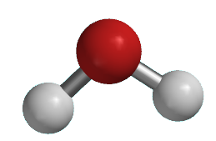
3

O 0.000000 0.000000 -0.396669
H 0.000000 -0.757387 0.198335
H 0.000000 0.757387 0.198335

Triflate Anion
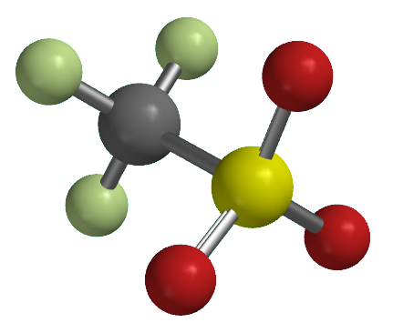
8

C 0.412837 0.702019 -0.326133
F -0.154696 1.833775 0.106129
F 1.697625 0.715721 0.047433
F 0.371385 0.702958 -1.663259
S -0.465655 -0.791363 0.367441
O 0.293531 -1.919462 -0.216423
O -0.310056 -0.615552 1.828573
O -1.844970 -0.628096 -0.143760

Benzene
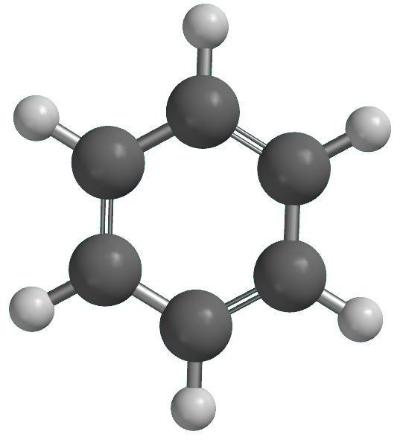
12

6 -0.365716 -1.330453 0.211711
6 0.365716 1.330453 -0.211712
6 0.812552 -0.832975 0.770979
6 -1.178255 -0.497409 -0.559355
6 -0.812553 0.832975 -0.770979
6 1.178255 0.497408 0.559356
1 1.448010 -1.484669 1.374011
1 -1.448012 1.484668 -1.374012
1 2.099985 0.886313 0.996760
1 0.651807 2.371054 -0.377227
1 -0.651806 -2.371053 0.377227
1 -2.099984 -0.886314 -0.996758

Isobutene
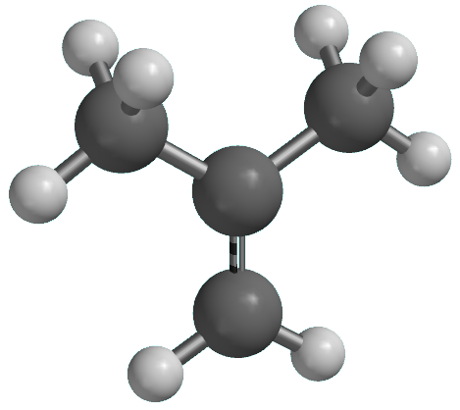
12

C 0.190855 1.450692 0.532448
H 1.184164 1.891629 0.640585
H -0.662804 2.071133 0.813731
C 0.026411 0.200858 0.073881
C 1.182896 -0.662570 -0.315906
H 2.146204 -0.157168 -0.182490
H 1.100889 -0.977936 -1.367505
H 1.195744 -1.592112 0.273875
C -1.325149 -0.418822 -0.080917
H -1.406345 -1.339401 0.517427
H -1.499927 -0.724886 -1.123897
H -2.132938 0.258583 0.218768

[Ni(CH₂CMe₂Ph)(DMPE)]⁺, 6’

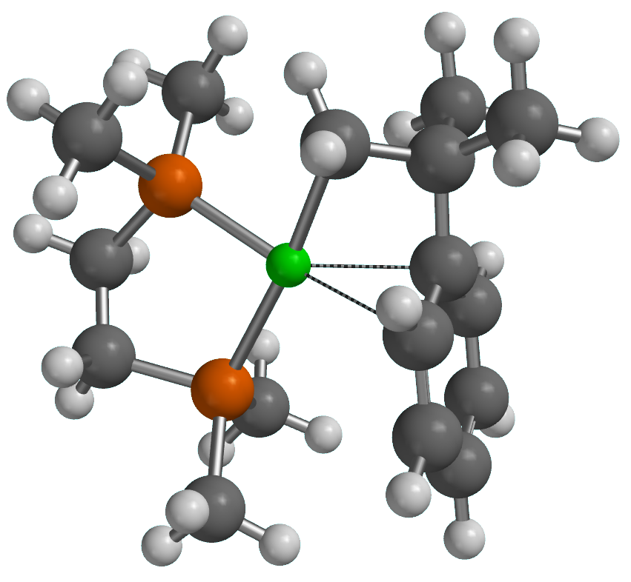
48

Ni -0.032031 0.391586 -0.200987
P -2.110095 0.730352 0.241889
P 0.414350 0.604725 2.020948
C -2.328355 0.830411 2.070165
H -2.486668 -0.197462 2.428099
H -3.240523 1.395088 2.308350
C -1.087075 1.436236 2.698742
H -1.102070 1.363048 3.795173
H -1.003127 2.504413 2.448708
C -2.757281 2.302436 -0.399658
H -2.177757 3.138494 0.008679
H -3.810487 2.422299 -0.114345
H -2.675939 2.323012 -1.492280
C -3.319007 -0.520801 -0.277140
H -3.020655 -1.504616 0.102857
H -3.385175 -0.568811 -1.369174
H -4.306951 -0.265928 0.127424
C 1.772275 1.602448 2.715734
H 2.728580 1.081586 2.600581
H 1.597095 1.781060 3.784535
H 1.835502 2.565910 2.196533
C 0.493560 -0.945852 2.980579
H 1.427909 -1.474540 2.759316
H -0.340223 -1.603189 2.705645
H 0.448425 -0.738198 4.057767
C -0.570608 0.346015 -2.079980
H -0.212519 1.319066 -2.453143
H -1.611908 0.213092 -2.395130
C 0.335378 -0.820111 -2.473032
C 1.718081 -1.916963 -0.565280
C 3.124828 0.463041 -0.162410
C 2.744558 -1.854381 0.369138
C 1.388017 -0.796546 -1.357203
C 2.083372 0.414411 -1.104143
C 3.462316 -0.668486 0.565892
H 2.993237 -2.742655 0.952209
H 4.271408 -0.631669 1.296776
H 3.665123 1.398708 -0.009967
C 0.994159 -0.620393 -3.838625
H 1.569499 0.313088 -3.877398
H 0.230078 -0.574674 -4.626566
H 1.675702 -1.449928 -4.076101
C -0.460875 -2.117892 -2.471982
H 0.165731 -2.987268 -2.710152
H -1.252692 -2.067027 -3.229344
H -0.941058 -2.300791 -1.500837
H 1.187110 -2.857358 -0.712177
H 1.906783 1.285014 -1.738682

TS1-Ni
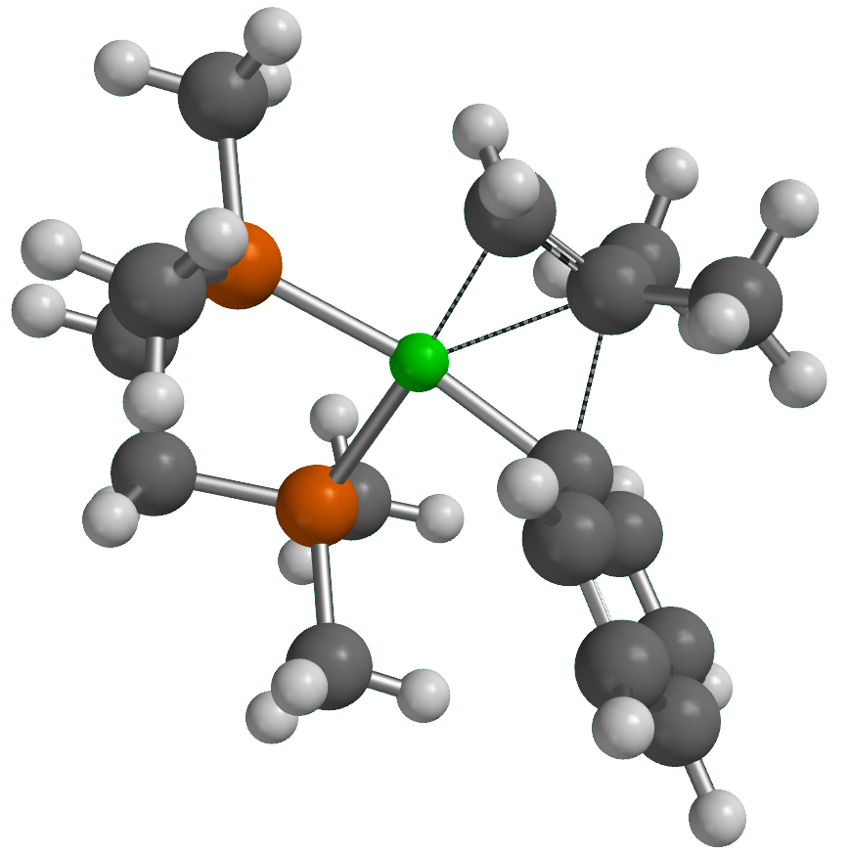
48

Ni -0.464605 0.019020 -0.298265
P -2.347074 0.975981 0.239607
P 0.048879 0.098325 1.865265
C -2.597419 0.814822 2.055010
H -2.977484 -0.201550 2.234418
H -3.372694 1.514798 2.396697
C -1.267864 1.032363 2.757591
H -1.302595 0.739754 3.815698
H -0.982272 2.093737 2.728888
C -2.236874 2.768445 -0.056881
H -1.347964 3.181939 0.434435
H -3.130160 3.278847 0.326527
H -2.150478 2.956672 -1.133498
C -3.927882 0.487153 -0.502396
H -4.086837 -0.589662 -0.372972
H -3.922402 0.714090 -1.574727
H -4.753747 1.032621 -0.029427
C 1.605789 0.860651 2.402350
H 2.455712 0.309001 1.983448
H 1.680587 0.857823 3.497106
H 1.650942 1.894757 2.040761
C 0.043936 -1.549455 2.640782
H 0.808672 -2.184900 2.179169
H -0.933588 -2.025040 2.496638
H 0.249514 -1.470367 3.716072
C -1.107269 -0.250772 -2.112465
H -1.116034 0.646153 -2.741356
H -2.062703 -0.780994 -2.087002
C 0.096089 -1.056843 -2.113846
C 2.236584 -1.420076 -0.232088
C 3.377145 1.048451 -0.854303
C 3.601883 -1.209731 -0.035582
C 1.423850 -0.403738 -0.754294
C 2.021431 0.828396 -1.081162
C 4.177619 0.024597 -0.339292
H 4.217190 -2.015899 0.368688
H 1.417012 1.625071 -1.526180
H 5.244949 0.187379 -0.182699
H 3.816219 2.018183 -1.097119
C 1.027470 -0.839985 -3.288133
H 1.165211 0.221050 -3.518740
H 0.559798 -1.310404 -4.166016
H 2.011014 -1.302030 -3.137952
C -0.113420 -2.518600 -1.791339
H 0.828469 -3.076306 -1.759226
H -0.729095 -2.964363 -2.584658
H -0.642899 -2.672147 -0.841475
H 1.807394 -2.387217 0.033944

[Ni(Ph)(η²-CH₂=CMe₂-∥)(DMPE)]⁺
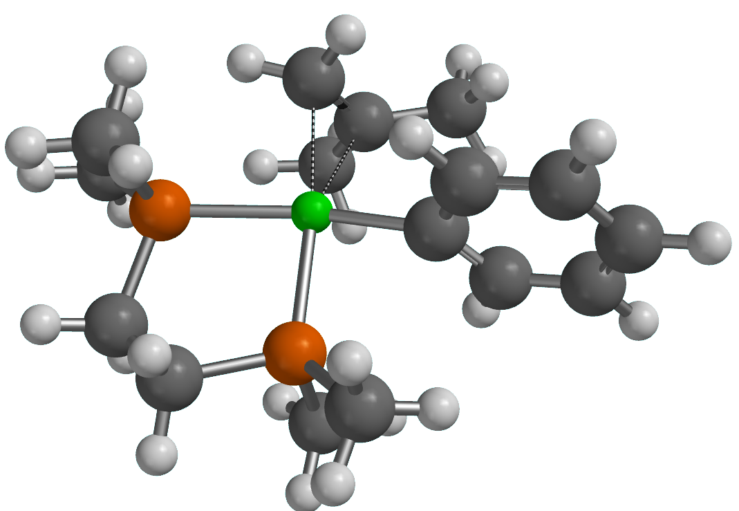
48

Ni -0.228190 0.114194 -0.317903
P -2.318913 0.777904 0.267861
P 0.198981 0.172778 1.832268
C -2.495727 0.653972 2.093952
H -2.772191 -0.384758 2.325302
H -3.317184 1.292569 2.446246
C -1.168804 1.019236 2.731115
H -1.124799 0.756443 3.797266
H -0.978696 2.099876 2.659623
C -2.446744 2.565263 -0.068040
H -1.597921 3.096031 0.379478
H -3.380742 2.971897 0.340917
H -2.424726 2.741316 -1.150149
C -3.878551 0.101560 -0.381088
H -3.977801 -0.952357 -0.096163
H -3.910678 0.172771 -1.474882
H -4.728211 0.661890 0.028510
C 1.701972 0.932603 2.502879
H 2.587275 0.369424 2.188583
H 1.647142 0.945340 3.598736
H 1.792129 1.961307 2.135019
C 0.180282 -1.522852 2.488889
H 1.006312 -2.101984 2.062132
H -0.763263 -2.016446 2.227616
H 0.287236 -1.503053 3.581274
C -0.789148 0.281139 -2.364062
H -0.131712 1.025795 -2.820967
H -1.850902 0.524222 -2.354267
C -0.368609 -1.031685 -2.279793
C 2.466611 -1.173476 -0.225241
C 3.722607 1.180057 -1.019114
C 3.853109 -1.143701 -0.392551
C 1.684951 -0.035100 -0.459395
C 2.337125 1.145987 -0.844851
C 4.486899 0.034233 -0.789864
H 4.440336 -2.046672 -0.210500
H 1.760611 2.060204 -1.021929
H 5.570409 0.060722 -0.919166
H 4.207730 2.107707 -1.331929
C 0.900312 -1.488545 -2.916594
H 1.612595 -0.676357 -3.090912
H 0.631119 -1.916271 -3.895089
H 1.393221 -2.288872 -2.352173
C -1.282787 -2.124400 -1.827988
H -0.817177 -2.713634 -1.022284
H -1.456209 -2.834665 -2.650700
H -2.253331 -1.756939 -1.481704
H 1.994052 -2.114673 0.071629

TS2-Ni
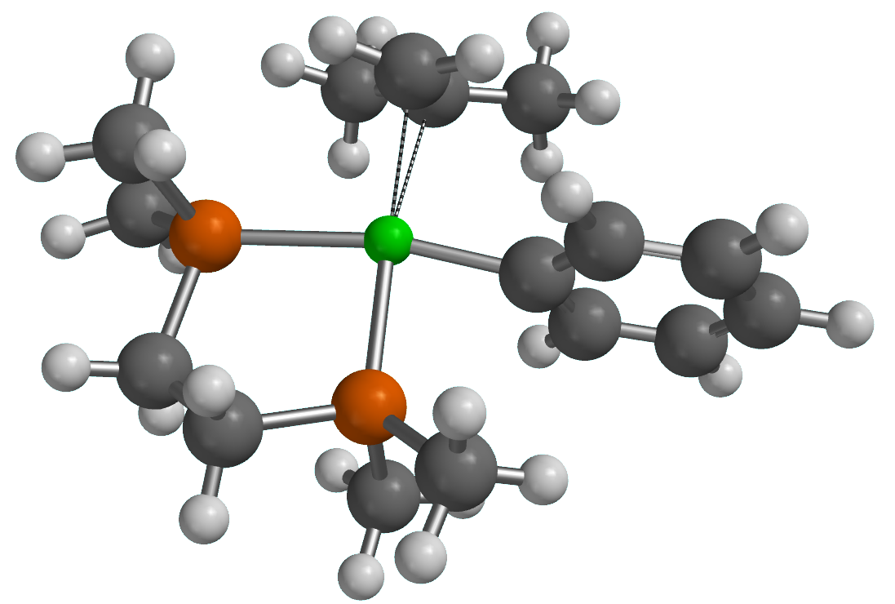
48

Ni -0.150643 0.134915 -0.261119
P -2.366429 0.481955 0.323706
P 0.299333 0.380157 1.870481
C -2.408561 0.624032 2.163004
H -2.538064 -0.393365 2.560202
H -3.292611 1.198557 2.471336
C -1.118583 1.237382 2.666933
H -1.020048 1.176524 3.760038
H -1.048668 2.300586 2.394413
C -2.991294 2.101072 -0.239981
H -2.269945 2.891376 0.000578
H -3.951603 2.331451 0.238306
H -3.135829 2.088206 -1.327298
C -3.774610 -0.635970 0.010866
H -3.497558 -1.672429 0.235183
H -4.102698 -0.576989 -1.031626
H -4.614919 -0.344904 0.654172
C 1.755324 1.311879 2.417032
H 2.667243 0.744263 2.201434
H 1.685208 1.491760 3.497205
H 1.809385 2.273386 1.893839
C 0.420754 -1.204641 2.753925
H 1.320306 -1.740901 2.432614
H -0.452714 -1.833555 2.547347
H 0.485272 -1.019012 3.833879
C -0.321758 0.771893 -2.297199
H 0.606338 1.321233 -2.465736
H -1.241570 1.357779 -2.277046
C -0.364479 -0.584428 -2.515892
C 2.304591 -1.379637 -0.132403
C 3.984025 0.704240 -0.891860
C 3.670720 -1.613691 -0.309142
C 1.753201 -0.109449 -0.351016
C 2.618315 0.932237 -0.715276
C 4.516109 -0.571171 -0.689855
H 4.074437 -2.615610 -0.146444
H 2.227374 1.941730 -0.873108
H 5.584533 -0.749600 -0.824019
H 4.637534 1.528450 -1.187009
C 0.829040 -1.355528 -2.968579
H 1.757724 -0.779742 -2.923015
H 0.659705 -1.657420 -4.013223
H 0.957390 -2.286875 -2.399671
C -1.655388 -1.334029 -2.545750
H -1.694881 -2.107987 -1.763649
H -1.752768 -1.869564 -3.500912
H -2.519427 -0.672681 -2.434512
H 1.661189 -2.215884 0.158846

[Ni(Ph)(η²-CH₂=CMe₂-⊥)(DMPE)]⁺
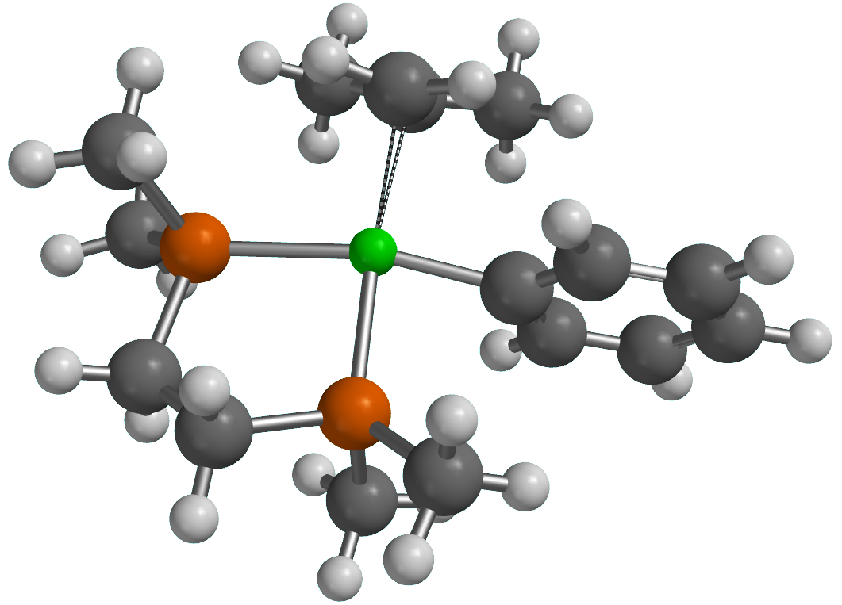
48

Ni -0.124498 0.164331 -0.243528
P -2.347766 0.398939 0.350669
P 0.329548 0.457836 1.877188
C -2.377962 0.663818 2.179059
H -2.481988 -0.327625 2.643161
H -3.272025 1.237115 2.458737
C -1.097714 1.333762 2.634733
H -0.991095 1.340631 3.728842
H -1.051687 2.379611 2.297585
C -3.168622 1.887480 -0.311312
H -2.551019 2.772703 -0.116083
H -4.151839 2.024032 0.155647
H -3.304050 1.795955 -1.395973
C -3.606773 -0.907380 0.154366
H -3.203794 -1.870912 0.488051
H -3.926001 -1.003263 -0.887727
H -4.484086 -0.659906 0.765719
C 1.780184 1.413813 2.394748
H 2.694099 0.841630 2.200827
H 1.707435 1.630380 3.467970
H 1.832707 2.357077 1.839252
C 0.457797 -1.098233 2.808466
H 1.359274 -1.638827 2.499488
H -0.412425 -1.737457 2.619735
H 0.522762 -0.882713 3.882765
C -0.241506 0.929836 -2.234176
H 0.724233 1.421033 -2.362005
H -1.117006 1.578371 -2.168599
C -0.382673 -0.401530 -2.543779
C 2.224394 -1.440419 -0.123765
C 4.054147 0.512659 -0.881976
C 3.566463 -1.779133 -0.315592
C 1.771632 -0.129994 -0.331730
C 2.711366 0.845030 -0.693288
C 4.486576 -0.802140 -0.696415
H 3.892604 -2.810369 -0.162851
H 2.399160 1.883017 -0.839919
H 5.536680 -1.061691 -0.841959
H 4.767380 1.286455 -1.175093
C 0.762889 -1.236799 -3.009101
H 1.727489 -0.728165 -2.926509
H 0.595422 -1.494573 -4.065581
H 0.817829 -2.192438 -2.468574
C -1.725601 -1.042092 -2.666966
H -1.833124 -1.901261 -1.988010
H -1.846801 -1.446974 -3.682226
H -2.542967 -0.336443 -2.487333
H 1.520955 -2.225177 0.173061

[Ni(Ph)(DMPE)]⁺
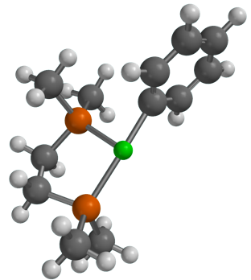
36

Ni -0.218416 -0.212965 -0.823579
P -2.418431 0.167074 -0.553331
P 0.178709 0.290379 1.186674
C -2.590724 0.298675 1.275917
H -2.660842 -0.725961 1.669102
H -3.527329 0.808972 1.539158
C -1.379893 1.017313 1.848002
H -1.353584 0.986275 2.946873
H -1.377078 2.078133 1.557981
C -3.003425 1.776973 -1.173018
H -2.353935 2.581050 -0.807293
H -4.032134 1.966865 -0.839896
H -2.975664 1.788267 -2.268861
C -3.710596 -1.002918 -1.065880
H -3.490857 -2.001986 -0.673004
H -3.747024 -1.059503 -2.159937
H -4.691481 -0.677553 -0.695803
C 1.471459 1.489270 1.590265
H 2.458273 1.049273 1.410235
H 1.385583 1.771988 2.647390
H 1.362235 2.385175 0.968677
C 0.518710 -1.165495 2.212106
H 1.477477 -1.608514 1.920376
H -0.269751 -1.915826 2.083486
H 0.564060 -0.867685 3.267819
C 2.132695 -1.798218 -0.909375
C 3.704854 0.218795 -2.032469
C 3.400482 -2.098356 -1.413026
C 1.623554 -0.492001 -0.997244
C 2.438874 0.521078 -1.528671
C 4.186196 -1.090798 -1.974665
H 3.778289 -3.121513 -1.359020
H 2.083053 1.554910 -1.565216
H 5.181044 -1.324011 -2.358270
H 4.321699 1.010409 -2.462976
H 1.533916 -2.597575 -0.462528

[Ni(Ph)(H₂O)(DMPE)]⁺
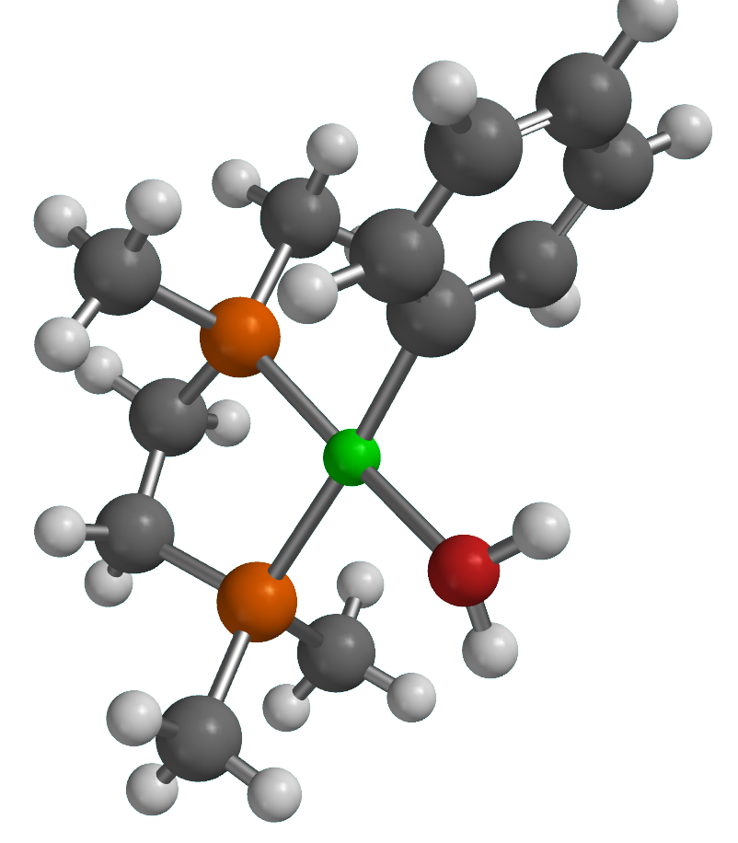
39

Ni -0.254402 -0.112793 -0.701729
P -2.418381 0.284936 -0.226533
P 0.190693 0.202596 1.357452
C -2.550316 0.288604 1.608450
H -2.643436 -0.759154 1.929234
H -3.461794 0.807928 1.934209
C -1.293896 0.920862 2.182969
H -1.215781 0.789477 3.271415
H -1.273562 2.003184 1.987909
C -3.003157 1.937900 -0.723616
H -2.348102 2.710435 -0.303719
H -4.029835 2.109381 -0.374257
H -2.979582 2.029398 -1.816297
C -3.721960 -0.839038 -0.810567
H -3.501916 -1.863884 -0.490436
H -3.760746 -0.820877 -1.906681
H -4.703036 -0.540302 -0.419206
C 1.561907 1.277239 1.858385
H 2.516681 0.807427 1.597160
H 1.523157 1.441588 2.942782
H 1.493368 2.243427 1.345519
C 0.490336 -1.361863 2.232557
H 1.405078 -1.829918 1.851083
H -0.346186 -2.052701 2.075551
H 0.604524 -1.173621 3.308025
C 2.180417 -1.673905 -0.893286
C 3.797297 0.452939 -1.677009
C 3.513753 -1.902302 -1.246090
C 1.629886 -0.383296 -0.930623
C 2.465338 0.676013 -1.319599
C 4.326760 -0.838171 -1.637957
H 3.918086 -2.916698 -1.213311
H 2.078282 1.699606 -1.344134
H 5.369303 -1.013581 -1.909840
H 4.426168 1.292864 -1.981571
H 1.563164 -2.525470 -0.589728
O -0.544078 -0.596118 -2.629908
H 0.246748 -0.574707 -3.184026
H -1.250781 -0.197404 -3.152580

TS3-Ni
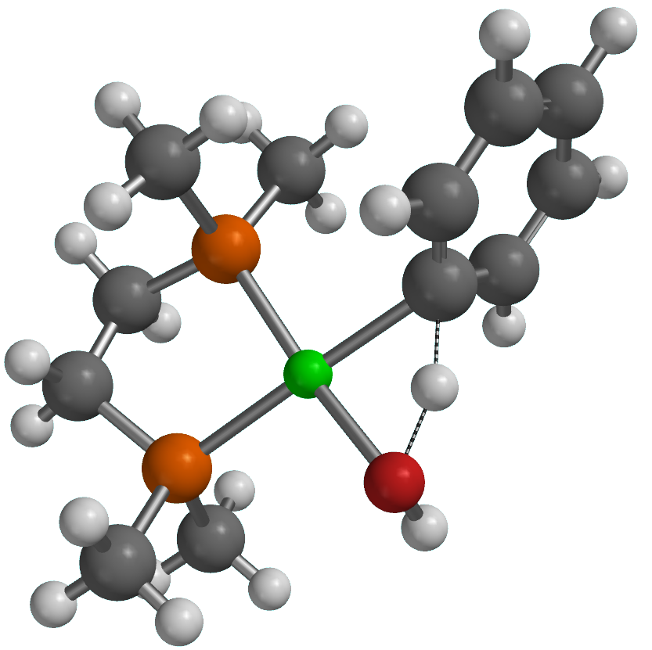
39

Ni -0.420152 -0.161478 -0.811024
P -2.469501 0.292551 -0.152937
P 0.175263 0.122283 1.255363
C -2.517845 0.350807 1.680323
H -2.654792 -0.679966 2.036428
H -3.382544 0.930515 2.029294
C -1.198516 0.926237 2.172217
H -1.060338 0.796229 3.254157
H -1.138175 2.004429 1.966328
C -2.992778 1.940377 -0.709673
H -2.305881 2.702882 -0.324574
H -4.008648 2.156708 -0.354049
H -2.980098 1.983576 -1.805046
C -3.771590 -0.840714 -0.695906
H -3.558830 -1.853350 -0.335808
H -3.804147 -0.857628 -1.791187
H -4.747640 -0.515621 -0.313582
C 1.667440 1.078370 1.623560
H 2.546007 0.549724 1.236284
H 1.771807 1.201697 2.708987
H 1.610692 2.064512 1.149396
C 0.422492 -1.477237 2.078357
H 1.263768 -2.004729 1.614442
H -0.474859 -2.098762 1.980908
H 0.640230 -1.320123 3.142664
C 2.142113 -1.676345 -1.085197
C 3.717052 0.571504 -1.590338
C 3.526539 -1.758017 -0.952776
C 1.513772 -0.469280 -1.452141
C 2.331466 0.649222 -1.710252
C 4.313774 -0.630922 -1.202619
H 3.996086 -2.699062 -0.661769
H 1.874563 1.594672 -2.015631
H 5.398587 -0.691648 -1.100649
H 4.335176 1.446518 -1.798325
H 1.535796 -2.567039 -0.898327
O -0.782477 -0.635965 -2.678720
H 0.449424 -0.579824 -2.284457
H -0.963237 0.154897 -3.203722

[Ni(OH)(Ph-H)(DMPE)]⁺
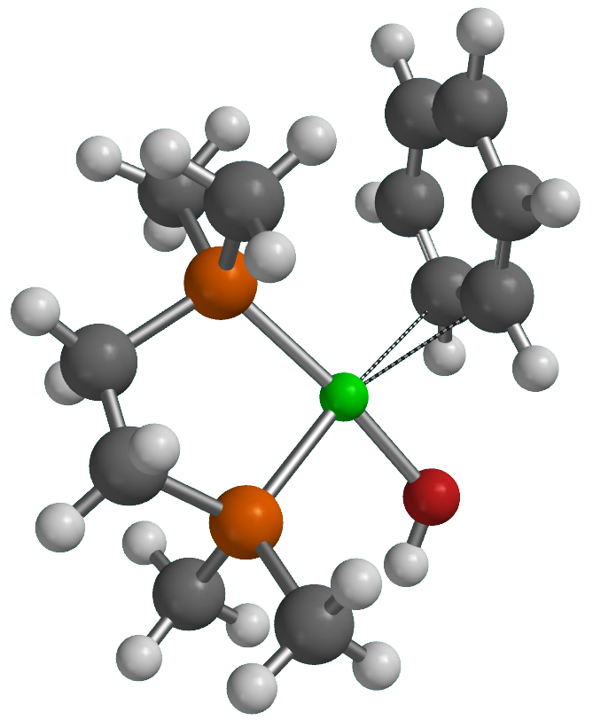
39

Ni -0.231162 0.125187 -0.969899
P -2.249095 0.445908 -0.253384
P 0.411373 0.200644 1.160614
C -2.291941 0.318195 1.572065
H -2.380661 -0.747654 1.825708
H -3.186484 0.821786 1.963088
C -1.001534 0.907025 2.106015
H -0.863408 0.716158 3.178938
H -0.975961 1.997373 1.965644
C -2.862926 2.108932 -0.635856
H -2.220187 2.862638 -0.166968
H -3.885948 2.217653 -0.251865
H -2.867554 2.281095 -1.717951
C -3.489214 -0.709158 -0.884345
H -3.183638 -1.738269 -0.665138
H -3.599208 -0.596608 -1.968076
H -4.454473 -0.507066 -0.401395
C 1.809720 1.231181 1.695266
H 2.765048 0.763146 1.442276
H 1.757048 1.361391 2.784044
H 1.758251 2.214268 1.213515
C 0.682154 -1.410131 1.962812
H 1.586103 -1.886758 1.571110
H -0.167997 -2.075131 1.769892
H 0.792229 -1.270144 3.045996
C 2.108642 -2.182849 -1.202698
C 3.035787 0.453474 -1.379513
C 3.264306 -1.801076 -0.533206
C 1.408364 -1.251079 -1.984119
C 1.872012 0.077883 -2.070032
C 3.730468 -0.482545 -0.624864
H 3.815339 -2.530310 0.063092
H 1.392176 0.777112 -2.754767
H 4.641621 -0.191678 -0.099433
H 3.400864 1.478845 -1.455622
H 1.753425 -3.212660 -1.143377
O -0.897537 0.191536 -2.704241
H 0.570038 -1.574527 -2.600295
H -1.746040 0.616214 -2.853032

Cis-5a’
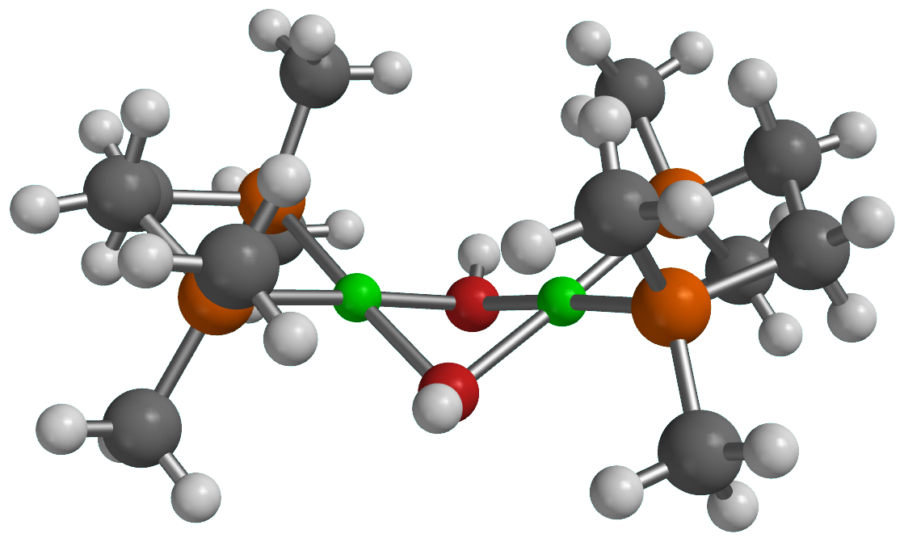
54

Ni -0.005464 0.796250 1.324025
P -1.497596 0.073199 2.726462
P 1.489903 0.091320 2.729216
C -0.675707 -0.918513 4.034238
H -0.568792 -1.940944 3.644713
H -1.313772 -0.977691 4.926107
C 0.680919 -0.300872 4.326785
H 1.321522 -0.955758 4.932455
H 0.574895 0.646333 4.874772
C -2.343373 1.433972 3.576722
H -1.618729 2.042919 4.129198
H -3.089140 1.034742 4.276574
H -2.844982 2.073686 2.841097
C -2.814808 -0.974383 2.054403
H -2.379199 -1.834270 1.533184
H -3.435989 -0.406120 1.352471
H -3.453091 -1.333322 2.872181
C 2.858845 1.216513 3.097735
H 3.441281 1.412068 2.190201
H 3.518111 0.766319 3.851234
H 2.469241 2.166832 3.479050
C 2.261061 -1.449193 2.158742
H 2.797029 -1.265178 1.220624
H 1.494106 -2.210929 1.976218
H 2.970794 -1.820675 2.909353
O -1.221644 1.475150 -0.004123
H -2.133653 1.168450 -0.010183
O 1.219881 1.475766 0.003792
H 2.132082 1.169639 0.009979
Ni 0.004108 0.795771 -1.324133
P -1.490163 0.090683 -2.730405
P 1.497310 0.072550 -2.725365
C 2.812390 -0.976876 -2.051978
H 3.452233 -1.335141 -2.868836
H 2.374978 -1.837186 -1.532953
H 3.432394 -0.410100 -1.347796
C 2.345683 1.433160 -3.573270
H 3.092133 1.033754 -4.272294
H 2.846766 2.071861 -2.836408
H 1.622419 2.043162 -4.126386
C 0.676308 -0.917366 -4.035061
H 1.315102 -0.975618 -4.926464
H 0.568817 -1.940240 -3.646859
C -2.260067 -1.451370 -2.162422
H -1.492402 -2.212390 -1.979901
H -2.968524 -1.822867 -2.914229
H -2.797303 -1.269071 -1.224716
C -0.679952 -0.299068 -4.327933
H -0.573317 0.648944 -4.874401
H -1.320120 -0.952991 -4.935108
C -2.859976 1.214990 -3.098353
H -3.518472 0.765012 -3.852651
H -2.471065 2.166086 -3.478436
H -3.443009 1.409000 -2.190871

Trans-5a'
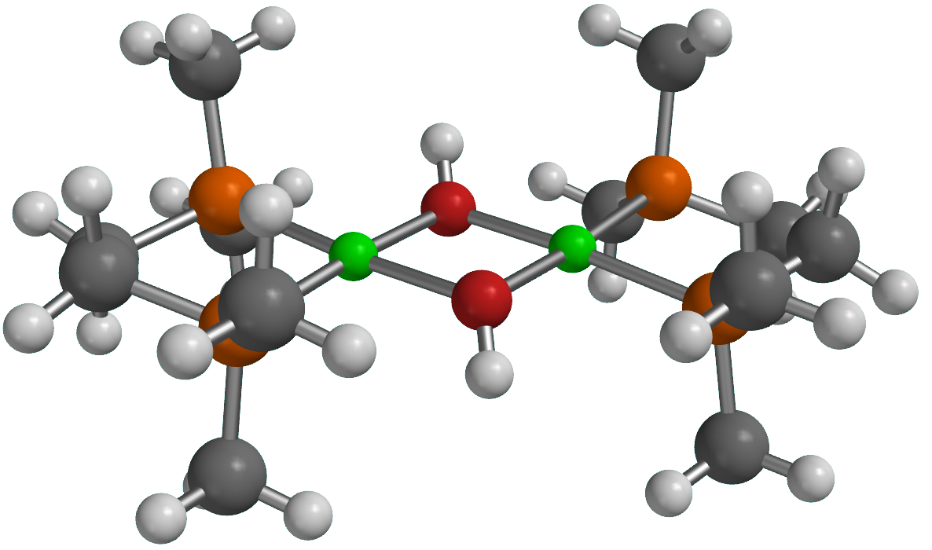
54

H 1.901327 3.373530 1.094023
H -1.941848 3.363304 1.054483
H -0.004802 2.048810 -0.405584
O -0.005922 1.260136 0.146203
C 4.637696 -0.651033 -0.331114
C 4.629389 0.687116 0.390084
C 2.815220 2.805869 1.302535
C 3.201322 2.354112 -1.526089
C 3.204547 -2.324451 1.575315
C 2.850356 -2.786981 -1.255652
H 4.727037 -0.513846 -1.418182
H 5.469803 -1.294874 -0.016135
H 4.710414 0.550583 1.477890
H 5.459137 1.337442 0.082338
H 4.006913 3.097634 -1.464810
H 4.016602 -3.061674 1.523996
Ni 1.450233 0.005707 0.012573
P 3.017180 1.501204 0.065383
P 3.029246 -1.477355 -0.020247
C -4.638195 0.651030 0.329163
C -4.628863 -0.687214 -0.391846
C -2.812916 -2.805339 -1.302307
C -3.203437 -2.354712 1.525889
C -3.202390 2.323334 -1.576193
C -2.852697 2.787924 1.254984
H -4.728920 0.513994 1.416135
H -5.469932 1.294780 0.013015
H -4.708505 -0.550824 -1.479771
H -5.458964 -1.337553 -0.085090
H -4.008833 -3.098319 1.463091
H -4.014567 3.060544 -1.526618
Ni -1.450249 -0.005584 -0.008932
P -3.017003 -1.501175 -0.064982
P -3.029414 1.477385 0.020229
H -1.899160 -3.372789 -1.092640
H 1.939593 -3.362163 -1.054207
H 0.004760 -2.047093 0.415504
O 0.005882 -1.260506 -0.139253
H -2.778451 2.348851 2.256074
H -3.717908 3.462256 1.216639
H -3.440076 -1.632354 2.315584
H -2.267732 -2.862329 1.788360
H 3.426216 -1.597860 2.365464
H 2.270038 -2.838839 1.828710
H 3.715408 -3.461610 -1.219015
H 2.774814 -2.347185 -2.256329
H 3.436641 1.631423 -2.315875
H 2.265273 2.861736 -1.787319
H 3.674547 3.488236 1.275812
H 2.734165 2.362720 2.301306
H -2.267522 2.837580 -1.828549
H -3.422818 1.596176 -2.366168
H -2.730534 -2.361811 -2.300803
H -3.672100 -3.487942 -1.277071

[Ni(CH₂CMe₂Ph)(PMe₃)(DMPE)]⁺

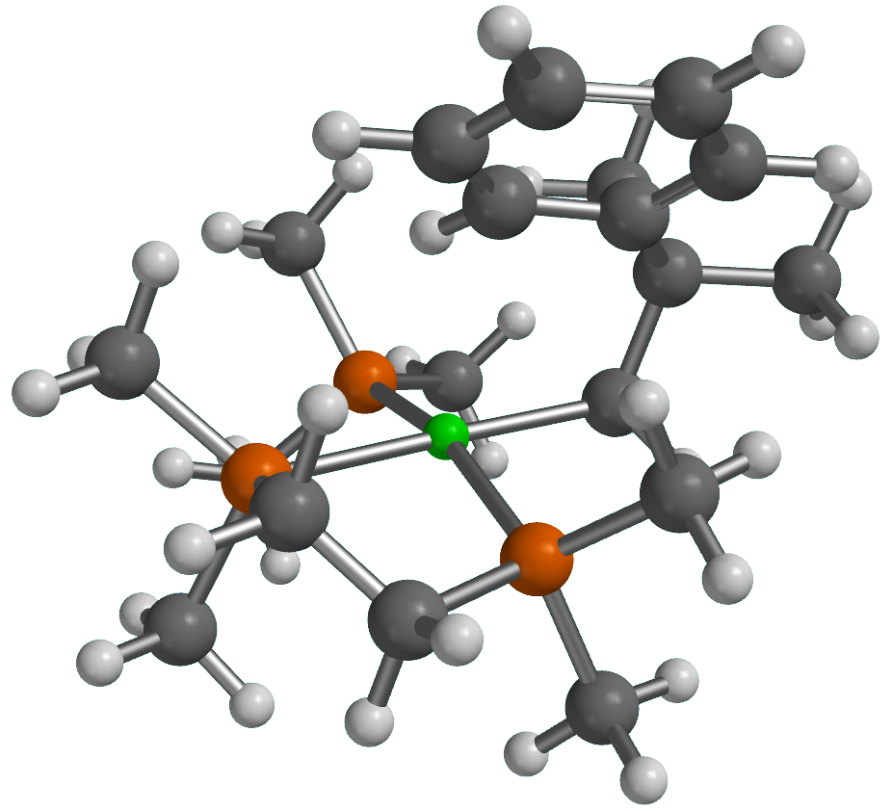

61

Ni -0.078611 -0.676721 0.290054
P 2.130653 -0.614505 0.384853
P 0.015884 -0.132083 2.475232
C 2.697505 -0.051361 2.054579
H 3.644670 0.496036 1.965731
H 2.899980 -0.940761 2.667239
C 1.596730 0.791324 2.674793
H 1.491329 1.750586 2.146418
H 1.782482 1.014540 3.734959
C 2.905539 -2.244483 0.153566
H 2.486373 -2.961686 0.868876
H 3.991120 -2.179256 0.303242
H 2.710232 -2.611097 -0.860917
C 3.061158 0.469262 -0.741063
H 2.817325 1.516667 -0.526684
H 2.811846 0.259627 -1.786828
H 4.137073 0.312793 -0.592043
C 0.243817 -1.502961 3.663083
H -0.700931 -2.024676 3.842541
H 0.616235 -1.115506 4.620434
H 0.960766 -2.232912 3.269461
C -1.221945 0.931498 3.285644
H -1.410309 1.823996 2.677598
H -0.863783 1.242735 4.275131
H -2.167988 0.392708 3.414426
C 0.135096 -0.968349 -1.693913
H -0.500310 -1.805371 -2.018943
H 1.160119 -1.295818 -1.924066
C -0.179635 0.258638 -2.592113
C 0.248382 1.574640 -1.940363
C 0.989533 3.977868 -0.640645
C -0.275368 1.920842 -0.684026
C 1.118607 2.486755 -2.545090
C 1.488266 3.672824 -1.904814
C 0.092437 3.096135 -0.034326
H -1.023409 1.267203 -0.216777
H 2.179343 4.357568 -2.399852
H -0.330743 3.330656 0.944121
H 1.282718 4.899878 -0.136448
C -1.683125 0.355401 -2.871118
H -2.271276 0.435078 -1.949920
H -2.031565 -0.527816 -3.422838
H -1.913096 1.239567 -3.480624
C 0.519088 0.040372 -3.935719
H 0.210457 -0.923523 -4.359495
H 1.612344 0.019676 -3.833090
H 0.262020 0.819086 -4.667695
H 1.539945 2.270646 -3.527139
P -2.199670 -1.400767 0.338939
C -2.557300 -2.467269 1.781758
H -3.546534 -2.929346 1.670149
H -2.563396 -1.872116 2.701862
H -1.803906 -3.257535 1.878440
C -2.808250 -2.456480 -1.018892
H -3.827878 -2.794863 -0.796103
H -2.813663 -1.916881 -1.970230
H -2.158774 -3.333761 -1.124690
C -3.519819 -0.144761 0.500621
H -3.567472 0.495133 -0.386979
H -3.326750 0.496553 1.368026
H -4.493566 -0.633628 0.631670

IV’
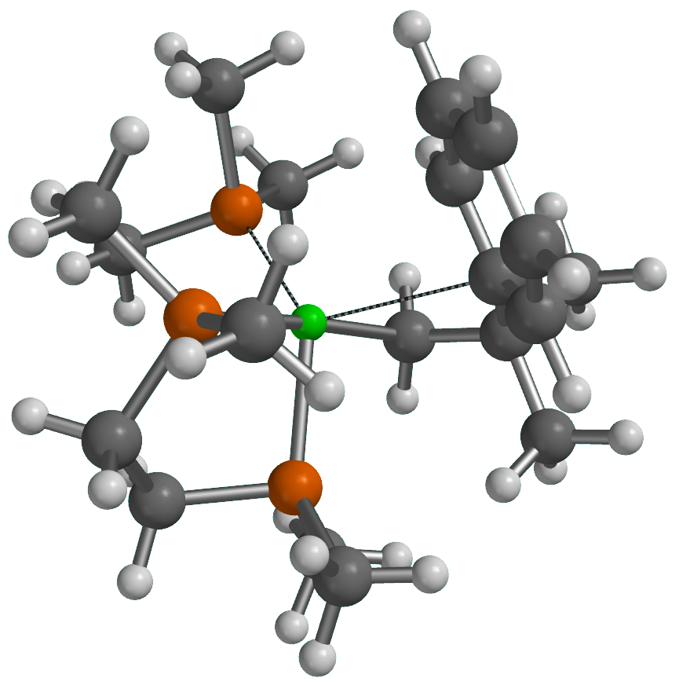
61

Ni -0.058517 -0.446326 0.046757
P 2.108273 -0.940403 -0.042220
P 0.486914 0.390046 2.093241
C 2.352672 -1.648458 1.641280
H 3.398089 -1.960000 1.779766
H 1.735881 -2.556424 1.686856
C 1.910608 -0.645498 2.699361
H 2.731568 0.031080 2.973429
H 1.604847 -1.152272 3.623584
C 2.649426 -2.285332 -1.143278
H 1.959024 -3.132412 -1.054653
H 3.660761 -2.612842 -0.871870
H 2.654384 -1.953210 -2.187765
C 3.496949 0.250970 -0.139219
H 3.448574 0.958158 0.696433
H 3.474666 0.827942 -1.069710
H 4.451564 -0.287735 -0.079862
C -0.588302 0.523505 3.567030
H -1.348336 1.296235 3.400976
H 0.020353 0.821142 4.430431
H -1.089492 -0.421210 3.802922
C 1.152765 2.090694 2.055775
H 1.806745 2.250674 1.193085
H 1.707796 2.298530 2.979709
H 0.321407 2.799379 1.977212
C -0.347015 -0.982307 -1.850602
H -1.374175 -1.333944 -1.985779
H 0.310447 -1.786009 -2.206714
C -0.139080 0.315561 -2.656649
C -0.419055 1.503623 -1.730693
C -1.123383 3.724742 -0.130366
C -1.654892 1.558105 -1.056767
C 0.457732 2.585954 -1.568872
C 0.107276 3.685515 -0.785300
C -2.002854 2.650606 -0.263106
H 0.806870 4.517226 -0.682657
H -2.972485 2.669782 0.238054
H -1.394966 4.586321 0.481787
C -1.144694 0.358480 -3.817328
H -2.180384 0.316097 -3.456487
H -0.989677 -0.498931 -4.487009
H -1.029427 1.276545 -4.411447
C 1.260204 0.369718 -3.253761
H 1.427303 -0.507344 -3.891103
H 2.045537 0.382949 -2.490743
H 1.402460 1.260693 -3.879422
H 1.425487 2.582873 -2.072007
P -1.946367 -1.436489 0.710675
C -1.543819 -2.723238 1.946994
H -2.455917 -3.183053 2.349788
H -0.956669 -2.314517 2.776828
H -0.940877 -3.501897 1.463990
C -2.947326 -2.393718 -0.478753
H -3.765747 -2.898748 0.049258
H -3.379806 -1.729624 -1.237426
H -2.332164 -3.145715 -0.986117
C -3.257856 -0.446489 1.511856
H -3.739838 0.184375 0.755199
H -2.857939 0.207841 2.290610
H -4.019091 -1.103712 1.952059
H -2.376431 0.752498 -1.207259

TS4
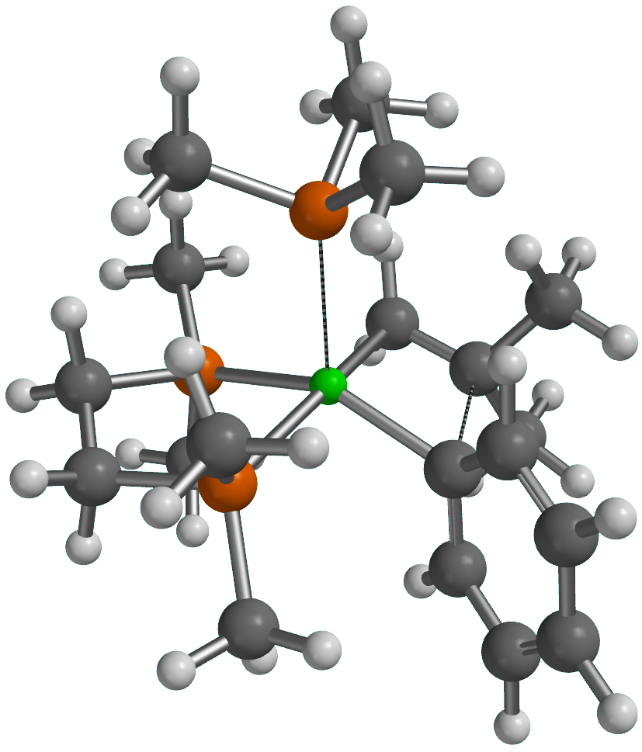
61

Ni 0.350220 -0.116466 -0.290616
P 2.006440 -1.471328 0.154235
P 0.728185 0.734539 1.753633
C 2.157065 -1.650834 1.980062
H 3.109353 -2.133941 2.241479
H 1.355172 -2.330153 2.298501
C 2.009194 -0.285705 2.626973
H 2.950331 0.276113 2.545526
H 1.776872 -0.352537 3.698266
C 2.026304 -3.180530 -0.468228
H 1.121048 -3.712020 -0.152511
H 2.904426 -3.717786 -0.088171
H 2.062361 -3.180187 -1.563790
C 3.624746 -0.812245 -0.368969
H 3.786803 0.176193 0.078093
H 3.640820 -0.696308 -1.459520
H 4.442322 -1.481892 -0.070284
C -0.714642 0.788709 2.870973
H -1.504890 1.386124 2.398349
H -0.443910 1.254739 3.826977
H -1.106153 -0.213979 3.066859
C 1.382273 2.421203 1.973426
H 2.237142 2.597927 1.310448
H 1.702806 2.548088 3.015655
H 0.605329 3.159723 1.748251
C 0.405717 -0.880762 -2.109367
H -0.183676 -1.799215 -2.141860
H 1.409376 -1.001124 -2.527233
C -0.257011 0.362205 -2.418744
C -0.356736 1.709970 -0.853678
C -1.033047 4.419416 -0.380345
C -1.651358 2.080491 -0.452308
C 0.584008 2.741089 -1.021127
C 0.254915 4.075161 -0.793751
C -1.983299 3.411840 -0.202877
H 1.013022 4.849305 -0.930866
H -2.994825 3.662492 0.123672
H -1.296206 5.463500 -0.203016
C -1.728339 0.265777 -2.736260
H -2.298644 -0.237474 -1.949215
H -1.845449 -0.322145 -3.658064
H -2.179783 1.249906 -2.904771
C 0.497288 1.226056 -3.401022
H 0.432041 0.733857 -4.382649
H 1.561036 1.309048 -3.152994
H 0.074268 2.231861 -3.500518
H 1.602852 2.497133 -1.331376
P -1.652130 -1.621653 0.409233
C -1.330002 -2.758059 1.821664
H -2.216013 -3.369724 2.038959
H -1.049165 -2.219591 2.733842
H -0.505155 -3.434355 1.564831
C -2.111573 -2.895419 -0.835890
H -2.899459 -3.552772 -0.445245
H -2.470971 -2.437608 -1.765189
H -1.237087 -3.511600 -1.080226
C -3.323305 -0.995288 0.854878
H -3.785360 -0.512641 -0.016138
H -3.258870 -0.249367 1.656225
H -3.979552 -1.812474 1.183850
H -2.417128 1.314721 -0.318041

13’
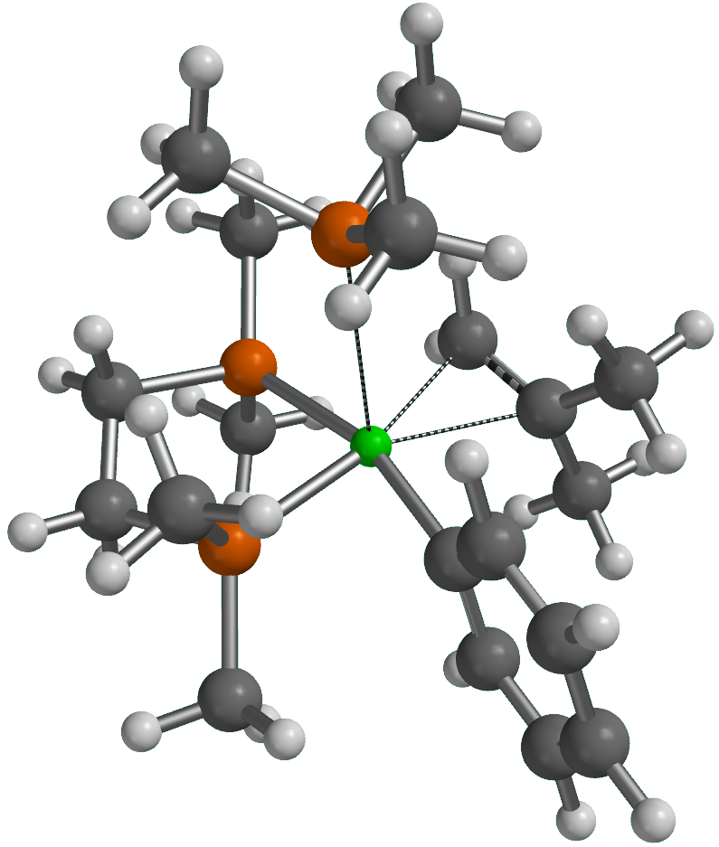
61

Ni 0.588196 0.160095 -0.376808
P 1.990150 -1.505725 0.152133
P 0.981609 0.883989 1.656426
C 2.190095 -1.559724 1.977181
H 3.060283 -2.169671 2.256120
H 1.297341 -2.053711 2.388322
C 2.296377 -0.130066 2.466704
H 3.265343 0.310522 2.192721
H 2.202477 -0.043525 3.557914
C 1.718324 -3.237598 -0.329217
H 0.745705 -3.587087 0.034460
H 2.503253 -3.872695 0.099710
H 1.741434 -3.342850 -1.419549
C 3.671928 -1.153946 -0.458359
H 3.989451 -0.154985 -0.137322
H 3.684092 -1.175475 -1.554622
H 4.386952 -1.897603 -0.083039
C -0.441625 0.656754 2.769157
H -1.343348 1.107078 2.340497
H -0.227781 1.128811 3.736632
H -0.619696 -0.411579 2.930793
C 1.513492 2.588120 1.997470
H 2.311600 2.890425 1.310208
H 1.887274 2.640542 3.027892
H 0.671806 3.279288 1.883595
C 0.546934 -0.930907 -2.205798
H -0.119217 -1.768603 -1.995393
H 1.569405 -1.189716 -2.485912
C 0.028724 0.274390 -2.634880
C -0.310148 1.898466 -0.459983
C -1.586441 4.424491 -0.587038
C -1.656215 2.055101 -0.098087
C 0.384208 3.048887 -0.864123
C -0.242224 4.293315 -0.940753
C -2.290717 3.297927 -0.160635
H 0.325830 5.167124 -1.268444
H -3.342523 3.382933 0.121819
H -2.079062 5.397183 -0.639255
C -1.444947 0.455426 -2.814241
H -2.028214 -0.117316 -2.083340
H -1.721338 0.098173 -3.818540
H -1.745888 1.507341 -2.752084
C 0.907606 1.235964 -3.367750
H 0.840376 1.016152 -4.444927
H 1.961346 1.146325 -3.077425
H 0.588851 2.276304 -3.241287
H 1.444240 2.978275 -1.125150
P -1.758120 -1.744125 0.478217
C -1.585151 -2.927457 1.881912
H -2.454380 -3.596537 1.949475
H -1.494768 -2.388247 2.833188
H -0.684581 -3.542824 1.763010
C -2.214990 -2.932377 -0.854068
H -3.050588 -3.576814 -0.548533
H -2.508161 -2.392036 -1.763509
H -1.360887 -3.572962 -1.109643
C -3.426320 -1.065571 0.860353
H -3.802815 -0.494066 0.001806
H -3.374575 -0.385251 1.720478
H -4.145300 -1.864515 1.088267
H -2.234679 1.186160 0.223251

TS5
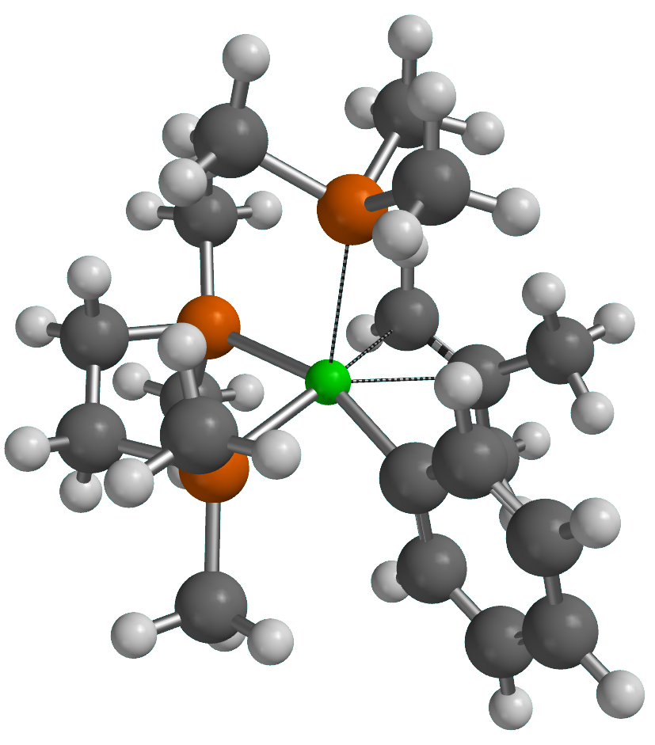
61

Ni 0.423242 0.054439 -0.210237
P 1.964903 -1.521003 0.199591
P 1.020585 0.881732 1.713971
C 2.229197 -1.593859 2.014782
H 3.123418 -2.183923 2.258571
H 1.365634 -2.108429 2.458499
C 2.326404 -0.164180 2.510538
H 3.295174 0.275251 2.235156
H 2.241623 -0.085214 3.602750
C 1.845327 -3.257902 -0.337050
H 0.960391 -3.740630 0.090976
H 2.736236 -3.814427 -0.020284
H 1.772756 -3.310373 -1.429527
C 3.603653 -1.024447 -0.435190
H 3.839040 -0.000236 -0.123476
H 3.607552 -1.050650 -1.530988
H 4.385519 -1.702121 -0.067796
C -0.346560 0.851059 2.916959
H -1.171147 1.478914 2.561522
H 0.001173 1.229272 3.886798
H -0.715468 -0.171103 3.048661
C 1.701325 2.555383 1.931548
H 2.493675 2.748089 1.199162
H 2.123331 2.635569 2.941531
H 0.916264 3.308370 1.809446
C 0.552949 -0.863370 -2.308017
H -0.112389 -1.704959 -2.130688
H 1.605862 -1.098295 -2.464287
C 0.072237 0.324354 -2.781340
C -0.420640 1.825736 -0.323642
C -1.581872 4.395444 -0.658438
C -1.755886 2.078243 0.023493
C 0.325171 2.914333 -0.805644
C -0.243616 4.175566 -0.989191
C -2.334020 3.339640 -0.141898
H 0.366941 4.993276 -1.378807
H -3.379252 3.495243 0.134089
H -2.029635 5.381987 -0.791268
C -1.387472 0.574142 -2.957613
H -2.002073 -0.044211 -2.293554
H -1.666552 0.338902 -3.996508
H -1.645342 1.627700 -2.795145
C 0.996285 1.309683 -3.413104
H 0.987066 1.140625 -4.501317
H 2.030831 1.195522 -3.069838
H 0.674381 2.345716 -3.262635
H 1.384246 2.778568 -1.041284
P -1.625780 -1.556229 0.331425
C -1.383791 -2.681238 1.767833
H -2.228645 -3.377074 1.859514
H -1.304440 -2.116842 2.703709
H -0.467717 -3.271552 1.654312
C -2.009453 -2.816850 -0.951900
H -2.799538 -3.494954 -0.603652
H -2.348773 -2.337626 -1.878782
H -1.121224 -3.416323 -1.187225
C -3.332503 -0.982670 0.703051
H -3.738904 -0.412394 -0.141407
H -3.335388 -0.332903 1.587212
H -3.994018 -1.837372 0.898340
H -2.372650 1.277330 0.427006

[Ni(Ph)(PMe₃)(DMPE)]⁺
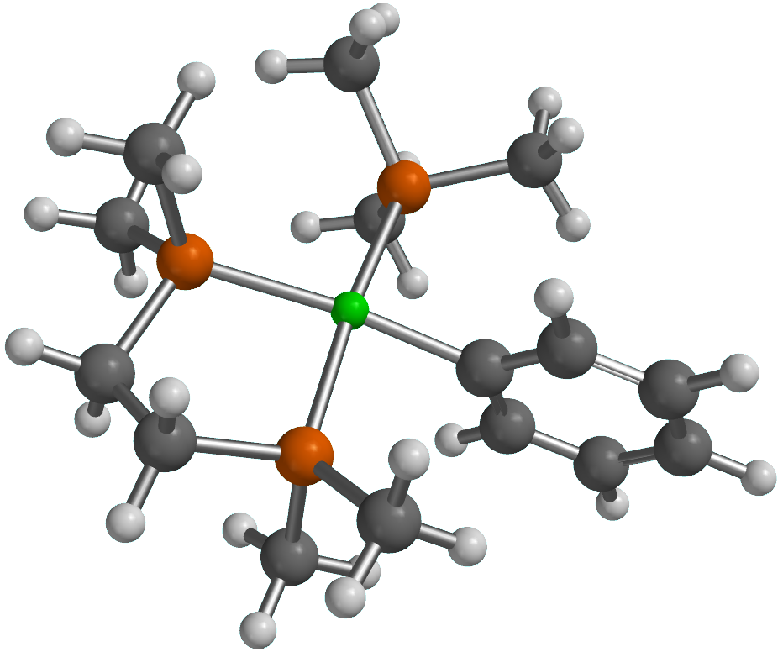
49

Ni -0.124489 0.001258 -0.121940
P -2.250233 0.529668 -0.582396
P 0.337834 2.127193 -0.409819
C -2.374632 2.372068 -0.632986
H -2.521026 2.711533 0.402931
H -3.268007 2.674348 -1.196706
C -1.098508 2.952350 -1.214961
H -1.037473 4.042362 -1.089442
H -1.027207 2.746789 -2.293089
C -2.788495 0.027299 -2.250836
H -2.090994 0.424001 -2.998269
H -3.795229 0.410477 -2.462616
H -2.796042 -1.064613 -2.340190
C -3.638521 0.062544 0.500219
H -3.432421 0.394689 1.524552
H -3.784949 -1.022851 0.513322
H -4.565499 0.535695 0.151881
C 1.791003 2.650904 -1.360962
H 2.702883 2.363555 -0.824692
H 1.779623 3.739798 -1.495794
H 1.796864 2.165752 -2.343771
C 0.515222 2.988825 1.183367
H 1.392161 2.600721 1.714594
H -0.369247 2.821389 1.809224
H 0.643018 4.066934 1.021498
C 2.228174 -0.089401 1.575158
C 4.028526 -0.751238 -0.437257
C 3.576470 -0.292097 1.883611
C 1.749994 -0.220445 0.261464
C 2.680494 -0.549124 -0.737913
C 4.483508 -0.626339 0.877308
H 3.917981 -0.188845 2.916316
H 2.352145 -0.655078 -1.776772
H 5.537108 -0.785645 1.114299
H 4.729225 -1.009256 -1.235093
H 1.538208 0.170398 2.384751
P -0.412113 -2.154969 0.361635
C 1.024177 -3.265184 0.209818
H 1.397939 -3.260645 -0.821003
H 0.734411 -4.288191 0.481535
H 1.833640 -2.930956 0.868413
C -1.697467 -3.096987 -0.528030
H -1.461356 -3.128768 -1.598469
H -2.683509 -2.636563 -0.405270
H -1.744121 -4.125501 -0.147745
C -0.882349 -2.334187 2.113557
H -0.104095 -1.895032 2.749437
H -0.996005 -3.394586 2.374881
H -1.826618 -1.814049 2.312254

6’
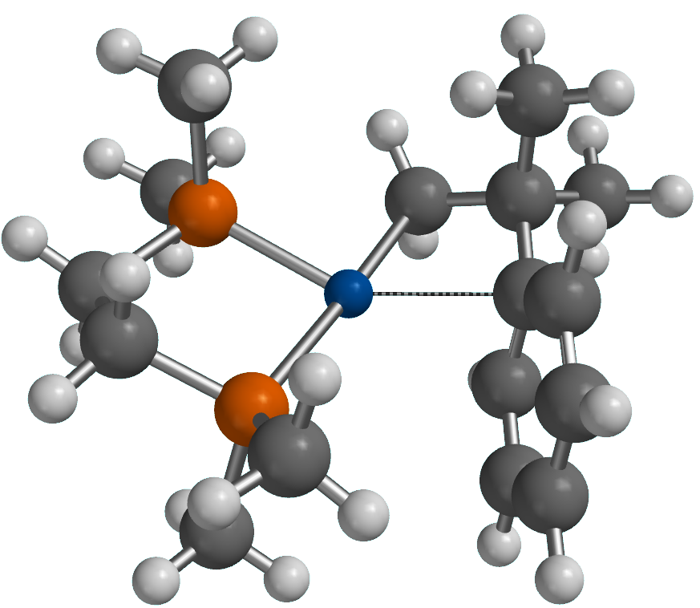
48

Pd -0.262932 0.295476 -0.124545
P -1.517762 0.968774 1.621674
P -1.230249 -1.879080 0.214666
C -2.718109 -0.369127 2.013046
H -3.564343 -0.246634 1.321040
H -3.113143 -0.217948 3.027872
C -2.076538 -1.737498 1.850450
H -2.816050 -2.542477 1.965390
H -1.307857 -1.900574 2.620451
C -0.297209 -3.436204 0.354285
H 0.098174 -3.723949 -0.626450
H -0.948431 -4.241034 0.720235
H 0.545520 -3.311099 1.044178
C -2.581558 -2.297776 -0.936289
H -2.172084 -2.462435 -1.940356
H -3.298793 -1.470304 -0.994010
H -3.107177 -3.205689 -0.611767
C -0.532723 1.197706 3.129892
H 0.193920 2.004164 2.976608
H 0.015139 0.278742 3.367962
H -1.186869 1.457182 3.972803
C -2.498951 2.483409 1.469928
H -3.169773 2.411992 0.606665
H -1.833792 3.343032 1.329785
H -3.093923 2.638469 2.379571
C 0.550284 2.204712 -0.347266
H 0.559360 2.840424 0.546131
H -0.031811 2.699727 -1.138656
C 0.771485 0.190409 -2.409149
C 2.306345 -1.993270 -1.625097
C 0.578675 -1.057684 -3.017334
C 1.751223 0.370815 -1.401596
C 2.495982 -0.760511 -1.009238
C 1.350886 -2.147600 -2.633610
H -0.173328 -1.161501 -3.800953
H 3.247404 -0.668360 -0.225275
H 1.205886 -3.119041 -3.108478
H 2.907460 -2.847693 -1.309668
C 1.951211 1.775842 -0.800002
C 2.885526 1.740530 0.403626
H 2.507387 1.074514 1.192206
H 2.972718 2.746333 0.831964
H 3.897130 1.410467 0.134137
C 2.520976 2.717916 -1.862446
H 3.513693 2.383817 -2.196904
H 2.625219 3.732918 -1.455677
H 1.868314 2.776595 -2.742580
H 0.213489 1.053523 -2.777214

[Pd(Ph)(η²-CH₂=CMe₂-∥)(DMPE)]⁺
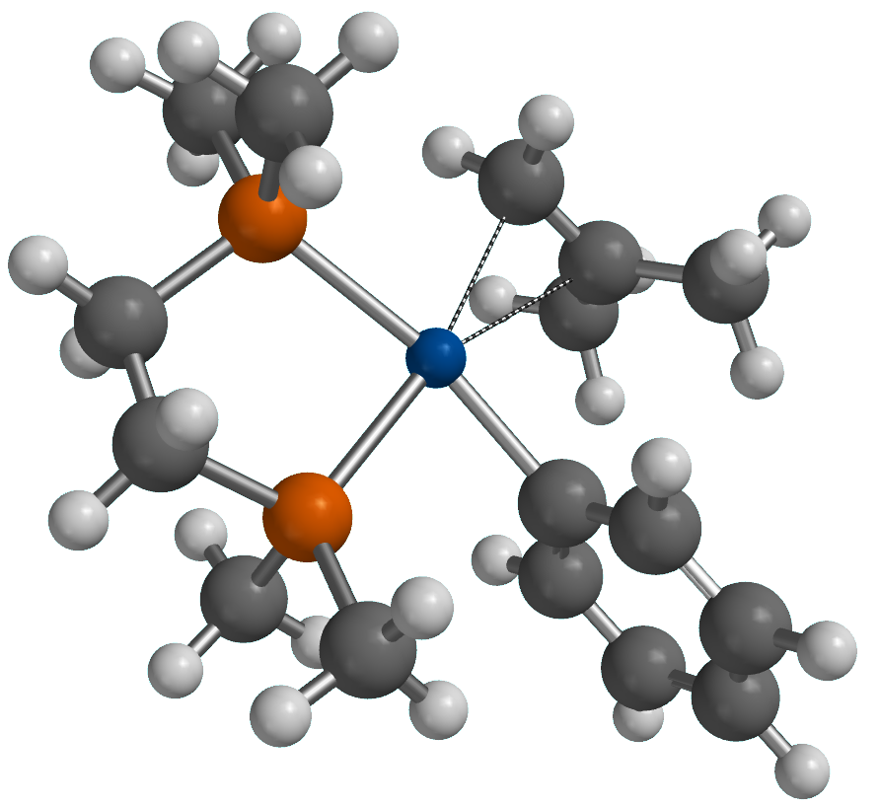
48

Pd -0.034650 0.385579 0.229374
P -1.603512 0.985798 1.928894
P -1.188724 -1.583093 0.151685
C -2.926596 -0.293625 1.882089
H -3.629116 -0.006206 1.086366
H -3.490891 -0.286432 2.825003
C -2.317189 -1.654665 1.603803
H -3.083163 -2.422081 1.423002
H -1.715163 -2.000580 2.456764
C -0.326441 -3.175815 0.157618
H 0.201640 -3.317337 -0.791921
H -1.058559 -3.982795 0.289837
H 0.402459 -3.211045 0.975227
C -2.280387 -1.653511 -1.296384
H -1.678710 -1.659879 -2.212380
H -2.943594 -0.781336 -1.319022
H -2.886377 -2.568283 -1.260254
C -0.893196 0.827271 3.598052
H -0.109691 1.580430 3.742435
H -0.440584 -0.163403 3.723217
H -1.668048 0.967505 4.363159
C -2.494390 2.568644 1.980834
H -2.978569 2.764425 1.017233
H -1.793930 3.384783 2.193128
H -3.256929 2.549652 2.769887
C 0.765254 2.531824 0.589261
H 1.221862 2.452672 1.578535
H -0.144600 3.128140 0.514918
C 0.957723 -0.670255 -2.485981
C 3.170033 -2.004451 -1.448565
C 1.819677 -1.366137 -3.340260
C 1.196202 -0.620028 -1.108313
C 2.304870 -1.311349 -0.600497
C 2.929611 -2.034173 -2.823944
H 1.617613 -1.386964 -4.413613
H 2.509868 -1.308378 0.474264
H 3.601742 -2.579923 -3.488645
H 4.033632 -2.528019 -1.032032
C 1.501790 2.275525 -0.541430
C 2.934402 1.863339 -0.466899
H 3.186991 1.377102 0.481647
H 3.554796 2.768635 -0.555245
H 3.220268 1.204397 -1.295557
C 1.008957 2.686458 -1.888830
H 1.206158 1.914974 -2.644617
H 1.564779 3.579418 -2.214352
H -0.059058 2.930585 -1.892692
H 0.091740 -0.157394 -2.914801

TS2-Pd
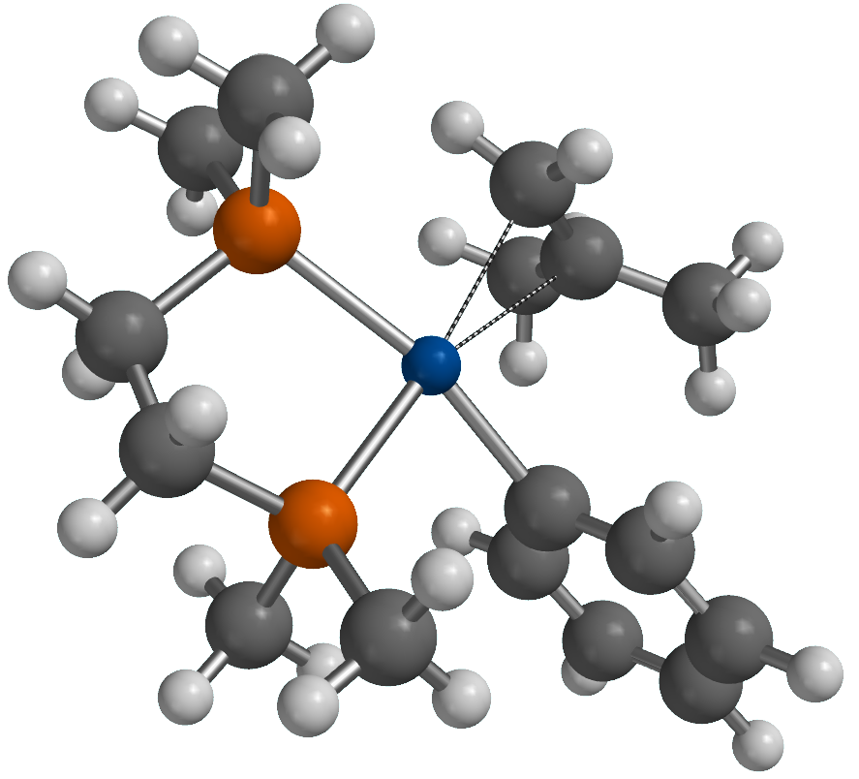
48

Pd 0.049448 0.249210 0.341507
P -1.657211 0.992202 1.835568
P -1.106866 -1.711161 0.276908
C -2.982399 -0.283905 1.734041
H -3.581319 -0.051283 0.841216
H -3.655346 -0.206467 2.599067
C -2.363160 -1.664469 1.623063
H -3.116109 -2.444124 1.439382
H -1.840741 -1.938150 2.551678
C -0.190972 -3.248582 0.559790
H 0.443469 -3.470866 -0.304836
H -0.899800 -4.073035 0.710169
H 0.443057 -3.152963 1.448664
C -2.047751 -1.999271 -1.246962
H -1.358479 -2.092300 -2.093737
H -2.729629 -1.163178 -1.440085
H -2.629126 -2.925608 -1.151644
C -1.249554 1.104710 3.605805
H -0.474446 1.865151 3.759577
H -0.863373 0.143624 3.965207
H -2.137427 1.377007 4.191314
C -2.512937 2.556263 1.474895
H -2.833366 2.573777 0.426586
H -1.843464 3.407004 1.647943
H -3.392956 2.670333 2.121060
C 1.171569 2.209535 0.998324
H 1.801116 1.837899 1.810721
H 0.344066 2.860028 1.279668
C 0.875191 -0.478198 -2.459728
C 3.134441 -1.973156 -1.829199
C 1.675456 -0.996954 -3.481818
C 1.204817 -0.675237 -1.112148
C 2.333923 -1.447521 -0.811730
C 2.811126 -1.744410 -3.168266
H 1.405000 -0.819103 -4.525423
H 2.609853 -1.638658 0.229592
H 3.437191 -2.153167 -3.963618
H 4.016577 -2.565295 -1.573931
C 1.627806 2.201480 -0.294184
C 3.000931 1.730701 -0.638246
H 3.428855 1.076062 0.128538
H 3.647593 2.618366 -0.721906
H 3.038409 1.222506 -1.609803
C 0.878121 2.891732 -1.384642
H 0.780767 2.242686 -2.266860
H 1.444911 3.772945 -1.721816
H -0.119154 3.219997 -1.069736
H -0.018107 0.093844 -2.729962

[Pd(Ph)(η²-CH₂=CMe₂-⊥)(DMPE)]⁺
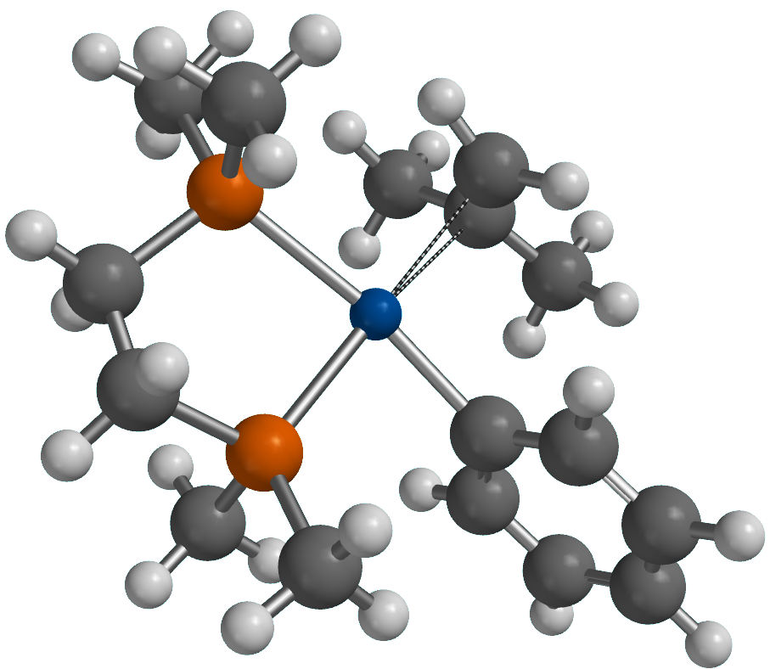
48

Pd 0.115795 0.230183 0.247284
P -1.574199 1.033225 1.763272
P -1.190633 -1.630259 0.079782
C -2.976298 -0.152265 1.598465
H -3.565433 0.162252 0.724504
H -3.638351 -0.077420 2.472502
C -2.451925 -1.565631 1.417505
H -3.256781 -2.277847 1.186243
H -1.963010 -1.926169 2.334308
C -0.427748 -3.267218 0.214265
H 0.212034 -3.446869 -0.657510
H -1.208516 -4.037462 0.257057
H 0.187697 -3.323641 1.119237
C -2.142988 -1.680854 -1.464093
H -1.462666 -1.772681 -2.318153
H -2.729862 -0.762772 -1.580960
H -2.819968 -2.545157 -1.453585
C -1.053439 0.845908 3.500523
H -0.246052 1.553104 3.725085
H -0.673311 -0.167475 3.675908
H -1.892678 1.037108 4.182229
C -2.372310 2.668787 1.738276
H -2.771491 2.882802 0.740044
H -1.641309 3.444162 1.997788
H -3.191080 2.703737 2.468543
C 1.587653 1.977303 0.822784
H 2.498743 1.439180 1.093485
H 1.019867 2.431483 1.635339
C 1.285453 -0.939826 -2.313797
C 3.499241 -2.102187 -1.089955
C 2.236689 -1.613744 -3.084886
C 1.433343 -0.827209 -0.926191
C 2.544187 -1.430727 -0.322069
C 3.347662 -2.196658 -2.474526
H 2.107020 -1.682652 -4.167354
H 2.682463 -1.375599 0.761829
H 4.090734 -2.725351 -3.074350
H 4.365118 -2.556193 -0.602364
C 1.368941 2.351217 -0.476034
C 2.354287 2.066957 -1.557868
H 3.116881 1.339221 -1.264145
H 2.858191 3.012008 -1.811921
H 1.865682 1.722596 -2.478719
C 0.228525 3.234895 -0.861376
H -0.377045 2.773772 -1.655692
H 0.613590 4.173151 -1.287073
H -0.422010 3.480432 -0.017162
H 0.429308 -0.479617 -2.816475

[Pd(Ph)(DiPPE)]
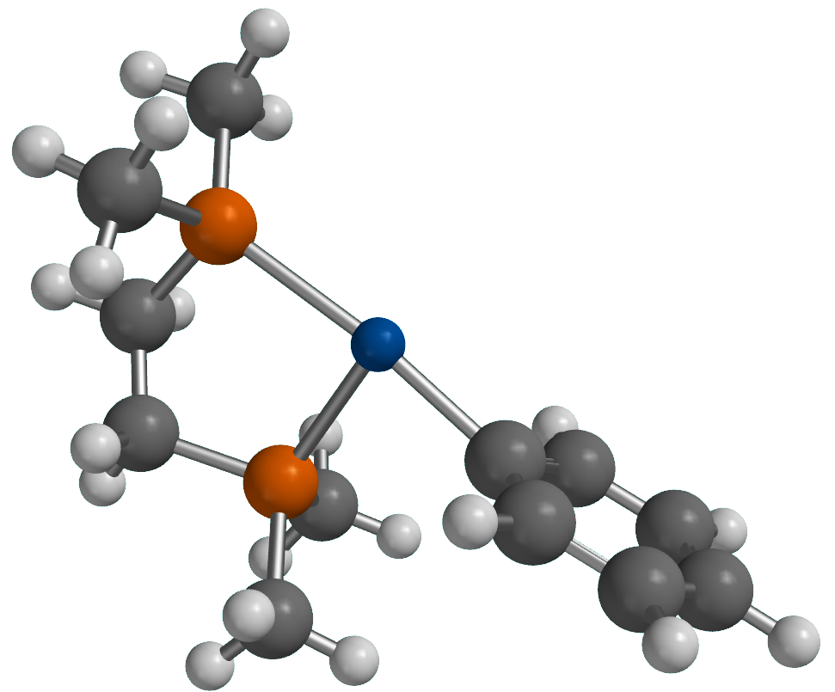
36

Pd -0.555061 -0.879091 0.085420
P 1.072327 -1.854711 1.556709
P 0.729103 0.940082 -0.048025
C 2.495262 -0.697355 1.358033
H 3.031783 -0.997260 0.446040
H 3.198362 -0.815495 2.194274
C 2.010534 0.738746 1.253166
H 2.831943 1.436803 1.034428
H 1.552573 1.073203 2.195605
C -0.012015 2.562549 0.234121
H -0.653641 2.830392 -0.612237
H 0.788213 3.307568 0.335624
H -0.613469 2.551377 1.149865
C 1.608971 1.051484 -1.624359
H 0.894318 1.220807 -2.437411
H 2.158094 0.124078 -1.821949
H 2.316453 1.890458 -1.584134
C 0.686565 -1.766447 3.334862
H -0.126981 -2.460505 3.576254
H 0.360207 -0.754187 3.601408
H 1.568754 -2.028229 3.933989
C 1.805508 -3.504924 1.347095
H 2.149014 -3.636244 0.314776
H 1.056080 -4.274581 1.564831
H 2.655695 -3.636356 2.029359
C -1.731549 -0.045918 -2.539634
C -3.938013 1.269300 -1.446925
C -2.756685 0.412924 -3.371903
C -1.816175 0.127689 -1.151839
C -2.913568 0.813693 -0.613433
C -3.859759 1.070381 -2.826363
H -2.687867 0.259818 -4.451001
H -2.983649 0.994689 0.462998
H -4.655170 1.436813 -3.477738
H -4.796385 1.788878 -1.015709
H -0.869776 -0.550428 -2.986195

[Pd((Ph)(H₂O)(DMPE)]⁺
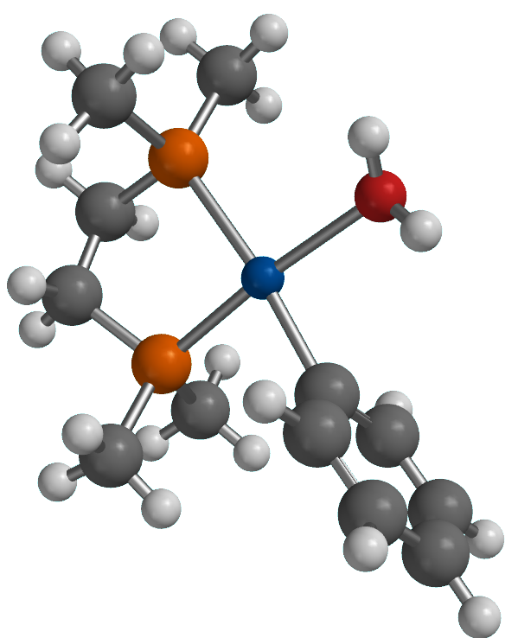
39

Pd 0.400883 0.691174 0.115159
P -1.261429 1.584900 1.582981
P -0.929630 -1.088503 -0.098227
C -2.716804 0.481765 1.331288
H -3.234802 0.831810 0.426393
H -3.424712 0.586325 2.165298
C -2.257769 -0.957664 1.169354
H -3.084693 -1.627163 0.892468
H -1.836795 -1.344662 2.109067
C -0.219603 -2.740275 0.111361
H 0.453756 -2.959894 -0.724923
H -1.023637 -3.487354 0.134348
H 0.350140 -2.792671 1.045967
C -1.786205 -1.141556 -1.695613
H -1.053994 -1.255451 -2.503206
H -2.346047 -0.213598 -1.858789
H -2.480729 -1.991689 -1.717330
C -0.900018 1.434127 3.362576
H -0.061301 2.087536 3.630756
H -0.617206 0.402488 3.603394
H -1.776106 1.714899 3.962222
C -1.919949 3.270510 1.409678
H -2.248969 3.440405 0.378188
H -1.135343 3.999101 1.646650
H -2.767006 3.430834 2.089701
C 1.622866 -0.115377 -2.536372
C 3.778451 -1.512433 -1.457338
C 2.605445 -0.646542 -3.378072
C 1.707686 -0.269068 -1.145948
C 2.793977 -0.982044 -0.618612
C 3.684919 -1.347741 -2.840134
H 2.523824 -0.512566 -4.459203
H 2.882841 -1.134430 0.461218
H 4.450009 -1.766647 -3.496405
H 4.619710 -2.060960 -1.027212
H 0.783784 0.427707 -2.981483
O 1.798819 2.442138 0.134675
H 1.946235 2.905361 0.968453
H 2.679398 2.217209 -0.192328

TS3-Pd
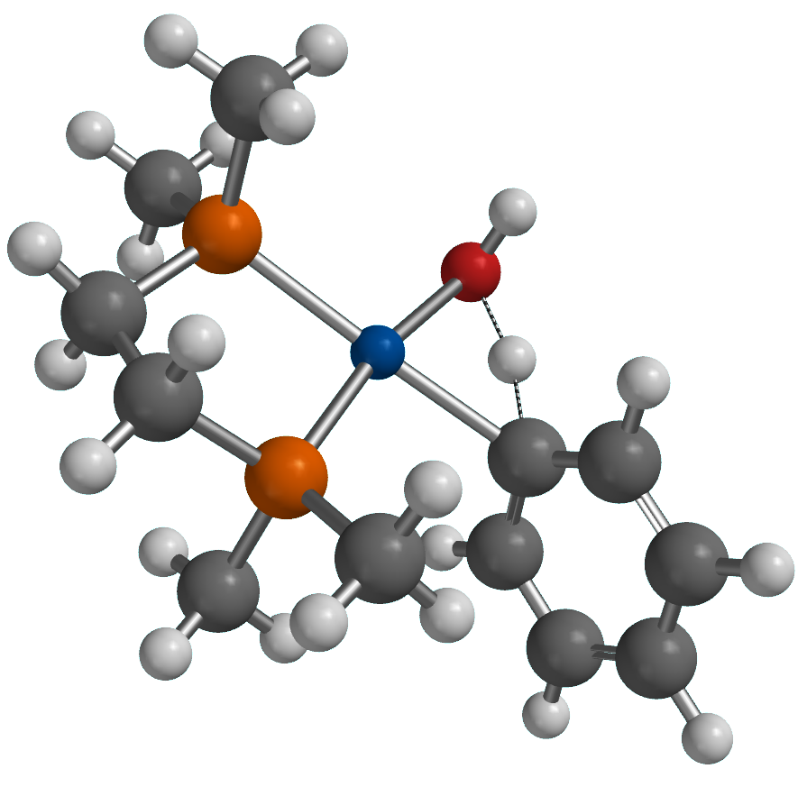
39

Pd 0.366496 0.873215 0.209174
P -1.355495 1.520783 1.592670
P -0.871657 -0.986149 -0.111851
C -2.748067 0.339289 1.386279
H -3.330516 0.674480 0.516139
H -3.415970 0.384580 2.257141
C -2.190589 -1.056573 1.163877
H -2.966908 -1.770925 0.856742
H -1.732039 -1.452848 2.081393
C 0.002314 -2.568090 -0.066519
H 0.710239 -2.615771 -0.902505
H -0.717936 -3.391798 -0.156690
H 0.556337 -2.669624 0.873300
C -1.730583 -0.953125 -1.708241
H -0.996880 -0.952298 -2.522569
H -2.349053 -0.052480 -1.793135
H -2.369682 -1.841341 -1.801643
C -0.899121 1.449202 3.346928
H -0.067353 2.135894 3.542691
H -0.584453 0.434444 3.615940
H -1.757100 1.738406 3.968461
C -2.020190 3.182183 1.327628
H -2.387443 3.279920 0.300049
H -1.228237 3.922476 1.491214
H -2.842461 3.377385 2.028713
C 1.822349 0.198101 -2.448863
C 3.594756 -1.637947 -1.318549
C 2.428421 -0.764055 -3.254103
C 2.082874 0.262113 -1.065757
C 2.978529 -0.678137 -0.518840
C 3.313400 -1.684067 -2.686381
H 2.215625 -0.799813 -4.324285
H 3.203917 -0.650878 0.551309
H 3.788403 -2.440277 -3.314276
H 4.291814 -2.354668 -0.880163
H 1.135637 0.917983 -2.903667
O 1.729523 2.555980 0.168935
H 2.091041 1.501620 -0.482912
H 2.250059 2.572810 0.982366

[Pd(OH)(Ph-H)(DMPE)]⁺
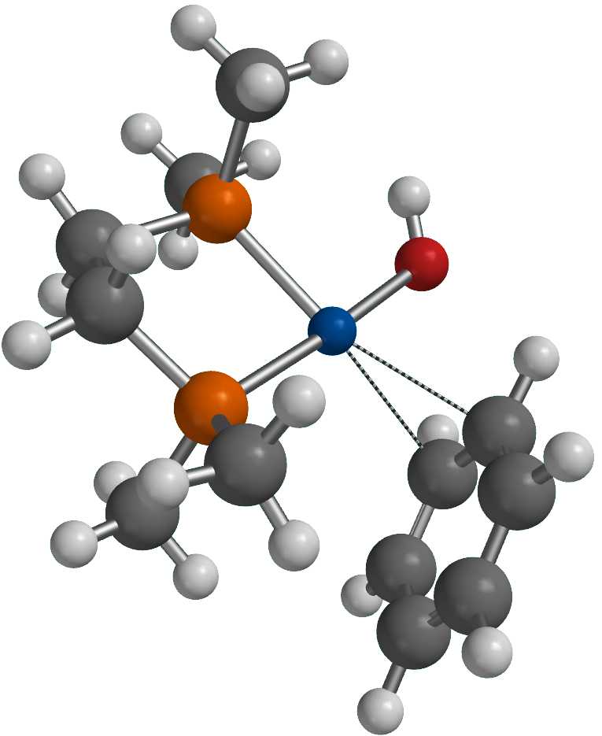
39

Pd 0.588491 0.770188 0.283956
P -1.124407 1.366117 1.621037
P -0.719568 -1.042750 -0.268951
C -2.573100 0.309106 1.251450
H -3.082901 0.755489 0.385758
H -3.275518 0.345477 2.095637
C -2.099814 -1.097678 0.947224
H -2.908323 -1.731467 0.558046
H -1.712432 -1.589640 1.851088
C -0.057044 -2.731343 -0.238048
H 0.593231 -2.908859 -1.099662
H -0.895091 -3.439897 -0.278147
H 0.514872 -2.898682 0.681423
C -1.540984 -0.891949 -1.882827
H -0.797972 -0.917042 -2.687579
H -2.085055 0.057746 -1.943105
H -2.246113 -1.722305 -2.020536
C -0.731585 1.125660 3.371573
H 0.141692 1.728675 3.645214
H -0.506798 0.071638 3.569064
H -1.589667 1.435448 3.983178
C -1.661301 3.081399 1.450457
H -1.924943 3.291278 0.408309
H -0.858155 3.759679 1.757869
H -2.538334 3.249310 2.089952
C 1.828952 0.265192 -2.818015
C 3.142285 -1.223296 -0.839983
C 2.083280 -1.087534 -3.012408
C 2.245867 0.892977 -1.634258
C 2.901409 0.144134 -0.638679
C 2.746640 -1.829165 -2.026598
H 1.771094 -1.573291 -3.938512
H 3.283812 0.649521 0.248858
H 2.947489 -2.889371 -2.189823
H 3.661164 -1.800436 -0.073302
H 1.324755 0.847529 -3.590715
O 1.649070 2.435748 0.829427
H 1.369873 2.821031 1.664710
H 2.135128 1.971360 -1.513081

Cis-[Pd(μ-OH)(DMPE)]₂²⁺
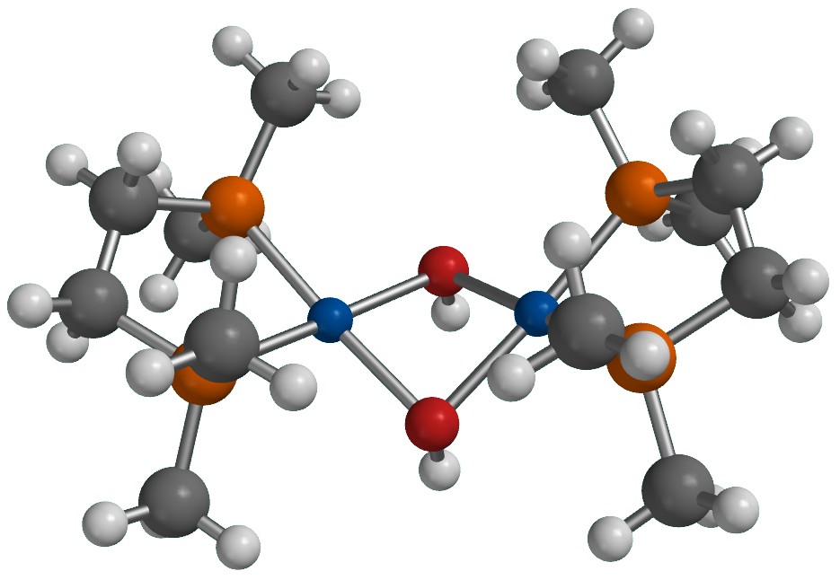
54

H 1.450035 3.397978 0.378502
H -1.474633 3.383357 0.353295
H 0.012105 1.508250 -2.373101
O 0.004807 1.454465 -1.409355
C 4.497126 -0.662427 0.452164
C 4.157807 0.684830 1.067136
C 2.148537 2.832099 1.004939
C 3.845182 2.386371 -1.294556
C 2.305708 -2.339067 1.440761
C 3.386754 -2.828986 -1.192304
H 5.096141 -0.540844 -0.461841
H 5.076782 -1.298139 1.134946
H 3.701422 0.562789 2.059894
H 5.045062 1.319425 1.195882
H 4.524281 3.125012 -0.848451
H 3.036148 -3.073342 1.805091
Pd 1.478629 0.014507 -0.805090
P 2.921579 1.537058 0.010277
P 2.945238 -1.511847 -0.037883
C -4.165941 0.649004 1.022236
C -4.493825 -0.697829 0.400114
C -3.364895 -2.840464 -1.261419
C -2.300234 -2.377987 1.382752
C -3.855616 2.356201 -1.335565
C -2.175944 2.814551 0.973835
H -3.711832 0.525493 2.015811
H -5.057956 1.276877 1.150814
H -5.090709 -0.576145 -0.515305
H -5.071580 -1.340535 1.077986
H -3.030091 -3.118802 1.734835
H -4.543651 3.088283 -0.892334
Pd -1.468582 0.004126 -0.829412
P -2.935053 -1.535320 -0.089051
P -2.931657 1.513761 -0.026526
H -2.462807 -3.402389 -1.528387
H 2.488111 -3.397161 -1.457784
H 0.024048 -1.465478 -2.420774
O 0.015064 -1.416076 -1.457153
H -1.631429 2.371481 1.815118
H -2.950711 3.491506 1.356748
H -2.103654 -1.654208 2.181832
H -1.363438 -2.888270 1.131383
H 2.103637 -1.606279 2.230246
H 1.371381 -2.855221 1.192359
H 4.112794 -3.505870 -0.723096
H 3.822708 -2.403729 -2.102791
H 4.427858 1.665755 -1.879326
H 3.145732 2.899441 -1.964794
H 2.915645 3.512898 1.396251
H 1.598357 2.384936 1.840346
H -3.157173 2.876258 -2.001387
H -4.428753 1.631262 -1.924449
H -3.797438 -2.406201 -2.169287
H -4.091077 -3.525358 -0.804131

Trans-[Pd(μ-OH)(DMPE)]₂²⁺
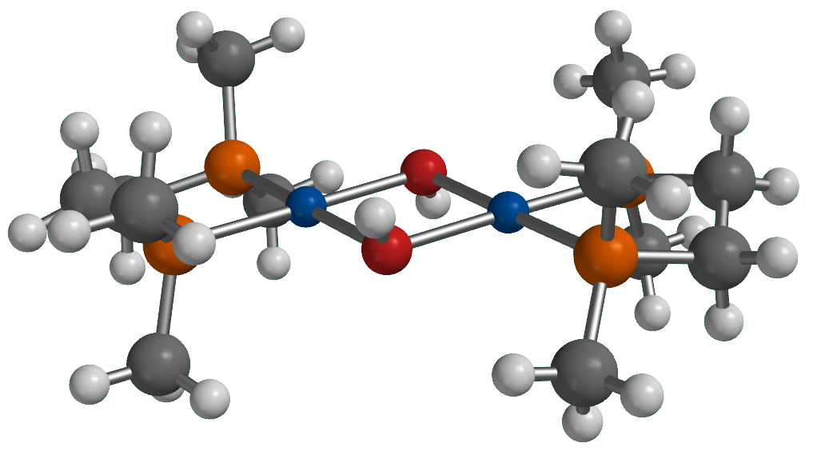
54

Pd 0.000032 -0.003626 1.603087
P -1.520934 0.010286 3.262624
P 1.520377 -0.008582 3.263410
C -0.680057 -0.338533 4.855942
H -0.577254 -1.430381 4.932954
H -1.310736 -0.012638 5.694085
C 0.678438 0.340803 4.856190
H 1.308750 0.014698 5.694618
H 0.575895 1.432682 4.933290
C -2.290680 1.640890 3.432591
H -1.530524 2.398892 3.652664
H -3.029435 1.621933 4.244749
H -2.792118 1.909183 2.495556
C -2.884846 -1.165519 3.104613
H -2.497934 -2.187305 3.025220
H -3.470156 -0.932820 2.207583
H -3.539707 -1.092174 3.982857
C 2.881285 1.170470 3.103817
H 3.467586 0.937975 2.207412
H 3.536009 1.100220 3.982428
H 2.491720 2.191161 3.022597
C 2.294119 -1.636952 3.436311
H 2.796073 -1.905804 2.499706
H 1.535713 -2.396300 3.657896
H 3.032865 -1.614731 4.248376
O -1.407895 0.030507 -0.001128
H -1.986804 -0.739912 -0.004183
O 1.407747 -0.050587 -0.000859
H 1.995147 0.713363 -0.004695
Pd 0.000321 -0.004956 -1.606216
P -1.522534 -0.031257 -3.263973
P 1.522484 0.029755 -3.264484
C 2.875782 -1.154066 -3.086222
H 3.541587 -1.092327 -3.957017
H 2.477859 -2.171248 -3.003743
H 3.447990 -0.922219 -2.180878
C 2.303257 1.654071 -3.452813
H 3.037386 1.621296 -4.268825
H 2.814201 1.930637 -2.523057
H 1.547320 2.415069 -3.676847
C 0.682278 -0.329396 -4.856321
H 1.308018 0.002348 -5.695966
H 0.590953 -1.422386 -4.932191
C -2.303208 -1.654780 -3.459155
H -1.547331 -2.414743 -3.687012
H -3.037935 -1.618527 -4.274534
H -2.813490 -1.935443 -2.530283
C -0.683087 0.335581 -4.854461
H -0.591657 1.428914 -4.924882
H -1.309195 0.008153 -5.695451
C -2.875889 1.151419 -3.079150
H -3.542586 1.093309 -3.949498
H -2.478247 2.168380 -2.992464
H -3.446953 0.915217 -2.174267

[Pd(CH₂CMe₂Ph)(PMe₃)(DMPE)]⁺

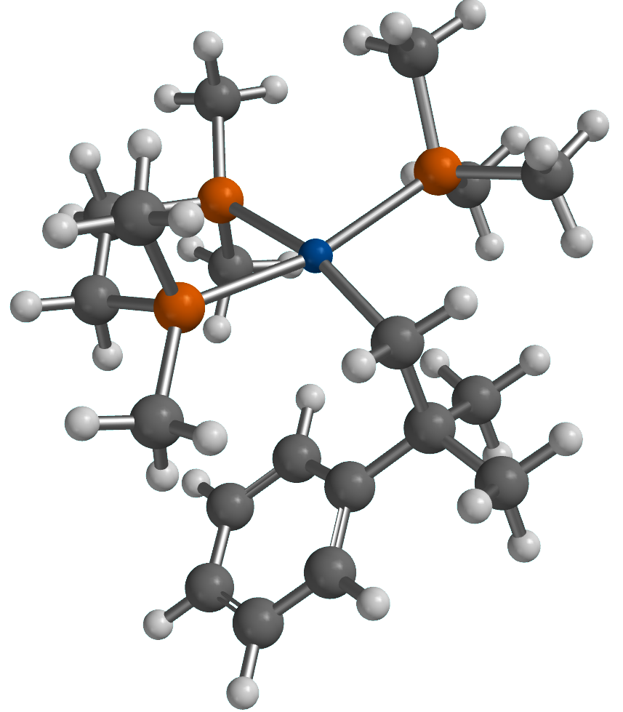
61

Pd 0.514373 -0.622437 0.290415
P -1.593158 -1.600320 0.080663
P -0.102971 -0.473137 2.599515
C -2.582597 -1.222042 1.585268
H -3.458372 -1.884786 1.632448
H -2.963128 -0.195803 1.471445
C -1.713598 -1.350545 2.824656
H -1.480215 -2.405613 3.028463
H -2.219760 -0.960963 3.719212
C -2.755108 -1.418264 -1.300638
H -3.173804 -0.406725 -1.318330
H -3.570780 -2.144489 -1.191528
H -2.243814 -1.601841 -2.252909
C -1.333372 -3.402929 0.172192
H -0.831241 -3.744581 -0.740796
H -2.292200 -3.929687 0.269603
H -0.693309 -3.656217 1.025336
C -0.538741 1.267481 2.943667
H 0.335562 1.913503 2.799218
H -0.900428 1.379582 3.974061
H -1.326052 1.602139 2.258446
C 0.831078 -0.954185 4.089475
H 1.124707 -2.008882 4.033953
H 0.214566 -0.802938 4.985183
H 1.735034 -0.340668 4.182639
C 0.674508 -0.429898 -1.821068
H -0.017919 -1.124880 -2.319817
H 1.686247 -0.729135 -2.129718
C 0.405609 0.999668 -2.343340
C -1.046112 1.413183 -2.087938
C -3.717064 2.202113 -1.559647
C -1.462154 1.781616 -0.797683
C -2.007049 1.459069 -3.105363
C -3.324133 1.847697 -2.848323
C -2.773519 2.166321 -0.530748
H -0.739093 1.772196 0.020452
H -4.046081 1.872270 -3.666698
H -3.059496 2.446487 0.485274
H -4.743999 2.510024 -1.357378
C 0.725250 0.995811 -3.843022
H 0.161359 0.226624 -4.385656
H 1.791514 0.783771 -3.992988
H 0.509090 1.967200 -4.310233
C 1.333865 2.027803 -1.684683
H 2.384542 1.782708 -1.881491
H 1.204498 2.076989 -0.596469
H 1.153203 3.033552 -2.087577
H -1.735468 1.190131 -4.126010
P 2.832621 -0.285729 0.586914
C 3.378758 1.256411 1.391954
H 4.462167 1.234205 1.568324
H 2.865758 1.376425 2.353805
H 3.140921 2.121873 0.762777
C 3.953208 -0.438029 -0.844985
H 4.994019 -0.346951 -0.508966
H 3.818796 -1.421144 -1.312260
H 3.758371 0.328716 -1.601128
C 3.508440 -1.578830 1.683711
H 3.303071 -2.569259 1.261014
H 3.048945 -1.526086 2.675268
H 4.594653 -1.458575 1.792037

[Pd(Ph)(PMe₃)(DMPE)]⁺

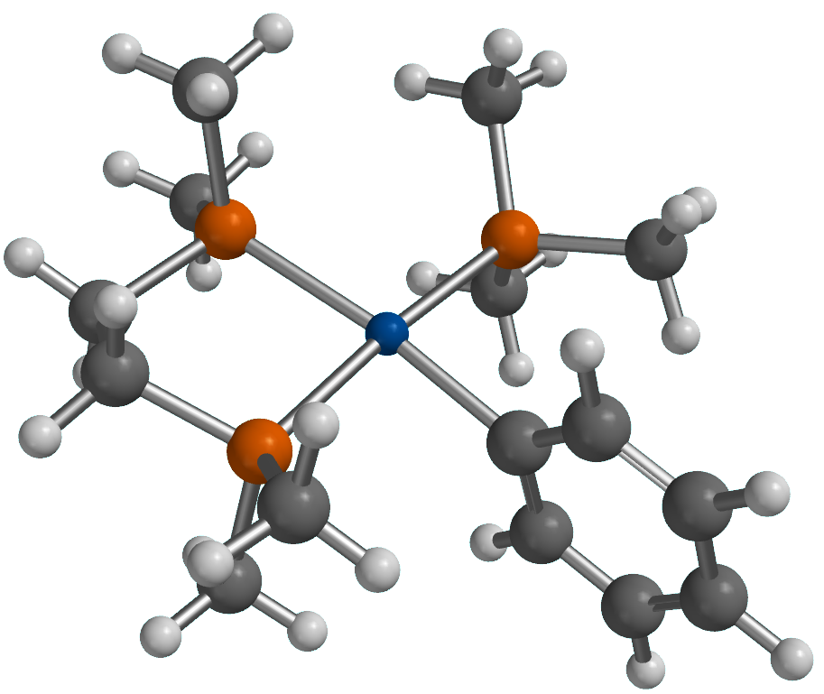
49

Pd -0.104085 0.098972 -0.008303
P -2.351894 0.610997 0.577428
P 0.339301 0.441923 2.247131
C -2.410099 0.614007 2.424178
H -2.516745 -0.434824 2.738753
H -3.311241 1.141293 2.767738
C -1.145691 1.222828 3.006458
H -1.107777 1.118777 4.100092
H -1.089521 2.299029 2.785706
C -2.914189 2.285170 0.126758
H -2.202477 3.031155 0.500101
H -3.904196 2.489552 0.555562
H -2.970598 2.384999 -0.963237
C -3.747986 -0.462946 0.117443
H -3.531027 -1.497621 0.407623
H -3.911490 -0.434949 -0.965853
H -4.667869 -0.135561 0.619273
C 1.747651 1.467032 2.750917
H 2.679355 0.973939 2.448938
H 1.750874 1.605605 3.839677
H 1.697482 2.446233 2.261099
C 0.565804 -1.115877 3.156491
H 1.452850 -1.635478 2.775002
H -0.303516 -1.768571 3.014596
H 0.698155 -0.919682 4.228589
C 2.361657 -1.652113 -0.139975
C 4.181664 0.346713 -0.795860
C 3.706280 -1.972753 -0.351447
C 1.902089 -0.332870 -0.261108
C 2.836468 0.661188 -0.585080
C 4.621712 -0.973371 -0.683446
H 4.037918 -3.009626 -0.257784
H 2.517986 1.703454 -0.682692
H 5.671720 -1.220741 -0.850694
H 4.890035 1.138668 -1.051157
H 1.663308 -2.455101 0.116237
P -0.425520 -0.398298 -2.292208
C 1.027253 -0.269994 -3.381127
H 1.419379 0.753890 -3.365973
H 0.751980 -0.534104 -4.410459
H 1.818691 -0.944128 -3.033362
C -1.683606 0.571392 -3.185644
H -1.413490 1.634085 -3.175344
H -2.664369 0.459451 -2.709766
H -1.758477 0.234752 -4.227992
C -0.968353 -2.122059 -2.515361
H -0.216944 -2.803112 -2.097680
H -1.100970 -2.350772 -3.581332
H -1.917482 -2.290549 -1.992909

